ARGUS UNIFIED

Argus Unified — Complete System Walkthrough
  - Architecture, module integration, deployment, operator flow, algorithms, evidence, and current limits
Document status | IMPLEMENTED / VERIFIED
As of | 10 August 2026
Basis | Consolidated source code, automated tests, build outputs, and browser verification
Scope rule | Implemented behavior only; no roadmap or unimplemented product claims

What was consolidated
Argus Unified is a new, clean project folder assembled around argus_main. No original source folder was modified. The standalone OSINT and breach codebase was merged once under backend/modules and exposed through the shared edge and UI. The unique Telegram monitor and PII-link behavior was reimplemented as backend/modules/telegram_intel and connected to the existing detection, correlation, finding, SLA, exposure, STIX, Redis/Celery, and customer-asset systems.
Source | Unified destination | Duplication decision
argus_main | Project shell, API, UI, infrastructure, scoring | Canonical base retained
osint and breach codebase | backend/modules/osint and backend/modules/breach; modules-ui | One mounted copy; duplicate product shell removed
cyber_threat_monitor | backend/modules/telegram_intel | Rules/workflow retained; duplicate SQLite services removed
pii_link | Shared IOC/PII/STIX and Telegram correlation | Concepts integrated; duplicate ES/Redis/Neo4j stack removed

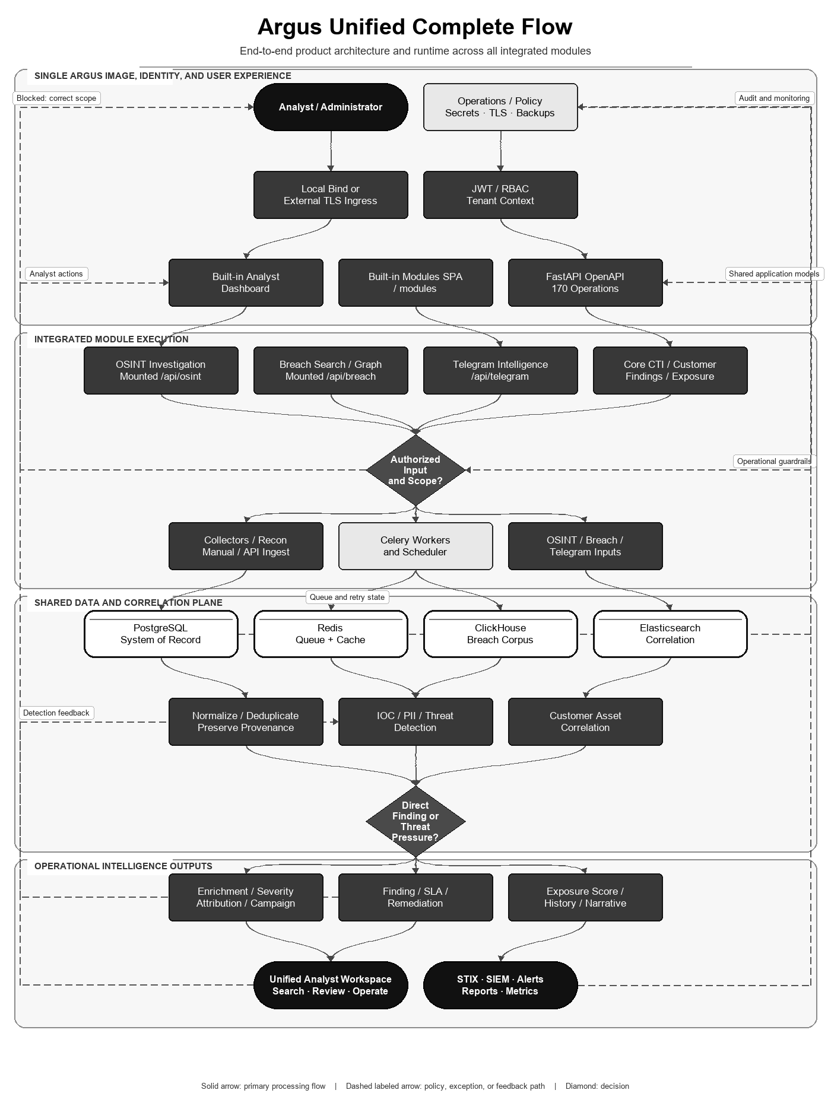
Figure 1. Unified request, execution, storage, and analyst-output path.

System map
Area | Location | Purpose
Core API | backend/arguswatch | FastAPI, models, collectors, engines, RBAC, metrics
Integrated modules | backend/modules | OSINT, breach search/graph, Telegram intelligence
Dashboard | backend/arguswatch/static | Canonical analyst UI including native Telegram page
Modules UI | modules-ui | OSINT and breach workflows served below /modules
Database bootstrap | initdb | PostgreSQL schema, migrations, Telegram tables
Deployment | docker/Dockerfile, docker/docker-compose.yml, setup/ launchers | One Argus image reused across isolated runtime roles
Tests | backend/tests | Unit, regression, API smoke, and integration specifications
Documentation | docs/modules and docs/flowcharts | Verified per-module reports and monochrome flows

Secure deployment walkthrough
- Run .\setup\setup.ps1 or setup\setup.bat to create .env with independent high-entropy PostgreSQL, Redis, JWT, administrator, ClickHouse, and breach-hash secrets; then review optional provider settings.
- Keep the default 127.0.0.1 bind for local use. For remote production access, terminate TLS at an approved reverse proxy, load balancer, VPN, or cluster ingress and configure allowed origins and trusted proxy addresses.
- Start with .\setup\start.ps1 or setup\start.bat. The Python startup module waits for PostgreSQL, runs the unified migration, and replaces itself with Uvicorn.
- Open http://127.0.0.1:7777. Create users/roles and onboard verified customer-owned assets before running matching or recon.
- If Telegram collection is required, set TELEGRAM_API_ID, TELEGRAM_API_HASH, TELEGRAM_PHONE and TELEGRAM_CHANNELS, then run the one-time authorization command documented in README.md.
- Run collectors or explicit imports within authorized scope. Confirm collector status, queue health, and datastore metrics before relying on coverage.
- Back up PostgreSQL, ClickHouse datasets, search indices, and the persistent Telegram session under the operator's secrets/retention policy.
.\setup\setup.ps1
.\setup\start.ps1
# Command Prompt alternatives: setup\setup.bat, setup\start.bat

# Validate configuration without starting containers
docker compose --project-directory . -f docker/docker-compose.yml config

Analyst walkthrough
- Onboard a customer and its owned assets. The matching gate blocks a newly created customer until assets exist.
- Use OSINT for subject discovery. Treat confidence/evidence tiers as analyst aids and preserve source URLs and pivot lineage.
- Use breach search for direct identifiers and the bounded graph for relationship hypotheses. Review common-value warnings and provenance.
- Use Telegram Analyze for stateless triage, Import for authorized exports, or the collector for authorized configured channels. Review risk reasons and extracted IOCs.
- Run correlation. Direct evidence becomes customer findings; unmatched activity contributes to sector/global pressure rather than false attribution.
- Review severity, match proof, exposure dimensions, actor/campaign context, SLA, and remediation steps. Human approval remains required for consequential action.
- Export STIX/SIEM or reports after evidence review.

Implemented mathematical reference
Module | Method | Implemented expression / rule
Core | Exposure | E=max(.50D1+.30D2+.20D3,.20D4); M=.75+.00125D4+.00125D5; Risk=min(100,E·M)
Core | Freshness | decay=exp(−ln(2)·age/half_life); normalized=raw·feed_confidence·decay
Core | Pressure | min(10,3.3log10(count)), recency boost, 7-day decay; sector=.60max+.40mean
OSINT | DOM similarity | Σ min(tag counts) / Σ max(tag counts)
OSINT | Confidence tiers | 95 confirmed; 75 high; 50 medium; 30 ambiguous; 1 unverified; 0 not found
Breach | Graph | Bounded BFS; >200 common-value short circuit; ≤500 records + ≤300 entities
Telegram | Category confidence | c=1−exp(−raw_weight/4)
Telegram | Risk | p=1−exp(−Σ impact·confidence), then complement boosts; flag at 55 or ransomware≥.65
IOC/STIX | Detection/export | 92 patterns / 17 ordered families; confidence cap; deterministic UUIDv5 STIX object IDs

Complete module flowcharts and formal algorithms
This section contains every module flowchart used by the five authoritative module reports. Each diagram is immediately followed by the corresponding code-faithful mathematical specification, executable pseudocode, bounds, invariants, complexity statement, and research/standards basis. The opening unified flowchart is Figure 1; the five module flows below are Figures 2–6.

Core platform
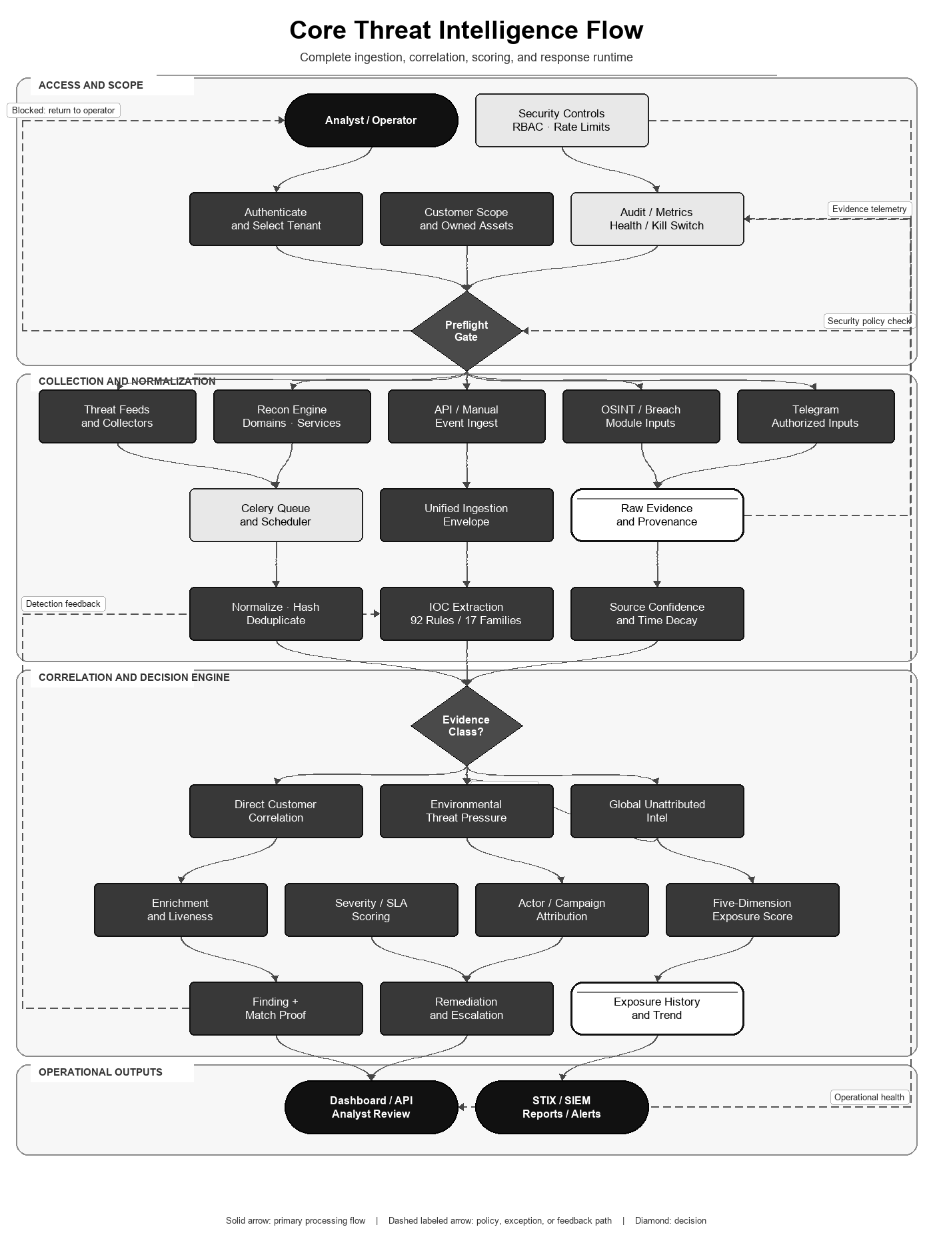
Figure 2. Core ingestion, correlation, scoring, and response path.

Flow-aligned mathematical algorithm and specification
This specification follows the core flowchart from normalized evidence through threat pressure, customer correlation, exposure scoring, and bounded operational output. Every coefficient below is present in the repository; no coefficient is presented as learned or statistically calibrated.
Symbol | Range / type | Implemented meaning
s_raw | real, normally 0..100 | Raw evidence or source score
c_src | 0..1 | Configured feed confidence; unknown source defaults to 0.5
a, h | days; h > 0 | Evidence age and decay half-life; default h=14, pressure h=7
D1..D5 | each 0..100 | Direct exposure, active exploitation, actor intent, attack surface, asset criticality
n | positive integer | Observation count in a threat category/family group
P_j | 0..10 | Decayed activity of threat group j

Freshness and source reliability
lambda = ln(2) / h
w_time(a,h) = exp(-lambda * max(a,0))
s_norm = s_raw * c_src * w_time(a,h)

Invariant: w_time(0,h)=1 and w_time(h,h)=0.5
The half-life parameter makes the decay interpretable and monotone: older evidence never gains weight, and every h days the temporal contribution halves. The implementation does not delete old evidence; it reduces its contribution to the current score.

Threat activity and sector pressure
A(n) = min(10, 3.3 * log10(max(n,1)))
b(r) = 1.3 if age_hours < 1; 1.1 if age_hours < 6; otherwise 1
P_j = min(10, A(n_j) * b(r_j) * exp(-ln(2) * age_days_j / 7))
P_sector = min(10, 0.60 * max_j(P_j) + 0.40 * mean_j(P_j))
The logarithm compresses burst volume, the recency multiplier distinguishes current activity, and the max/mean blend preserves both the dominant threat and the breadth of targeting. Groups with fewer than two observations are not persisted as pressure groups.

Five-dimension exposure score
E_signal = 0.50*D1 + 0.30*D2 + 0.20*D3
E_floor = 0.20*D4
E_base = max(E_signal, E_floor)
M_impact = 0.75 + 0.00125*D4 + 0.00125*D5
Risk = min(100, E_base * M_impact)
For D4,D5 in [0,100], M_impact is bounded in [0.75,1.00]. Risk is bounded in [0,100], is monotone non-decreasing in every dimension, and cannot be zero solely because direct threat evidence is absent when attack-surface exposure exists. Operational labels are LOW <40, MEDIUM 40-59, HIGH 60-79, and CRITICAL 80-100.

Executable algorithm
CORE-SCORE(evidence, customer):
1. validate scope, tenant and provenance
2. normalize and deduplicate evidence
3. for each item: apply source confidence and half-life decay
4. group current observations; compute P_j and P_sector
5. correlate exact customer assets and compute D1..D5
6. compute E_base, M_impact and bounded Risk
7. persist finding, SLA/remediation state and score history
8. emit reviewed alerts, reports, STIX or SIEM output
Property | Result
Determinism | Same stored evidence, customer assets, configuration, and time reference produce the same score
Boundedness | Pressure <=10 and final Risk <=100
Dominant runtime | Linear in evidence processed plus datastore query/index costs; scoring arithmetic is O(N)
Calibration boundary | Weights and thresholds are engineering policy constants, not fitted probabilities

Research and standards basis
NIST SP 800-30 supports explicit treatment of threat sources, vulnerabilities, likelihood and impact, while temporal-information-retrieval research supports time-aware weighting. Neither source specifies Argus's exact coefficients; the formula is an auditable implementation policy that still requires organization-specific validation and sensitivity analysis.
- NIST SP 800-30 Rev. 1 — Guide for Conducting Risk Assessments
- Campos et al. — Temporal Information Retrieval

OSINT investigation
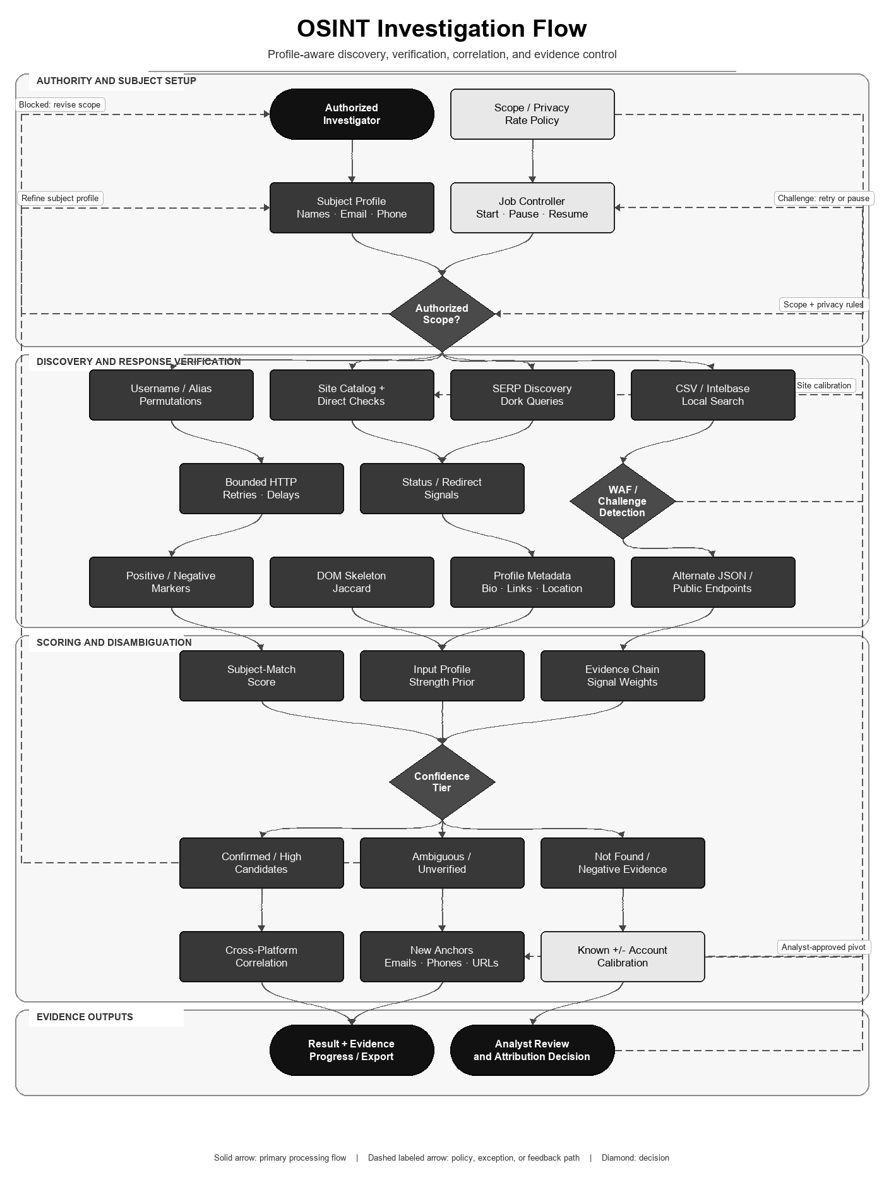
Figure 3. Profile-aware OSINT investigation and verification path.

Flow-aligned mathematical algorithm and specification
The OSINT mathematics maps the flowchart's subject profile, direct checks, response verification, evidence chain, confidence tier, correlation, and analyst-review stages. Scores rank evidence; they do not prove identity.

Subject evidence and profile-strength priors
S_subject = min(100, sum_j w_j * I_j)
I_j = 1 when the normalized candidate contains the supplied attribute, else 0
Matched signal | Implemented weight
Email; phone | +30 each (first match of each type)
Workplace; company | +25; +20 (company counted once)
Education; occupation; industry | +20; +15; +10
City; state; non-obvious country | +20; +10; +5
Full display name; known-profile cross-link | +10; +20

S_profile = min(100, 35*email + 30*phone + 15*photo + 20*username
+ 15*workplace + 10*education + 10*city + 5*full_name)
STRONG >=60; MODERATE 25..59; WEAK <25
All variables in S_profile are binary presence indicators. The score measures expected disambiguation power of the supplied input, not the probability that any result is correct.

DOM soft-404 discrimination
For tag t, let f_A(t), f_B(t) be counts in the first 10 KB.
J_w(A,B) = sum_t min(f_A(t),f_B(t)) / sum_t max(f_A(t),f_B(t))
DOM differs when J_w < 0.90
This is a weighted multiset form of Jaccard similarity. A candidate page that closely resembles the calibrated nonexistent-account page is treated as soft-404 evidence rather than a confirmed profile.

Rank prior and three-way decision
R_on(k) = max(0, floor(35*(1-k/12)))
R_off(k) = max(0, floor(25*(1-k/12)))
Final rank = min(100, rank prior + documented attribute boosts)

Decision = CONFIRMED/HIGH/MEDIUM/AMBIGUOUS/UNVERIFIED/NOT_FOUND
Thresholds = 95/75/50/30/1/0
The evidence-chain gate separately records DEFINITIVE, HIGH, POSSIBLE, or UNLIKELY support. This preserves a link / possible-link / non-link style decision rather than forcing every response into a binary identity claim.

Executable algorithm
OSINT-INVESTIGATE(profile):
1. validate scope; compute permutations and S_profile
2. run bounded direct-site, SERP and local-intelbase checks
3. classify status, redirects, markers and WAF/challenge evidence
4. compare candidate DOM with calibrated negative baseline
5. extract metadata and compute S_subject plus evidence tier
6. assign confidence class; keep negative and ambiguous evidence
7. cluster cross-platform candidates and return bounded pivots
8. require analyst review before attribution
Property | Result
Score bounds | All public scores are clipped to 0..100
DOM cost | O(T_A + T_B) over extracted tag counts
Network cost | Dominated by bounded external requests, retries and configured concurrency
Statistical boundary | Weights are deterministic heuristics, not Fellegi-Sunter log-likelihood ratios learned from labeled pairs

Research and standards basis
Fellegi-Sunter provides the classical theoretical basis for link, possible-link, and non-link decisions from comparison evidence. Jaccard provides the similarity basis adapted here to DOM tag-frequency multisets. Argus borrows these structures but does not claim a trained probabilistic record-linkage model.
- Fellegi and Sunter — A Theory for Record Linkage
- Jaccard — Étude comparative de la distribution florale

Breach search and graph
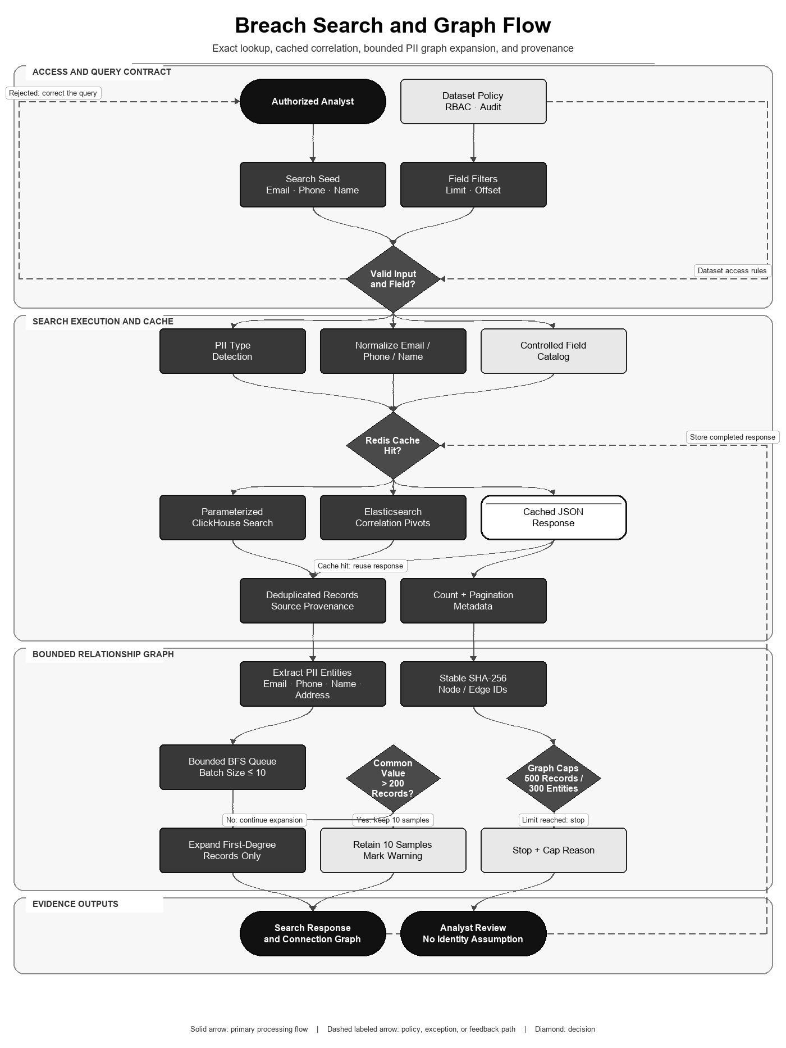
Figure 4. Direct breach lookup, correlation, caching, and graph expansion.

Flow-aligned mathematical algorithm and specification
The breach algorithm follows the flowchart's validated seed, controlled field catalog, cache decision, parameterized search, provenance-preserving records, entity extraction, bounded graph traversal, and capped response.

Canonicalization and stable identifiers
email_norm(x) = lowercase(trim(x))
phone_norm(x) = canonical ten-digit representation after prefix/trunk handling
row_id = SHA256(source_file || '|' || email_norm || '|' || phone_norm)
entity_id = SHA256(UPPER(type) || ':' || lowercase(trim(value)))
edge_id = SHA256(row_id || '|' || entity_id)
These hashes make repeated rows and entities stable within the same canonicalization policy. They are identifiers, not proof that two people are identical and not a substitute for encrypting sensitive values.

Bipartite graph and bounded BFS
G = (R union E, L)
R = breach-record nodes; E = normalized EMAIL/PHONE/NAME/ADDRESS nodes
(r,e) in L iff record r contains entity e

Hard bounds: |R| <= 500, |E| <= 300, |R union E| <= 800
Common-value gate: degree(e) > 200 => retain 10 samples and do not expand
Expansion depth: seed records -> entities -> first-degree records -> second-degree entities
BREACH-GRAPH(seed):
1. normalize and resolve at most 100 seed records
2. create stable record/entity nodes and enqueue unseen entities
3. dequeue entities in batches of at most 10
4. query 201 rows to detect degree >200
5. if common: mark warning, keep 10 samples, stop that branch
6. else add deduplicated rows and one further entity layer
7. stop at 500 records, 300 entities, timeout, or empty queue
8. return provenance, pagination, capped and cap_reason metadata
Property | Result
Traversal | Breadth-first over a bipartite graph with explicit visited sets
In-memory complexity | O(|R|+|E|+|L|), absolutely bounded by configured node caps
External query cost | Bounded by unique expanded entities, batch size, timeout and datastore indexes
Precision guard | High-degree values are warned and sampled because common names/addresses create noisy joins
Interpretation boundary | An edge shows shared data, not identity, ownership, compromise, or causation

Research and standards basis
Moore's breadth-first search supplies the traversal basis; entity-resolution meta-blocking research supports restricting noisy comparison graphs for scalability; FIPS 180-4 specifies SHA-256. Argus's thresholds (200, 10, 500, 300 and depth two) are implementation safety bounds, not values established as optimal by those publications.
- Moore — The Shortest Path Through a Maze
- Papadakis et al. — Enhanced Meta-Blocking for Entity Resolution
- NIST FIPS 180-4 — Secure Hash Standard

Telegram threat intelligence
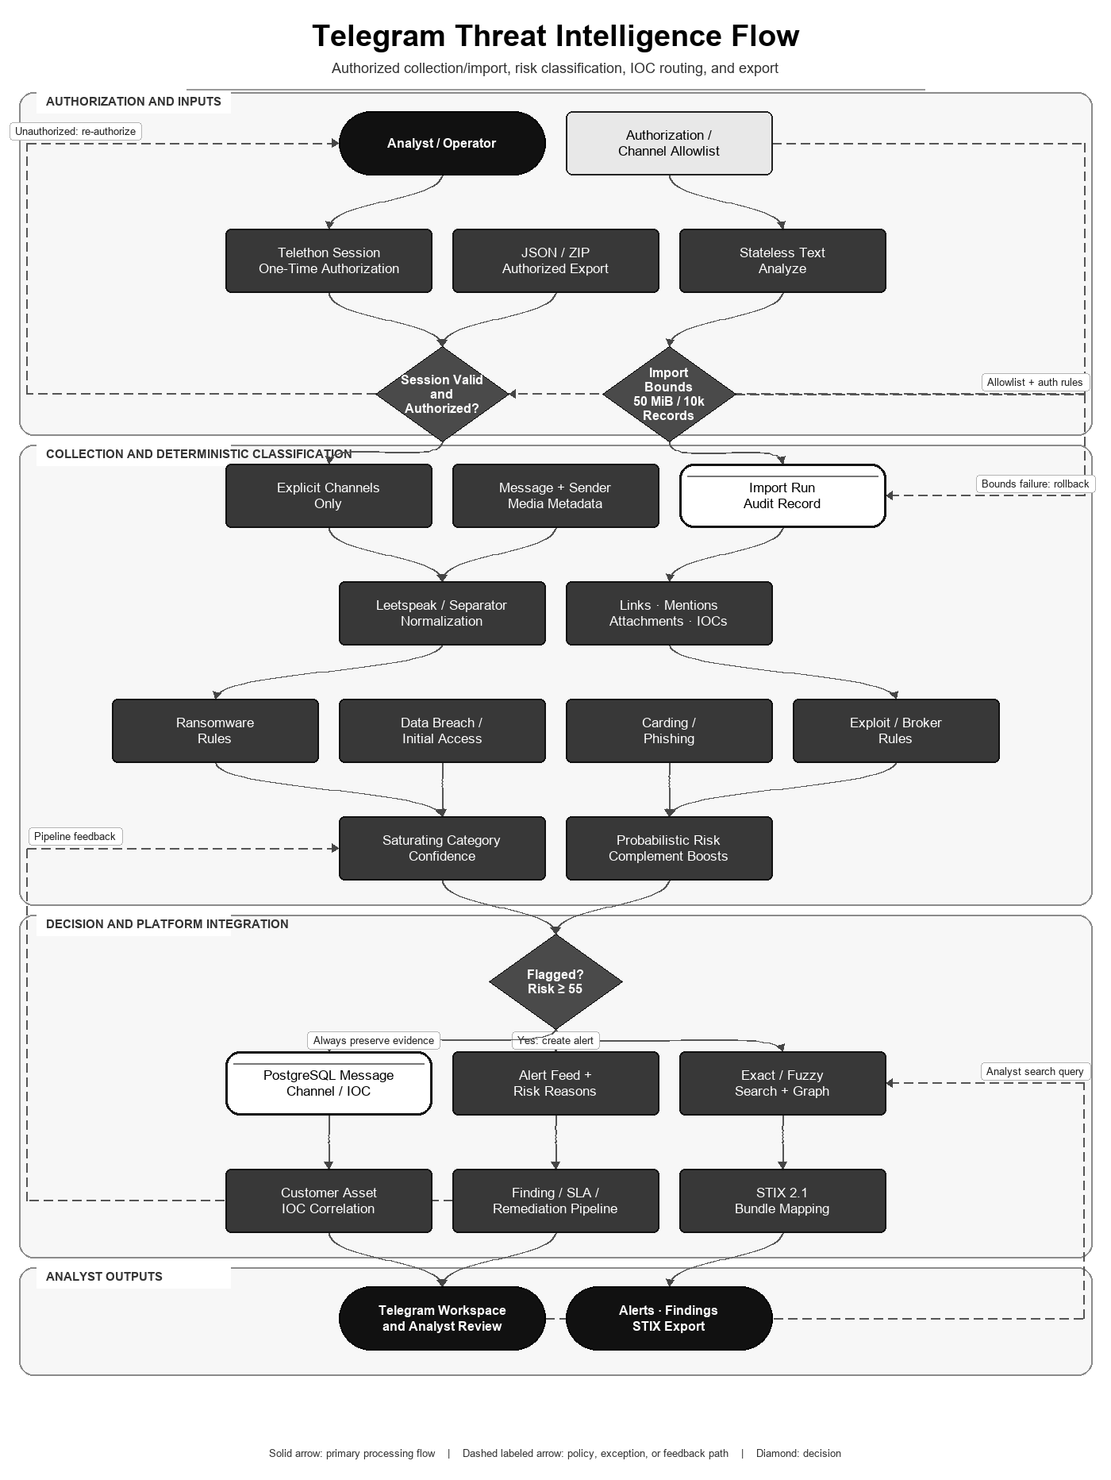
Figure 5. Telegram ingestion, classification, correlation, and response path.

Flow-aligned mathematical algorithm and specification
The Telegram algorithm follows authorization/import gates, normalization, rule categories, saturating confidence, bounded risk aggregation, flagging, persistence, customer correlation, search, graphing, and STIX export.

Category saturation and aggregate risk
r_k = sum_i w_i * I(rule_i matches raw text or normalized text)
c_k = 1 - exp(-r_k/4)
A = sum_k alpha_k * c_k
p_0 = 1 - exp(-A)
Category k | alpha_k
Ransomware | 1.00
Data breach | 0.90
Initial access | 0.90
Carding | 0.85
Phishing | 0.75
Exploit | 0.80
Broker contact | 0.35

if external channel: p = 1 - (1-p_0)*0.90
if risky attachment: p = 1 - (1-p)*0.88
risk = clip(round(100*p), 0, 100)
flagged = (risk >= 55) OR (c_ransomware >= 0.65)
The exponential transforms are monotone and bounded, so repeated synonymous rules have diminishing marginal effect. The complement updates have a noisy-OR-style form. The resulting p is a risk-like score, not a calibrated real-world probability of criminality or compromise.

Typo-tolerant token similarity
sim(q,t) = 2*M / (|q|+|t|)
M = total characters in recursively matched common subsequences
best(q,text) = max over bounded query/candidate token pairs sim(q_i,t_j)
The implementation uses Python SequenceMatcher, discards tokens shorter than four characters, caps candidate tokens at 450, and skips pairs whose lengths differ by more than 50 percent. Search fetches at most 2,000 database candidates before ranking.

Executable algorithm
TELEGRAM-ANALYZE(message):
1. validate authorized session/channel or bounded import
2. normalize case, leetspeak, separators and whitespace
3. evaluate deterministic rules in raw and normalized text
4. compute r_k, c_k, A and bounded risk
5. apply channel/attachment complement boosts; evaluate flag gate
6. extract links, mentions, attachments and IOCs
7. persist evidence and correlate exact customer assets
8. expose alerts/search/graph and STIX after analyst review
Property | Result
Bounds | 0 <= c_k < 1 and 0 <= risk <= 100
Rule evaluation | Deterministic for the same text, media name and rule set
Fuzzy-search bound | At most 450 candidate tokens per message and 2,000 fetched message rows
Validation boundary | Weights and flag thresholds require labeled-corpus precision/recall calibration before probabilistic interpretation

Research and standards basis
Noisy-OR literature supports bounded aggregation of multiple partially independent causes, and Ratcliff-Metzener describes the Gestalt string-similarity family used by SequenceMatcher. Argus uses these mathematical shapes deterministically; independence and probability calibration have not been established on a labeled Telegram corpus.
- Srinivas — A Generalization of the Noisy-Or Model
- Ratcliff and Metzener — Pattern Matching: The Gestalt Approach

PII, IOC correlation and STIX
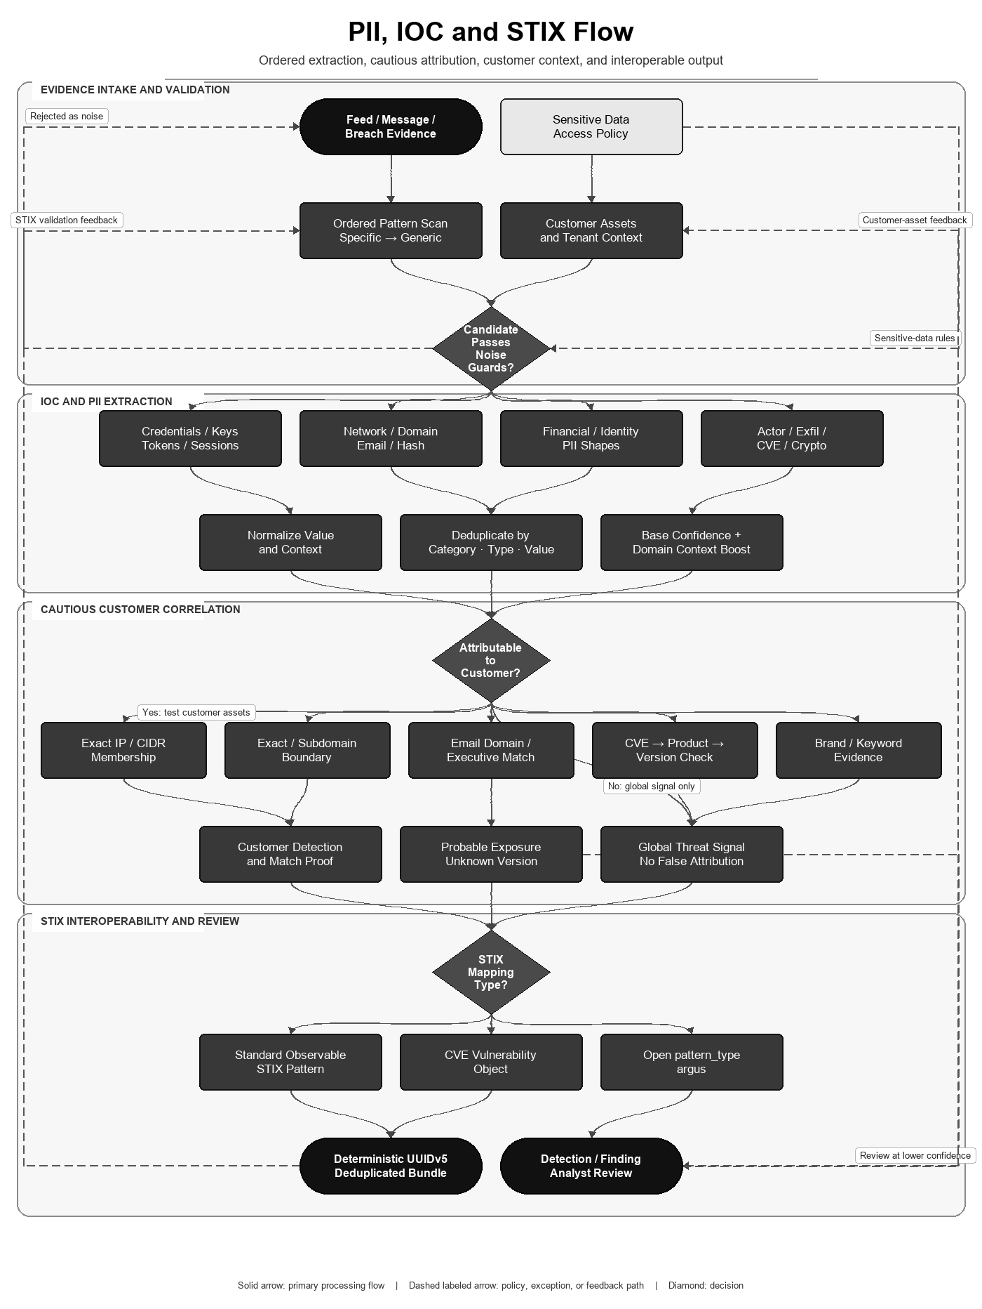
Figure 6. Shared PII/IOC extraction, customer correlation, and STIX mapping.

Flow-aligned mathematical algorithm and specification
The PII/IOC/STIX algorithm follows ordered pattern recognition, noise guards, canonicalization, deduplication, confidence adjustment, cautious customer attribution, and standards-based object mapping.

Ordered detection and confidence
For ordered pattern p_i and line l:
I_i(l) = 1 if regex p_i matches l and all noise guards pass, else 0
K(match) = (category, ioc_type, exact_value)
keep the first unique K under specific-to-generic scan order
confidence = min(1, base_confidence + 0.10*I(customer_domain occurs on same line))
The engine evaluates 92 expressions in 17 ordered families. Specific credential, token, session and exfiltration patterns precede generic URL, domain, email, IP and hash patterns. Private/localhost IP guards and removed high-noise expressions reduce false positives.

Customer attribution predicates
A(e,c) = IP_EXACT_OR_CIDR(e,c) OR DOMAIN_EXACT_OR_SUBDOMAIN(e,c)
OR EMAIL_DOMAIN_OR_EXECUTIVE(e,c) OR CVE_PRODUCT_VERSION(e,c)
OR BOUNDED_BRAND_KEYWORD_EVIDENCE(e,c)

Direct finding only when an implemented attribution predicate supplies match proof.
Unknown product version => probable exposure at lower confidence.
No attributable predicate => global signal, not a customer finding.
Domain matching is boundary-aware; raw substring containment is not treated as exact ownership. IP ranges use canonical address membership. These are conservative logical predicates rather than a learned entity-resolution model.

STIX confidence and deterministic names
C_stix = clip(round(100*confidence), 0, 100)
UUIDv5(namespace,name) = RFC9562_Format(first128(SHA1(namespace || canonical_name)))
Bundle UUIDs are UUIDv4; Telegram-derived object IDs use UUIDv5.
Duplicate exported objects are removed by normalized (type,value) identity.
Standard IP, domain, URL, email and hash values become STIX Indicator patterns; CVEs become Vulnerability objects in the Telegram export path; unsupported types use the documented open 'argus' pattern type instead of pretending to be valid STIX pattern syntax.

Executable algorithm
PII-IOC-STIX(text, customer):
1. scan each line with specific-to-generic compiled patterns
2. reject short, private, localhost and duplicate candidates
3. normalize values; attach line context and bounded confidence
4. evaluate exact/boundary/CIDR/CVE customer predicates
5. create direct, probable or global evidence without false attribution
6. map supported values to STIX 2.1 objects and escape patterns
7. assign bounded confidence and stable IDs where implemented
8. deduplicate bundle and retain evidence for analyst review
Property | Result
Detection cost | O(L * P * match_cost) for L lines and P compiled expressions; P is fixed at 92
Deduplication | Expected O(M) with a hash set for M candidate matches
Interoperability | STIX structure and pattern vocabulary follow OASIS STIX 2.1
Validation boundary | Regex-shaped PII and secrets are candidates; provider checksums/contextual validation may still be required

Research and standards basis
Kleene's formal-language work supplies the theoretical basis for regular-expression recognition; OASIS specifies STIX 2.1; RFC 9562 specifies UUIDv5; FIPS 180-4 specifies SHA-1/SHA-256 primitives. These standards validate representation mechanics, not the semantic truth of a regex match or customer attribution.
- Kleene — Representation of Events in Nerve Nets and Finite Automata
- OASIS STIX 2.1 introduction
- IETF RFC 9562 — Universally Unique IDentifiers
- NIST FIPS 180-4 — Secure Hash Standard

Unified end-to-end mathematical algorithm
The unified model composes the five module algorithms without averaging incompatible scores. OSINT identity evidence, breach relationships, Telegram risk, IOC candidates and core exposure remain typed values until explicit correlation predicates create a customer finding.
O = O_core union O_osint union O_breach union O_telegram union O_pii_ioc
E = DEDUP(NORMALIZE(O), provenance-preserving typed key)
F_c = { e in E : A(e,c)=1 and policy_gate(e,c)=ALLOW }
G_c = { e in E : A(e,c)=0 } # global/sector evidence, never forced attribution
Risk_c = CORE_D1_D5(F_c, threat_pressure(G_c), assets_c)
ARGUS-UNIFIED(input, customer):
1. enforce authorization, tenant, source and rate-limit gates
2. dispatch typed input to OSINT, breach, Telegram and IOC modules
3. preserve each module's raw evidence, confidence and provenance
4. normalize/deduplicate; do not numerically merge unlike scores
5. evaluate exact customer-asset attribution predicates
6. route direct evidence to findings and unmatched evidence to pressure
7. calculate D1..D5 exposure and remediation priority
8. require analyst review for identity, attribution and consequential action
9. export reviewed intelligence to STIX/SIEM/reports/alerts
10. retain audit trail, score history and operational bounds
System invariant | Meaning
Type preservation | An OSINT confidence class is not treated as a Telegram probability or breach graph weight
No forced attribution | Unmatched indicators contribute only to global/sector pressure
Bounded outputs | Module caps and the 0..100 core score prevent unbounded operational values
Human decision gate | Automated evidence ranking does not establish identity, intent, ownership or legal conclusion
Reproducibility | Deterministic modules reproduce results for identical inputs, configuration, data and time reference

Research and standards basis
The complete pipeline combines established structures from risk assessment, record linkage, bounded entity-resolution graphs, noisy-OR-style evidence aggregation and standardized CTI representation. The integration is engineering work specific to Argus; publication-quality empirical validation would additionally require labeled datasets, calibration curves, error analysis, ablation studies and external replication.
- NIST SP 800-30 Rev. 1 — Guide for Conducting Risk Assessments
- Fellegi and Sunter — A Theory for Record Linkage
- Papadakis et al. — Enhanced Meta-Blocking for Entity Resolution
- Srinivas — A Generalization of the Noisy-Or Model
- OASIS STIX 2.1 introduction

Consolidated market alternatives
The following matrices consolidate the module-level research into the system walkthrough. They compare native, evidenced capability rather than marketing similarity. Argus checks reflect the present repository only; external checks reflect the cited official product documentation reviewed on 10 August 2026. A product can often gain crossed capabilities through custom development, paid add-ons, connectors, or partner data.
Argus area | Representative alternatives | Where the alternative is strongest | Argus-specific integration
Core CTI platform | OpenCTI, MISP, ThreatConnect, Recorded Future | Mature CTI sharing/graphs, commercial case tooling, or managed intelligence corpus | Owned-asset correlation plus recon, breach, Telegram, exposure, SLA, and remediation
OSINT investigation | SpiderFoot, Maltego, Sherlock, Maigret | Broad modules, graph analysis/collaboration, or focused username enumeration | Subject disambiguation, evidence tiers, calibration, resumable jobs, downstream pivots
Breach search | HIBP, Intelligence X, LeakCheck, DeHashed | Hosted corpora, notifications, and externally maintained search coverage | Operator-controlled stores, bounded PII graph, stable IDs, customer finding handoff
Telegram intelligence | Telethon, Maltego Monitor, Social Links, OpenCTI | Raw MTProto development, commercial monitoring/transforms, or general CTI graphing | Deterministic cybercrime scoring, bounded import, IOC/customer matching, STIX
PII / IOC / STIX | Presidio, Google SDP, Macie, iocextract, OpenCTI, MISP | PII anonymization, managed data discovery, defanged IOC extraction, CTI sharing | One ordered detector feeding attribution, breach graph, findings, and deterministic STIX

Core platform alternatives
Evidence rule (reviewed 10 August 2026): ✓ = native capability implemented in Argus or explicitly documented by the cited primary source; ✗ = not evidenced as a native capability in the reviewed source. A cross does not mean a custom integration, partner feed, or extension is impossible. Product editions and licensing can change.
Feature | Argus Unified | OpenCTI | MISP | ThreatConnect | Recorded Future
Self-hosted open-source deployment | ✓ | ✓ | ✓ | ✗ | ✗
Structured CTI objects and relationships | ✓ | ✓ | ✓ | ✓ | ✓
Feed/import connector framework | ✓ | ✓ | ✓ | ✓ | ✓
STIX 2.1-compatible export | ✓ | ✓ | ✓ | ✓ | ✗
Customer/victim asset inventory | ✓ | ✓ | ✗ | ✓ | ✓
Automated asset-to-indicator correlation | ✓ | ✓ | ✗ | ✗ | ✓
Native attack-surface/recon collection | ✓ | ✗ | ✗ | ✗ | ✓
Native breach-record search and graph | ✓ | ✗ | ✗ | ✗ | ✗
Native Telegram collection and analysis | ✓ | ✗ | ✗ | ✗ | ✗
Case/task or investigation workflow | ✓ | ✓ | ✓ | ✓ | ✗
Finding SLA and remediation state | ✓ | ✗ | ✗ | ✗ | ✗
Published deterministic exposure formula | ✓ | ✗ | ✗ | ✗ | ✗
Built-in commercial intelligence corpus | ✗ | ✗ | ✗ | ✗ | ✓
API/SIEM-oriented integration | ✓ | ✓ | ✓ | ✓ | ✓
RBAC and auditable activity controls | ✓ | ✓ | ✓ | ✓ | ✗
Dashboards or analyst reporting | ✓ | ✓ | ✓ | ✓ | ✓

OSINT alternatives
Evidence rule (reviewed 10 August 2026): ✓ = native capability implemented in Argus or explicitly documented by the cited primary source; ✗ = not evidenced as a native capability in the reviewed source. A cross does not mean a custom integration, partner feed, or extension is impossible. Product editions and licensing can change.
Feature | Argus Unified | SpiderFoot | Maltego | Sherlock | Maigret
Self-hosted open-source core | ✓ | ✓ | ✗ | ✓ | ✓
Username enumeration | ✓ | ✓ | ✓ | ✓ | ✓
Name/email/phone/person inputs | ✓ | ✓ | ✓ | ✗ | ✗
Multi-source module/transform ecosystem | ✓ | ✓ | ✓ | ✗ | ✗
Rich subject-profile disambiguation | ✓ | ✗ | ✗ | ✗ | ✗
Evidence-chain confidence tiers | ✓ | ✗ | ✗ | ✗ | ✗
DOM-skeleton account verification | ✓ | ✗ | ✗ | ✗ | ✗
Structured profile metadata extraction | ✓ | ✓ | ✓ | ✗ | ✓
Recursive pivot discovery | ✓ | ✓ | ✓ | ✗ | ✓
WAF/challenge-aware checks | ✓ | ✗ | ✗ | ✗ | ✓
Known-positive/negative calibration | ✓ | ✗ | ✗ | ✗ | ✗
Pause/resume/cancel background jobs | ✓ | ✗ | ✗ | ✗ | ✗
Visual relationship graph | ✗ | ✓ | ✓ | ✗ | ✓
Real-time graph collaboration | ✗ | ✗ | ✓ | ✗ | ✗
Local CSV/intelbase lookup | ✓ | ✗ | ✓ | ✗ | ✗
Structured report/export formats | ✓ | ✓ | ✓ | ✓ | ✓

Breach-search alternatives
Evidence rule (reviewed 10 August 2026): ✓ = native capability implemented in Argus or explicitly documented by the cited primary source; ✗ = not evidenced as a native capability in the reviewed source. A cross does not mean a custom integration, partner feed, or extension is impossible. Product editions and licensing can change.
Feature | Argus Unified | HIBP | Intelligence X | LeakCheck | DeHashed
Self-hosted local-corpus search | ✓ | ✗ | ✗ | ✗ | ✗
Vendor-hosted breach corpus | ✗ | ✓ | ✓ | ✓ | ✓
Email lookup | ✓ | ✓ | ✓ | ✓ | ✓
Username lookup | ✓ | ✓ | ✓ | ✓ | ✓
Phone lookup | ✓ | ✓ | ✓ | ✓ | ✓
IP-address lookup | ✓ | ✗ | ✓ | ✗ | ✓
Domain exposure/search | ✓ | ✓ | ✓ | ✓ | ✗
Name/address pivot | ✓ | ✗ | ✗ | ✗ | ✓
Combined multi-field query | ✓ | ✗ | ✗ | ✗ | ✓
Full raw record fields | ✓ | ✗ | ✓ | ✓ | ✓
Dataset/breach provenance | ✓ | ✓ | ✓ | ✓ | ✓
Paginated programmatic API | ✓ | ✗ | ✓ | ✓ | ✓
Record-to-PII relationship graph | ✓ | ✗ | ✗ | ✗ | ✗
Common-value graph expansion guard | ✓ | ✗ | ✗ | ✗ | ✗
Stable local node/edge identifiers | ✓ | ✗ | ✗ | ✗ | ✗
Redis cache with uncached fallback | ✓ | ✗ | ✗ | ✗ | ✗
Integrated customer finding/exposure | ✓ | ✗ | ✗ | ✗ | ✗
Hosted monitoring/notifications | ✗ | ✓ | ✓ | ✗ | ✓

Telegram-intelligence alternatives
Evidence rule (reviewed 10 August 2026): ✓ = native capability implemented in Argus or explicitly documented by the cited primary source; ✗ = not evidenced as a native capability in the reviewed source. A cross does not mean a custom integration, partner feed, or extension is impossible. Product editions and licensing can change.
Feature | Argus Unified | Telethon | Maltego Monitor | Social Links | OpenCTI
Self-hosted open-source component | ✓ | ✓ | ✗ | ✗ | ✓
Authorized Telegram account/API collection | ✓ | ✓ | ✓ | ✓ | ✗
Explicit channel/group monitoring | ✓ | ✓ | ✓ | ✓ | ✗
Historical message retrieval | ✓ | ✓ | ✓ | ✓ | ✗
Incoming-message event handling | ✗ | ✓ | ✓ | ✗ | ✗
Bounded JSON/ZIP offline import | ✓ | ✗ | ✗ | ✗ | ✗
Text, links and attachment extraction | ✓ | ✓ | ✓ | ✓ | ✗
Obfuscation/leetspeak normalization | ✓ | ✗ | ✗ | ✗ | ✗
Deterministic cybercrime categories | ✓ | ✗ | ✗ | ✗ | ✗
Published risk/confidence formula | ✓ | ✗ | ✗ | ✗ | ✗
Typo-tolerant local message search | ✓ | ✗ | ✗ | ✗ | ✗
Alert/case monitoring interface | ✓ | ✗ | ✓ | ✓ | ✓
Channel/reference relationship graph | ✓ | ✗ | ✗ | ✓ | ✓
Customer asset-to-IOC findings | ✓ | ✗ | ✗ | ✗ | ✓
STIX 2.1 export after ingestion | ✓ | ✗ | ✗ | ✗ | ✓
General-purpose Telegram client API | ✗ | ✓ | ✗ | ✗ | ✗

PII and sensitive-data alternatives
Evidence rule (reviewed 10 August 2026): ✓ = native capability implemented in Argus or explicitly documented by the cited primary source; ✗ = not evidenced as a native capability in the reviewed source. A cross does not mean a custom integration, partner feed, or extension is impossible. Product editions and licensing can change.
Feature | Argus Unified | Presidio | Google SDP | Amazon Macie
Self-hosted text detection | ✓ | ✓ | ✗ | ✗
Built-in PII/financial identifiers | ✓ | ✓ | ✓ | ✓
Credential/secret detection | ✓ | ✗ | ✓ | ✓
Regex/context/custom detectors | ✓ | ✓ | ✓ | ✓
NER or machine-learning detection | ✗ | ✓ | ✓ | ✓
Detection confidence/likelihood | ✓ | ✓ | ✓ | ✗
Threat IOC families in same scan | ✓ | ✗ | ✗ | ✗
Cloud data-store discovery | ✗ | ✗ | ✓ | ✓
Image PII inspection/redaction | ✗ | ✓ | ✓ | ✗
Anonymize/de-identify operations | ✗ | ✓ | ✓ | ✗
Customer asset attribution | ✓ | ✗ | ✗ | ✗
Breach relationship-graph integration | ✓ | ✗ | ✗ | ✗
STIX 2.1 CTI export | ✓ | ✗ | ✗ | ✗
Fully managed cloud service | ✗ | ✗ | ✓ | ✓

IOC extraction and STIX alternatives
Evidence rule (reviewed 10 August 2026): ✓ = native capability implemented in Argus or explicitly documented by the cited primary source; ✗ = not evidenced as a native capability in the reviewed source. A cross does not mean a custom integration, partner feed, or extension is impossible. Product editions and licensing can change.
Feature | Argus Unified | iocextract | OpenCTI | MISP
Self-hosted open-source component | ✓ | ✓ | ✓ | ✓
IOC extraction from free text | ✓ | ✓ | ✓ | ✓
Defanged IOC decoding/refanging | ✗ | ✓ | ✗ | ✗
Credential/token/PII pattern families | ✓ | ✗ | ✗ | ✗
Normalization and deduplication | ✓ | ✗ | ✓ | ✓
Per-indicator confidence | ✓ | ✗ | ✓ | ✓
False-positive/noise guard lists | ✓ | ✗ | ✗ | ✓
Customer asset/CIDR/domain matching | ✓ | ✗ | ✓ | ✗
CVE-to-product/version correlation | ✓ | ✗ | ✗ | ✗
STIX 2.1 import/export platform | ✓ | ✗ | ✓ | ✓
Deterministic UUIDv5 output IDs | ✓ | ✗ | ✗ | ✗
Knowledge/event relationship graph | ✓ | ✗ | ✓ | ✓
Breach-record graph integration | ✓ | ✗ | ✗ | ✗
Case or workflow handling | ✓ | ✗ | ✓ | ✓

Configuration and migration
- The unified migration is backend/arguswatch/scripts/migrate_unified.py; database bootstrap includes initdb/15_telegram_intel.sql.
- Auth and AI defaults are secure: AUTH_DISABLED=false and AI_AUTONOMY_ENABLED=false unless deliberately changed.
- Only the Argus API port is published and it binds to 127.0.0.1 by default; infrastructure and internal application roles publish no host ports.
- The canonical docker/Dockerfile builds the dashboard, modules SPA, API, workers, breach roles, intelligence proxy, and recon tools into the same non-root Argus image.
- Python and JavaScript dependency pins were updated and audited; deprecated Starlette WSGI middleware was replaced with a2wsgi.
- The multi-stage image builds Python wheels and the modules SPA once, pins recon-tool releases, runs as a non-root user, and keeps test dependencies outside the production image.

Verification ledger
Check | Result | Boundary
Python parse | 193 files passed | Syntax/AST only
Backend unit/stateless suite | 242 passed | DB-heavy suites excluded from this pass
Application smoke | 9 passed | Boot/CORS/validation/auth without live data stores
Frontend lint/build | Passed | Optimized Vite output generated
Browser input | Passed | Telegram analysis verified at 1600×1000
Python dependency audit | 0 known vulnerabilities | Based on current advisory database
npm audit | 0 known vulnerabilities | Current lockfile
Compose resolution | Passed | Configuration only
Live Docker stack | Not run | Local Docker Linux engine unavailable
Live Telegram collection | Not run | No authorized credentials/session supplied

Documentation set
- 01_Argus_Core_Platform.docx
- 02_OSINT_Investigation_Module.docx
- 03_Breach_Search_and_Graph_Module.docx
- 04_Telegram_Threat_Intelligence_Module.docx
- 05_PII_IOC_and_STIX_Module.docx
- Six matching black-and-white SVG flowcharts in docs/flowcharts.
These reports are the authoritative implemented-state documentation for this consolidation. The source DOCX files remain historical input material.

Current operational boundaries
- Production readiness is conditional on environment-specific deployment validation, approved secrets/TLS, backup/restore testing, capacity testing, and legal authorization for every data source.
- No document asserts that Argus universally outperforms commercial platforms. The comparisons expose native feature differences and the unified workflow's specific strengths and gaps.
- External services can change without code changes; revalidate provider behavior, quotas, and contracts before each release.

Source material and market references
Existing project documents reused as implementation lineage:
- argus_main\docs\ArgusWatch_Project_Professional_Documentation.docx
- cyber_threat_monitor\docs\Cyber_Threat_Monitor_Report_updated.docx
- osint and breach codebase\docs\OSINT module v1.docx
- osint and breach codebase\docs\Breach Module v1.docx
- pii_link\docs\pii.docx
Official sources used for comparison matrices:
- OpenCTI documentation
- OpenCTI connector documentation
- MISP feature overview
- ThreatConnect indicator API
- ThreatConnect associations API
- ThreatConnect case-management SDK
- ThreatConnect API endpoint catalog
- ThreatConnect system roles
- ThreatConnect STIX support release notes
- Recorded Future Intelligence Cloud
- CrowdStrike adversary intelligence
- SpiderFoot official repository
- Maltego Transform Hub
- Maltego transform execution
- Maltego graph collaboration
- Sherlock official repository
- Maigret official repository
- Have I Been Pwned API v3
- Intelligence X API
- LeakCheck API documentation
- DeHashed
- Telethon quick start
- Telethon update events
- Maltego Monitor
- Maltego Telegram transforms
- Social Links platform capabilities
- Social Links Telegram Pack
- Microsoft Presidio
- Presidio supported PII entities
- Presidio anonymizer
- OASIS STIX 2.1 introduction
- Google Sensitive Data Protection text inspection
- Google custom infoType detectors
- Amazon Macie managed identifiers
- Amazon Macie custom identifiers
- iocextract official repository
- NIST SP 800-30 Rev. 1 — Guide for Conducting Risk Assessments
- Campos et al. — Temporal Information Retrieval
- Fellegi and Sunter — A Theory for Record Linkage
- Jaccard — Étude comparative de la distribution florale
- Papadakis et al. — Enhanced Meta-Blocking for Entity Resolution
- Moore — The Shortest Path Through a Maze
- NIST FIPS 180-4 — Secure Hash Standard
- Srinivas — A Generalization of the Noisy-Or Model
- Ratcliff and Metzener — Pattern Matching: The Gestalt Approach
- Kleene — Representation of Events in Nerve Nets and Finite Automata
- IETF RFC 9562 — Universally Unique IDentifiers

