ARGUS UNIFIED

Core Threat Intelligence Platform
  - Canonical ArgusWatch shell, shared services, scoring, correlation, operations, and exports
Document status | IMPLEMENTED / VERIFIED
As of | 10 August 2026
Basis | Consolidated source code, automated tests, build outputs, and browser verification
Scope rule | Implemented behavior only; no roadmap or unimplemented product claims

Executive implementation summary
Argus Unified keeps argus_main as the canonical product shell. One multi-stage Argus image contains the FastAPI service, built-in dashboard, compiled modules SPA, workers, breach roles, intelligence proxy, and scoped recon engine. PostgreSQL, Redis, ClickHouse, and Elasticsearch remain independent infrastructure services. OSINT, breach, Telegram, and PII/IOC capabilities are modules inside the shared application rather than parallel products.
The OpenAPI schema exposes 156 native FastAPI paths and 170 HTTP operations. The legacy OSINT and breach applications are mounted under /api/osint and /api/breach, avoiding the previous broad /api path collision.

Source lineage and reuse
The consolidated report reuses verified implementation descriptions, workflows, and terminology from the existing project documents, reconciled against the final code. Obsolete database stacks, duplicate services, future work, and unverified readiness claims were excluded.
- argus_main\docs\ArgusWatch_Project_Professional_Documentation.docx
- Architecture and operational flow were retained only where verified against the consolidated repository.

Implemented architecture
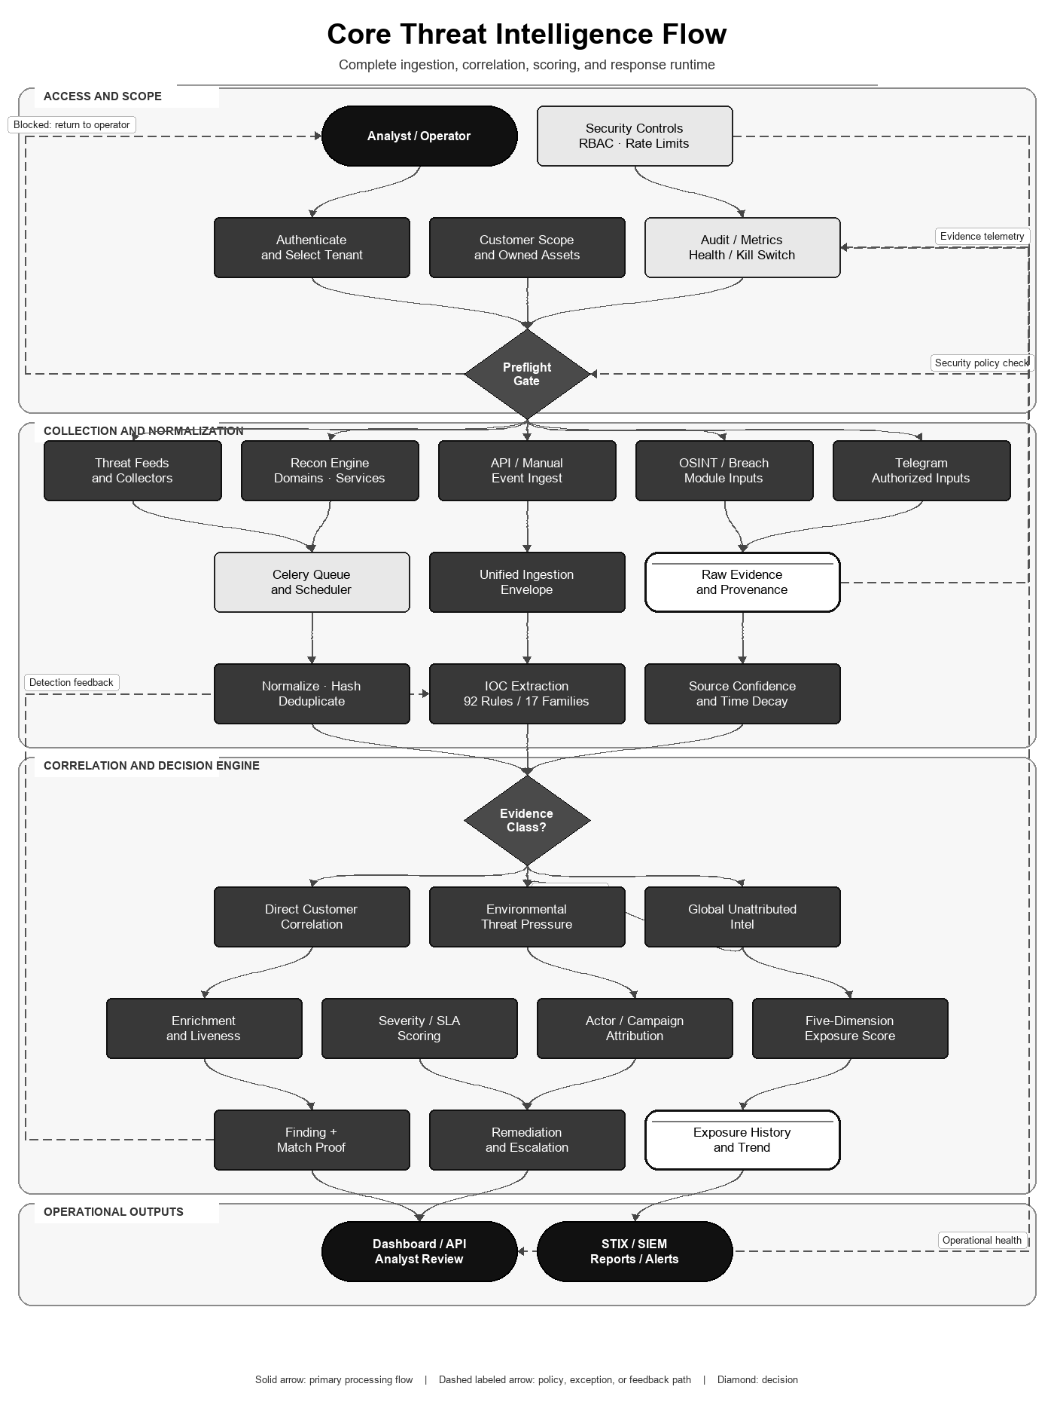
Figure 1. Core ingestion, correlation, scoring, and response path.
Layer | Implemented components | Responsibility
Entry/UI | Local bind or external TLS ingress; built-in dashboard and modules SPA | Access policy, static delivery, and analyst workflows
API | FastAPI + mounted a2wsgi Flask modules | RBAC, validation, orchestration, module endpoints
Execution | Celery workers and beat | Collection, enrichment, correlation, exports, scheduled jobs
State | PostgreSQL, Redis, ClickHouse, Elasticsearch | System of record, cache/queue, breach data, search correlation
Collection | Native collectors, recon engine, Telegram collector | Authorized source acquisition and normalization
Outputs | Findings, SLA, reports, STIX, SIEM/syslog | Actionable analyst and integration artifacts

Primary workflows
- Create a customer, set sector metadata, and register owned domains, IPs, CIDRs, brands, executives, and technology-stack assets.
- Run authorized collectors, recon, Telegram import/collection, or explicit API ingestion. Inputs become normalized detections or module records.
- Extract IOCs, suppress duplicates, apply source confidence and freshness, and preserve raw evidence/provenance.
- Route direct evidence to customers using exact IP, CIDR, domain-boundary, credential-domain, brand, and CVE-to-product/version strategies.
- Convert unmatched activity into environmental threat-pressure signals rather than forcing false customer attribution.
- Enrich and score findings, attach attribution/campaign context, generate remediation and SLA state, and expose results through the UI/API.

Flow-aligned mathematical algorithm and specification
This specification follows the core flowchart from normalized evidence through threat pressure, customer correlation, exposure scoring, and bounded operational output. Every coefficient below is present in the repository; no coefficient is presented as learned or statistically calibrated.
Symbol | Range / type | Implemented meaning
s_raw | real, normally 0..100 | Raw evidence or source score
c_src | 0..1 | Configured feed confidence; unknown source defaults to 0.5
a, h | days; h > 0 | Evidence age and decay half-life; default h=14, pressure h=7
D1..D5 | each 0..100 | Direct exposure, active exploitation, actor intent, attack surface, asset criticality
n | positive integer | Observation count in a threat category/family group
P_j | 0..10 | Decayed activity of threat group j

Freshness and source reliability
lambda = ln(2) / h
w_time(a,h) = exp(-lambda * max(a,0))
s_norm = s_raw * c_src * w_time(a,h)

Invariant: w_time(0,h)=1 and w_time(h,h)=0.5
The half-life parameter makes the decay interpretable and monotone: older evidence never gains weight, and every h days the temporal contribution halves. The implementation does not delete old evidence; it reduces its contribution to the current score.

Threat activity and sector pressure
A(n) = min(10, 3.3 * log10(max(n,1)))
b(r) = 1.3 if age_hours < 1; 1.1 if age_hours < 6; otherwise 1
P_j = min(10, A(n_j) * b(r_j) * exp(-ln(2) * age_days_j / 7))
P_sector = min(10, 0.60 * max_j(P_j) + 0.40 * mean_j(P_j))
The logarithm compresses burst volume, the recency multiplier distinguishes current activity, and the max/mean blend preserves both the dominant threat and the breadth of targeting. Groups with fewer than two observations are not persisted as pressure groups.

Five-dimension exposure score
E_signal = 0.50*D1 + 0.30*D2 + 0.20*D3
E_floor = 0.20*D4
E_base = max(E_signal, E_floor)
M_impact = 0.75 + 0.00125*D4 + 0.00125*D5
Risk = min(100, E_base * M_impact)
For D4,D5 in [0,100], M_impact is bounded in [0.75,1.00]. Risk is bounded in [0,100], is monotone non-decreasing in every dimension, and cannot be zero solely because direct threat evidence is absent when attack-surface exposure exists. Operational labels are LOW <40, MEDIUM 40-59, HIGH 60-79, and CRITICAL 80-100.

Executable algorithm
CORE-SCORE(evidence, customer):
1. validate scope, tenant and provenance
2. normalize and deduplicate evidence
3. for each item: apply source confidence and half-life decay
4. group current observations; compute P_j and P_sector
5. correlate exact customer assets and compute D1..D5
6. compute E_base, M_impact and bounded Risk
7. persist finding, SLA/remediation state and score history
8. emit reviewed alerts, reports, STIX or SIEM output
Property | Result
Determinism | Same stored evidence, customer assets, configuration, and time reference produce the same score
Boundedness | Pressure <=10 and final Risk <=100
Dominant runtime | Linear in evidence processed plus datastore query/index costs; scoring arithmetic is O(N)
Calibration boundary | Weights and thresholds are engineering policy constants, not fitted probabilities

Research and standards basis
NIST SP 800-30 supports explicit treatment of threat sources, vulnerabilities, likelihood and impact, while temporal-information-retrieval research supports time-aware weighting. Neither source specifies Argus's exact coefficients; the formula is an auditable implementation policy that still requires organization-specific validation and sensitivity analysis.
- NIST SP 800-30 Rev. 1 — Guide for Conducting Risk Assessments
- Campos et al. — Temporal Information Retrieval

Matching correctness controls
- Domain comparison uses exact host, subdomain boundary, or delimited occurrence; raw substring matching is not used.
- CIDR matching uses Python ipaddress with strict=False and skips invalid networks.
- CVE matches pass through product normalization and affected-version checks. Unknown versions create lower-confidence probable exposures instead of confirmed findings.
- Cross-source confirmation can raise severity by one level; provenance and match proof are stored on findings.
- AI automation is opt-in and disabled by default. Deterministic collection, matching, scoring, and reporting do not require an AI provider.

Security and operations
- Authentication fails closed unless AUTH_DISABLED is explicitly set for controlled development tests.
- JWT handling uses PyJWT with cryptographic extras; API writes are role-gated and rate limiting is enabled.
- Only the FastAPI entry port is published, and it binds to 127.0.0.1 by default. Databases, queues, search services, collectors, and recon remain internal to Compose.
- Required secrets have no production fallback in Compose. Production TLS terminates at a reviewed reverse proxy, load balancer, VPN, or cluster ingress.
- The API, workers, breach roles, intelligence proxy, recon engine, dashboard, and modules SPA are built once and reuse the same immutable Argus image.
- Migrations are idempotent and consolidate the duplicate dark-web table into dark_web_mentions.
- Start, stop, backup/migration, and one-time Telegram authorization commands are documented in README.md.

Market feature comparison
Evidence rule (reviewed 10 August 2026): ✓ = native capability implemented in Argus or explicitly documented by the cited primary source; ✗ = not evidenced as a native capability in the reviewed source. A cross does not mean a custom integration, partner feed, or extension is impossible. Product editions and licensing can change.
Feature | Argus Unified | OpenCTI | MISP | ThreatConnect | Recorded Future
Self-hosted open-source deployment | ✓ | ✓ | ✓ | ✗ | ✗
Structured CTI objects and relationships | ✓ | ✓ | ✓ | ✓ | ✓
Feed/import connector framework | ✓ | ✓ | ✓ | ✓ | ✓
STIX 2.1-compatible export | ✓ | ✓ | ✓ | ✓ | ✗
Customer/victim asset inventory | ✓ | ✓ | ✗ | ✓ | ✓
Automated asset-to-indicator correlation | ✓ | ✓ | ✗ | ✗ | ✓
Native attack-surface/recon collection | ✓ | ✗ | ✗ | ✗ | ✓
Native breach-record search and graph | ✓ | ✗ | ✗ | ✗ | ✗
Native Telegram collection and analysis | ✓ | ✗ | ✗ | ✗ | ✗
Case/task or investigation workflow | ✓ | ✓ | ✓ | ✓ | ✗
Finding SLA and remediation state | ✓ | ✗ | ✗ | ✗ | ✗
Published deterministic exposure formula | ✓ | ✗ | ✗ | ✗ | ✗
Built-in commercial intelligence corpus | ✗ | ✗ | ✗ | ✗ | ✓
API/SIEM-oriented integration | ✓ | ✓ | ✓ | ✓ | ✓
RBAC and auditable activity controls | ✓ | ✓ | ✓ | ✓ | ✗
Dashboards or analyst reporting | ✓ | ✓ | ✓ | ✓ | ✓

Selection context: OpenCTI and MISP are stronger fits when the primary requirement is a mature CTI knowledge-sharing ecosystem. ThreatConnect adds commercial intelligence and case APIs. Recorded Future supplies a large managed intelligence corpus and attack-surface intelligence. Argus is differentiated here by combining customer-owned assets, recon, breach search, Telegram analysis, deterministic exposure scoring, findings, SLA, and remediation in one self-hosted implementation; it does not include a commercial intelligence corpus.

Reviewed external sources
Competitor capabilities were marked only when explicitly evidenced by the reviewed official source. Accessed 10 August 2026.
- NIST SP 800-30 Rev. 1 — Guide for Conducting Risk Assessments
- Campos et al. — Temporal Information Retrieval
- OpenCTI documentation
- OpenCTI connector documentation
- MISP feature overview
- ThreatConnect indicator API
- ThreatConnect associations API
- ThreatConnect case-management SDK
- ThreatConnect API endpoint catalog
- ThreatConnect system roles
- ThreatConnect STIX support release notes
- Recorded Future Intelligence Cloud

Verification evidence
- All 193 Python source files parse successfully.
- Python unit/stateless suite: 242 tests passed in the isolated Python 3.12 environment.
- Application smoke subset: 9 tests passed, including boot, CORS, validation, and authentication flows.
- Frontend ESLint and optimized Vite build completed successfully; npm audit reported zero known vulnerabilities.
- pip-audit reported zero known vulnerabilities for backend/requirements.txt.
- OpenAPI inspection: 156 native paths and 170 operations; mounted legacy modules are intentionally outside the generated FastAPI schema.
- Docker Compose configuration resolves with required test secrets. Full container runtime validation was unavailable because the local Docker Linux engine was not running.

Current operational boundaries
- Live collector behavior depends on source credentials, quotas, availability, and program authorization.
- Enterprise collector status endpoints include configured adapters and stubs; a stub is not documented as a working data source.
- A real PostgreSQL/ClickHouse/Elasticsearch/Redis container pass remains required on a host with a running Docker Linux engine before production promotion.

