ARGUS UNIFIED

OSINT Investigation Module
  - Profile-aware discovery, verification, evidence chains, correlation, and resumable job control
Document status | IMPLEMENTED / VERIFIED
As of | 10 August 2026
Basis | Consolidated source code, automated tests, build outputs, and browser verification
Scope rule | Implemented behavior only; no roadmap or unimplemented product claims

Implemented scope
The module accepts a username or a richer subject profile and runs direct site checks, candidate generation, search-engine discovery, CSV/Intelbase lookup, profile parsing, evidence scoring, cross-platform correlation, and export. Synchronous and background workflows are mounted at /api/osint; background investigations support status, result, pause, resume, cancel, and bounded progress state.

Source lineage and reuse
The consolidated report reuses verified implementation descriptions, workflows, and terminology from the existing project documents, reconciled against the final code. Obsolete database stacks, duplicate services, future work, and unverified readiness claims were excluded.
- osint and breach codebase\docs\OSINT module v1.docx
- Verified concepts reused: candidate generation, multi-signal verification, calibration, DOM comparison, evidence tiers, and job controls.
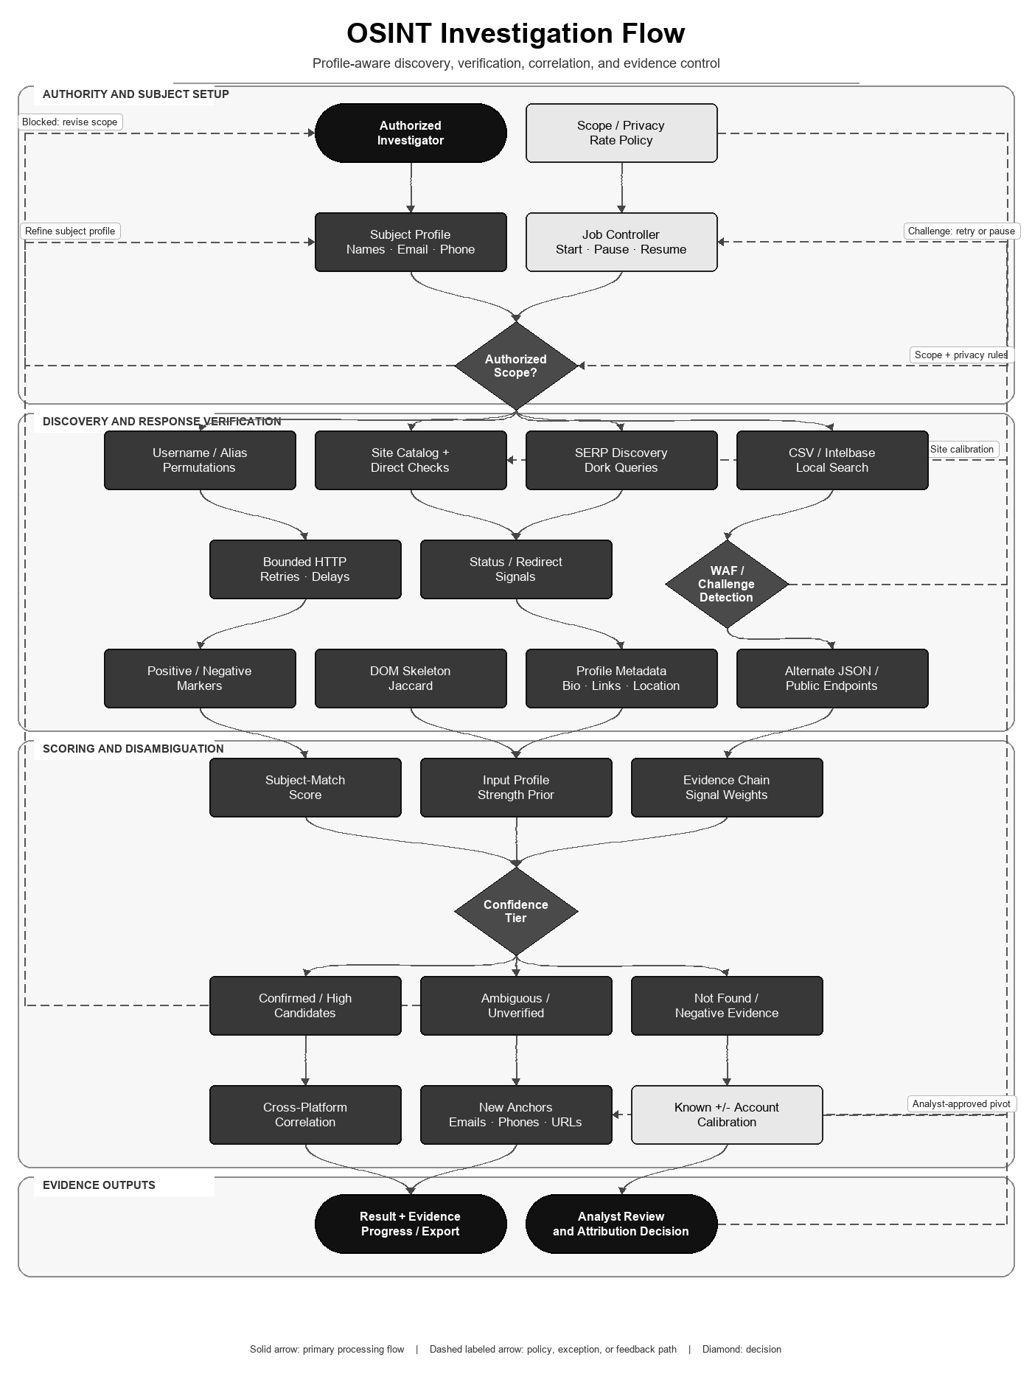
Figure 1. Profile-aware OSINT investigation and verification path.

Endpoints and inputs
Endpoint family | Implemented behavior | Representative input
/api/osint/search* | Direct username checks; start/status/result/cancel; recursive search | username, mode, site filters
/api/osint/v2/investigate* | Profile-aware synchronous/background investigation with pause/resume | name, aliases, email, phone, location, employment, education
/api/osint/v2/quick | Reduced-latency profile investigation | subject profile
/api/osint/v2/calibrate | Known-positive/known-negative detection calibration | optional site list
/api/osint/v2/export | Structured result export | completed investigation payload
/api/osint/csv-only | Local authorized CSV search path | identifier and selected fields

Flow-aligned mathematical algorithm and specification
The OSINT mathematics maps the flowchart's subject profile, direct checks, response verification, evidence chain, confidence tier, correlation, and analyst-review stages. Scores rank evidence; they do not prove identity.

Subject evidence and profile-strength priors
S_subject = min(100, sum_j w_j * I_j)
I_j = 1 when the normalized candidate contains the supplied attribute, else 0
Matched signal | Implemented weight
Email; phone | +30 each (first match of each type)
Workplace; company | +25; +20 (company counted once)
Education; occupation; industry | +20; +15; +10
City; state; non-obvious country | +20; +10; +5
Full display name; known-profile cross-link | +10; +20

S_profile = min(100, 35*email + 30*phone + 15*photo + 20*username
+ 15*workplace + 10*education + 10*city + 5*full_name)
STRONG >=60; MODERATE 25..59; WEAK <25
All variables in S_profile are binary presence indicators. The score measures expected disambiguation power of the supplied input, not the probability that any result is correct.

DOM soft-404 discrimination
For tag t, let f_A(t), f_B(t) be counts in the first 10 KB.
J_w(A,B) = sum_t min(f_A(t),f_B(t)) / sum_t max(f_A(t),f_B(t))
DOM differs when J_w < 0.90
This is a weighted multiset form of Jaccard similarity. A candidate page that closely resembles the calibrated nonexistent-account page is treated as soft-404 evidence rather than a confirmed profile.

Rank prior and three-way decision
R_on(k) = max(0, floor(35*(1-k/12)))
R_off(k) = max(0, floor(25*(1-k/12)))
Final rank = min(100, rank prior + documented attribute boosts)

Decision = CONFIRMED/HIGH/MEDIUM/AMBIGUOUS/UNVERIFIED/NOT_FOUND
Thresholds = 95/75/50/30/1/0
The evidence-chain gate separately records DEFINITIVE, HIGH, POSSIBLE, or UNLIKELY support. This preserves a link / possible-link / non-link style decision rather than forcing every response into a binary identity claim.

Executable algorithm
OSINT-INVESTIGATE(profile):
1. validate scope; compute permutations and S_profile
2. run bounded direct-site, SERP and local-intelbase checks
3. classify status, redirects, markers and WAF/challenge evidence
4. compare candidate DOM with calibrated negative baseline
5. extract metadata and compute S_subject plus evidence tier
6. assign confidence class; keep negative and ambiguous evidence
7. cluster cross-platform candidates and return bounded pivots
8. require analyst review before attribution
Property | Result
Score bounds | All public scores are clipped to 0..100
DOM cost | O(T_A + T_B) over extracted tag counts
Network cost | Dominated by bounded external requests, retries and configured concurrency
Statistical boundary | Weights are deterministic heuristics, not Fellegi-Sunter log-likelihood ratios learned from labeled pairs

Research and standards basis
Fellegi-Sunter provides the classical theoretical basis for link, possible-link, and non-link decisions from comparison evidence. Jaccard provides the similarity basis adapted here to DOM tag-frequency multisets. Argus borrows these structures but does not claim a trained probabilistic record-linkage model.
- Fellegi and Sunter — A Theory for Record Linkage
- Jaccard — Étude comparative de la distribution florale

Reliability controls
- Site-specific positive/negative markers, redirect behavior, WAF/challenge detection, response status, JSON markers, and page metadata are evaluated together.
- HTTP concurrency, retries, delays, per-site configuration, cancellation, and progress callbacks bound active investigations.
- Calibration checks known-existing and known-nonexistent accounts to expose broken site rules.
- Correlation adds bounded boosts for usernames, names, dates of birth, cross-links, and metadata richness while preserving source evidence.

Market feature comparison
Evidence rule (reviewed 10 August 2026): ✓ = native capability implemented in Argus or explicitly documented by the cited primary source; ✗ = not evidenced as a native capability in the reviewed source. A cross does not mean a custom integration, partner feed, or extension is impossible. Product editions and licensing can change.
Feature | Argus Unified | SpiderFoot | Maltego | Sherlock | Maigret
Self-hosted open-source core | ✓ | ✓ | ✗ | ✓ | ✓
Username enumeration | ✓ | ✓ | ✓ | ✓ | ✓
Name/email/phone/person inputs | ✓ | ✓ | ✓ | ✗ | ✗
Multi-source module/transform ecosystem | ✓ | ✓ | ✓ | ✗ | ✗
Rich subject-profile disambiguation | ✓ | ✗ | ✗ | ✗ | ✗
Evidence-chain confidence tiers | ✓ | ✗ | ✗ | ✗ | ✗
DOM-skeleton account verification | ✓ | ✗ | ✗ | ✗ | ✗
Structured profile metadata extraction | ✓ | ✓ | ✓ | ✗ | ✓
Recursive pivot discovery | ✓ | ✓ | ✓ | ✗ | ✓
WAF/challenge-aware checks | ✓ | ✗ | ✗ | ✗ | ✓
Known-positive/negative calibration | ✓ | ✗ | ✗ | ✗ | ✗
Pause/resume/cancel background jobs | ✓ | ✗ | ✗ | ✗ | ✗
Visual relationship graph | ✗ | ✓ | ✓ | ✗ | ✓
Real-time graph collaboration | ✗ | ✗ | ✓ | ✗ | ✗
Local CSV/intelbase lookup | ✓ | ✗ | ✓ | ✗ | ✗
Structured report/export formats | ✓ | ✓ | ✓ | ✓ | ✓

Selection context: SpiderFoot is broader for automated infrastructure and OSINT module coverage; Maltego is stronger for interactive graph analysis, transforms, and team collaboration; Sherlock is a focused username enumerator; Maigret provides deep username dossiers and many export formats. Argus focuses on profile-aware identity disambiguation, explicit evidence tiers, DOM/marker verification, calibration, resumable jobs, and direct handoff into breach and threat workflows.

Reviewed external sources
Competitor capabilities were marked only when explicitly evidenced by the reviewed official source. Accessed 10 August 2026.
- Fellegi and Sunter — A Theory for Record Linkage
- Jaccard — Étude comparative de la distribution florale
- SpiderFoot official repository
- Maltego Transform Hub
- Maltego transform execution
- Maltego graph collaboration
- Sherlock official repository
- Maigret official repository

Verification evidence
- All 193 Python source files parse successfully.
- Python unit/stateless suite: 242 tests passed in the isolated Python 3.12 environment.
- Application smoke subset: 9 tests passed, including boot, CORS, validation, and authentication flows.
- Frontend ESLint and optimized Vite build completed successfully; npm audit reported zero known vulnerabilities.
- pip-audit reported zero known vulnerabilities for backend/requirements.txt.
- OSINT scoring, type detection, verification helpers, and API validation are covered by the consolidated backend tests.

Current operational boundaries
- A positive site response is evidence, not identity proof. Analyst review is required for high-impact decisions.
- Coverage changes as sites modify markup, authentication, rate limits, or bot defenses; calibration exposes but cannot prevent external drift.
- The module does not bypass authentication controls or access private profiles. Use must be authorized and lawful.

