ARGUS UNIFIED

Breach Search and Correlation Module
  - Direct ClickHouse search, Elasticsearch pivots, Redis caching, and bounded PII relationship graphs
Document status | IMPLEMENTED / VERIFIED
As of | 10 August 2026
Basis | Consolidated source code, automated tests, build outputs, and browser verification
Scope rule | Implemented behavior only; no roadmap or unimplemented product claims

Implemented scope
The breach module is mounted at /api/breach for the product UI and also contains its canonical FastAPI search service. It performs parameterized direct searches over ClickHouse, optional Elasticsearch correlation, Redis JSON caching, combined responses, and a bounded breadth-first connection graph. It does not claim a proprietary breach corpus; results depend on authorized datasets loaded into the configured stores.

Source lineage and reuse
The consolidated report reuses verified implementation descriptions, workflows, and terminology from the existing project documents, reconciled against the final code. Obsolete database stacks, duplicate services, future work, and unverified readiness claims were excluded.
- osint and breach codebase\docs\Breach Module v1.docx
- Verified concepts reused: ClickHouse exact search, Elasticsearch correlation, Redis cache, field catalog, provenance, and bounded graph expansion.
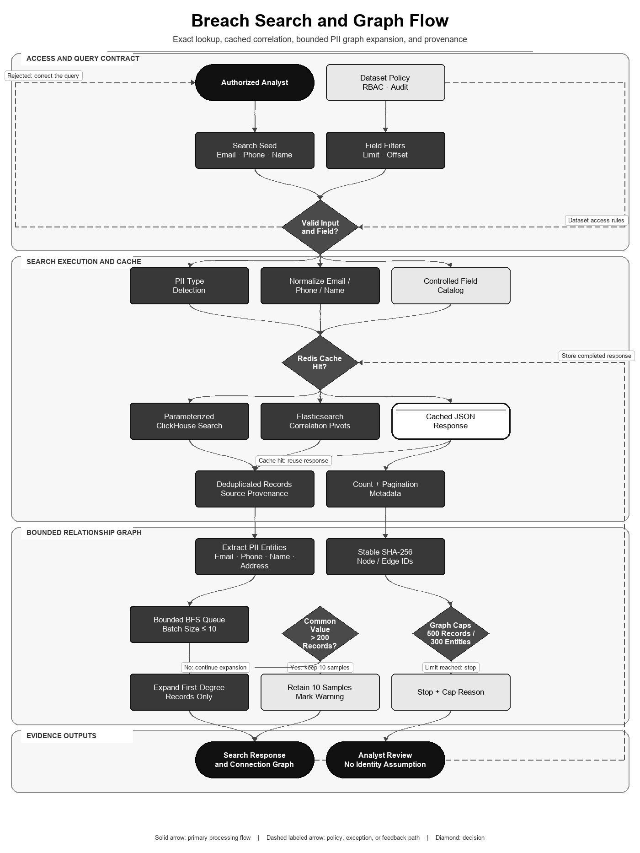
Figure 1. Direct breach lookup, correlation, caching, and graph expansion.

Search interfaces
Interface | Behavior | Bounds
POST /api/breach/search | UI gateway to the canonical search service | limit 1–500; non-negative offset
POST /api/breach/graph/connections | Connection graph from email, phone, or name seed | timeout and hard graph caps
GET /search | Field/value direct ClickHouse query | default 50; maximum 500
POST /search/direct | Multi-filter exact/direct search | server-enforced maximum
POST /search/correlation | Elasticsearch pivot search | max results per query
POST /search/combined | Direct and correlated results in one response | independent direct offsets
POST /search/connections | Canonical bounded graph | 500 records + 300 entities

Normalization and deterministic identifiers
- Input type detection recognizes email, phone, IPv4, Aadhaar-shaped values, names, usernames, and unknown input.
- Emails are trimmed and lowercased. Phone numbers remove non-digits and normalize common country/trunk prefixes before retaining a ten-digit form for search.
- Direct filters are compiled into parameterized ClickHouse predicates; field names come from a controlled field catalog rather than raw client SQL.
- Optional privacy-preserving email indexing uses SHA-256(salt + ':' + normalized_email).
row_id = SHA256(source_file | lowercase(email) | normalized_phone)
entity_id = SHA256(UPPER(entity_type) : lowercase(trim(value)))
edge_id = SHA256(row_id | entity_id)

Bounded connection graph
- Resolve up to 100 seed records using the normalized email, phone, or name.
- Extract EMAIL, PHONE, NAME, and ADDRESS entities from each record and enqueue unvisited entities.
- Query entities in concurrent batches of at most ten, requesting 201 records to detect common values.
- When an entity returns more than 200 records, mark it common and retain only ten samples instead of expanding it.
- Expand only first-degree records into second-degree entities; deduplicate all nodes and edges by stable hashes.
- Stop at the combined 800-node ceiling (500 records plus 300 entities) and return capped/cap_reason metadata.
The algorithm is breadth-first over a bipartite graph of breach records and extracted entities. The hard caps and common-value short circuit prevent names or shared addresses from producing unbounded traversal.

Data and failure behavior
- ClickHouse is authoritative for direct bulk breach records; Elasticsearch supplies correlation pivots; Redis cache failures degrade to uncached queries.
- Every returned record preserves source_file provenance where present.
- Count queries and data queries are separate; pagination returns limit, offset, and total metadata.
- Search errors are converted to bounded API errors without exposing database credentials or raw stack traces.

Flow-aligned mathematical algorithm and specification
The breach algorithm follows the flowchart's validated seed, controlled field catalog, cache decision, parameterized search, provenance-preserving records, entity extraction, bounded graph traversal, and capped response.

Canonicalization and stable identifiers
email_norm(x) = lowercase(trim(x))
phone_norm(x) = canonical ten-digit representation after prefix/trunk handling
row_id = SHA256(source_file || '|' || email_norm || '|' || phone_norm)
entity_id = SHA256(UPPER(type) || ':' || lowercase(trim(value)))
edge_id = SHA256(row_id || '|' || entity_id)
These hashes make repeated rows and entities stable within the same canonicalization policy. They are identifiers, not proof that two people are identical and not a substitute for encrypting sensitive values.

Bipartite graph and bounded BFS
G = (R union E, L)
R = breach-record nodes; E = normalized EMAIL/PHONE/NAME/ADDRESS nodes
(r,e) in L iff record r contains entity e

Hard bounds: |R| <= 500, |E| <= 300, |R union E| <= 800
Common-value gate: degree(e) > 200 => retain 10 samples and do not expand
Expansion depth: seed records -> entities -> first-degree records -> second-degree entities
BREACH-GRAPH(seed):
1. normalize and resolve at most 100 seed records
2. create stable record/entity nodes and enqueue unseen entities
3. dequeue entities in batches of at most 10
4. query 201 rows to detect degree >200
5. if common: mark warning, keep 10 samples, stop that branch
6. else add deduplicated rows and one further entity layer
7. stop at 500 records, 300 entities, timeout, or empty queue
8. return provenance, pagination, capped and cap_reason metadata
Property | Result
Traversal | Breadth-first over a bipartite graph with explicit visited sets
In-memory complexity | O(|R|+|E|+|L|), absolutely bounded by configured node caps
External query cost | Bounded by unique expanded entities, batch size, timeout and datastore indexes
Precision guard | High-degree values are warned and sampled because common names/addresses create noisy joins
Interpretation boundary | An edge shows shared data, not identity, ownership, compromise, or causation

Research and standards basis
Moore's breadth-first search supplies the traversal basis; entity-resolution meta-blocking research supports restricting noisy comparison graphs for scalability; FIPS 180-4 specifies SHA-256. Argus's thresholds (200, 10, 500, 300 and depth two) are implementation safety bounds, not values established as optimal by those publications.
- Moore — The Shortest Path Through a Maze
- Papadakis et al. — Enhanced Meta-Blocking for Entity Resolution
- NIST FIPS 180-4 — Secure Hash Standard

Market feature comparison
Evidence rule (reviewed 10 August 2026): ✓ = native capability implemented in Argus or explicitly documented by the cited primary source; ✗ = not evidenced as a native capability in the reviewed source. A cross does not mean a custom integration, partner feed, or extension is impossible. Product editions and licensing can change.
Feature | Argus Unified | HIBP | Intelligence X | LeakCheck | DeHashed
Self-hosted local-corpus search | ✓ | ✗ | ✗ | ✗ | ✗
Vendor-hosted breach corpus | ✗ | ✓ | ✓ | ✓ | ✓
Email lookup | ✓ | ✓ | ✓ | ✓ | ✓
Username lookup | ✓ | ✓ | ✓ | ✓ | ✓
Phone lookup | ✓ | ✓ | ✓ | ✓ | ✓
IP-address lookup | ✓ | ✗ | ✓ | ✗ | ✓
Domain exposure/search | ✓ | ✓ | ✓ | ✓ | ✗
Name/address pivot | ✓ | ✗ | ✗ | ✗ | ✓
Combined multi-field query | ✓ | ✗ | ✗ | ✗ | ✓
Full raw record fields | ✓ | ✗ | ✓ | ✓ | ✓
Dataset/breach provenance | ✓ | ✓ | ✓ | ✓ | ✓
Paginated programmatic API | ✓ | ✗ | ✓ | ✓ | ✓
Record-to-PII relationship graph | ✓ | ✗ | ✗ | ✗ | ✗
Common-value graph expansion guard | ✓ | ✗ | ✗ | ✗ | ✗
Stable local node/edge identifiers | ✓ | ✗ | ✗ | ✗ | ✗
Redis cache with uncached fallback | ✓ | ✗ | ✗ | ✗ | ✗
Integrated customer finding/exposure | ✓ | ✗ | ✗ | ✗ | ✗
Hosted monitoring/notifications | ✗ | ✓ | ✓ | ✗ | ✓

Selection context: HIBP is optimized for breach membership, verified-domain exposure, stealer-log and notification use cases without exposing raw breach rows. Intelligence X, LeakCheck, and DeHashed provide vendor-hosted search corpora with different field access and commercial tiers. Argus instead searches operator-supplied authorized stores and adds a bounded record-to-PII graph plus customer finding correlation; it ships with no breach dataset.

Reviewed external sources
Competitor capabilities were marked only when explicitly evidenced by the reviewed official source. Accessed 10 August 2026.
- Moore — The Shortest Path Through a Maze
- Papadakis et al. — Enhanced Meta-Blocking for Entity Resolution
- NIST FIPS 180-4 — Secure Hash Standard
- Have I Been Pwned API v3
- Intelligence X API
- LeakCheck API documentation
- DeHashed

Verification evidence
- All 193 Python source files parse successfully.
- Python unit/stateless suite: 242 tests passed in the isolated Python 3.12 environment.
- Application smoke subset: 9 tests passed, including boot, CORS, validation, and authentication flows.
- Frontend ESLint and optimized Vite build completed successfully; npm audit reported zero known vulnerabilities.
- pip-audit reported zero known vulnerabilities for backend/requirements.txt.
- Input classification, normalization, query construction, graph caps, and mocked graph traversal are exercised without requiring production breach data.

Current operational boundaries
- No breach records are bundled. The operator must lawfully obtain, secure, retain, and delete datasets under applicable policy and law.
- Data-store end-to-end validation requires running ClickHouse, Elasticsearch, and Redis services and representative authorized fixtures.
- Name/address correlation is heuristic and can join different people; evidence must be reviewed before action.

