ARGUS UNIFIED

Telegram Threat Intelligence Module
  - Authorized collection/import, obfuscation-aware classification, fuzzy search, IOC routing, and STIX export
Document status | IMPLEMENTED / VERIFIED
As of | 10 August 2026
Basis | Consolidated source code, automated tests, build outputs, and browser verification
Scope rule | Implemented behavior only; no roadmap or unimplemented product claims

Implemented scope
This is the unique functionality consolidated from cyber_threat_monitor and pii_link into the shared Argus platform. It supports one-time Telethon session authorization, explicit-channel collection, JSON/ZIP imports, deterministic text analysis, persistent message/channel/import audit records, typo-tolerant search, alerts, graph summaries, customer asset correlation, downstream finding creation, and STIX 2.1 export.

Source lineage and reuse
The consolidated report reuses verified implementation descriptions, workflows, and terminology from the existing project documents, reconciled against the final code. Obsolete database stacks, duplicate services, future work, and unverified readiness claims were excluded.
- cyber_threat_monitor\docs\Cyber_Threat_Monitor_Report_updated.docx
- pii_link\docs\pii.docx
- The old SQLite/Elasticsearch/Neo4j service stacks were not duplicated. Their verified Telegram classification and entity-correlation concepts now use Argus PostgreSQL, Redis/Celery, IOC matching, findings, and exports.
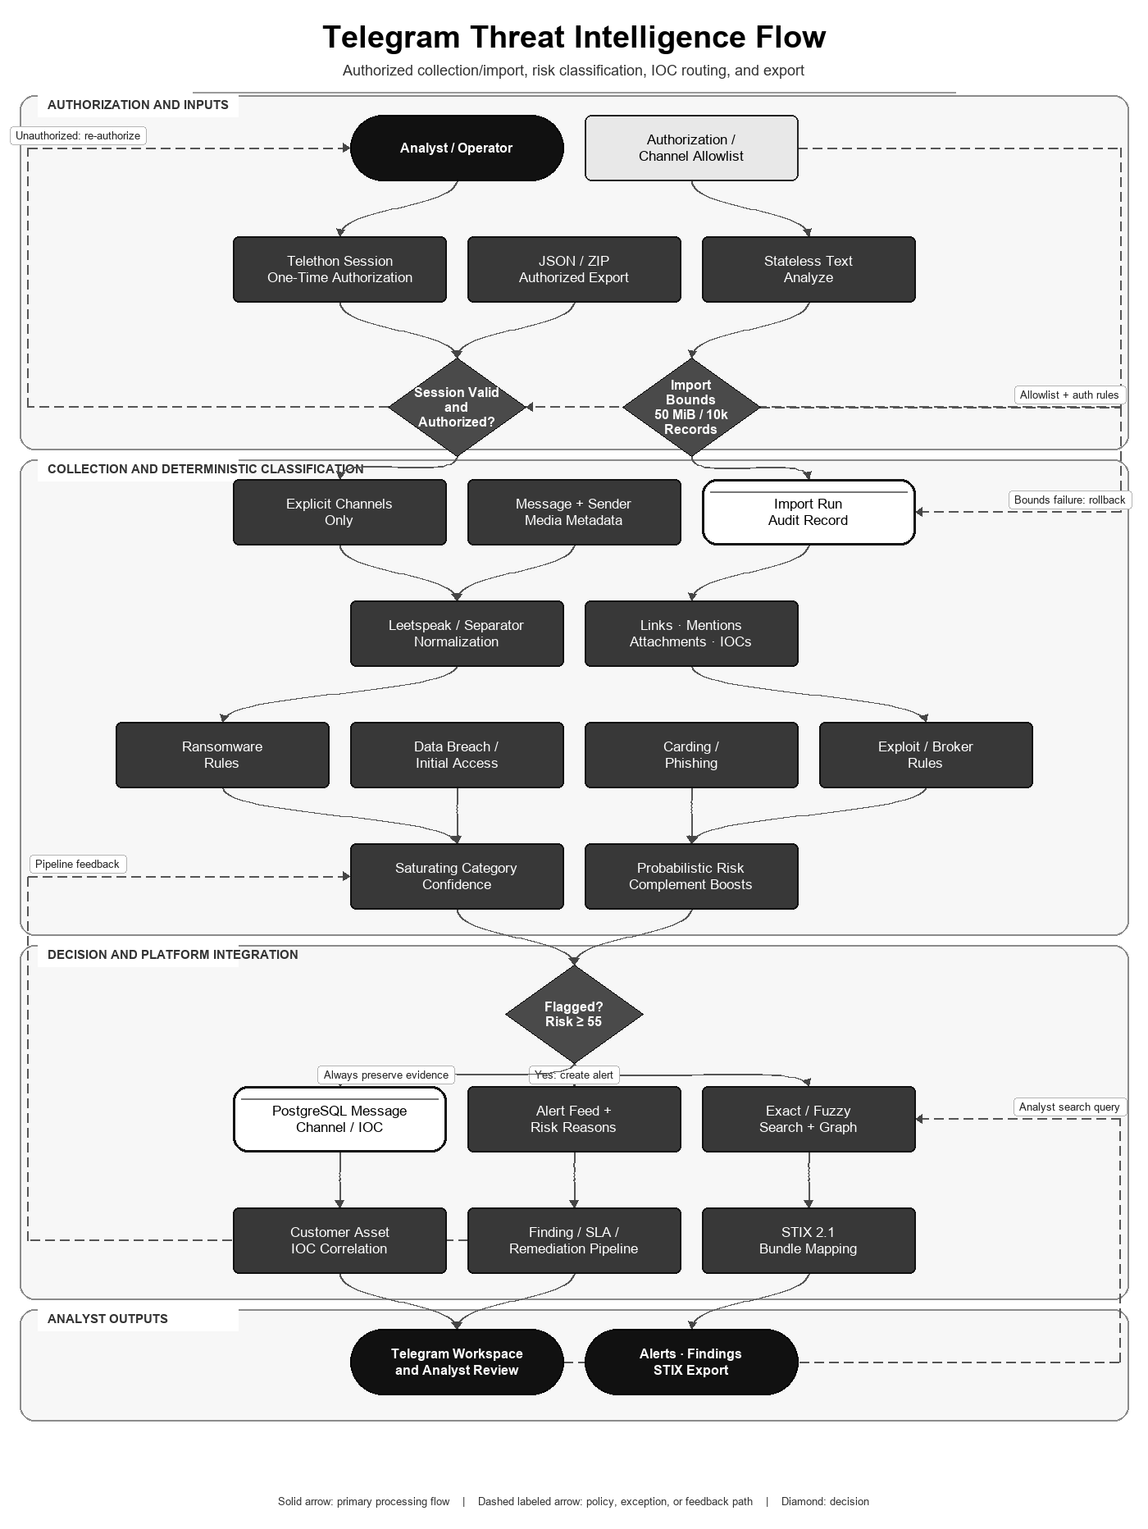
Figure 1. Telegram ingestion, classification, correlation, and response path.

API and storage
Endpoint | Implemented behavior
GET /api/telegram/health | Stateless module health
POST /api/telegram/analyze | Offline deterministic analysis without persistence
POST/GET /api/telegram/messages | Persist and list messages; exact or fuzzy query
GET /api/telegram/alerts | Recent flagged messages ordered by risk and time
GET /api/telegram/stats | Message, flagged, channel, category, and import counts
GET /api/telegram/channels | Channel activity summary
GET /api/telegram/graph | Channel/reference relationship data
GET /api/telegram/stix/export | STIX bundle for selected/recent messages
POST /api/telegram/import | Bounded JSON/ZIP import with audit and rollback

Persistence uses telegram_messages, telegram_channels, and telegram_import_runs in the shared PostgreSQL schema. Imported or collected messages are processed by the same IOC matcher and finding pipeline used by other intelligence sources.

Flow-aligned mathematical algorithm and specification
The Telegram algorithm follows authorization/import gates, normalization, rule categories, saturating confidence, bounded risk aggregation, flagging, persistence, customer correlation, search, graphing, and STIX export.

Category saturation and aggregate risk
r_k = sum_i w_i * I(rule_i matches raw text or normalized text)
c_k = 1 - exp(-r_k/4)
A = sum_k alpha_k * c_k
p_0 = 1 - exp(-A)
Category k | alpha_k
Ransomware | 1.00
Data breach | 0.90
Initial access | 0.90
Carding | 0.85
Phishing | 0.75
Exploit | 0.80
Broker contact | 0.35

if external channel: p = 1 - (1-p_0)*0.90
if risky attachment: p = 1 - (1-p)*0.88
risk = clip(round(100*p), 0, 100)
flagged = (risk >= 55) OR (c_ransomware >= 0.65)
The exponential transforms are monotone and bounded, so repeated synonymous rules have diminishing marginal effect. The complement updates have a noisy-OR-style form. The resulting p is a risk-like score, not a calibrated real-world probability of criminality or compromise.

Typo-tolerant token similarity
sim(q,t) = 2*M / (|q|+|t|)
M = total characters in recursively matched common subsequences
best(q,text) = max over bounded query/candidate token pairs sim(q_i,t_j)
The implementation uses Python SequenceMatcher, discards tokens shorter than four characters, caps candidate tokens at 450, and skips pairs whose lengths differ by more than 50 percent. Search fetches at most 2,000 database candidates before ranking.

Executable algorithm
TELEGRAM-ANALYZE(message):
1. validate authorized session/channel or bounded import
2. normalize case, leetspeak, separators and whitespace
3. evaluate deterministic rules in raw and normalized text
4. compute r_k, c_k, A and bounded risk
5. apply channel/attachment complement boosts; evaluate flag gate
6. extract links, mentions, attachments and IOCs
7. persist evidence and correlate exact customer assets
8. expose alerts/search/graph and STIX after analyst review
Property | Result
Bounds | 0 <= c_k < 1 and 0 <= risk <= 100
Rule evaluation | Deterministic for the same text, media name and rule set
Fuzzy-search bound | At most 450 candidate tokens per message and 2,000 fetched message rows
Validation boundary | Weights and flag thresholds require labeled-corpus precision/recall calibration before probabilistic interpretation

Research and standards basis
Noisy-OR literature supports bounded aggregation of multiple partially independent causes, and Ratcliff-Metzener describes the Gestalt string-similarity family used by SequenceMatcher. Argus uses these mathematical shapes deterministically; independence and probability calibration have not been established on a labeled Telegram corpus.
- Srinivas — A Generalization of the Noisy-Or Model
- Ratcliff and Metzener — Pattern Matching: The Gestalt Approach

Import safety and collection model
- Upload limit: 50 MiB; expanded ZIP limit: 250 MiB; maximum 2,000 archive files; maximum 10,000 imported records.
- A failed import rolls back partial message writes while retaining the failed import-run audit record.
- Live collection reads only explicitly configured channels and bounded textual attachment types.
- The Celery worker is non-interactive. If its persisted session is not authorized, it returns session_not_authorized; authorization is performed once with scripts/authorize_telegram.py.
- Telegram API ID/hash and user authorization are required; no credentials or session are bundled.

Market feature comparison
Evidence rule (reviewed 10 August 2026): ✓ = native capability implemented in Argus or explicitly documented by the cited primary source; ✗ = not evidenced as a native capability in the reviewed source. A cross does not mean a custom integration, partner feed, or extension is impossible. Product editions and licensing can change.
Feature | Argus Unified | Telethon | Maltego Monitor | Social Links | OpenCTI
Self-hosted open-source component | ✓ | ✓ | ✗ | ✗ | ✓
Authorized Telegram account/API collection | ✓ | ✓ | ✓ | ✓ | ✗
Explicit channel/group monitoring | ✓ | ✓ | ✓ | ✓ | ✗
Historical message retrieval | ✓ | ✓ | ✓ | ✓ | ✗
Incoming-message event handling | ✗ | ✓ | ✓ | ✗ | ✗
Bounded JSON/ZIP offline import | ✓ | ✗ | ✗ | ✗ | ✗
Text, links and attachment extraction | ✓ | ✓ | ✓ | ✓ | ✗
Obfuscation/leetspeak normalization | ✓ | ✗ | ✗ | ✗ | ✗
Deterministic cybercrime categories | ✓ | ✗ | ✗ | ✗ | ✗
Published risk/confidence formula | ✓ | ✗ | ✗ | ✗ | ✗
Typo-tolerant local message search | ✓ | ✗ | ✗ | ✗ | ✗
Alert/case monitoring interface | ✓ | ✗ | ✓ | ✓ | ✓
Channel/reference relationship graph | ✓ | ✗ | ✗ | ✓ | ✓
Customer asset-to-IOC findings | ✓ | ✗ | ✗ | ✗ | ✓
STIX 2.1 export after ingestion | ✓ | ✗ | ✗ | ✗ | ✓
General-purpose Telegram client API | ✗ | ✓ | ✗ | ✗ | ✗

Selection context: Telethon is the flexible MTProto client library used by Argus, not an intelligence product by itself. Maltego Monitor provides paid continuous public-source monitoring and filtering. Social Links provides commercial Telegram transforms and relationship investigation, with advanced Telegram packs restricted to eligible government customers. OpenCTI supplies a CTI graph, cases, alerts, and STIX connectors but no native Telegram collector was evidenced. Argus supplies the Telegram-specific classification, risk mathematics, bounded import, customer matching, and STIX pipeline.

Reviewed external sources
Competitor capabilities were marked only when explicitly evidenced by the reviewed official source. Accessed 10 August 2026.
- Srinivas — A Generalization of the Noisy-Or Model
- Ratcliff and Metzener — Pattern Matching: The Gestalt Approach
- Telethon quick start
- Telethon update events
- Maltego Monitor
- Maltego Telegram transforms
- Social Links platform capabilities
- Social Links Telegram Pack
- OpenCTI documentation
- OpenCTI connector documentation

Verification evidence
- All 193 Python source files parse successfully.
- Python unit/stateless suite: 242 tests passed in the isolated Python 3.12 environment.
- Application smoke subset: 9 tests passed, including boot, CORS, validation, and authentication flows.
- Frontend ESLint and optimized Vite build completed successfully; npm audit reported zero known vulnerabilities.
- pip-audit reported zero known vulnerabilities for backend/requirements.txt.
- Telegram detector, fuzzy matcher, import bounds, STIX mapping, and API analysis inputs are covered by automated tests.
- Browser input verification confirmed ransomware text, CVE extraction, Telegram URL extraction, 78 risk, 91% ransomware confidence, and flagged output in the final UI.

Current operational boundaries
- Live MTProto collection was not executed because no user Telegram credentials/session were supplied.
- Classification is deterministic lexical evidence, not authorship proof or a substitute for analyst validation.
- Only channels the operator is authorized to access may be configured.

