ARGUS UNIFIED

PII, IOC Correlation and STIX Module
  - Ordered extraction, confidence, entity normalization, customer correlation, and interoperable CTI output
Document status | IMPLEMENTED / VERIFIED
As of | 10 August 2026
Basis | Consolidated source code, automated tests, build outputs, and browser verification
Scope rule | Implemented behavior only; no roadmap or unimplemented product claims

Implemented scope
The original pii_link concepts are integrated as shared platform capabilities rather than a duplicate standalone service. Argus scans unstructured intelligence, breach records, and Telegram messages for structured indicators; normalizes PII entities; correlates attributable evidence to customer assets; preserves confidence/provenance; and emits STIX 2.1-compatible bundles.

Source lineage and reuse
The consolidated report reuses verified implementation descriptions, workflows, and terminology from the existing project documents, reconciled against the final code. Obsolete database stacks, duplicate services, future work, and unverified readiness claims were excluded.
- pii_link\docs\pii.docx
- argus_main\docs\ArgusWatch_Project_Professional_Documentation.docx
- The corrupted embedded image in the original pii.docx did not prevent reuse of its document XML text. Neo4j and a second Elasticsearch/Redis stack were deliberately excluded because equivalent shared services already existed.
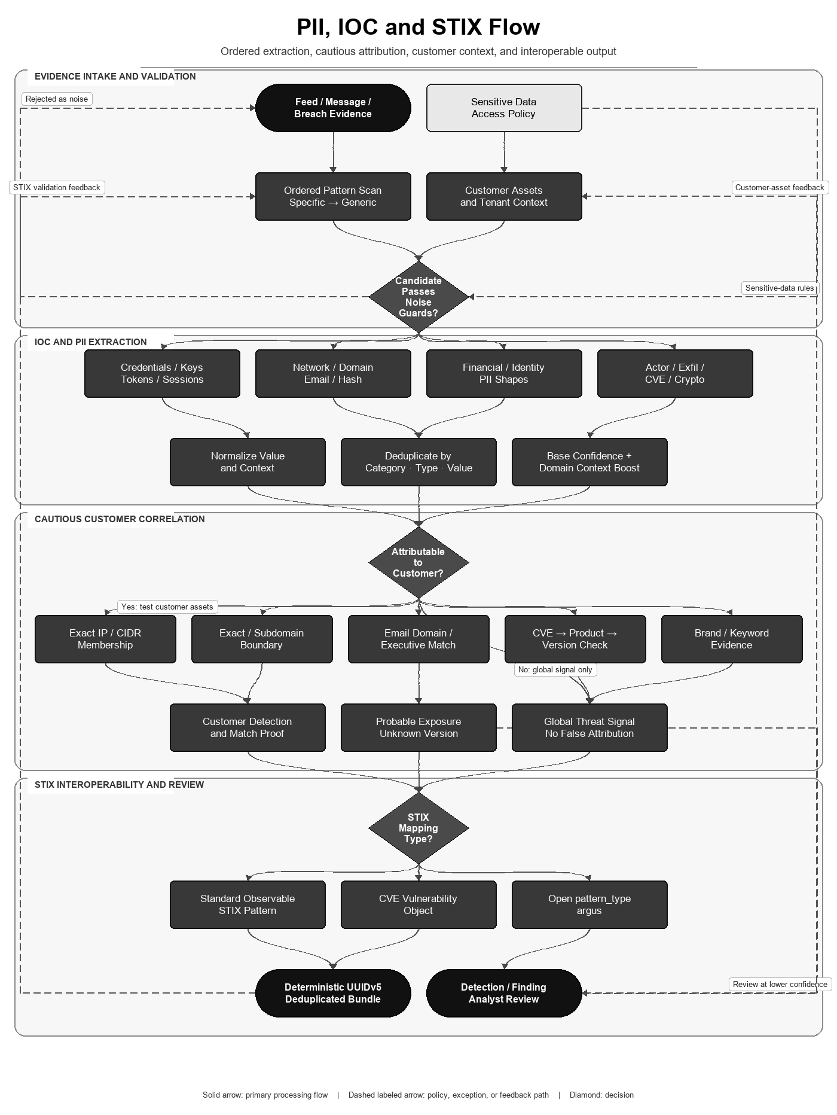
Figure 1. Shared PII/IOC extraction, customer correlation, and STIX mapping.

IOC extraction
The ordered scanner implements 92 regex patterns across 17 families. Specific families run before generic hashes, URLs, domains, emails, and IPs so a narrow token is not stolen by a broad pattern. Results are deduplicated by category, IOC type, and exact value, then sorted by confidence.
Pattern families | Representative outputs | Reliability guard
Credentials / API keys / OAuth / sessions | email-password pairs, AWS/GitHub/Slack/Google tokens, JWT, NTLM | Strict prefixes and lengths; known noisy patterns removed
Network / domain / email / file hashes | IPv4/IPv6/CIDR, URL/domain/onion, email, MD5/SHA | Private/localhost IPs skipped; generic families run last
Infrastructure / SaaS / shadow IT | config/database files, public object storage, tunnels | Context-bound expressions and minimum lengths
Financial and identity | card-shaped values, SSN, IBAN, SWIFT BIC | Country-code-constrained case-sensitive BIC; no broad ACH matcher
Actor / exfiltration / CVE / crypto | ransomware/APT names, dump evidence, CVE IDs, addresses | Evidence patterns; not customer attribution by themselves

A match starts with the pattern's base confidence. If a supplied customer domain appears in the same line, confidence increases by 0.10 and is capped at 1.00.

PII normalization and graph entities
- Email: trim and lowercase; reject missing-@ and empty/nan values.
- Phone: keep digits, normalize common +91/0 forms in the graph path and common country/trunk forms in direct search.
- Name: collapse whitespace and normalize title case for graph nodes; lower/collapse for search input.
- Aadhaar-shaped input: detect 4-4-4 digits and remove spaces for lookup. Detection is formatting only, not checksum validation.
- Graph extraction produces EMAIL, PHONE, NAME, and ADDRESS entities and deduplicates them per record.

Customer attribution
- Exact IP and CIDR membership for owned network ranges.
- Exact-domain and subdomain-boundary matching; delimited path/text occurrences remain lower-confidence keyword evidence.
- Credential/email-domain matching for registered customer domains and executives.
- CVE-to-product matching through CveProductMap with normalized product names and conservative version-range evaluation.
- Brand/keyword matching in dark-web and ransomware evidence.
- Unattributable financial identifiers remain global threat signals; they are not falsely assigned to a customer.

STIX 2.1 mapping
IOC | STIX object/pattern
IPv4 / IPv6 | indicator with ipv4-addr / ipv6-addr value pattern
Domain / URL / email | indicator with domain-name / url / email-addr value pattern
MD5 / SHA-1 / SHA-256 / SHA-512 | indicator with file:hashes pattern
CVE | vulnerability object with deterministic UUIDv5 identifier
Non-standard Telegram/entity type | indicator using open pattern_type 'argus', not invalid STIX syntax

Telegram-derived identity, vulnerability, and indicator identifiers use UUIDv5 over a stable namespace/key; bundle IDs use UUIDv4. Values are escaped before insertion into STIX patterns, duplicate type/value pairs are removed, and confidence is clamped to 0–100.

Flow-aligned mathematical algorithm and specification
The PII/IOC/STIX algorithm follows ordered pattern recognition, noise guards, canonicalization, deduplication, confidence adjustment, cautious customer attribution, and standards-based object mapping.

Ordered detection and confidence
For ordered pattern p_i and line l:
I_i(l) = 1 if regex p_i matches l and all noise guards pass, else 0
K(match) = (category, ioc_type, exact_value)
keep the first unique K under specific-to-generic scan order
confidence = min(1, base_confidence + 0.10*I(customer_domain occurs on same line))
The engine evaluates 92 expressions in 17 ordered families. Specific credential, token, session and exfiltration patterns precede generic URL, domain, email, IP and hash patterns. Private/localhost IP guards and removed high-noise expressions reduce false positives.

Customer attribution predicates
A(e,c) = IP_EXACT_OR_CIDR(e,c) OR DOMAIN_EXACT_OR_SUBDOMAIN(e,c)
OR EMAIL_DOMAIN_OR_EXECUTIVE(e,c) OR CVE_PRODUCT_VERSION(e,c)
OR BOUNDED_BRAND_KEYWORD_EVIDENCE(e,c)

Direct finding only when an implemented attribution predicate supplies match proof.
Unknown product version => probable exposure at lower confidence.
No attributable predicate => global signal, not a customer finding.
Domain matching is boundary-aware; raw substring containment is not treated as exact ownership. IP ranges use canonical address membership. These are conservative logical predicates rather than a learned entity-resolution model.

STIX confidence and deterministic names
C_stix = clip(round(100*confidence), 0, 100)
UUIDv5(namespace,name) = RFC9562_Format(first128(SHA1(namespace || canonical_name)))
Bundle UUIDs are UUIDv4; Telegram-derived object IDs use UUIDv5.
Duplicate exported objects are removed by normalized (type,value) identity.
Standard IP, domain, URL, email and hash values become STIX Indicator patterns; CVEs become Vulnerability objects in the Telegram export path; unsupported types use the documented open 'argus' pattern type instead of pretending to be valid STIX pattern syntax.

Executable algorithm
PII-IOC-STIX(text, customer):
1. scan each line with specific-to-generic compiled patterns
2. reject short, private, localhost and duplicate candidates
3. normalize values; attach line context and bounded confidence
4. evaluate exact/boundary/CIDR/CVE customer predicates
5. create direct, probable or global evidence without false attribution
6. map supported values to STIX 2.1 objects and escape patterns
7. assign bounded confidence and stable IDs where implemented
8. deduplicate bundle and retain evidence for analyst review
Property | Result
Detection cost | O(L * P * match_cost) for L lines and P compiled expressions; P is fixed at 92
Deduplication | Expected O(M) with a hash set for M candidate matches
Interoperability | STIX structure and pattern vocabulary follow OASIS STIX 2.1
Validation boundary | Regex-shaped PII and secrets are candidates; provider checksums/contextual validation may still be required

Research and standards basis
Kleene's formal-language work supplies the theoretical basis for regular-expression recognition; OASIS specifies STIX 2.1; RFC 9562 specifies UUIDv5; FIPS 180-4 specifies SHA-1/SHA-256 primitives. These standards validate representation mechanics, not the semantic truth of a regex match or customer attribution.
- Kleene — Representation of Events in Nerve Nets and Finite Automata
- OASIS STIX 2.1 introduction
- IETF RFC 9562 — Universally Unique IDentifiers
- NIST FIPS 180-4 — Secure Hash Standard

PII and sensitive-data comparison
Evidence rule (reviewed 10 August 2026): ✓ = native capability implemented in Argus or explicitly documented by the cited primary source; ✗ = not evidenced as a native capability in the reviewed source. A cross does not mean a custom integration, partner feed, or extension is impossible. Product editions and licensing can change.
Feature | Argus Unified | Presidio | Google SDP | Amazon Macie
Self-hosted text detection | ✓ | ✓ | ✗ | ✗
Built-in PII/financial identifiers | ✓ | ✓ | ✓ | ✓
Credential/secret detection | ✓ | ✗ | ✓ | ✓
Regex/context/custom detectors | ✓ | ✓ | ✓ | ✓
NER or machine-learning detection | ✗ | ✓ | ✓ | ✓
Detection confidence/likelihood | ✓ | ✓ | ✓ | ✗
Threat IOC families in same scan | ✓ | ✗ | ✗ | ✗
Cloud data-store discovery | ✗ | ✗ | ✓ | ✓
Image PII inspection/redaction | ✗ | ✓ | ✓ | ✗
Anonymize/de-identify operations | ✗ | ✓ | ✓ | ✗
Customer asset attribution | ✓ | ✗ | ✗ | ✗
Breach relationship-graph integration | ✓ | ✗ | ✗ | ✗
STIX 2.1 CTI export | ✓ | ✗ | ✗ | ✗
Fully managed cloud service | ✗ | ✗ | ✓ | ✓

Selection context: Presidio is the strongest fit here for extensible self-hosted PII analysis and anonymization. Google Sensitive Data Protection provides managed inspection, discovery, custom detectors, likelihoods, and de-identification across cloud/hybrid workflows. Amazon Macie specializes in managed S3 sensitive-data discovery and findings. Argus is narrower as an enterprise DLP tool, but connects PII candidates to CTI indicators, customer assets, breach graphs, findings, and STIX.

IOC extraction and CTI interoperability comparison
Evidence rule (reviewed 10 August 2026): ✓ = native capability implemented in Argus or explicitly documented by the cited primary source; ✗ = not evidenced as a native capability in the reviewed source. A cross does not mean a custom integration, partner feed, or extension is impossible. Product editions and licensing can change.
Feature | Argus Unified | iocextract | OpenCTI | MISP
Self-hosted open-source component | ✓ | ✓ | ✓ | ✓
IOC extraction from free text | ✓ | ✓ | ✓ | ✓
Defanged IOC decoding/refanging | ✗ | ✓ | ✗ | ✗
Credential/token/PII pattern families | ✓ | ✗ | ✗ | ✗
Normalization and deduplication | ✓ | ✗ | ✓ | ✓
Per-indicator confidence | ✓ | ✗ | ✓ | ✓
False-positive/noise guard lists | ✓ | ✗ | ✗ | ✓
Customer asset/CIDR/domain matching | ✓ | ✗ | ✓ | ✗
CVE-to-product/version correlation | ✓ | ✗ | ✗ | ✗
STIX 2.1 import/export platform | ✓ | ✗ | ✓ | ✓
Deterministic UUIDv5 output IDs | ✓ | ✗ | ✗ | ✗
Knowledge/event relationship graph | ✓ | ✗ | ✓ | ✓
Breach-record graph integration | ✓ | ✗ | ✗ | ✗
Case or workflow handling | ✓ | ✗ | ✓ | ✓

Selection context: iocextract is a focused library for extracting and refanging common or encoded IOCs. OpenCTI and MISP are mature CTI knowledge-sharing platforms with graph/event models and STIX-oriented interoperability. Argus combines broader credential/PII/IOC patterns with conservative customer matching, deterministic output identifiers, breach-graph linkage, and remediation workflow; it currently lacks iocextract's dedicated defang/refang coverage.

Reviewed external sources
Competitor capabilities were marked only when explicitly evidenced by the reviewed official source. Accessed 10 August 2026.
- Kleene — Representation of Events in Nerve Nets and Finite Automata
- OASIS STIX 2.1 introduction
- IETF RFC 9562 — Universally Unique IDentifiers
- NIST FIPS 180-4 — Secure Hash Standard
- Microsoft Presidio
- Presidio supported PII entities
- Presidio anonymizer
- Google Sensitive Data Protection text inspection
- Google custom infoType detectors
- Amazon Macie managed identifiers
- Amazon Macie custom identifiers
- iocextract official repository
- OpenCTI documentation
- OpenCTI connector documentation
- MISP feature overview

Verification evidence
- All 193 Python source files parse successfully.
- Python unit/stateless suite: 242 tests passed in the isolated Python 3.12 environment.
- Application smoke subset: 9 tests passed, including boot, CORS, validation, and authentication flows.
- Frontend ESLint and optimized Vite build completed successfully; npm audit reported zero known vulnerabilities.
- pip-audit reported zero known vulnerabilities for backend/requirements.txt.
- Pattern ordering and false-positive regressions are tested, including rejection of an uppercase English word as a SWIFT BIC.
- STIX tests validate standard patterns, deterministic IDs, CVE vulnerability objects, escaping, confidence bounds, and non-standard pattern handling.

Current operational boundaries
- Regex matches are candidates, not proof of validity. Card numbers, national identifiers, and secrets require contextual or checksum/provider validation before action.
- This is CTI-focused PII/IOC correlation, not a general enterprise DLP discovery engine for every storage platform.
- Sensitive values may appear in evidence; access control, retention, encryption, and redaction policies remain operator responsibilities.

