TRUSTNET
Intelligent Device Trust Verification and Monitoring System
Source Code and Output

1. Main.java
import java.util.*;

class Device {
String ip;
String name;
String type;
boolean trusted;

Device(String ip, String name, String type, boolean trusted) {
this.ip = ip;
this.name = name;
this.type = type;
this.trusted = trusted;
}
}

public class Main {

static Scanner sc = new Scanner(System.in);

static ArrayList<Device> devices = new ArrayList<>();

public static void main(String[] args) {

// Known devices
devices.add(new Device("192.168.1.10", "Laptop-HP", "Laptop", true));
devices.add(new Device("192.168.1.11", "Mobile-Realme", "Mobile", true));
devices.add(new Device("192.168.1.12", "Printer", "Printer", true));
devices.add(new Device("192.168.1.15", "Device-04", "Unknown", false));
devices.add(new Device("192.168.1.20", "CCTV-Camera", "Camera", true));

while (true) {

System.out.println();
System.out.println("==============================================");
System.out.println(" TRUSTNET");
System.out.println(" Intelligent Device Trust Verification");
System.out.println(" and Network Access Monitoring");
System.out.println("==============================================");

System.out.println();
System.out.println("1. Scan Network Devices");
System.out.println("2. View Trusted Devices");
System.out.println("3. View Security Alerts");
System.out.println("4. Exit");

System.out.print("\nEnter your choice: ");

int choice = sc.nextInt();

switch (choice) {

case 1:
scanNetwork();
break;

case 2:
showTrustedDevices();
break;

case 3:
showAlerts();
break;

case 4:
System.out.println("\nThank you for using TrustNet!");
System.exit(0);
break;

default:
System.out.println("\nInvalid choice!");
}
}
}

// Scan network
static void scanNetwork() {

System.out.println();
System.out.println("==============================================");
System.out.println(" NETWORK DEVICE SCANNING");
System.out.println("==============================================");

System.out.println("\nScanning network 192.168.1.0/24...");
System.out.println();

System.out.printf("%-17s %-20s %-15s%n",
"IP Address", "Device Name", "Status");

System.out.println("----------------------------------------------------------");

for (Device d : devices) {

String status;

if (d.trusted) {
status = "TRUSTED";
} else {
status = "UNKNOWN";
}

System.out.printf("%-17s %-20s %-15s%n",
d.ip, d.name, status);
}

System.out.println();

// Find unknown device
for (Device d : devices) {

if (!d.trusted) {

System.out.println("==============================================");
System.out.println(" SECURITY ALERT");
System.out.println("==============================================");

System.out.println("Unknown device detected!");
System.out.println("Device Name : " + d.name);
System.out.println("IP Address : " + d.ip);
System.out.println("Status : UNKNOWN");
System.out.println("Access : RESTRICTED");

System.out.println("==============================================");
}
}

System.out.println("\nNetwork scan completed.");
}

// Show trusted devices
static void showTrustedDevices() {

System.out.println();
System.out.println("==============================================");
System.out.println(" TRUSTED DEVICES");
System.out.println("==============================================");

System.out.printf("%-17s %-20s %-15s%n",
"IP Address", "Device Name", "Type");

System.out.println("----------------------------------------------------------");

for (Device d : devices) {

if (d.trusted) {

System.out.printf("%-17s %-20s %-15s%n",
d.ip, d.name, d.type);
}
}
}

// Show alerts
static void showAlerts() {

System.out.println();
System.out.println("==============================================");
System.out.println(" SECURITY ALERTS");
System.out.println("==============================================");

boolean alertFound = false;

for (Device d : devices) {

if (!d.trusted) {

alertFound = true;

System.out.println();
System.out.println("⚠ UNKNOWN DEVICE");
System.out.println("Device : " + d.name);
System.out.println("IP : " + d.ip);
System.out.println("Action : Network Access Restricted");
}
}

if (!alertFound) {
System.out.println("\nNo security alerts found.");
}

System.out.println("\n==============================================");
}
}

2. TrustNetServer.java
import com.sun.net.httpserver.HttpServer;
import com.sun.net.httpserver.HttpExchange;

import java.io.IOException;
import java.io.OutputStream;
import java.net.InetAddress;
import java.net.InetSocketAddress;

public class TrustNetServer {

public static void main(String[] args) throws Exception {

HttpServer server = HttpServer.create(
new InetSocketAddress(8080), 0);

server.createContext("/", TrustNetServer::home);
server.createContext("/scan", TrustNetServer::scan);

server.start();

System.out.println("=================================");
System.out.println(" TRUSTNET SERVER");
System.out.println("=================================");
System.out.println("Server started successfully!");
System.out.println("Open: http://localhost:8080");
}

static void home(HttpExchange exchange) throws IOException {

String html = """
<!DOCTYPE html>
<html>
<head>
<meta charset="UTF-8">
<title>TrustNet</title>

<style>
body {
font-family: Arial;
background: #eef4ff;
padding: 30px;
}

.container {
max-width: 900px;
margin: auto;
background: white;
padding: 30px;
border-radius: 15px;
box-shadow: 0 0 15px #aaa;
}

h1 {
text-align: center;
color: #173b7a;
}

.subtitle {
text-align: center;
color: #555;
}

.button {
display: block;
width: 200px;
margin: 30px auto;
padding: 15px;
background: #2563eb;
color: white;
text-align: center;
text-decoration: none;
border-radius: 8px;
font-size: 17px;
}

.button:hover {
background: #1746a2;
}

.info {
background: #e8f1ff;
padding: 20px;
border-radius: 10px;
}
</style>
</head>

<body>

<div class="container">

<h1>🛡️ TRUSTNET</h1>

<p class="subtitle">
Intelligent Device Trust Verification
and Network Access Monitoring
</p>

<a class="button" href="/scan">
🔍 Scan Network
</a>

<div class="info">
<h2>Network Monitoring</h2>

<p>
Click Scan Network to detect
active devices.
</p>

<p>
Network:
<b>10.106.40.0/24</b>
</p>
</div>

</div>

</body>
</html>
""";

send(exchange, html);
}

static void scan(HttpExchange exchange) throws IOException {

StringBuilder html = new StringBuilder();

html.append("""
<!DOCTYPE html>
<html>

<head>
<meta charset="UTF-8">

<title>TrustNet Scan</title>

<style>

body {
font-family: Arial;
background: #eef4ff;
padding: 30px;
}

.container {
max-width: 900px;
margin: auto;
background: white;
padding: 30px;
border-radius: 15px;
box-shadow: 0 0 15px #aaa;
}

h1 {
text-align: center;
color: #173b7a;
}

table {
width: 100%;
border-collapse: collapse;
margin-top: 25px;
}

th {
background: #173b7a;
color: white;
padding: 12px;
}

td {
border: 1px solid #ddd;
padding: 12px;
text-align: center;
}

.active {
color: green;
font-weight: bold;
}

.success {
margin-top: 25px;
padding: 20px;
background: #e5ffe9;
border-left: 6px solid green;
border-radius: 8px;
}

.alert {
margin-top: 25px;
padding: 20px;
background: #ffe5e5;
border-left: 6px solid red;
border-radius: 8px;
}

.back {
display: inline-block;
margin-top: 25px;
padding: 12px 20px;
background: #2563eb;
color: white;
text-decoration: none;
border-radius: 8px;
}

</style>
</head>

<body>

<div class="container">

<h1>🔍 NETWORK SCAN RESULT</h1>

<p>
Scanning:
<b>10.106.40.0/24</b>
</p>

<table>

<tr>
<th>IP Address</th>
<th>Status</th>
<th>Device Name</th>
</tr>
""");

int activeDevices = 0;

for (int i = 1; i <= 254; i++) {

String ip = "10.106.40." + i;

try {

InetAddress address =
InetAddress.getByName(ip);

boolean reachable =
address.isReachable(50);

if (reachable) {

activeDevices++;

String name =
address.getHostName();

html.append("<tr>");

html.append("<td>")
.append(ip)
.append("</td>");

html.append("<td class='active'>")
.append("🟢 ACTIVE")
.append("</td>");

html.append("<td>")
.append(name)
.append("</td>");

html.append("</tr>");
}

} catch (Exception e) {

// Ignore unavailable devices
}
}

html.append("</table>");

if (activeDevices == 0) {

html.append("""
<div class="alert">

<h2>⚠ No Devices Detected</h2>

<p>
No reachable devices were found.
</p>

<p>
Your network may block
ping/reachability checks.
</p>

</div>
""");

} else {

html.append("""
<div class="success">

<h2>✅ Scan Completed</h2>

<p>
Active devices found:
""");

html.append(activeDevices);

html.append("""
</p>

</div>
""");
}

html.append("""
<a class="back" href="/">
← Back to TrustNet
</a>

</div>

</body>
</html>
""");

send(exchange, html.toString());
}

static void send(
HttpExchange exchange,
String html) throws IOException {

exchange.getResponseHeaders().set(
"Content-Type",
"text/html; charset=UTF-8"
);

byte[] data = html.getBytes("UTF-8");

exchange.sendResponseHeaders(
200,
data.length
);

OutputStream output =
exchange.getResponseBody();

output.write(data);
output.close();
}
}

3. Output
Output 1: TrustNet home page
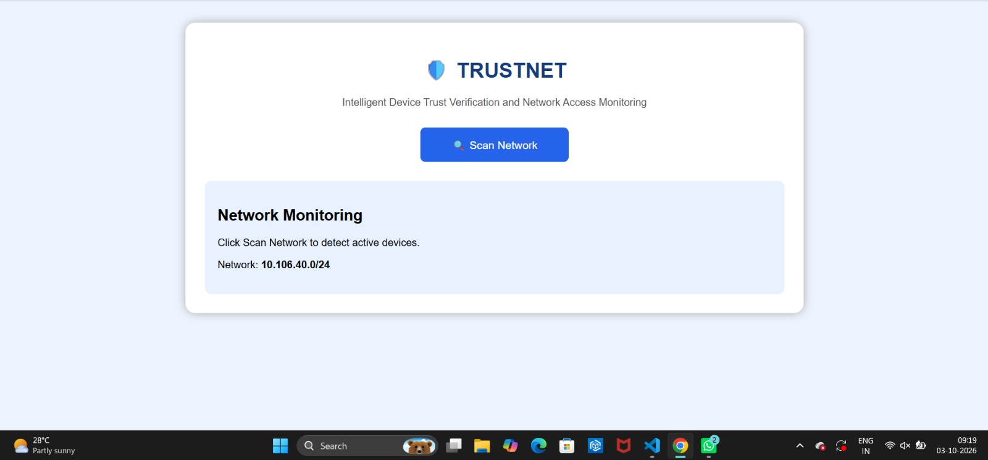
Output 2: Network scan result (2 active devices)
