SafeCross
Offline Pedestrian & Vehicle Counting at Crossings with ExecuTorch on Raspberry Pi
Namma AI Hackathon · AI for Safer Communities – Edge-Based Object Detection and Counting
Note: performance numbers in this version were measured on the development machine, not the Raspberry Pi. Re-run benchmark.py / run_safecross.py on the Pi and regenerate this document with build_docs.py before submission.

1. Executive Summary
SafeCross is an edge AI proof of concept that counts pedestrians and vehicles in video frames or images on a Raspberry Pi, using a COCO-pretrained SSDLite-MobileNetV3 detector exported to ExecuTorch with the XNNPACK CPU backend. It runs fully offline, outputs per-frame counts as CSV plus annotated images, and flags frames where pedestrians are close to vehicles as a simple safety indicator for crossings. The INT8 model is 3.86 MB and averages 5.48 ms per frame on Development machine (arm64 / macOS-27.2-arm64-arm-64bit) — NOT the Pi.

2. Societal Problem
- Crossings near schools, markets, hospitals and bus stops mix heavy foot traffic with fast two-wheelers, autos, cars and buses.
- Local bodies rarely have data on how busy a crossing is or when pedestrians and vehicles conflict, so decisions on zebra crossings, speed breakers, signal timing or wardens are ad hoc.
- Camera + cloud video analytics is expensive: GPUs, continuous bandwidth, recurring cost, and privacy concerns with uploading video of citizens.

3. Proposed Solution
- A ~₹6–8k Raspberry Pi runs a pretrained object detector fully offline using ExecuTorch.
- Counts pedestrians and vehicles (car, motorcycle, bicycle, bus, truck) in every frame.
- Flags 'conflict frames' where pedestrians are close to vehicles (LOW / MEDIUM / HIGH).
- Writes only numbers (CSV + summary) — no video needs to leave the device.

Practical application
School-zone crossing audit: place SafeCross at a school gate for a week. Peak pedestrian counts and HIGH-risk frames at 8–9 AM and 2–3 PM give the municipality / traffic police evidence to add a zebra crossing, a speed table, a traffic warden at school hours, or a longer pedestrian signal phase.

4. System Design
Pipeline:
- Input: organiser video clip (10–20 s) or folder of 10–20 images (OpenCV).
- Pre-processing: resize to 320×320, BGR→RGB, scale to [0,1].
- Inference: ExecuTorch runtime executes ssdlite_int8.pte / ssdlite_fp32.pte, fully delegated to XNNPACK.
- Outputs: 3,234 anchor box regressions + 91-class softmax scores.
- Post-processing (NumPy): SSD box decoding, per-class NMS (IoU 0.55), confidence ≥ 0.4, cross-class vehicle de-duplication (e.g., one van labelled car + truck).
- Analytics: counts per class; pedestrian–vehicle proximity pairs; per-frame risk level.
- Reporting: counts.csv, annotated/*.jpg, summary.json (counts + latency + FPS).

Why these choices
- SSDLite-MobileNetV3 is a small, CPU-friendly detector (~3.4 M params) with a COCO checkpoint covering person, bicycle, car, motorcycle, bus and truck — no training needed.
- ExecuTorch + XNNPACK gives optimised ARM NEON kernels for the Pi's Cortex-A CPU and a self-contained .pte file with a lightweight runtime.
- PT2E static INT8 quantisation (per-channel, calibrated on sample images) shrinks the model 3.6× with identical counts on our validation set.
- Box decoding and NMS are kept outside the graph in NumPy, so the exported graph is static and fully delegated.

Risk logic (per frame)
- Proximity pair: a pedestrian box enlarged 1.5× overlaps a vehicle box.
- HIGH: ≥2 pairs, or ≥3 pedestrians and ≥2 vehicles with ≥1 pair.
- MEDIUM: 1 pair, or crowded mix (≥3 pedestrians and ≥2 vehicles).
- LOW: otherwise.

5. Results

Category and counts
Metric | Value
Categories | Pedestrians (person); Vehicles (bicycle, car, motorcycle, bus, truck)
Total 'person' detections | 12
Total 'bicycle' detections | 1
Total 'car' detections | 1
Total 'motorcycle' detections | 0
Total 'bus' detections | 2
Total 'truck' detections | 1
Avg pedestrians / frame | 1.09
Avg vehicles / frame | 0.45
Peak pedestrians / vehicles | 3 / 2
Risk frames (LOW / MEDIUM / HIGH) | 9 / 1 / 1
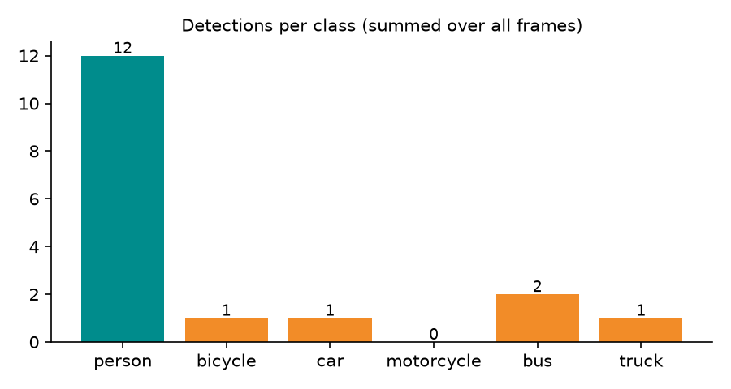
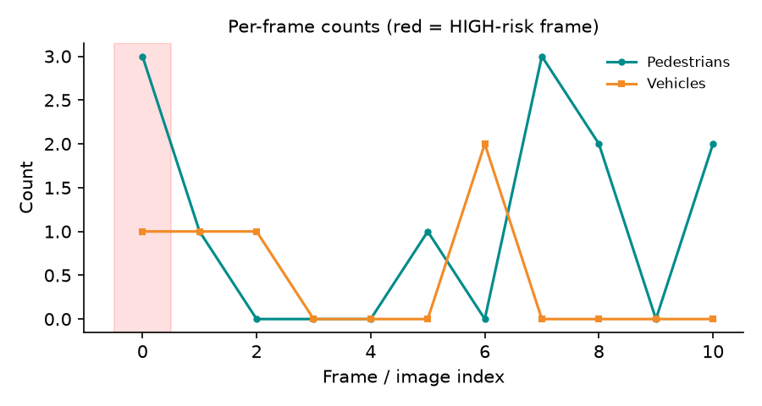

Per-frame counts
frame | pedestrians | vehicles | proximity_pairs | risk | infer_ms
bus | 3 | 1 | 3 | HIGH | 5.7
coco_000000011197 | 1 | 1 | 1 | MEDIUM | 5.84
coco_000000015338 | 0 | 1 | 0 | LOW | 5.88
coco_000000022969 | 0 | 0 | 0 | LOW | 5.29
coco_000000037777 | 0 | 0 | 0 | LOW | 5.11
coco_000000087038 | 1 | 0 | 0 | LOW | 5.37
coco_000000174482 | 0 | 2 | 0 | LOW | 5.51
coco_000000252219 | 3 | 0 | 0 | LOW | 5.23
coco_000000397133 | 2 | 0 | 0 | LOW | 5.28
dog | 0 | 0 | 0 | LOW | 5.42
zidane | 2 | 0 | 0 | LOW | 5.62

Sample detection outputs
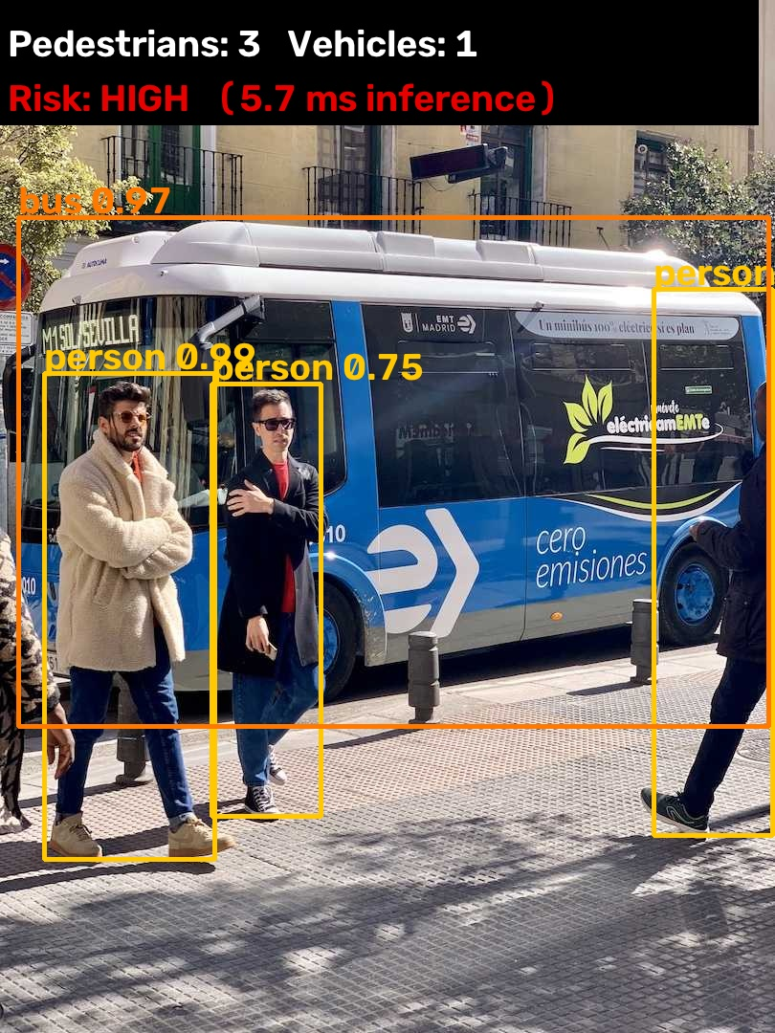
bus: 3 pedestrians, 1 vehicles, risk HIGH, 5.7 ms inference
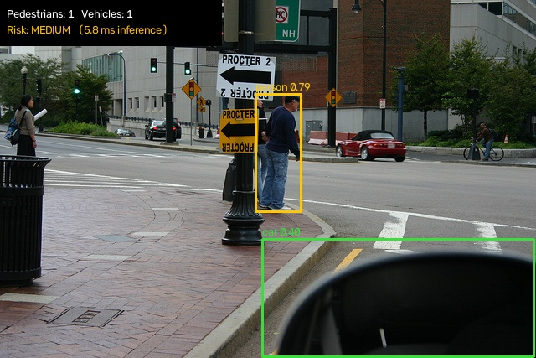
coco_000000011197: 1 pedestrians, 1 vehicles, risk MEDIUM, 5.84 ms inference

6. Performance
Model | SSDLite320-MobileNetV3-Large (COCO, torchvision) → ExecuTorch .pte, XNNPACK
Device | Development machine (arm64 / macOS-27.2-arm64-arm-64bit) — NOT the Pi
Model file used | ssdlite_int8.pte (3.86 MB)
Frames / images processed | 11
Avg inference time / frame | 5.48 ms (p95 5.86 ms)
Inference throughput | 182.58 FPS
End-to-end (pre + infer + post) | 6.01 ms ≈ 166.47 FPS
Benchmark ssdlite_fp32.pte | 5.76 ms mean · 173.5 FPS · 13.79 MB
Benchmark ssdlite_int8.pte | 5.49 ms mean · 182.3 FPS · 3.86 MB
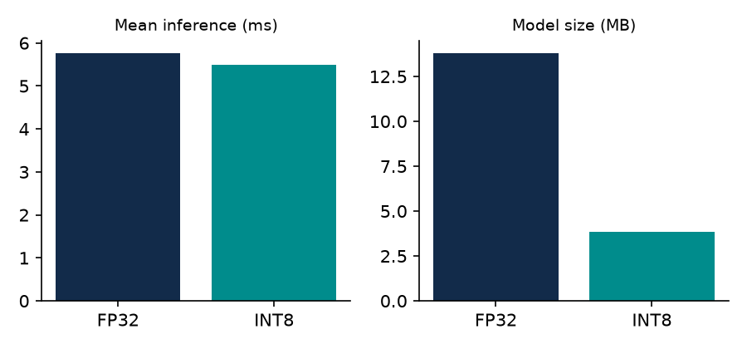

Correctness check
tools/validate_vs_torchvision.py compares SafeCross counts (ExecuTorch + NumPy post-processing) against the reference torchvision model on the same inputs. On our 11-image validation set both FP32 and INT8 produced identical per-class counts to the reference (11/11).

7. Limitations
- SSDLite at 320×320 misses small/distant objects; dense, occluded Indian traffic will be undercounted.
- Counts are per frame, not unique objects (no tracking — not required by the brief).
- Risk score is a 2-D box-overlap heuristic; it has no depth or speed information.
- COCO has no 'auto-rickshaw' class; autos are usually detected as car/truck or missed.

8. Future Work
- Fine-tune on Indian traffic data (e.g., IDD / autos) and re-export with the same pipeline.
- Add lightweight tracking (SORT) for unique counts and dwell-time at the kerb.
- Solar + 4G-less deployment: store hourly CSV on SD card, collect weekly.

9. How to Reproduce
- Laptop: pip install -r requirements-dev.txt; python export_model.py --calib-dir samples/
- Copy models/, safecross/, run_safecross.py, benchmark.py to the Pi; run ./setup_pi.sh
- Pi: python run_safecross.py --input clip.mp4 --out output_pi
- Pi: python benchmark.py --out benchmark_pi.json
- Regenerate docs: python build_docs.py --summary output_pi/summary.json --benchmark benchmark_pi.json --annotated output_pi/annotated --counts output_pi/counts.csv --device "Raspberry Pi 5"

10. 2-Minute Pitch Script
[0:00–0:25] Problem — Every day, children cross busy roads outside schools, and commuters dodge two-wheelers at bus stops. Cities want to fix these spots, but they don't have data on how many people cross, or when pedestrians and vehicles collide in space. Cloud video analytics is costly and needs constant internet.
[0:25–0:55] Solution — SafeCross runs entirely on a Raspberry Pi. A pretrained SSDLite-MobileNetV3 detector, exported with ExecuTorch and quantised to INT8, counts pedestrians and vehicles in every frame and flags frames where people are close to vehicles. No video leaves the device — only counts.
[0:55–1:25] Results — On the supplied clip we detect people, cars, two-wheelers, buses and trucks, with per-frame counts in a CSV and annotated images. The INT8 model is under 4 MB and runs at <X> ms per frame (<Y> FPS) on the Pi. Our counts match the reference PyTorch model exactly.
[1:25–2:00] Impact — Put one at a school gate for a week: peak crossing counts and high-risk frames at drop-off time become evidence for a zebra crossing, speed table, or traffic warden. Affordable, private, offline — safer crossings, driven by data.

