- Installation of Android Studio.

Android Studio System Requirements for Windows
- Microsoft Windows 7/8/10 (32-bit or 64-bit)
- 4 GB RAM minimum, 8 GB RAM recommended (plus 1 GB for the Android Emulator)
- 2 GB of available disk space minimum, 4 GB recommended (500 MB for IDE plus 1.5 GB for Android SDK and emulator system image)
- 1280 x 800 minimum screen resolution
- Steps to Install Android Studio on Windows

Step 1: Go to https://developer.android.com/studio/#downloads Download Android Studio executable or zip file.

Step 2: Click on the Download Android Studio Button.

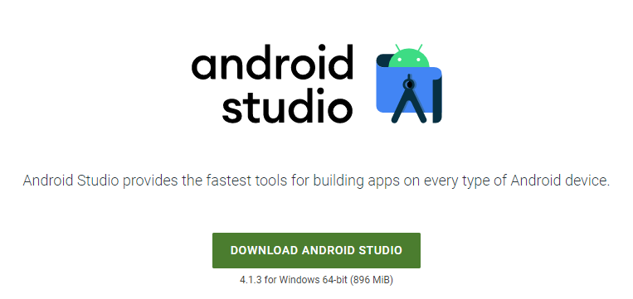
Click on the "I have read and agree with the above terms and conditions" checkbox followed by the download button.

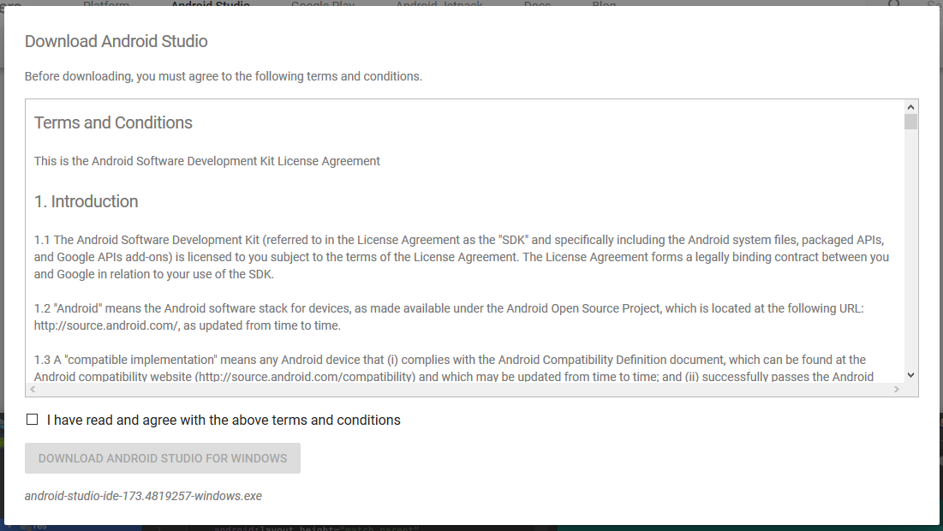

Click on the Save file button in the appeared prompt box and the file will start downloading.

Step 3: After the downloading has finished, open the file from downloads and run it. It will prompt the following dialog box.

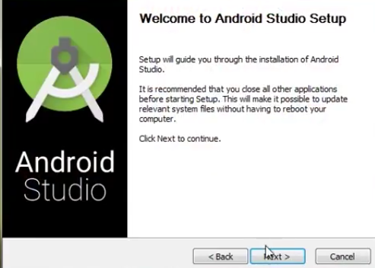

Click on next. In the next prompt, it'll ask for a path for installation. Choose a path and hit next.

Step 4: It will start the installation, and once it is completed, it will be like the image shown below.

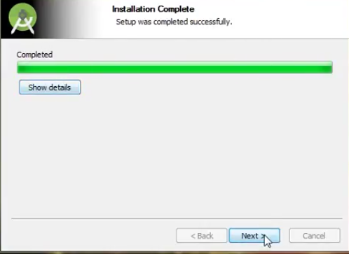

Click on next.

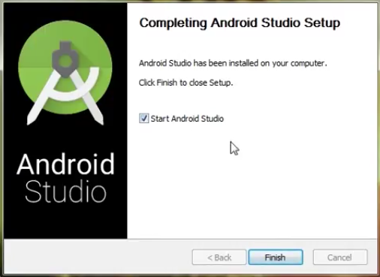

Step 5: Once " Finish " is clicked, it will ask whether the previous settings need to be imported [if the android studio had been installed earlier], or not. It is better to choose the 'Don't import Settings option'.

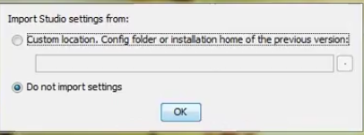

Click the OK button.

Step 6: This will start the Android Studio.

Meanwhile, it will be finding the available SDK components.
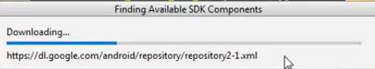

Step 7: After it has found the SDK components, it will redirect to the Welcome dialog box.

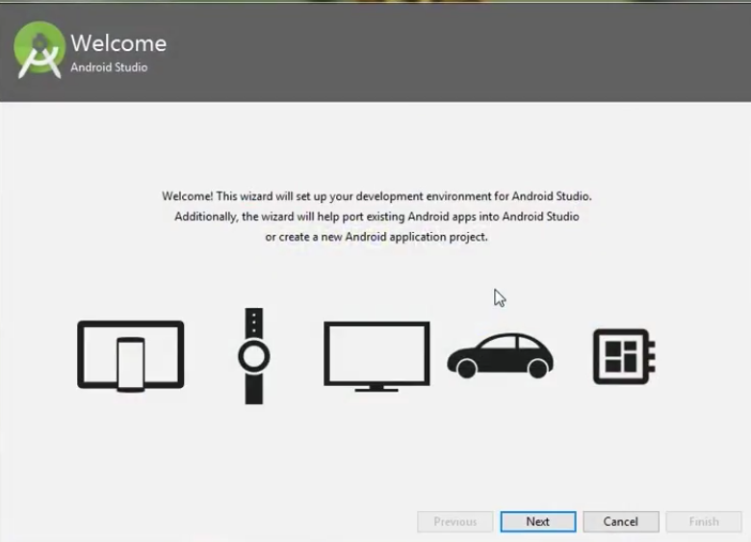

Click on Next .

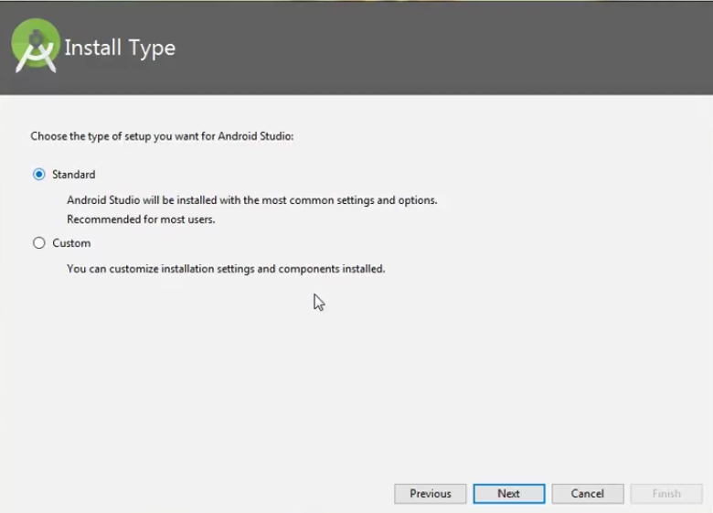

Choose Standard and click on Next. Now choose the theme, whether the Light theme or the Dark one. The light one is called the IntelliJ theme whereas the dark theme is called Dracula . Choose as required.

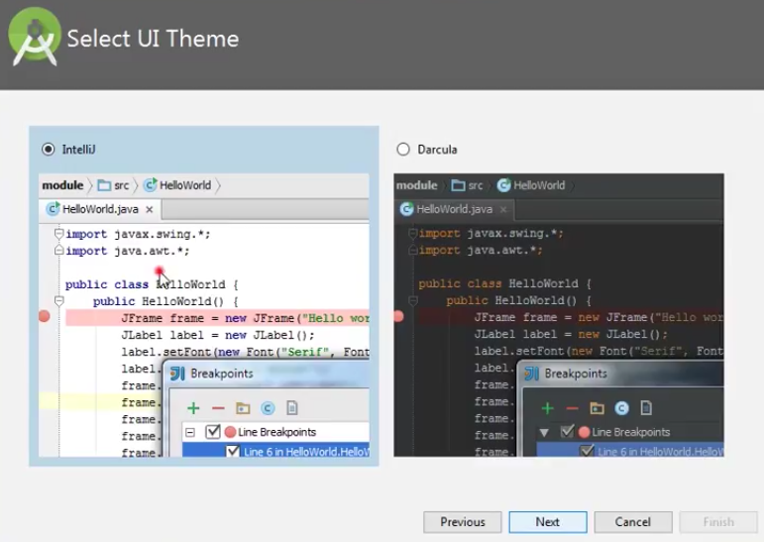

Click on the Next button.

Step 8: Now it is time to download the SDK components.

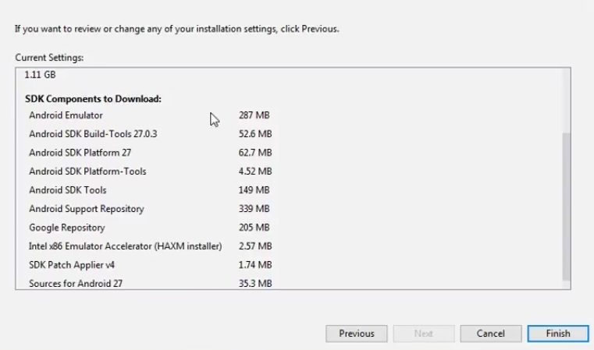

Click on Finish. Components begin to download let it complete.

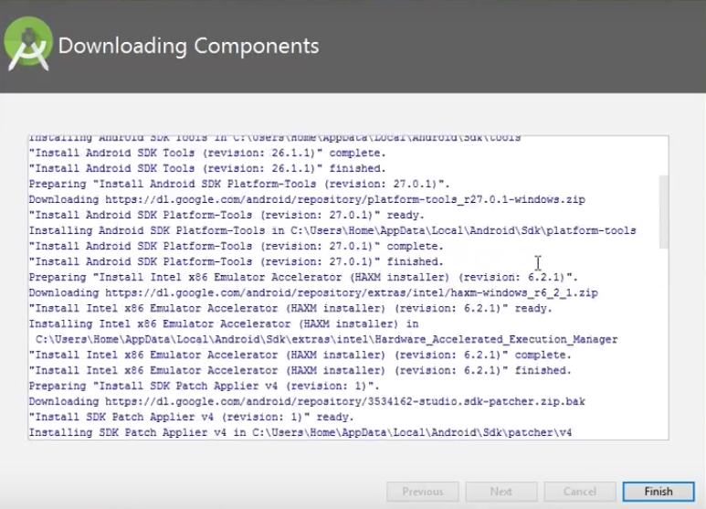

The Android Studio has been successfully configured. Now it's time to launch and build apps. Click on the Finish button to launch it.

Step 9: Click on Start a new Android Studio project to build a new app.

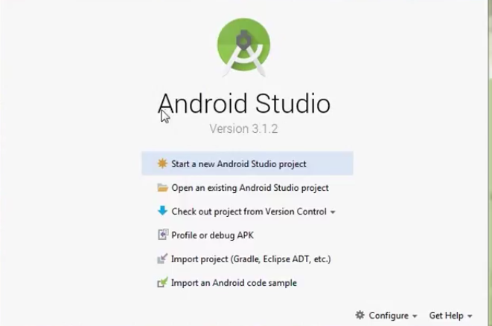

- Write a program using Button, TextView, EditText, Toast, and ToggleButton

activity_main.xml
<?xml version="1.0" encoding="utf-8"?>
<LinearLayout
xmlns:android="http://schemas.android.com/apk/res/android"
xmlns:tools="http://schemas.android.com/tools"
xmlns:app="http://schemas.android.com/apk/res-auto"
android:id="@+id/main"
android:layout_width="match_parent"
android:layout_height="match_parent"
tools:context=".MainActivity"
android:orientation="vertical"
android:gravity="center">

<TextView
android:id="@+id/textViewLabel"
android:layout_width="wrap_content"
android:layout_height="wrap_content"
android:text="Enter your name:"
android:textSize="18sp" />

<EditText
android:id="@+id/editTextName"
android:layout_width="match_parent"
android:layout_height="wrap_content"
android:hint="Your name" />

<ToggleButton
android:id="@+id/toggleButton"
android:layout_width="wrap_content"
android:layout_height="wrap_content"
android:textOn="ON"
android:textOff="OFF" />

<Button
android:id="@+id/buttonShowToast"
android:layout_width="wrap_content"
android:layout_height="wrap_content"
android:text="Show Toast" />

</LinearLayout>

MainActivity.java

public class MainActivity extends AppCompatActivity {

@Override
protected void onCreate(Bundle savedInstanceState) {
super.onCreate(savedInstanceState);
EdgeToEdge.enable(this);
setContentView(R.layout.activity_main);
ViewCompat.setOnApplyWindowInsetsListener(findViewById(R.id.main), (v, insets) -> {
Insets systemBars = insets.getInsets(WindowInsetsCompat.Type.systemBars());
v.setPadding(systemBars.left, systemBars.top, systemBars.right, systemBars.bottom);
return insets;
});

EditText editTextName = findViewById(R.id.editTextName);
ToggleButton toggleButton = findViewById(R.id.toggleButton);
Button buttonShowToast = findViewById(R.id.buttonShowToast);

buttonShowToast.setOnClickListener(new View.OnClickListener() {
@Override
public void onClick(View view) {
String name = editTextName.getText().toString();
if(toggleButton.isChecked()){
Toast.makeText(MainActivity.this, name, Toast.LENGTH_SHORT).show();
}else{
Toast.makeText(MainActivity.this, "Toggle button is off", Toast.LENGTH_SHORT).show();
}
}
});
}
}

Output:

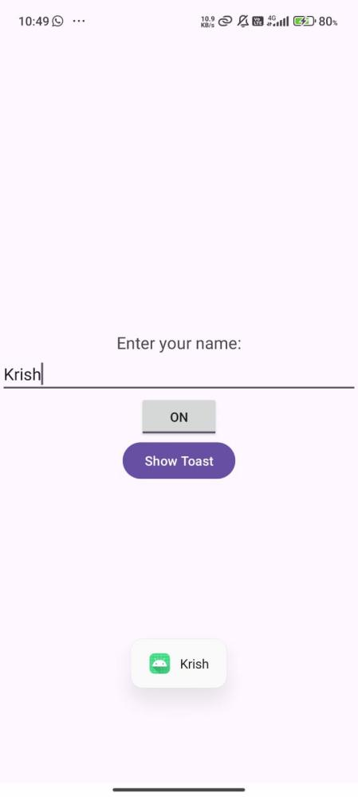

- Create a Registration Page with Button, TextView, EditText, CheckBox, RadioButton, RadioGroup, and Toast

activity_main.xml

<?xml version="1.0" encoding="utf-8"?>
<LinearLayout xmlns:android="http://schemas.android.com/apk/res/android"
xmlns:app="http://schemas.android.com/apk/res-auto"
xmlns:tools="http://schemas.android.com/tools"
android:id="@+id/main"
android:layout_width="match_parent"
android:layout_height="match_parent"
tools:context=".MainActivity2"
android:orientation="vertical"
android:gravity="center">

<TextView
android:id="@+id/textViewTitle"
android:layout_width="wrap_content"
android:layout_height="wrap_content"
android:text="Registration Form"
android:textSize="24sp"
android:textStyle="bold"
android:layout_gravity="center_horizontal"
android:layout_marginBottom="24dp"/>

<TextView
android:layout_width="wrap_content"
android:layout_height="wrap_content"
android:text="Full Name:" />

<EditText
android:id="@+id/editTextName"
android:layout_width="match_parent"
android:layout_height="wrap_content"
android:hint="Enter your full name"
android:inputType="textPersonName" />

<TextView
android:layout_width="wrap_content"
android:layout_height="wrap_content"
android:text="Email:" />

<EditText
android:id="@+id/editTextEmail"
android:layout_width="match_parent"
android:layout_height="wrap_content"
android:hint="Enter your email"
android:inputType="textEmailAddress" />

<TextView
android:layout_width="wrap_content"
android:layout_height="wrap_content"
android:text="Password:" />

<EditText
android:id="@+id/editTextPassword"
android:layout_width="match_parent"
android:layout_height="wrap_content"
android:hint="Enter your password"
android:inputType="textPassword" />

<TextView
android:layout_width="wrap_content"
android:layout_height="wrap_content"
android:text="Gender:" />

<RadioGroup
android:id="@+id/radioGroupGender"
android:layout_width="match_parent"
android:layout_height="wrap_content"
android:orientation="horizontal">

<RadioButton
android:id="@+id/radioMale"
android:layout_width="wrap_content"
android:layout_height="wrap_content"
android:text="Male" />

<RadioButton
android:id="@+id/radioFemale"
android:layout_width="wrap_content"
android:layout_height="wrap_content"
android:text="Female" />

<RadioButton
android:id="@+id/radioOther"
android:layout_width="wrap_content"
android:layout_height="wrap_content"
android:text="Other" />
</RadioGroup>

<CheckBox
android:id="@+id/checkboxTerms"
android:layout_width="wrap_content"
android:layout_height="wrap_content"
android:text="I agree to the Terms and Conditions" />

<Button
android:id="@+id/buttonRegister"
android:layout_width="match_parent"
android:layout_height="wrap_content"
android:text="Register" />

</LinearLayout>

MainActivity.java

public class MainActivity2 extends AppCompatActivity {

EditText editTextName, editTextEmail, editTextPassword;
RadioGroup radioGroupGender;
CheckBox checkboxTerms;
Button buttonRegister;

@Override
protected void onCreate(Bundle savedInstanceState) {
super.onCreate(savedInstanceState);
EdgeToEdge.enable(this);
setContentView(R.layout.activity_main2); // Make sure this matches your XML file name

// Handle system insets (status/nav bar paddings)
ViewCompat.setOnApplyWindowInsetsListener(findViewById(R.id.main), (v, insets) -> {
Insets systemBars = insets.getInsets(WindowInsetsCompat.Type.systemBars());
v.setPadding(systemBars.left, systemBars.top, systemBars.right, systemBars.bottom);
return insets;
});

editTextName = findViewById(R.id.editTextName);
editTextEmail = findViewById(R.id.editTextEmail);
editTextPassword = findViewById(R.id.editTextPassword);
radioGroupGender = findViewById(R.id.radioGroupGender);
checkboxTerms = findViewById(R.id.checkboxTerms);
buttonRegister = findViewById(R.id.buttonRegister);

buttonRegister.setOnClickListener(new View.OnClickListener() {
@Override
public void onClick(View v) {
String name = editTextName.getText().toString().trim();
String email = editTextEmail.getText().toString().trim();
String password = editTextPassword.getText().toString().trim();
int selectedGenderId = radioGroupGender.getCheckedRadioButtonId();

if (name.isEmpty() || email.isEmpty() || password.isEmpty()) {
Toast.makeText(MainActivity2.this, "Please fill all fields", Toast.LENGTH_SHORT).show();
} else if (selectedGenderId == -1) {
Toast.makeText(MainActivity2.this, "Please select a gender", Toast.LENGTH_SHORT).show();
} else if (!checkboxTerms.isChecked()) {
Toast.makeText(MainActivity2.this, "Please agree to the terms and conditions", Toast.LENGTH_SHORT).show();
} else {
RadioButton selectedRadioButton = findViewById(selectedGenderId);
String gender = selectedRadioButton.getText().toString();

String message = "Registered: " + name + "\nEmail: " + email + "\nGender: " + gender;
Toast.makeText(MainActivity2.this, message, Toast.LENGTH_LONG).show();
}
}
});
}
}
Output:

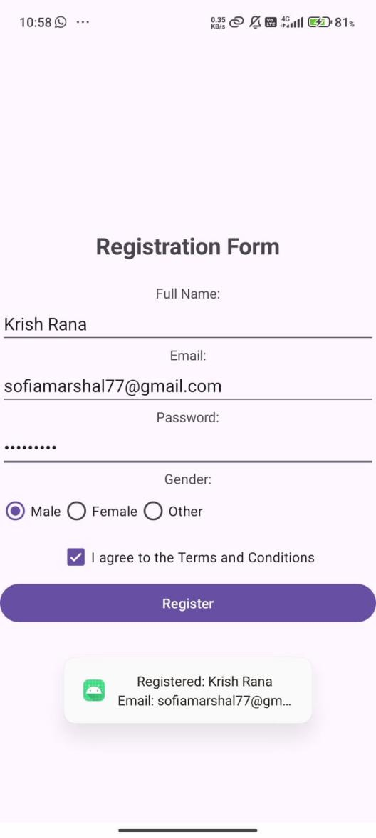

- Write a program to implement AutoCompleteTextView.

activity_main.xml

<?xml version="1.0" encoding="utf-8"?>
<LinearLayout xmlns:android="http://schemas.android.com/apk/res/android"
xmlns:app="http://schemas.android.com/apk/res-auto"
xmlns:tools="http://schemas.android.com/tools"
android:id="@+id/main"
android:layout_width="match_parent"
android:layout_height="match_parent"
tools:context=".MainActivity3"
android:gravity="center"
android:orientation="vertical">

<AutoCompleteTextView
android:layout_width="match_parent"
android:layout_height="wrap_content"
android:id="@+id/autocompleteTextView"/>

<Button
android:layout_width="wrap_content"
android:layout_height="wrap_content"
android:text="Click Me"
android:id="@+id/button"/>

</LinearLayout>

MainActivity.java

public class MainActivity3 extends AppCompatActivity {

AutoCompleteTextView autoCompleteTextView;
Button button;

String[] countries = {
"India", "United States", "Canada", "Australia", "Germany",
"France", "Japan", "China", "Brazil", "United Kingdom"
};

@Override
protected void onCreate(Bundle savedInstanceState) {
super.onCreate(savedInstanceState);
EdgeToEdge.enable(this);
setContentView(R.layout.activity_main3);

// Handle system insets if needed
ViewCompat.setOnApplyWindowInsetsListener(findViewById(R.id.main), (v, insets) -> {
Insets systemBars = insets.getInsets(WindowInsetsCompat.Type.systemBars());
v.setPadding(systemBars.left, systemBars.top, systemBars.right, systemBars.bottom);
return insets;
});

autoCompleteTextView = findViewById(R.id.autocompleteTextView);
button = findViewById(R.id.button);

// Set up adapter for AutoCompleteTextView
ArrayAdapter<String> adapter = new ArrayAdapter<>(
this,
android.R.layout.simple_dropdown_item_1line,
countries
);
autoCompleteTextView.setAdapter(adapter);
autoCompleteTextView.setThreshold(1);

button.setOnClickListener(new View.OnClickListener() {
@Override
public void onClick(View v) {
String selectedCountry = autoCompleteTextView.getText().toString().trim();
if (selectedCountry.isEmpty()) {
Toast.makeText(MainActivity3.this, "Please select a country", Toast.LENGTH_SHORT).show();
} else {
Toast.makeText(MainActivity3.this, "Selected country: " + selectedCountry, Toast.LENGTH_SHORT).show();
}
}
});
}
}

Output:

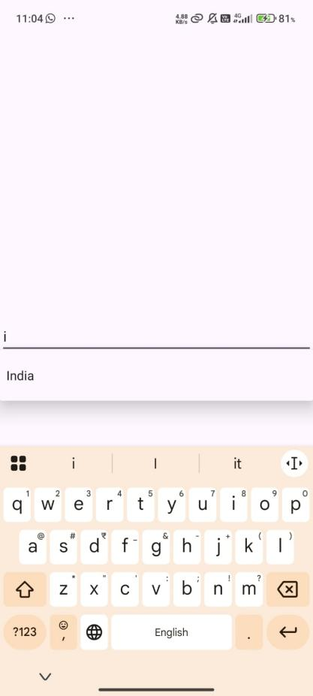

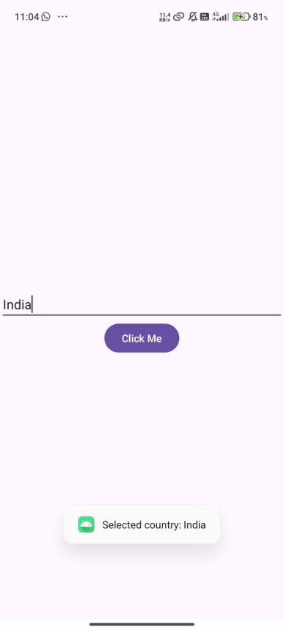

- Write a program to implement ImageButton.

activity_main.xml

<?xml version="1.0" encoding="utf-8"?>
<LinearLayout xmlns:android="http://schemas.android.com/apk/res/android"
xmlns:app="http://schemas.android.com/apk/res-auto"
xmlns:tools="http://schemas.android.com/tools"
android:id="@+id/main"
android:layout_width="match_parent"
android:layout_height="match_parent"
tools:context=".MainActivity4"
android:gravity="center"
android:orientation="vertical">

<ImageButton
android:layout_width="wrap_content"
android:layout_height="wrap_content"
android:id="@+id/imageButton"
android:src="@drawable/img"/>

</LinearLayout>

MainActivity.java

public class MainActivity4 extends AppCompatActivity {

@Override
protected void onCreate(Bundle savedInstanceState) {
super.onCreate(savedInstanceState);
EdgeToEdge.enable(this);
setContentView(R.layout.activity_main4);
ViewCompat.setOnApplyWindowInsetsListener(findViewById(R.id.main), (v, insets) -> {
Insets systemBars = insets.getInsets(WindowInsetsCompat.Type.systemBars());
v.setPadding(systemBars.left, systemBars.top, systemBars.right, systemBars.bottom);
return insets;
});

ImageButton button = findViewById(R.id.imageButton);

button.setOnClickListener(new View.OnClickListener() {
@Override
public void onClick(View view) {
Toast.makeText(MainActivity4.this, "Image button clicked", Toast.LENGTH_SHORT).show();
}
});
}
}

Output:

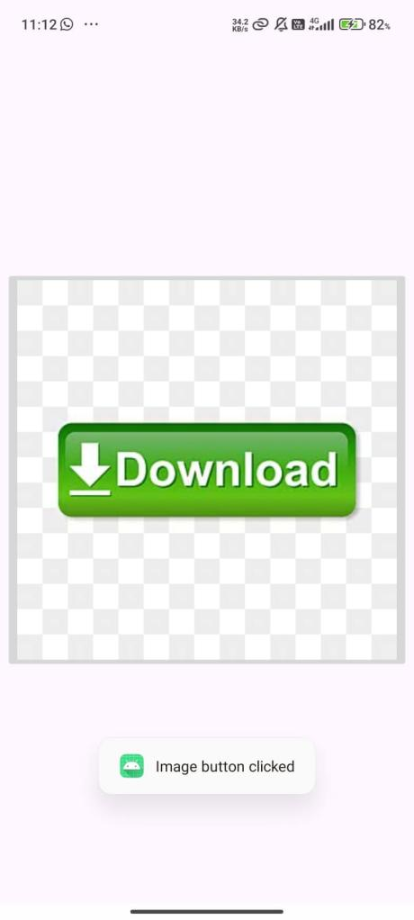

- Write a program to implement AlertDialog with Positive and Negative buttons.

activity_main.xml

<?xml version="1.0" encoding="utf-8"?>
<LinearLayout xmlns:android="http://schemas.android.com/apk/res/android"
xmlns:app="http://schemas.android.com/apk/res-auto"
xmlns:tools="http://schemas.android.com/tools"
android:id="@+id/main"
android:layout_width="match_parent"
android:layout_height="match_parent"
tools:context=".MainActivity5"
android:orientation="vertical"
android:gravity="center">

<Button
android:layout_width="wrap_content"
android:layout_height="wrap_content"
android:text="Alert"
android:id="@+id/alertbtn" />
</LinearLayout>

MainActivity.java

public class MainActivity5 extends AppCompatActivity {

@Override
protected void onCreate(Bundle savedInstanceState) {
super.onCreate(savedInstanceState);
EdgeToEdge.enable(this);
setContentView(R.layout.activity_main5);

// Handle system insets
ViewCompat.setOnApplyWindowInsetsListener(findViewById(R.id.main), (v, insets) -> {
Insets systemBars = insets.getInsets(WindowInsetsCompat.Type.systemBars());
v.setPadding(systemBars.left, systemBars.top, systemBars.right, systemBars.bottom);
return insets;
});

// Button for showing alert
Button btn = findViewById(R.id.alertbtn);

btn.setOnClickListener(new View.OnClickListener() {
@Override
public void onClick(View view) {
// Create AlertDialog
AlertDialog.Builder builder = new AlertDialog.Builder(MainActivity5.this);
builder.setTitle("Error");
builder.setMessage("This is an Alert Dialog");

// Positive Button
builder.setPositiveButton("OK", (dialog, which) -> {
// Code for OK button click
dialog.dismiss(); // Close the dialog
});

// Negative Button
builder.setNegativeButton("Cancel", (dialog, which) -> {
// Code for Cancel button click
dialog.dismiss(); // Close the dialog
});

// Show the dialog
AlertDialog alertDialog = builder.create();
alertDialog.show();
}
});
}
}

Output:

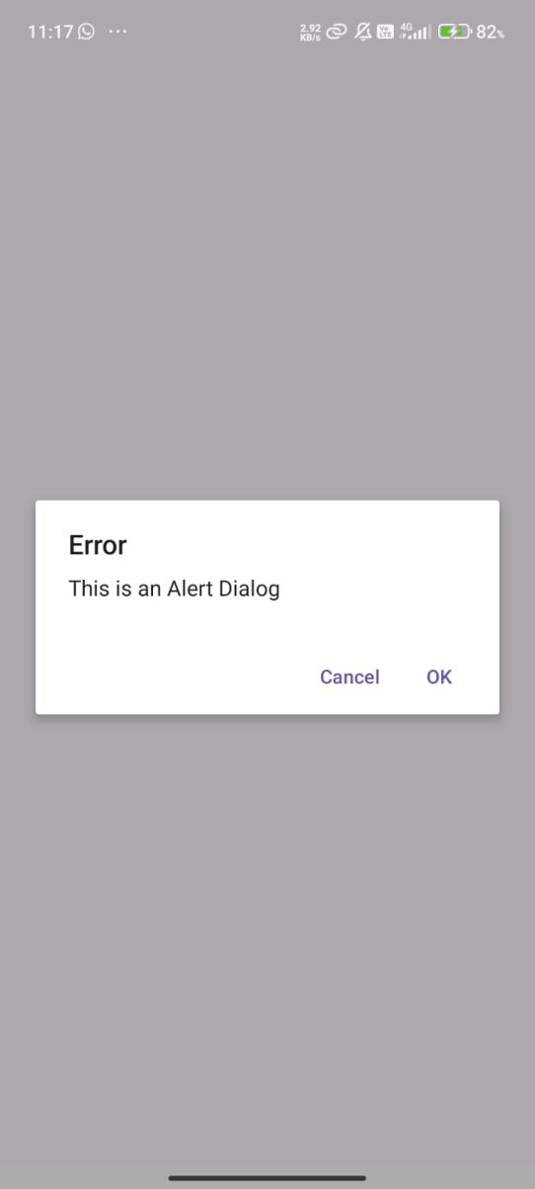

- Write a program to implement AlertDialog with single choice items.

activity_main.xml

<?xml version="1.0" encoding="utf-8"?>
<LinearLayout xmlns:android="http://schemas.android.com/apk/res/android"
xmlns:app="http://schemas.android.com/apk/res-auto"
xmlns:tools="http://schemas.android.com/tools"
android:id="@+id/main"
android:layout_width="match_parent"
android:layout_height="match_parent"
tools:context=".MainActivity7"
android:orientation="vertical"
android:gravity="center">

<Button
android:layout_width="wrap_content"
android:layout_height="wrap_content"
android:id="@+id/alertbtn2"
android:text="Alert" />

</LinearLayout>

MainActiviity.java

public class MainActivity7 extends AppCompatActivity {

Button btn;
String[] options = {"Option 1", "Option 2", "Option 3"};
int selectedOption = -1; // Default to no selection

@Override
protected void onCreate(Bundle savedInstanceState) {
super.onCreate(savedInstanceState);
EdgeToEdge.enable(this);
setContentView(R.layout.activity_main7);

ViewCompat.setOnApplyWindowInsetsListener(findViewById(R.id.main), (v, insets) -> {
Insets systemBars = insets.getInsets(WindowInsetsCompat.Type.systemBars());
v.setPadding(systemBars.left, systemBars.top, systemBars.right, systemBars.bottom);
return insets;
});

btn = findViewById(R.id.alertbtn2);

btn.setOnClickListener(v -> {
AlertDialog.Builder builder = new AlertDialog.Builder(MainActivity7.this);
builder.setTitle("Choose an option");

builder.setSingleChoiceItems(options, selectedOption, (dialog, which) -> {
selectedOption = which;
Toast.makeText(MainActivity7.this, "Selected: " + options[which], Toast.LENGTH_SHORT).show();
dialog.dismiss(); // Close the dialog after selection
});

builder.setNegativeButton("Cancel", (dialog, which) -> dialog.dismiss());

AlertDialog dialog = builder.create();
dialog.show();
});
}
}

Output:

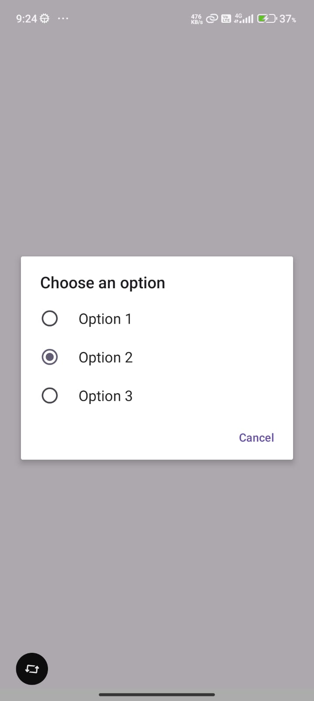

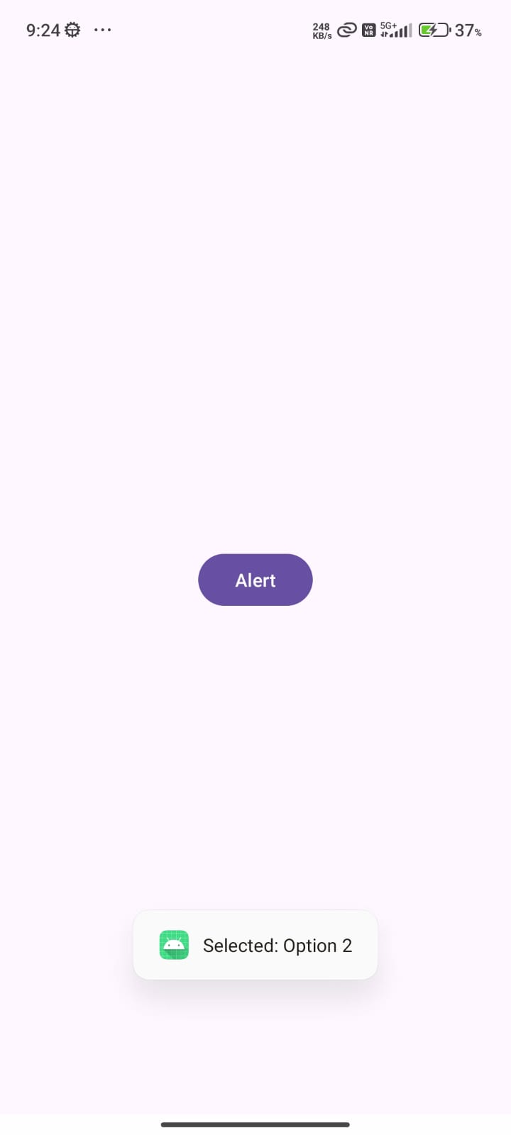

- Write a program to implement Spinner

activity_main.xml

<?xml version="1.0" encoding="utf-8"?>
<LinearLayout xmlns:android="http://schemas.android.com/apk/res/android"
xmlns:app="http://schemas.android.com/apk/res-auto"
xmlns:tools="http://schemas.android.com/tools"
android:id="@+id/main"
android:layout_width="match_parent"
android:layout_height="match_parent"
tools:context=".MainActivity6"
android:gravity="top"
android:orientation="vertical">

<Spinner
android:layout_width="match_parent"
android:layout_height="wrap_content"
android:id="@+id/spinner"
android:layout_marginTop="50sp"/>

</LinearLayout>

MainActivity.java

public class MainActivity6 extends AppCompatActivity {

Spinner spinner;

@Override
protected void onCreate(Bundle savedInstanceState) {
super.onCreate(savedInstanceState);
EdgeToEdge.enable(this);
setContentView(R.layout.activity_main6);

ViewCompat.setOnApplyWindowInsetsListener(findViewById(R.id.main), (v, insets) -> {
Insets systemBars = insets.getInsets(WindowInsetsCompat.Type.systemBars());
v.setPadding(systemBars.left, systemBars.top, systemBars.right, systemBars.bottom);
return insets;
});

spinner = findViewById(R.id.spinner);

// Define string array in Java instead of strings.xml
String[] countries = {"India", "USA", "UK", "Canada", "Australia"};

// Create ArrayAdapter with Java string array
ArrayAdapter<String> adapter = new ArrayAdapter<>(
this,
android.R.layout.simple_spinner_item,
countries
);
adapter.setDropDownViewResource(android.R.layout.simple_spinner_dropdown_item);
spinner.setAdapter(adapter);

// Handle selection
spinner.setOnItemSelectedListener(new AdapterView.OnItemSelectedListener() {
@Override
public void onItemSelected(AdapterView<?> parent, View view, int position, long id) {
String selectedCountry = parent.getItemAtPosition(position).toString();
Toast.makeText(MainActivity6.this, "Selected: " + selectedCountry, Toast.LENGTH_SHORT).show();
}

@Override
public void onNothingSelected(AdapterView<?> parent) {
// Optional
}
});
}
}

Output:

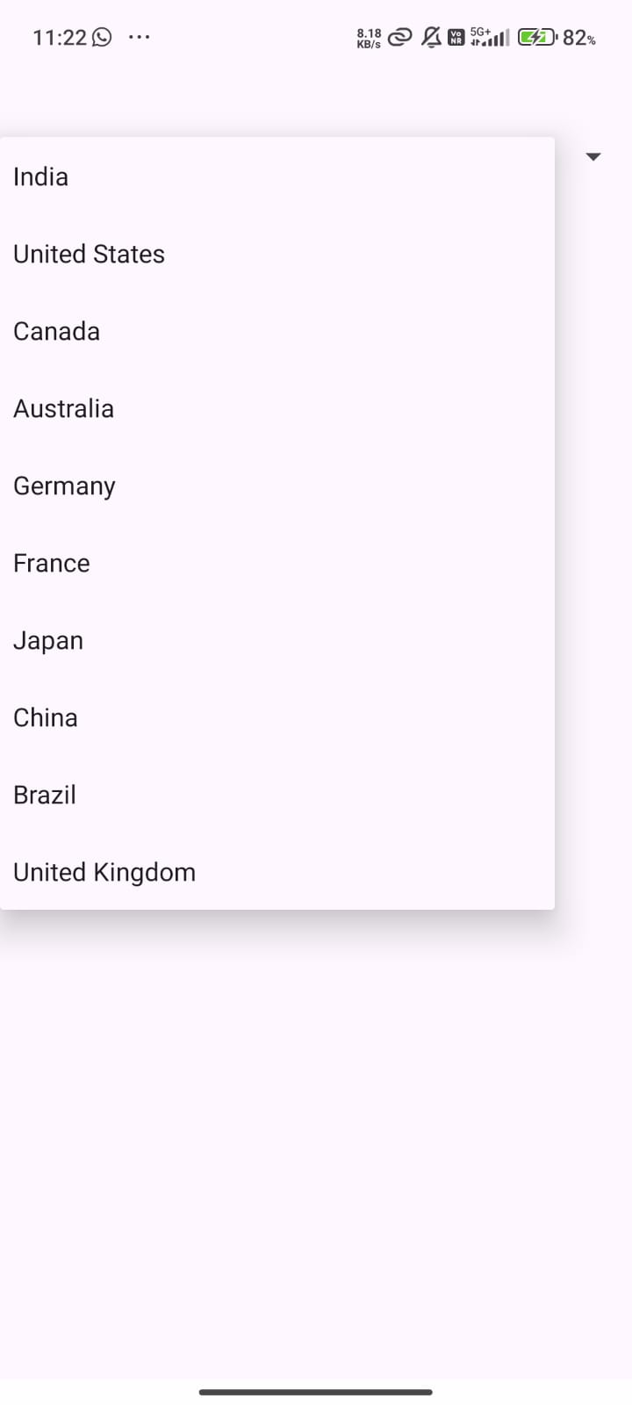

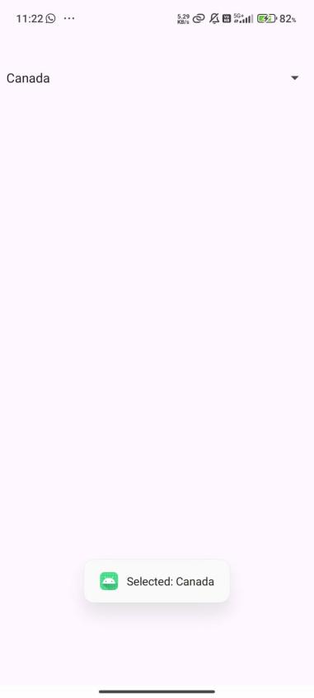

- Write a program to implement Spinner using strings.xml.

String.xml

<resources>
<string name="app_name">Prac1</string>

<string-array name="countries_array">
<item>India</item>
<item>United States</item>
<item>Canada</item>
<item>Australia</item>
<item>Germany</item>
<item>France</item>
<item>Japan</item>
<item>China</item>
<item>Brazil</item>
<item>United Kingdom</item>
</string-array>
</resources>

Activity_main.xml

<?xml version="1.0" encoding="utf-8"?>
<LinearLayout xmlns:android="http://schemas.android.com/apk/res/android"
xmlns:app="http://schemas.android.com/apk/res-auto"
xmlns:tools="http://schemas.android.com/tools"
android:id="@+id/main"
android:layout_width="match_parent"
android:layout_height="match_parent"
tools:context=".MainActivity6"
android:gravity="top"
android:orientation="vertical">

<Spinner
android:layout_width="match_parent"
android:layout_height="wrap_content"
android:id="@+id/spinner"
android:layout_marginTop="50sp"/>

</LinearLayout>

MainActivity.java

public class MainActivity6 extends AppCompatActivity {

Spinner spinner;

@Override
protected void onCreate(Bundle savedInstanceState) {
super.onCreate(savedInstanceState);
EdgeToEdge.enable(this);
setContentView(R.layout.activity_main6);

ViewCompat.setOnApplyWindowInsetsListener(findViewById(R.id.main), (v, insets) -> {
Insets systemBars = insets.getInsets(WindowInsetsCompat.Type.systemBars());
v.setPadding(systemBars.left, systemBars.top, systemBars.right, systemBars.bottom);
return insets;
});

spinner = findViewById(R.id.spinner);

// Create adapter using string-array from strings.xml
ArrayAdapter<CharSequence> adapter = ArrayAdapter.createFromResource(
this,
R.array.countries_array,
android.R.layout.simple_spinner_item
);
adapter.setDropDownViewResource(android.R.layout.simple_spinner_dropdown_item);
spinner.setAdapter(adapter);

// Handle selection
spinner.setOnItemSelectedListener(new AdapterView.OnItemSelectedListener() {
@Override
public void onItemSelected(AdapterView<?> parent, View view, int position, long id) {
String selectedCountry = parent.getItemAtPosition(position).toString();
Toast.makeText(MainActivity6.this, "Selected: " + selectedCountry, Toast.LENGTH_SHORT).show();
}

@Override
public void onNothingSelected(AdapterView<?> parent) {
// Optional: do nothing
}
});
}
}

Output:

- Write a program to implement ListView using strings.xml.

String.xml
<?xml version="1.0" encoding="utf-8"?>
<resources>
<string name="app_name">YourAppName</string>

<string-array name="country_list">
<item>India</item>
<item>USA</item>
<item>UK</item>
<item>Canada</item>
<item>Australia</item>
<item>Germany</item>
<item>France</item>
</string-array>
</resources>

Activity_main.xml

<?xml version="1.0" encoding="utf-8"?>
<LinearLayout xmlns:android="http://schemas.android.com/apk/res/android"
android:id="@+id/main_layout"
android:layout_width="match_parent"
android:layout_height="match_parent"
android:orientation="vertical"
android:padding="16dp">

<ListView
android:id="@+id/listView"
android:layout_width="match_parent"
android:layout_height="wrap_content"
android:divider="@android:color/darker_gray"
android:dividerHeight="1dp" />
</LinearLayout>

MainActivity.java

public class MainActivity8 extends AppCompatActivity {

ListView listView;

@Override
protected void onCreate(Bundle savedInstanceState) {
super.onCreate(savedInstanceState);
setContentView(R.layout.activity_main8);

listView = findViewById(R.id.listView);

String[] countries = getResources().getStringArray(R.id.countries);

ArrayAdapter<String> adapter = new ArrayAdapter<>(
this,
android.R.layout.simple_list_item_1,
countries
);

// Attach adapter to ListView
listView.setAdapter(adapter);

// Handle item click
listView.setOnItemClickListener(new AdapterView.OnItemClickListener() {
@Override
public void onItemClick(AdapterView<?> parent, View view, int position, long id) {
String selectedCountry = parent.getItemAtPosition(position).toString();
Toast.makeText(MainActivity8.this, "Clicked: " + selectedCountry, Toast.LENGTH_SHORT).show();
}
});
}
}

Output:

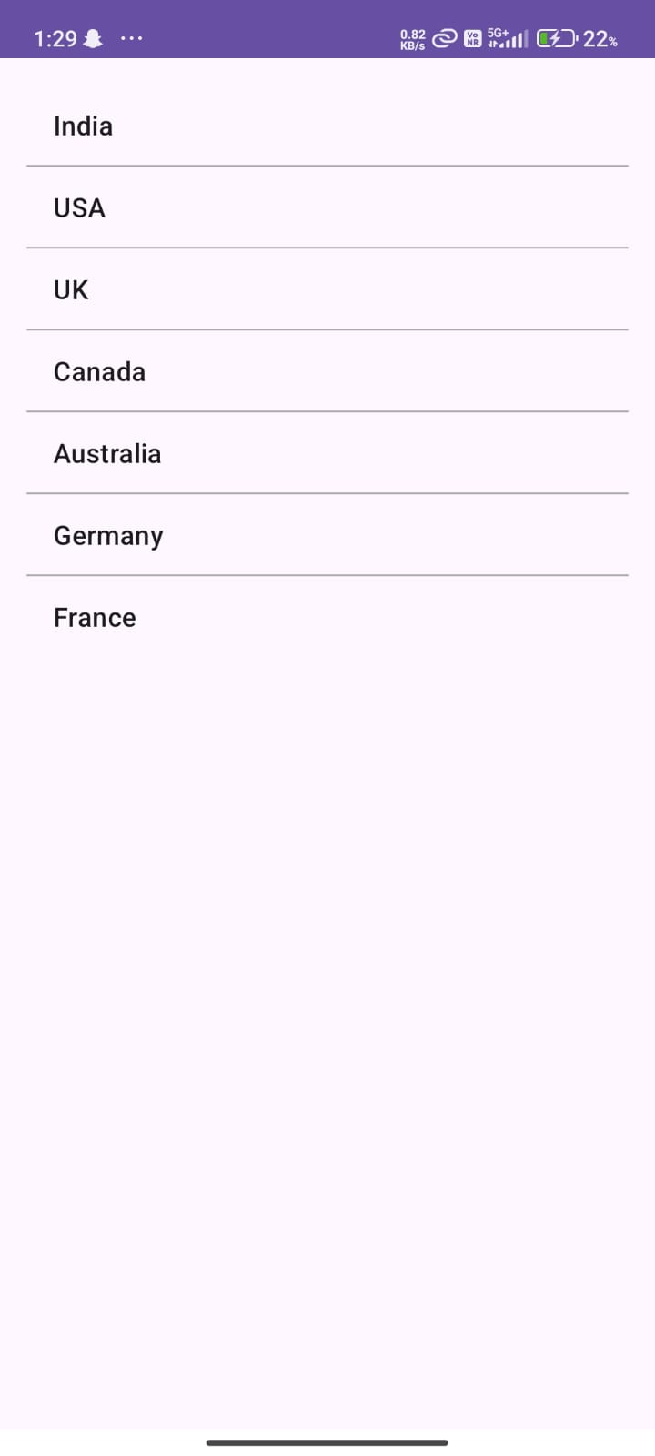

- Write a program to implement Custom ListView.

Activity_main.xml

<?xml version="1.0" encoding="utf-8"?>
<LinearLayout
xmlns:android="http://schemas.android.com/apk/res/android"
android:layout_width="match_parent"
android:layout_height="match_parent"
android:orientation="vertical">

<ListView
android:id="@+id/listView"
android:layout_width="match_parent"
android:layout_height="match_parent"/>
</LinearLayout>
List_item.xml
<?xml version="1.0" encoding="utf-8"?>
<LinearLayout
xmlns:android="http://schemas.android.com/apk/res/android"
android:orientation="horizontal"
android:padding="10dp"
android:layout_width="match_parent"
android:layout_height="wrap_content">

<ImageView
android:id="@+id/icon"
android:layout_width="50dp"
android:layout_height="50dp"
android:layout_marginEnd="10dp" />

<LinearLayout
android:orientation="vertical"
android:layout_width="wrap_content"
android:layout_height="wrap_content">

<TextView
android:id="@+id/title"
android:textSize="18sp"
android:textStyle="bold"
android:layout_width="wrap_content"
android:layout_height="wrap_content" />

<TextView
android:id="@+id/subtitle"
android:textSize="14sp"
android:textColor="#777"
android:layout_width="wrap_content"
android:layout_height="wrap_content" />
</LinearLayout>
</LinearLayout>

MainActivity.java

public class MainActivity extends AppCompatActivity {

ListView listView;

String[] titles = {
"INSTAGRAM","PINTEREST","TWITTER","YOUTUBE","FACEBOOK"
};

String[] subtitles = {
"Connect with people",
"Watch & upload videos",
"Stay in touch",
"Discover ideas",
"Share photos"
};

int[] images = {
R.drawable.facebook,
R.drawable.instagram,
R.drawable.pinterest,
R.drawable.twitter,
R.drawable.youtube,
};

@Override
protected void onCreate(Bundle savedInstanceState) {
super.onCreate(savedInstanceState);
setContentView(R.layout.activity_main);

listView = findViewById(R.id.listView);

CustomAdapter adapter = new CustomAdapter(this, titles, subtitles, images);
listView.setAdapter(adapter);
}
}

CustomAdaapter.java

public class CustomAdapter extends ArrayAdapter<String> {

private final Activity context;
private final String[] titles;
private final String[] subtitles;
private final int[] images;

public CustomAdapter(Activity context, String[] titles, String[] subtitles, int[] images) {
super(context, R.layout.list_item, titles);
this.context = context;
this.titles = titles;
this.subtitles = subtitles;
this.images = images;
}

public View getView(int position, View view, ViewGroup parent) {
LayoutInflater inflater = context.getLayoutInflater();
View rowView = inflater.inflate(R.layout.list_item, null, true);

TextView titleText = rowView.findViewById(R.id.title);
TextView subtitleText = rowView.findViewById(R.id.subtitle);
ImageView imageView = rowView.findViewById(R.id.icon);

titleText.setText(titles[position]);
subtitleText.setText(subtitles[position]);
imageView.setImageResource(images[position]);

return rowView;
}
}

Output:

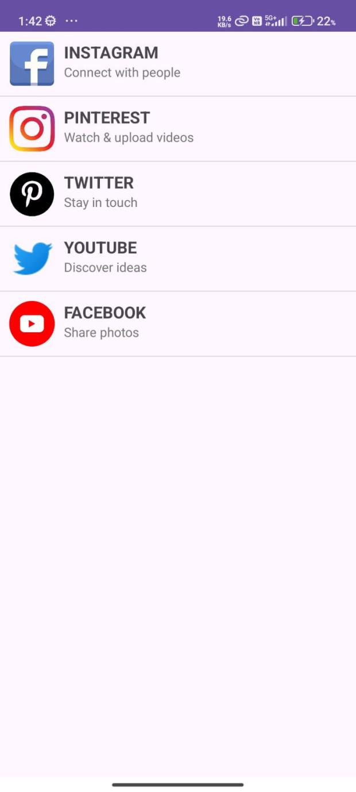

- Write a program to implement Dynamic RadioButton.

MainActivity.java

public class MainActivity extends AppCompatActivity {

@Override
protected void onCreate(Bundle savedInstanceState) {
super.onCreate(savedInstanceState);
EdgeToEdge.enable(this);
setContentView(R.layout.activity_main);
ViewCompat.setOnApplyWindowInsetsListener(findViewById(R.id.main), (v, insets) -> {
Insets systemBars = insets.getInsets(WindowInsetsCompat.Type.systemBars());
v.setPadding(systemBars.left, systemBars.top, systemBars.right, systemBars.bottom);
return insets;
});

RadioButton r1,r2;
RadioGroup rg;
LinearLayout rl;

r1 = new RadioButton(this);
r2 = new RadioButton(this);
rg = new RadioGroup(this);
rl = findViewById(R.id.main);

r1.setText("Male");
r2.setText("Female");
rg.addView(r1);
rg.addView(r2);
rg.setOrientation(LinearLayout.HORIZONTAL);

LinearLayout.LayoutParams params = new LinearLayout.LayoutParams(LinearLayout.LayoutParams.WRAP_CONTENT, LinearLayout.LayoutParams.WRAP_CONTENT);
rg.setLayoutParams(params);

rl.addView(rg);

}
}
Output:

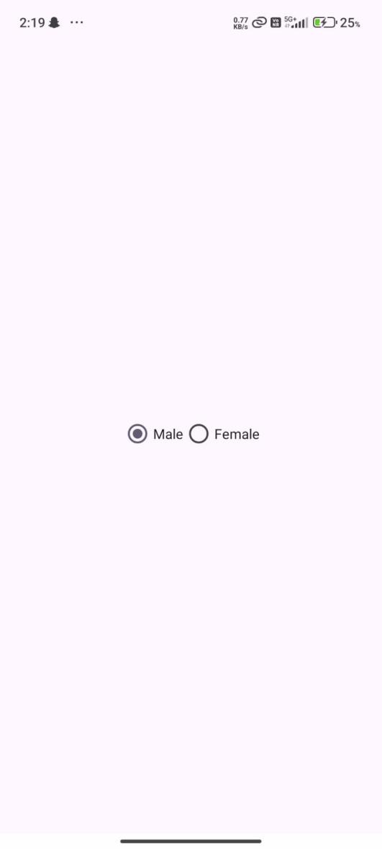

- Write a program to implement RatingBar.
Activity_main.xml

<?xml version="1.0" encoding="utf-8"?>
<LinearLayout xmlns:android="http://schemas.android.com/apk/res/android"
xmlns:app="http://schemas.android.com/apk/res-auto"
xmlns:tools="http://schemas.android.com/tools"
android:id="@+id/main"
android:layout_width="match_parent"
android:layout_height="match_parent"
tools:context=".AndroidRatingBar"
android:orientation="vertical"
android:gravity="center">

<RatingBar
android:id="@+id/ratingBar"
android:layout_width="wrap_content"
android:layout_height="wrap_content"
tools:layout_editor_absoluteX="89dp"
tools:layout_editor_absoluteY="89dp" />

<Button
android:id="@+id/button"
android:layout_width="wrap_content"
android:layout_height="wrap_content"
android:text="Click Me"
android:onClick="showRating"/>
</LinearLayout>

MainActivity.java

public class AndroidRatingBar extends AppCompatActivity {

RatingBar rb;

@SuppressLint("MissingInflatedId")
@Override
protected void onCreate(Bundle savedInstanceState) {
super.onCreate(savedInstanceState);
EdgeToEdge.enable(this);
setContentView(R.layout.activity_android_rating_bar);
ViewCompat.setOnApplyWindowInsetsListener(findViewById(R.id.main), (v, insets) -> {
Insets systemBars = insets.getInsets(WindowInsetsCompat.Type.systemBars());
v.setPadding(systemBars.left, systemBars.top, systemBars.right, systemBars.bottom);
return insets;
});

rb = findViewById(R.id.ratingBar);
}

public void showRating(View view){
Toast.makeText(getApplicationContext(), ""+rb.getRating(), Toast.LENGTH_LONG).show();
}
}

Output:

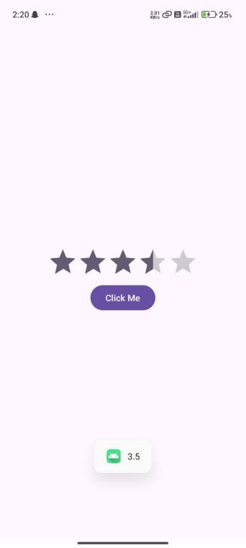

- Write a program to implement Android WebView.

AndroidMenifest.xml

<manifest xmlns:android="http://schemas.android.com/apk/res/android"
xmlns:tools="http://schemas.android.com/tools">

<uses-permission android:name="android.permission.INTERNET" />

<application
android:allowBackup="true"
android:dataExtractionRules="@xml/data_extraction_rules"
android:fullBackupContent="@xml/backup_rules"
android:icon="@mipmap/ic_launcher"
android:label="@string/app_name"
android:roundIcon="@mipmap/ic_launcher_round"
android:supportsRtl="true"
android:theme="@style/Theme.MyApplication"
tools:targetApi="31">
<activity
android:name=".AndroidWebView"
android:exported="true">
<intent-filter>
<action android:name="android.intent.action.MAIN" />

<category android:name="android.intent.category.LAUNCHER" />
</intent-filter>
</activity>
</menifest>

Activity_main.xml

<?xml version="1.0" encoding="utf-8"?>
<LinearLayout xmlns:android="http://schemas.android.com/apk/res/android"
xmlns:app="http://schemas.android.com/apk/res-auto"
xmlns:tools="http://schemas.android.com/tools"
android:id="@+id/main"
android:layout_width="match_parent"
android:layout_height="match_parent"
tools:context=".AndroidW"
android:orientation="vertical"
android:gravity="center">

<EditText
android:id="@+id/urlEditText"
android:layout_width="match_parent"
android:layout_height="wrap_content"
android:hint="Enter URL (e.g. google.com)"
android:inputType="textUri"/>

<Button
android:id="@+id/loadButton"
android:layout_width="wrap_content"
android:layout_height="wrap_content"
android:text="Load Website" />

<WebView
android:id="@+id/webView"
android:layout_width="match_parent"
android:layout_height="0dp"
android:layout_weight="1" />

</LinearLayout>

MainActivity.java

public class AndroidWebView extends AppCompatActivity {

EditText urlEditText;
Button loadButton;
WebView webView;

@Override
protected void onCreate(Bundle savedInstanceState) {
super.onCreate(savedInstanceState);
setContentView(R.layout.activity_android_web_view);

urlEditText = findViewById(R.id.urlEditText);
loadButton = findViewById(R.id.loadButton);
webView = findViewById(R.id.webView);

// Enable JavaScript and settings
WebSettings webSettings = webView.getSettings();
webSettings.setJavaScriptEnabled(true);

// Ensure links open in WebView
webView.setWebViewClient(new WebViewClient());

loadButton.setOnClickListener(new View.OnClickListener() {
@Override
public void onClick(View view) {
String url = urlEditText.getText().toString().trim();

// Add "https://" if not already present
if (!url.startsWith("http://") && !url.startsWith("https://")) {
url = "https://" + url;
}

webView.loadUrl(url);
}
});
}
}

Output:

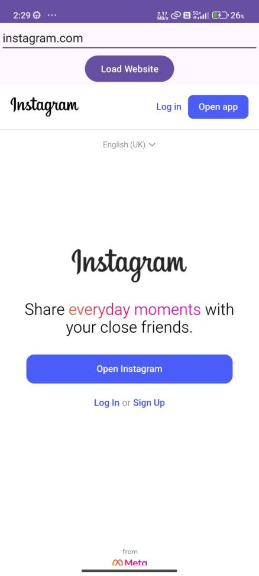

- Write a program to implement SeekBa.

Activity_main.xml

<?xml version="1.0" encoding="utf-8"?>
<LinearLayout xmlns:android="http://schemas.android.com/apk/res/android"
xmlns:app="http://schemas.android.com/apk/res-auto"
xmlns:tools="http://schemas.android.com/tools"
android:id="@+id/main"
android:layout_width="match_parent"
android:layout_height="match_parent"
tools:context=".AndroidSeekBar"
android:orientation="vertical"
android:gravity="center">

<SeekBar
android:layout_width="match_parent"
android:layout_height="wrap_content"
android:id="@+id/seekBar" />

<TextView
android:layout_width="wrap_content"
android:layout_height="wrap_content"
android:id="@+id/textView" />

<TextView
android:layout_width="wrap_content"
android:layout_height="wrap_content"
android:id="@+id/progress" />

</LinearLayout>
MainActivity.java

public class AndroidSeekBar extends AppCompatActivity {

SeekBar sb;
TextView tv, progress;
@SuppressLint("MissingInflatedId")
@Override
protected void onCreate(Bundle savedInstanceState) {
super.onCreate(savedInstanceState);
EdgeToEdge.enable(this);
setContentView(R.layout.activity_android_seek_bar);
ViewCompat.setOnApplyWindowInsetsListener(findViewById(R.id.main), (v, insets) -> {
Insets systemBars = insets.getInsets(WindowInsetsCompat.Type.systemBars());
v.setPadding(systemBars.left, systemBars.top, systemBars.right, systemBars.bottom);
return insets;
});

sb = findViewById(R.id.seekBar);
tv = findViewById(R.id.textView);
progress = findViewById(R.id.progress);

sb.setOnSeekBarChangeListener(new SeekBar.OnSeekBarChangeListener() {
@Override
public void onProgressChanged(SeekBar seekBar, int i, boolean b) {
progress.setText(""+i);
}

@Override
public void onStartTrackingTouch(SeekBar seekBar) {
tv.setText("Tracking Started");
}

@Override
public void onStopTrackingTouch(SeekBar seekBar) {
tv.setText("Tracking Stopped");
}
});
}
}

Output:

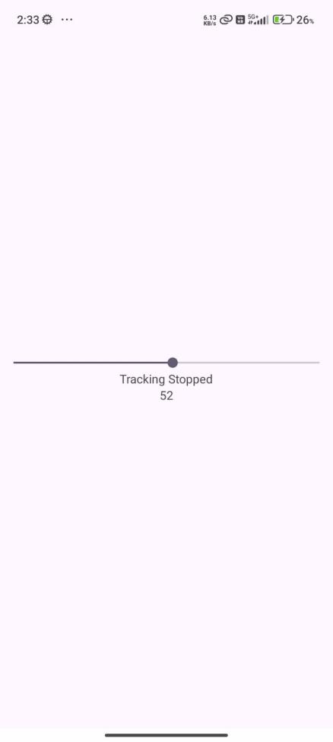

- Write a program to implement DatePicker.

Activity_main.java

<?xml version="1.0" encoding="utf-8"?>
<LinearLayout xmlns:android="http://schemas.android.com/apk/res/android"
xmlns:app="http://schemas.android.com/apk/res-auto"
xmlns:tools="http://schemas.android.com/tools"
android:id="@+id/main"
android:layout_width="match_parent"
android:layout_height="match_parent"
tools:context=".AndroidDatePicker"
android:orientation="vertical"
android:gravity="center">

<DatePicker
android:layout_width="match_parent"
android:layout_height="wrap_content"
android:id="@+id/datePicker" />

<TextView
android:layout_width="wrap_content"
android:layout_height="wrap_content"
android:id="@+id/showdate" />

<Button
android:layout_width="wrap_content"
android:layout_height="wrap_content"
android:id="@+id/button"
android:text="Click Me"
android:onClick="showDate"/>

</LinearLayout>

MainActivity.java

public class AndroidDatePicker extends AppCompatActivity {

DatePicker dp;
TextView show;

@SuppressLint("MissingInflatedId")
@Override
protected void onCreate(Bundle savedInstanceState) {
super.onCreate(savedInstanceState);
EdgeToEdge.enable(this);
setContentView(R.layout.activity_android_date_picker);
ViewCompat.setOnApplyWindowInsetsListener(findViewById(R.id.main), (v, insets) -> {
Insets systemBars = insets.getInsets(WindowInsetsCompat.Type.systemBars());
v.setPadding(systemBars.left, systemBars.top, systemBars.right, systemBars.bottom);
return insets;
});

dp = findViewById(R.id.datePicker);
show = findViewById(R.id.showdate);

show.setText("Current Date: " + getCurrentDate());
}

public void showDate(View view){
show.setText("Selected date: "+getCurrentDate());
}

public String getCurrentDate(){
return ""+dp.getDayOfMonth()+"/"+(dp.getMonth()+1)+"/"+dp.getYear();
}
}

Output:

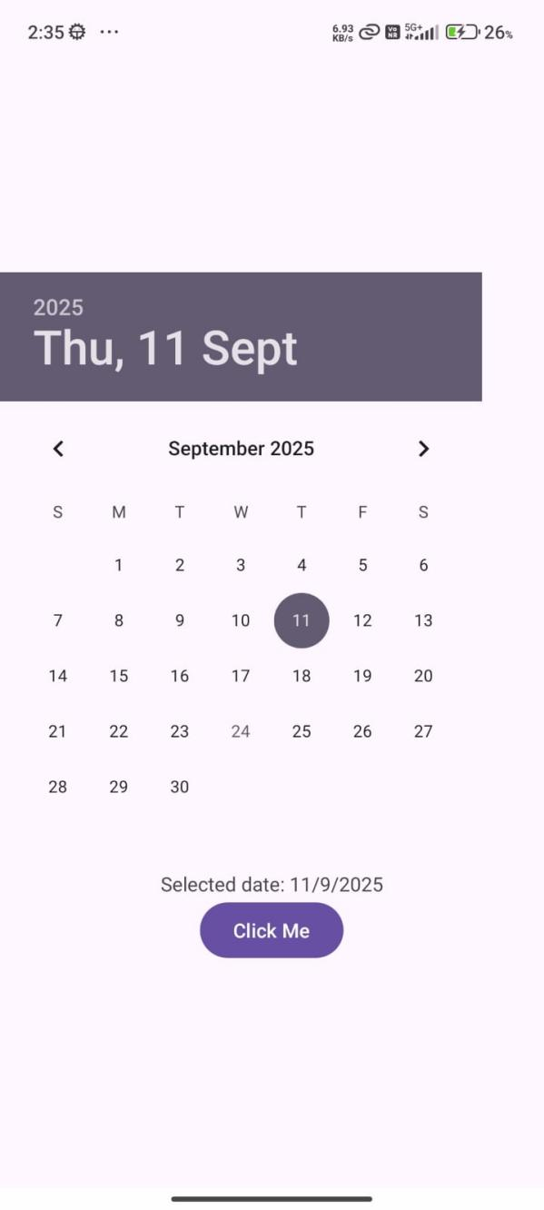

- Write a program to implement TimePicke.

Activity_main.xml

<?xml version="1.0" encoding="utf-8"?>
<LinearLayout xmlns:android="http://schemas.android.com/apk/res/android"
xmlns:app="http://schemas.android.com/apk/res-auto"
xmlns:tools="http://schemas.android.com/tools"
android:id="@+id/main"
android:layout_width="match_parent"
android:layout_height="match_parent"
tools:context=".AndroidTimePicker"
android:gravity="center"
android:orientation="vertical">

<TimePicker
android:layout_width="wrap_content"
android:layout_height="wrap_content"
android:id="@+id/timePicker"/>

<TextView
android:layout_width="wrap_content"
android:layout_height="wrap_content"
android:id="@+id/showtime" />

<Button
android:layout_width="wrap_content"
android:layout_height="wrap_content"
android:text="Click Me"
android:onClick="showTime" />

</LinearLayout>
MainActivity.java

public class AndroidTimePicker extends AppCompatActivity {

TimePicker tp;
TextView show;

@Override
protected void onCreate(Bundle savedInstanceState) {
super.onCreate(savedInstanceState);
EdgeToEdge.enable(this);
setContentView(R.layout.activity_android_time_picker);
ViewCompat.setOnApplyWindowInsetsListener(findViewById(R.id.main), (v, insets) -> {
Insets systemBars = insets.getInsets(WindowInsetsCompat.Type.systemBars());
v.setPadding(systemBars.left, systemBars.top, systemBars.right, systemBars.bottom);
return insets;
});

tp = findViewById(R.id.timePicker);
show = findViewById(R.id.showtime);

tp.setIs24HourView(true);

show.setText("Current Time: "+getCurrentTime());
}

public void showTime(View view){
show.setText("Selected Time: "+getCurrentTime());
}

public String getCurrentTime(){
return ""+tp.getHour()+":"+tp.getMinute();
}
}

Output:

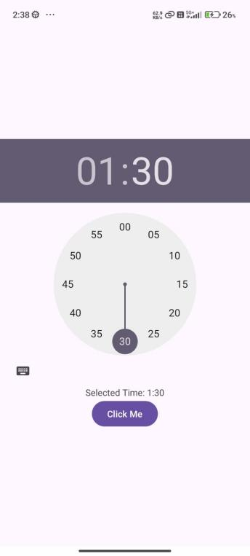

- Write a program to implement AnalogClock and DigitalClock.

Activity_main.xml

<?xml version="1.0" encoding="utf-8"?>
<LinearLayout xmlns:android="http://schemas.android.com/apk/res/android"
xmlns:app="http://schemas.android.com/apk/res-auto"
xmlns:tools="http://schemas.android.com/tools"
android:id="@+id/main"
android:layout_width="match_parent"
android:layout_height="match_parent"
tools:context=".AndroidDigitalAnalogClock"
android:gravity="center"
android:orientation="vertical">

<DigitalClock
android:layout_width="wrap_content"
android:layout_height="wrap_content"/>

<AnalogClock
android:layout_width="wrap_content"
android:layout_height="wrap_content"/>

</LinearLayout>

Output:

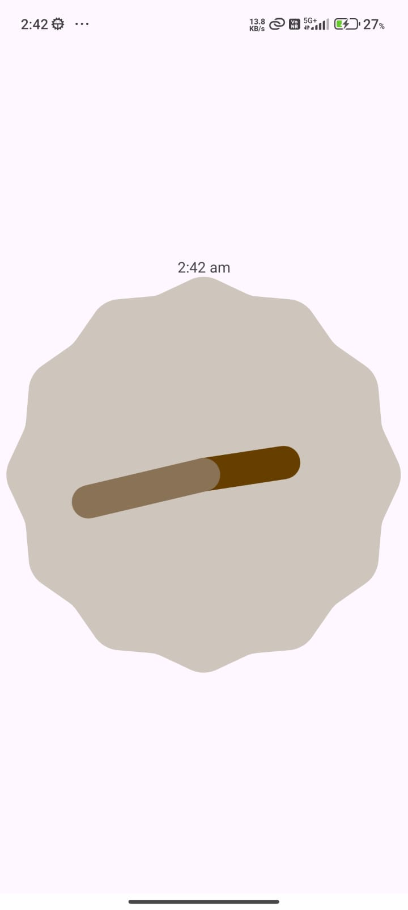

- Write a program to implement ProgressBar.

MainActivity.java

public class AndroidProgressBar extends AppCompatActivity {

@Override
protected void onCreate(Bundle savedInstanceState) {
super.onCreate(savedInstanceState);
EdgeToEdge.enable(this);
setContentView(R.layout.activity_android_progress_bar);
ViewCompat.setOnApplyWindowInsetsListener(findViewById(R.id.main), (v, insets) -> {
Insets systemBars = insets.getInsets(WindowInsetsCompat.Type.systemBars());
v.setPadding(systemBars.left, systemBars.top, systemBars.right, systemBars.bottom);
return insets;
});

ProgressDialog pg = new ProgressDialog(this);
pg.setCancelable(true);
pg.setProgressStyle(ProgressDialog.STYLE_HORIZONTAL);
pg.setMessage("Downloading");
pg.setProgress(0);
pg.setMax(100);
pg.show();
}
}

Output:

- Write a program to implement ScrollView.

Activity_main.xml

<?xml version="1.0" encoding="utf-8"?>
<ScrollView xmlns:android="http://schemas.android.com/apk/res/android"
xmlns:app="http://schemas.android.com/apk/res-auto"
xmlns:tools="http://schemas.android.com/tools"
android:id="@+id/main"
android:layout_width="match_parent"
android:layout_height="match_parent"
tools:context=".AndroidScrollView">

<LinearLayout
android:layout_width="match_parent"
android:layout_height="match_parent"
android:orientation="vertical"
android:gravity="center"
>

<DatePicker
android:layout_width="wrap_content"
android:layout_height="wrap_content"/>

<Button
android:layout_width="match_parent"
android:layout_height="wrap_content"
android:text="Button"/>
<Button
android:layout_width="match_parent"
android:layout_height="wrap_content"
android:text="Button"/>
<Button
android:layout_width="match_parent"
android:layout_height="wrap_content"
android:text="Button"/>
<Button
android:layout_width="match_parent"
android:layout_height="wrap_content"
android:text="Button"/>
<Button
android:layout_width="match_parent"
android:layout_height="wrap_content"
android:text="Button"/>
<Button
android:layout_width="match_parent"
android:layout_height="wrap_content"
android:text="Button"/>
<Button
android:layout_width="match_parent"
android:layout_height="wrap_content"
android:text="Button"/>
<Button
android:layout_width="match_parent"
android:layout_height="wrap_content"
android:text="Button"/>
<Button
android:layout_width="match_parent"
android:layout_height="wrap_content"
android:text="Button"/>
<Button
android:layout_width="match_parent"
android:layout_height="wrap_content"
android:text="Button"/>
<Button
android:layout_width="match_parent"
android:layout_height="wrap_content"
android:text="Button"/>
<Button
android:layout_width="match_parent"
android:layout_height="wrap_content"
android:text="Button"/>
<Button
android:layout_width="match_parent"
android:layout_height="wrap_content"
android:text="Button"/>

</LinearLayout>

</ScrollView>

Output:
