**Ex No : 3 Implementation of SOAP Web Service**

**Date :**

**Aim:**

To implement a SOAP web service using Eclipse IDE and test it.

**Procedure:**

1. Install Eclipse IDE on the machine.
2. Save the java files in a folder.
3. Create a SOAP web service and publish it in a specific port.
4. Make sure that the port is unused.
5. Run the command netstat –ano | findstr :8080 to display the port status.
6. Kill the process running on the port.
7. Test the web service.

**Code:**

Names.java

**package** cloud;

**public** **interface** name {

**public** **void** getSum(**int** no1 , **int** no2);

}

Displaynames.java

**package** cloud;

**import** cloud.displayname;

**public** **class** displayname **implements** name {

**public** **void** getSum(**int** no1, **int** no2) {

System.***out***.println("The sum of two numbers is"+(no1+no2));

}

**public** **static** **void** main(String args[]){

displayname ex=**new** displayname();

ex.getSum(15, 15);

}

}

**Screenshots:**

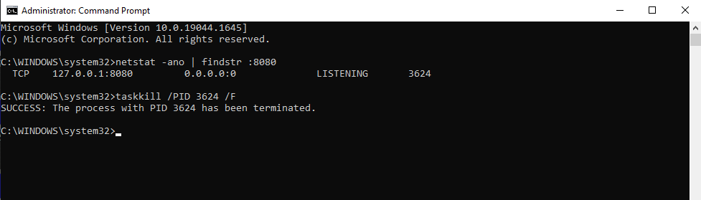

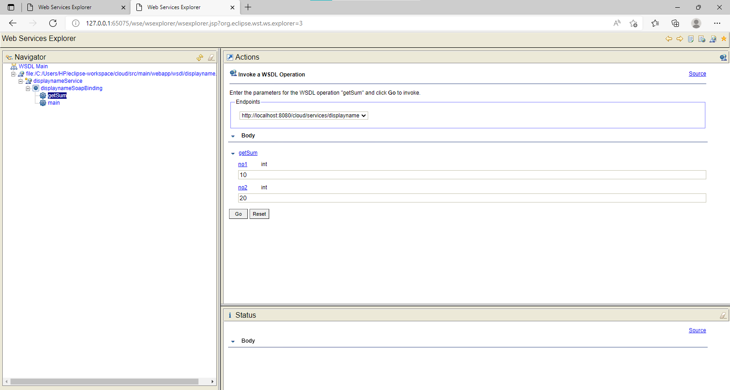

**Result:**

The experiment is completed and the result is verified.