Blood Spatter Analysis
In this project we are classifying and interpreting different types of blood stain such as Spatter, Drip and Transfer Pattern. This classification and interpretation will help in know and reconstructing crime scenes such as Weapon used, size or shape of blood stain and type.
For classification and interpretation we are using CNN deep learning algorithm and this algorithm will take input image and then classify blood stain type.
To train deep learning algorithm we are using below types of images
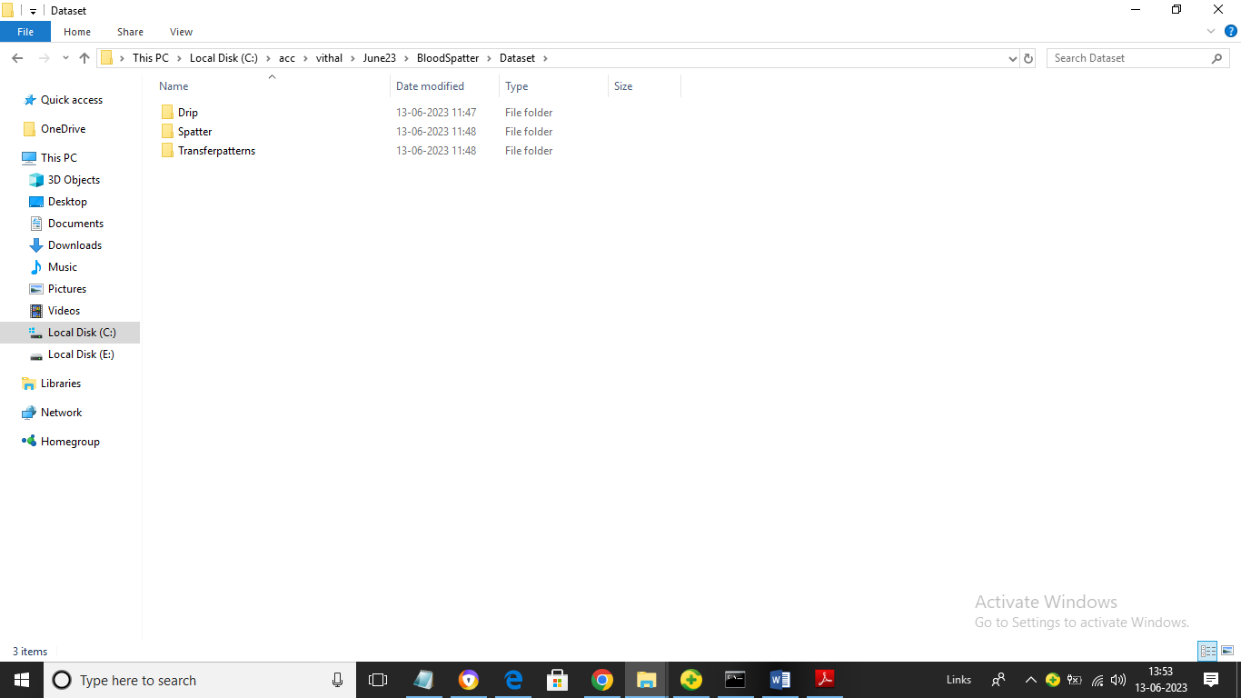
In above screen we have 3 different types of blood stain folders and just go inside any folder to view training images like below screen
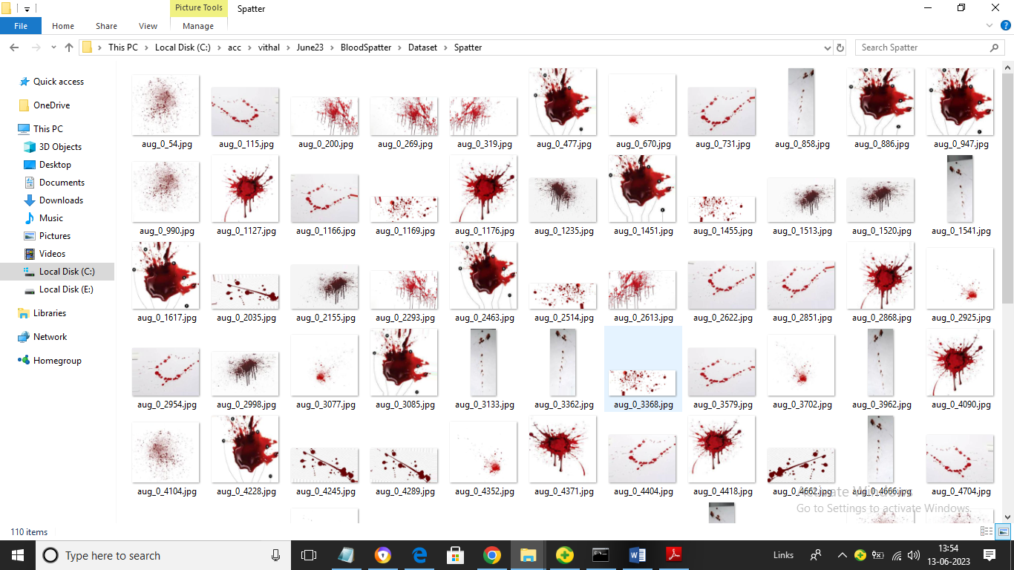
So by using above images we will train algorithm to classify blood stain type. We have coded this project using JUPYTER notebook and below are the code and output screens with blue colour comments
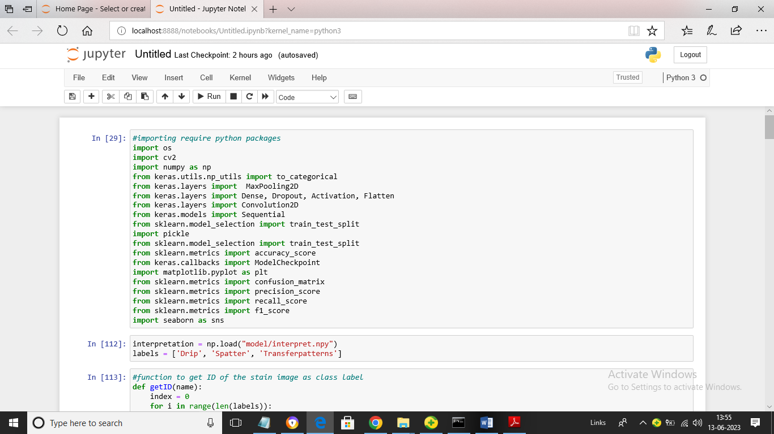
In above screen we are loading require python classes and packages
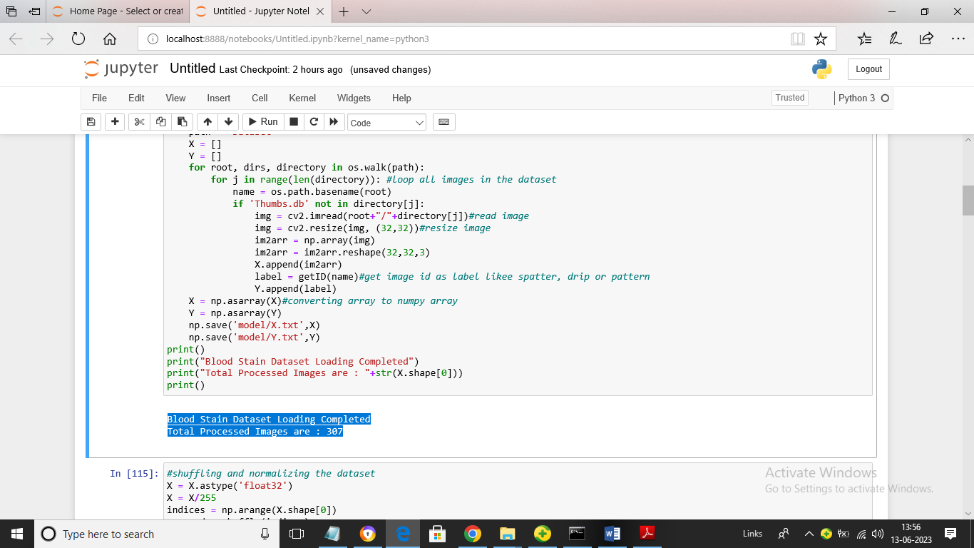
In above screen we are looping entire dataset folder to read all types of images and then in blue colour we can see output of total images loaded
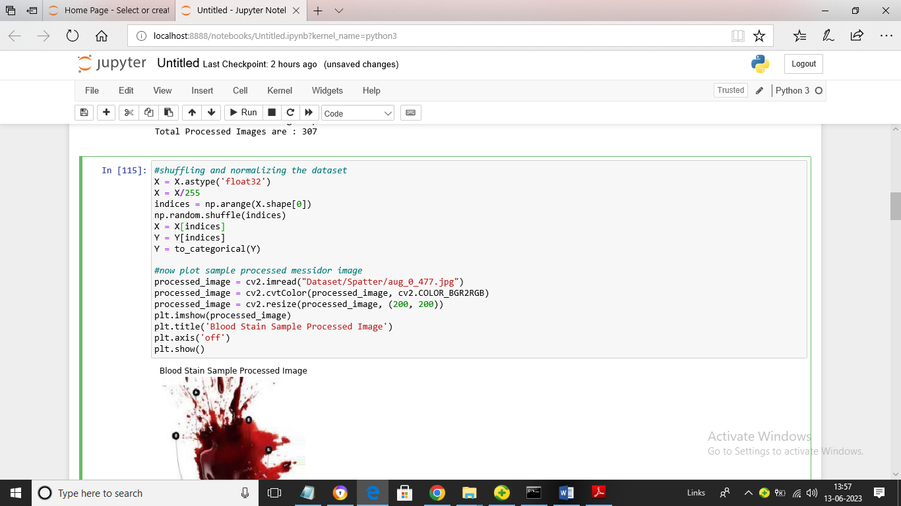
In above screen we are processing images by using shuffling, normalizing techniques and then displaying processed images
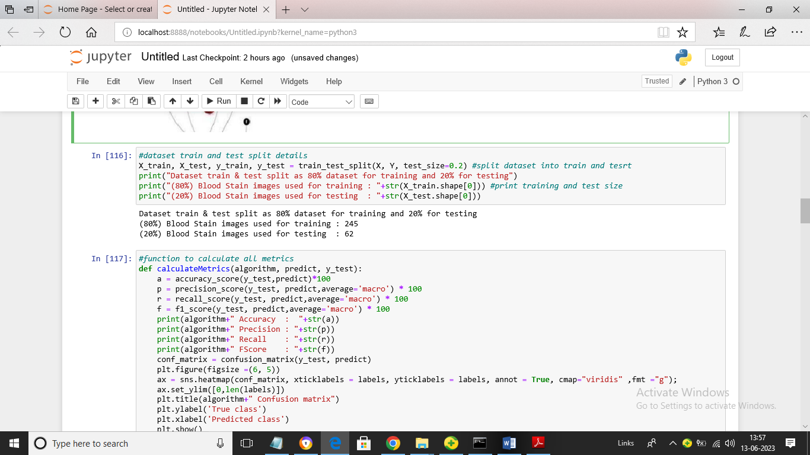
In above screen we are splitting dataset into train and test where application using 80% dataset for training and 20% for testing and then defining function to calculate prediction accuracy of CNN algorithm for blood stain dataset
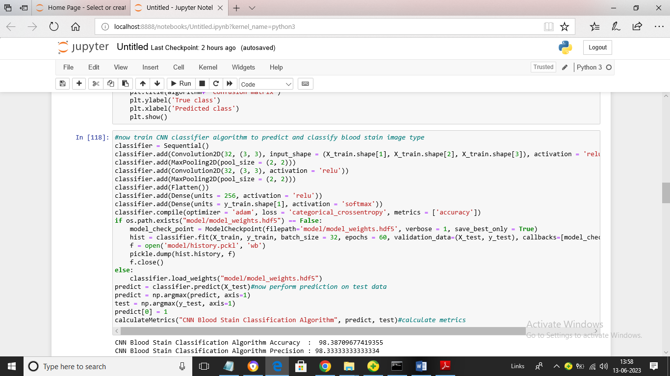
In above screen we are training CNN algorithm on given X_train data and then testing on X_test data and after training will get below output
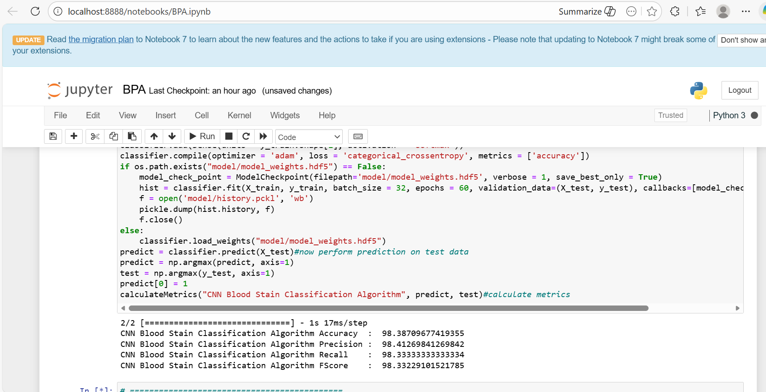
In above screen CNN algorithm got 98% blood stain classification accuracy and we can see other metrics like precision, recall and FSCORE.
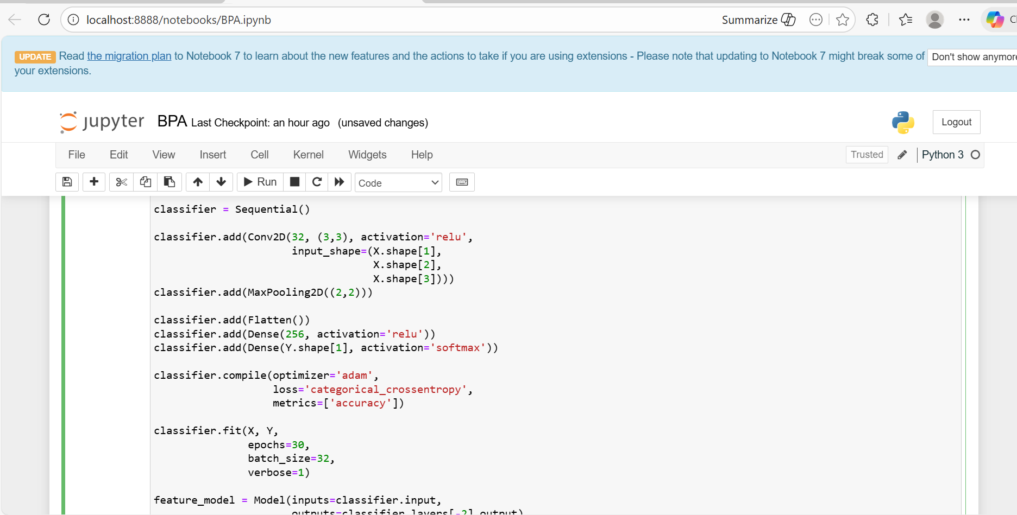
In above screen we are training Hybrid CNN + SVM algorithm on given X_train data and then testing on X_test data and after training will get below output
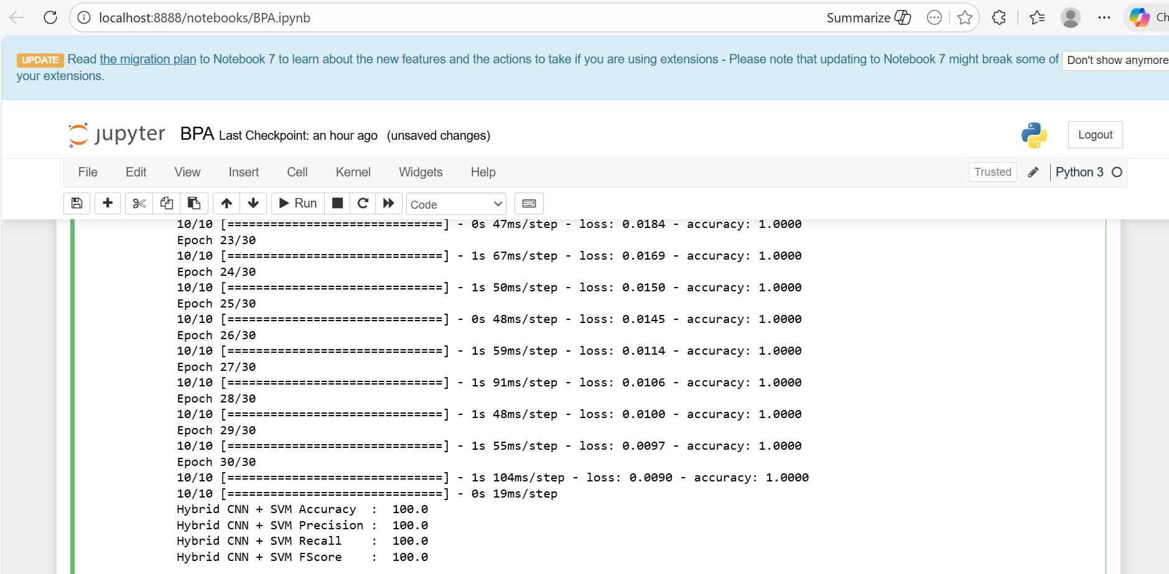
In above screen Hybrid CNN + SVM algorithm got 100% blood stain classification accuracy and we can see other metrics like precision, recall and FSCORE.
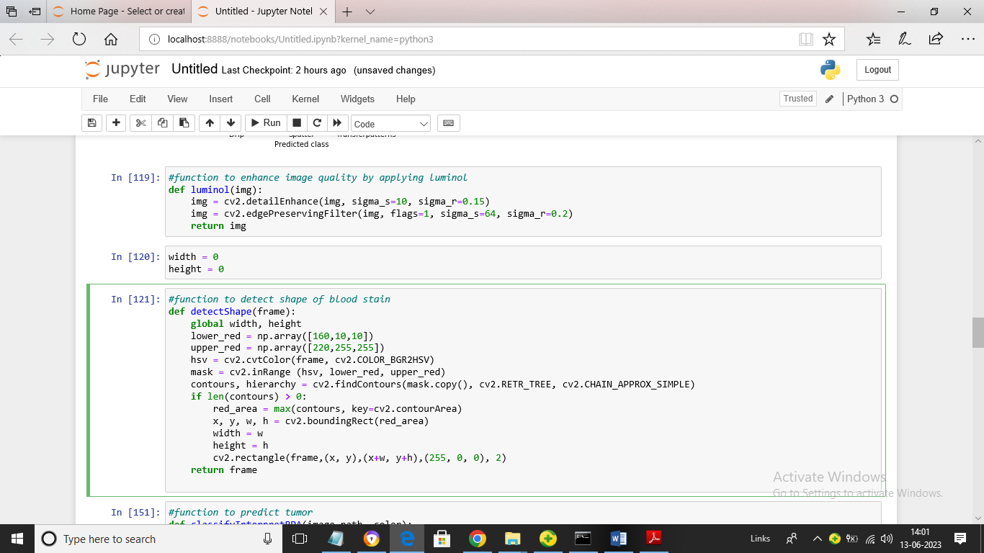
In above screen we are defining function to enhance images using LUMINOL technique and then defining function to detect blood stain shape or size
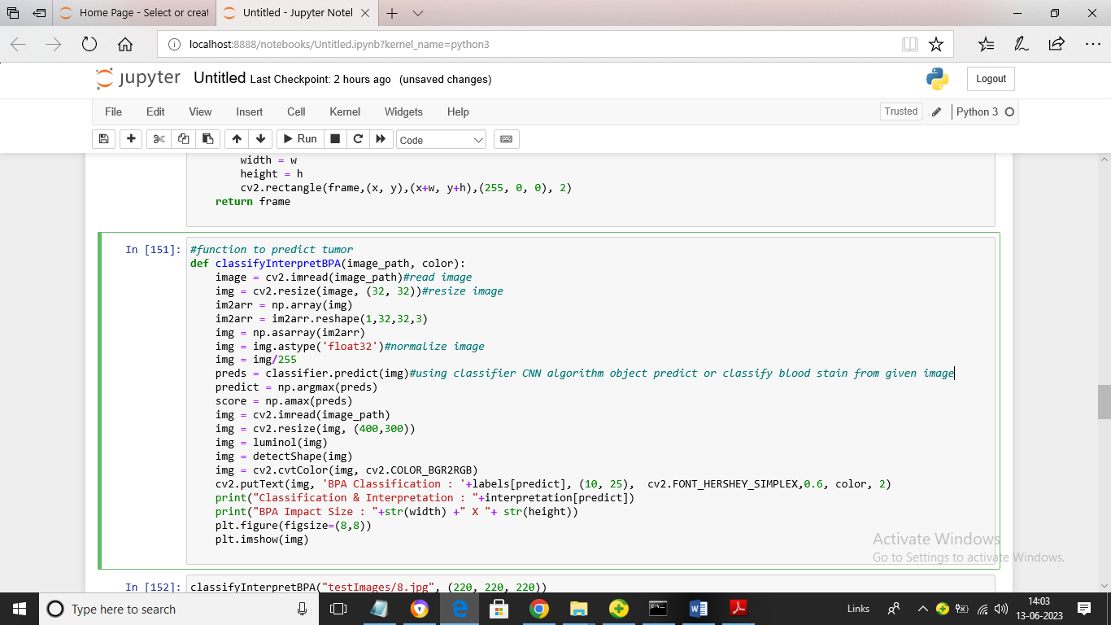
In above screen defining function to classify blood stain from given input image path
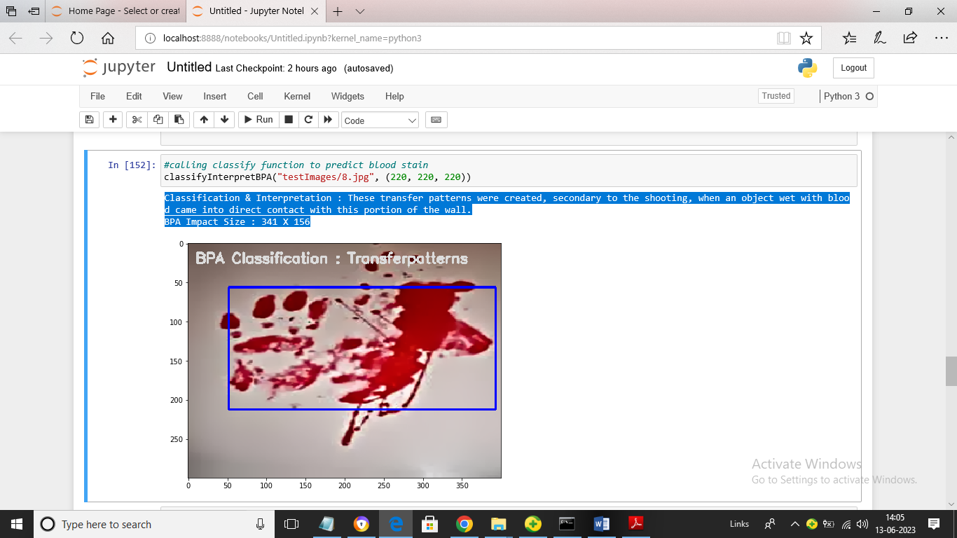
In above screen by calling classify function we got blood stain classified as “transfer Pattern’ and in blue colour text we can see interpretation result as Weapon used with complete details and size of blood stain. Blue box represents detection of blood stain
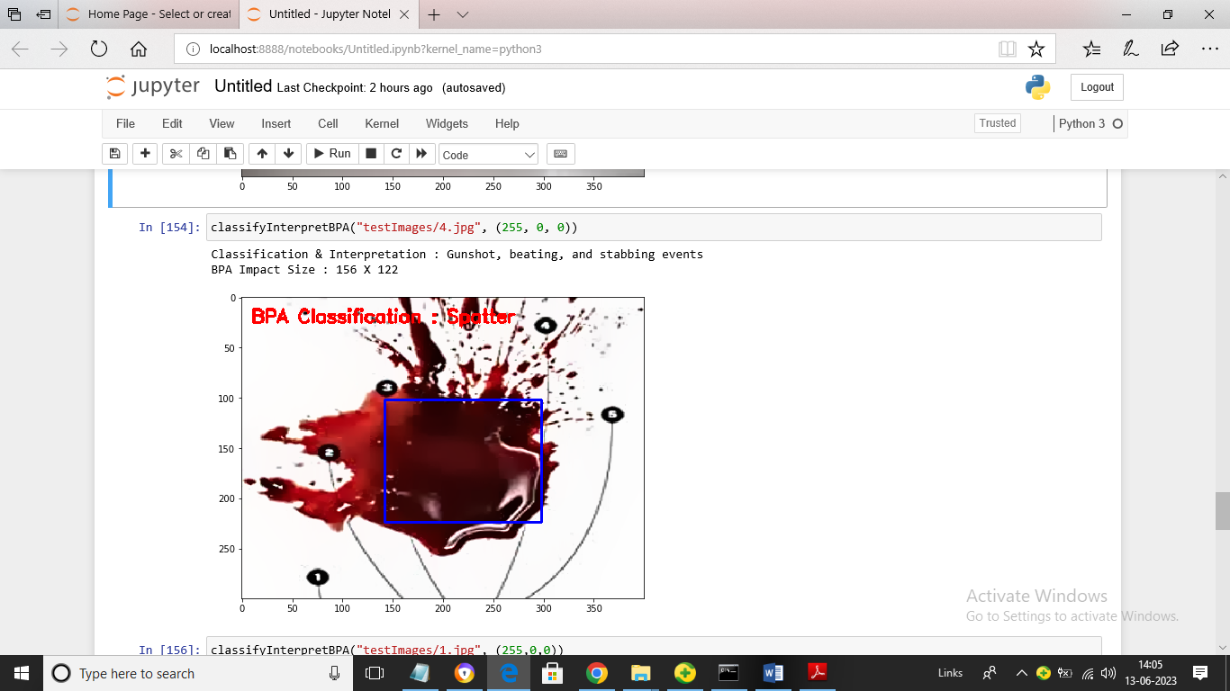
In above screen given image is classified as ‘Spatter’
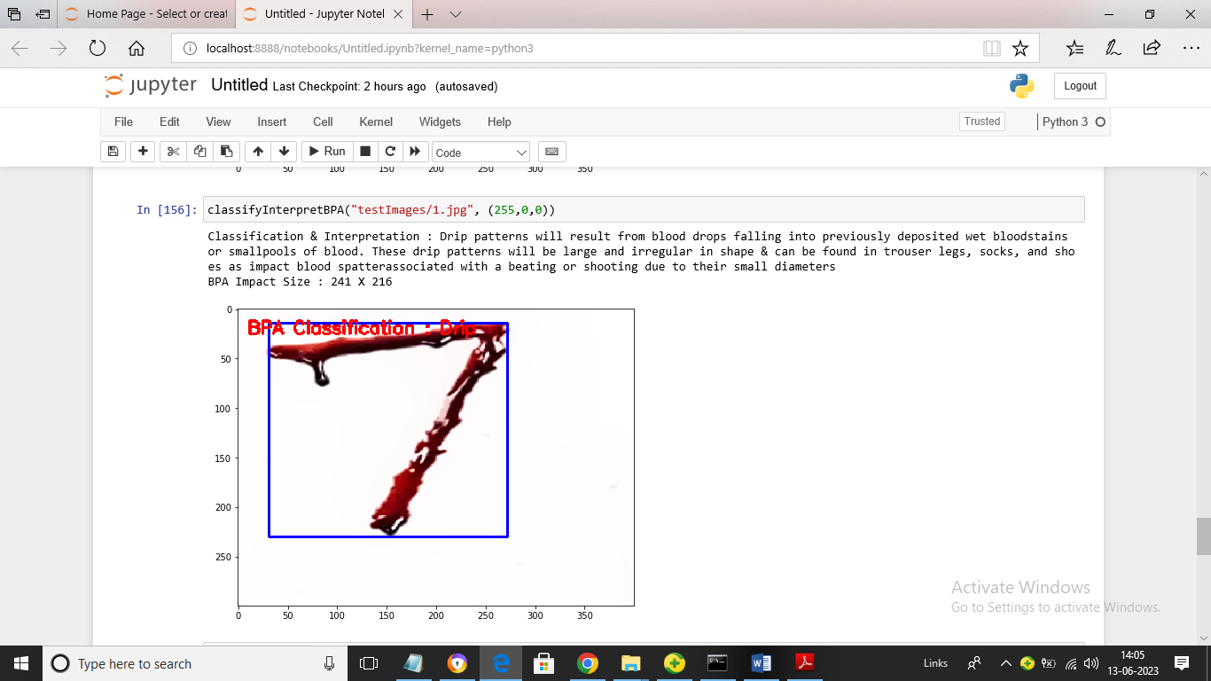
In above screen given image is classified as Drip and we can read interpretation result also for classified stain
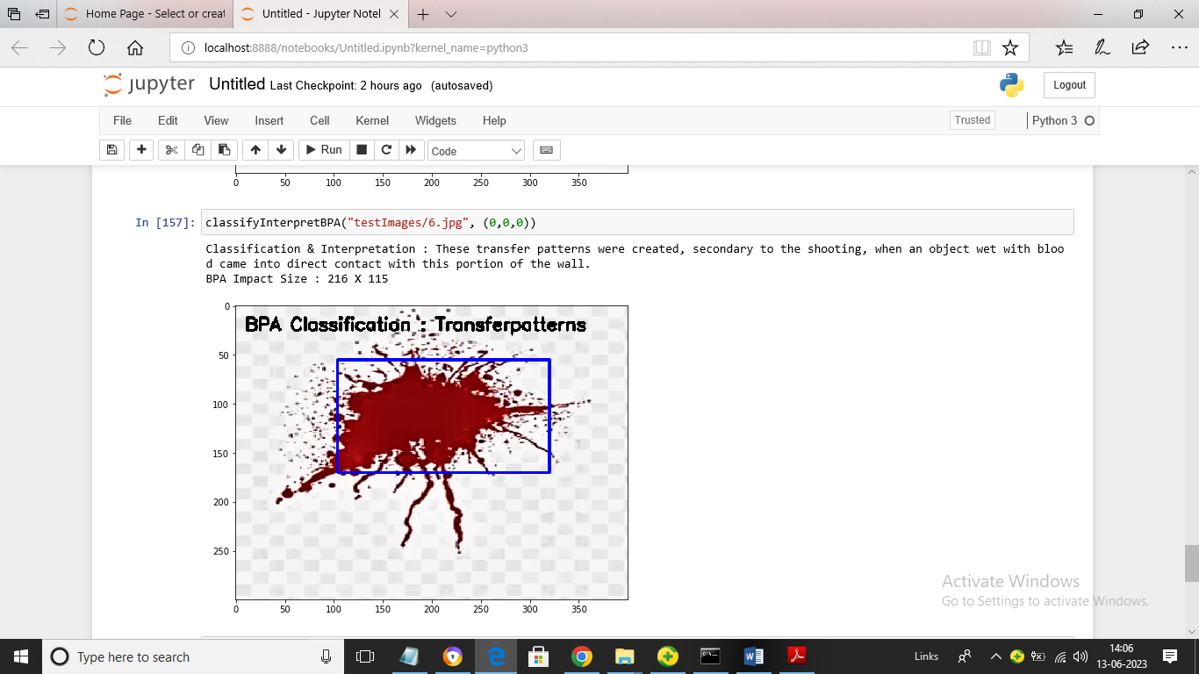
In above screen given image classified as ‘Transfer Pattern’. Similarly by giving input image we can get classification and interpretation output

