SIMULATIO AND MODELLING LAB – MC2130

2023 - 24

# DEPARTMENT OF MECHATRONICS ENGINEERING

**SCHOOL OF AUTOMOBILE, MECHANICAL AND MECHATRONICS ENGINEERING**



# Simulation and Modelling Lab Course Code: MC2130

**LAB MANUAL**

# Third Semester

SIMULATIO AND MODELLING LAB – MC2130

2023 - 24

|  |  |  |  |  |  |  |  |  |  |  |  |  |  |  |  |
| --- | --- | --- | --- | --- | --- | --- | --- | --- | --- | --- | --- | --- | --- | --- | --- |
|  | | **Mechatronics Engineering Department, Manipal University Jaipur LAB CONTENT & VALUATION REPORT** | | | | | | | | | | | | | |
|  | | **Name of Laboratory :** SIMULATION AND MODELLING | | | | | | | | | | | | | **Lab code : MC2130** |
| **Student Name :** | | | | | **Reg. No.:** | | | | | **Batch :** | | | | | **Group no.** |
| **Exp**  **.**  **No.** | **Exp. Name** | | | | **Pag e No.** | **Date of allotment** | **Date of performanc e** | **Attendance (01)** | | | **Recor d (03)** | **Perfor**  **.* (03)** | **Viva (03)** | **Tot al (10)** | **Teacher remark** |
| 01 |  | | | |  |  |  |  | | |  |  |  |  |  |
| 02 |  | | | |  |  |  |  | | |  |  |  |  |  |
| 03 |  | | | |  |  |  |  | | |  |  |  |  |  |
| 04 |  | | | |  |  |  |  | | |  |  |  |  |  |
| 05 |  | | | |  |  |  |  | | |  |  |  |  |  |
| 06 |  | | | |  |  |  |  | | |  |  |  |  |  |
| 07 |  | | | |  |  |  |  | | |  |  |  |  |  |
| 08 |  | | | |  |  |  |  | | |  |  |  |  |  |
| 09 |  | | | |  |  |  |  | | |  |  |  |  |  |
| 10 |  | | | |  |  |  |  | | |  |  |  |  |  |
| 11 |  | | | |  |  |  |  | | |  |  |  |  |  |
| 12 |  | | | |  |  |  |  | | |  |  |  |  |  |
| 13 |  | | | |  |  |  |  | | |  |  |  |  |  |
| 14 |  | | | |  |  |  |  | | |  |  |  |  |  |
| 15 |  | | | |  |  |  |  | | |  |  |  |  |  |
|  | | **\*Preparation of Sheet** | | | | | | | | | | | | | |
|  | | **\*\*Overall Quality of performance , knowledge about application of experiment , technical detail of equipment’s, process and theories involved in practical** | | | | | | | | | | | | | |
| **Max. Marks :** | | |  | **Marks Obtained :** | | | | | **Normalized score :** | | | | | | |

Contents

|  |  |  |
| --- | --- | --- |
| S.No. | Contents | Page No. |
| I | Evaluation Scheme | 4 |
| II | Do’s and Don’ts | 4 |
| III | Laboratory Instructions | 5 |
| IV | Introduction to Laboratory components | 6 |
| V | Exercise 01: Understanding different windows of MATLAB. | 13 |
|  | Exercise 02: Understanding different data formats of MATLAB. | 16 |
|  | Exercise 03: Implementation of different loops and logics of MATLAB. | 18 |
|  | Exercise 04: Implementation of array and matrix operations in MATLAB. | 20 |
|  | Exercise 05: Study and implementation of function calls in MATLAB. | 23 |
|  | Exercise 06: Study and implementation of plotting techniques in MATLAB | 26 |
|  | Exercise 07: Implementation of basic library toolbox in MATLAB. | 29 |
|  | Exercise 08: To study and implement basic operations in SIMULINK. | 32 |
|  | Exercise 09: To study and analyze basic circuit operations in SIMULINK. | 36 |
|  | Exercise 10: To study and implementation of models in SIMSCAPE SIMULINK. | 40 |
|  | Exercise 11: To study and analyze basic control operations in SIMULINK. | 43 |
|  | Exercise 12: Interface Hardwares with help of SIMULINK | 45 |
|  | Exercise 13: To study and analyze Kinematic linkage operations in SIMULINK. | 48 |

I. Evaluation Scheme

|  |  |
| --- | --- |
| Class: IV Semester B.Tech. | Evaluation |
| Branch: Mechatronics Schedule per Week Practical Hrs : 2 hr/week | Evaluation scheme followed as per lab session Viva-voce taken at each lab session (Internal) Main Examination Time = Three (3) Hours Maximum Marks = 100  [Internal (60) & External (40)] |



II.



DO’S AND DONT’S

DO’S:

* Students should get the record of previous experiment checked before starting the new experiment.
* Read the manual carefully before starting the experiment.
* Before starting the experiment, get circuit diagram checked by the teacher.
* Before switching on the power supply, get the circuit connections checked.
* Get your program and connections checked by the teacher.
* Apparatus must be handled carefully.
* Maintain strict discipline.
* Keep your mobile phone switched off or in vibration mode.
* Students should get the experiment allotted for next turn, before leaving the lab.



DONT’S:

* Do not touch or attempt to touch the main power supply wire with bare hands.
* Do not overcrowd the tables.
* Do not tamper the equipment.
* Do not leave the lab without prior permission from the teacher.

III. Instructions to the Students

General Instructions

* + Maintain separate observation copy for each laboratory.
  + Codes and models should be copied in observation copy.
  + Get the assignment signed by the faculty after the completion of the experiment.
  + Maintain Index column in the observation copy and get the signature of the faculty before leaving the lab.

## Before Entering the Lab

* + The previous experiment should have been written in the practical file, without which the students will not be allowed to enter the lab.
  + The students should have written the experiment in the observation copy that they are supposed to perform in the lab.
  + The experiment written in the observation copy should have aim, circuit diagram/algorithm, formula (if any), program (if any), timing diagram (if any) and space for result.

## When Working in the Lab

* + Necessary equipment/apparatus should be taken only from the lab assistant by making an issuing slip, which would contain name of the experiment, names of batch members and apparatus or components required.

## Before Leaving the Lab

* + The equipment/components should be returned back to the lab assistant in good condition after the completion of the experiment.
  + The students should get the signature from the faculty in the observation copy.
  + They should also check whether their file is checked and counter signed in the index.

# BASIC INTRODUCTION TO Raspberry Pi

Raspberry Pi is a series of small, affordable, credit card-sized single-board computers developed by the Raspberry Pi Foundation, a UK-based charity. These devices are designed to promote computer science education and provide a versatile platform for various projects and applications. Since its inception in 2012, Raspberry Pi has gained immense popularity and has been widely used by hobbyists, students, educators, and professionals alike.

**Key features of Raspberry Pi:**

**Affordability:** One of the most appealing aspects of Raspberry Pi is its low cost, making it accessible to a wide range of people, especially students and enthusiasts.

**Hardware:** Raspberry Pi boards typically include components such as a CPU, RAM, USB ports, HDMI output, GPIO (General Purpose Input/Output) pins, and more, depending on the model.

**Operating Systems:** Raspberry Pi can run various operating systems, with the most popular being Raspberry Pi OS (formerly Raspbian), a Linux distribution based on Debian. Other operating systems like Ubuntu, Windows 10 IoT Core, and various specialized distributions are also available.

**Programming:** Raspberry Pi supports multiple programming languages, making it an excellent tool for learning programming and computer science concepts. Python is often the language of choice due to its simplicity and versatility.

**GPIO Pins:** Raspberry Pi's GPIO pins allow you to interact with external hardware components and sensors, making it suitable for electronics and robotics projects.

**Projects:** Raspberry Pi has been used for a wide range of projects, including home automation, media centers, retro gaming consoles, robotics, weather stations, security systems, educational tools, and more.

**Community and Resources**: The Raspberry Pi community is vibrant and supportive, with a wealth of online resources, tutorials, forums, and projects available. This community-driven aspect contributes to the platform's popularity and growth.

**Versions and Models:** Over the years, several versions and models of Raspberry Pi have been released, each with varying specifications and capabilities. These range from the original Raspberry Pi Model B to more recent models like the Raspberry Pi 4.

Whether you're a beginner looking to learn about programming and electronics or an experienced enthusiast seeking to build complex projects, Raspberry Pi offers an excellent platform to explore and experiment. Its versatility, affordability, and strong community support make it an attractive choice for a wide range of applications.

# Exercise 01: Connecting RPi with personal computer over LAN and operate GPIO

**Objective:** To be able to connect Laptop or PC with Raspberry Pi over LAN/WAN and operating GPIO

**Task:**

**Direct Ethernet Connection:**

a. **Configure the Raspberry Pi:**

* Connect an Ethernet cable from your Raspberry Pi's Ethernet port to your laptop's Ethernet port.
* Power up the Raspberry Pi.
* On the Raspberry Pi, you need to configure a static IP address (since you're not using a router to assign IPs). To do this, you'll need to modify the **/etc/dhcpcd.conf** file on the Raspberry Pi. Open a terminal on the Raspberry Pi and use a command like:

Replace **192.168.1.2** with the IP address you assigned to your Raspberry Pi.

1. **Using Wi-Fi Hotspot:**

a. **Configure Wi-Fi Hotspot on Laptop:**

* + On your laptop, you can set up a Wi-Fi hotspot using the laptop's Wi-Fi adapter. This essentially creates a mini Wi-Fi network that your Raspberry Pi can connect to.

b. **Connect Raspberry Pi to Wi-Fi Hotspot:**

* + On the Raspberry Pi, you can then connect to the Wi-Fi hotspot you created using the built-in Wi-Fi module.
  + Once both devices are connected to the same Wi-Fi hotspot, you can SSH into the Raspberry Pi using its IP address.

Always ensure that you have the appropriate security measures in place, such as using strong passwords and configuring firewalls, to protect your devices when setting up direct connections like these.

Top of Form

# Additional exercise:

**Exercise 02: Connecting Ultrasonic Sensor to Raspberry Pi**

# Components Required:

1. Raspberry Pi (any model with GPIO pins)
2. Ultrasonic Sensor (HC-SR04 is a commonly used model)
3. Jumper Wires (Male to Female and Male to Male)
4. Breadboard (optional)

# Steps:

**Wiring:**

Connect the ultrasonic sensor to the Raspberry Pi using jumper wires. The HC-SR04 ultrasonic sensor typically has four pins:

* VCC: Connect to a 5V pin on the Raspberry Pi.
* GND: Connect to a ground (GND) pin on the Raspberry Pi.
* Trig (Trigger): Connect to a GPIO pin on the Raspberry Pi (e.g., GPIO17 - Pin 11).
* Echo: Connect to another GPIO pin on the Raspberry Pi (e.g., GPIO27 - Pin 13).

Here's a basic wiring diagram:

**Code:**

You'll need to write a Python script to interact with the ultrasonic sensor. This script will read the distance measured by the sensor and print it.

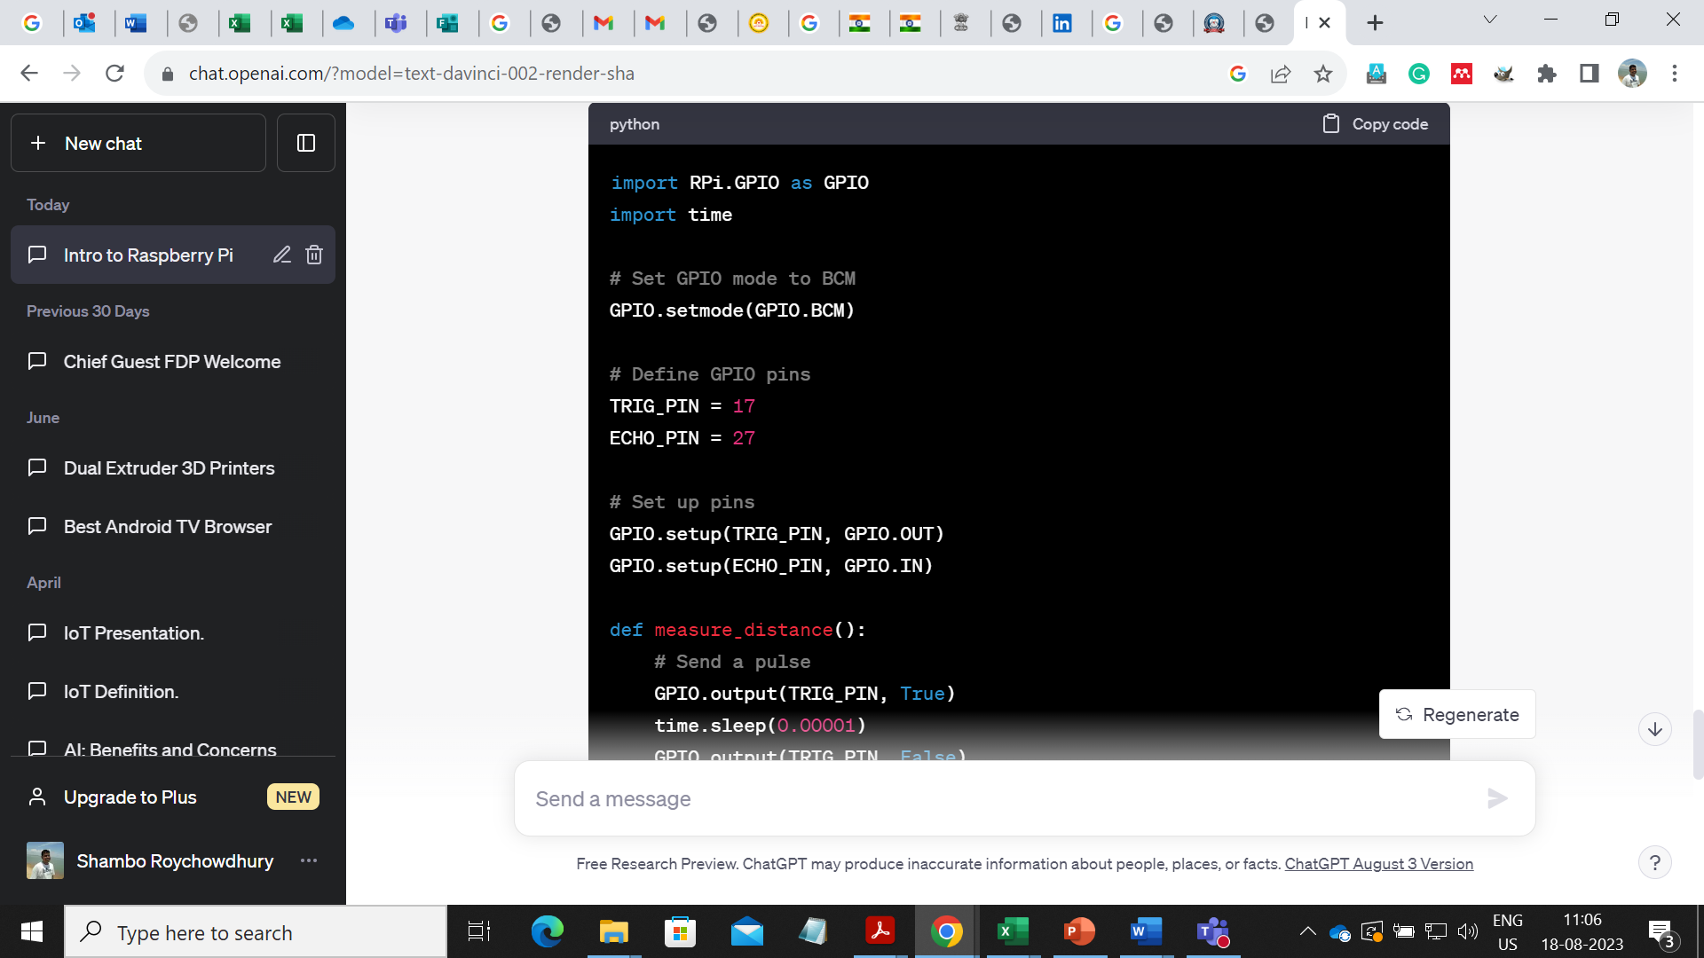

# Exercise tasks:

**Exercise 03: Operating Servo Motor with raspberry pi.**

**Definition**: -

Operating a servo motor with a Raspberry Pi involves using GPIO pins to control the motor's position. Servo motors are commonly used for precise angular control in robotics, automation, and other projects.

# Exercise tasks

**Components Needed:**

1. Raspberry Pi (any model with GPIO pins)
2. Servo Motor
3. Jumper Wires (Male to Female)

**Steps:**

1. **Wiring:**

Connect the servo motor to the Raspberry Pi using jumper wires. Servo motors typically have three wires:

* + Brown/Black: Connect to a ground (GND) pin on the Raspberry Pi.
  + Red: Connect to a 5V pin on the Raspberry Pi.
  + Orange/Yellow: Connect to a GPIO pin on the Raspberry Pi (e.g., GPIO17 - Pin 11).

Here's a basic wiring diagram:

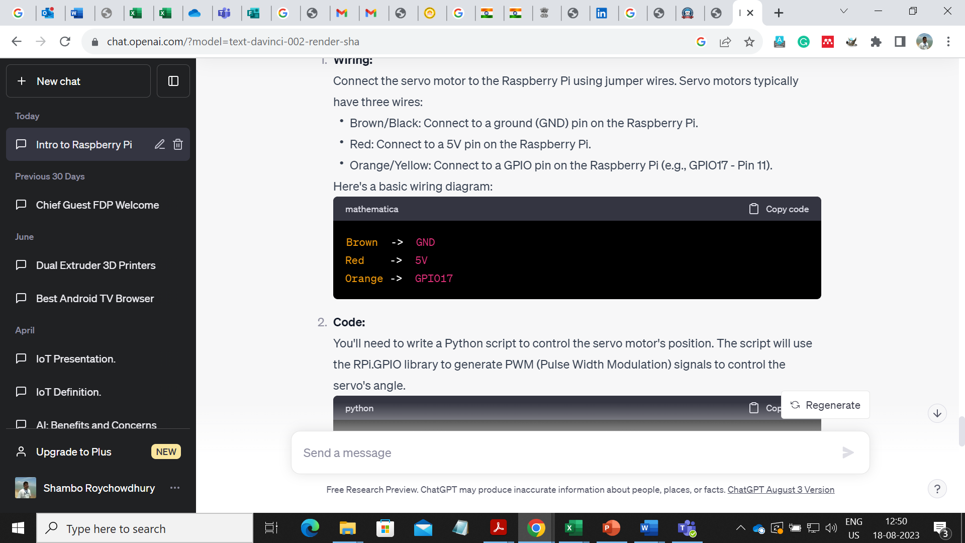

1. **Code:**

You'll need to write a Python script to control the servo motor's position. The script will use the RPi.GPIO library to generate PWM (Pulse Width Modulation) signals to control the servo's angle.

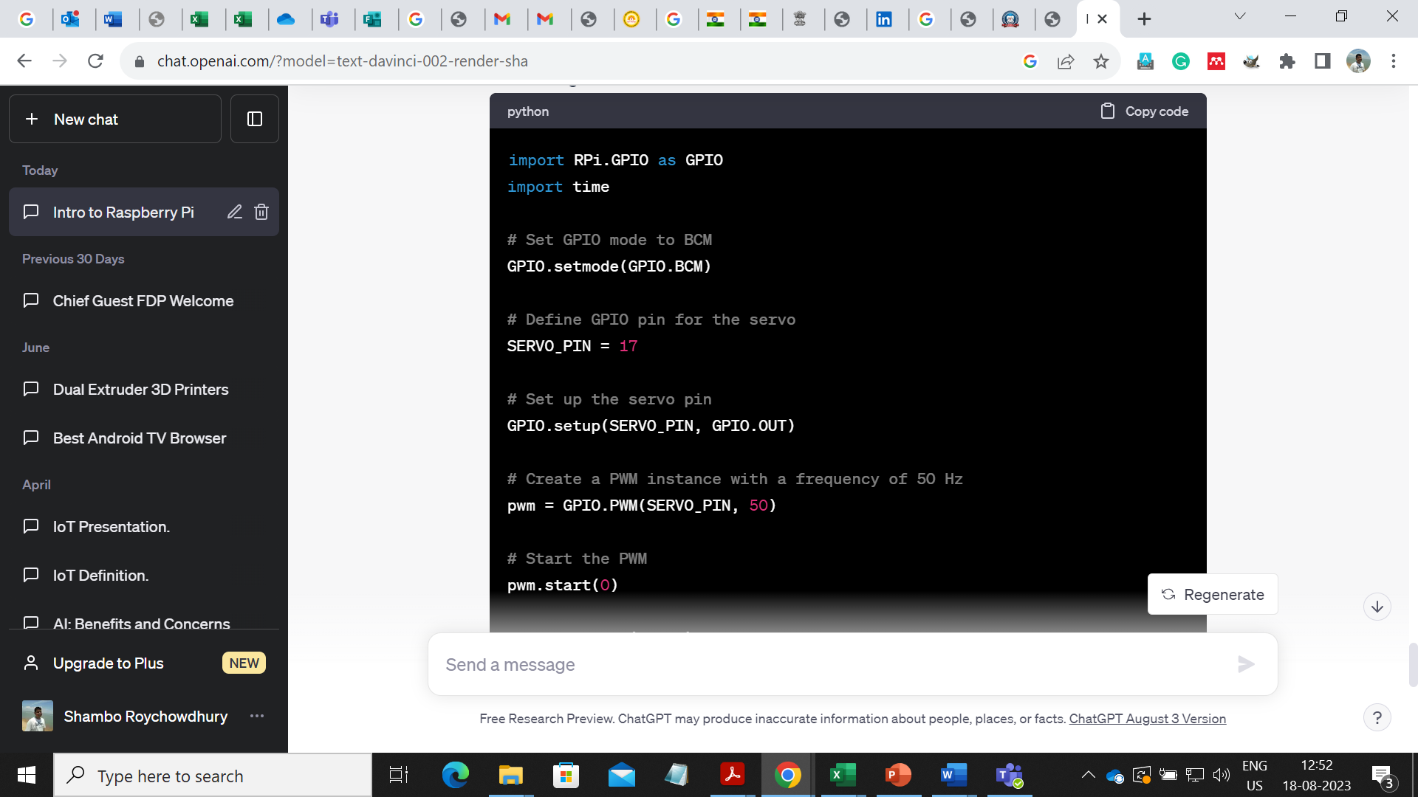

1. **Run the Code:**

Save the Python script on your Raspberry Pi (e.g., as **servo_control.py**). Open a terminal and navigate to the directory where you saved the script.

The script will rotate the servo motor to different angles (0, 90, and 180 degrees) in a loop. You can adjust the angles and timing as needed.

Remember that servo motors may have specific operating voltage and current requirements. Ensure that your Raspberry Pi and servo motor are properly powered and connected. Always follow safety precautions when working with electronic components.

Top of Form