**Titanic Associate chart**

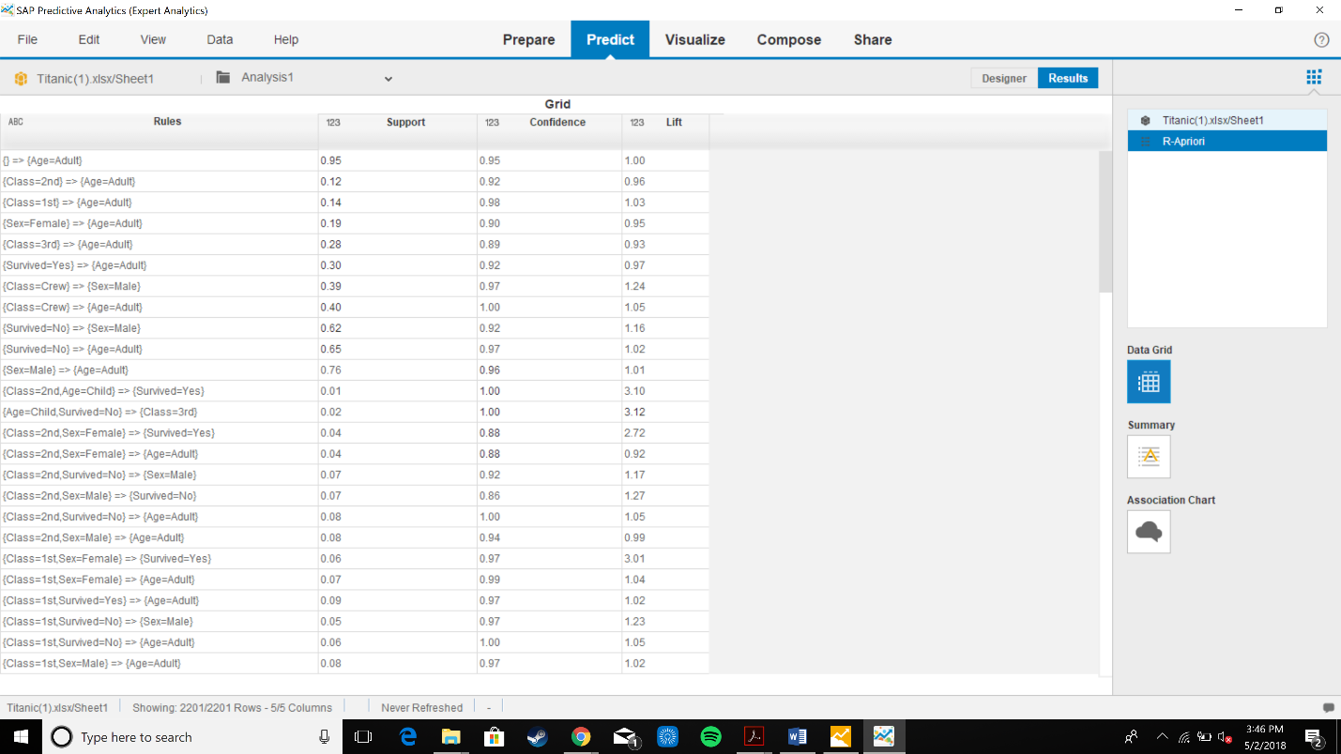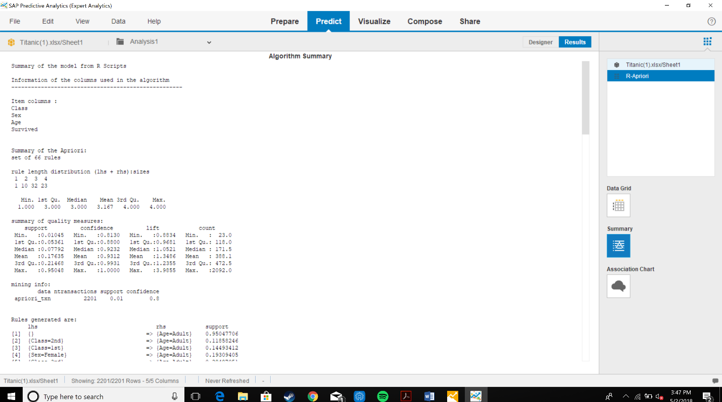

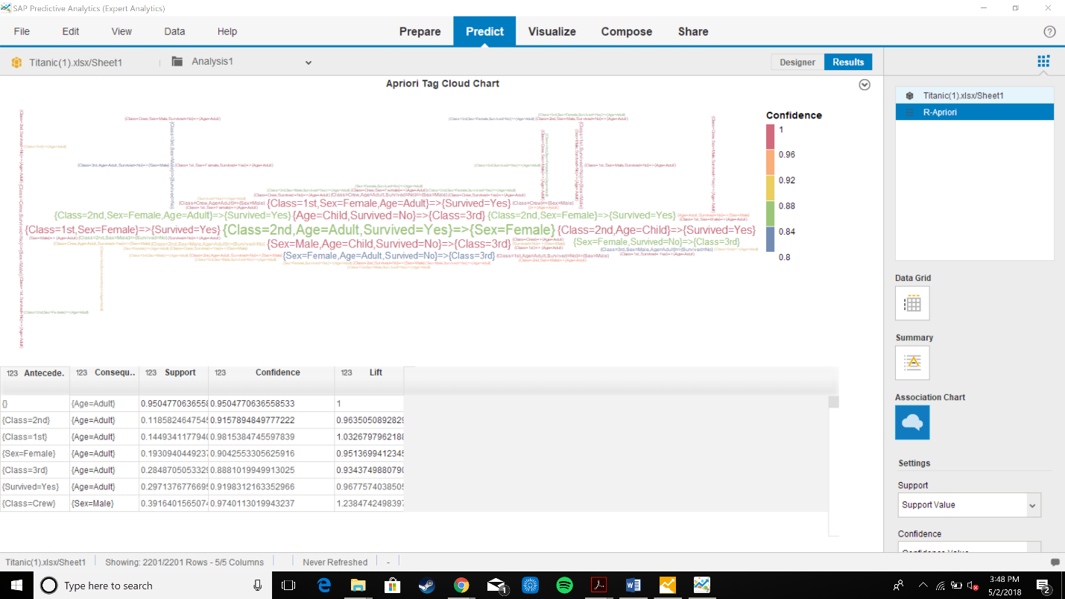

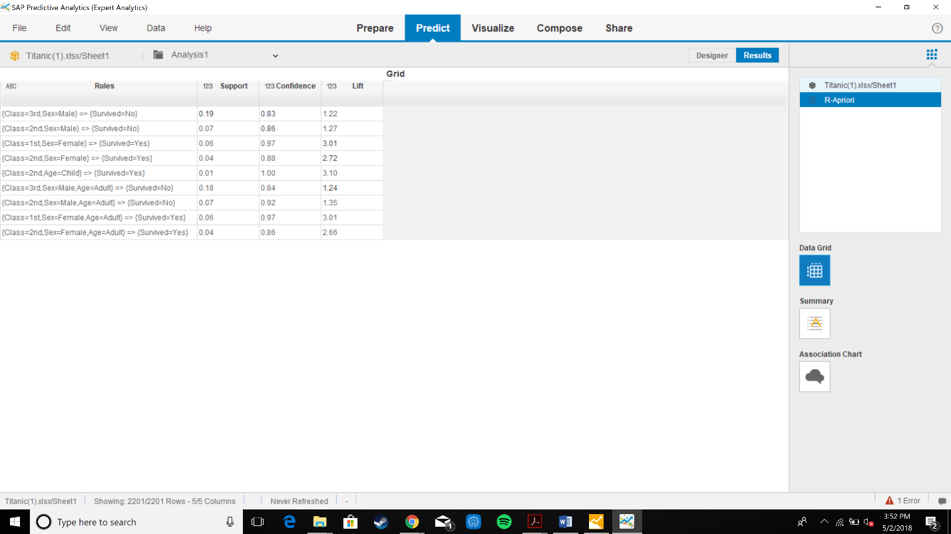

Class=2nd, Age= child=> survived= Yes rule provides the best model for survival

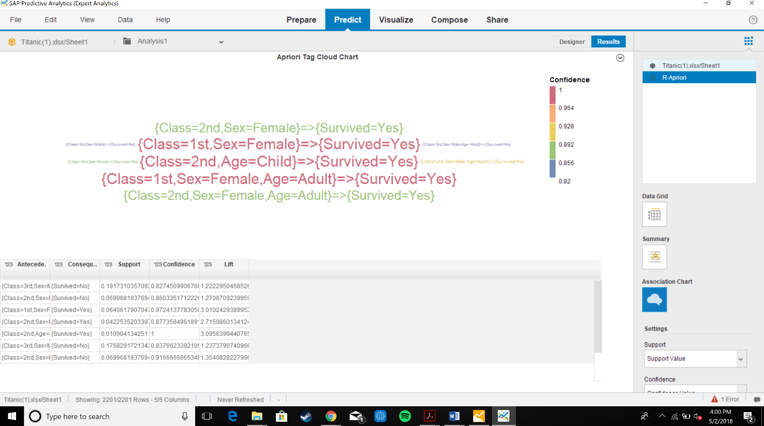

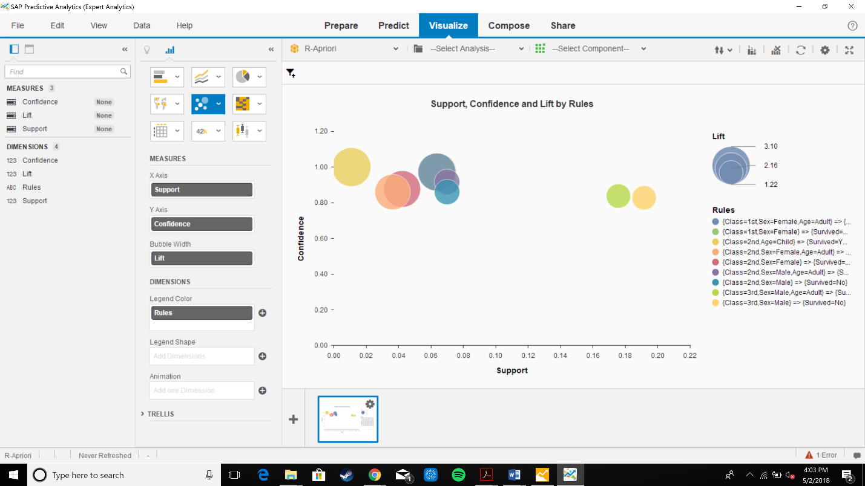

Support- number of transactions in data that include antecedent and consequent item set and confidence

Confidence – it is measure of viewed conditional probability of the consequent set occurs high confidence value suggest a rule in which the consequent is frequently true when the antecedent is also true

Lift is the ratios computed for rule by accounting for the frequency of the consequent