**Decision tree**

Results of the Prediction

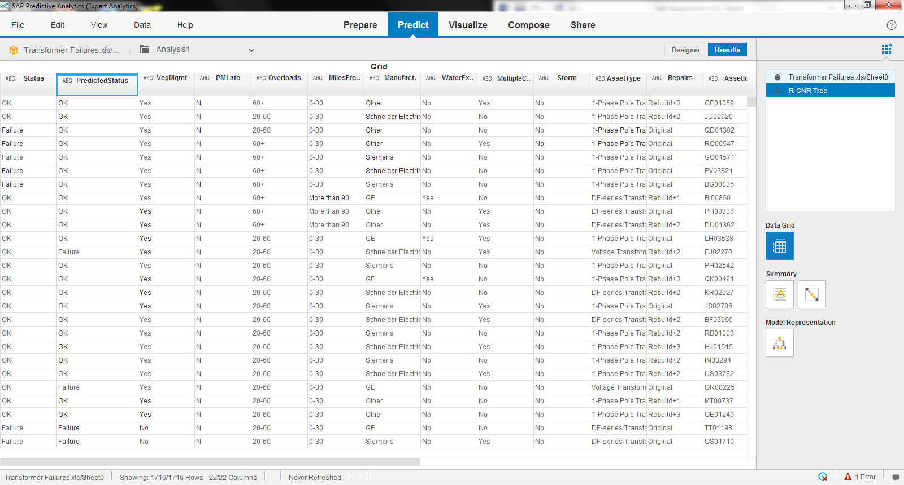

DECISION TREE

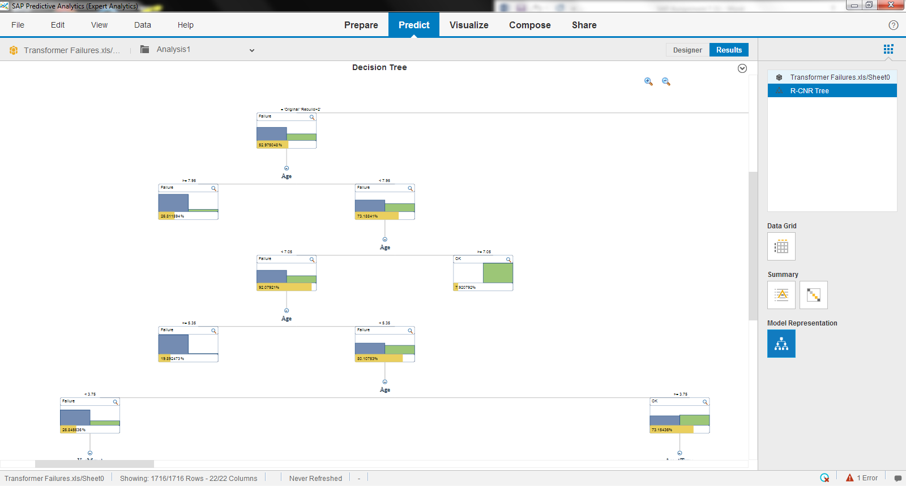

The chart shows confusion matrix.

The model says that actual and predicted failure is 677 and actual OK and predicted OK is 761. With this the model accuracy is determined to be 0.84. 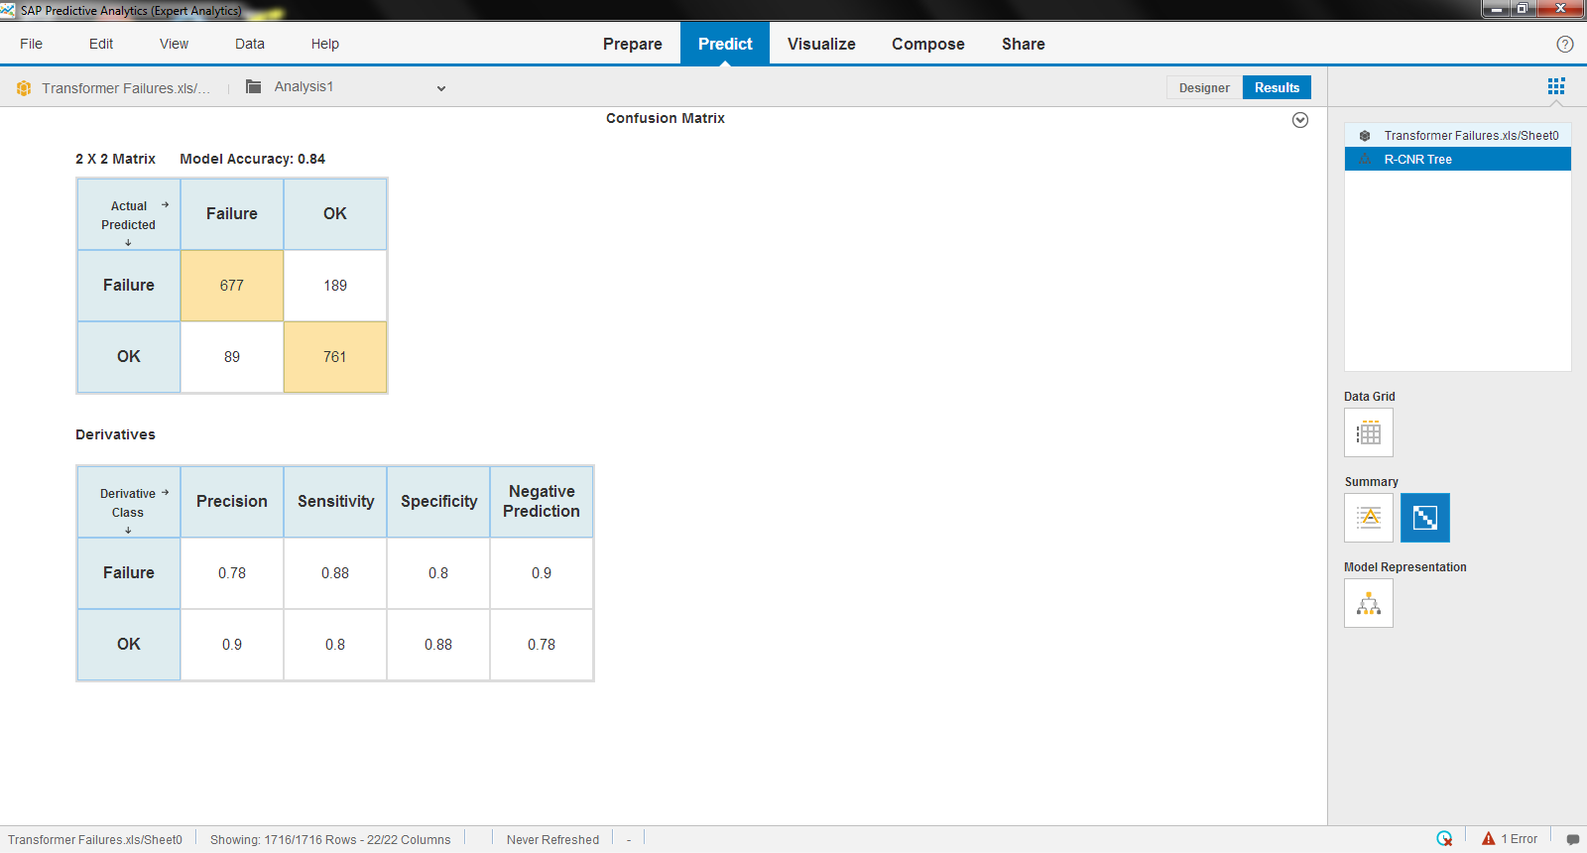

SHOWING THE VARIABLE IMPORTANCE TABLE

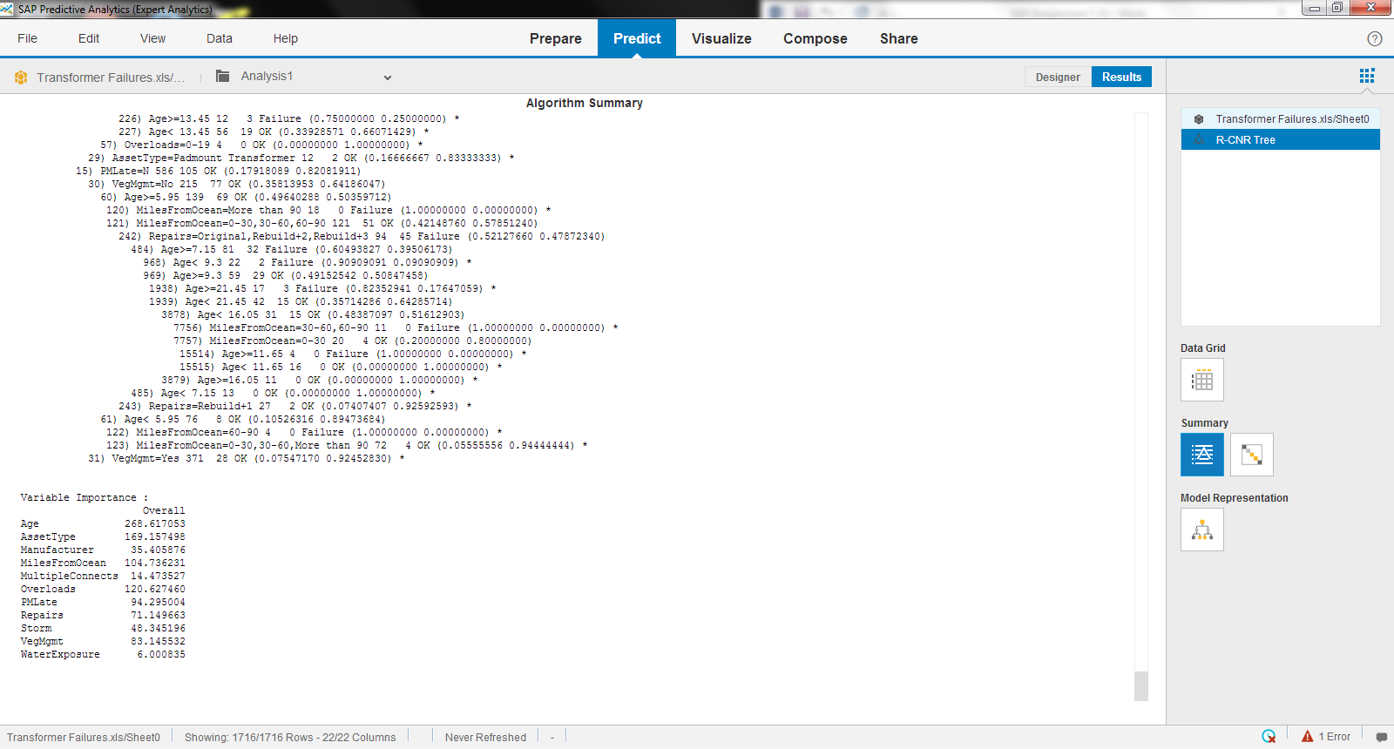

The three variables are considered most important when determining causes for transformer failures are Age, Asset type and Over loads

The three variables are considered least important when determining causes for transformer failures are Water exposure, multiple connects and manufacturer.