**Forecasting Sales Revenue**

The below line graph shows revenue from 2007-2011. Every peak indicates highest revenue month of the year. Shows ups and downs in revenue each month.

Every June the sale increases from January and starts decreasing the sales from January to December throughout 2007 to 2011.

(Support your answers with a screenshot.)

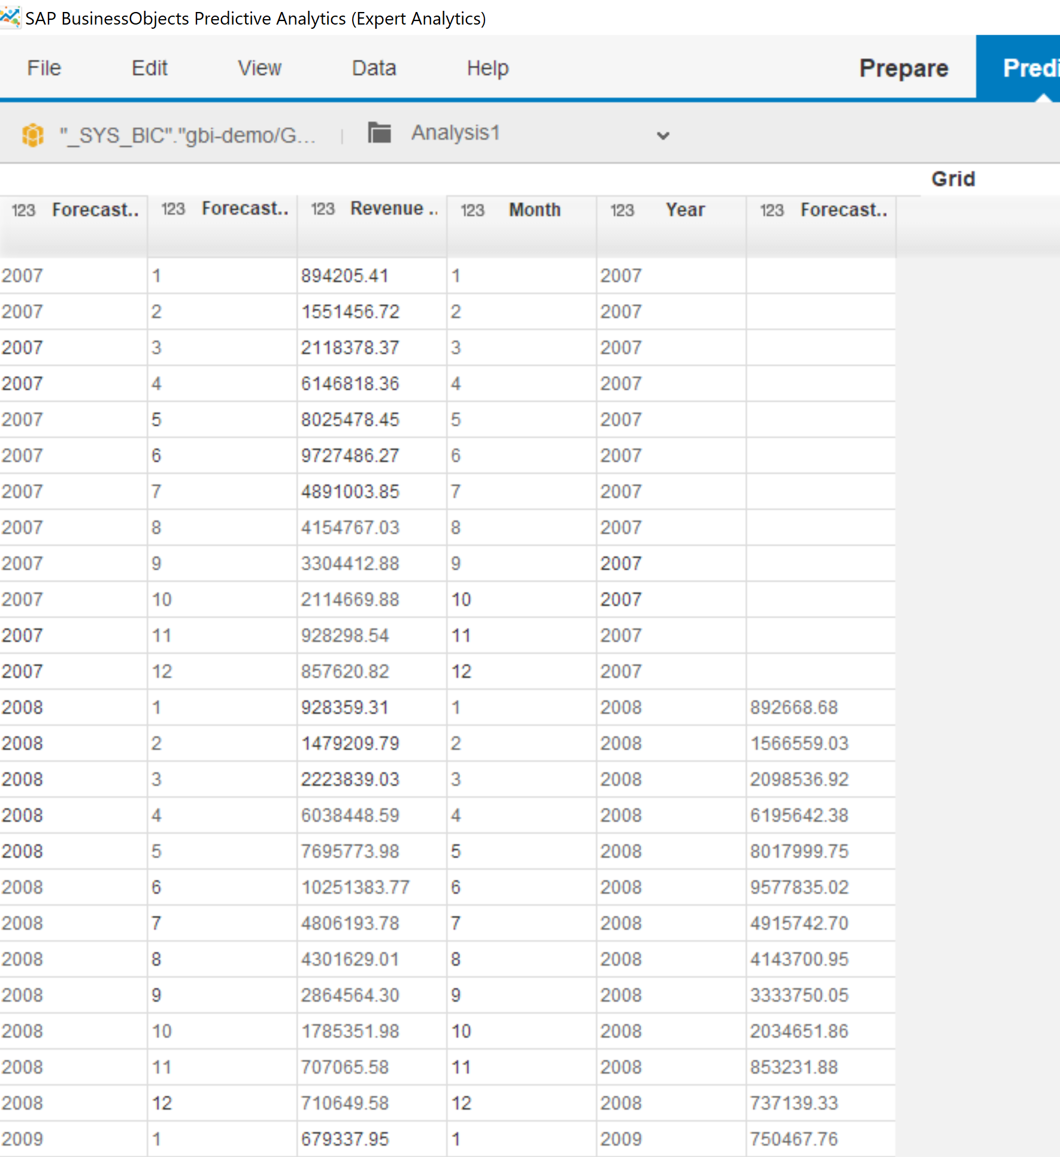

1. Do the results appear to be properly aligned chronologically?

yes

1. Do the forecast values appear to fit the historical data reasonably well?

(Support your answers with a screenshot.)

