**Forte Hotel Design Project**

Krishanthi Weragalaarachchi

**MT880 – Marketing analytics**

Kansas State University

**Background:**

Forte Hotels, the largest United Kingdom’s hotel chain, is developing a new hotel chain in the United States mainly targeting European business people who come to United Sates. Forte’s strategy in developing the new chain, named Forte Executive Innes, is twofold. It will combine the ambiance of a European hotel with American functionality and convenience. European business travelers in the United States will recognize the Forte name and associate it with comfort and service. Although the hotels will have a European ambiance, the facilities and services will be comparable to those available in such hotel chains as Hilton, Sheraton and Courtyard by Marriott.

**Objective:**

The main objective is to find best bundle from proposed room bundles for target customer base so that the Forte hotels can be competitive in the business with the other existing hotels. Along the way it is expected to find the customer preferences of the customers in order to better serve them for forever trust. Once identifying the customer segments in the market, the management can plan promotions to the targeted customer group to expand the sales as well.

**Data:**

We have given,

**design.csv** - Conjoint study design (5 attributes that can be decompose in to 15 level names)

|  |  |  |  |  |
| --- | --- | --- | --- | --- |
| **Attributes** | **Level 1** | **Level 2** | **Level 3** | **Level 4** |
| Room | Small_Suite | Large_Room | Room_Office |  |
| Bus_Amenities | Internet_access | Speaker_phone | Room_fax |  |
| Leisure | Exercise_room | Pool | Exercise_room_and_Pool |  |
| Extras | Shoe_shine | Tape_library | Fruit_and_cheese | Newspaper |
| Rest_Delivery | Yes | No |  |  |

**bundles.csv** -16 most valued bundles of rooms that were identified for customers to rate.

**ratings.csv -** preference ratings given by 40 customers to above 16 bundles of rooms.

**existing_profiles.csv** - 5 existing bundles in the market

|  |  |  |  |  |  |
| --- | --- | --- | --- | --- | --- |
| **Attributes** | **Courtyard_by**  **_Marriott** | **Nittany_Lion_Inn** | **Atherton_Hilton** | **Toftrees** | **Scanticon** |
| Room | Small_Suite | Large_Room | Large_Room | Small_Suite | Room_Office |
| Bus_Amenities | Speaker_phone | Speaker_phone | Speaker_phone | Speaker_phone | Room_fax |
| Leisure | Exercise_room_  and_Pool | Exercise_room | Exercise_room | Exercise_room_  and_Pool | Exercise_room_  and_Pool |
| Extras | Newspaper | Newspaper | Tape_library | Newspaper | Shoe_shine |
| Rest_Delivery | Yes | Yes | No | No | Yes |

**new_profiles.csv** - 4 new hotel room bundles to the market

|  |  |  |  |  |
| --- | --- | --- | --- | --- |
| **Attributes** | **Professional01** | **Professional02** | **Tourist** | **Deluxe** |
| Room | Room_Office | Small_Suite | Large_Room | Large_Room |
| Bus_Amenities | Internet_access | Room_fax | Speaker_phone | Internet_access |
| Leisure | Exercise_room | Exercise_room | Exercise_room_  and_Pool | Exercise_room_  and_Pool |
| Extras | Fruit_and_  cheese | Tape_library | Tape_library | Tape_library |
| Rest_Delivery | No | Yes | No | Yes |

A survey that can be used to collect this data can be accessed via Qualtrics : <https://qfreeaccountssjc1.az1.qualtrics.com/jfe/form/SV_eIP1iAIHIdzJwbQ>

**Analysis:**

1. **Partworth utility and total utility for each respondent.**

The first step is to estimate the partworth utilities for each person using multiple regression model. (Appendix: Table A). Here for each categorical variable (feature or attribute), one level is used as a reference(base) level. We need to remember that, higher the utility value, the more importance that a customer places on that attribute level. This partworth utility data of each respondent can be used to estimate preference share for new/existing room bundles later.

Next, the total utility of each bundle for each person is calculated (Appendix: Table B).

**The most preferred profile for 10th respondent (Elio):**

From the calculated partworth utilities, 10th respondents’ (Elio) the most preferred amenities from 5 attributes are large room, Room fax, exercise room and pool, fruit and cheese and restaurant deliveries. (Table 1). They represent highest values in row 10 for each attribute. However, from the total utility table (Table 2), we can clearly see that the most preferred room bundle for Elio is **Bundle 16**; which includes large room, internet access, exercise room and pool, newspaper and restaurant deliveries. As you can see Bundle 16 includes “exercise room and pool” and “large room” in which Elio cares more. The partworth utility of those two amenities for Elio are 14.708 and 8.583 respectively and they are the most important amenities to him.

|  |  |  |  |  |  |  |  |  |  |  |  |  |  |  |  |  |
| --- | --- | --- | --- | --- | --- | --- | --- | --- | --- | --- | --- | --- | --- | --- | --- | --- |
|  | **intercept** | **Small Suite** | **Large Room** | **Room Office** | **Internet access** | **Speaker phone** | **Room fax** | **Exercise room** | **Pool** | **Exercise room and Pool** | **Shoe shine** | **Tape library** | **Fruit and cheese** | **News paper** | **Yes** | **No** |
| 10 | 47.708 | 0.708 | 8.583 | -9.292 | -0.25 | -8.25 | 8.5 | -1.292 | -13.417 | 14.708 | -3.688 | -7.688 | 8.312 | 3.063 | 4.938 | -4.938 |

Table 01: Partworth utilities of 10th respondent

|  |  |  |  |  |  |  |  |  |  |  |  |  |  |  |  |  |
| --- | --- | --- | --- | --- | --- | --- | --- | --- | --- | --- | --- | --- | --- | --- | --- | --- |
|  | **Bundle 01** | **Bundle 02** | **Bundle 03** | **Bundle 04** | **Bundle 05** | **Bundle 06** | **Bundle 07** | **Bundle 08** | **Bundle 09** | **Bundle 10** | **Bundle 11** | **Bundle 12** | **Bundle 13** | **Bundle 14** | **Bundle 15** | **Bundle 16** |
| 10 | 48.13 | 54.13 | 34.75 | 26.00 | 24.00 | 30.00 | 42.13 | 50.88 | 75.00 | 60.00 | 28.13 | 47.88 | 24.88 | 59.38 | 27.00 | 78.75 |

Table 02: Total utilities of 10th respondent

1. **Conjoint Analysis (Matching Hotel Attributes to Customer Preferences)**

We can perform the conjoint analysis for one individual or group of people. Following are the results from conjoint analysis for 26th respondent (Nissa) of the surveyed population and for whole surveyed population.

**The most preferred profile for 26th Respondent (Nissa):**

Summary of regression model (Figure 01) from Conjoint analysis for 26th respondent (Nissa) shows that the model attributes are good at explaining 99.99% (R2 = 0.9999) of the variation in Nissa’a rankings. The standard error of 0.2236 indicates that 95% of the predictions that can be calculated for ranks would be accurate within two standard errors (0.45). Also, significance F value from ANOVA is 10^(-9) and this tells that there is 0 chance that the independent variables (attributes) are not useful in predicting Nissa’s rankings . So, all the attributes are useful in predicting rankings.

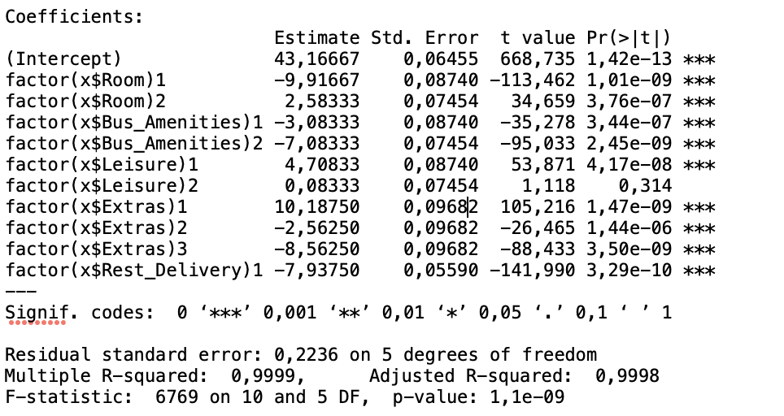

Figure 01: summary of conjoint analysis for Nissa

As can be seen from the below (Table 03 and graph 07), the **most important attribute for Nissa is “Extras” (importance = 23.85)**. “Room type” and “Business amenities” comes next as equally important attributes for her with importance of 21.94. these two attributes are only less than about 2 units from importance of Extras.

Conjoint analysis results suggests that, the most preferred levels from 5 attributes for Nissa are room office, room fax, exercise room, shoe shine, and no restaurant delivery. (Table 03 and Figures 02 - 07). It seems like she is more business-oriented person.

|  |  |  |  |
| --- | --- | --- | --- |
| **Attributes** | **Level names** | **Part-worth utility** | **Importance** |
| Room | Small Suite | -9.9167 | 21.94 |
| Large Room | 2.5833 |
| Room Office | 7.3333 |
| Bus amenities | Internet access | -3.0833 | 21.94 |
| Speaker phone | -7.0833 |
| Room fax | 10.1667 |
| Leisure | Exercise room | 4.7083 | 12.08 |
| Pool | 0.0833 |
| Exercise room and Pool | -4.7917 |
| Extras | Shoe shine | 10.1875 | 23.85 |
| Tape library | -2.5625 |
| Fruit and cheese | -8.5625 |
| Newspaper | 0.9375 |
| Rest_Delivery | Yes | -7.9375 | 20.19 |
| No | 7.9375 |

Table 03 : Part-worth utilities for levels and importance of attributes for 26th respondent (Nissa)

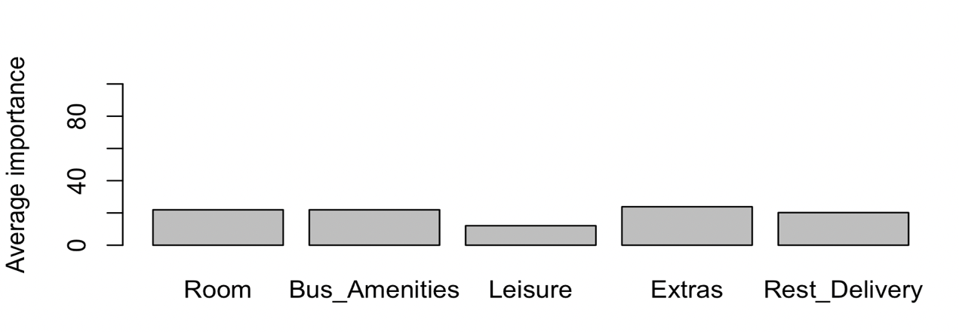

Figure 07: The chart of average importance of attributes for Nissa from conjoint analysis

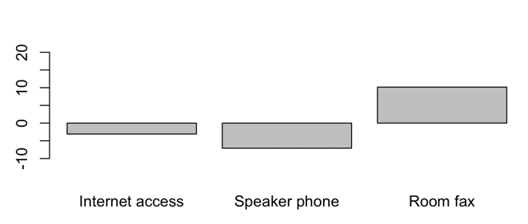

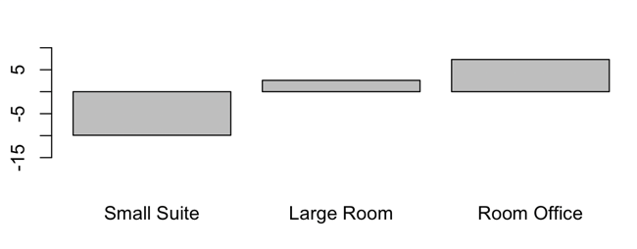

Figure 08: Room type Figure 09: Business Amenities

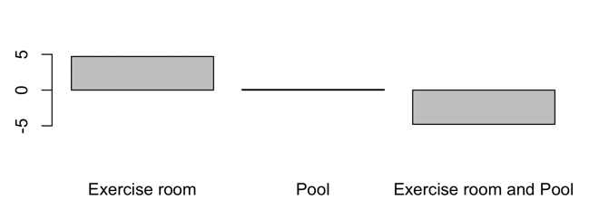

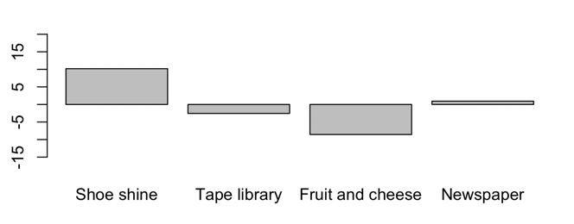

Figure 10: Leisure facilities Figure 11: Extras

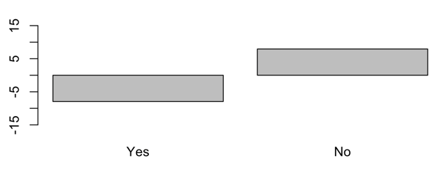

Figure 12: Restaurant Deliveries

Figure 08-12: Graphs of preference levels of 5 variables for Nissa from conjoint analysis:

Total utilities calculated for Nissa shows that **Bundle 08**(66.00) is the most preferred bundle for her out of all 16 room bundles(Table 04). It includes large room, room fax, exercise room, tape library and no restaurant delivery.

|  |  |  |  |  |  |  |  |  |  |  |  |  |  |  |  |  |
| --- | --- | --- | --- | --- | --- | --- | --- | --- | --- | --- | --- | --- | --- | --- | --- | --- |
|  | **Bundle 01** | **Bundle 02** | **Bundle 03** | **Bundle 04** | **Bundle 05** | **Bundle 06** | **Bundle 07** | **Bundle 08** | **Bundle 09** | **Bundle 10** | **Bundle 11** | **Bundle 12** | **Bundle 13** | **Bundle 14** | **Bundle 15** | **Bundle 16** |
| 26 | 37.13 | 52.00 | 63.00 | 56.88 | 15.75 | 48.13 | 28.13 | 66.00 | 38.00 | 26.88 | 46.88 | 22.25 | 35.13 | 49.00 | 57.00 | 30.88 |

Table 04: total utilities for Nissa

**The most preferred profile for All respondents:**

Summary of regression model (Figure 13) from Conjoint analysis of all respondents shows that the model attributes are good at explaining only 2.8% (R2 = 0.0276) of the variation in rankings. The standard error of 17.81 indicates that 95% of the predictions that can be calculated for ranks would be accurate within two standard errors (35.62). Also, significance F value from ANOVA is 0.05914 and this tells that there is 5.9% chance that the independent variables (attributes) are not useful in predicting rankings. As you can see from the p-values of each level, Room is the only predictor variable that is significant at predicting rankings.

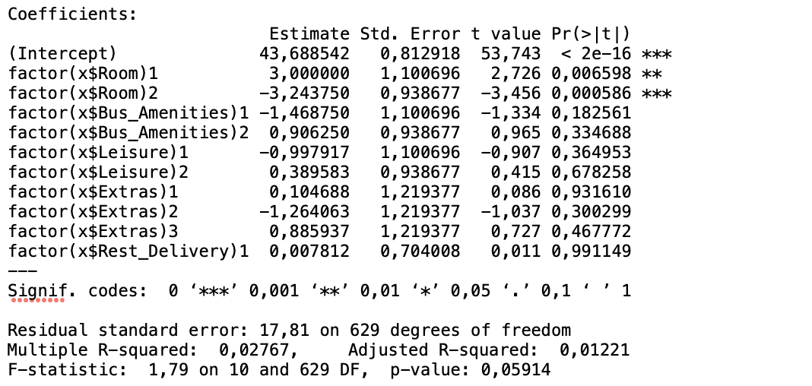

Figure 13: summary of conjoint analysis for all respondents.

As can be seen below (Table 05 and Figure14) the **most important attribute for all customers is the “Room” (importance = 29.2)**. Business amenities comes next and thirdly they care about the leisure facilities offered with the bundle.

Conjoint analysis results suggests that, the most preferred levels from 5 attributes are small suite, speaker phone, exercise room and pool, fruit and cheese and restaurant delivery. (Table 05 and Figures 15 - 20). Partworth utility of each level gives us very precious information about how changing the features of hotel rooms improve utility. As an example, changing large room and room_office concept to small suite will increase the utility. Some other ways of increasing the utility would be providing speaker phones instead of internet access, provide complimentary fruit and cheese bowl and restaurant delivery service rather than providing shoe-shine service and videotape service.

|  |  |  |  |
| --- | --- | --- | --- |
| **Attributes** | **Level names** | **Partworth utility** | **Importance** |
| Room | Small_Suite | 3 | 29.2 |
| Large_Room | -3.2438 |
| Room_Office | 0.2438 |
| Bus amenities | Internet_access | -1.4687 | 21.32 |
| Speaker_phone | 0.9063 |
| Room_fax | 0.5625 |
| Leisure | Exercise_room | -0.9979 | 19.74 |
| Pool | 0.3896 |
| Exercise_room_and_Pool | 0.6083 |
| Extras | Shoe_shine | 0.1047 | 15.94 |
| Tape_library | -1.2641 |
| Fruit_and_cheese | 0.8859 |
| Newspaper | 0.2734 |
| Rest_Delivery | Yes | 0.0078 | 13.8 |
| No | -0.0078 |

Table 05: Partworth utilities for levels and importance of attributes for all respondents

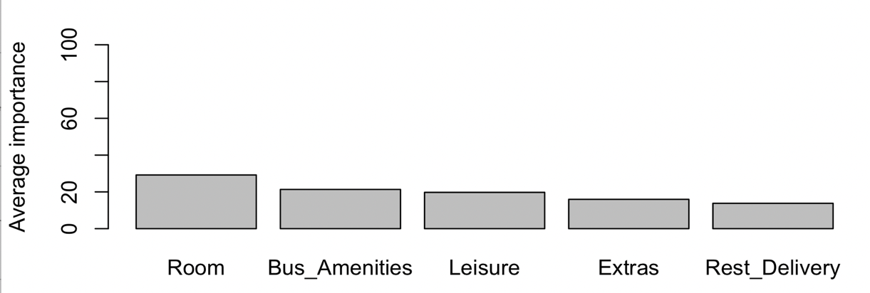

Figure 14: The chart of average importance of attributes of all respondents from conjoint analysis

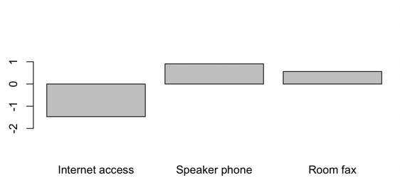

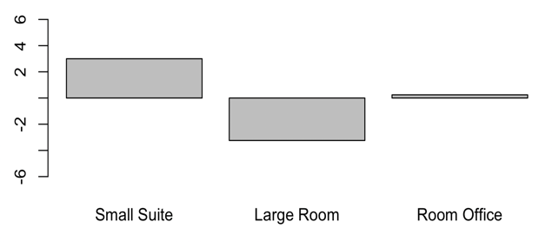

Room type Business Amenities

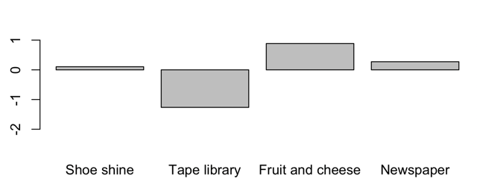

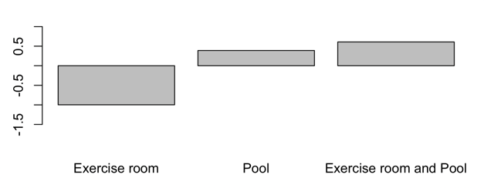

Leisure facilities Extras

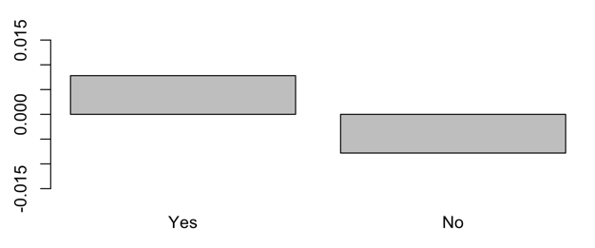

Restaurant Deliveries

Figure 15 - 20 : Graphs of preference levels of 5 variables for all respondents

By summing up all the total utilities of all respondents for each bundle and by looking at the highest value, we can conclude that the most preferred bundle among all respondents is **bundle 09**. Bundle 09 includes small suite, room fax, exercise room and pool, fruit and cheese and no restaurant delivery. It sums up all the respondents’ total utilities to 1921.50 (Appendix: Table B).

As another approach, the bundle with highest total utility was selected as each respondent’s choice of bundle and the choice frequency for each bundle was calculated. The data show that Bundle 09 and Bundle 03 have higher chance of choosing over other bundles (Table 06).

|  |  |
| --- | --- |
| **Bundle_name** | **Freq** |
| Bundle01 | 3 |
| Bundle02 | 2 |
| Bundle03 | 6 |
| Bundle04 | 1 |
| Bundle05 | 2 |
| Bundle06 | 1 |
| Bundle07 | 1 |
| Bundle08 | 2 |
| Bundle09 | 6 |
| Bundle10 | 3 |
| Bundle11 | 3 |
| Bundle12 | 2 |
| Bundle13 | 1 |
| Bundle14 | 2 |
| Bundle15 | 4 |
| Bundle16 | 2 |

Table 06 : Frequency of purchase for bundles

Moreover, the preference scores for each profile were calculated according to the below equation (Table 07) and the preference score is highest for **Bundle 09** as well.

Prefi = β0+ β1(Small_Suite)i + β2(Large_Room)i + β3(Room_Office)i + β4(Internet_access)i + β5(Speaker_phone)i + β6(Room_fax)i + β7(Exercise_room)i + β8(Pool)i + β9(Exercise_room_and_Pool)i + β10(Shoe_shine)i + β11(Tape_library)i + β12(Fruit_and_cheese)i + β13(Newspaper)i + β14(Yes)i + β15(No)i + εi

Where βi = Partworth utility of each level(considering all respondents)

εi = error term

reference level = 0

|  |  |  |  |  |  |  |  |  |  |  |  |  |  |  |  |  |
| --- | --- | --- | --- | --- | --- | --- | --- | --- | --- | --- | --- | --- | --- | --- | --- | --- |
|  | **Bundle 01** | **Bundle 02** | **Bundle 03** | **Bundle 04** | **Bundle 05** | **Bundle 06** | **Bundle 07** | **Bundle 08** | **Bundle 09** | **Bundle 10** | **Bundle 11** | **Bundle 12** | **Bundle 13** | **Bundle 14** | **Bundle 15** | **Bundle 16** |
| Preferance score | 44.33 | 42.06 | 45.00 | 41.84 | 46.73 | 38.09 | 44.19 | 38.74 | 48.74 | 41.25 | 43.73 | 42.63 | 48.25 | 41.68 | 44.11 | 39.87 |

Table 07 : preference score for bundle 01 through bundle 16

Considering all 3 approaches above, **we can conclude that Bundle 09 is the most preferred bundle.**

1. **Segmentation Analysis (Segmenting customers based on their preferences)**

Then, all the respondents were segmented in to two clusters based on conjoint results using caSegmentation() function from “conjoint” package. caSegmentation(_) uses k-means clustering technique. Table 08 shows the cluster membership of each respondent. There are 28 respondents belong to cluster-1 and 12 respondents belong to cluster-2. Figure-21 shows cluster-1 in red and cluster-2 in blue.

|  |  |  |  |  |  |
| --- | --- | --- | --- | --- | --- |
|  | **Respondents** | **Cluster** |  | **Respondents** | **Cluster** |
| 1 | Amanda | 1 | 21 | Lawrence | 2 |
| 2 | Ann | 2 | 22 | Marina | 1 |
| 3 | Bruce | 1 | 23 | Martina | 2 |
| 4 | Byron | 1 | 24 | Michael | 1 |
| 5 | Byung | 1 | 25 | Nicholas | 1 |
| 6 | Colleen | 1 | 26 | Nissa | 1 |
| 7 | Courtney | 1 | 27 | Oliver | 2 |
| 8 | Daniel | 1 | 28 | Peony | 1 |
| 9 | Dierdre | 1 | 29 | Robert | 1 |
| 10 | Elio | 2 | 30 | Sally | 1 |
| 11 | Eugene | 2 | 31 | Saulo | 1 |
| 12 | Frank | 1 | 32 | Scott | 2 |
| 13 | Gabriel | 1 | 33 | Shawn | 1 |
| 14 | George | 2 | 34 | Stacy | 1 |
| 15 | Gina | 2 | 35 | Sukhdeep | 1 |
| 16 | Hans | 2 | 36 | Thomas | 1 |
| 17 | Hector | 1 | 37 | Tiffany | 1 |
| 18 | Jin Hyuk | 1 | 38 | Traci | 1 |
| 19 | Jose | 1 | 39 | Trevor | 2 |
| 20 | Kevin | 1 | 40 | Vladimir | 2 |

Table 08 : Cluster membership of respondents.

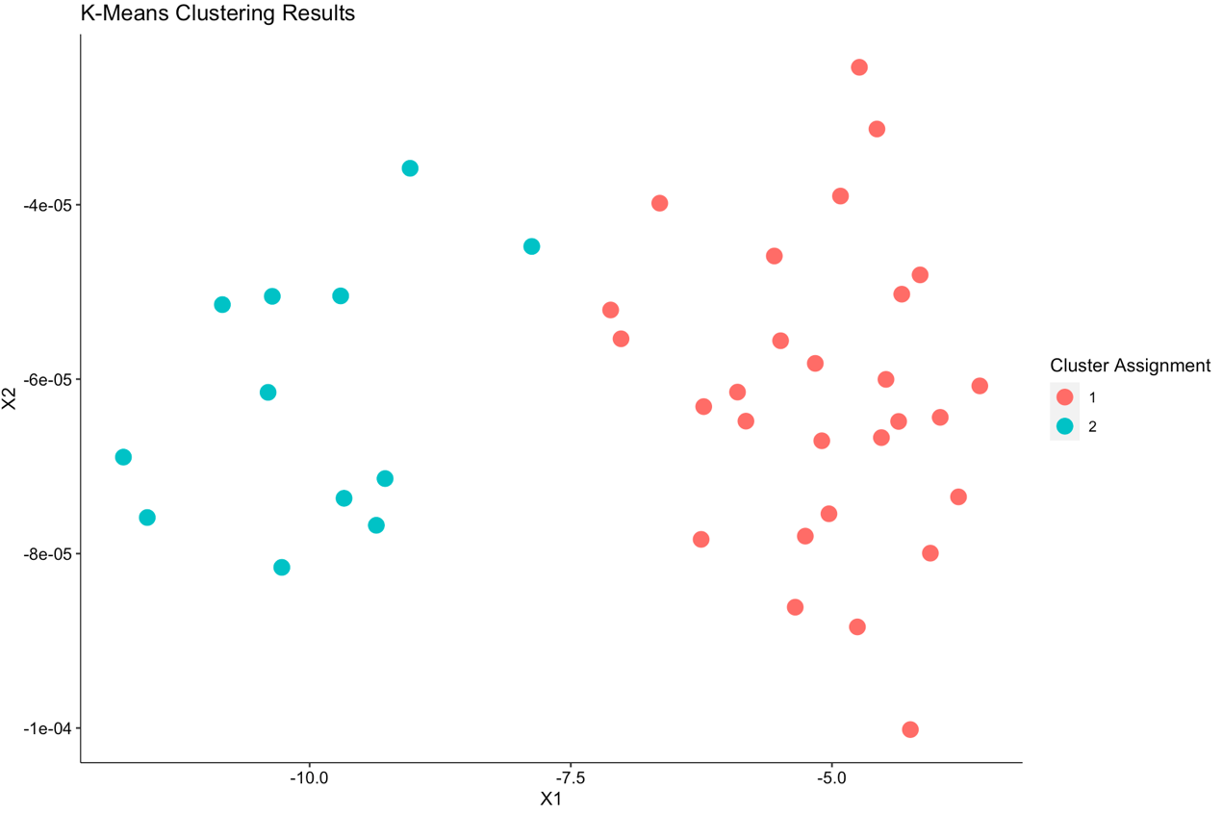

Figure 21 : K-means clustering results for 40 respondents

Identification of cluster properties

In order to clearly identify cluster properties, 2 approaches were taken.

1. Mean value of each segmentation variable(bundle) for each cluster was calculated and compared it with the overall mean for the segmentation variable (Table 09). The idea is to look for cluster means that are either well above(green) or well below(red) the Overall mean. Then the bundles prominent in each cluster were identified and their levels (properties) were identified (Table 10). The only level (property) that is in cluster_2 but not in cluster_1 is the “room type”. This approach does not give much of insight to differentiate between clusters. However, we can conclude that main difference between two clusters is due to the respondent’s choice of room type.

|  |  |  |  |
| --- | --- | --- | --- |
|  | **cluster_1** | **cluster_2** | **overall_mean** |
| Bundle01 | 41.85 | 50.13 | 44.33 |
| Bundle02 | 36.81 | 54.29 | 42.05 |
| Bundle03 | 47.55 | 39.04 | 45.00 |
| Bundle04 | 36.00 | 55.46 | 41.85 |
| Bundle05 | 45.18 | 50.34 | 46.75 |
| Bundle06 | 32.05 | 52.20 | 38.05 |
| Bundle07 | 46.81 | 38.07 | 44.18 |
| Bundle08 | 31.89 | 54.72 | 38.78 |
| Bundle09 | 50.76 | 44.02 | 48.73 |
| Bundle10 | 32.71 | 61.17 | 41.23 |
| Bundle11 | 48.41 | 32.81 | 43.75 |
| Bundle12 | 35.23 | 59.92 | 42.65 |
| Bundle13 | 48.89 | 46.76 | 48.25 |
| Bundle14 | 34.13 | 59.30 | 41.65 |
| Bundle15 | 47.19 | 36.91 | 44.10 |
| Bundle16 | 32.58 | 56.86 | 39.90 |

Table 09: mean value of each bundle for each cluster and overall mean of each bundle.

|  |  |  |  |
| --- | --- | --- | --- |
| **bundles prominent in cluster_1** | **bundles prominent in cluster_2** | **cluster_1 properties** | **cluster_2 properties** |
| Bundle03 | Bundle01 | Room Office | Small Suite |
| Bundle07 | Bundle02 | Room fax | Internet access |
| Bundle09 | Bundle04 | Pool | Exercise room |
| Bundle11 | Bundle05 | Shoe shine | Shoe shine |
| Bundle13 | Bundle06 | Restaurant Delivary | Restaurant Delivary |
| Bundle15 | Bundle08 | Speaker phone | Large Room |
|  | Bundle10 | Exercise room + Pool | Speaker phone |
|  | Bundle12 | Tape library | Exercise room + Pool |
|  | Bundle14 | Small Suite | Pool |
|  | Bundle16 | Fruit and cheese | No Restaurant Delivary |
|  |  | No Restaurant Delivary | Tape library |
|  |  | Internet access | Internet access |
|  |  | Newspaper | Room fax |
|  |  | Exercise room | Fruit and cheese |
|  |  |  | Newspaper |

Table 10: bundles and attribute levels prominent in each cluster.

1. As the second approach to identify cluster properties conjoint analysis were performed for two clusters separately and partworth utilities and importance of attributes were calculated for each cluster.(Table 11)

|  |  |  |  |  |  |  |
| --- | --- | --- | --- | --- | --- | --- |
| **Attributes** | **Level names** | **Cluster_1** | | **Cluster_2** | | |
|  |  | Partworth utility | Importance | Partworth utility | Importance |
| Room | Small Suite | 3.9747 | 28.07 | 0.7257 | 31.85 |
| Large Room | -8.7708 | 9.6528 |
| Room Office | 4.7961 | -10.3785 |
| Bus amenities | Internet access | -1.5789 | 23.77 | -1.2118 | 15.61 |
| Speaker phone | 0.8006 | 1.1528 |
| Room fax | 0.7783 | 0.059 |
| Leisure | Exercise room | -1.9494 | 16.03 | 1.2222 | 28.38 |
| Pool | 0.5685 | -0.0278 |
| Exercise room and Pool | 1.381 | -1.1944 |
| Extras | Shoe shine | 0.0513 | 17.66 | 0.2292 | 11.92 |
| Tape library | -1.5201 | -0.6667 |
| Fruit and cheese | 1.2746 | -0.0208 |
| Newspaper | 0.1942 | 0.4583 |
| Rest_Delivery | Yes | -0.9978 | 14.46 | 2.3542 | 12.25 |
| No | 0.9978 | -2.3542 |

Table 11: Partworth utilities for levels and importance of attributes for 2 clusters

The room type is the highest important attribute for both the clusters, and this finding well aligned with the finding we already obtained comparing means of bundles with overall means. It also can be clear that the respondents from cluster_1 prefer room office(part-worth utility = 4.7961) which has one queen-sized bed and a well-lit work area with a large desk and swivel chair in place of the other bed whereas respondents from cluster_2 prefer larger rooms (part-worth utility = 9.6528) that are longer than a standard room with two queen sized beds.

Another finding that differentiate two clusters is that the second important attribute of cluster_1 is business amenities (importance = 23.77) and for cluster_2, it is leisure facilities (importance = 28.38)(Figure 22,23).The business facilities include a computer complete with software (e.g., Netscape) with access to Internet and world wide web at a low hourly connection rate, a speakerphone for group business discussions and a fax machine and a private fax number that expires at checkout. The later seems popular in cluster _1 with part-worth utility of 0.7783 which is little less than part-worth utility of speaker phone availability. The customers in cluster_1 seems to contend with small exercise room with less features and small pool (not for lapping). They prefer having a complimentary fruit and gourmet cheese bowl in the room and not much interested about restaurant delivery via room service. We can conclude from those findings that customers in cluster_1 are more business orientated people who likes to have their own space with out disturbance from companions. They seem to carry on their business-related work in an office like environment with snacks in hand. They may probably have their business meeting face to face in hotel dining area or in another arranged space so that they can eat their meals while working. These cluster seems to be representing workaholic and rich business group.

On the other hand, customers in cluster_2 are fond of Leisure facilities (importance = 28.38) over business amenities (importance = 15.61)(Figure 23). They seem to like full equipped exercise rooms with Nautilus machines, free weights, stationary bikes, treadmills, stairclimbing machines, and a sauna. They like to have a free complimentary copy of USA Today outside the door every day and enjoy food from different restaurants nearby via room service. They also prefer large rooms with two queen beds over small suite with one bed or room office with office desk. When considering all that, we can conclude that the cluster_2 consists of customers who enjoy their stay and they could be normal people who travels with their families.

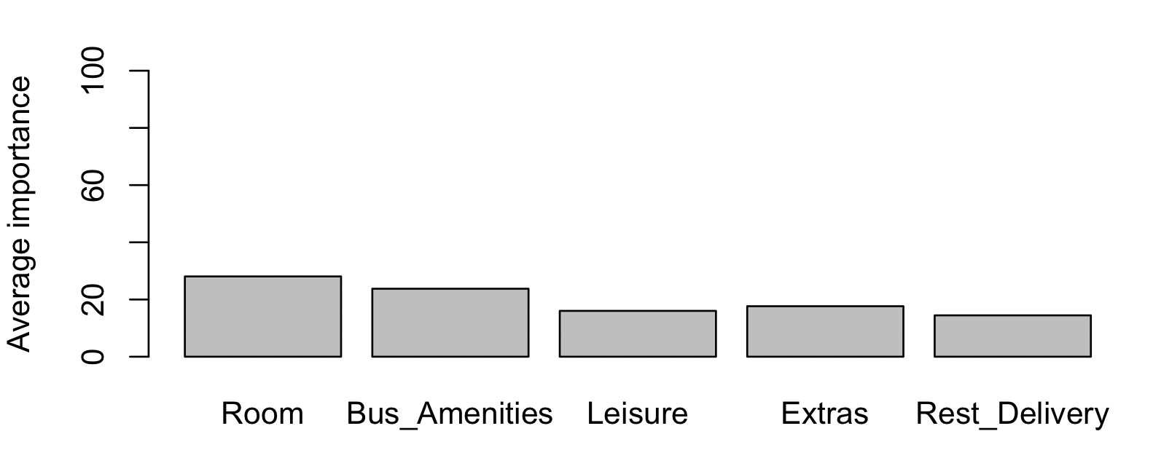

Figure 22: The chart of average importance of attributes for cluster_1 from conjoint analysis

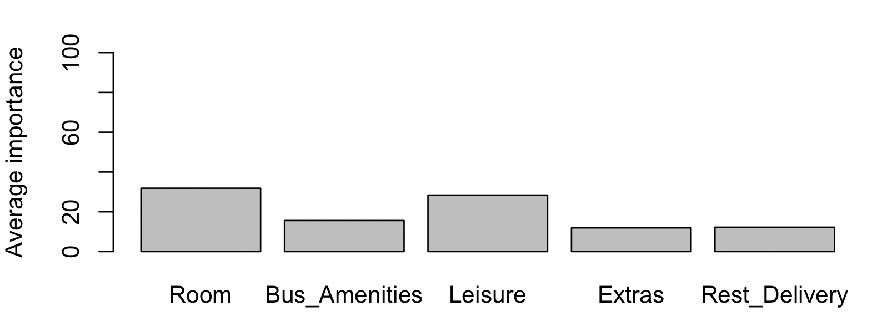

Figure 23: The chart of average importance of attributes for cluster_2 from conjoint analysis

Considering all that, we can conclude that, the cluster_1 is better at targeting because, it mainly consists of business people who consider their work seriously and Forte Hotel’s main goal is to target business people who comes from Europe to United States for business work and the American business class.

1. **Market Share Analysis**

Once partworths are estimated for each respondent’s it is easy to assess the likely success of a new product concept under various simulated market conditions. There are four new bundles (Professional01, Professional02, Tourist, Deluxe) with their own combination of attribute levels and five existing bundles (Courtyard by Marriott, Nittany Lion Inn, Atherton Hilton, Toftrees, Scanticon) with their own combination of levels are given. The competitors of the best bundle chosen from conjoint analysis (Bundle 09) were identified when it is launched with given existing profiles and new profiles separately.

Here, the “preference share” of each individual were calculated and then used it for forecast the market share. There are 3 choice rules that can be used to transform partworths in to product choices customers most likely to make. They are

1. Maximum utility rule
2. Logit model
3. Share of utility

Market share percentages were forecasted for following conditions using **Maximum utility rule (**as described in https://www.slideshare.net/MinhaHwang/conjoint-analysis-part-33-market-simulator) It computes the number of customers for whom that product offers the highest utility and dividing this figure by the numbers of customers in the study.

1. When launching Bundle09 (most preferred) to the competitive market with existing hotel rooms.

|  |  |  |
| --- | --- | --- |
| **Bundle name** | **Freq** | **share_percentage**  **%** |
| Courtyard_by_Marriott | 6 | 15 |
| Nittany_Lion_Inn | 4 | 10 |
| Atherton_Hilton | 3 | 7.5 |
| Toftrees | 10 | 25 |
| Scanticon | 10 | 25 |
| bundles_data$Bundle09 | 7 | 17.5 |

Table 12: market share percentage for Bundle 09 and existing hotel room bundles

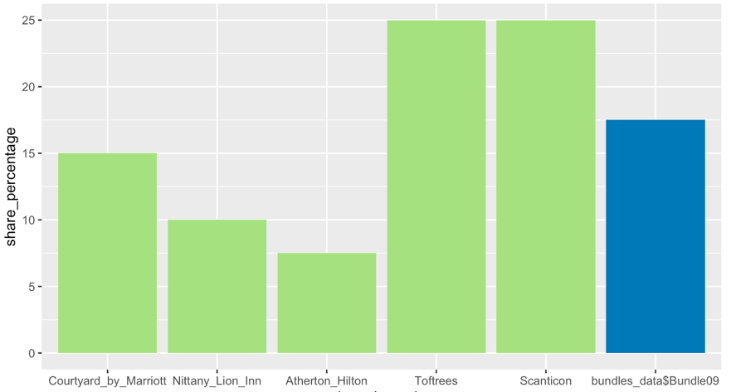

Figure 24: The chart of market share percentage for Bundle09 and existing hotel room Bundles

When launching the most preferred bundle selected from conjoint analysis (Bundle 09) to a competing market which consists of given existing hotels, “Toftrees”, and “Scanticon” would be the most competitive duo as the market share of those two are the highest in the market and are higher than that of Bundle 09 as well (Table 12, Figure24).

1. When launching Bundle09 (most preferred) to the competitive market with new hotel rooms.

|  |  |  |
| --- | --- | --- |
| **Bundle name** | **Freq** | **share_percentage**  **%** |
| Professional01 | 9 | 22.5 |
| Professional02 | 10 | 25 |
| Tourist | 7 | 17.5 |
| Deluxe | 4 | 10 |
| bundles_data$Bundle09 | 10 | 25 |

Table 13: market share percentage for Bundle09 and new hotel room Bundles

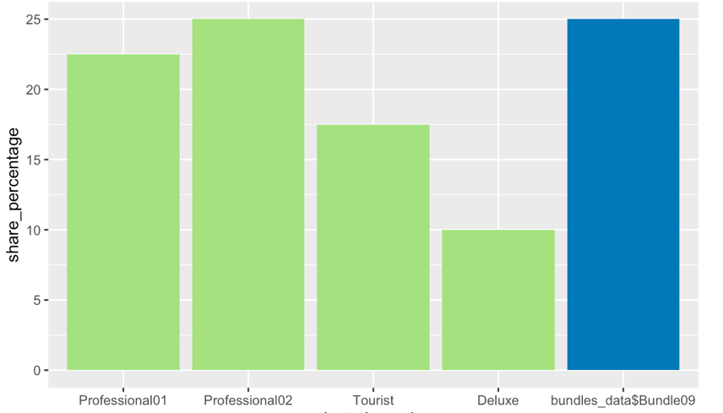

Figure 25: The chart of market share percentage for Bundle09 and new hotel room Bundles

When launching Bundle 09 to a competitive market which consists of proposed new hotels, “Professional02” would be the most competitive room bundle. Its market share is as the same as the market share of Bundle 09(Table 13, Figure25).

1. **Summary and Recommendations:**

* The most attractive feature in the market - Room
* In general, small suite, speaker phones, small exercise room and small pool combo, complimentary fruit and cheese bowl, and restaurant delivery via room service are most attractive amenities of all respondents.
* The most preferred bundle of the surveyed population is Bundle 09 which includes
  + *small suite,*
  + *room fax,*
  + *exercise room and pool,*
  + *fruit and cheese*
  + *no restaurant delivery*
* The most preferred bundle for 10th respondent is Bundle 16 and that for 26th respondent is Bundle 08
* There are two segments in the market.
  + *business class*
  + *family oriented people who like to relax*
* In case of launching the most preferred bundle (Bundle 09) to the market which consists of existing hotels, **Toftrees** and **Scanticon** would be the biggest competitors to look for.
* In case of launching the most preferred bundle (Bundle 09) to the market which consist of new hotel room bundles, Professional 02 bundle would be the greatest competitor.
* Forte Executive Inn should be targeting the cluster_1 (Business class) as their goal is attracting European business class who travels to United Sates and American business class.

**Appendix:**

Table A: partworth utilities of all respondents

|  |  |  |  |  |  |  |  |  |  |  |  |  |  |  |  |  |
| --- | --- | --- | --- | --- | --- | --- | --- | --- | --- | --- | --- | --- | --- | --- | --- | --- |
|  | intercept | Small Suite | Large Room | Room Office | Internet access | Speaker phone | Room fax | Exercise room | Pool | Exercise room and Pool | Shoe shine | Tape library | Fruit and cheese | News paper | Yes | No |
| 1 | 40.25 | -5.25 | 1.75 | 3.5 | 23.625 | -6.75 | -16.875 | -4.75 | 1.75 | 3 | 6.062 | -2.188 | 3.063 | -6.938 | -3.813 | 3.813 |
| 2 | 41.458 | -4.333 | 15.667 | -11.333 | -2.875 | 3.5 | -0.625 | -14.75 | 14 | 0.75 | 1 | -1 | 1.25 | -1.25 | 4.5 | -4.5 |
| 3 | 46.583 | 12.292 | -10.583 | -1.708 | 8.125 | -10.25 | 2.125 | 0.375 | 6.75 | -7.125 | -8.562 | 3.438 | -2.813 | 7.938 | 8.063 | -8.063 |
| 4 | 44.417 | -1.75 | -8.75 | 10.5 | 0.167 | 10.917 | -11.083 | -5.458 | 5.417 | 0.042 | 8.937 | -0.563 | -10.812 | 2.438 | -8.313 | 8.313 |
| 5 | 54.5 | 10.583 | -17.667 | 7.083 | -7.542 | 5.833 | 1.708 | -7.542 | 5.833 | 1.708 | 8.5 | -8.75 | 2.75 | -2.5 | 5.375 | -5.375 |
| 6 | 43.167 | 20.625 | -17.25 | -3.375 | -0.75 | 1.25 | -0.5 | -13.167 | -0.417 | 13.583 | 1.187 | -0.563 | -0.812 | 0.188 | -8.063 | 8.063 |
| 7 | 30.125 | 6.417 | -0.833 | -5.583 | -2.208 | 9.667 | -7.458 | -5.083 | -8.833 | 13.917 | -2.875 | 6.125 | 1.375 | -4.625 | -4.375 | 4.375 |
| 8 | 35.917 | 4.542 | -7.083 | 2.542 | -13.333 | -2.583 | 15.917 | -0.25 | -3.25 | 3.5 | -2.437 | -0.938 | -6.438 | 9.812 | -6.563 | 6.563 |
| 9 | 45.083 | 0.583 | -10.917 | 10.333 | -1 | 10.75 | -9.75 | 7.208 | -5.417 | -1.792 | -2.687 | -9.938 | 11.562 | 1.063 | 6.688 | -6.688 |
| 10 | 47.708 | 0.708 | 8.583 | -9.292 | -0.25 | -8.25 | 8.5 | -1.292 | -13.417 | 14.708 | -3.688 | -7.688 | 8.312 | 3.063 | 4.938 | -4.938 |
| 11 | 42.875 | -9.667 | 13.083 | -3.417 | 1.833 | -1.917 | 0.083 | 25.833 | -4.917 | -20.917 | -0.937 | 4.312 | -4.187 | 0.812 | 1.188 | -1.188 |
| 12 | 43.833 | -4.167 | -10.667 | 14.833 | 1.5 | -5 | 3.5 | 4.333 | -0.667 | -3.667 | -8 | -2.5 | 4 | 6.5 | 12.5 | -12.5 |
| 13 | 38.125 | 6.125 | -8 | 1.875 | -6.792 | -1.667 | 8.458 | 3.042 | -3.333 | 0.292 | 17.875 | -2.125 | -4.125 | -11.625 | -3.25 | 3.25 |
| 14 | 46.833 | -7.125 | 9.75 | -2.625 | -0.792 | 10.083 | -9.292 | 14.208 | 0.083 | -14.292 | 2.688 | 4.938 | -5.062 | -2.563 | 7.188 | -7.188 |
| 15 | 49.083 | -1 | 14 | -13 | 4.292 | -7.833 | 3.542 | -3.375 | 12.5 | -9.125 | 2.75 | -8.25 | 7 | -1.5 | 5.25 | -5.25 |
| 16 | 46.208 | -1.125 | 7.75 | -6.625 | -7.375 | 6.75 | 0.625 | -5.583 | -12.083 | 17.667 | -1.313 | -6.063 | 1.938 | 5.438 | -9.812 | 9.812 |
| 17 | 41.792 | -14.417 | -9.167 | 23.583 | -8.958 | -2.333 | 11.292 | 3.083 | 0.833 | -3.917 | -1.625 | 4.875 | 1.625 | -4.875 | -2.875 | 2.875 |
| 18 | 38.417 | 12.75 | -12.25 | -0.5 | -3.542 | 11.583 | -8.042 | 0.25 | -5.25 | 5 | -1.187 | -3.938 | 3.313 | 1.813 | -5.563 | 5.563 |
| 19 | 36.792 | -0.708 | -9.333 | 10.042 | -6.333 | -9.833 | 16.167 | -7.25 | 6.5 | 0.75 | 1.125 | 3.875 | -4.625 | -0.375 | 1.375 | -1.375 |
| 20 | 39.125 | -12.583 | -2.833 | 15.417 | -1 | 9.5 | -8.5 | -3.042 | 1.333 | 1.708 | 3.125 | -9.125 | 8.625 | -2.625 | 6.5 | -6.5 |
| 21 | 51.042 | 30.333 | 4.083 | -34.417 | 2.417 | 1.417 | -3.833 | 1.083 | -4.917 | 3.833 | -2.187 | -2.188 | 2.062 | 2.312 | -2.688 | 2.688 |
| 22 | 37.208 | 8.167 | -0.083 | -8.083 | -0.708 | 10.417 | -9.708 | -6.292 | 10.083 | -3.792 | 7.938 | -1.562 | 1.937 | -8.312 | -4.313 | 4.313 |
| 23 | 46.083 | -6.792 | 6.833 | -0.042 | 0.75 | 12 | -12.75 | -14.042 | 10.833 | 3.208 | -6 | 4.75 | -0.75 | 2 | 6 | -6 |
| 24 | 47.083 | 18.333 | -16.667 | -1.667 | 7.833 | -7.667 | -0.167 | 2 | 5 | -7 | 2 | -5.5 | 0.5 | 3 | 1.75 | -1.75 |
| 25 | 42.917 | 5.667 | -15.333 | 9.667 | -1.792 | 11.833 | -10.042 | -1.042 | -0.167 | 1.208 | -2.25 | -7 | 13 | -3.75 | -3.375 | 3.375 |
| 26 | 43.167 | -9.917 | 2.583 | 7.333 | -3.083 | -7.083 | 10.167 | 4.708 | 0.083 | -4.792 | 10.187 | -2.562 | -8.562 | 0.937 | -7.938 | 7.938 |
| 27 | 44.458 | 21.417 | 1.167 | -22.583 | -6.667 | 9.833 | -3.167 | 4.542 | -5.333 | 0.792 | -3.875 | 3.375 | 0.625 | -0.125 | 5.25 | -5.25 |
| 28 | 41.833 | -2 | -9.5 | 11.5 | 0.792 | 3.667 | -4.458 | -11.625 | 11 | 0.625 | -3.625 | 1.625 | 6.625 | -4.625 | 4.75 | -4.75 |
| 29 | 40.792 | 16.083 | -12.667 | -3.417 | 9.208 | 0.833 | -10.042 | -1.083 | 5.667 | -4.583 | -1.25 | -5.75 | 1 | 6 | 7.25 | -7.25 |
| 30 | 42.208 | 10.792 | -8.333 | -2.458 | -11.833 | 0.167 | 11.667 | 2.333 | -3.167 | 0.833 | 0.875 | -2.375 | 8.125 | -6.625 | -9.375 | 9.375 |
| 31 | 46.208 | 5.75 | -8.5 | 2.75 | -1.583 | -8.833 | 10.417 | 1.125 | 3 | -4.125 | -8.625 | -0.125 | 5.875 | 2.875 | 8.125 | -8.125 |
| 32 | 47.667 | -4.583 | 20.167 | -15.583 | 2.792 | -6.333 | 3.542 | -1.375 | 11 | -9.625 | -3.625 | 2.875 | 1.125 | -0.375 | -4.875 | 4.875 |
| 33 | 44.125 | -6.917 | -1.167 | 8.083 | -12.625 | 10 | 2.625 | -0.833 | -10.833 | 11.667 | -2.125 | 1.625 | -5.375 | 5.875 | -5.75 | 5.75 |
| 34 | 48.417 | 8.833 | -14.167 | 5.333 | -15.458 | -4.333 | 19.792 | -3.292 | 0.333 | 2.958 | 3.125 | 1.375 | -3.625 | -0.875 | -6.75 | 6.75 |
| 35 | 39.833 | 12.875 | 0 | -12.875 | 6.542 | -0.333 | -6.208 | -8.25 | -0.5 | 8.75 | -4.125 | 0.375 | 1.875 | 1.875 | 5 | -5 |
| 36 | 41.708 | -0.333 | -13.583 | 13.917 | -6.958 | 5.917 | 1.042 | 4.458 | -6.417 | 1.958 | -12.938 | -3.688 | 14.563 | 2.063 | -2.062 | 2.062 |
| 37 | 47.083 | -0.542 | -12.417 | 12.958 | -1.75 | -7.25 | 9 | 8.333 | 0.083 | -8.417 | -1.438 | 0.312 | -4.937 | 6.062 | -7.687 | 7.687 |
| 38 | 45.167 | 9.458 | -12.167 | 2.708 | 5.25 | -6 | 0.75 | -16.875 | 0.5 | 16.375 | -5.75 | 3 | -2 | 4.75 | -5.25 | 5.25 |
| 39 | 51.583 | 0.583 | 12.083 | -12.667 | -7.708 | 3.917 | 3.792 | 8.917 | -15.583 | 6.667 | 4.812 | 0.563 | -4.688 | -0.687 | 3.938 | -3.938 |
| 40 | 46.667 | -9.708 | 2.667 | 7.042 | -0.958 | -9.333 | 10.292 | 0.5 | 7.5 | -8 | 13.125 | -3.625 | -7.875 | -1.625 | 7.375 | -7.375 |

Table B: Total utilities of all respondents

|  |  |  |  |  |  |  |  |  |  |  |  |  |  |  |  |  |
| --- | --- | --- | --- | --- | --- | --- | --- | --- | --- | --- | --- | --- | --- | --- | --- | --- |
|  | V1 | V2 | V3 | V4 | V5 | V6 | V7 | V8 | V9 | V10 | V11 | V12 | V13 | V14 | V15 | V16 |
| 1 | 56.13 | 48.13 | 30.88 | 46.88 | 24.00 | 69.00 | 34.00 | 22.00 | 28.00 | 29.75 | 76.00 | 36.25 | 26.88 | 16.13 | 29.13 | 57.88 |
| 2 | 25.00 | 57.88 | 49.00 | 71.13 | 58.13 | 62.75 | 37.88 | 36.25 | 34.00 | 51.63 | 38.00 | 80.38 | 48.88 | 73.75 | 13.13 | 58.25 |
| 3 | 66.88 | 2.00 | 53.25 | 15.88 | 66.88 | 46.25 | 39.00 | 33.88 | 43.00 | 31.38 | 48.88 | 37.75 | 55.25 | 60.88 | 34.88 | 53.00 |
| 4 | 38.00 | 63.88 | 49.88 | 69.25 | 50.13 | 49.00 | 57.00 | 26.88 | 29.13 | 22.00 | 58.00 | 32.88 | 69.75 | 24.13 | 71.13 | 30.00 |
| 5 | 63.88 | 47.50 | 83.00 | 51.63 | 73.38 | 21.00 | 65.75 | 16.88 | 65.88 | 43.25 | 57.25 | 56.63 | 68.88 | 47.25 | 52.00 | 33.88 |
| 6 | 43.00 | 50.00 | 32.00 | 36.00 | 56.00 | 32.25 | 46.00 | 19.75 | 84.13 | 5.13 | 45.88 | 17.88 | 72.88 | 17.13 | 36.13 | 30.88 |
| 7 | 22.00 | 54.38 | 1.00 | 31.63 | 39.13 | 28.75 | 49.88 | 27.25 | 48.75 | 30.88 | 19.25 | 27.13 | 37.13 | 4.00 | 28.88 | 32.00 |
| 8 | 17.88 | 33.88 | 42.13 | 27.13 | 27.13 | 17.88 | 31.88 | 50.13 | 60.00 | 13.00 | 22.00 | 10.00 | 51.00 | 44.75 | 52.00 | 22.25 |
| 9 | 55.88 | 33.75 | 44.25 | 30.13 | 47.75 | 11.13 | 61.13 | 15.00 | 39.00 | 70.38 | 53.88 | 57.75 | 45.38 | 26.75 | 67.75 | 39.13 |
| 10 | 48.13 | 54.13 | 34.75 | 26.00 | 24.00 | 30.00 | 42.13 | 50.88 | 75.00 | 60.00 | 28.13 | 47.88 | 24.88 | 59.38 | 27.00 | 78.75 |
| 11 | 61.13 | 31.00 | 34.88 | 47.00 | 31.88 | 56.00 | 22.13 | 85.00 | 7.00 | 76.88 | 31.00 | 46.13 | 26.00 | 53.13 | 63.00 | 38.88 |
| 12 | 50.00 | 4.00 | 66.00 | 7.00 | 44.00 | 19.00 | 60.00 | 26.00 | 31.00 | 49.00 | 51.00 | 44.00 | 28.00 | 55.00 | 52.00 | 50.00 |
| 13 | 55.13 | 49.88 | 59.75 | 46.25 | 33.88 | 21.13 | 33.25 | 42.75 | 52.13 | 24.13 | 29.00 | 17.75 | 30.88 | 20.38 | 33.00 | 8.75 |
| 14 | 63.00 | 47.88 | 44.88 | 62.25 | 62.00 | 53.63 | 52.13 | 59.25 | 3.88 | 83.00 | 31.25 | 68.88 | 40.13 | 52.00 | 58.75 | 46.13 |
| 15 | 57.00 | 43.63 | 60.13 | 65.25 | 49.75 | 66.38 | 16.13 | 49.75 | 44.25 | 64.13 | 54.63 | 80.00 | 46.00 | 82.88 | 18.13 | 62.00 |
| 16 | 21.00 | 86.88 | 17.00 | 57.13 | 23.88 | 38.25 | 48.13 | 52.75 | 75.13 | 47.25 | 31.88 | 40.75 | 55.00 | 38.13 | 56.00 | 59.88 |
| 17 | 17.00 | 27.63 | 73.00 | 32.38 | 27.88 | 32.25 | 61.13 | 54.75 | 39.25 | 32.13 | 61.75 | 29.88 | 23.88 | 37.00 | 64.13 | 12.00 |
| 18 | 41.13 | 47.13 | 17.88 | 36.88 | 48.00 | 19.00 | 45.00 | 20.00 | 57.00 | 35.75 | 38.00 | 30.25 | 64.88 | 9.13 | 57.13 | 23.88 |
| 19 | 25.00 | 18.13 | 72.00 | 23.88 | 38.00 | 30.13 | 43.00 | 38.88 | 47.00 | 7.13 | 41.00 | 20.88 | 31.00 | 51.13 | 28.00 | 22.88 |
| 20 | 32.13 | 44.13 | 57.00 | 43.75 | 34.75 | 21.00 | 63.13 | 9.13 | 21.88 | 57.88 | 57.00 | 62.25 | 28.25 | 33.00 | 51.88 | 40.88 |
| 21 | 80.00 | 60.88 | 3.00 | 52.13 | 73.00 | 53.13 | 17.00 | 52.88 | 86.13 | 57.00 | 18.88 | 51.00 | 82.88 | 46.00 | 24.13 | 61.00 |
| 22 | 42.00 | 56.00 | 33.13 | 69.88 | 60.00 | 49.25 | 29.88 | 23.88 | 38.13 | 38.88 | 44.75 | 55.25 | 61.88 | 24.88 | 29.25 | 20.00 |
| 23 | 26.00 | 56.13 | 44.13 | 63.75 | 72.88 | 63.25 | 72.00 | 24.88 | 23.00 | 56.13 | 50.88 | 81.00 | 58.13 | 59.00 | 40.00 | 64.88 |
| 24 | 79.00 | 16.00 | 54.00 | 28.00 | 59.00 | 36.00 | 27.00 | 25.00 | 57.00 | 27.00 | 57.00 | 30.00 | 64.00 | 40.00 | 41.00 | 36.00 |
| 25 | 40.13 | 41.75 | 36.75 | 40.38 | 49.88 | 22.00 | 55.25 | 12.88 | 56.13 | 48.00 | 67.00 | 48.88 | 59.88 | 10.25 | 63.00 | 19.88 |
| 26 | 37.13 | 52.00 | 63.00 | 56.88 | 15.75 | 48.13 | 28.13 | 66.00 | 38.00 | 26.88 | 46.88 | 22.25 | 35.13 | 49.00 | 57.00 | 30.88 |
| 27 | 65.13 | 47.13 | 14.75 | 41.00 | 79.00 | 31.75 | 41.13 | 45.13 | 58.88 | 65.88 | 5.25 | 56.00 | 65.00 | 42.25 | 30.88 | 44.88 |
| 28 | 30.13 | 28.25 | 61.00 | 38.63 | 60.88 | 41.00 | 64.00 | 13.13 | 37.88 | 35.75 | 67.00 | 58.38 | 45.13 | 39.00 | 36.00 | 33.88 |
| 29 | 71.00 | 15.88 | 39.00 | 26.13 | 64.88 | 30.00 | 35.13 | 4.00 | 36.00 | 36.13 | 46.00 | 42.88 | 62.13 | 37.00 | 35.88 | 46.00 |
| 30 | 35.00 | 45.13 | 39.75 | 41.13 | 38.25 | 25.88 | 29.00 | 54.88 | 83.00 | 35.13 | 42.25 | 29.63 | 52.75 | 26.38 | 45.00 | 6.88 |
| 31 | 51.00 | 8.00 | 61.88 | 15.13 | 54.13 | 30.88 | 44.00 | 41.00 | 56.00 | 44.00 | 48.13 | 45.88 | 40.88 | 62.13 | 36.00 | 43.00 |
| 32 | 36.00 | 53.13 | 38.13 | 73.75 | 45.75 | 89.38 | 14.13 | 77.75 | 43.00 | 56.38 | 51.88 | 68.75 | 52.25 | 77.13 | 28.88 | 55.75 |
| 33 | 15.88 | 68.25 | 36.13 | 45.75 | 32.25 | 26.88 | 69.75 | 52.13 | 51.88 | 41.00 | 29.13 | 31.00 | 48.00 | 34.88 | 73.00 | 42.13 |
| 34 | 34.88 | 42.75 | 70.25 | 40.13 | 47.88 | 27.25 | 47.00 | 58.88 | 83.13 | 16.25 | 41.75 | 19.88 | 59.13 | 46.75 | 52.00 | 14.13 |
| 35 | 51.88 | 39.13 | 21.13 | 29.88 | 57.25 | 41.25 | 40.75 | 20.75 | 52.13 | 38.13 | 29.88 | 45.88 | 48.75 | 40.00 | 15.25 | 62.00 |
| 36 | 23.88 | 25.13 | 35.25 | 16.75 | 35.13 | 13.13 | 57.75 | 32.00 | 61.00 | 51.00 | 58.88 | 40.13 | 45.00 | 22.75 | 70.13 | 23.13 |
| 37 | 44.00 | 25.25 | 60.00 | 33.75 | 32.00 | 41.00 | 37.00 | 60.00 | 49.88 | 23.13 | 61.13 | 14.88 | 53.13 | 42.13 | 74.88 | 22.88 |
| 38 | 32.00 | 42.88 | 38.13 | 27.00 | 46.88 | 47.00 | 56.00 | 25.13 | 75.00 | 2.88 | 56.88 | 20.25 | 59.13 | 33.75 | 35.00 | 54.13 |
| 39 | 62.13 | 75.13 | 35.88 | 52.88 | 45.00 | 37.00 | 54.00 | 73.00 | 54.00 | 75.75 | 7.00 | 51.25 | 35.88 | 55.13 | 47.13 | 65.88 |
| 40 | 57.00 | 37.75 | 92.00 | 53.25 | 38.88 | 44.88 | 40.13 | 49.13 | 24.00 | 40.00 | 45.00 | 47.00 | 26.13 | 72.88 | 35.88 | 46.13 |
| Total | 1717.25 | 1634.13 | 1769.00 | 1626.63 | 1845.13 | 1454.75 | 1733.63 | 1527.50 | 1921.50 | 1620.13 | 1673.25 | 1669.13 | 1903.13 | 1651.00 | 1735.13 | 1536.75 |

**References:**

1.<https://www.slideshare.net/MinhaHwang/conjoint-analysis-part-33-market-simulator>

2.<https://www.r-bloggers.com/2018/12/conjoint-analysis-understand-your-customer-and-beat-the-competition/>

3. https://faculty.idc.ac.il/jgoldenberg/pdf/Conjoint.pdf