**NAGARJUNA COLLEGE OF INFORMATION TECHNOLOGY**

Statistics Practical No.: 01

Programme: B.Sc.CSIT Semester: Third semester

Roll No. 09/080 Date: 2081/11/15

Subject code: STA 215

**QUESTION**: The following observations of heights of children are given in below. Find standard error of given information and also find 95% confidence interval for population mean.

|  |  |  |  |  |  |  |  |  |  |
| --- | --- | --- | --- | --- | --- | --- | --- | --- | --- |
| 78 | 55 | 68 | 48 | 65 | 76 | 57 | 55 | 65 | 75 |
| 51 | 61 | 68 | 67 | 76 | 78 | 71 | 56 | 57 | 67 |
| 58 | 51 | 50 | 58 | 50 | 77 | 55 | 48 | 70 | 55 |
| 58 | 70 | 56 | 52 | 74 | 61 | 69 | 76 | 61 | 68 |
| 78 | 56 | 78 | 57 | 66 | 66 | 74 | 66 | 48 | 73 |
| 71 | 70 | 62 | 74 | 76 | 50 | 69 | 75 | 65 | 48 |

**WORKING EXPRESSION**:

**CALCULATION**: Using SPSS,

**(I) DATA:**

height(in cm) :

|  |  |  |  |  |  |  |  |  |  |
| --- | --- | --- | --- | --- | --- | --- | --- | --- | --- |
| 78 | 55 | 68 | 48 | 65 | 76 | 57 | 55 | 65 | 75 |
| 51 | 61 | 68 | 67 | 76 | 78 | 71 | 56 | 57 | 67 |
| 58 | 51 | 50 | 58 | 50 | 77 | 55 | 48 | 70 | 55 |
| 58 | 70 | 56 | 52 | 74 | 61 | 69 | 76 | 61 | 68 |
| 78 | 56 | 78 | 57 | 66 | 66 | 74 | 66 | 48 | 73 |
| 71 | 70 | 62 | 74 | 76 | 50 | 69 | 75 | 65 | 48 |

**(II) SYNTAX:**

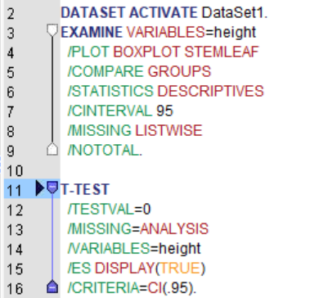

**(III) OUTPUT:**

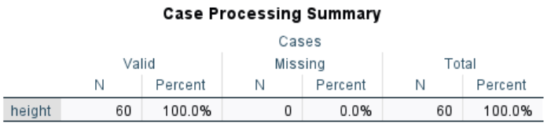

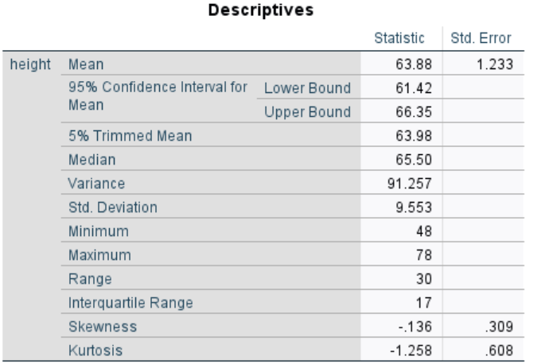

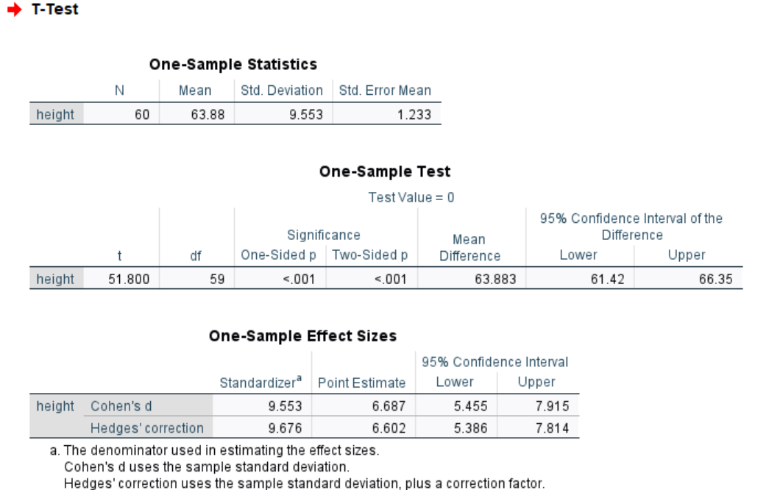

**RESULTS**:

**NAGARJUNA COLLEGE OF INFORMATION TECHNOLOGY**

Statistics Practical No.: 02

Programme: B.Sc.CSIT Semester: Third semester

Roll No. 09/080 Date: 2081/11/15

Subject code: STA 215

**QUESTION**: The time (in minutes) spent by 10 randomly selected customers using internet in a cyber café is as follows: 35, 20, 30, 45, 60, 40, 65, 40, 25, 50. Can you say that the average time by customers is more than 30 minutes at 5% level of significance?

**WORKING EXPRESSION**:

**CALCULATION**: Using SPSS,

**(I) DATA:**

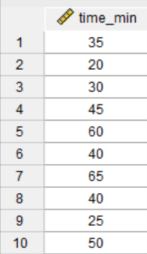

**(II) SYNTAX:**

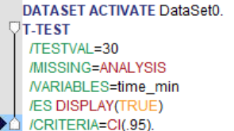

**(III) OUTPUT:**

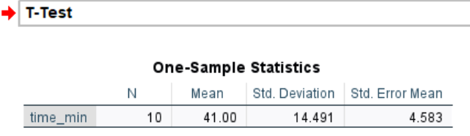

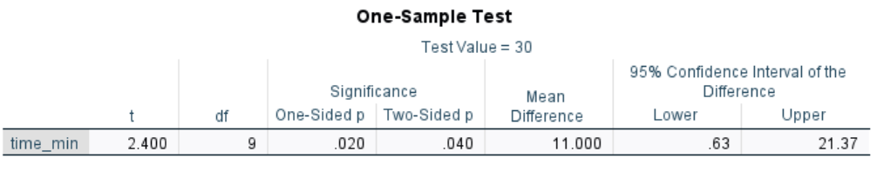

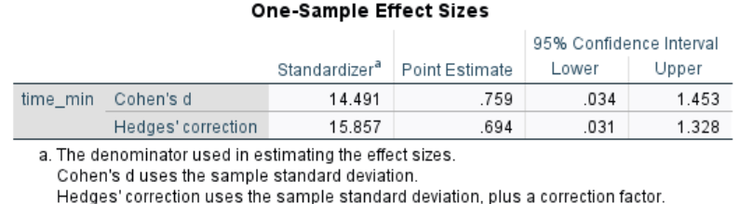

**RESULTS**:

**NAGARJUNA COLLEGE OF INFORMATION TECHNOLOGY**

Statistics Practical No.: 03

Programme: B.Sc.CSIT Semester: Third semester

Roll No. 09/080 Date: 2081/11/21

Subject code: STA 215

**QUESTION**: Two kinds of manure were applied to sixteen one-hectare plot, other conditions remaining to the same. The yields in quintals are given below:

|  |  |  |  |  |  |  |  |  |  |
| --- | --- | --- | --- | --- | --- | --- | --- | --- | --- |
| Manure-I | 18 | 20 | 36 | 50 | 49 | 36 | 34 | 49 | 41 |
| Manure-II | 29 | 28 | 26 | 35 | 30 | 44 | 46 |  |

Is there any significance difference between the mean yields? Use 5% level of significance.

**WORKING EXPRESSION**:

**CALCULATION**: Using SPSS,

1. **DATA:**

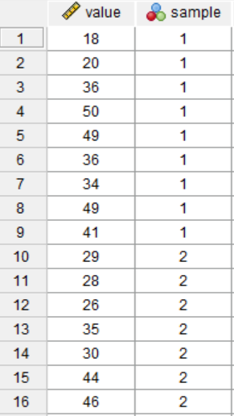

**(II) SYNTAX:**

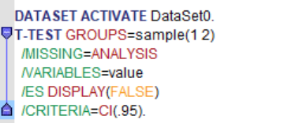

**(III) OUTPUT:**

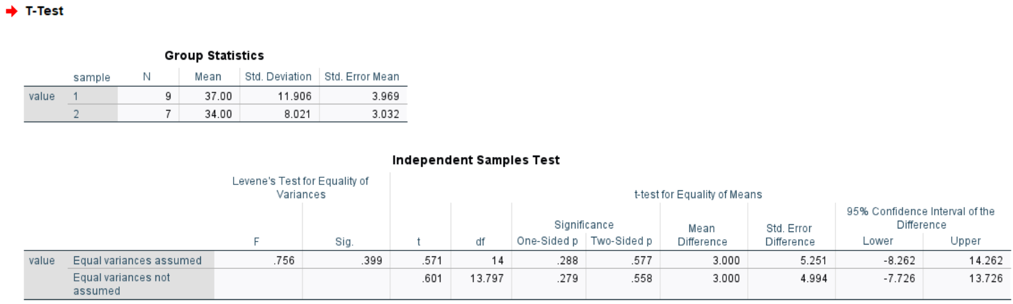

**RESULTS**:

**NAGARJUNA COLLEGE OF INFORMATION TECHNOLOGY**

Statistics Practical No.: 04

Programme: B.Sc.CSIT Semester: Third semester

Roll No. 09/080 Date: 2081/11/21

Subject code: STA 215

**QUESTION**: Memory capacity of 10 students was tested and after training, state whether the training was effective or not from the following scores:

|  |  |  |  |  |  |  |  |  |  |  |
| --- | --- | --- | --- | --- | --- | --- | --- | --- | --- | --- |
| Roll No. | 1 | 2 | 3 | 4 | 5 | 6 | 7 | 8 | 9 | 10 |
| Before | 12 | 14 | 11 | 8 | 7 | 10 | 3 | 0 | 5 | 6 |
| After | 15 | 16 | 10 | 7 | 5 | 12 | 10 | 2 | 3 | 8 |

**WORKING EXPRESSION**:

**CALCULATION**: Using SPSS,

**(I) DATA:**

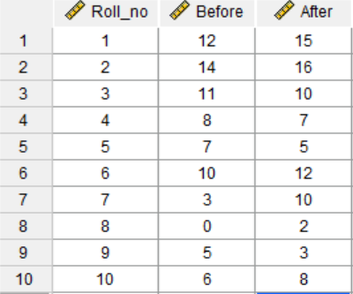

**(II) SYNTAX:**

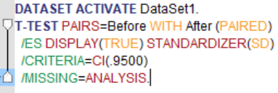

**(III) OUTPUT:**

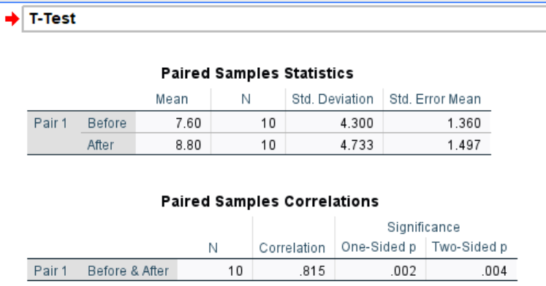

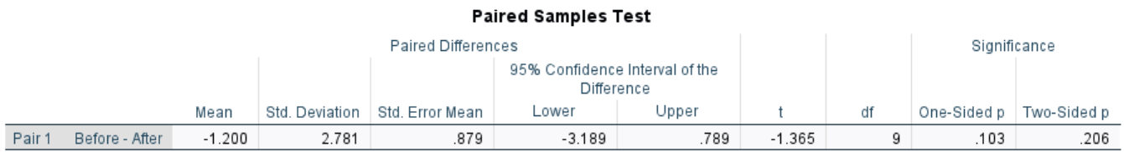

**RESULTS**:

**NAGARJUNA COLLEGE OF INFORMATION TECHNOLOGY**

Statistics Practical No.: 05

Programme: B.Sc.CSIT Semester: Third semester

Roll No. 09/080 Date: 2081/11/22

Subject code: STA 215

**QUESTION**: A developer of food for pig wish to determine what relationship exists among ‘age of pig’ when it starts receiving a newly developed food supplement, the initial weights of the pig and the amount of weight it gains in a week period

|  |  |  |  |  |  |  |  |  |
| --- | --- | --- | --- | --- | --- | --- | --- | --- |
| Piglet number | 1 | 2 | 3 | 4 | 5 | 6 | 7 | 8 |
| Initial weight(lbs)x1 | 39 | 52 | 49 | 46 | 61 | 35 | 25 | 55 |
| Initial age(weeks)x2 | 8 | 6 | 7 | 12 | 9 | 6 | 7 | 4 |
| Weight gain(y) | 7 | 6 | 8 | 10 | 9 | 5 | 3 | 4 |

(i) Determine the least square equation that best describes these three variables?

(ii) Calculate the standard error.

(iii) How much gain in weight of a pig in a week can we expect with the food supplement if it were 9 weeks old and weighed 48 pounds?

(iv) Test the significance of regression coefficients and overall fit the regression equation.

(v) Conduct the residual analysis.

(vi) Determine partial correlations, multiple correlation and coefficient of multiple correlation. Determine and interpret.

**WORKING EXPRESSION**:

**CALCULATION**: Using SPSS,

**(I) DATA:**

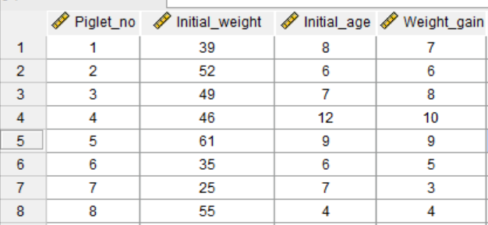

**(II) SYNTAX:**

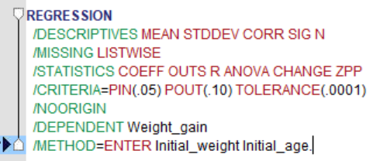

**(III) OUTPUT:**

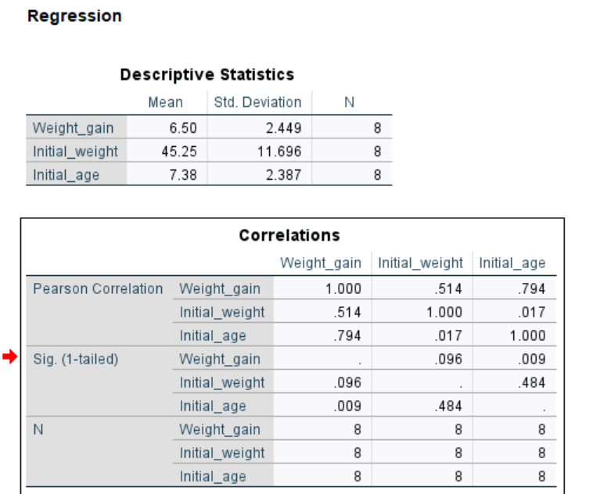

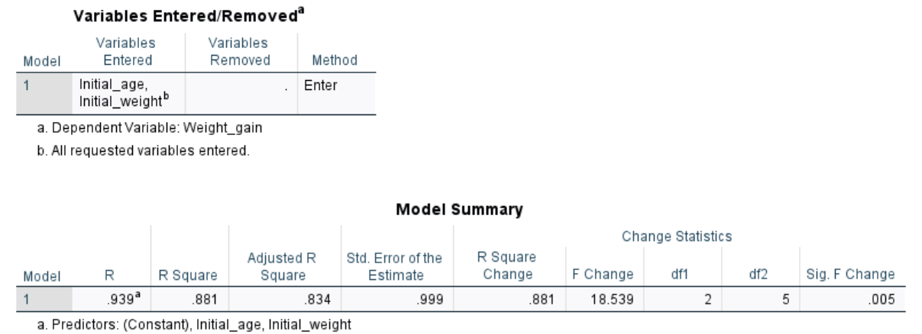

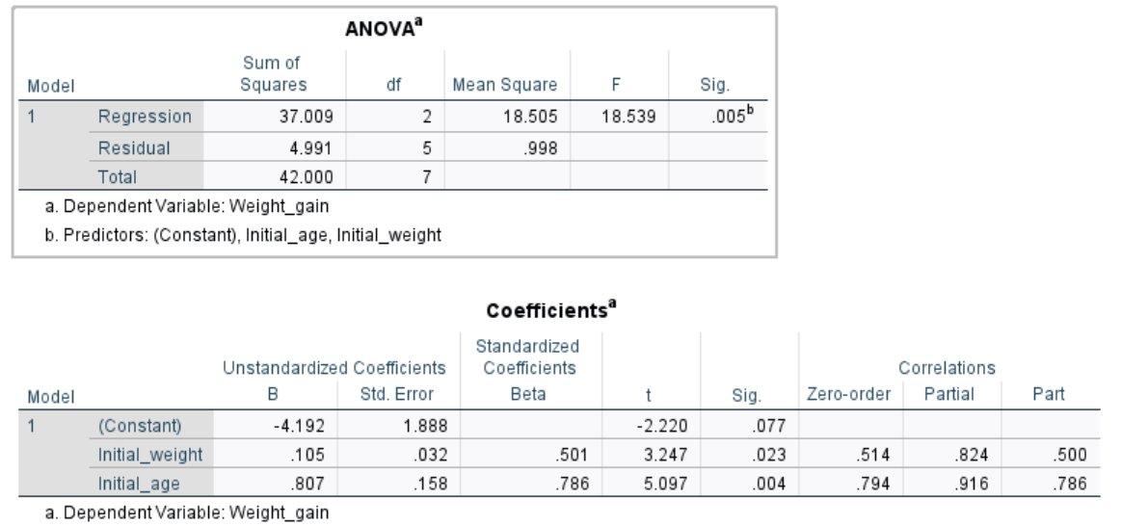

**RESULTS**:

**NAGARJUNA COLLEGE OF INFORMATION TECHNOLOGY**

Statistics Practical No.: 06

Programme: B.Sc.CSIT Semester: Third semester

Roll No. 09/080 Date: 2081/11/22

Subject code: STA 215

**QUESTION**: The yields of treatments in different plots are as shown in the following plots. Carry out analysis of CRD.

|  |  |  |  |  |  |
| --- | --- | --- | --- | --- | --- |
| t1 1401 | t2 2536 | t3 2459 | t1 2537 | t3 2827 | t1 2069 |
| t2 2211 | t1 1797 | t4 1170 | t4 1516 | t4 2104 | t3 2385 |
| t2 3366 | t1 2104 | t2 2591 | t 2460 | t 1077 | t 2544 |

**WORKING EXPRESSION**:

**CALCULATION**: Using SPSS,

**(I) DATA:**

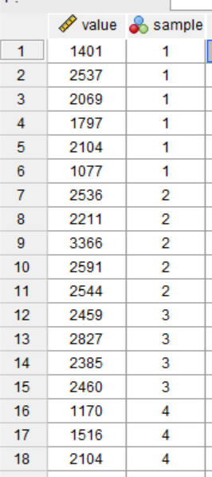

**(II) SYNTAX:**

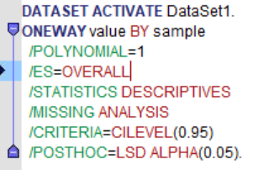

**(III) OUTPUT:**

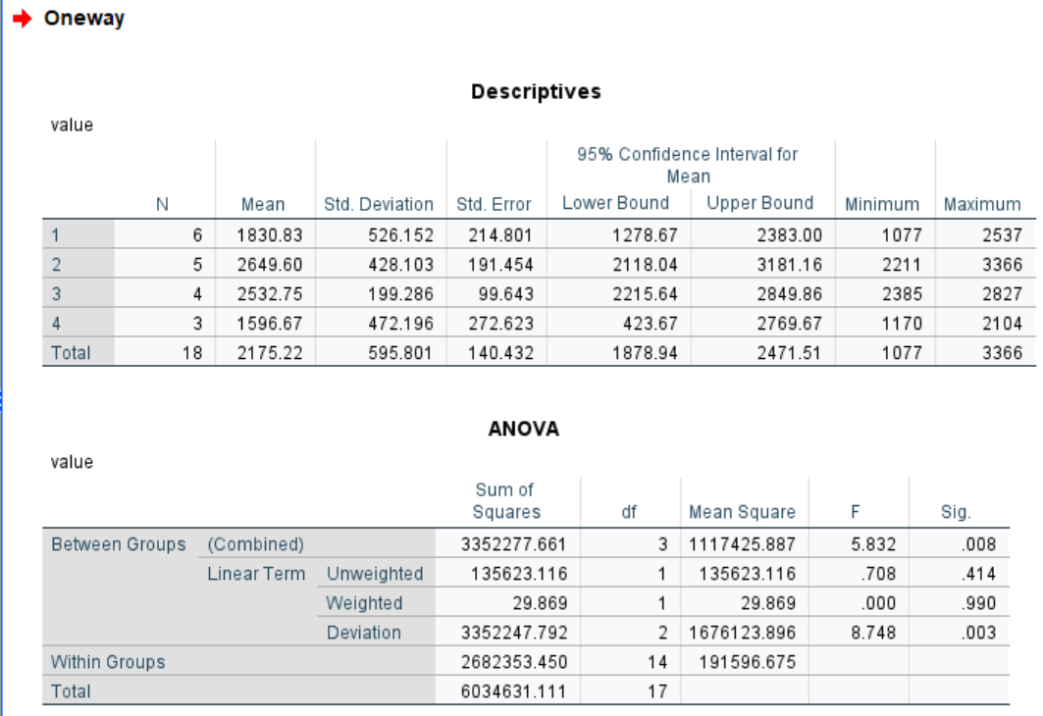

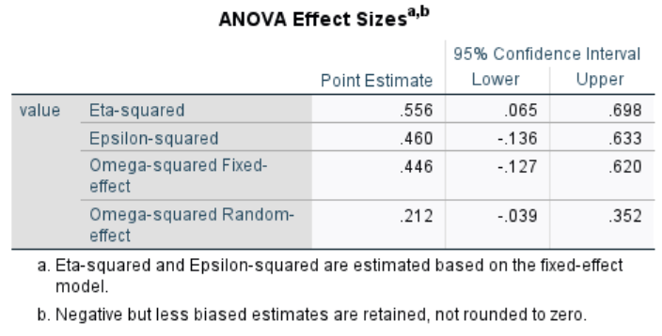

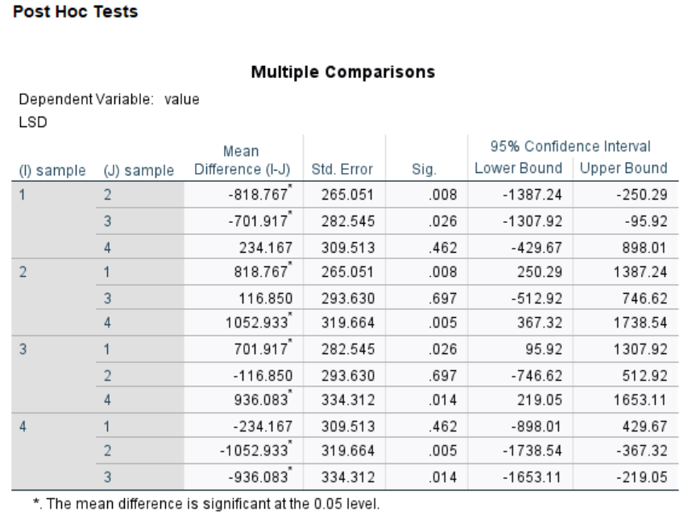

**RESULTS**:

**NAGARJUNA COLLEGE OF INFORMATION TECHNOLOGY**

Statistics Practical No.: 07

Programme: B.Sc.CSIT Semester: Third semester

Roll No. 09/080 Date: 2081/11/23

Subject code: STA 215

**QUESTION**: The yields of treatments in different plots are as shown in the following plots.

Carry out analysis of CRD.

|  |  |  |  |  |
| --- | --- | --- | --- | --- |
| Block1 | Block2 | Block3 | Block4 | Block5 |
| A 32 | B 33 | D 30 | A 35 | C 36 |
| B 34 | C 34 | C 35 | C 32 | D 29 |
| C 31 | A 34 | B 36 | B 37 | A 37 |
| D 29 | D 26 | A 33 | D 28 | B 35 |

Analysis the above result to test whether there is significant difference between yields of four varieties.

**WORKING EXPRESSION**:

**CALCULATION**: Using SPSS,

**(I) DATA:**

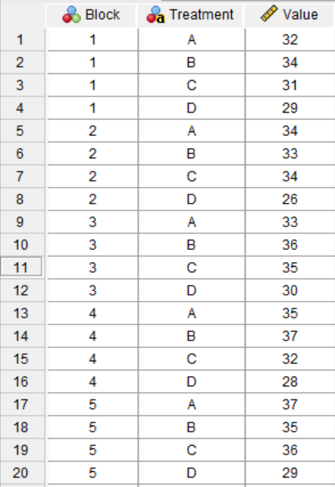

**(II) SYNTAX:**

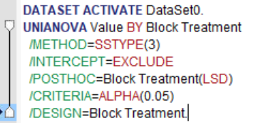

**(III) OUTPUT:**

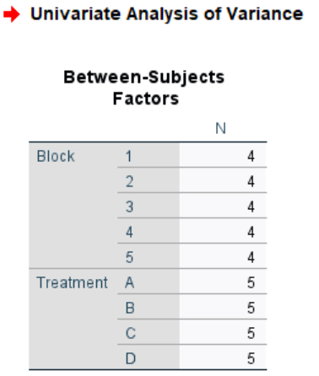

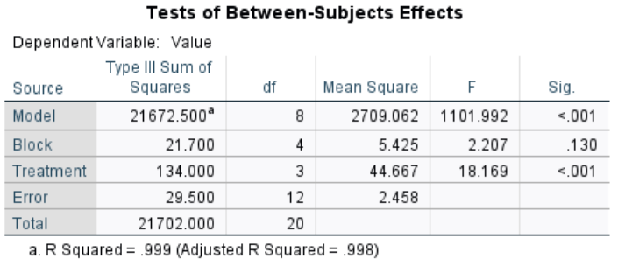

**RESULTS**:

**NAGARJUNA COLLEGE OF INFORMATION TECHNOLOGY**

Statistics Practical No.: 08

Programme: B.Sc.CSIT Semester: Third semester

Roll No. 09/080 Date: 2081/11/23

Subject code: STA 215

**QUESTION**: The following is the 5 5 Latin square design for the data taken from a manorial experiment with significance. The five treatments were A = no. of manure, B = an inorganic manure, CD and E = three levels of farm yard manure. Plan and yield of sugarcane (in suitable unit) per plot,

|  |  |  |  |  |  |
| --- | --- | --- | --- | --- | --- |
| Row | Column | | | | |
| I | II | III | IV | V |
| I | A 52.5 | E 46.3 | D 44.1 | C 48.1 | B 40.9 |
| II | D 44.2 | B 42.9 | A 51.3 | E 49.3 | C 32.6 |
| III | B 49.1 | A 47.3 | C 38.1 | D 41.0 | E 47.2 |
| IV | C 43.2 | D 42.5 | E 67.2 | B 55.1 | A 45.3 |
| V | E 47.0 | C 43.2 | B 46.7 | A 46.0 | D 43.2 |

Analyze the above data to find if there are any treatment effects.

**WORKING EXPRESSION**:

**CALCULATION**: Using SPSS,

**(I) DATA:**

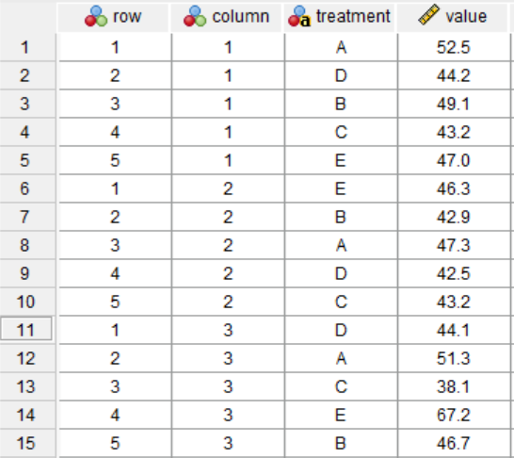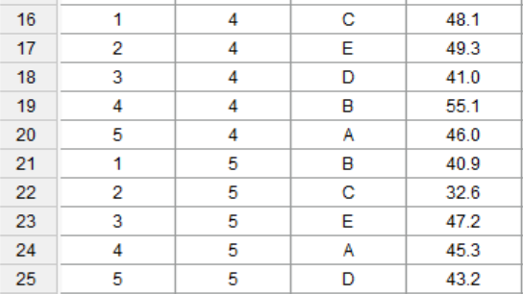

**(II) SYNTAX:**

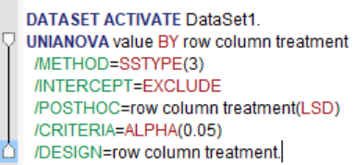

**(III) OUTPUT:**

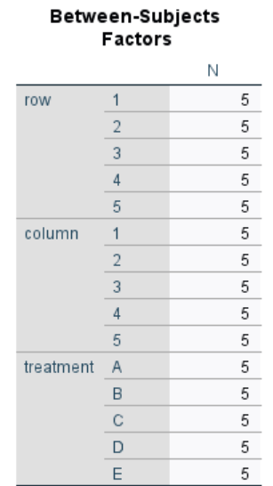

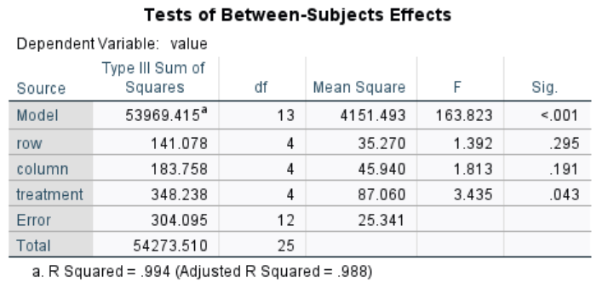

**RESULTS**:

**NAGARJUNA COLLEGE OF INFORMATION TECHNOLOGY**

Statistics Practical No.: 09

Programme: B.Sc.CSIT Semester: Third semester

Roll No. 09/080 Date: 2081/12/01

Subject code: STA 215

**QUESTION**: Following are the scores obtained by trains in 3 different categories. Test whether 3 categories have performed equally.

|  |  |  |  |  |  |  |  |  |  |  |
| --- | --- | --- | --- | --- | --- | --- | --- | --- | --- | --- |
| Categories | Scores | | | | | | | | | |
| A | 68 | 65 | 92 | 82 | 62 | 64 | 68 | 92 | 86 | 64 |
| B | 93 | 86 | 73 | 87 | 76 | 85 | 67 | 79 | 75 | 75 |
| C | 95 | 72 | 85 | 70 | 80 | 80 | 78 | 85 | 72 | 90 |

**WORKING EXPRESSION**:

**CALCULATION**: Using SPSS,

**(I) DATA:**

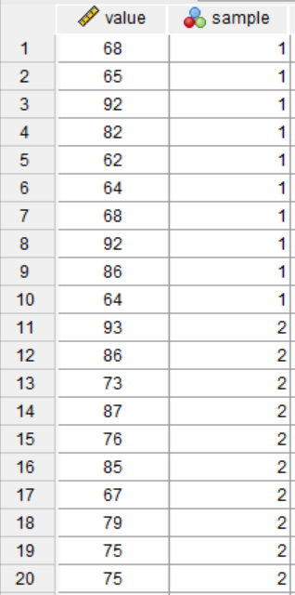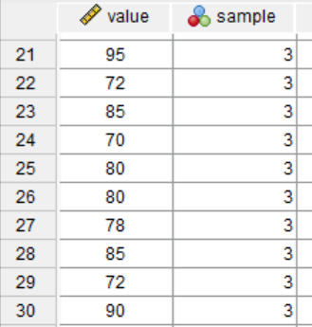

**(II) SYNTAX:**

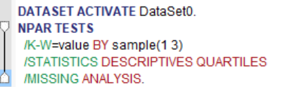

**(III) OUTPUT:**

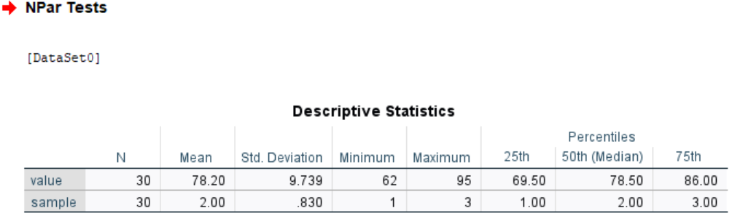

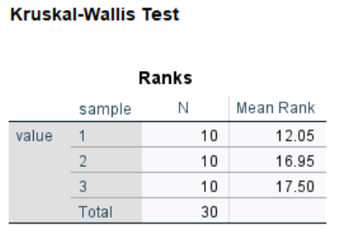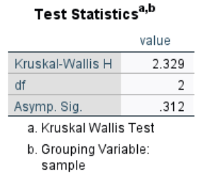

**RESULTS**:

**NAGARJUNA COLLEGE OF INFORMATION TECHNOLOGY**

Statistics Practical No.: 10

Programme: B.Sc.CSIT Semester: Third semester

Roll No. 09/080 Date: 2081/12/01

Subject code: STA 215

**QUESTION**: Three different advertising media TV, Radio and Newspaper are being compared to study their effectiveness in promoting sales of Wai Wai noodles. Each advertising media is exposed for specified period of time and sales (000 packages) from 10 stores located at different areas are recorded.

|  |  |  |  |  |  |  |  |  |  |  |
| --- | --- | --- | --- | --- | --- | --- | --- | --- | --- | --- |
| Advertising  media | Scores | | | | | | | | | |
| A | B | C | D | E | F | G | H | I | J |
| TV | 20 | 21 | 15 | 12 | 14 | 17 | 21 | 16 | 20 | 18 |
| Radio | 7 | 9 | 11 | 12 | 10 | 10 | 14 | 12 | 8 | 7 |
| Newspaper | 8 | 6 | 11 | 12 | 9 | 6 | 8 | 10 | 8 | 6 |

Are three advertising media equally effective, use Friedman two way ANOVA test.

**WORKING EXPRESSION**:

**CALCULATION**: Using SPSS,

**(I) DATA:**

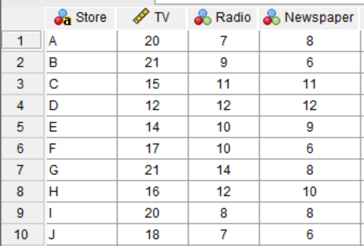

**(II) SYNTAX:**

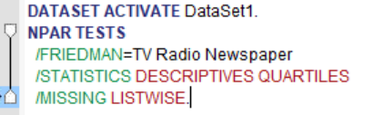

**(III) OUTPUT:**

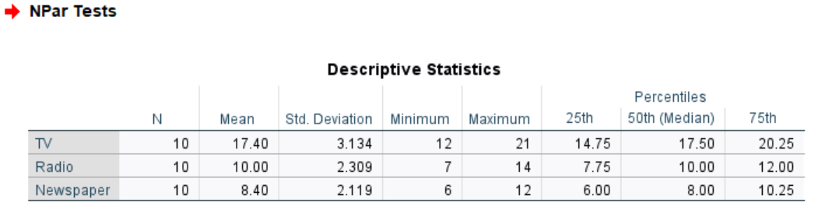

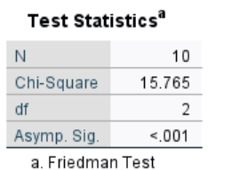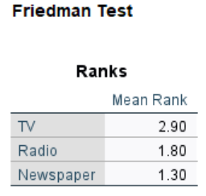

**RESULTS**:

**NAGARJUNA COLLEGE OF INFORMATION TECHNOLOGY**

Statistics Practical No.: 11

Programme: B.Sc.CSIT Semester: Third semester

Roll No. 09/080 Date: 2081/12/01

Subject code: STA 215

**QUESTION**: Use Wilcoxon Mathced Pair Signed rank test to determine the equality of effectiveness of two types of drugs in suppressing pain from following data.

|  |  |  |  |  |  |
| --- | --- | --- | --- | --- | --- |
| Patient no. | Drug A | Drug B | Patient no. | Drug A | Drug B |
| 1 | 6.5 | 3.5 | 11 | 5.4 | 5.5 |
| 2 | 3.7 | 3.7 | 12 | 4 | 4.1 |
| 3 | 3.9 | 4.7 | 13 | 5.7 | 4.1 |
| 4 | 6.7 | 5 | 14 | 3.9 | 4.2 |
| 5 | 6.2 | 5.6 | 15 | 3.6 | 3.7 |
| 6 | 6.7 | 4.3 | 16 | 4.9 | 4.1 |
| 7 | 6.1 | 5.4 | 17 | 3.9 | 5.4 |
| 8 | 4.3 | 5.8 | 18 | 5.8 | 3.7 |
| 9 | 5.5 | 4.3 | 19 | 4.9 | 4.1 |
| 10 | 6.8 | 4.3 | 20 | 4.9 | 4.1 |

**WORKING EXPRESSION**:

**CALCULATION**: Using SPSS,

**(I) DATA:**

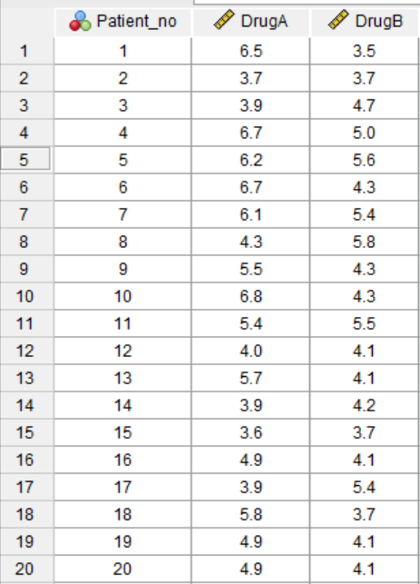

**(II) SYNTAX:**

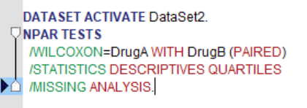

**(III) OUTPUT:**

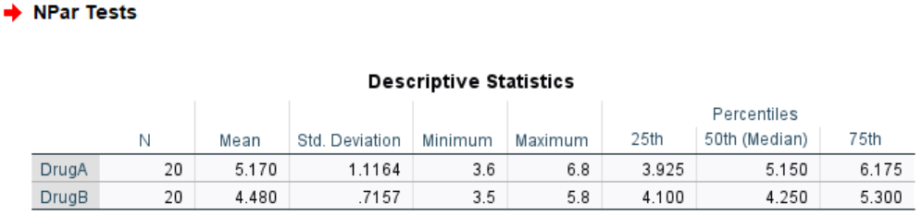

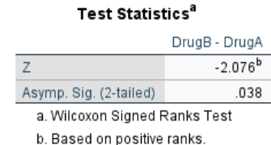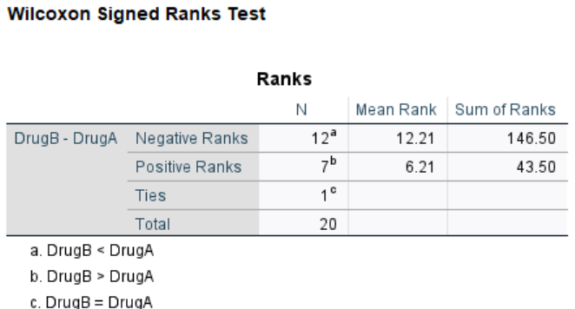

**RESULTS**:

**NAGARJUNA COLLEGE OF INFORMATION TECHNOLOGY**

Statistics Practical No.: 12

Programme: B.Sc.CSIT Semester: Third semester

Roll No. 09/080 Date: 2081/12/01

Subject code: STA 215

**QUESTION**: An IQ test was given to a randomly selected 15 male and 20 female students of a university. Their scores were recorded as follows:

|  |  |
| --- | --- |
| Male | 56, 66, 62, 81, 75, 73, 68, 48, 70, 60, 77, 86, 44, 72 |
| Female | 63, 77, 65, 71, 74, 60, 76, 61, 67, 72, 64, 65, 55, 89, 45, 53, 68, 73, 50, 81 |

Use median test to determine whether IQ of male and female students is same in the university. (Given that the median of combined sample = 68)

**WORKING EXPRESSION**:

**CALCULATION**: Using SPSS,

**(I) DATA:**

|  |  |
| --- | --- |
| Male | 56, 66, 62, 81, 75, 73, 68, 48, 70, 60, 77, 86, 44, 72 |
| Female | 63, 77, 65, 71, 74, 60, 76, 61, 67, 72, 64, 65, 55, 89, 45, 53, 68, 73, 50, 81 |

**(II) SYNTAX:**

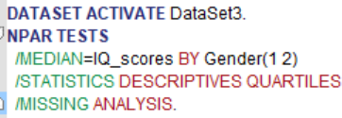

**(III) OUTPUT:**

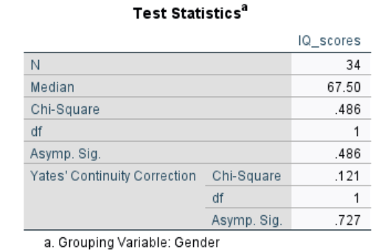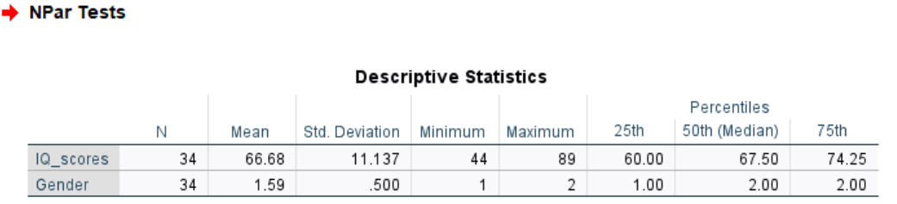

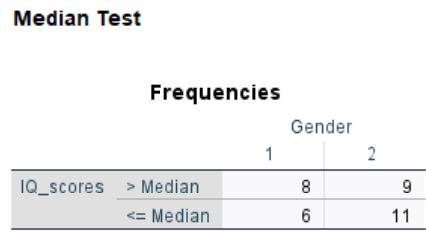

**RESULTS**:

**NAGARJUNA COLLEGE OF INFORMATION TECHNOLOGY**

Statistics Practical No.: 13

Programme: B.Sc.CSIT Semester: Third semester

Roll No. 09/080 Date: 2081/12/06

Subject code: STA 215

**QUESTION**: Five housewives were asked for the acceptability of four brands of lipsticks for daily use. The response of acceptability (A) and rejection (B) are given below:

|  |  |  |  |  |
| --- | --- | --- | --- | --- |
| House wives | Alfa | Beta | Gamma | Delta |
| H1 | A | B | A | B |
| H2 | B | A | A | B |
| H3 | B | A | B | A |
| H4 | A | B | B | B |
| H5 | A | A | B | A |

Test whether there is any significant difference between brands with respect to acceptability.

**WORKING EXPRESSION**:

**CALCULATION**: Using SPSS,

**(I) DATA:**

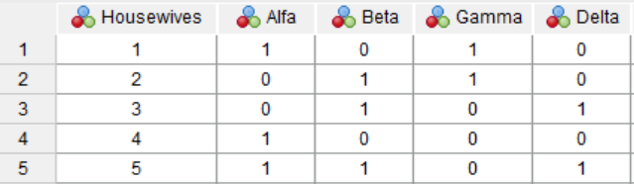

**(II) SYNTAX:**

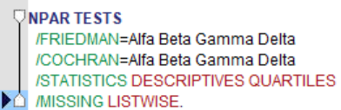

**(III) OUTPUT:**

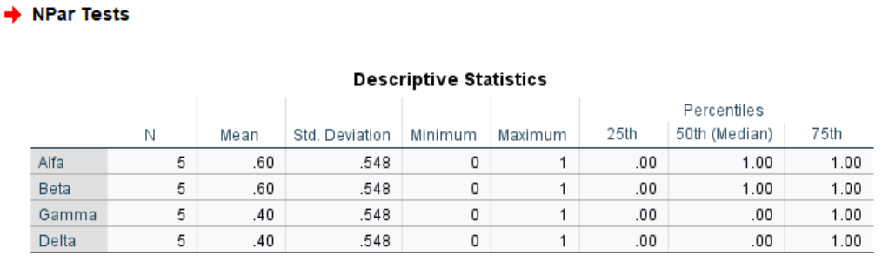

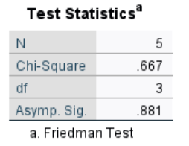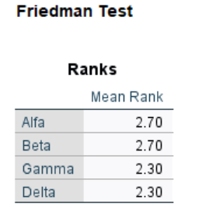

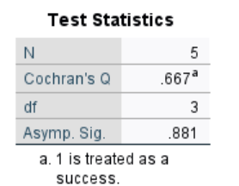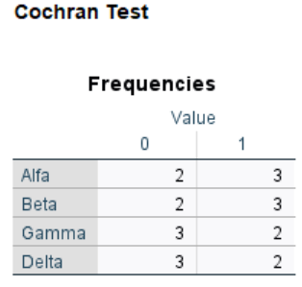

**RESULTS**:

**NAGARJUNA COLLEGE OF INFORMATION TECHNOLOGY**

Statistics Practical No.: 14

Programme: B.Sc.CSIT Semester: Third semester

Roll No. 09/080 Date: 2081/12/06

Subject code: STA 215

**QUESTION**: In 30 toss of a coin, the following sequence of heads(H) and tails(T) is obtained.

H TT H T HHH T HH TT H T H T HH T H TT H T HH T H T

Test at 0.05 level of significance level whether the sequence is random.

**WORKING EXPRESSION**:

**CALCULATION**: Using SPSS,

**(I) DATA:**

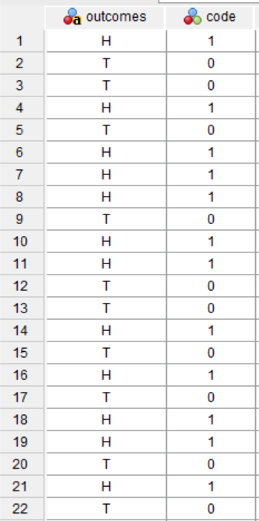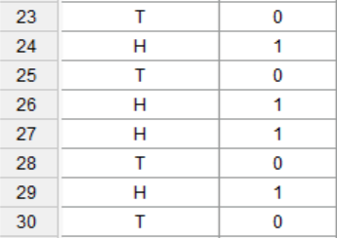

**(II) SYNTAX:**

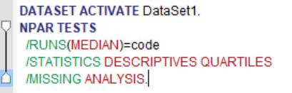

**(III) OUTPUT:**

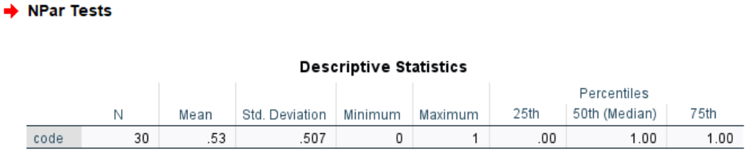

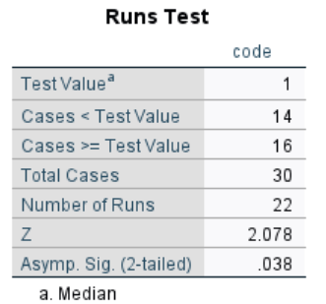

**RESULTS**:

**NAGARJUNA COLLEGE OF INFORMATION TECHNOLOGY**

Statistics Practical No.: 15

Programme: B.Sc.CSIT Semester: Third semester

Roll No. 09/080 Date: 2081/12/06

Subject code: STA 215

**QUESTION**: In 50 toss of a coin the following sequence of heads (H) and tails (T) is obtained. Test whether the coin is unbiased from the following observations:

|  |  |  |  |  |  |  |  |  |  |
| --- | --- | --- | --- | --- | --- | --- | --- | --- | --- |
| TAIL | HEAD | TAIL | TAIL | TAIL | TAIL | HEAD | TAIL | TAIL | HEAD |
| HEAD | HEAD | TAIL | HEAD | TAIL | HEAD | TAIL | TAIL | TAIL | TAIL |
| TAIL | HEAD | HEAD | TAIL | HEAD | HEAD | HEAD | TAIL | TAIL | TAIL |
| TAIL | HEAD | TAIL | HEAD | HEAD | HEAD | HEAD | TAIL | TAIL | TAIL |
| HEAD | HEAD | TAIL | TAIL | TAIL | TAIL | HEAD | TAIL | TAIL | TAIL |

**WORKING EXPRESSION**:

**CALCULATION**: Using SPSS,

**(I) DATA:**

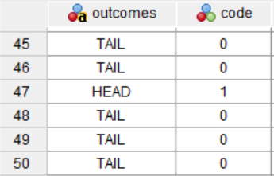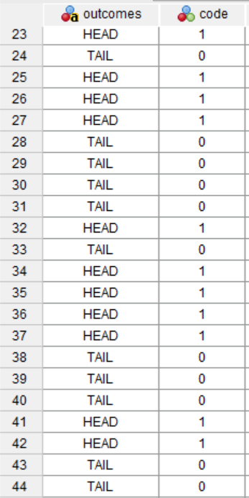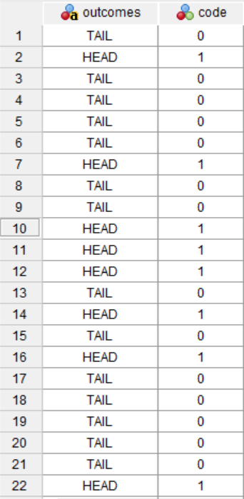

**(II) SYNTAX:**

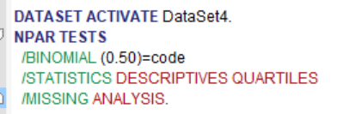

**(III) OUTPUT:**

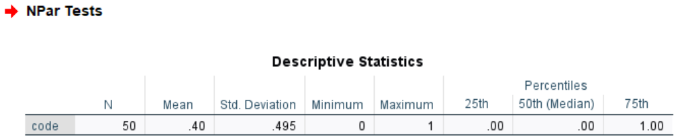

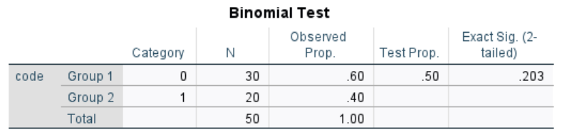

**RESULTS**: