Academic Year 2025-26
SY MCA- SEM III

IT35 Principles of Cloud Management and Security
Assessment 1

Date: 14/11/2025 Roll No: 2401026
Time: 90 Mins Name: Arnav Rajesh Chandure
Marks: 80 Marks

Kindly write the question and paste the screenshots of execution from your system

Q.1) Create an Rds MySQL instance in eu-central-1. (40m)
Disable backup retention and scaling.
Tags: (name), (project) -- mysql-lab-04, (roll_no), (date).
Import dataset, export as classimodel_export_04.sql.
Upload to S3 rollno-bucket-04, download and tag.

Solution:

  - Choose Region (eu-central-1):
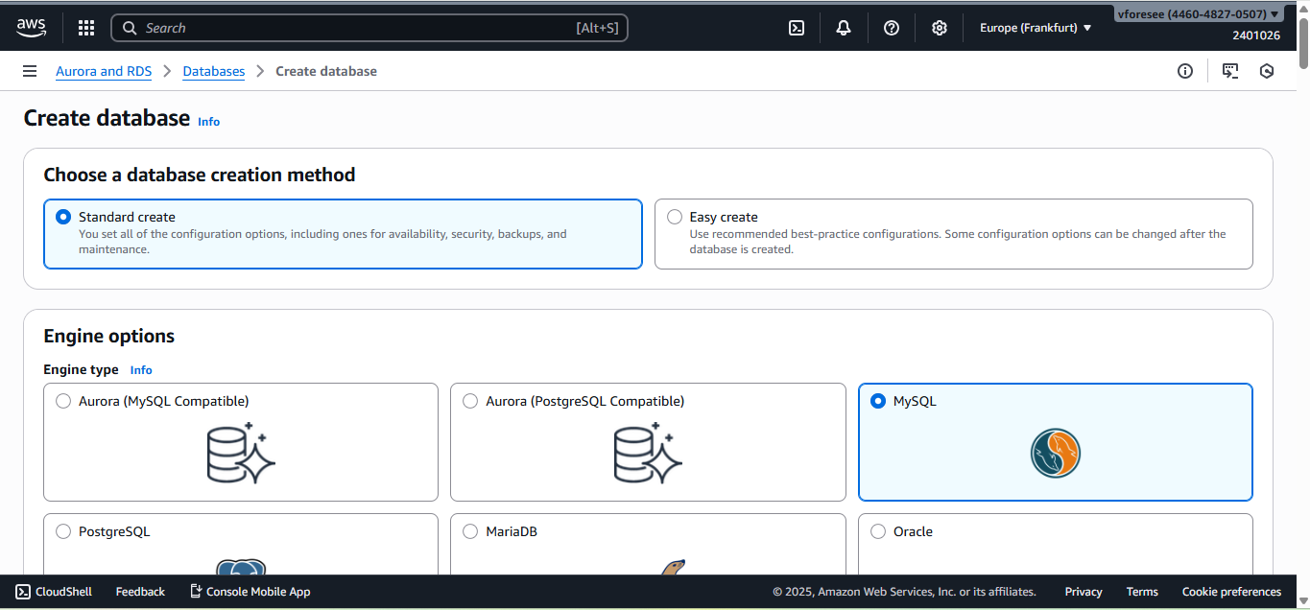
  - Create Database – Engine Selection:

  - Add Tags:
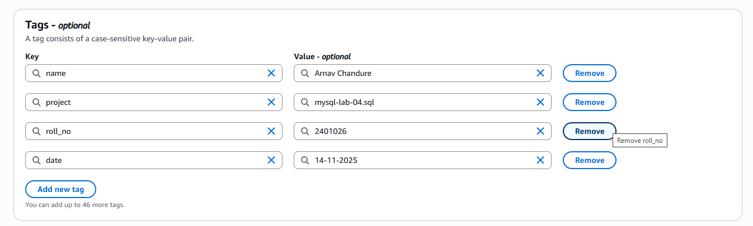

1.4 DB Configuration:
- Disable Backup retention
- Disable auto-scaling
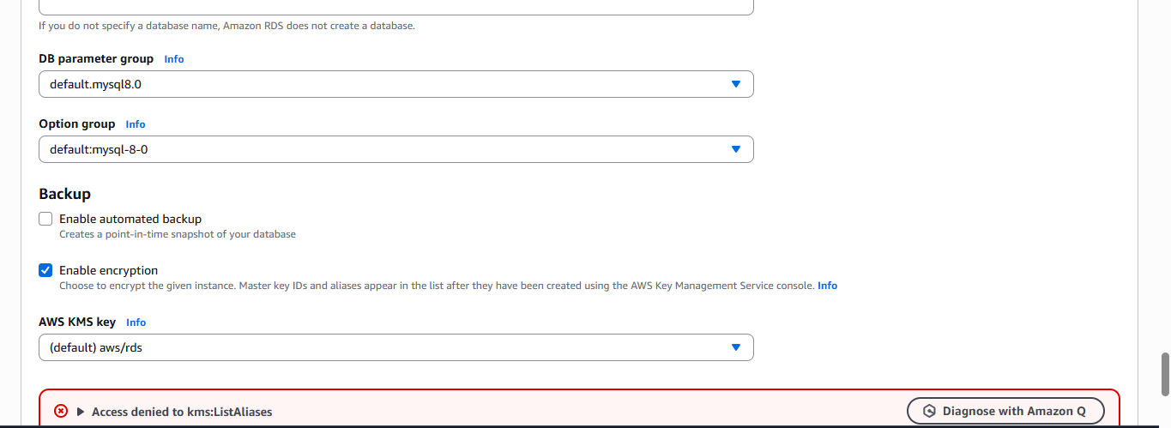
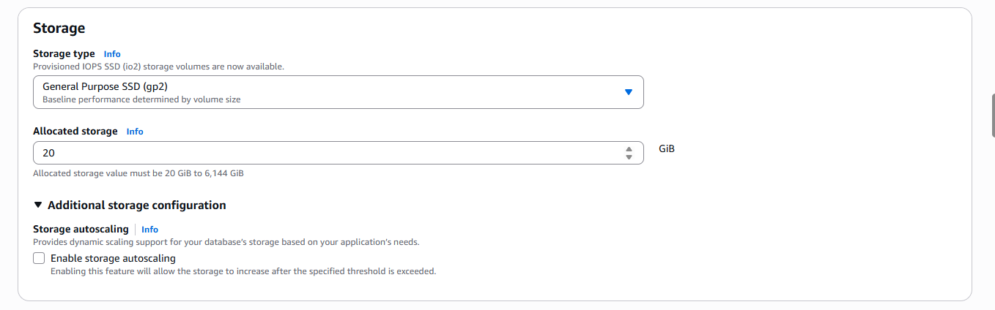

1.5 Connectivity Setup:
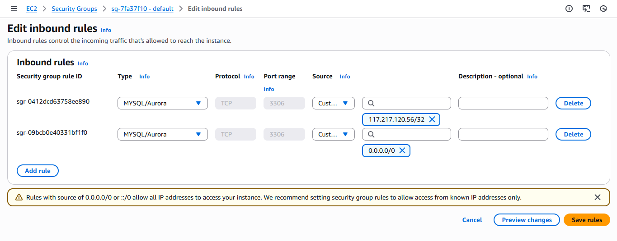
1.6 RDS Instance Created:
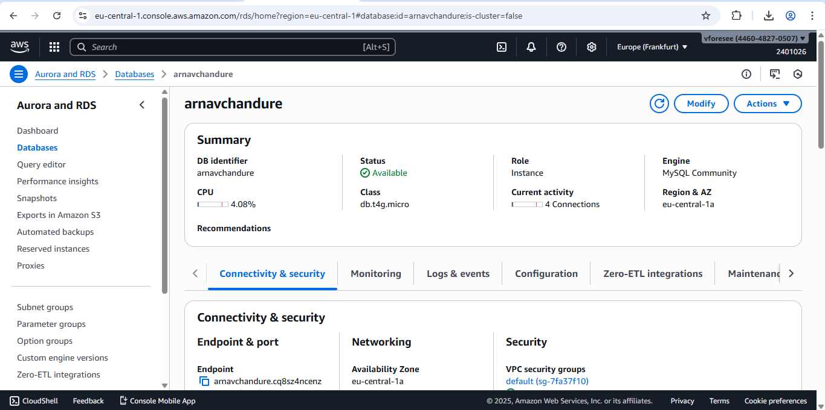

2.1 New Connection Setup:
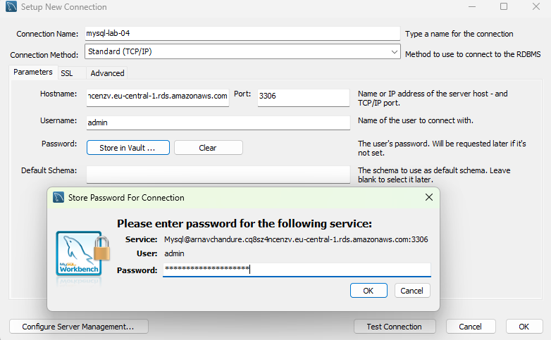
3.1 Import Dataset:
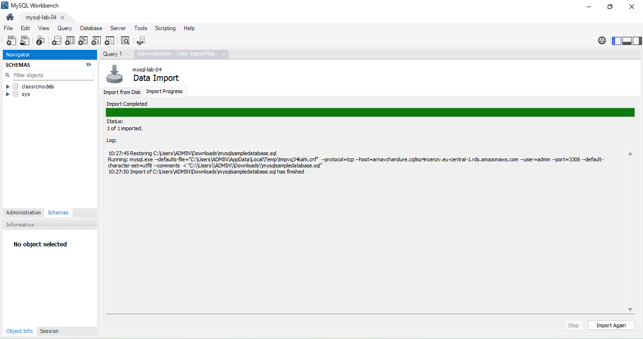
3.2 Export Dataset:
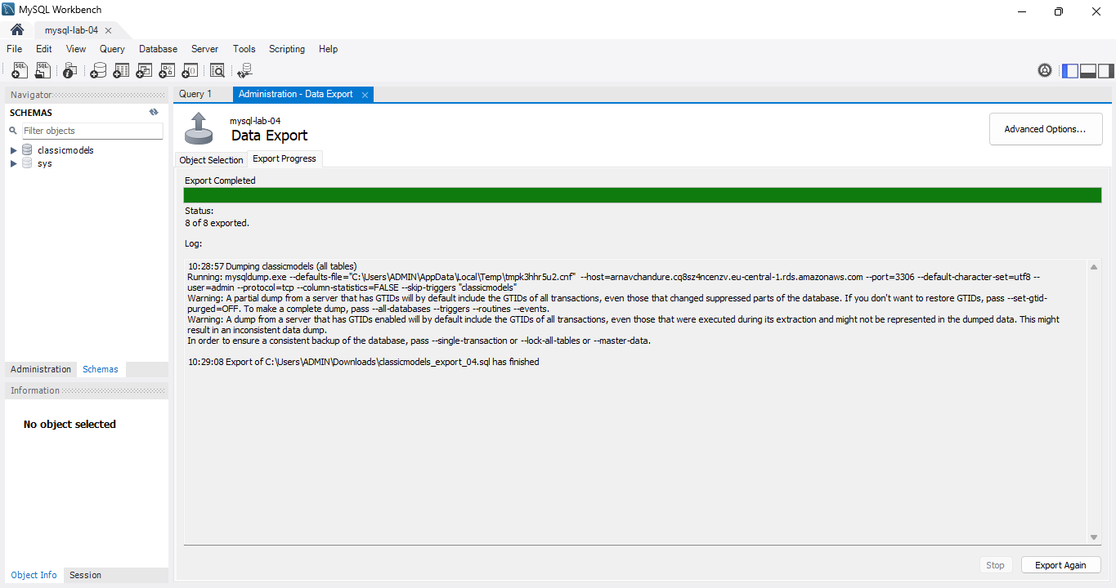
3.3 Export Successful:
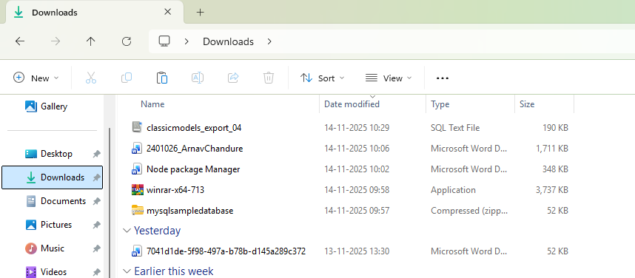

4.1 Create S3 Bucket:
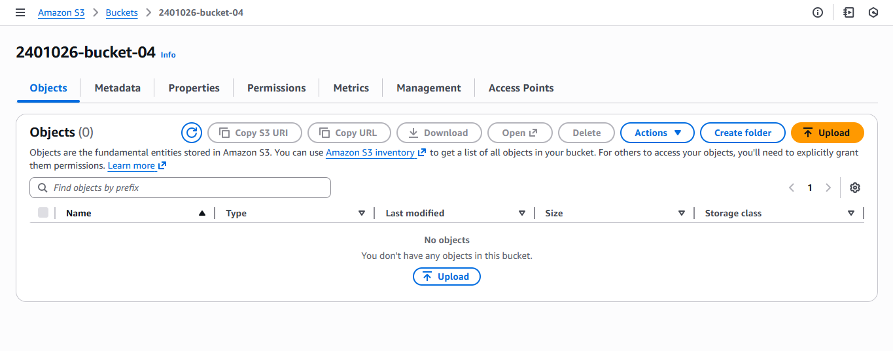

4.2 Upload Export File:
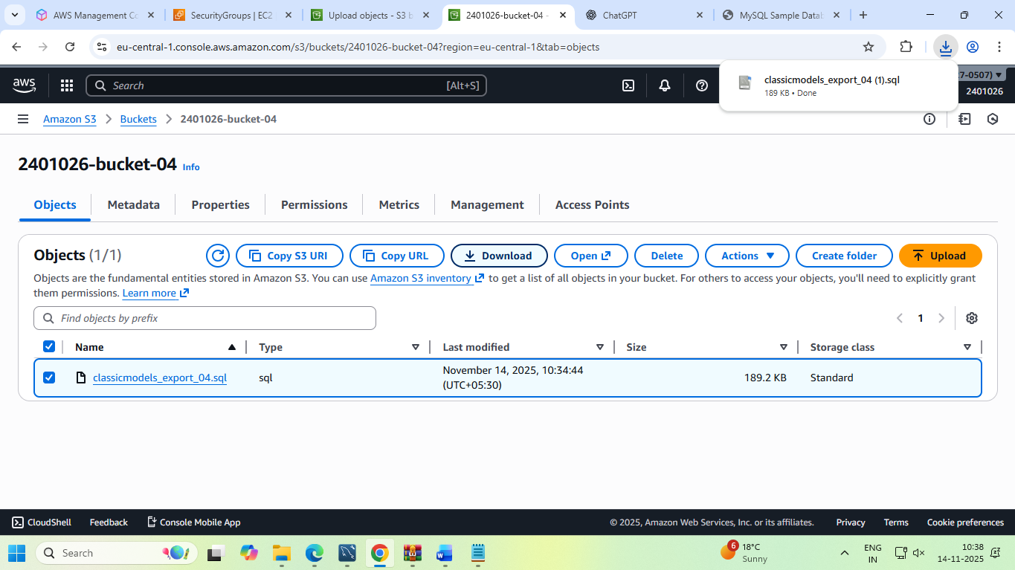
4.3 Add Tags to S3 Object:
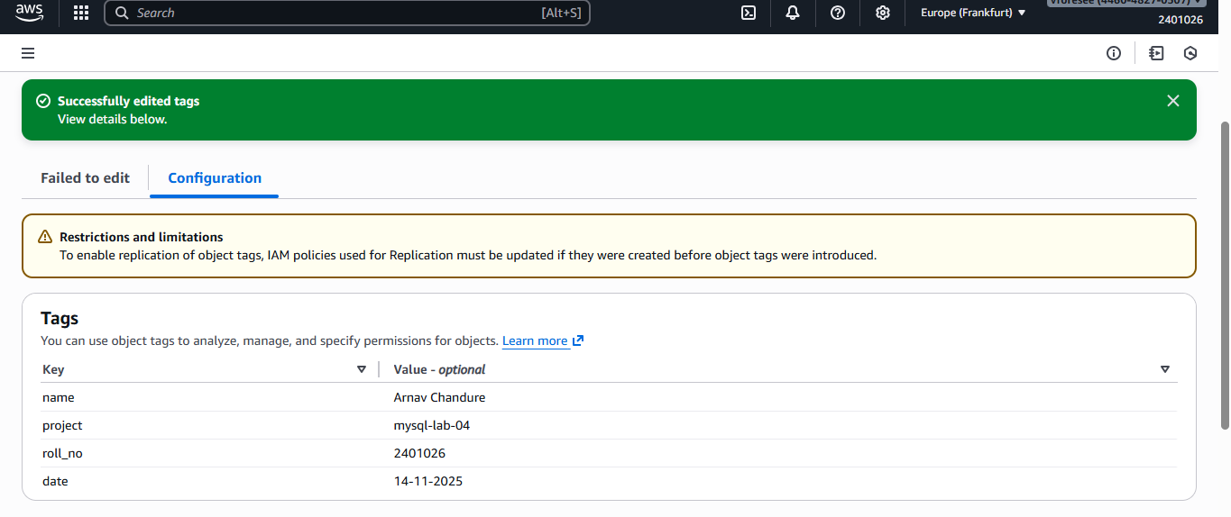
4.4 Download File from S3:

Q.2) Select a PHP application (simple PHP app). (40m)
1. Set up the application on Windows inside folder C:\php_app_lab2.
2. Deploy and run the application. Show it to the examiner and take screenshots.
3. Migrate the same app to Linux (/home/student/php_app_lab2/) and deploy it.
4. Take screenshots of setup, migration, and successful Linux deployment. Upload to Google Doc.
Solution:
  - Creating the Project Folder:
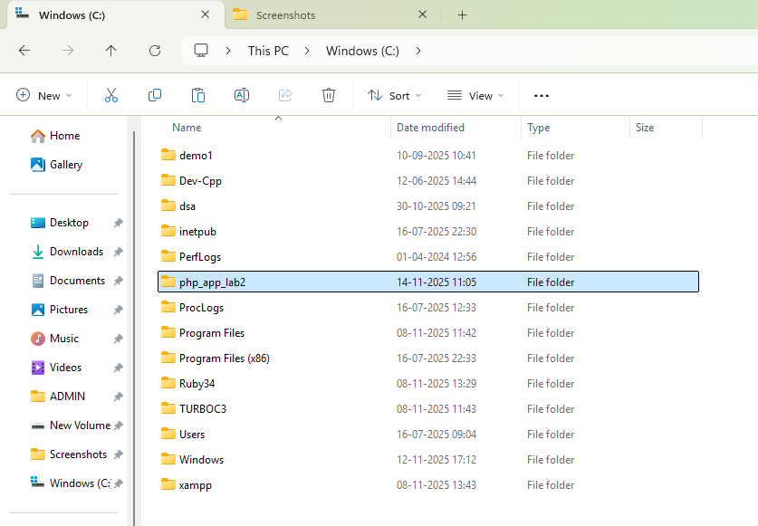

  - Running PHP Project on Windows:
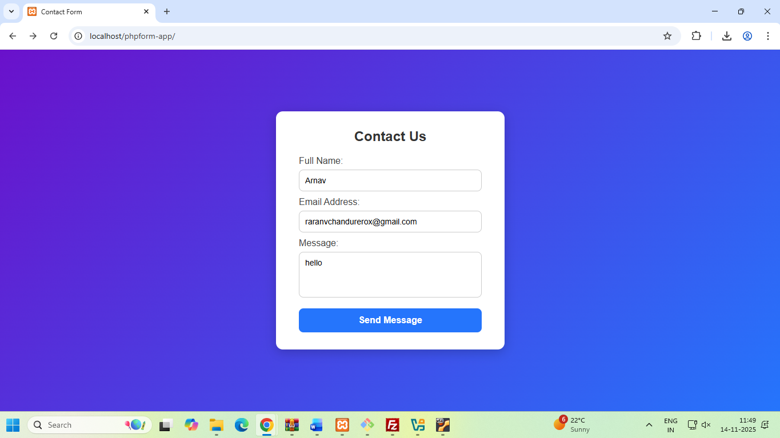
  - Migration to Linux(ubuntu) using Filezilla:
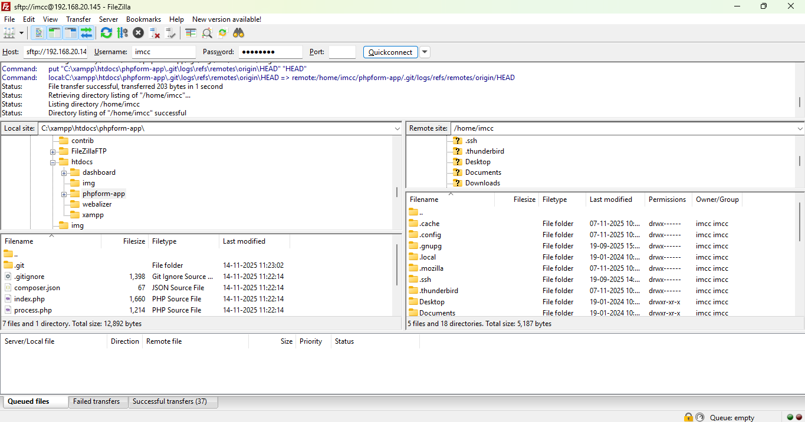

1.4 Running PHP Project on Windows:
