Shree shambhubhai v. patel college of Computer science and business management

Title:- Google Play Store Data Analysis

Submitted By ;-
491– Pambhar Krishna B.
521 - Raval Charmi J.
522 – Rokad Laxmi R.

Course: TYBCA semester 6

Submitted To: Asst. Prof. Dharni

Academic Year: 2024- 2025

Google Play Store Data Analysis Dashboard Using Python

1. Introduction
In today's digital world, mobile applications play an important role in everyday life. The Google Play Store contains millions of applications across different categories such as education, entertainment, business, lifestyle, and many more.

This project focuses on analyzing the Google Play Store dataset using Python. The main objective of this project is to understand the relationship between different variables such as ratings, reviews, installs, and app categories.

A dashboard is created using Streamlit, which allows users to interactively visualize the data using different graphs and charts.

Through this project, we can understand which type of applications are more popular and how different factors affect app ratings and installs.

2. Objectives of the Project

The main objectives of this project are:

- To analyze the Google Play Store dataset.
- To perform data cleaning and preprocessing.
- To visualize the data using different graphs.
- To understand the relationship between different app attributes.
- To implement machine learning techniques for prediction.
- To create an interactive dashboard using Streamlit.
- 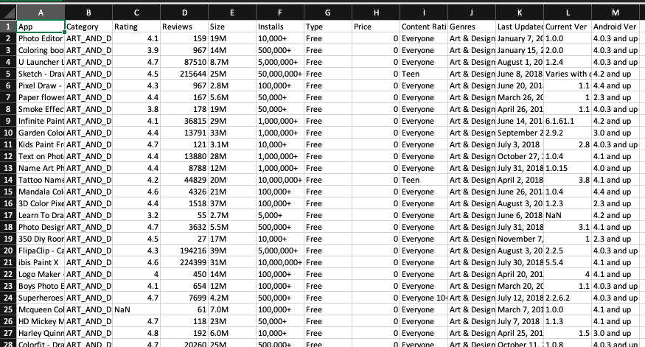

3. Tools and Technologies Used

The following tools and technologies are used in this project:

1. Python
Python is used as the main programming language for data analysis and machine learning.
2. Streamlit
Streamlit is used to create an interactive web dashboard for data visualization.
3. Pandas
Pandas is used for data manipulation and data analysis.
4. NumPy
NumPy is used for numerical computations.
5. Matplotlib
Matplotlib is used to create graphs and charts.
6. Seaborn
Seaborn is used for advanced data visualization.
7. Scikit-learn
Scikit-learn is used to implement machine learning algorithms like Linear Regression and K-Means Clustering.

4. Dataset Description

The dataset used in this project is the Google Play Store dataset. It contains information about different applications available on the Play Store.

- Some important attributes in the dataset include:
App Name – Name of the application
Category – Type of application
Rating – User rating of the app
Reviews – Number of reviews given by users
Installs – Number of installations
Type – Free or Paid application
Price – Cost of the application
Content Rating – Age group suitability

The dataset helps analyze how these attributes affect the popularity and performance of applications.

5. Data Preprocessing

Before performing analysis, the dataset needs to be cleaned and prepared.
The following preprocessing steps are performed:
1. Handling Missing Values
Some columns in the dataset contain missing values. These values are replaced using statistical methods like median.
2. Data Type Conversion
Some columns such as Reviews and Installs are converted into numeric values for analysis.
3. Removing Special Characters
Characters like "+" and "," in the installs column are removed to convert the data into proper numeric format.
4. Data Cleaning
Unnecessary rows and inconsistent data values are removed from the dataset.

6. Data Analysis and Visualization

Different types of analysis are performed using graphs and charts.

6.1 Univariate Analysis
Univariate analysis studies a single variable at a time.
Examples include:
- Rating Distribution
- Reviews Distribution
- Installs Distribution
- Category Frequency
These graphs help understand the distribution of individual variables.

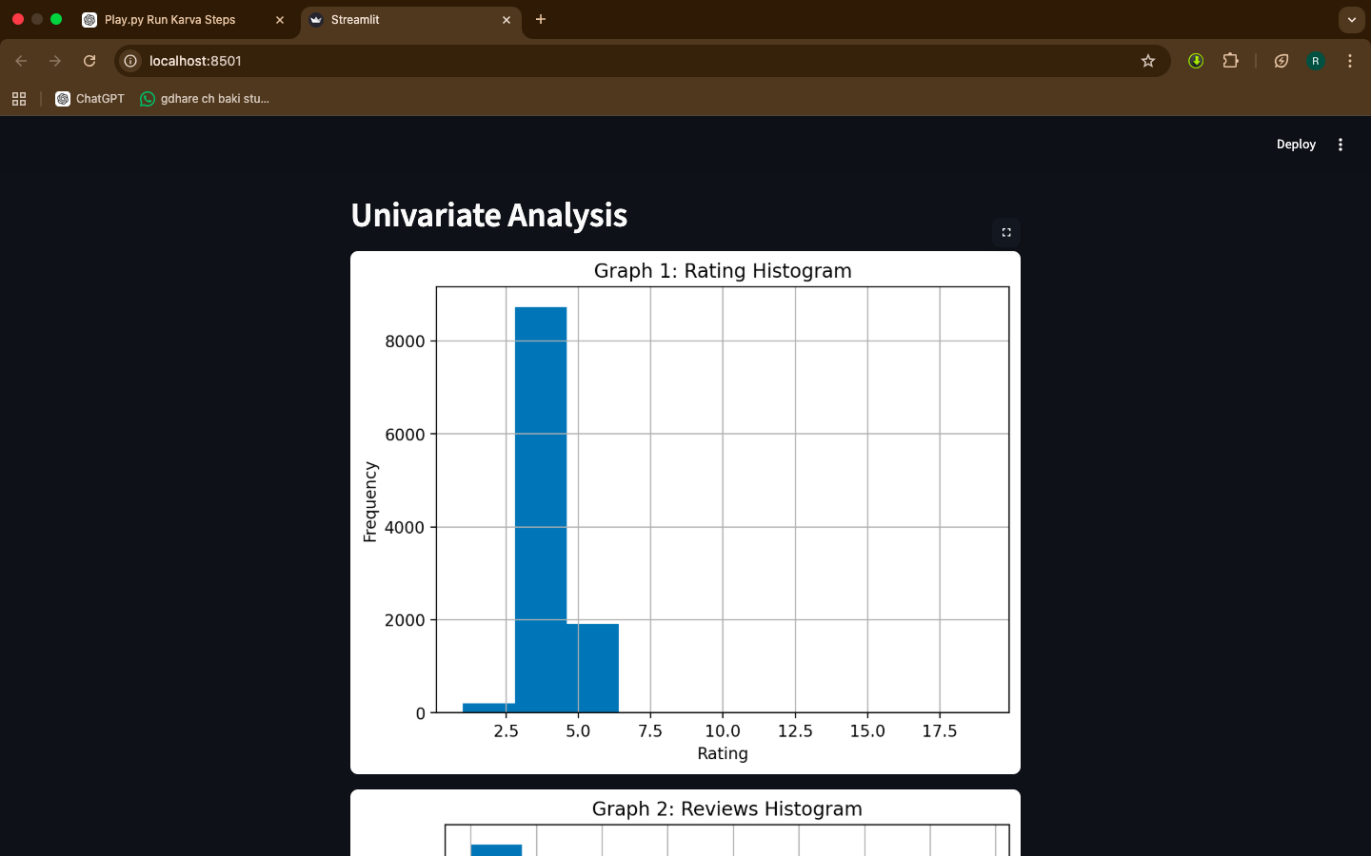

6.2 Bivariate Analysis
Bivariate analysis studies the relationship between two variables.
Examples include:
- Reviews vs Rating
- Installs vs Rating
- Installs vs Reviews
- Rating by Category
These visualizations help identify patterns and relationships in the data.
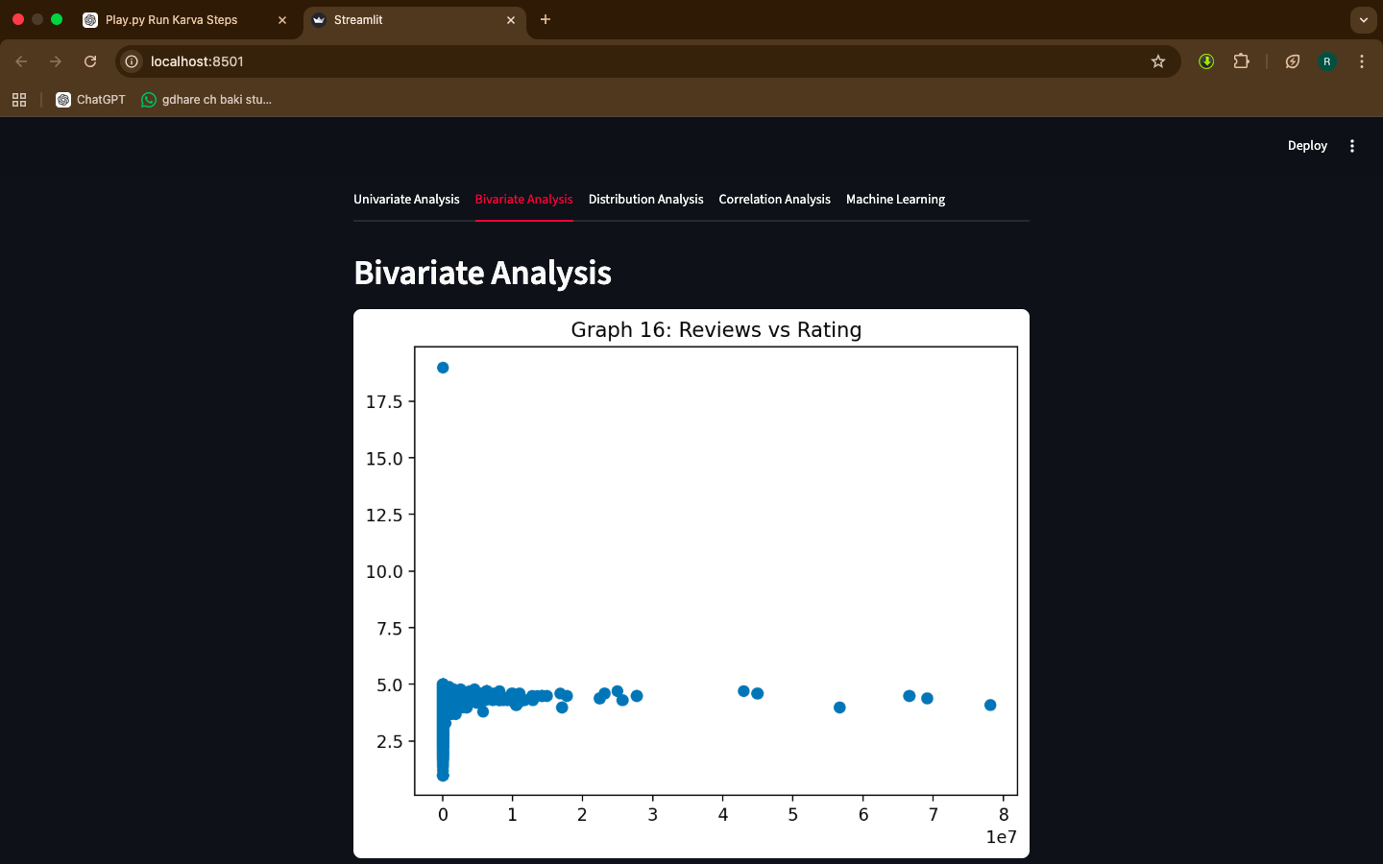

6.3 Distribution Analysis
Distribution analysis helps understand how data values are spread across the dataset.
Examples include:
- Histogram plots
- Box plots
- Density plots
These graphs help identify outliers and trends.

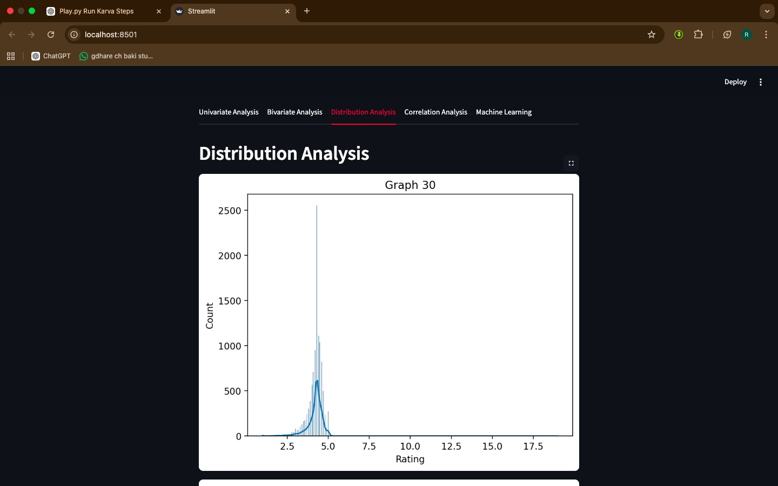

6.4 Correlation Analysis
Correlation analysis helps determine how strongly variables are related to each other.
A heatmap is used to visualize the correlation between different features such as rating, reviews, and installs.

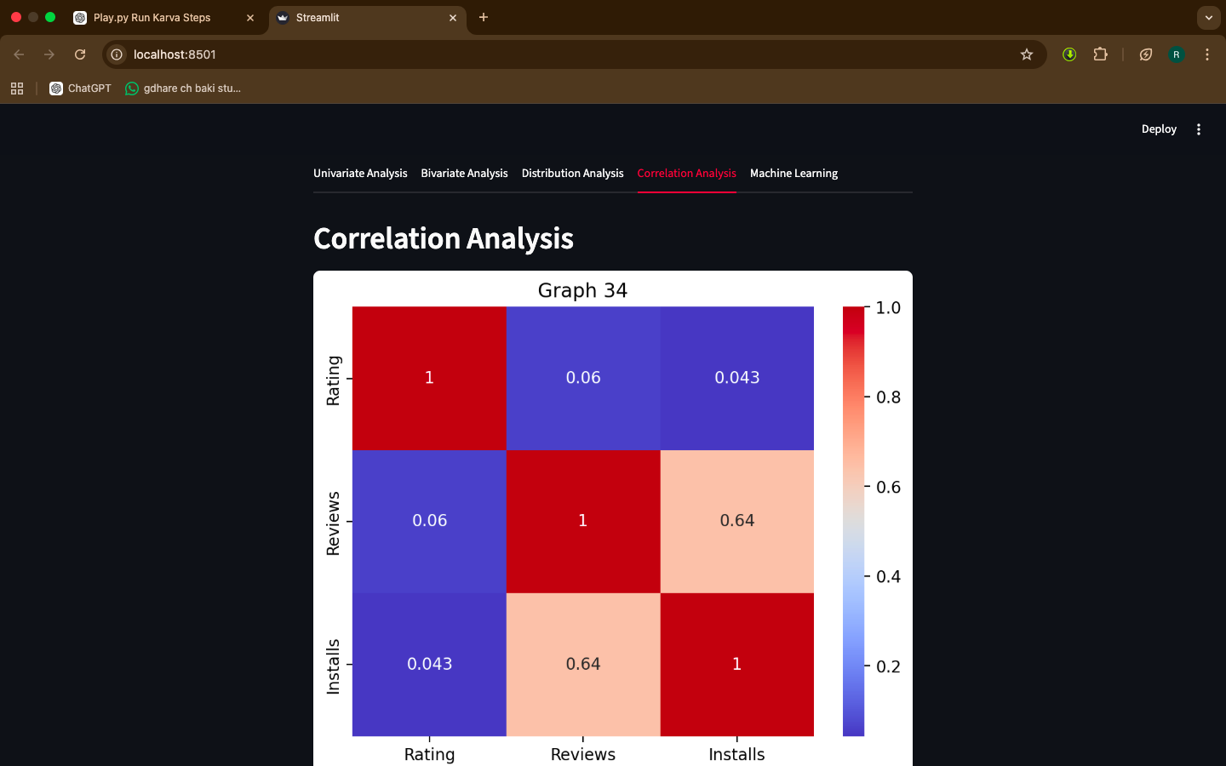

7. Machine Learning Implementation

Two machine learning techniques are implemented in this project.

7.1 Linear Regression
Linear Regression is used to predict app ratings based on the number of reviews.
The model learns the relationship between reviews and ratings and predicts rating values.
This helps understand how user feedback influences app ratings.

7.2 K-Means Clustering

K-Means clustering is used to group similar applications together based on features like installs and reviews.
This helps categorize apps into clusters such as:
High popularity apps
Medium popularity apps
Low popularity apps
Clustering helps identify patterns in the dataset.
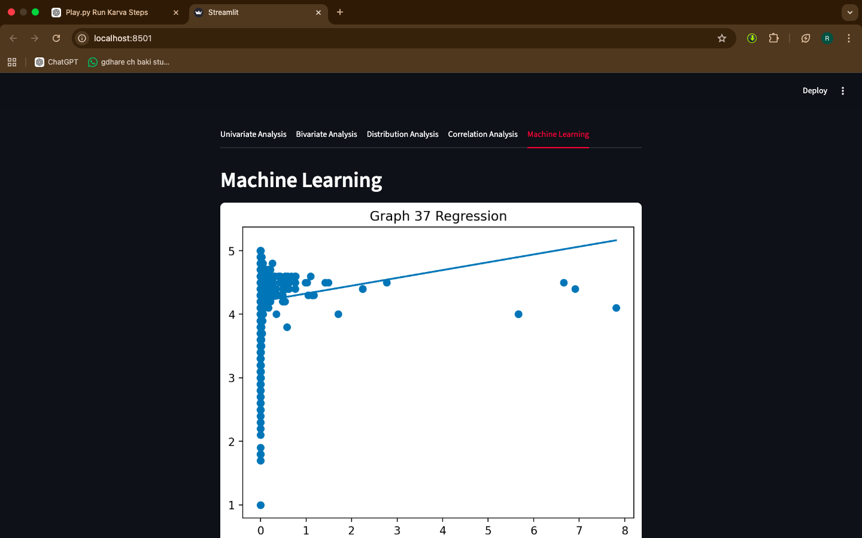

8. Dashboard Implementation

The dashboard is developed using Streamlit.
The dashboard contains different sections:
- Univariate Analysis
- Bivariate Analysis
- Distribution Analysis
- Correlation Analysis
- Machine Learning Analysis

Users can interact with the dashboard to view different graphs and insights.

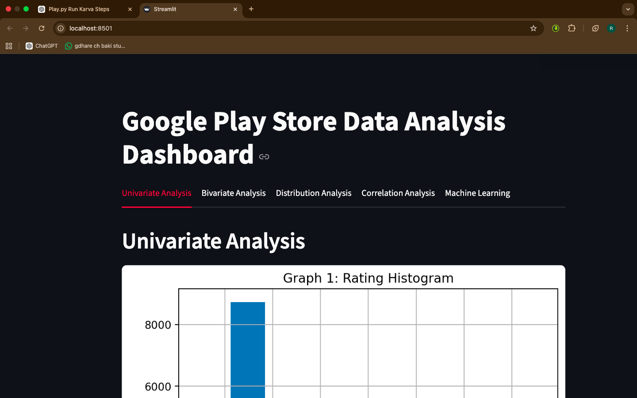

9. Results and Findings

From the analysis, the following insights can be observed:
Applications with more reviews tend to have higher installs.
Most applications in the Play Store are free.
Certain categories like Games and Tools have the highest number of installs.
Ratings are mostly distributed between 4.0 and 4.5.
Machine learning models help identify patterns and predict ratings.

10. Conclusion

This project successfully analyzes the Google Play Store dataset using Python.
Different visualization techniques are used to understand the behavior and trends of applications in the Play Store.
Machine learning algorithms such as Linear Regression and K-Means Clustering help in prediction and grouping of applications.
The Streamlit dashboard makes the analysis interactive and easy to understand.
Overall, this project demonstrates the power of Python in data analysis, visualization, and machine learning.

