## Project name: LogBook

## Team name: Group 2

## Team members [names]: Jordan Atanasov, Kristiyana Stoyanova

## Link to the repositories [one or more]: https://github.com/krisi03/logBookFrw.git

## Used technologies: C#, Windows forms application(.Framework), MySQL, Micron

## Basic description of the project [purpose of the project]: Desktop application built to be used by company employees and people with a hectic daily life to keep track of their tasks and to be on time.

## Basic architecture of the project [details about different]:

* Details about different components (components e.g mobile app/front end app, back end app, database, relation between them)

Logbook is based on Model-View-ViewModel architectural pattern (MVVM). This is how MVVM works: 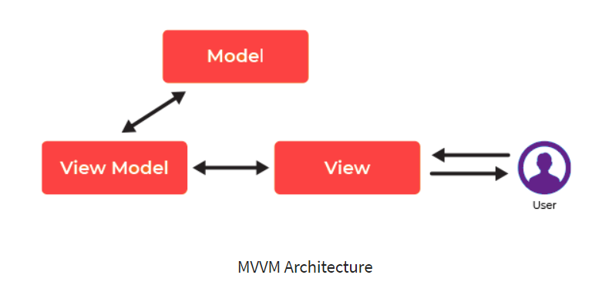

Model stores data and related logic. Whereas the view model is responsible for presenting functions, commands, methods, to support the state of the View. The View stands for user interface and has references to the View-Model.

* Database structure

Database contains two tables. One of them is user_info, which stores information about the users, based on their registration in the Logbook. The other one is user_task table, which stores details about the user's tasks like task title, description, end time and end date, just to remind them to do the task before time expires. The connection between these two tables is user id, that we need to identify which task corresponds to which user.

* 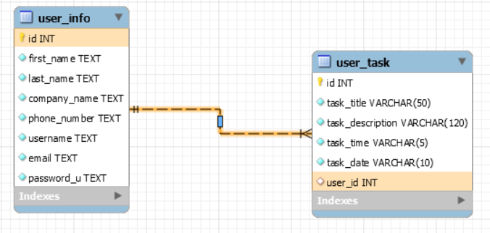

## Link to the database script

## <https://pastebin.com/pprvszkz>

## Link to the readme file : <https://github.com/krisi03/logBookFrw/blob/main/README.md>

## Features: [describe different functionalities implemented in the project]:

* E.g login/register page – user will be able to login or register to the application

Every user should have his own registration in Logbook in order to protect their personal task’s data like important meetings in company or personal engagements. Here are registration and sign in dialog windows.

* Registration

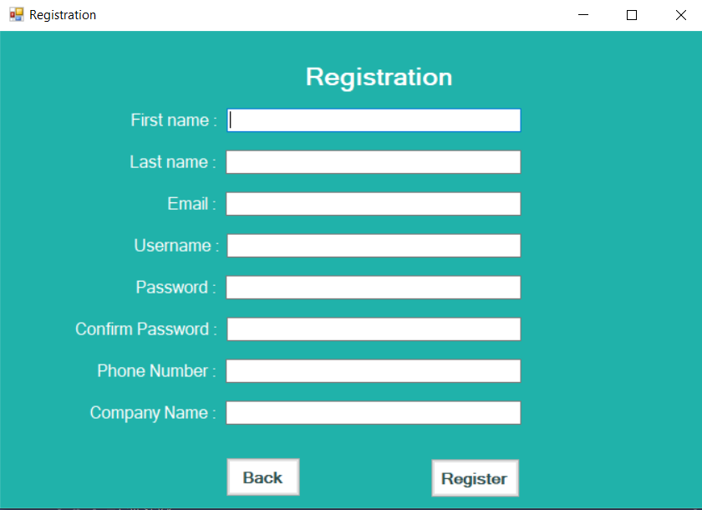

* Sign in

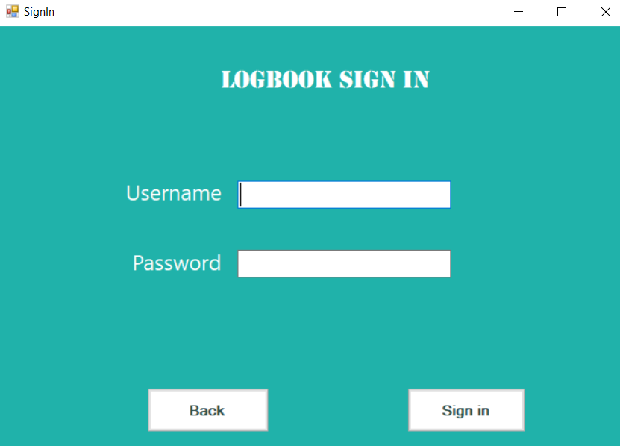

* Page with devices data – provide information about the different devices available to the users (for example)
  + After creating an account and login the logBook shows the following tab. User have two options: to create a task or to see their current tasks. The default one is “Create task”.

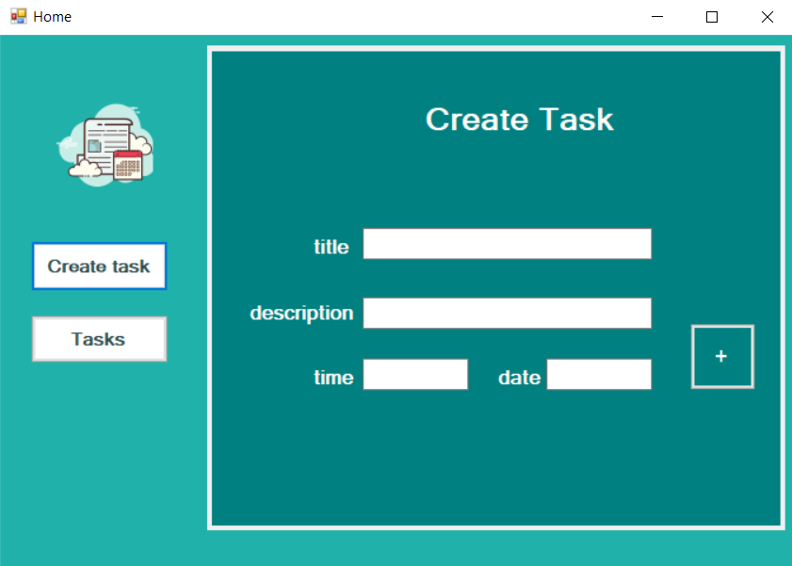

By creating a task, the user adds title, description, time and date due when this task has to be finished. This data is added to database context by clicking ot button +; Every task from “Create task” is transformed into “Task”, where the user can read their task and can also check them, when the user is done.

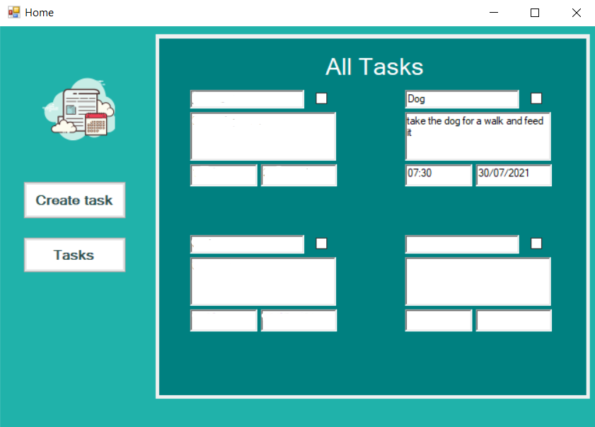

Future realisation: We will add two roles: the one is “employee” and the other one is “boss” and each boss will be able to add a task to the task list of their employees. Another future realisation is getting notifications: every user will receive a notification with time left due the expiring task. For example there will be notification when 1 day, 2 hour and 30minutes left.

