username: team43
password: jubilant-bagpipe-lightbulb-karate

Team 43: C-43PO
Kristiyana Evtimova
Hidde Meiburg
Qun Cao
Bogdan Mladin
Seth de Jong
David Virlan-Blaj
Monika Khachatryan
[Project Documentation]
[2IRR10 CBL Autonomous Systems Twinning]

Introduction
This documentation presents the development of R2-Drip2, a digitally twinned autonomous irrigation system designed to support more efficient water use in agriculture, developed by team C-43PO (team 43). It explains the stakeholder problem, the proposed technical solution, the Proof-of-Concept implementation and how the system demonstrates core DTAS characteristics. The document also evaluates the project’s timeline, resources, risks, team collaboration and final takeaways.

Technical Solution
Our technical solution focuses on how digital twinning can be applied to an autonomous irrigation system to address inefficient water use in agriculture. Our main stakeholders are open-field vegetable growers in the Jordan Valley, where irrigation decisions are difficult because water is scarce and rainfall is unstable. In this context, relying only on reactive watering can lead to water waste, inefficient irrigation and lower crop yield. These challenges are relevant to SDG 2: Zero Hunger, especially Target 2.3, which aims to improve agricultural productivity, and Target 2.4, which aims to support more resilient and sustainable farming practices.
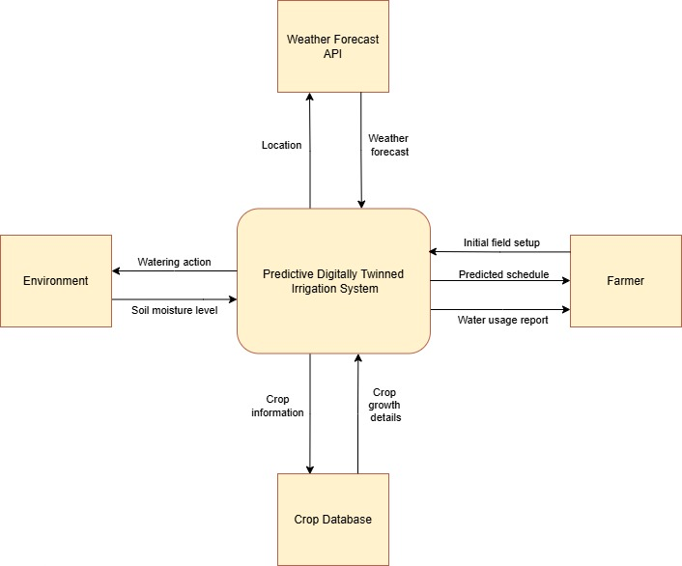
To address this challenge, we propose R2-Drip2, a smarter digitally twinned irrigation system. The full technical solution combines an autonomous irrigation robot with a digital twin of the field. The autonomous robot executes irrigation actions in the physical environment, while the digital twin represents the field state and supports decision-making. The twin stores information such as soil moisture, crop type, target moisture values, environmental conditions and weather input. This means the system does not only react to the current situation but can support more precise and dynamic irrigation decisions while the weather changes.
- Level 0 Context Diagram
The technical diagrams show this logic at two levels. The Level 0 context diagram places R2-Drip2 within its environment and shows its connection to the farmer, the physical field and the crop database.¹ The Level 1 diagram then shows the main internal processes: collecting field and external data, maintaining the digital twin, determining the irrigation strategy, operating the autonomous robot and presenting information to the farmer.² Together, these processes form a DTAS feedback loop: data is collected, the digital twin is updated, an irrigation decision is made, the robot executes the task and the result is logged and published back into the digital model.
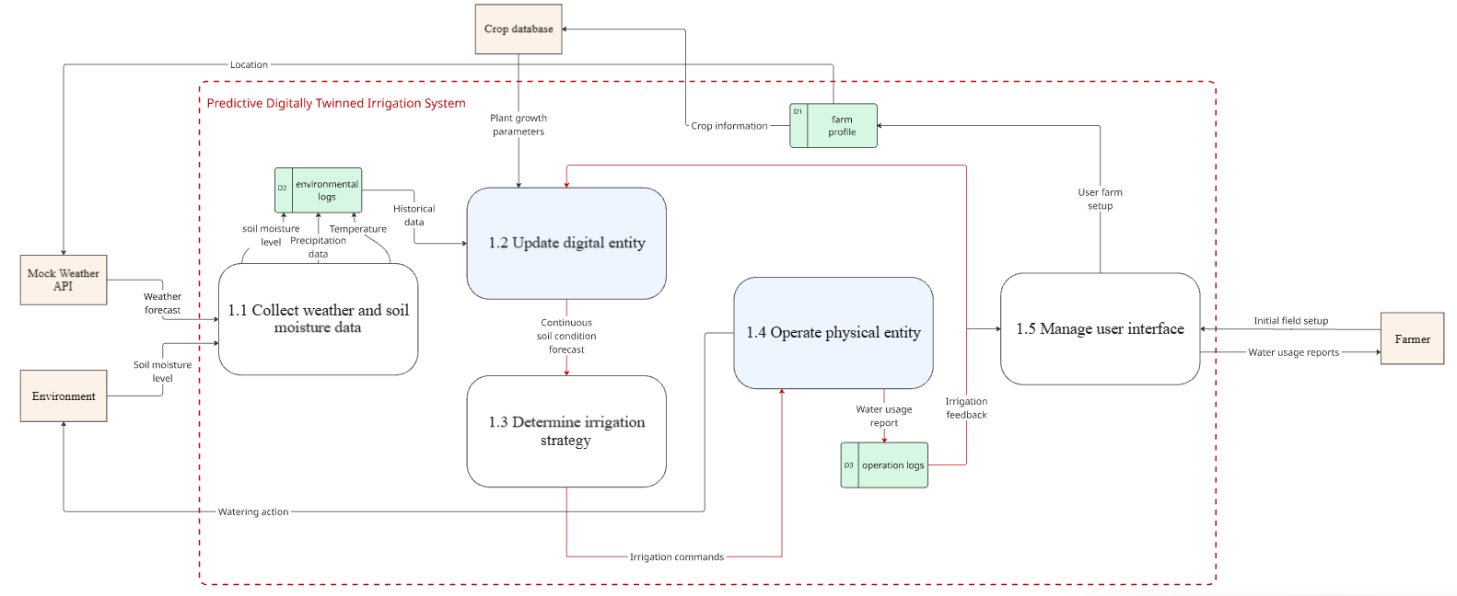
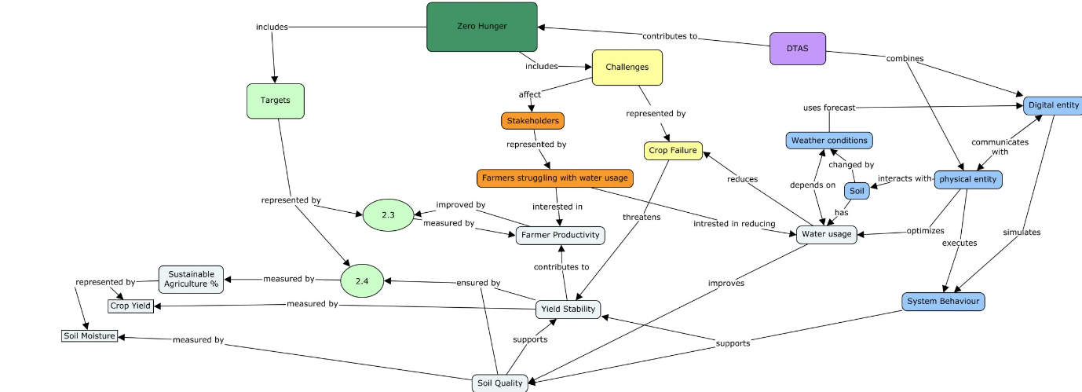
(2) Level 1 Context Diagram
(3) Concept Map
This approach directly addresses the stakeholders' challenges. By selecting only the cells that need attention, R2-Drip2 aims to reduce unnecessary watering and support better soil moisture control. In the long term, these effects are expected to support water saving and more stable crop growth for farmers working under difficult environmental conditions. Therefore, the technical solution is connected both to the stakeholder needs and to the intended SDG impact, which can be evaluated through indicators such as reduced unnecessary irrigation events (reduced litres of water wasted), improved moisture stability across crop cells, increased crop yield and fewer cases where watering occurs shortly before rainfall. Applying this system can be beneficial for all farmers working in harsh weather conditions, if done on a global scale.

Proof of Concept: Initial Goals
The Proof of Concept does not aim to build the full R2-Drip2 system. Instead, it focuses on testing the main feasibility question: whether a digitally twinned TurtleBot can use simplified digital field information to choose and perform the right action in a simplified physical environment. In the full technical solution, the robot would irrigate a real field. In the PoC, the TurtleBot represents the autonomous robot while the digital twin represents a simplified field model. This lets us test the core digital-to-physical loop without needing real agricultural hardware.
The PoC was designed to demonstrate the three key DTAS characteristics: bidirectional communication through command and result exchange, state synchronization through updated robot and farm states, and environment-driven behaviour through mock weather and moisture conditions influencing irrigation decisions.
Both the digital and physical environments are reduced to a 3x3 grid of nine cells. Each cell has a digital state, including soil moisture and crop information. Instead of real sensors and real weather data, the system uses mock plant and weather data. Based on this information, the decision program identifies which cell needs water and creates a live irrigation task containing the target cell and a simulated water amount. The TurtleBot then receives this task, navigates to the selected cell and performs simulated watering. The watering action is represented by beeping rather than by releasing real water.
After the robot completes a task, the result is logged and the digital field state is updated. This is important because it shows the feedback part of the DTAS: the digital model influences the robot's behaviour, and the robot's completed action changes the digital model again. The PoC is therefore in scope for demonstrating autonomous movement between grid cells, a simplified decision algorithm, mock environmental input, simulated watering, task logging and state updates. Real watering, real soil/crop sensing, learning from historical data and a complete farmer-facing interface are intentionally left out of scope.
Even with these simplifications, the PoC is meaningful because it demonstrates the central mechanism of the proposed solution. It shows that a digital representation of the field can guide an autonomous robot to act in the correct place and that the result of this action can be reflected back into the digital system. This gives an initial demonstration that the larger R2-Drip2 concept is technically viable, while also making clear which parts would need to be extended in a future version.

Implementation & Demonstration

Non-/Functional requirements that were implemented
For clarity, the implemented functional requirements are referred to as FR1-FR6 in the same order as the final PoC scope.⁴ During implementation, the original idea of reading a static schedule file was changed into a live decision output. Functionally, this still acts as the irrigation schedule, because it provides the robot with the target cell, but it is generated autonomously based on the weather state and moisture levels of the soil.
Requirement | Implemented behavior | How it is demonstrated
FR1: read target cell | Implemented through the live decision program, which selects the cell that needs watering based on soil moisture, crop target values and weather input. | Show the selected cell in the logs, then showcase the robot navigating to it.
FR2: read water amount | Implemented as a simulated/mock water amount attached to the irrigation task. This keeps the PoC focused on the DTAS logic instead of real irrigation hardware. | Display the generated task and show the same water amount in the log/update after the task.
FR3: 9-cell fields | Implemented as a digital 3x3 field with nine cells. Each cell stores a crop type and a soil-moisture level. | Show both the digital and physical layout before the task starts in the logs.
FR4: move to selected cell | Implemented through TurtleBot navigation on the simplified grid. The robot uses position feedback to navigate to and stop at the selected cell. | Run the program and observe the navigation system guiding the physical entity.
FR5: log completed task | Done through readable operation logs that record the task status, target cell and simulated water amount in real time. | Show each log entry in parallel to all the actions taken by the physical robot.
FR6: update digital field | Updating the digital field after the task is completed. Weather changes and irrigation completion affect the moisture values. | Show the digital field’s status before and after task completion for each cell.
(4) Requirements table
All non-functional requirements were also addressed within the simplified project scope. We did not implement the GUI component that was originally planned; however, the core system functionality was made as human friendly as possible through the logs and the demonstration sequence. Moreover, the PoC intentionally does not implement real watering or real crop sensing. Soil moisture, crop data, weather input and water amounts are simulated values, and watering is represented by a beeping sound. This matches the purpose of the PoC, which is to demonstrate the DTAS logic rather than a complete agricultural robot.

Tests and Scope Changes
Several elements were added during implementation to make the PoC work as an integrated system: an automatic decision program, weather-based drying and rain effects, a crop list with target moisture values and a settings file. The main changed requirement was the schedule mechanism. The robot no longer depends on a prepared schedule file as the live control path; instead, the decision program generates the target directly in real time based on the weather conditions. Other items that remained out of scope are real watering, real weather data, long-term learning from historical data and weather-based prediction system.
There are no automated checks integrated into the project. Validation was performed through manual acceptance tests in Gazebo and on the TurtleBot.⁶ Each test had an expected easily measurable outcome. These tests are suitable for the PoC because the goal is to show an integrated DTAS loop rather than to validate a production-ready irrigation product.

DTAS Characteristics Demonstration
The implementation demonstrates bidirectional communication. The digital side sends the selected target cell and simulated water amount to the TurtleBot. After reaching the target and completing the simulated watering action, the robot-side sends reports about task completion back to the digital side, which allows the log and field state to be updated.
State synchronization is demonstrated through the field state with a combination of continuous and event-based updates. The digital twin mirrors the battery level, tasks status, selected target cell, arrival/completion events, irrigation action and field moisture updates when relevant events occur. Although not every robot-internal state was continuously streamed, e.g. sensors for object avoidance, both entities continuously share enough information with each other to show the irrigation loop clearly.
Environment interaction is demonstrated through the mock weather loop. Weather is not only shown as background information; it changes the digital soil state and therefore influences the robot's next task. For example, rain can lead the system to skip watering, while dry weather increases watering priority.

Demonstration Sequence
- Show the initial 3x3 field state, including the cell numbers, crop/moisture values and current weather state.
- Run the program and show the generated irrigation task: target cell and simulated water amount.
- Show the TurtleBot navigating to the same target cell in the physical and simulated layout.
- Show the log messages announcing arrival at the target cell and the start/completion of simulated irrigation; Confirm of the synchronization between both entities by the beeping sounds indicating irrigation.
- Show the updated digital field and operation log after the task, proving that the physical action was communicated back to the digital twin.

Execution
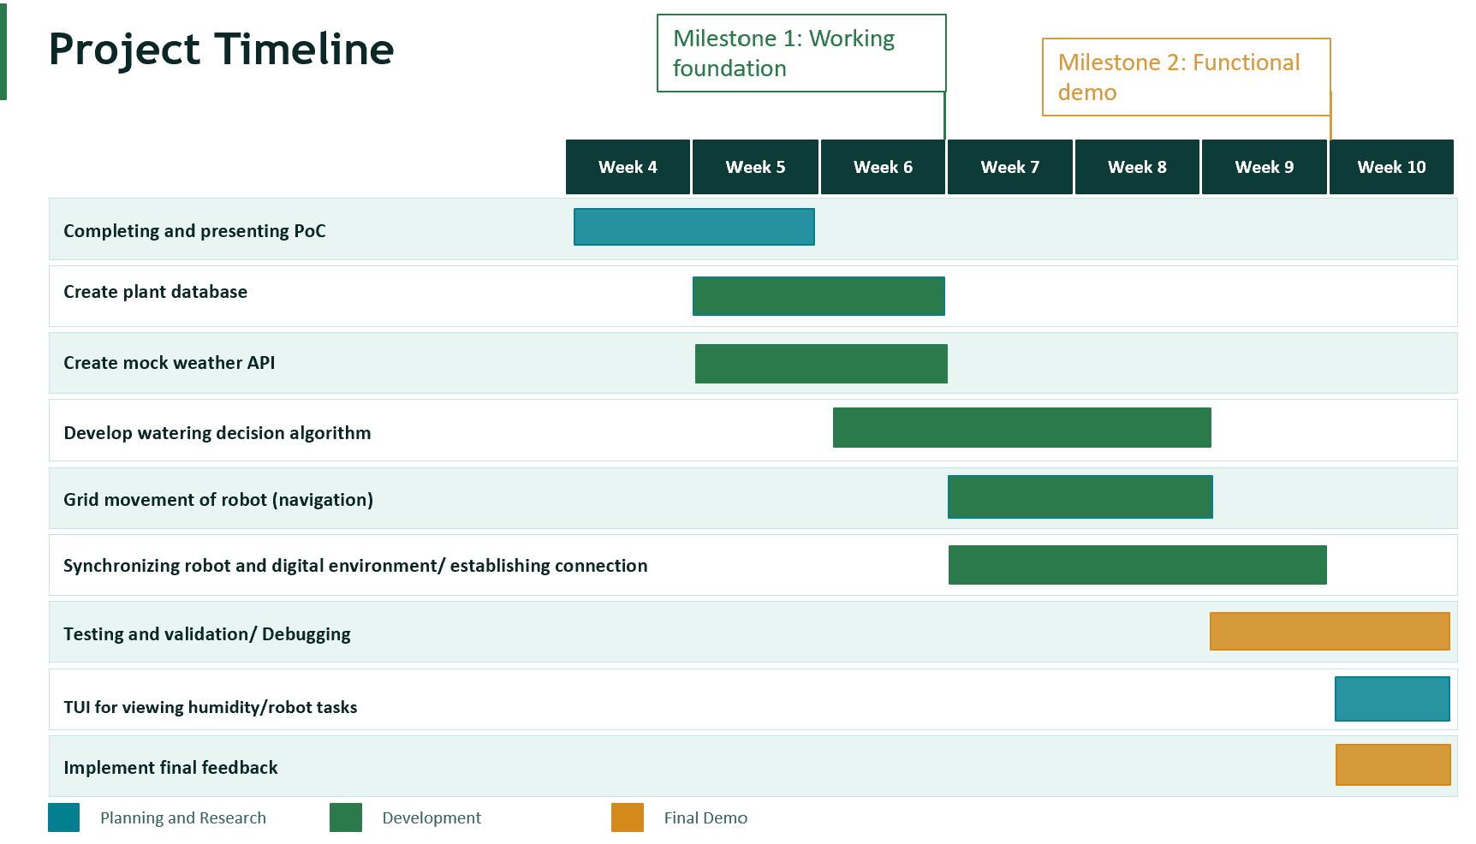
(5) Project Timeline

Executed Timeline
Weeks 4-5 focused on planning, research and scoping. The team clarified the stakeholder problem, the SDG connection, the Proof-of-Concept scope and the main technical direction. During this period, the team also started preparing the simplified field representation and the resources needed for later implementation and in particular - the .json files for the crop database, logs, digital farm, etc.
In Week 6, the work shifted towards the internal logic. The lab setup and TurtleBot connection were tested, and the first manual movement code was developed up to this point, so our focus shifted on creating the decision-making algorithm.
In Week 7, the development process had passed its first milestone – having stable foundation. The team started working on better navigation system and the integration process of the already developed components.
Weeks 8 was centred around the finalizing touches of all separate features and the full completion of the integration. While in week 9 the last phase of this timeline began - testing, debugging and cleaning the implementation. The second major milestone was reached, marking the completion of a functional demo version of the PoC.
Currently, towards the end of week 9 and the beginning of week 10, the focus of the team is to implement all the received feedback up to this moment, rework the documentations and prepare for the final presentation of our work.

Resources
The Proof of Concept used a mix of physical, digital and organizational resources. The main physical resource was the TurtleBot, which represented the autonomous irrigation robot, while the main digital ones were the mock weather input, the crop information, the generated irrigation task, the digital farm grid and the operation logs. Gazebo was used as a simulation environment before or alongside testing with the real robot, and ROS was used for movement commands and communication between project components.

Utilized Resources
Resource | Purpose (from Phase 4 slide) | Status
TurtleBot | Physical robot used to show movement to selected field cells | As planned
Gazebo | Simulates robot movement before testing with the real TurtleBot | As planned
ROS | Connects movement commands, robot control, and system scripts | As planned
Python | Implements the digital farm grid, irrigation schedule, and task logs | As planned
Lab access | Allows testing with the real TurtleBot under controlled conditions | As planned
Docker | Runs the simulation and project code inside a controlled container, set up as described on Canvas | As planned
Git / GitHub | Version control and team collaboration through feature branches and pull requests | Added
Course materials & lectures | Provide the ROS, digital-twin, and lab-setup knowledge used to build the PoC | As planned
LLM | CoPilot was used as a supporting tool for understanding error messages, debugging and finding resources for various relevant topics. | Added
(6) Resources table; Added = used but not mentioned in Phase 4;
Overall, the TurtleBot, Gazebo, ROS and Python formed the main technical basis for connecting the physical robot with the digital farm model. Adding Git and a LLM was necessary because they facilitated collaboration, research, debugging and implementation.

Post-Project Evaluation

Goals Evaluation
Comparing all our initial requirements and the achieved ones there is a noticeable difference.⁴ The main difference is that the initial system aimed for predictive autonomous irrigation based on future weather data, while the final PoC implements rule-based irrigation based on simulated current weather and farm moisture. Multiple of our functional requirements were centred around this concept. However, as the weeks progressed and we ended up reworking a big portion of our plan to satisfy the approaching deadlines. Therefore, the autonomy goal was reduced in scope, but the DTAS communication, synchronization and environment-response requirements were still demonstrated through ROS topic exchange, battery/task-state feedback, weather-driven moisture changes and digital farm updates after robot watering.

Bidirectional Communication
The two-way data flow between the two entities requirement was demonstrated through ROS 2 publish/subscribe topics. The digital side published the irrigation commands, which the robot-side controller subscribed to and translated into movement commands. After reaching the target and completing simulated watering, the robot published a completion message back to the digital side, where the farm state and operation log were updated. Therefore, both entities published and subscribed to at least one stream from the other entity.

State synchronization

The mirroring of meaningful states across the two entities was achieved by synchronizing the battery state, irrigation status and digital farm state. The robot published state-related updates, such as low-battery information and watering completion, while the digital entity subscribed to these updates and reflected them in the system logs and farm simulation. When watering was completed, the farm moisture value and operation log were updated as well. This shows that both sides maintained shared view of the farm state and the irrigation progress.

Environmental & Object Interaction
This requirement was met through the simulated weather conditions and the digital farm state. Environmental changes, such as dry weather or rain, changed the soil moisture values in the digital farm. These updated values were then used by the decision-making system to decide whether the robot should move to a cell and water it or skip watering and wait. When the robot completed a watering action, this was reported back to the digital farm and the moisture value of that cell was updated again. Therefore, the environment-driven behaviour did not stay on only one side of the system, but passed through the digital farm, the decision system, and the robot.
Resources Evaluation
Comparing the initially identified resources with those used during the project shows that the original resource planning was largely accurate.⁶ Most of the planned physical, digital and practical resources remained relevant throughout development, although two additional resources proved to be valuable aids that were not explicitly considered during the planning of the PoC.
The most significant addition to the resource we identified was Git/Github. Its use was central because it enabled us to collaborate in the coding process and supported parallel development of different features. Our Github repository was a virtual checkpoint for our code with its history, as it allowed us to keep track of all the changes and integrate them more easily, despite all the obstacles we encountered.
Moreover, we ended up also using Large Language Model which was used as a support tool in our research of all topics required to complete our project. Initially this was not included since our plan was to refrain from using any due to the strong Fraud Policy of the course. However, as we further discussed with our TA, we discovered that CoPilot could be used to aid us in refining our code and/or finding better suited resources for our project-specific requirements. Especially in such a new and challenging environment, understanding error messages and finding the intended way to implement features would have been even more difficult without the support this resource provided.
Alongside everything already mentioned, we used various sites on the internet to gather the technical references and domain knowledge needed to gain a better comprehension of the correct way to implement features with the given tools.
All the other resources present in our initial resource analysis were kept and used throughout the project. The TurtleBot, Gazebo, ROS, Python, the project-specific digital files, lab access and team technical time were all used as intended.
Unfortunately, we had to make changes to our initial PoC for multiple reasons, partially involving the way we had our resources presented to us and how fast we managed to familiarize ourselves with each of the new ones. This led to a great impact on our Technical solution, as it put some of the key requirements at stake. Additional 5-8 weeks would theoretically provide us with the required time to improve on our current PoC by adding all the features which we had to leave out of scope for this version of our project. These improvements are represented by a predictive irrigation schedule based on provided future weather data and UI for the relative stakeholders which would benefit from the use of our system.
Overall, there were a couple differences between the planned and utilized resources. The original resource assessment was used as intended, while adding Git and LLMs was necessary because they facilitated collaboration, research, debugging and implementation. Unfortunately, some parts of the PoC had to be left out of scope for the current version of the project, however, the core functionality of the system has not been affected.

Timeline Evaluation
While the overall project progressed according to the planned schedule⁵, a comparison between the initial and executed timelines shows some differences in how specific tasks were carried out. Some of them closely followed the original planning, whereas others evolved into more iterative processes as the project developed.
The biggest timeline deviation centred around the navigation system of the robot as it was expected to be fully developed by week 7 or 8, but it continued to require rework during the final integration with all other components. Thus, we adopted a strategy similar to prototyping which our initial timeline failed to reflect it accurately. As a result, the connection between the robot and the digital farm got the delayed, reducing the time available for the predictive irrigation algorithm. The team had to prioritize a functional PoC including the core DTAS requirements over implementing all originally planned features.
The other development tasks, such as creating the plant database, the mock weather API and developing the decision algorithm did follow the predicted timeline, as they were less broad in terms of scope and complexity.
The Final Demo tasks also respected the timeline. In the last weeks we focused on implementing feedback and heavy testing and debugging. It is worth noting that, naturally, testing and debugging happened all throughout the development process, and our timeline only highlights the period when this activity was the primary focus.
The Planning and Research tasks largely followed our planned timeline. We completed and delivered the first draft of the PoC presentation on time, and this enabled our team to start working on the implementation promptly.
Overall, the executed timeline remained mostly aligned with the initial plan despite some deviations in the implementation and changes to the initial PoC. The experience showed that tasks involving system integration and robot functionality benefited from an iterative approach, while smaller development tasks could be completed in a more traditionally linear manner as originally planned.

Risk Assessment Evaluation
Since the beginning of the course, our team realised how important for us a good risk assessment would be. This was due to many factors which showed their first signs early. Thus, we were quick to create the first draft of our risk assessment which has been continuously updated throughout the course as we encounter a variety of roadblocks in our progress. The initial RA was useful but incomplete, because it focused more on technical risks failing to see all the endless possibilities for human error.
To begin with, during our first group session everyone was reviewed their personal schedules, when multiple members realised that due to abnormally high number of holidays in this quartile, they would be missing for large portions of the work. This was the first issue we had to tackle. We settled on a mitigation strategy - every member will inform the others ahead of time for their absences, so tasks can be planned accordingly, while one person of the group will keep a calendar with everyone’s indicated “absent” periods. Unfortunately, this strategy was not implemented successfully, and we had to resort to our planned response for most of the course’s duration – workload being split unevenly among members to prioritise task completion over personal preferences.
Some of the other issues we encountered were difficulty applying new material, teammates’ over-reliance on LLMs, conflicting deadlines with other courses, missed internal team deadlines and team member ghosting. For most of these issues, their occurrence can be partially explained by the fact that they were absent from the initial version of the RA and were only added later, as they were actively happening. Tackling them was mostly successful, thanks to our planned and immediate responses. Some productive reactions included turning to our TA for support, conducting a team discussion, improving communication channels and making several compromises.
On the other hand, plenty of our mitigation strategies proved pleasantly successful. Our team never encountered TurtleBot connection failure during testing, missed mandatory deadlines, lack of helpful feedback from other teams, loss of work due to technical issues and others. All thanks to our regular preparations before lab work, asking for specific feedback, improved communications channels, adding Github as a resource and closely keeping up with information on the Canvas page.
To conclude, despite the concept of a risk assessment being new for all of us, it supported our work throughout the entirety of this course. Changes have been made since the RA was last submitted but they mainly consisted out of adding more possible risks and updating some of the planned responses to be more comprehensible.
(The final version of the RA is included in Appendix 1 of this documentation.)

Detailed Reflection
Our Team Dashboard captured a team of seven with unbalanced but complementary strengths. Two members noted having significant technical skill, while the rest sat around average and similarly, self-rated leadership skills were high in just two people. The clearest common challenge was thought to be Collaboration, with as many as four of us expecting this to be the hardest part of our project. Creativity and Innovation was expected to be the most exciting opportunity for five of us. Lack of skills and lack of time were identified to be the biggest threats to the success of our project.
(All team composition dashboards can be found in Appendix 2 of this documentation.)

Identifying and distributing tasks
Starting off, most of us expected collaboration to be the most difficult, and we identified “different levels of engagement” as a probable risk. In practice, our engagement was reasonably balanced, leading us to lower the risk from high to low in the Evaluation. The dashboard helps explain this: since two members were confident in their leadership abilities, it was natural for one of them to lead the software architecture, and for the other one to lead the overall course of the project. Because technical skill was concentrated, we made a clear task division (mock weather API, decision algorithm, farm management) through an open poll. Giving each person an ownable piece meant differences in pace and technical skills mattered far less. We see this as positive: a weakness our initial Dashboard predicted was avoided through deliberate planning rather than left to chance.

Lab sessions and feedback
Preparing for and conducting lab sessions revealed a threat to success from our Dashboard that we genuinely did face: “Lack of Time” proved to be accurate. Issues with TurtleBot connection early on ate into our already limited lab time. As a result, we adopted a more iterative, prototype-led approach for the navigation of the robot instead of a traditional top-down approach.⁵ Public speaking was also a skill many of us were unsure about in the Dashboard, which made presentation preparation and the feedback we exchanged with other teams particularly valuable: giving and receiving feedback was a great way to improve our weak spot. We see the shift in navigation strategy as positive, since it played into our strengths, and the time pressure as a negative constraint that we nevertheless dealt with responsibly.

Research and adapting our approach
Most of us marked Creativity and Innovation as the most exciting opportunity and that view on the project showed up in how willingly we revised designs. Two planned approaches changed in the middle of the project: the digital communication of the robot was moved from JSON files to ROS services⁶ once we realized that the file-based design was inconvenient and the farm state ended up as a JSON file rather than the dedicated UI we first planned. These revisions were made because of how we worked: pull requests with code review by a teammate who consistently evaluated them and thereby pointed out design flaws early, which our team investigated rather than getting defensive. “Lack of skills” was the other main threat on the Dashboard and we answered it by adding two unplanned resources, Git and LLMs⁶, to facilitate collaboration and get familiar with an unknown ROS environment. We perceive both changes as positive: they illustrate that our team adapted to change rather than clinging to its first plan.

Training session, risk assessment and team agreement
The project training session and the structure in the team we built from it were very helpful to our project. Having identified team risks early, with collaboration issues being the most prevalent, we set up various communication channels (a WhatsApp chat plus a structured Discord server) and agreed to share availability and possible absences.^{(Appendix 1)} This exact preparation helped us respond proactively rather than reactively to the unexpected Canvas data breach, contacting our instructor immediately to confirm deadlines and requirements. Our initial risk assessment needed only small changes over the project, which indicates that our team agreement was strong and extensive from the start.

Lessons learned and what we would change
What worked: a clear task distribution that helped us overcome our most feared challenge, consistent communication, an early start on our risk assessment that let us act in advance and a creative environment that treated plans as revisable. What we would change: we would commit to tools like Git and LLMs earlier on instead of recognizing them as resources in hindsight and, given our weakness in public speaking, practice presentations earlier and more often. Furthermore, we learned that in the planning stages human error needs to be accounted for in all tasks, since it contributes the most to work delays. Overall, our team differences helped us adapt to the project’s challenges and make better use of each member’s strengths.

Appendix 1 Risk Assessment
# | Risk | Likelihood | Impact | Planned Response | Mitigation Strategy
1 | TurtleBot connection failure during testing | Medium | High  Losing time during the lab that was meant for testing. | Switch to running the tests in simulation for the session and retry in the next one. | Testing the connection setup before the lab session to catch issues early.
2 | Missing deadline due to Canvas situation | High | High  Losing the opportunity to get feedback on the work. | Contact the instructor directly to confirm the deadline and ask for an alternative way to submit. | Reaching out to the lecturers/TA to inform in advance; Regularly check the Canvas page.
3 | Nobody wants to present the assignment | High | Medium  A presentation that reflects poorly on the team's work and affects our final grade. | Pre-assign sections with a named backup for each part, so someone can step in if needed. | Present as a team, each person has a short sequence, so the presentation doesn’t seem overwhelming.
4 | Lack of feedback from other teams | Medium | Medium  Presenting a weaker version of our work with easily avoidable issues. | Reach out to another team for a cross-review and follow up with the instructor for extra feedback. | Ask for more feedback from the instructor and other teams and friends.
5 | Loss of work due to technical issues (consider equipment/communication issues) | Low | Medium  Loss of file access, delays, disrupted communication, loss of progress. | Alert TA as soon as possible and inform teammates. Find a way to get access to new equipment; Restore files from backup. | Implement version control for any code and keeping a shared online drive for all project files.
6 | Difficulty in acquiring and applying learnt material | Medium | Medium  Uneven work quality, increased dependence on more experienced teammates. | Ask tutor for help with the challenging area; maybe contacting someone who has done the course before asking for advice; research for learning resources online. | Staying connected with teammates and asking for help if needed; Splitting tasks based on everyone's strengths and meetings to work together.
7 | Different levels of engagement in the course between team members. | High | Medium  Uneven workload distribution and reduced team motivation. | Informing our tutor and try to resolve the issue with a group discussion within the team. | Updating each other on our availability in advance; Have a discussion on everyone's final grade expectation.
8 | Teammate on a vacation/ away for a short time period | High | Low  Reduced attendance in meetings and delayed task completion. | Tasks will be split accordingly where that might mean uneven workload on some weeks. | Members will inform the others ahead of time, so work can be planned easily.
9 | Teammate commits fraud | Low | High  Academic integrity issues, penalties, and damage to the whole team’s result. | Contacting our tutor and discussing the situation with the teammate; read the fraud policy on Canvas ; | Everyone is instructed to keep a proper citation and is aware of the rules; Keeping honest communication within the team.
10 | Conflicting deadlines with other courses and personal situations. | High | High  Reduced attendance, delayed task completion and low-quality results. | Update the absent member so they can catch up or complete some tasks online; Redistribute essential work if necessary; Inform the tutor early if a milestone is at risk. | Warning teammates ahead of time in case of a packed schedule. Trying to be ahead on schedule with one's work - have buffer time in between deadlines.
11 | Communication breakdown | Medium | High  Misunderstandings, delayed decisions, unresolved conflicts. | Contact tutor/lecturer and inform them of the situation; Hold a meeting discussing the issue - compromises might need to be made. | Keep consistent communication; Plan meetings and make decisions based on majority; be respectful towards each other.
12 | Missing internal team deadlines | Medium | High  Delayed project progress, rushed final work. | Reorganising the project plan ; shifting focus of the current work; | Creating a detailed project plan; keeping regular communication; Leaving buffer time before final deadline.
13 | Team member stops responding / ghosting | Medium | Medium  Unclear task ownership and uneven workload distribution. | If no reply for 3 days then alert the TA. Redistribute the missing person's tasks within the team; If they return, they help by taking extra work. | Agree on 24h reply rule in group chat. Have fixed number of meetings per week to monitor progress. Attend group sessions with the whole team whenever possible.
14 | Social Loafing | Medium | High  Uneven workload, reduced team motivation and poor work quality. | Discuss the issue with the individuals involved and try to come to a solution; Worst case, turn towards the TA and the lecturer informing them of the issue. | Keeping track of all tasks and who has taken responsibility for them. Weekly check-ins and every taken task gets disclosed to the team.

Appendix 2 Team Dashboards

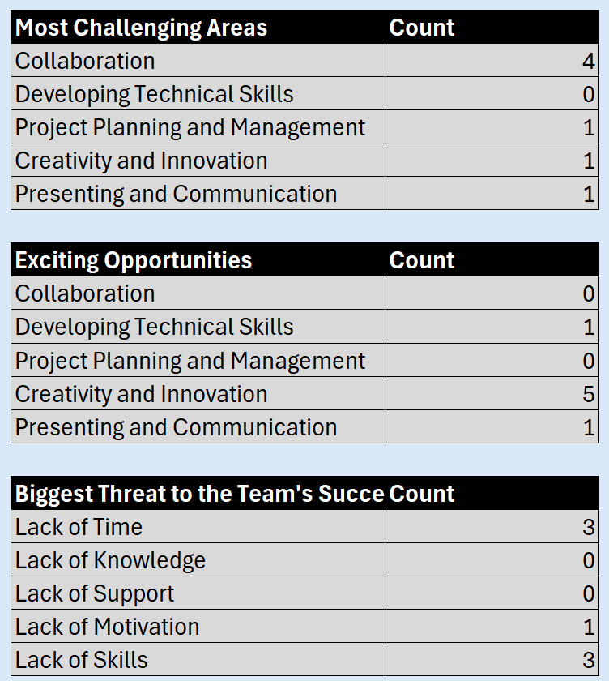
Team Dashboard Phase 1
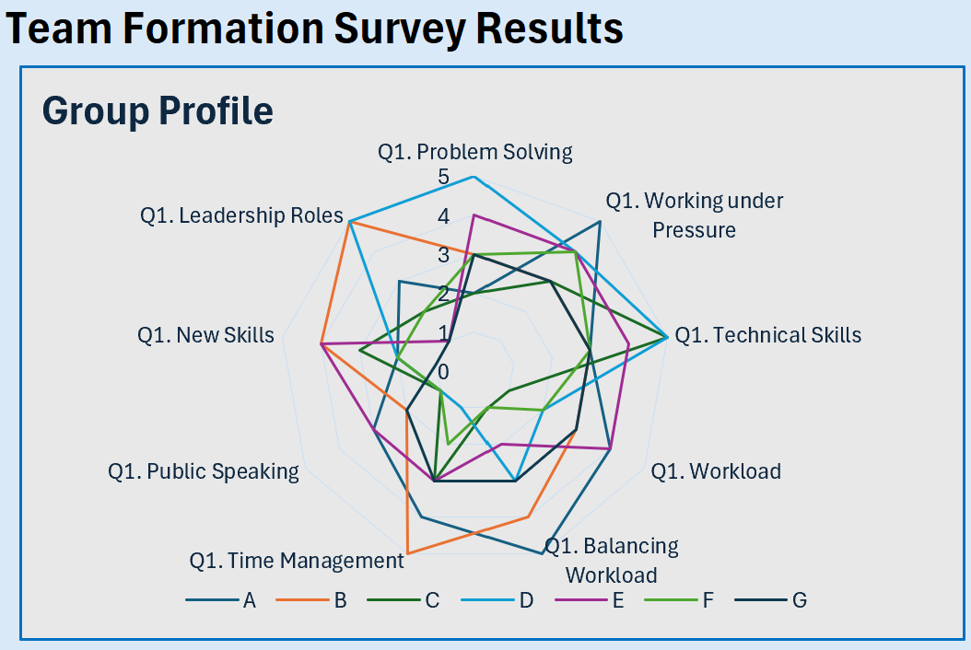
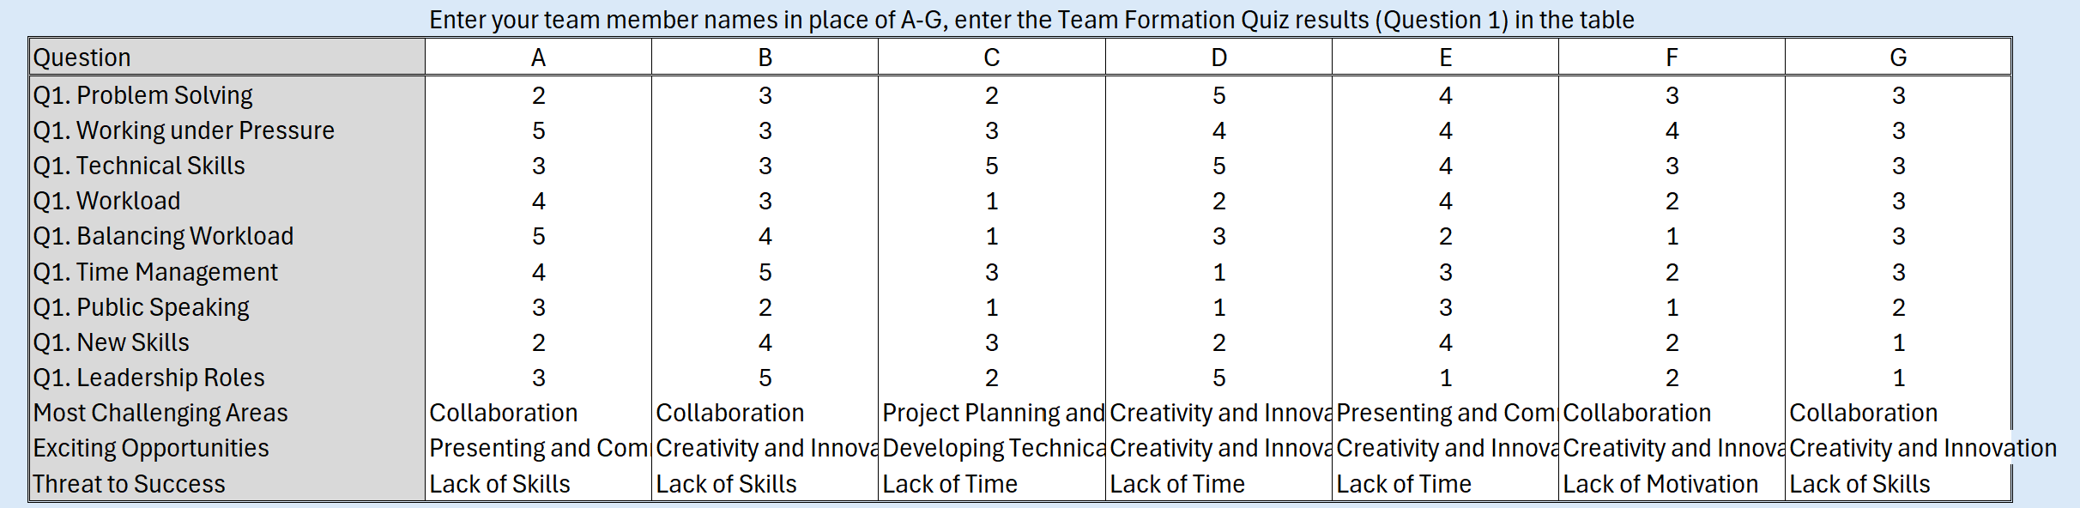
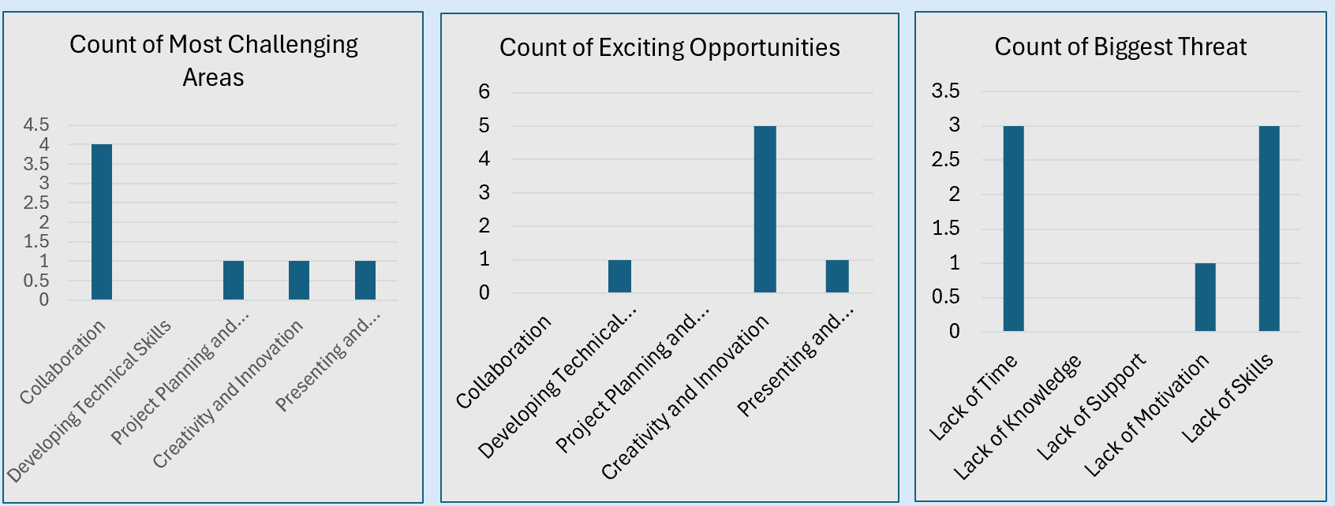

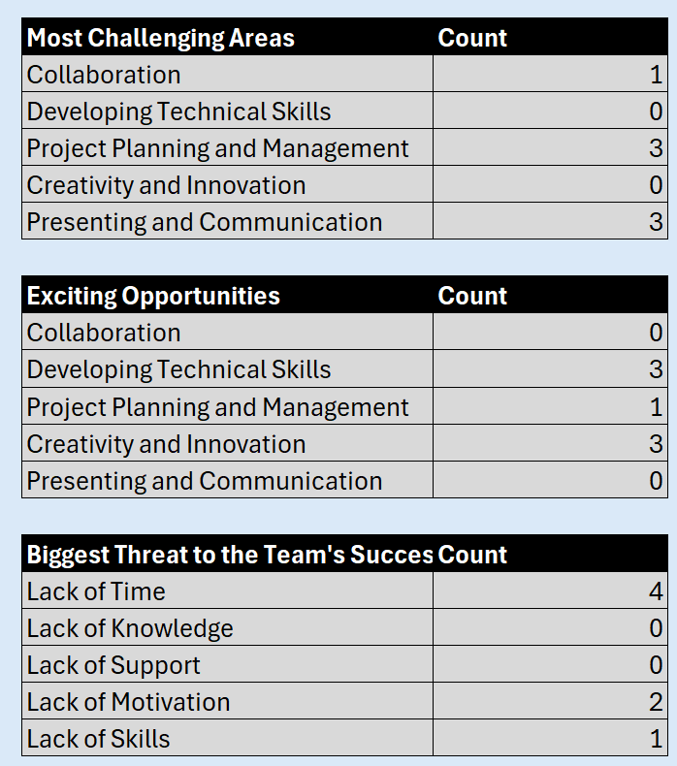
Team Dashboard Phase 5
