CASE
CREATE TABLE t_employee (
c_emp_empid INTEGER,
c_emp_name VARCHAR(50),
c_emp_salary NUMERIC(10,2),
c_emp_age INTEGER,
c_emp_joiningdate DATE
);
INSERT INTO t_employee
(c_emp_empid, c_emp_name, c_emp_salary, c_emp_age, c_emp_joiningdate)
VALUES
(101, 'Rahul', 45000.00, 22, '2024-07-10'),
(102, 'Priya', 75000.00, 28, '2023-05-15'),
(103, 'Amit', 95000.00, 35, '2022-03-20'),
(104, 'Neha', 60000.00, 25, '2025-01-12'),
(105, 'Raj', 120000.00, 42, '2021-11-05');
Q1
Query | SELECT  c_emp_empid,  c_emp_name,  c_emp_salary,  CASE  WHEN c_emp_salary >= 100000 THEN 'High'  WHEN c_emp_salary >= 60000 THEN 'Medium'  ELSE 'Low'  END AS salary_category  FROM t_employee;
Output | 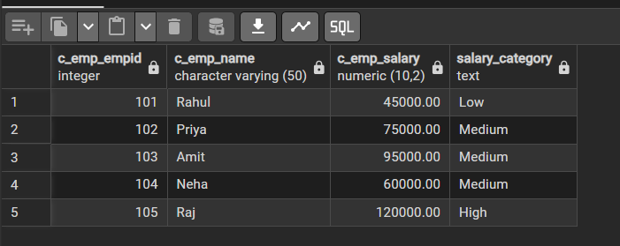

Q2
Query | SELECT  c_emp_empid,  c_emp_name,  c_emp_age,  CASE  WHEN c_emp_age < 25 THEN 'Young'  WHEN c_emp_age BETWEEN 25 AND 35 THEN 'Adult'  ELSE 'Senior'  END AS age_category  FROM t_employee;
Output | 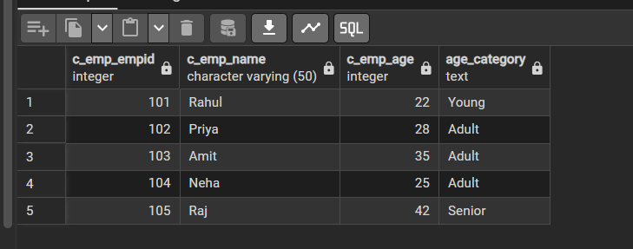

CAST
Q1
Query | SELECT  c_emp_name,  c_emp_salary,  CAST(c_emp_salary AS INTEGER) AS salary_integer  FROM t_employee;
Output | 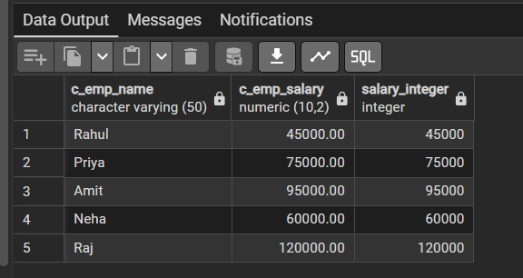

Q2
Query | SELECT  c_emp_name,  c_emp_joiningdate,  CAST(c_emp_joiningdate AS VARCHAR) AS joining_date_text  FROM t_employee;
Output | 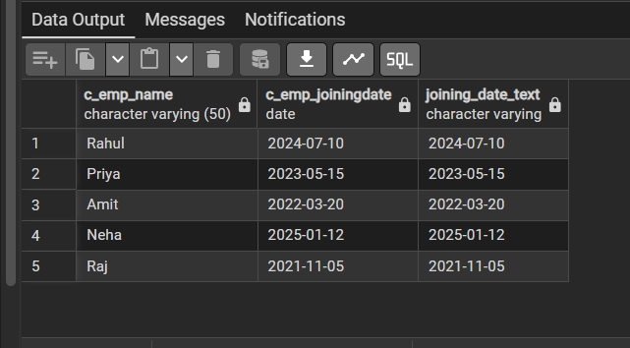

SEQUENCE
Q1
Query | CREATE SEQUENCE seq_employee_id  START 106  INCREMENT 1;  SELECT nextval('seq_employee_id');
Output | 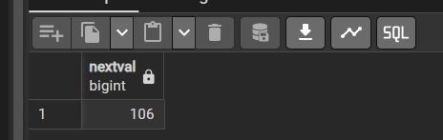

Q2
Query | INSERT INTO t_employee  (c_emp_empid, c_emp_name, c_emp_salary, c_emp_age, c_emp_joiningdate)  VALUES  (nextval('seq_employee_id'), 'Karan', 55000, 24, '2026-08-26');
Output | 