Mapping Name: **PICASSO_TO_GENESIS_NUTRITION_DATA**

Step 1:

Import or check out project from SVN: https://63.128.188.19/svn/008061/PicassoToGenesisnutritionData/Trunk/Source/picasso_to_genesis_nutrition_data_integration_onperm

Go to that project and right click on project and select check out option.

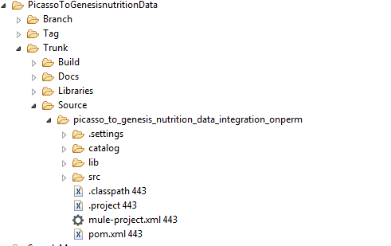

Open your Anypoint studio.

To Import project in Studio.

1. Go to FILE select Import option, or right click select Import .

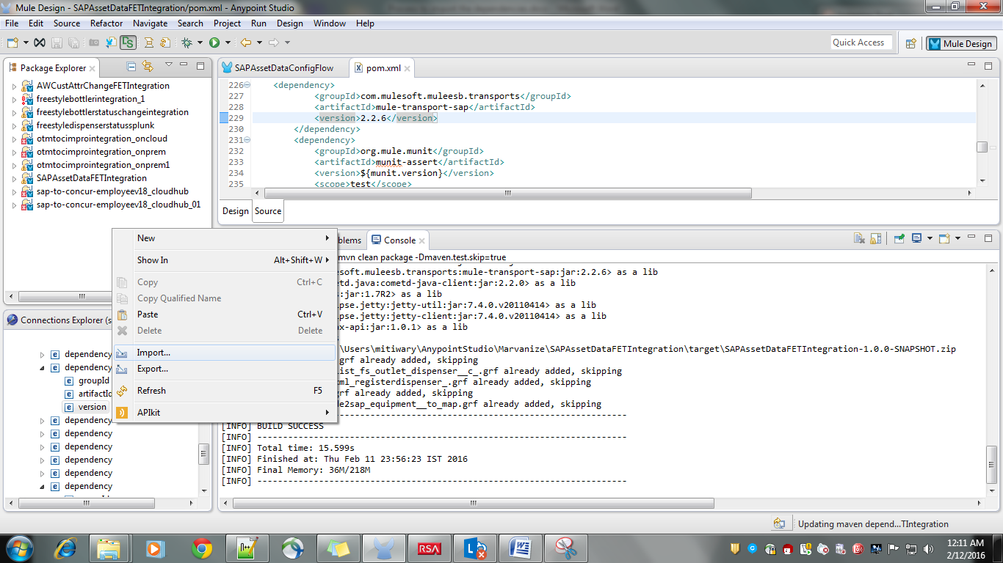

**2.)Select option Maven-based Mule Project from pom.xml**

**Click on NEXT**

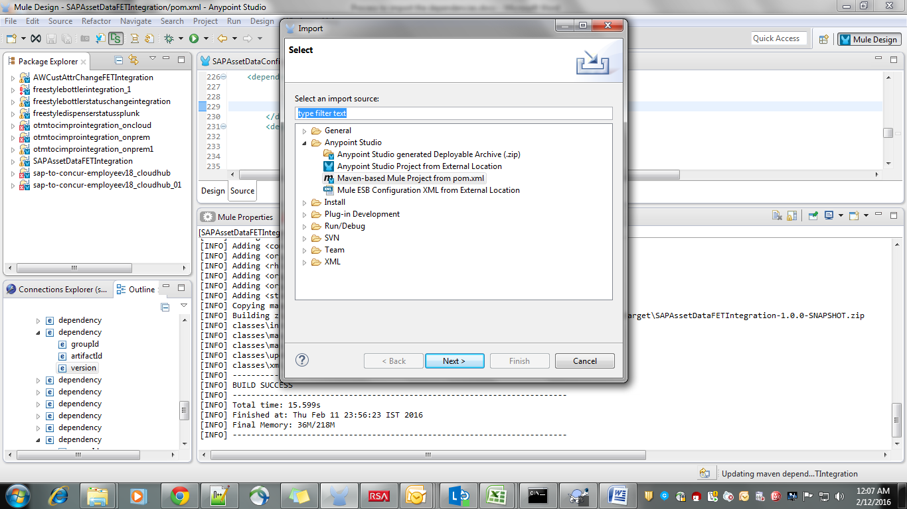

**Go to your file location (where you have checked out the code .) select POM.XMl**

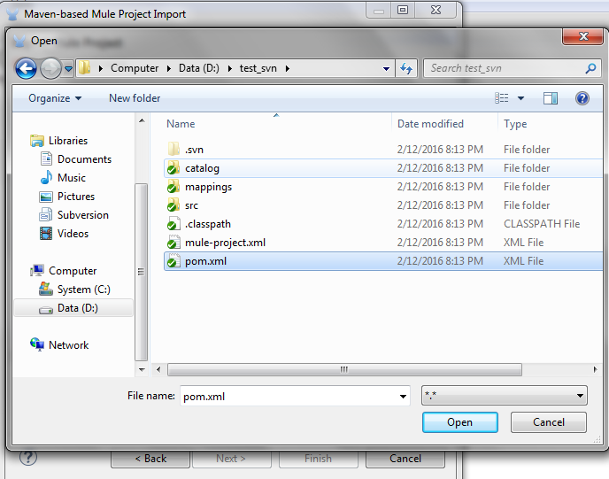

**Select the version check the option Copy project into workspace**

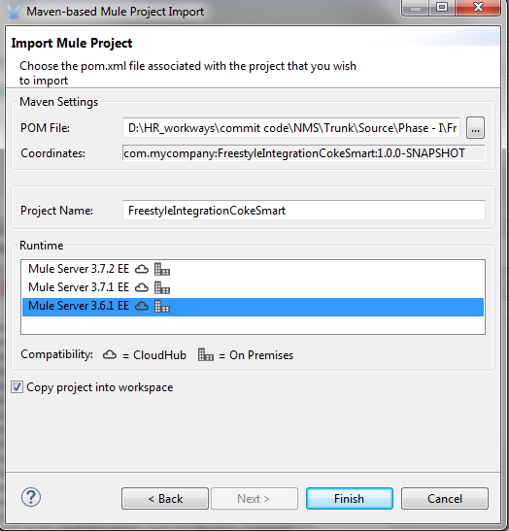

**Click on FINISH**

**After importing the project run .**

a.) Select the project.

b.)Right click select Run As Mule Application with Maven

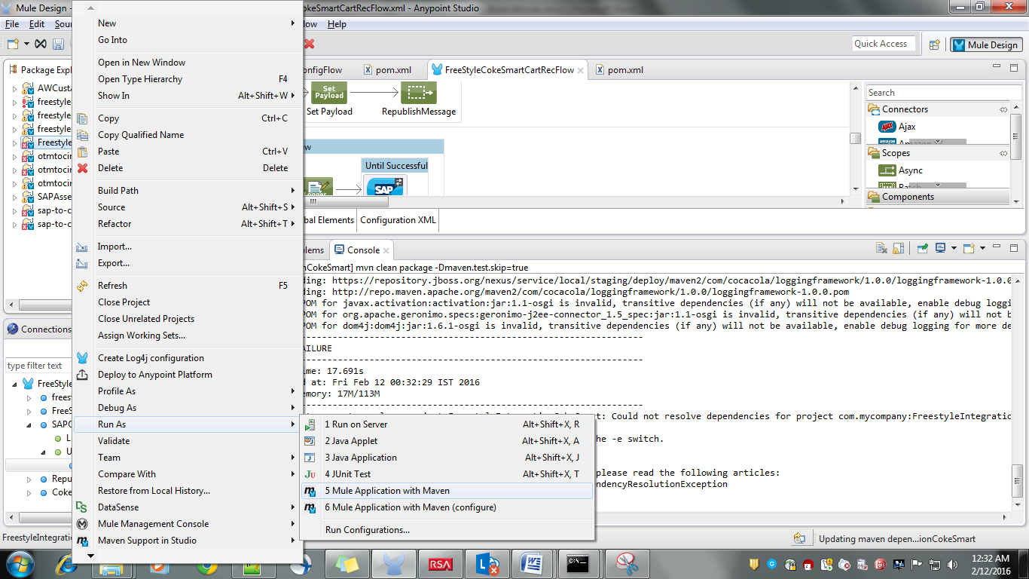

**After running build gets success. It will be Deployed**

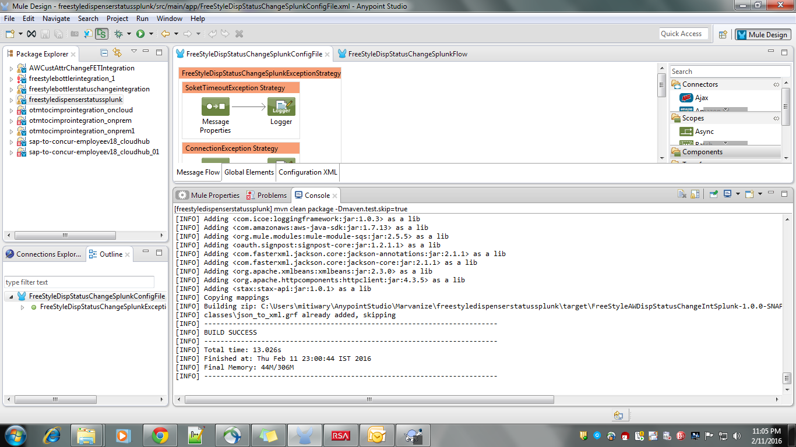

Step 4:

Select the project, right click and run as **Mule application with Maven**

I deployment got success.

