CSCI 313 Hyeonji Lee

/\*----------------------------------------DESIGN EXPLANATION Q8-------------------------------------------------\*/

This program is made with one class “Queue”. This class holds multiple functions that creates a queue to provide the service in first come first serve order. Additionally, this class has a function for the user to select a priority option to get faster service.

Queue:

In this program, we aim to provide a desired priority requested by the user.

The user gets 4 options: 0) Regular order, 1) Express order, 2) Bulk order, 3) Friends and Family order. The selected choice is then used for priority position calculation.

Our program has the function that takes the choice and use its number to calculate the position in the queue. The queue is first come first serve, however, if the user requests special priority service, we will minus the entered number from the position and let it move to closer to front. Regular order doesn’t have any priority so it deducts 0. Friends and Family order has the highest priority so it deducts 3 from the position. For example, on the 5th order, the position 5 will become 2 (5 minus 3 makes it 2nd position).

We have an if statement to make the position 1st if there are smaller numbers in front of the position.

For example, if there are 2 orders in front, even if the user chooses to cut 3 positions by selecting Friends and Family order, since the place cannot be negative number and the first position is the fastest position, the priority position will become 1. The entire process is then timed and printed.

Members:

data, front, rear, capacity, pos;

capacity is set for 6 orders in this program

Methods:

bool empty()

void enqueue(const T& d)

void dequeue()

int yourOrder()

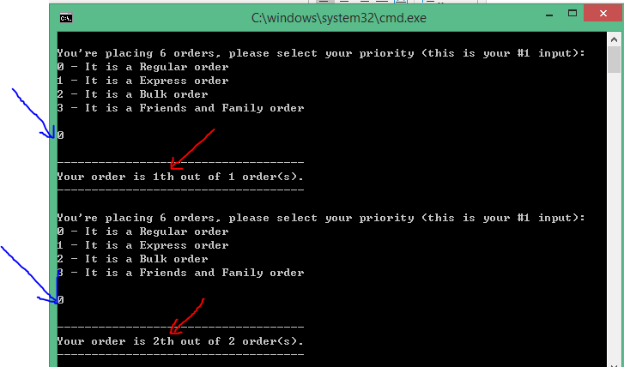

//priority #0 doesn’t change the position

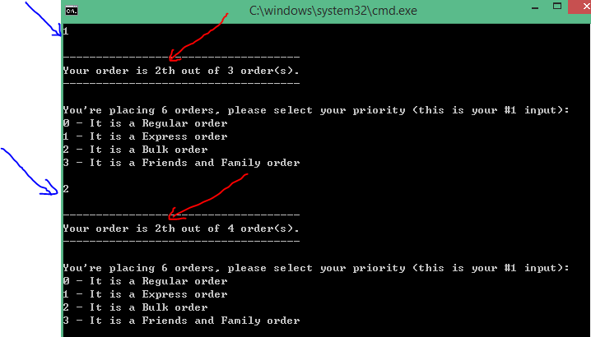

The user selection #1 deducted 1 from place#3, and it became 2nd place.

The selection #2 changed 4th place to 2nd place (4-2=2).