First, we add two rows to the Airport table: <jfk, jfk, null, null> and <yyz, yyz, null, null>.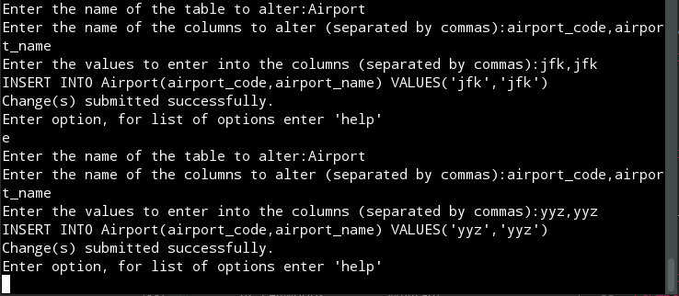

Then, we change the airport_name to notjfk where the name is equal to jfk. After that we delete where airport_name is equal to yyz.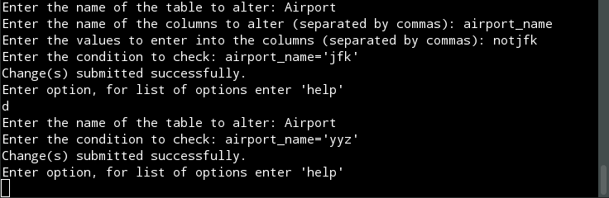

This screenshot shows the resulting table.