Virtual Directory

Network Group Models Analysis

Last change: 2007-28-02

Table of Contents
Introduction 1
Specification Of DIT Exposure 2
Model 1 2
Model 2 2
Model 3 3

Introduction
This document describes the possible way to expose DITs to the end user. The document is making reference to the following concepts (given that these concepts are accepted by all—if not then discussion need to take place prior to read this document):

- There are network group in OpenDS
A network group allows classification of client connections through criterii. A connection belonging to a network group has to comply with the policies attached to the network group. Requests coming on the connection has to comply with the policies as well.
- Network group exposes DITs through workflows
Once a client request is cleared then it is routed to one DIT. How the operation is processed depends on the workflow attached to the DIT.
There are several solution to expose DITs through workflows. Each of these have pros and cons as described hereafter.

Specification Of DIT Exposure

Model 1

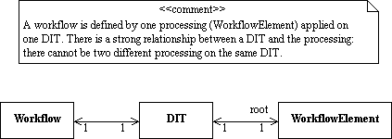

This is the simpliest model and the most limited one. Requests are routed to a workflow which exposes a DIT and the DIT has its own processing (the processing is identified by the root workflow element). This means that the processing is tightly coupled to the DIT and we cannot have different processing on the same DIT, nor we can have several DITs using the same processing. The following object diagram illustrates a deployment using this model:

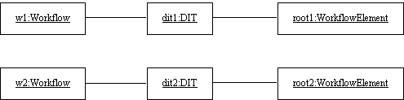

Model 2

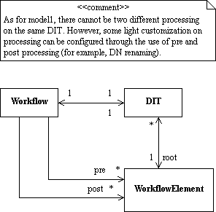

As for model 1, requests are routed to a workflow which exposes a DIT, and the DIT defines its own processing. So we end up with the same limitation than model 1. However, as opposed to model 1, we may specify pre and post transformation at the workflow level, so that exposed DITs may appear a bit differently.

Let's consider the following deployment based on that model:

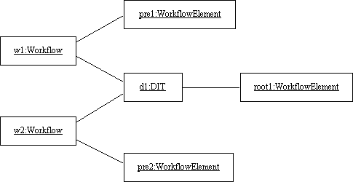

A request can be routed to one of the two workflows, w1 and w2. Both workflows are using the same DIT, d1 (hence the same processing root1) but w1 may apply some transformation prior to execute the root1 processing, while w2 may apply some other transformation prior to execute the same root1 processing.
A use case for such deployment: [d1,root1] is the DIT exposed to the customer for o=sun. Now Storagetek is part of Sun and we want to access to the same DIT through o=stk. To do so, we just need to configure a pre transformation for w2 (rename o=stk to o=sun) and use the same DIT [d1,root1].

Model 3
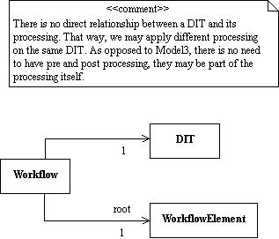

A request is routed to a workflow which applies a processing on a DIT. As opposed to Model 1 and Model 2, the processing is no more defined by the DIT itself. This means we may apply several processing on the same DIT, as shown in the following object diagram:

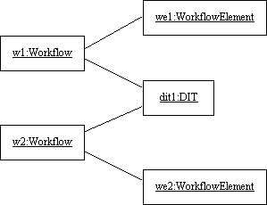

This model is a general purpose model. In the deployment above, a same DIT may be exposed differently to the client. Note that pre and post transformations are no more needed as they are embedded in the processing itself.

