Virtual Directory

Virtual Directory Prototype in OpenDS

White Paper
Last change: 2007-22-02

Table of Contents
Introduction 1
Specification 1
The Network Group Model 2
The Workflow Model 3
Implementation 6
Overview 6
ConnectionHandler 8
RequestHandler 9
NetworkGroup and Workflow Engine 11
NetworkGroup and NetworkGroupManager 13
DIT and DITManager 16
Workflow 16
WorkflowElement 17
FinalWorkflowElement 17
Addendum 20
Prototype Specification 20

Introduction
The purpose of this document is to describe the Virtual Directory high level design and how this design is intended to be integrated into the current core server. As a proof of concept, a prototype is specified and will be implemented. The main objective of the prototype is to evaluate how virtual is impacting the existing core server, both in term of code refactory and performance hit.

Note: a document, based on that white paper, will be created later on for maintenance purpose and will be stored in the official documentation depot.

Specification
The current core server is able to process LDAP requests against a single backend (each backend can handle one or more suffixes). With Virtual Directory, new features are coming such as load balancing, distribution and virtual transformation. These new features require some adaptation in the core server, in particular LDAP requests may now be routed to more than one backends, and backend types are extended to fit a new model: a backend can be of type local database, remote LDAP server, JDBC repository. Along with these new features, the Virtual Directory is bringing a new way to present the data: while the current core server is presenting simple local backends (basically DITs), the Virtual Directory is exposing DITs and processing (aka workflow) around the DITs. How Virtual Directory is exposing these new DITs is done through the network group model.

The Network Group Model
A network group defines which DIT can be accessed by client applications and what can be done on the DIT. Each new connection is evaluated and attached to the most appropriate network group. Evaluation criteria may be bind DN for example. Then requests coming on the connection can be routed to one or more DIT of the network group. The route is based on the operation type and the base DN of the operation.

In the example below, the network group exposes two DITs: one for o=sun and one for o=ibm. Requests with base DN under o=sun are routed to the DIT o=sun, and processing of the request starts with the we1 workflow element. A workflow element is a building block of the processing chain attached to the DIT o=sun.

NetworkGroup
DIT Pool

we1
o=sun
we2
backend1
route
o=sun
we3
o=ibm
we4
o=ibm
backend2

Because Sun has bought Storagetek, databases of the two companies were merged and unified under o=sun namespace. To be able to handle requests coming from Storagetek legacy applications, we need a way to route the requests with base DN o=stk to the DIT o=sun. One solution to achieve that would be to insert a transformation prior to the workflow element we1 so that o=stk can be renamed into o=sun. and be processed by we1 workflow. Such transformation is performed by a building block called a pre-workflow element.

NetworkGroup
DIT Pool

route
we1
o=sun
we2
backend1
o=sun
o=stk

transformation
o=stk <-> o=sun

A request can be routed to more than one DIT. When this happens, the route process submits the request to the workflow of each elected DIT.

NetworkGroup
DIT Pool

we1
o=sun
we2
backend1
route

we3
ou=people,
o=sun
subtree
search on
o=sun
we4
backend2

Now let's describe a bit more in detail the workflow topology.

The Workflow Model
The workflow is a topology of workflow elements and the workflow element defines a basic processing. Each workflow element belongs to one of the categories final, virtual and route as shown below. Note that each exposed DIT is associated to one workflow topology whose root is the rootWorkflow workflow element.

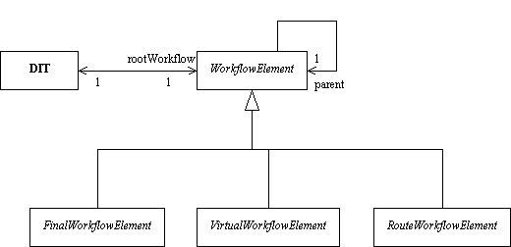
The FinalWorkflowElement gathers all the workflow elements that are encapsulating a physical repository such as local database, remote LDAP servers, JDBC repository or LDIF flat file.

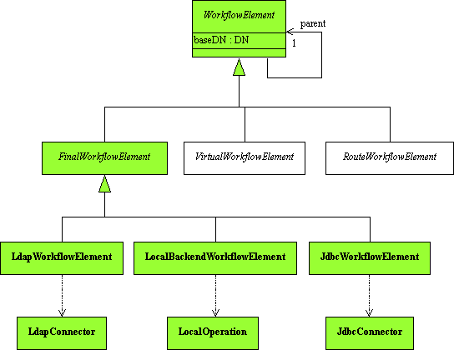

The VirtualWorkflowElement gathers all the workflow elements that are creating virtual content such as virtual transformation (to transform DNs, to create are delete attribute on the fly, ...) or join of entries.

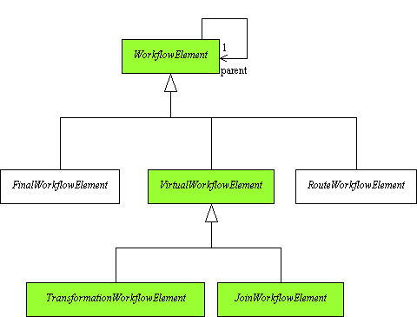

The RouteWorkflowElement gathers all the workflow elements that are used to route requests to an appropriate workflow element. The route processing may be of type load balancing or distribution. Both types have to implement the appropriate interface (LbInterface and DistributionInterface). By default, a number of load balancers and distributions will be shipped, but the customers will be allowed to create their own route workflow element as long as their route workflow element complies with the interface.

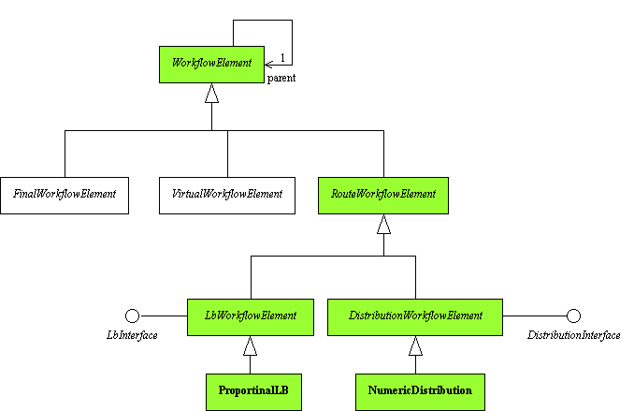

Implementation

Overview

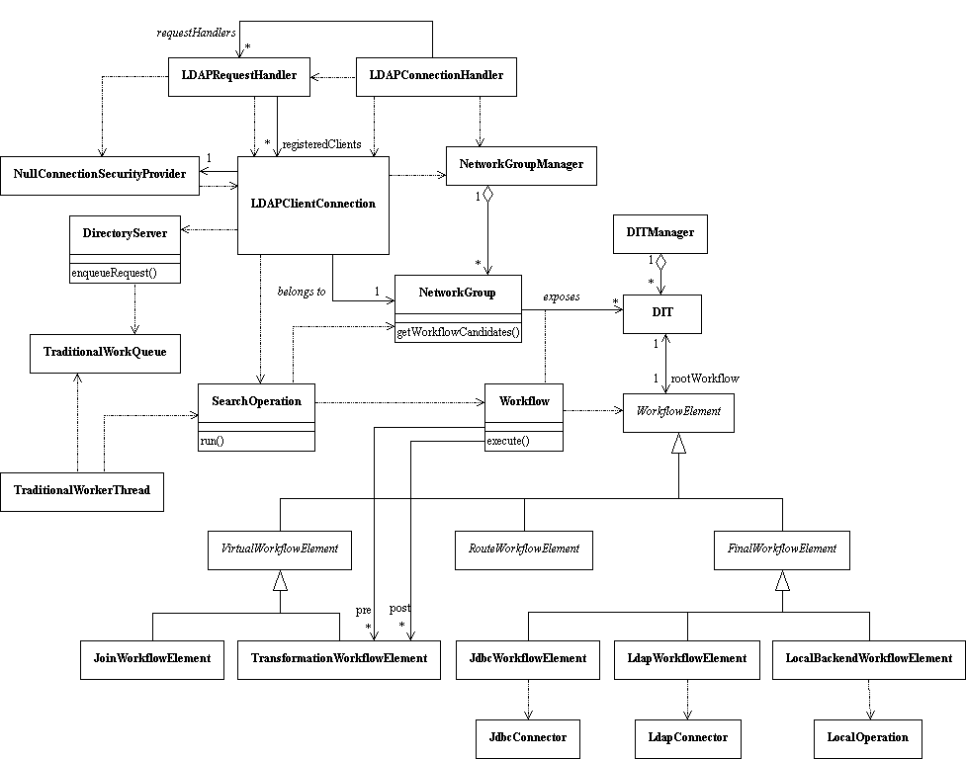

When LDAPConnectionHandler detects a new client connection, it creates an LDAPClientConnection, attaches the default network group to that connection and registers the connection to one LDAPRequestHandler (there can be more than one request handler for performance purpose).

The LDAPRequestHandler, through the client connection ConnectionSecurityProvider, lets the LDAPClientConnection reads the data on the network. As soon as LDAPClientConnection has an operation, it checks whether the connection should move to another network group, then it creates an operation object, say SearchOperation. and enqueues the operation in a TraditionalWorkQueue.

A TraditionalWorkerThread gets the operation in the TraditionalWorkQueue and runs the SearchOperation object. SearchOperation first retrieves from its client connection the network group to use and then gets from the network group the list of DIT to route the request to. For each DIT, SearchOperation executes the Workflow attached to the DIT.

The Workflow object first executes its pre-WorkflowElement (if any), then executes the root WorkflowElement attached to the DIT, then executes its post-WorkflowElement (if any).

ConnectionHandler
The LDAPConnectionHandler is accepting new connections from client applications. When a new connection is detected, LDAPConnectionHandler creates an LDAPClientConnection and checks whether the new connection can be accepted:

- if denied list exists then IP address must not be part of it
- if allowed list exists then IP must be part of it
- server has not reached its maximum number of connections
- all post-connect plugins or OK

If connection is cleared then LDAPConnectionHandler attaches a ConnectionSecurityProvider to the LDAPClientConnection then it registers the LDAPConnectionClient to the LDAPRequestHandler. A ConnectionSecurityProvider is an API used to encode and decode data over a secure channel; if the channel not secure then a NullConnectionSecurityProvider implementation is used.

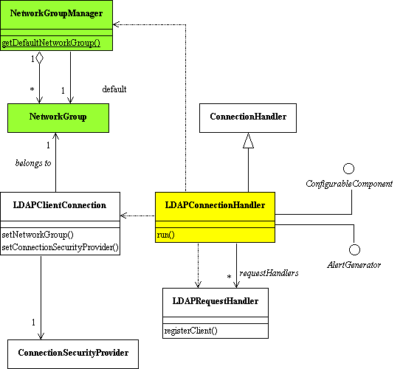

Additional step - LDAPConnectionHandler attaches the defaultNetworkGroup to the LDAPCLientConnection. The new connection belongs to that default network group unless criterii evaluation done is the LDAPRequestHandler says otherwise.

The next sequence diagram recaps the whole processing (in green: the new code for the additional step described above):

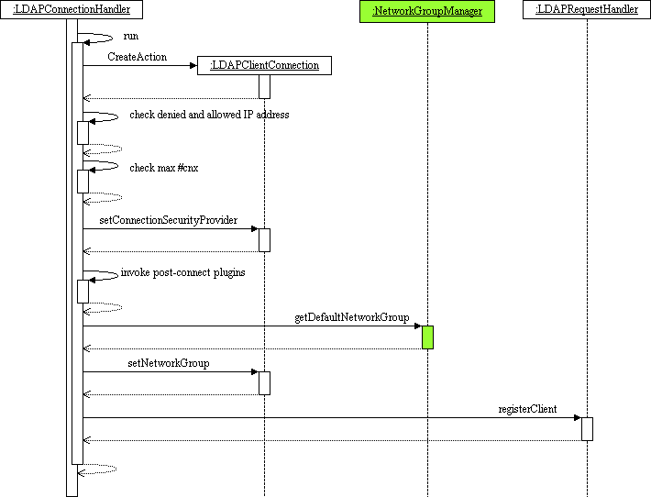

RequestHandler
Incoming requests are handled by the LDAPRequestHandler. LDAPRequestHandler is going through an LDAPClientConnection to get the appropriate ConnectionSecurityProvider which in turn will read the data from the network. Once the LDAPClientConnection has a full LDAP request then it creates an Operation of the appropriate type (Add, Search...) and enqueue the Operation in the work queue through DirectoryServer object.

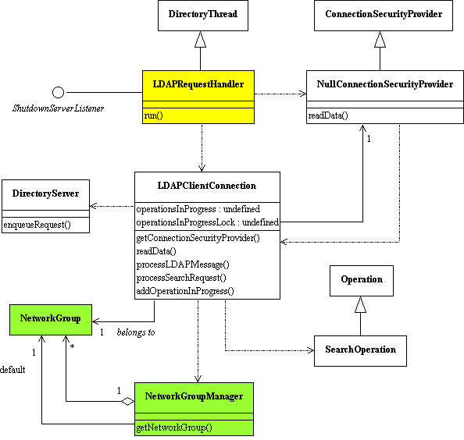

Additional Step – Once the LDAPClientConnection has a full LDAP operation, it has to decode the request base DN and to retrieve from to the the NetworkGroupManager the appropriate network group for the operation. Note: the evaluation of the criterii by the NetworkGroupManager is planned for milestone v0.4 (task 924); until then, the NetworkGroupManager will always return the predefined default network group (named defaultNetworkGroup in the diagram above). Once the NetworkGroup has been elected, LDAPClientConnection checks the policies attached to that NetworkGroup. Policy check is planned for milestone v0.4 (task 924), so until then the check will always succeed.

The next sequence diagram recaps the whole processing (in green: the new code for the additional step described above):

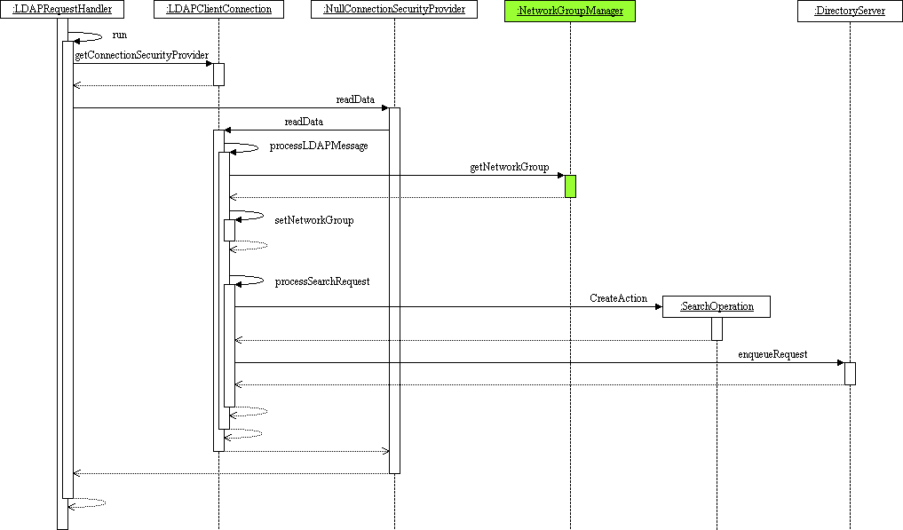

NetworkGroup and Workflow Engine
Operation object needs to go through the NetworkGroup object to get the list of DIT involved in the processing of the current operation. The network group DIT exposure is implemented by the Workflow class. This means NetworkGroup will return to Operation a list of Workflow.

Each Workflow object has a reference to a DIT (no more than one). Through that DIT the Workflow gets a reference to a root WorkflowElement which is the entry point for the workflow processing. Workflow object may also have references to pre WorkfowElement(s) and post WorkflowElement(s). These pre and post WorkflowElement(s) are executed before and after the DIT workflow.

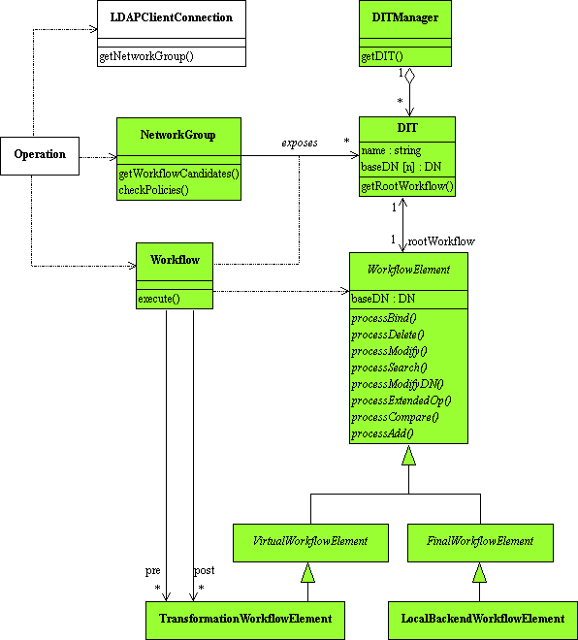

Object Description

- DIT - a simple repository (local backend, LDAP server) or a virtual respository (Join, JDBC)
- DITPool – a pool where all the DITs are stored
- Workflow – chain of processing applied on a DIT
- WorkflowElement – building block, part of a workflow
- NetworkGroup – entity that exposes DITs to the client applications; exposure is implemented by the Workflow class association

Dynamic Description

A worker thread gets an operation from the work queue and executes it. Operation retrieves the NetworkGroup to which the client connection belongs then Operation gets from the NetworkGroup the list of workflow candidates to which the request can be routed to. Then Operation goes through the list of workflows and executes them all (sequential?).

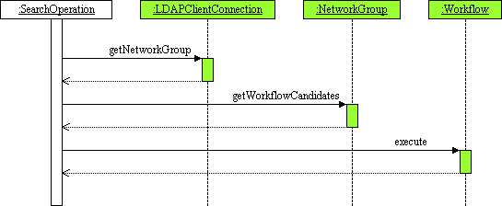

Each Workflow object retrieves the root workflow element attached to the DIT then
- invokes pre-workflow elements (if any)
- executes the root workflow element attached to the DIT
- invokes post-workflow elements (if any)

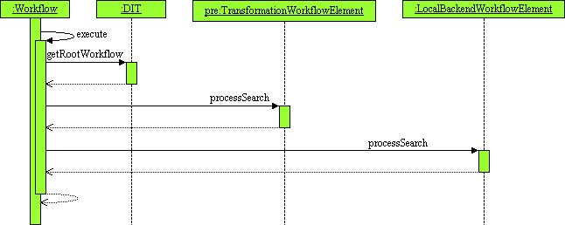

NetworkGroup and NetworkGroupManager
The NetworkGroup exposes a set of DIT that can be candidate for the operation routing process. Each NetworkGroup has a set of criterii and a client connection that meets all the criterii belongs to that NetworkGroup. If a connection connection cannot meet the criterii of any NetworkGroup then it will belong to the defaultNetworkGroup which is unique within the server. Criterii may be based on client IP adress, client domain, bind DN, and soon (TBC)...

When a client connection belongs to a specific NetworkGroup then it has to comply with all the policies that have been attached to that NetworkGroup. The policies are ressource limit oriented, for example the maximum number of connections for a given client (TBC)... Once a client connection is cleared then all operations coming on that connection can be routed to one (or more) DIT(s) defined in the scope of the NetworkGroup.

The NetworkGroupManager handles of the NetworkGroup created on the server. The NetworkgroupManager automatically creates the defaultNetworkgroup so that connections can always belong to a network group even though none was defined by the customer.

NetworkGroupManage

- getDefaultNetworkGroup()

Returns the defaultNetworkGroup object, which is unique in the whole server. The defaultNetworkGroup is the one used by all the connections that do not meet the criterii of the other NetworkGroup.

- getNetworkGroup (in baseDN, in ipAddress, in domainName, in authMethod, in isSSL)

Returns the most appropriate NetworkGroup object in regard to the parameters.

NetworkGroup

- getWorkflowCandidates (in baseDN, in scope)

Returns the list of Workflow candidates for a given operation in the scope of the NetworkGroup.

To elaborate the list of Workflow candidates, the NetworkGroup keeps a table containing: [DIT ref, WorkFlow ref]. The function goes through the table and for each DIT reference, tries to figure out whether the DIT handles the request baseDN or not. Reminder: each DIT can handle several base Dns.

There can be more than one DIT candidate in the case of subtree search on a mapping tree configuration. That's why we need the scope parameter.

- checkPolicies()

Returns OK/NOK depending on the checks done on the policies that have been attached to the NetworkGroup.

Note: a client connection may change its NetworkGroup over time depending on the NetworkGroup criterri. For example, anonymous connections can belong to the defaultNetworkGroup until the client performs a bind operation and a criterri based on bind DN may move the connection to another NetworkGroup.

Note: with the current implementation, backend base DNs are registered by Backend sub-classes through DirectoryServer. This will be no more the case: each Backend is now configured to belong to one (or more) NetworkGroup. During initialization phase, each Backend will registered itself to the NetworkGroup it belongs to. In the scope of the prototype, there will be only one NetworkGroup, the defaultNetworkGroup. So each Backend instance will registered itself to the defaultNetworkGroup object through a call to NetworkGroupManager.getDefaultNetworkGroup.registerBaseDN()

The following diagram shows how DirectoryServer is initializing the backends:

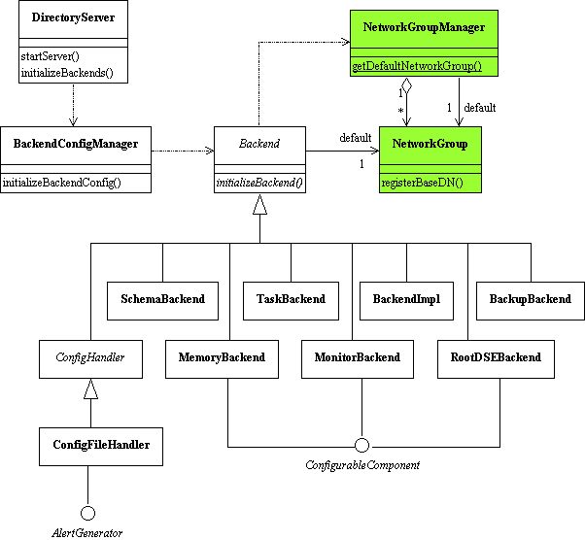

Each Backend has its own implementation of initializeBackend method. Within this method, each Backend has to register its base DN to the NetworkGroup it belongs to (ie. the defaultNetworkGroup in the scope of the prototype). The next sequence diagram depicts such initialization sequence:

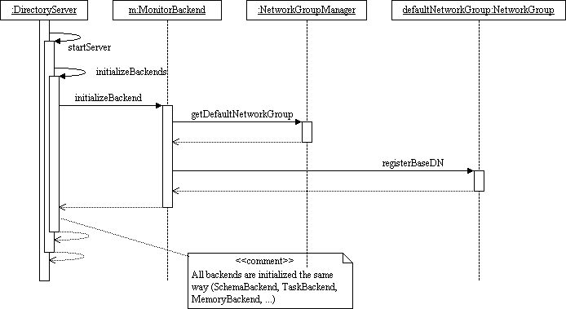

DIT and DITManager
Each DIT is identified by a name. Each DIT can handle several base DN. This ability to let a DIT handle more than one base DN will ease the configuration because when an LDAP backend contains several suffixes we will map only one DIT object to the backend.

Each DIT is associated to one root WorkflowElement and this root WorkflowElement cannot be used by any other DIT. This is a strong association because the workflow is specific to a DIT and we don't want to share a workflow to several DITs - too complex to manage.

The DITManager object is responsible for the creation of DIT.

DITManager

- createDIT (in name, in baseDN, in rootWorkflowElement)

Create a new DIT and store it in the DIT pool

DIT

- getRootWorkflowElement

Returns the root workflow element of the workflow topology associated to the DIT

Workflow
The Workflow object is responsible for the execution of the full chain of actions. Workflow keeps the following information:

- the DIT name
- a list of pre WorkflowElement
- a list of post WorkflowElement

With the DIT name the Workflow can retrieve the DIT from the DITManager, then access the root WorkflowElement through the DIT. Then Workflow will

- invoke the list of pre WorkflowElement if any
- invoke the root WorkflowElement
- invoke the list of post WorkflowElement if any

Note: pre and post WorkflowElement can be of type TransformationWorkflowElement only. Pre and post WorkflowElement are used to perform transformation such as DN renaming.

Workflow

- execute (in operation)

Execute the operation on the workflow associated to a DIT (the workflow has a reference to the DIT it is associated to).

WorkflowElement
A WorkflowElement is the building block for the workflow. A workflow topology is a tree of WorkflowElement, and the root of the tree is called rootWorkFlowElement.

Each WorkflowElement implements 8 functions, one per LDAP operation (processBind, processAdd, ...).

WorkflowElement can be of type final, virtual or route.

WorkflowElement

- [virtual] execute (in operation)

Execute the operation on the workflow element.

FinalWorkflowElement
A FinaleWorkflowElement is encapsulating a physical repository: local backend, remote LDAP server, relational database accessed through JDBC, or LDIF flat file, as shown in the next diagram:

- LdapWorkflowElement

The LdapWorkflowElement is a wrapper to remote LDAPserver. Connection to remote server is done through the LDAPConnector object.

- LocalBackendWorkflowElement

LocalBackendWorkflowElement is mainly a wrapper to LocalOperation.

- JdbcWorkflowElement

The JdbcWorkflowElement object is a wrapper to remote relational database. Connection to remote server is done through the JdbcConnector object.

FinalWorkflowElement

- [virtual] execute (in operation)

Execute the operation on the final workflow element.

LocalBackendWorkflowElement

- execute (in operation)

Execute the operation on the local backend workflow element.

Addendum

Prototype Specification

The prototype is implementing a small subset of virtual features:
- basic implementation of network group for the operation routing purpose (no criteria evaluation and no policy check)
- reduced topology of workflow element, mainly for local backend support...
- ... and reduced set of LDAP operations supported (for example ADD, SEARCH, MODIFY)

Key point: the prototype is compliant with the final design, meaning that all objects developped for the prototype are going to be re-used in the final code.

The next diagram is showing an overview of the impacted objects in the core server after the refactory:

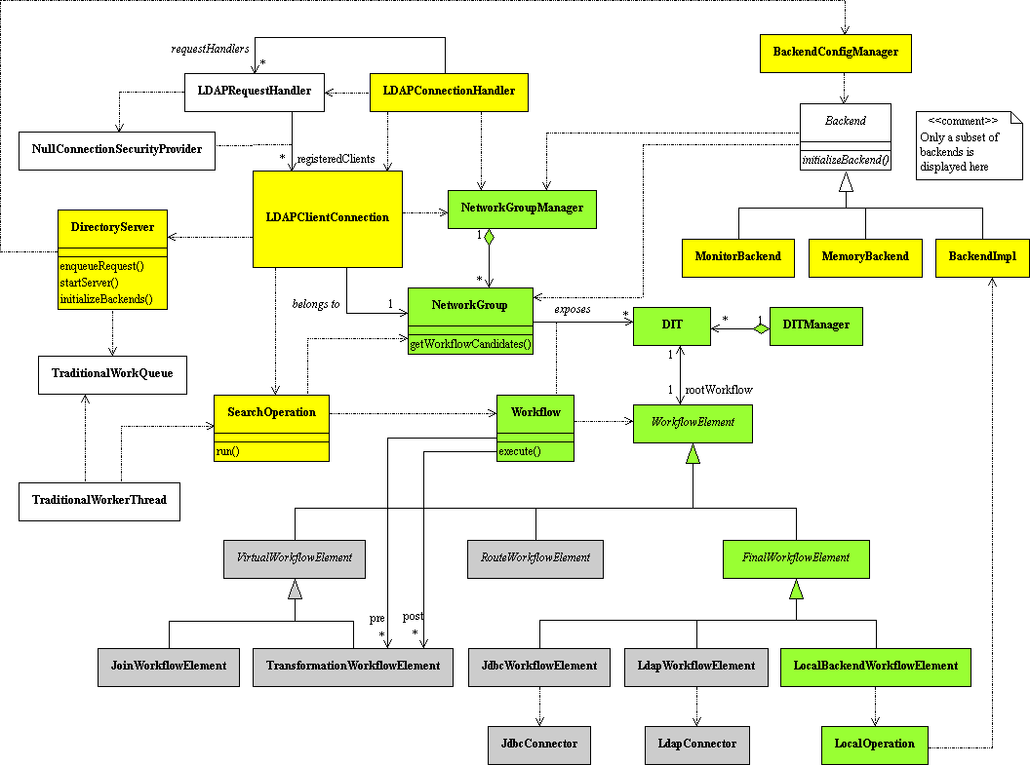

- White objects - existing objects that do not need to be modified for the prototype.
- Yellow objects - existing objects that need to be modified for the prototype.
- Green objects - new objects that need to be created for the prototype.
- Grey objects - new objects that do not need to be created for the prototype.

Task List

- Create new objects
NetworkGroup
DIT
Workflow
WorkflowElement
FinalWorkflowElement
LocalBackendWorkflowElement
LocalOperation
- Let DirectoryServer register the backends to the defaultNetworkGroup
- At startup, each backend--in the initializeBackend method--have to register itself to the NetworkGroup it belongs to (ie. to the defaultNetworkGroup for the prototype)
- Let LDAPConnectionHandler attach the defaultNetworkGroup to each LDAPClientConnection
- Let LDAPClientConnection retrieve the appropriate NetworkGroup for the current operation (ie. the defaultNetworkGroup for the prototype)
- Each Operation now gets the appropriate DIT to process an operation, and the processing is done through the Workflow...
- The LocalBackendWorkflowElement is using the LocalOperation object to execute the request

