Wistia Video Analytics
Final Report
Data Engineering Project 4
Krishna C. Mukherjee
October 7, 2026
Repository: github.com/krismukh/wistia-video-analytics

1. Summary
This project delivers an end-to-end data pipeline on Azure that ingests video engagement data from the Wistia Stats API for two media, transforms it with PySpark into a dimensional model, serves the model through serverless SQL views, and runs unattended on a daily schedule. The pipeline completed seven consecutive scheduled production runs from September 30 to October 6, 2026, without failure or manual intervention. All twelve functional requirements are met; the optional dashboards are delivered as a Streamlit application.
The two media are rivas_-_de_testimonial (hashed ID 8hunphufxp, 16.5 minutes, created June 2024) and The Gap Method (9k4tbcdfg0, 36.6 minutes, created January 2025). As of October 6 the gold layer holds 1,490 media-days, 1,154 visitors with plays on the tracked media, and 1,166 visitor-day engagement rows.

2. Architecture
The design follows a medallion pattern: raw API responses land in bronze as JSON, one file per page; silver holds typed, deduplicated Parquet tables with personal fields retained only there; gold holds the dimensional model, rebuilt on every run and exposed to SQL clients through serverless views. Azure Data Factory orchestrates three Synapse notebooks in sequence each day; the Wistia token is held in Key Vault and read at run time by managed identity.
Layer | Azure resource | Role
Storage | stwistiakcm (ADLS Gen2) | Containers bronze, silver, gold, synapse
Secrets | kv-wistia-kcm | Secret wistia-api-token; read by the Synapse and Data Factory identities
Compute | syn-wistia-kcm, Spark pool sparkpool1 | Notebooks 00_ingest_wistia (Python), 01_silver and 02_gold (PySpark)
Serving | Synapse serverless SQL, database wistia_gold | Seven gold.* views over Parquet
Orchestration | adf-wistia-kcm | Pipeline pl_wistia_daily; trigger trg_daily_0300 (03:00 Eastern)
Delivery | GitHub, GitHub Actions | Repository, continuous integration, secret scan

Deviations from the approved proposal, all recorded in docs/decision_log.md: the Data Factory identity holds the Key Vault read role alongside the Synapse identity, because notebooks started by ADF execute as the ADF identity; silver treats a day with no new events or visitors as valid rather than as an error; and the production window moved to September 30 through October 6 once the first clean end-to-end run completed on September 29.

3. Pipeline

3.1 Ingestion
The ingestion notebook pulls, for each media, media metadata, cumulative statistics, daily statistics, the engagement curve, and events, plus the visitors feed. Paged endpoints are walked with page and per_page=100 until a short page. Incremental pulls use per-endpoint watermarks stored in bronze/control/watermarks.json with a three-day lookback; the daily statistics endpoint is always called with an explicit start_date because it returns only two rows otherwise; events are bounded by Wistia's two-year retention. HTTP 429 and 5xx responses are retried with exponential backoff (1, 2, 4, 8, 16 seconds); 401, 403, and 404 fail at once. Every call is recorded in a run log, and the watermarks are written last so that a failure leaves them unchanged. Visitors are pulled in full once at backfill (104,882 account-wide records) and thereafter only for visitor keys seen in the day's new events.

3.2 Silver
Silver types every column, derives channel from the media name under the program rule (YouTube, Facebook, otherwise Unknown; both media resolve to Unknown), explodes the engagement arrays by position, and merges each feed into its table on natural keys, keeping the most recently ingested record. A generated date dimension covers 2024 through 2027. Reconciliation counts (bronze records, distinct keys, silver rows) are written to silver/control on every run.

3.3 Gold
Gold rebuilds dim_media, dim_date, dim_visitor, fact_media_engagement (media by visitor by date), and fact_media_daily, plus fact_media_cumulative (one snapshot per run) and fact_engagement_curve. dim_visitor includes only visitors with events on the tracked media and carries IP address and geography as the brief's model requires, but not email, name, organization, or coordinates. Four reconciliation checks fail the run on mismatch: engagement plays equal distinct play events; media-days match; distinct visitors match dim_visitor; every fact media exists in dim_media.

3.4 Orchestration and security
Pipeline pl_wistia_daily runs the three notebooks in sequence on sparkpool1 with one retry each and passes the scheduled date as run_date. The trigger fires daily at 03:00 Eastern. The API token never appears in code or the repository: it lives in Key Vault, is read at runtime, and the CI secret scan fails the build if a token-like string is committed. The raw exploration output, which contains visitor IP addresses and emails, is excluded from the repository.

4. Requirements traceability
FR | Requirement | How it is met
FR1 | Own architecture, approved by the SME | Proposal approved September 2026; medallion on Azure with ADF orchestration (docs/Wistia_Video_Analytics_Architecture_Proposal.docx).
FR2 | AWS or Azure | Azure: ADLS Gen2, Key Vault, Synapse, Data Factory, resource group rg-wistia (West US 3).
FR3 | Python for API ingestion | Notebook 00_ingest_wistia; pure-Python client in src/wistia_client/client.py with 26 unit tests.
FR4 | PySpark for transformation | Notebooks 01_silver and 02_gold on Spark pool sparkpool1 (Spark 3.4).
FR5 | No dbt | Transformations are PySpark; views are plain T-SQL (sql/create_gold_views.sql).
FR6 | GitHub with CI/CD | github.com/krismukh/wistia-video-analytics; GitHub Actions runs ruff, pytest, notebook syntax, ADF JSON validation, and a secret scan on every push.
FR7 | Pagination and incremental ingestion | per_page=100 paging to a short page; per-endpoint watermarks with a three-day lookback; deduplication in silver on natural keys.
FR8 | Seven consecutive days in production | trg_daily_0300 ran September 30 to October 6, seven of seven Succeeded (section 5).
FR9 | Structured data model | dim_media, dim_visitor, dim_date, fact_media_engagement, plus fact_media_daily, fact_media_cumulative, fact_engagement_curve, served as SQL views in database wistia_gold.
FR10 | Warehouse / serving layer | Synapse serverless SQL views over gold Parquet (OPENROWSET).
FR11 | Dashboards (optional) | Streamlit app, five pages, over a synced copy of gold (section 6).
FR12 | Repository with documentation | README, API exploration, data quality inventory, decision log, production run log, evidence screenshots, proposal, and diagram under docs/.

5. Production evidence (FR8)
Seven consecutive scheduled runs of pl_wistia_daily, each triggered by trg_daily_0300 at 03:00 Eastern, all succeeded. Durations ranged from 8m 45s to 9m 49s, of which roughly two to three minutes per notebook is Spark session start-up on the auto-paused pool. A manual debug run of the full pipeline on September 29 preceded the window.
Day | Run date | ADF run ID | Status | Duration
1 | 2026-09-30 | 50d3a483 | Succeeded | 9m 49s
2 | 2026-10-01 | bdee9b29 | Succeeded | 8m 45s
3 | 2026-10-02 | 4f10be1b | Succeeded | 9m 15s
4 | 2026-10-03 | c6df1a79 | Succeeded | 9m 18s
5 | 2026-10-04 | 7ce834b4 | Succeeded | 9m 8s
6 | 2026-10-05 | abffb3ab | Succeeded | 9m 31s
7 | 2026-10-06 | afe660b8 | Succeeded | 9m 7s
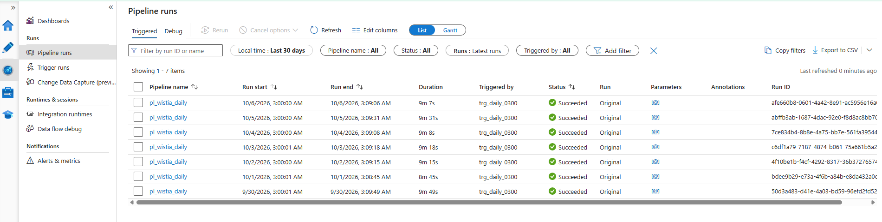
Figure 1. Azure Data Factory Monitor, pipeline runs, 30-day view (captured October 6, 2026).
Over the window, the gold layer grew as expected under incremental loading: dim_visitor from 1,147 to 1,154 rows, fact_media_daily from 1,472 to 1,490, and fact_media_engagement from 1,159 to 1,166, with a cumulative snapshot added per run.

6. Dashboards (FR11)
A Streamlit application (dashboards/app.py) reads a local copy of the gold tables produced by dashboards/sync_gold.py. It has five pages: Overview, Media comparison, Audience, Engagement curve, and Data quality. Visitor information is shown only at country, platform, and browser grain.
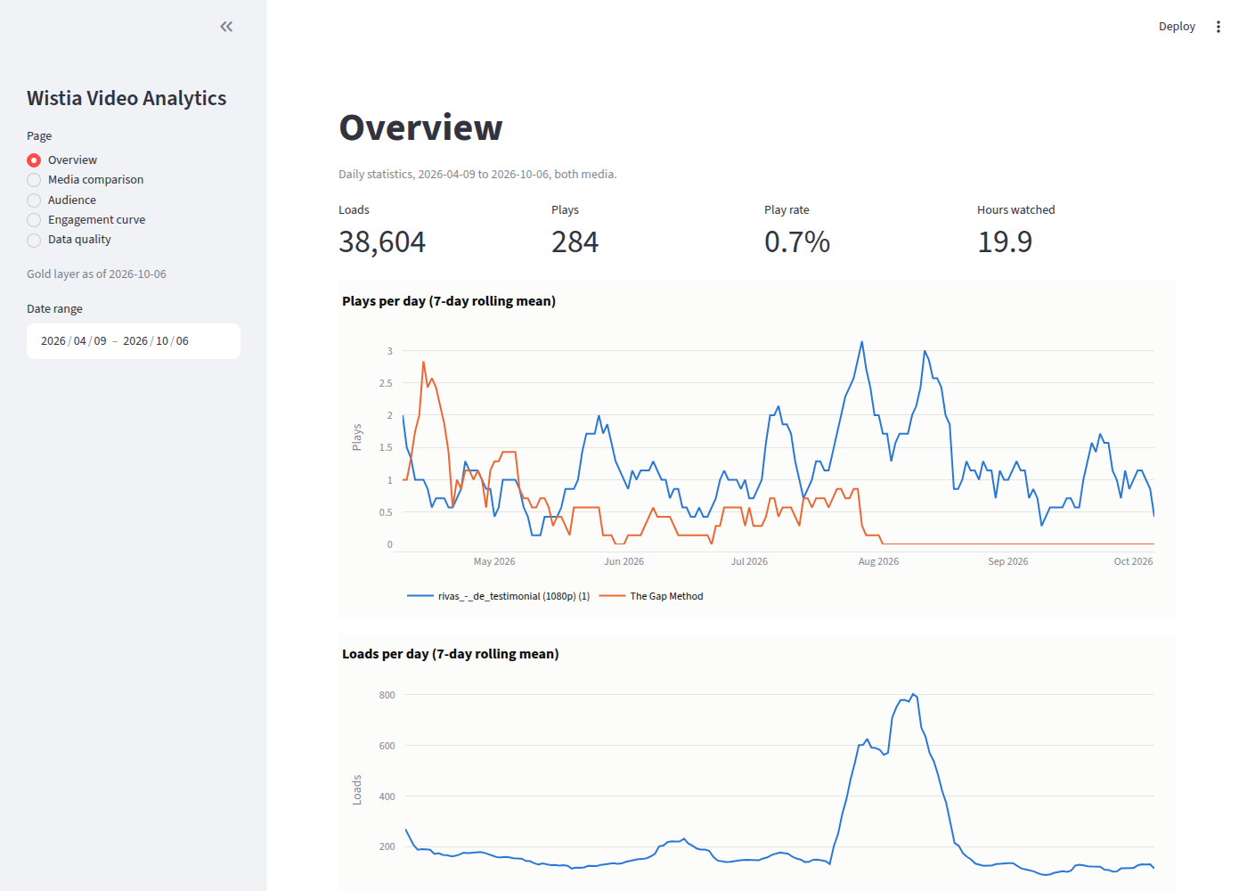
Figure 2. Overview: loads, plays, play rate, hours watched, and 7-day trends.
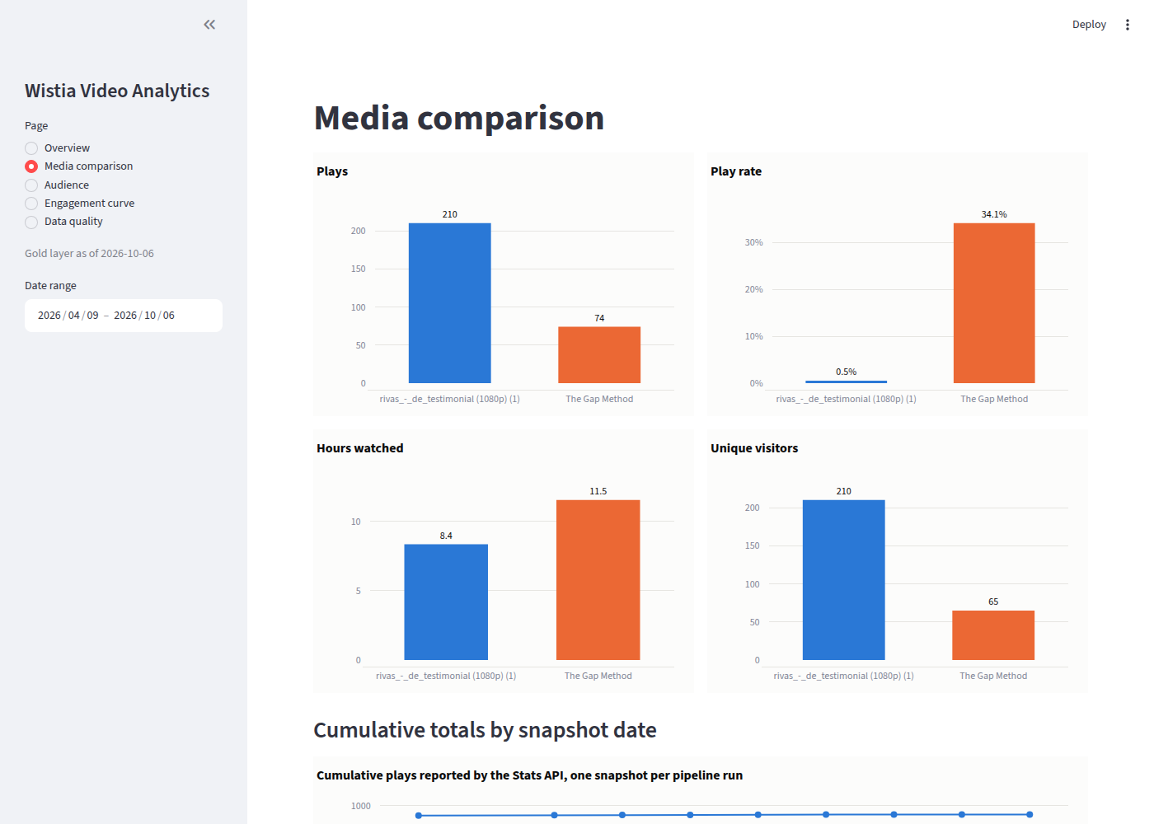
Figure 3. Media comparison.
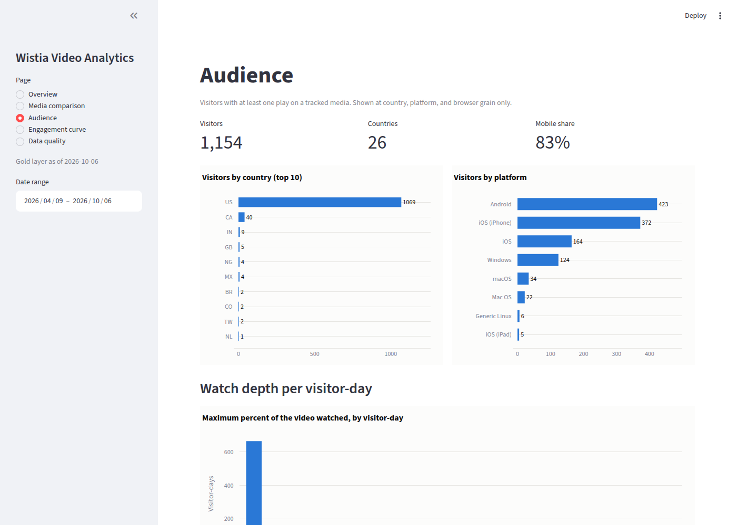
Figure 4. Audience by country and platform, and watch depth.
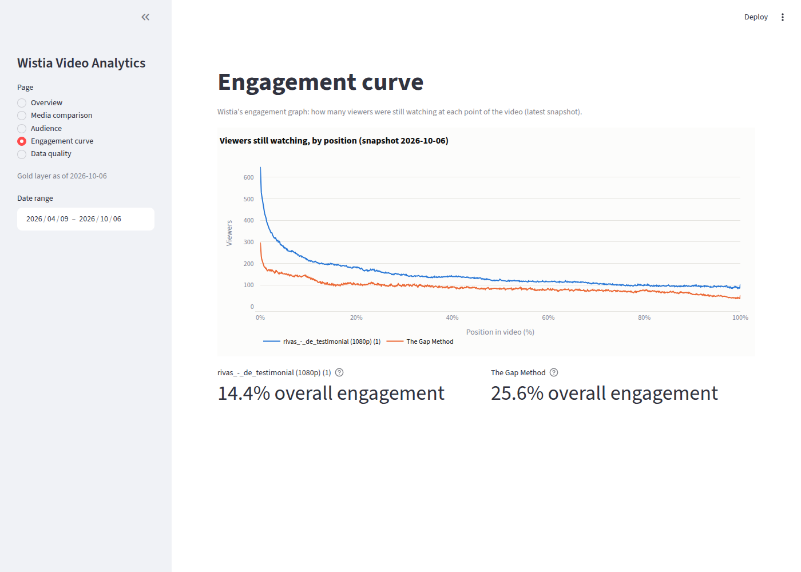
Figure 5. Engagement curve, latest snapshot.

7. Data quality findings
The full inventory is in docs/data_quality_inventory.md. The findings that affect interpretation of the data are:
- For The Gap Method, the daily series sums to 915 loads and 320 plays against cumulative counters of 934 and 328, about 2 percent short, because by_date omits the earliest sparse days. Cumulative counters are treated as authoritative for totals and the daily series for trends. rivas_-_de_testimonial reconciles exactly on plays (943).
- Two event records in the backfill shared an event_key with another record; silver deduplicates on event_key.
- Wistia retains events for two years, so visitor-level facts begin in 2024 for the older media; daily counts are retained in full.
- The daily statistics endpoint returns only two rows without an explicit start_date; the ingestion always supplies one.
- A day with no new events produces no bronze partition for events or visitors; silver treats this as nothing new to merge.
- percent_viewed, play_rate, and engagement are fractions in the API and are converted to percentages only where displayed.
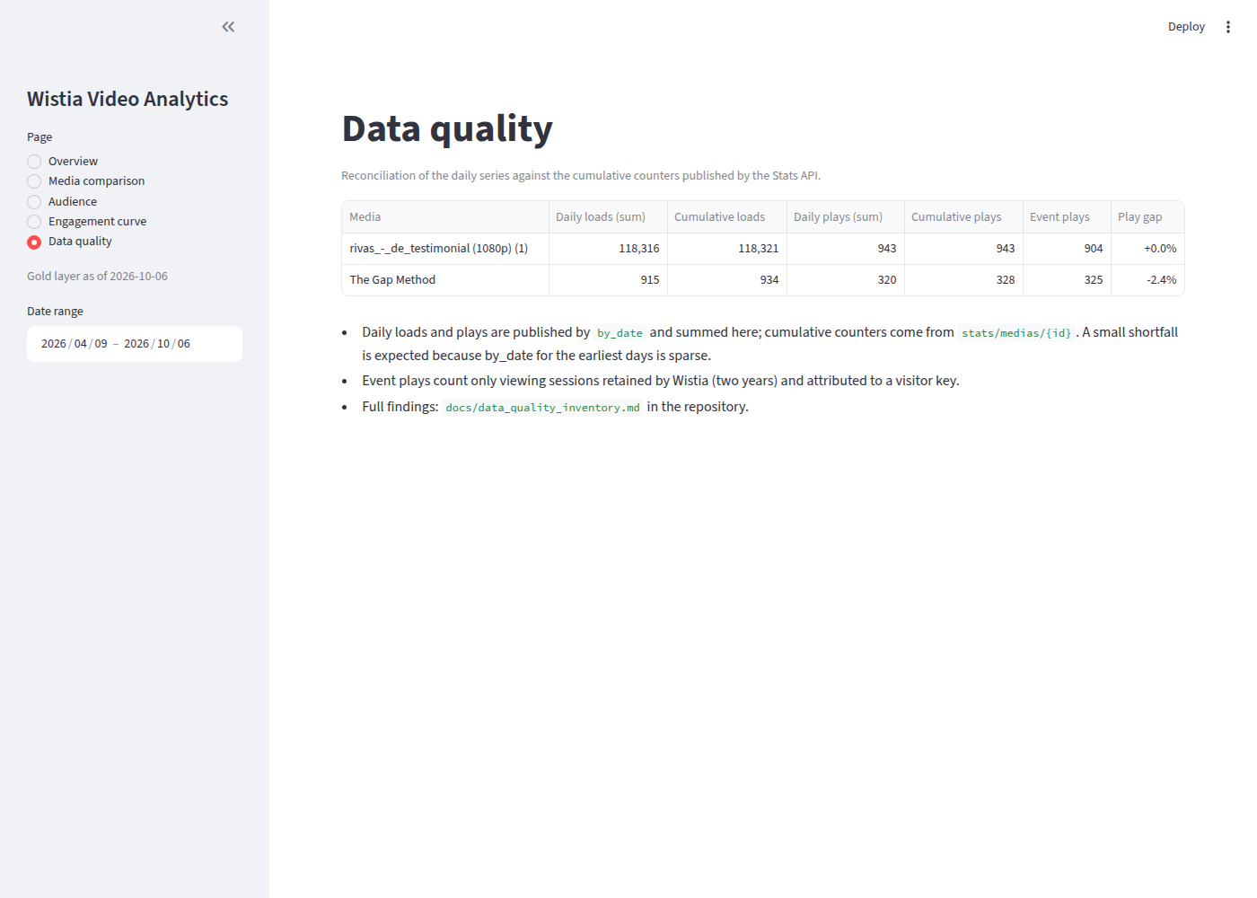
Figure 6. Data quality page: daily versus cumulative reconciliation.

8. Repository and continuous integration
github.com/krismukh/wistia-video-analytics. The GitHub Actions workflow runs on every push: ruff lint, 26 unit tests of the API client (pagination, retries, watermarks, channel rule, and notebook-module synchronization), py_compile of the notebook scripts, validation of the ADF definitions, and a scan for committed secrets. The infrastructure scripts under infra/ recreate the environment idempotently.

9. Hand-off
- To stop production: Data Factory, Manage, Triggers, stop trg_daily_0300. To resume: start it; the next run picks up from the saved watermarks.
- To rebuild from scratch: run 00_ingest_wistia with backfill=True, then 01_silver with full_rebuild=True, then 02_gold.
- To add a media: append its hashed ID to the media_ids default in 00_ingest_wistia (or the pipeline parameter) and run a backfill for it.
- Monthly cost at this scale is dominated by the Spark pool's roughly ten minutes per day; storage and serverless SQL are negligible.
- Outstanding: none required. Possible extensions are hosting the dashboards, adding alerting on pipeline failure, and extending the model to a third media.

