# Assignment 1

## 1.

## 2.

## 3.

Suggestions for such systems

1. The absence of the item stock feature so that users cannot know the number of available goods
2. In each product sold can only be purchased a number of 1 item, it cannot be more
3. There is no menu for historical and tracing of purchased items
4. At checkout, there is no payment method selection feature and cannot input the delivery/recipient location

## 4.

Bugs Report

1. When logging in using the standard_user there is no validation during the items checkout because even though the user does not add the items to the cart the system still continues the checkout process.
2. When logging in using problem_user every click on the icon / picture items will direct into a different product description, and this also happens when we have added products in the cart and at checkout cannot fill in personal data in the last name field so that it results in the product cannot be checked out as well as the filter on the homepage does not work.
3. When logging in using performance_glitch_user each time doing a certain event the time interval needed is quite time consuming such as when logging in adding goods to the cart and others

# Assignment 2

# Assignment 3

Run this Code on your IDE

## Code

import java.util.Arrays;

public class Assigment3 {

static void Case1(Integer arr[], int n) {

int l = 0, r = n - 1, k = 0;

while (l < r) {

while (arr[l] % 2 != 0) {

l++;

k++;

while (arr[r] % 2 == 0)

r--;

if (l < r) {

int temp = arr[l];

arr[l] = arr[r];

arr[r] = temp;

}

Arrays.sort(arr, 0, k);

}

}

}

public static void main(String[] args) {

Integer arr[] = {3, 2, 5, 1, 8, 9, 6};

System.out.println("Input ");

System.out.print(Arrays.toString(arr));

System.out.println("\nOutput ");

Case1(arr, arr.length);

System.out.println(Arrays.toString(arr));

}

}

## Output

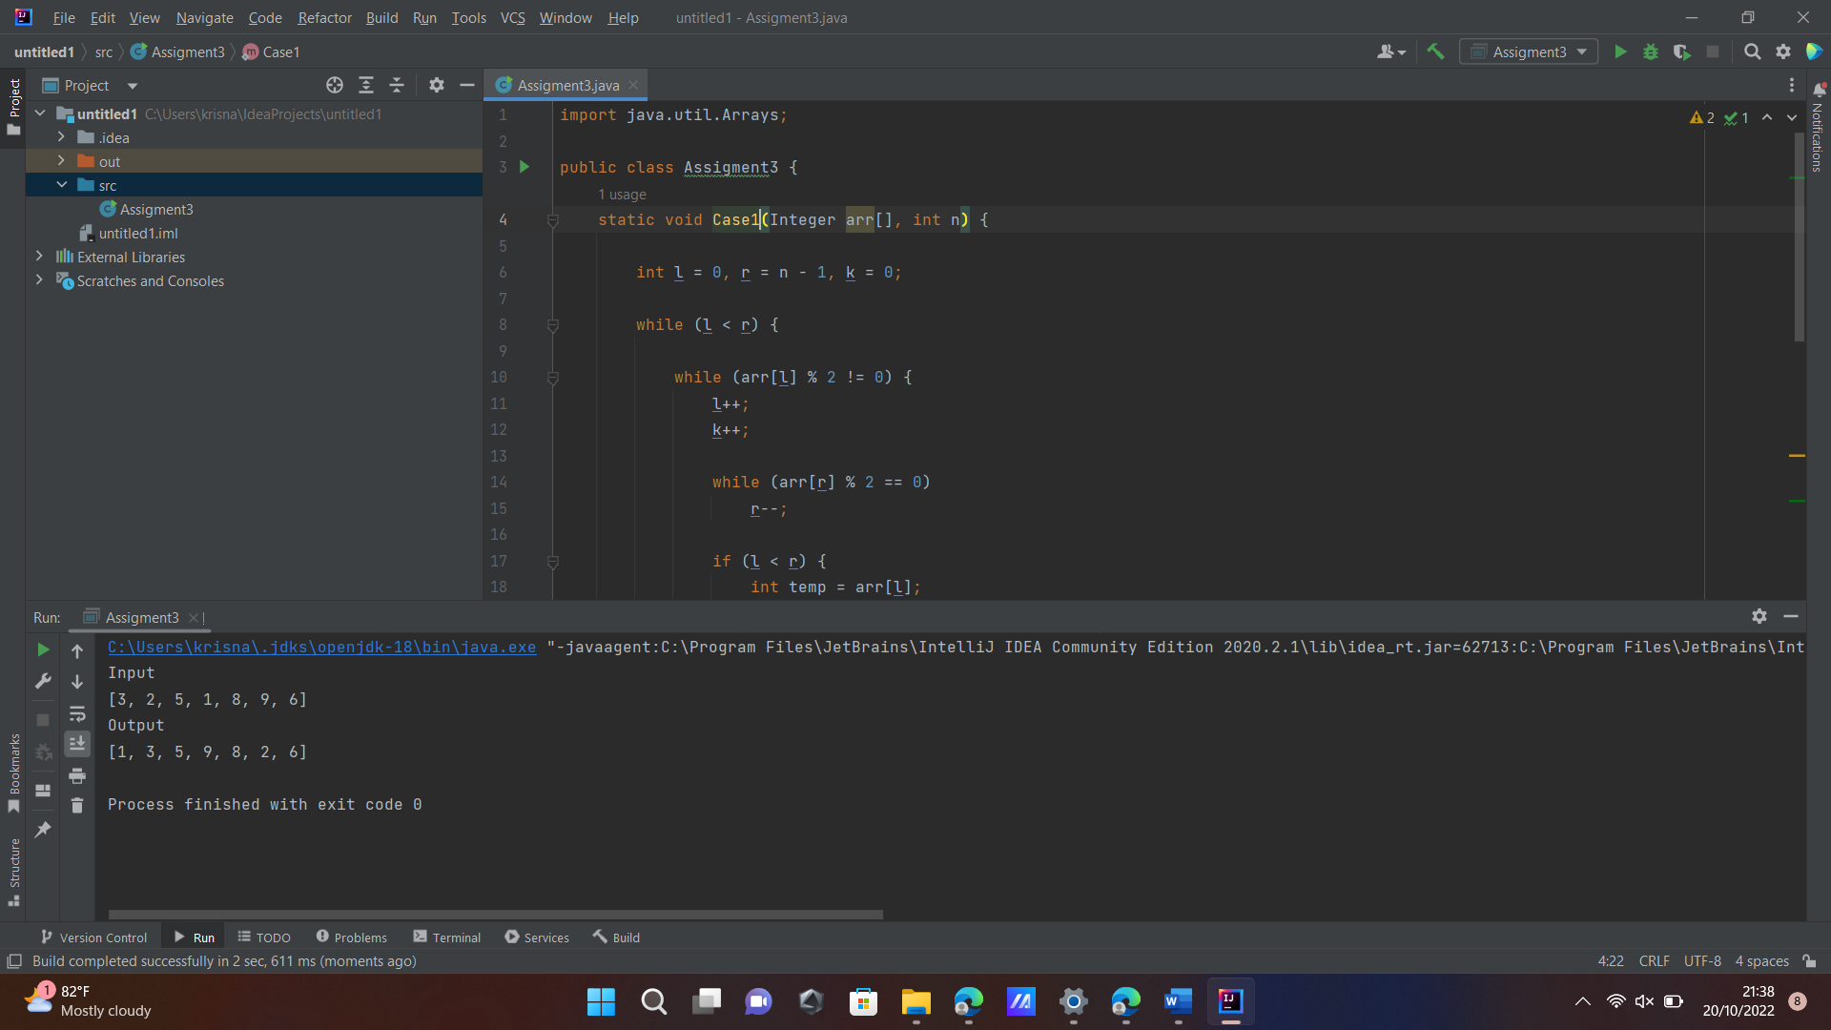

# Assignment 4

Please Upload This Attachment SQL to Localhost



Then Run Query Below

## 1.

SELECT de.de_name, de.de_position, dge.dge_salary FROM data_employee de

LEFT JOIN data_grade_employee dge

ON de.de_id = dge.dge_de_id WHERE dge.dge_salary < 5000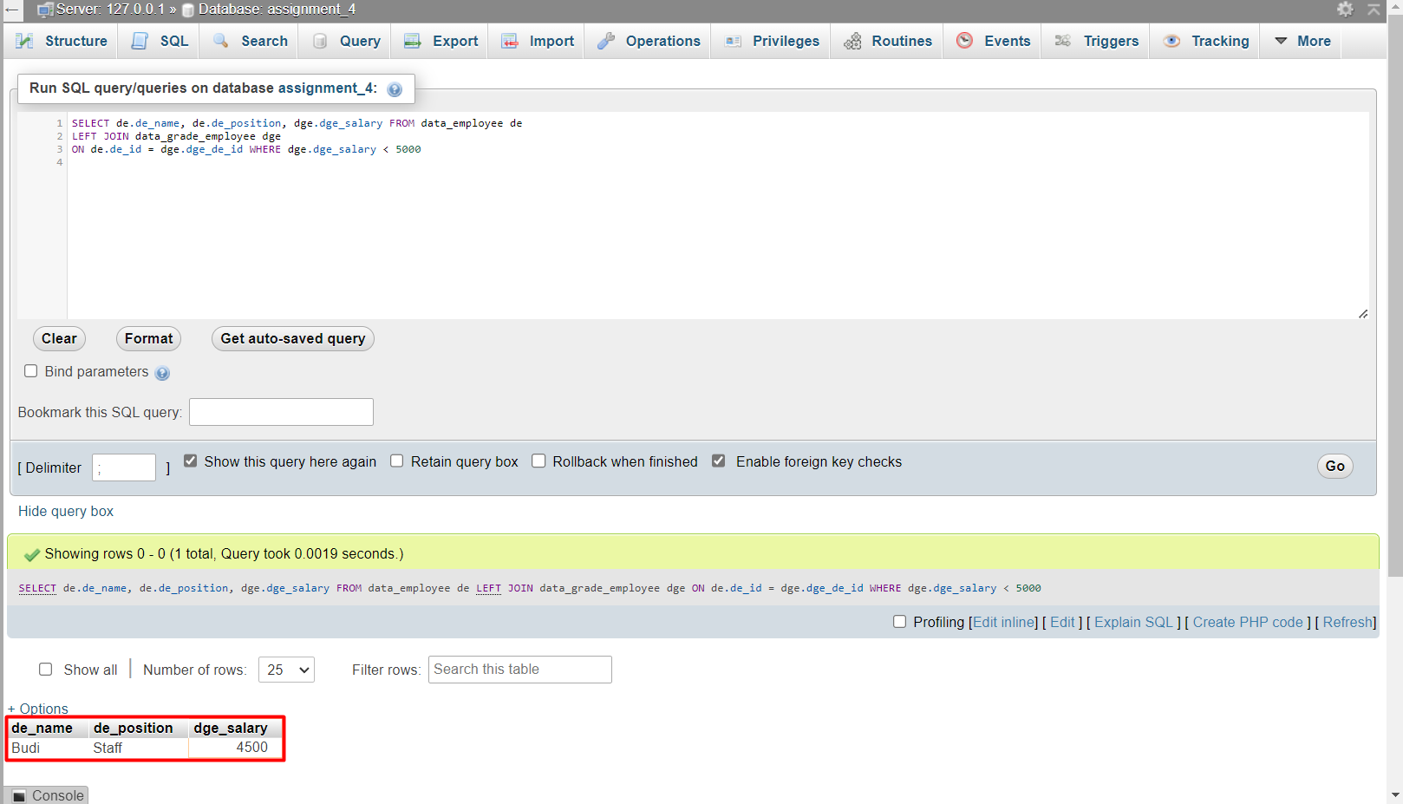

## 2.

SELECT de.de_position AS position,

COUNT(de.de_position) AS total_employee,

SUM(dge.dge_salary) AS total_salary

FROM data_employee de, data_grade_employee dge

WHERE dge.dge_de_id= de.de_id

GROUP BY de.de_position

ORDER BY total_salary ASC;

