Transportation System’s Policies

Indonesia:

* 3 in 1 system
* electronic road pricing
* designated time one way system
* motorcycle prohibition in designated roads
* special busway
* restriction on car ownerships based on car age
* odd and even plate number restrictions

India

* parking restrictions
* promoting bicycle
* promoting car sharing
* Tightening vehicle emissions standards and inspection and maintenance programs
* Roll on roll off scheme

Public transportion frequency

Building new fly-overs

<https://www.weforum.org/agenda/2014/07/seven-ways-cities-around-world-tackling-traffic/>

Stockholm: Electronic Road Pricing

Barcelona: Urban Lab – Dynamic Traffic Forecasting (using cctv to forecast)

London: Electronic Journey Planner

Hongkong: public light bus

Copenhagen: Integrative Public Transport Model

Hangzhou: Public Cycling System

UK: Active Traffic Management Approach

China:

<https://www.researchgate.net/publication/277883359_China's_Public_Transportation_Problems_Policies_and_Future_Prospective_to_Sustainability>

* License plate lottery

General policies:

<https://tcf.org/content/facts/4-steps-improving-americas-transportation-policy/>

NYC:  
<https://www1.nyc.gov/assets/planning/download/pdf/plans/transportation/world_cities_full.pdf>

Transportation challenge:

* The congestion challenge: subway congestion, traffic congestion
* The flooding challenge
* The information challenge: real time info technology
* The infrastructure challenge: waterways, bicycle, increasing speed of city buses

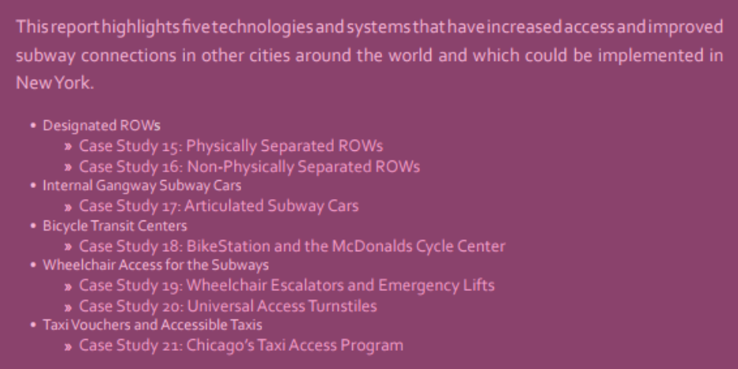

Indonesia traffic data:

* Still many location data, difficult to analyze