

Darshan University

A Project Report on

# “Learning With Fun”

Under the subject

**Software Engineering (2101CS503)**

B. Tech, Semester – V

Computer Science & Engineering Department

Submitted By

Student Name: Gohil Krishna Enrollment No.: 21010101071

Academic Year (2023-2024)

|  |  |
| --- | --- |
| Internal Guide  Prof. Devangi Kotak  Darshan University | Dean-DIET  Dr. Gopi Sanghani  Darshan University |

**Computer Science & Engineering**

**Department**

**Darshan University**

## DECLARATION

We here by declare that the SRS, submitted along with the **Software Engineering(2101CS503)** for entitled **“Learning With Fun”** submitted in partial fulfilment for the Semester-5 of **Bachelor Technology (B. Tech)** in **Computer Science and Engineering (CSE)** Department to Darshan University, Rajkot, is a record of the work carried out at **Darshan University, Rajkot** under the supervision of **Devangi Kotak** and that no part of any of report has been directly copied from any students’ reports, without providing due reference.

Gohil Krishna

Student’s Signature

Date: __________

**Computer Science & Engineering**

**Department**

**Darshan University**

## CERTIFICATE

This is to certify that the SRS on **“Learning With Fun” has** been satisfactorily prepared by **Gohil Krishna** (**21010101071**) under my guidance in the fulfillment of the course **Software Engineering (2101CS503)** work during the academic year2023-2024.

Internal Guide Dean-DIET

Prof Devangi Kotak Dr. Gopi Sanghani

Darshan University Darshan University

## ACKNOWLEDGEMENT

I wish to express my sincere gratitude to my project guide Prof. **Devangi Kotak** and all the faculty members for helping me through my project by giving me the necessary suggestions and advices along with their valuable co-ordination in completing this work.

I also thank my parents, friends and all the members of the family for their precious support and encouragement which they had provided in completion of my work. In addition to that, I would also like to mention the Darshan University personals who gave me the permission to use and experience the valuable resources required for the project from the University premises.

Thus, in conclusion to the above said, I once again thank the faculties and members of **Darshan University** for their valuable support in completion of the project.

Thanking You

**Gohil Krishna**

## ABSTRACT

The educational app we have developed is a comprehensive and interactive platform designed to facilitate the learning journey of young children. With a focus on teaching alphabets, numbers, poems, stories, rhymes, and more, our app provides a stimulating and engaging environment for children to explore and acquire essential skills.

Through a combination of captivating visuals, audio pronunciations, interactive activities, and games, children can learn alphabets and numbers in a fun and intuitive manner. The app offers a rich library of age-appropriate poems, stories, and rhymes, brought to life through colorful illustrations and audio narration, fostering a love for reading and language development.

**Table of Contents**

List of Figures ................................................................................................................................................ I

List of Tables ................................................................................................................................................ II

1. Introduction ......................................................................................................................................... 1
   1. Product perspective ...................................................................................................................... 1
   2. Product features ........................................................................................................................... 1
      1. Here in my Project there are three different users who will be using this product: .................. 1
      2. The features that are required for the App are: ................................................................. 1
   3. Functional Requirement ............................................................................................................... 1
   4. Non-Functional Requirement ........................................................................................................ 2
      1. Usability: ............................................................................................................................... 2
      2. Accuracy: .............................................................................................................................. 2
      3. Availability: ........................................................................................................................... 2
      4. Maintainability:..................................................................................................................... 2
2. Design and Implementation Constraints ............................................................................................... 3
   1. Use case diagram.......................................................................................................................... 3
   2. Activity diagram and Swimlane diagram ....................................................................................... 4
   3. Sequence diagram ........................................................................................................................ 4
   4. State diagram ............................................................................................................................... 6
   5. Class diagram ............................................................................................................................... 6
   6. Data flow diagram ........................................................................................................................ 7
      1. Context diagram (level-0) ...................................................................................................... 7
      2. DFD Level-1 ........................................................................................................................... 7
      3. DFD Level-2 ........................................................................................................................... 8
3. External interface requirement (Screens) ............................................................................................. 9
   1. Screen-1: Sign Up Form(Page 1) .................................................................................................... 9
   2. Screen-2: Login Form .................................................................................................................. 10
   3. Screen-3: Transaction Screen ...................................................................................................... 11
4. Database design ................................................................................................................................. 12
   1. List of Tables............................................................................................................................... 12
5. Stories and Scenario ........................................................................................................................... 14
   1. Story-1: Account Creation ........................................................................................................... 14
      1. Scenario# S1.1 .................................................................................................................... 14
      2. Scenario# S1.2 .................................................................................................................... 14
      3. Scenario# S1.3 .................................................................................................................... 14
   2. Story-2: Account Balance Inquiry ................................................................................................ 15
      1. Scenario# S2.1 .................................................................................................................... 15
      2. Scenario# S2.2 .................................................................................................................... 15
   3. Story-3: Fund Transfer ................................................................................................................ 16
      1. Scenario# S3.1 .................................................................................................................... 16
      2. Scenario# S3.2 .................................................................................................................... 16
   4. Story-4: Cash Withdrawal ........................................................................................................... 17
   5. Story-5: Cash Deposit ................................................................................................................. 17
   6. Story-6: Fast Cash Withdrawal .................................................................................................... 17
   7. Story-7: PIN Change .................................................................................................................... 17
   8. Story-8: Mini Statement ............................................................................................................. 18
6. Test cases........................................................................................................................................... 19
7. References ......................................................................................................................................... 24

### List of Figures

Figure 2.1-1 Use case diagram for bank account management system ......................................................... 3

Figure 2.2-1 Activity diagram for transactions .............................................................................................. 4

Figure 2.2-2 Swimlane diagram for transactions .......................................................................................... 4

Figure 2.3-1 Sequence diagram for money withdrawal ................................................................................. 5

Figure 2.4-1 State diagram of Book .............................................................................................................. 6

Figure 2.5-1 Class diagram for bank account management system ............................................................... 6

Figure 2.6-1 Context diagram for bank account management system........................................................... 7

Figure 2.6-2 DFD level-1 for bank account management system................................................................... 7

Figure 2.6-3 DFD level-2 for bank account system ........................................................................................ 8

Figure 3.1-1 Screen-1: Sign Up Form ............................................................................................................ 9

Figure 3.2-1 Screen-2: Login Form .............................................................................................................. 10

Figure 3.3-1 Screen-3: Transaction Screen .................................................................................................. 11

### List of Tables

Table 3.1-1 Screen element of SignUp form ................................................................................................. 9

Table 3.2-1Screen element of Login form ................................................................................................... 10

Table 3.3-1Screen element of Add transaction screen ................................................................................ 11

Table 4.1-1 Table: SignUpPageOne ............................................................................................................. 12

Table 4.1-2 Table: SignUpPageTwo ............................................................................................................ 12

Table 4.1-3 Table: LoginDetails................................................................................................................... 13

Table 4.1-4 Table: statement_table ............................................................................................................ 13

### 1 Introduction

#### 1.1 Product perspective

Welcome to our educational app designed for young children! Our app offers a fun and interactive learning experience, teaching alphabets, numbers, poems, stories, rhymes, and more. With online lectures by experienced teachers, we provide personalized education for children.

#### 1.2 Product features

1.2.1 Here in my Project there are three different users who will be using this product:

* Children : The primary users of the app are young children who will be learning
* Parents/Guardians : They will create accounts for themselves and their children, manage settings, set learning goals, monitor progress, and have access to parental controls.
* Teachers: They will have access to tools and resources to deliver interactive lessons, answer questions, and provide guidance.

1.2.2 The features that are required for the App are:

* Engaging activities and games to teach alphabets and numbers.
* Extensive collection of poems, stories, and rhymes with interactive elements.
* Live online lectures by experienced teachers for personalized learning.
* Progress tracking and performance analytics for parents and teachers.
* Intuitive parental controls to customize and manage children's learning.
* Child-friendly interface with vibrant visuals and interactive animations.
* Secure authentication and data encryption for user privacy.
* Compatibility with various devices and operating systems.
* Accessibility features for children with disabilities.

#### 1.3 Functional Requirement

* Alphabet Learning
* Number Learning
* Poems, Stories, and Rhymes
* Interactive Activities
* User Registration and Profile Management
* Progress Tracking and Reports
* Parental Controls
* Live Online Lectures
* Content Creation and Management
* Student Interaction and Feedback

#### 1.4 Non-Functional Requirement

1.4.1 User Interface:

* Design an intuitive and child-friendly user interface.
* Use vibrant colors, age-appropriate graphics, and engaging animations.

1.4.2 Performance:

* Ensure fast and responsive performance of the application.
* Optimize loading times for lessons, activities, and multimedia content.

1.4.3 Security:

* Implement secure authentication and data encryption to protect user information.
* Comply with privacy regulations and guidelines for handling personal data

1.4.4 Compatibility:

* Develop the application to be compatible with a variety of devices (smartphones, tablets, etc.) and operating systems (iOS, Android, etc.).

### 2 Design and Implementation Constraints

#### 2.1 Use case diagram

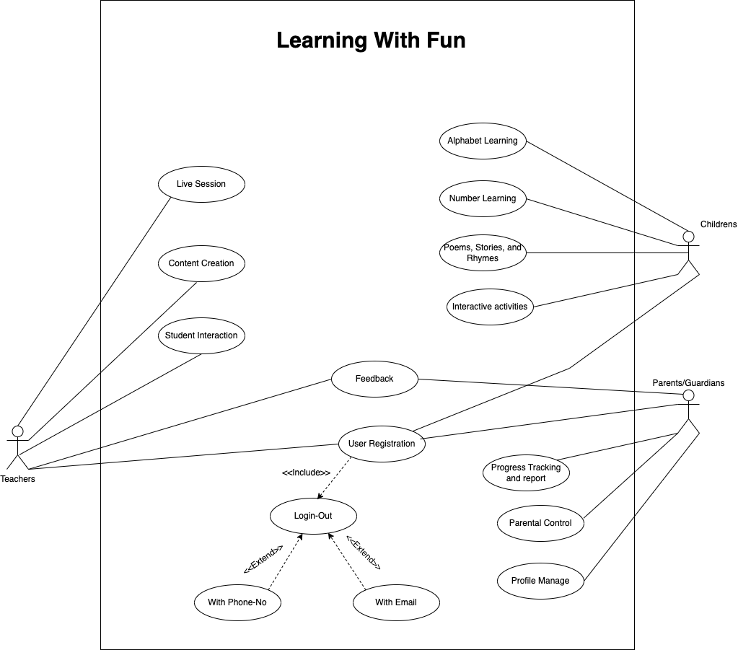

*Figure 2.1-1Use case diagram for Learning With Fun*

#### 2.2 Activity diagram and Swimlane diagram

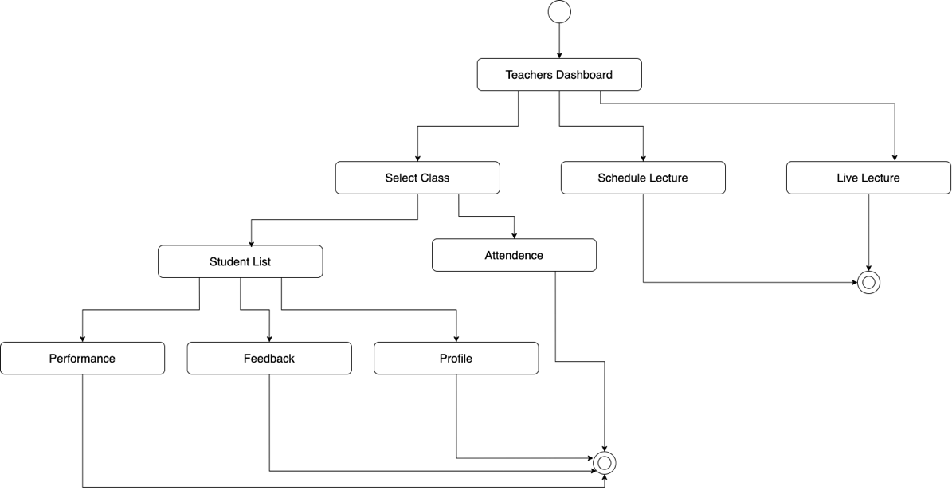

*Figure 2.2-1Activity diagram for Teachers Live Lecture*

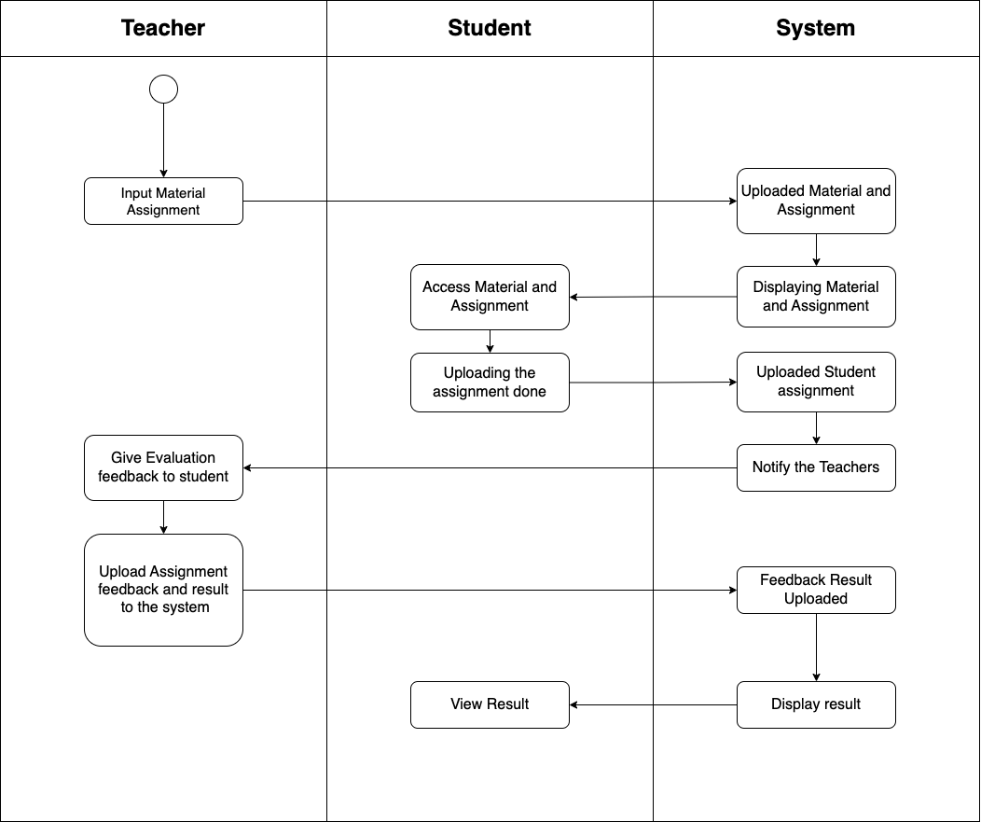

*Figure 2.2-2 Swimlane diagram for Assignment Submission*

#### 2.3 Sequence diagram

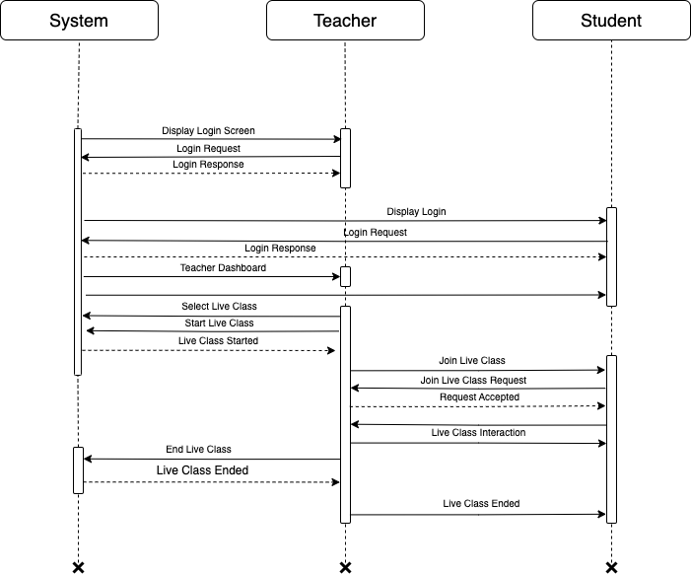

*Figure 2.3-1Sequence diagram for Live Class*

#### 2.4 State diagram

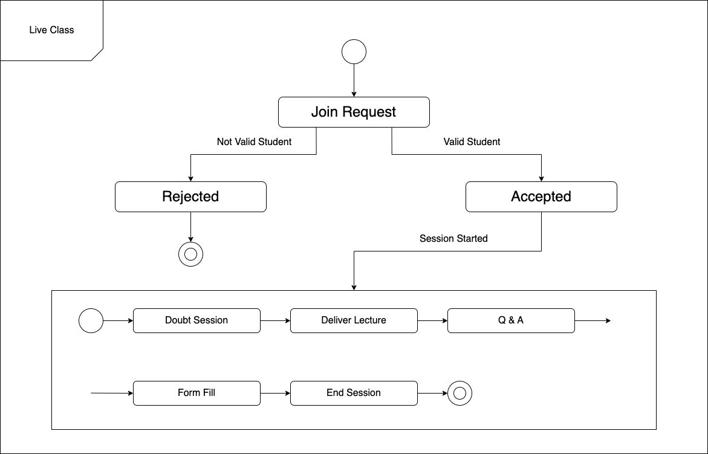

*Figure 2.4-1 State diagram of Live Class*

#### 2.5 Class diagram

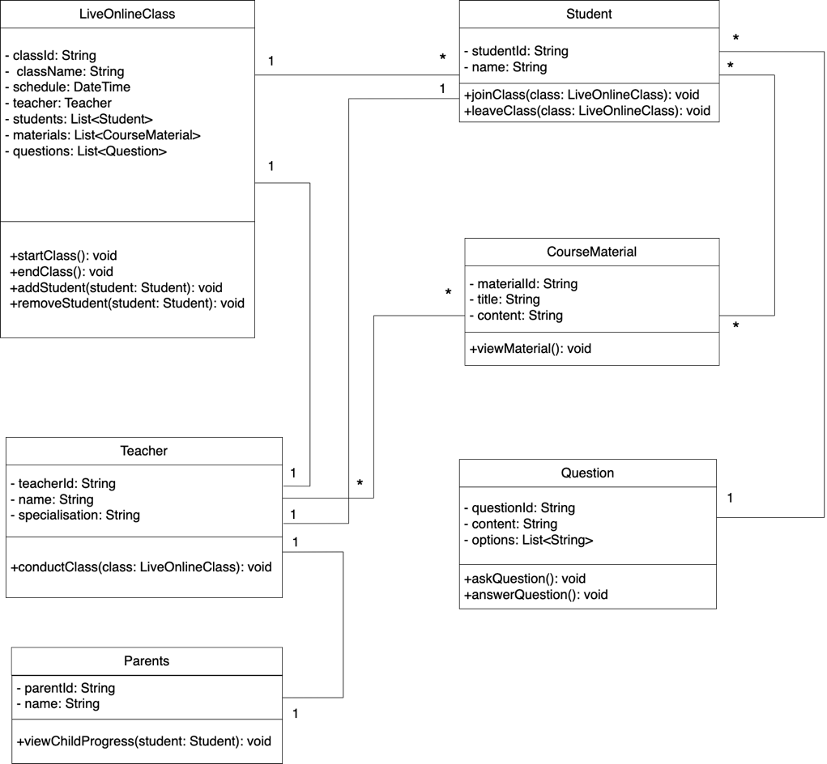

*Figure 2.5-1Class diagram for LiveOnlineCLass*

#### 2.6 Data flow diagram

2.6.1 Context diagram (level-0)

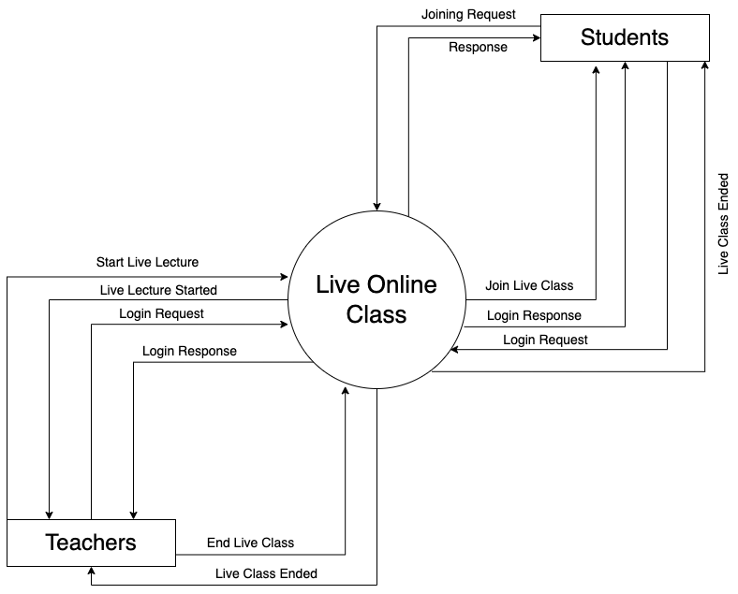

*Figure 2.6-1Context diagram for LiveOnlineClass*

2.6.2 DFD Level-1

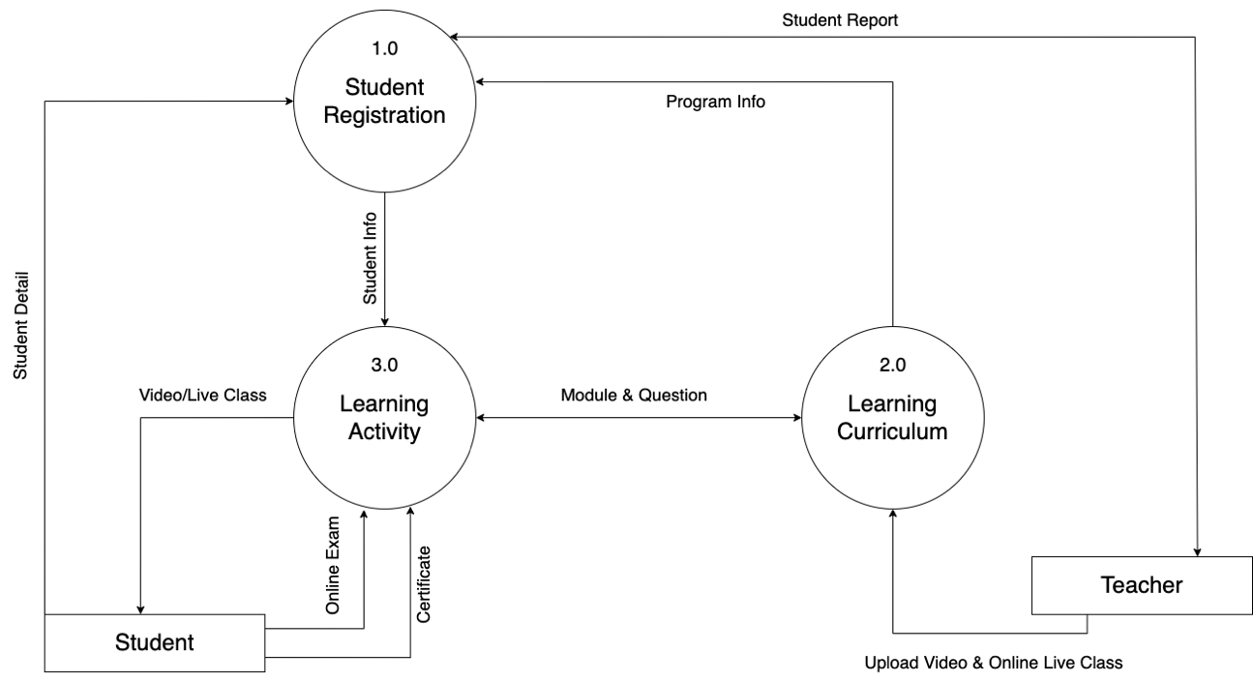

*Figure 2.6-2DFD level-1 for LiveOnlineCLass*

2.6.3 DFD Level-2

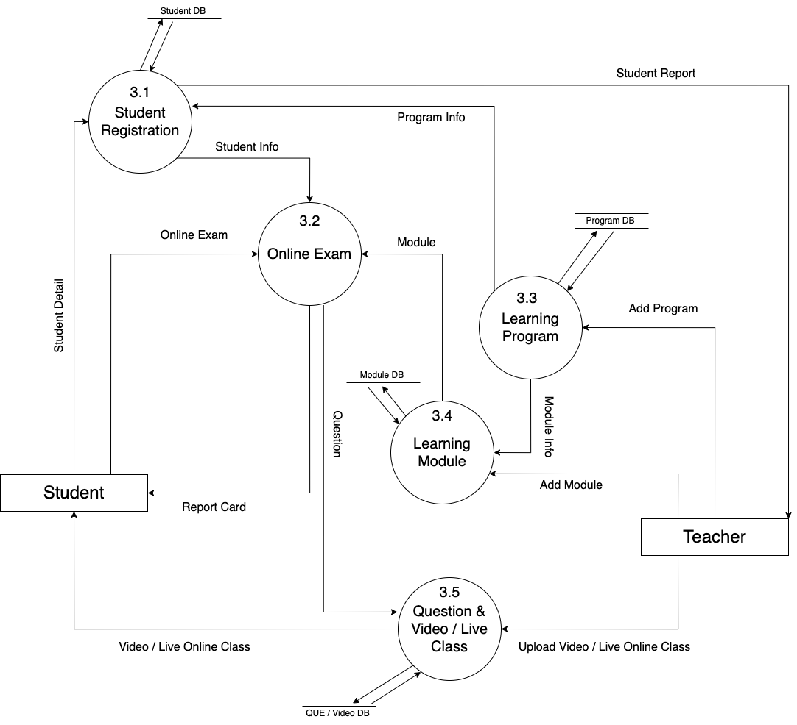

*Figure 2.6-3 DFD level-2 for bank account system*

### 3 External interface requirement (Screens)

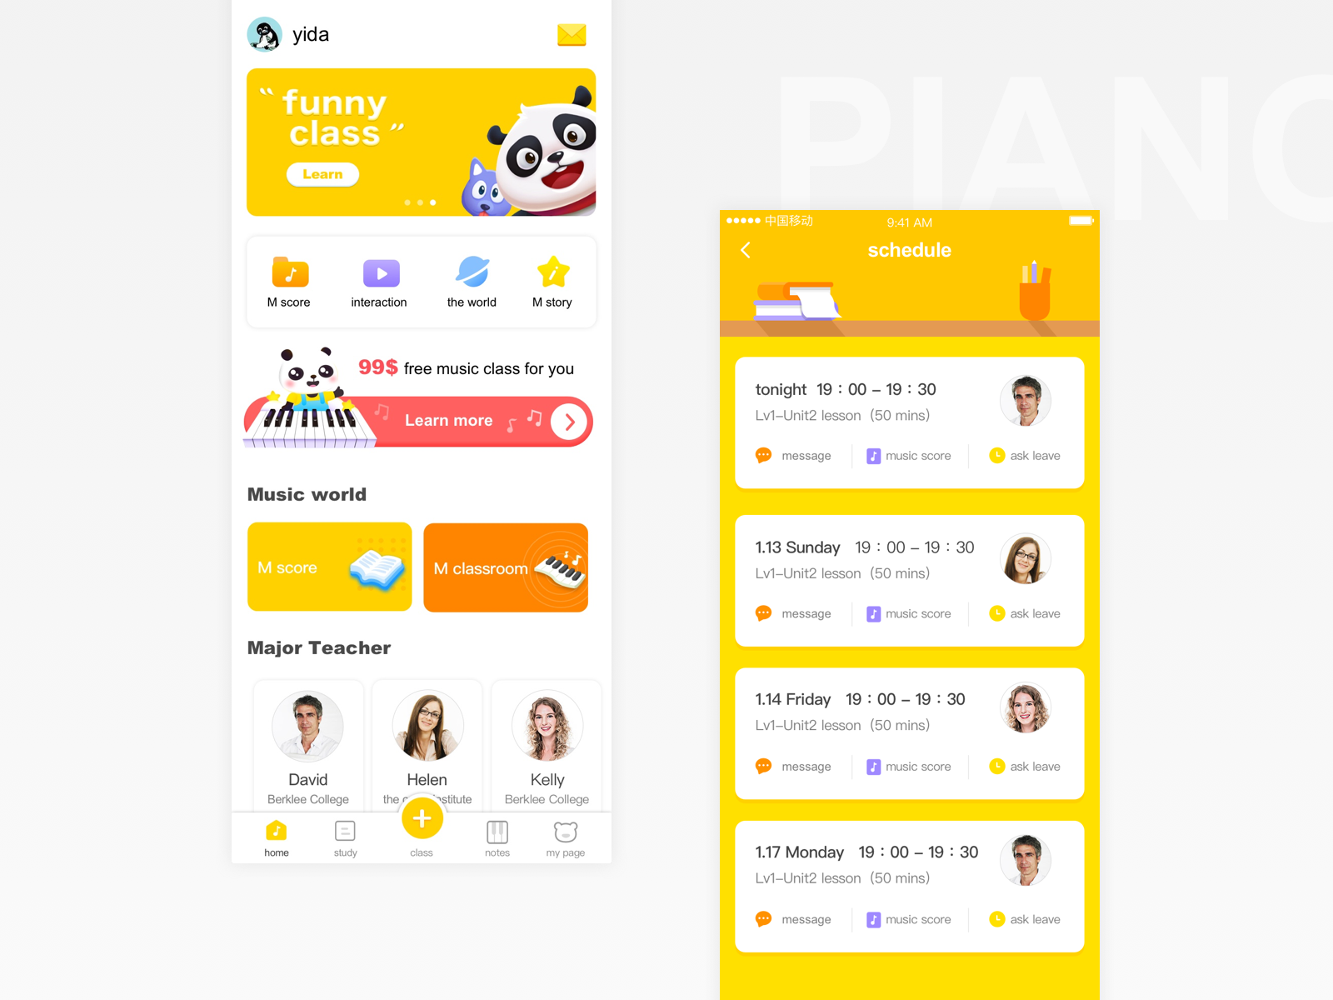

*Figure 3.1-1Screen-1: Home Screen*

**Purpose:** here are detailed descriptions for the elements you can include on the home screen of your app

*Table 3.1-1 Screen element of Registration form*

|  |  |  |  |  |  |
| --- | --- | --- | --- | --- | --- |
| **Sr.** | **Screen Element** | **Input Type** | **O/M** | **1/N** | **Description** |
| **1** | App Logo/Title | Static | M | 1 | The app's logo and title are displayed at the top of the home screen for branding and recognition. This static element provides users with a visual identity for the app.. |
| **2** | Navigation Menu | Buttons or Icons | M | N | The navigation menu consists of buttons or icons that allow users to easily access different sections of the app, such as Alphabets, Numbers, Poems, Stories, Games, User Profile, and Settings. |
| **3** | Search Bar | Textbox | O | 1 | The search bar is an optional text input field that enables users to search for specific content within the app. |
| **4** | Featured Content | Thumbnails or Cards | M | N | Featured content is displayed prominently on the home screen and consists of thumbnail images or cards representing content such as the "Book of the Day," "Poem of the Week," or other engaging items. |
| **5** | Category Tiles | Tiles or Icons | M | N | Category tiles are interactive elements that provide users with quick access to different content categories, including Alphabets, Numbers, Poems, Stories, and more. |
| **6** | Settings Icon/Button | Button | M | 1 | The settings icon or button grants users access to the app's settings, including language preferences, notification settings, and parental controls. |

#### 3.2 Screen-2: Parent-Teacher Communication

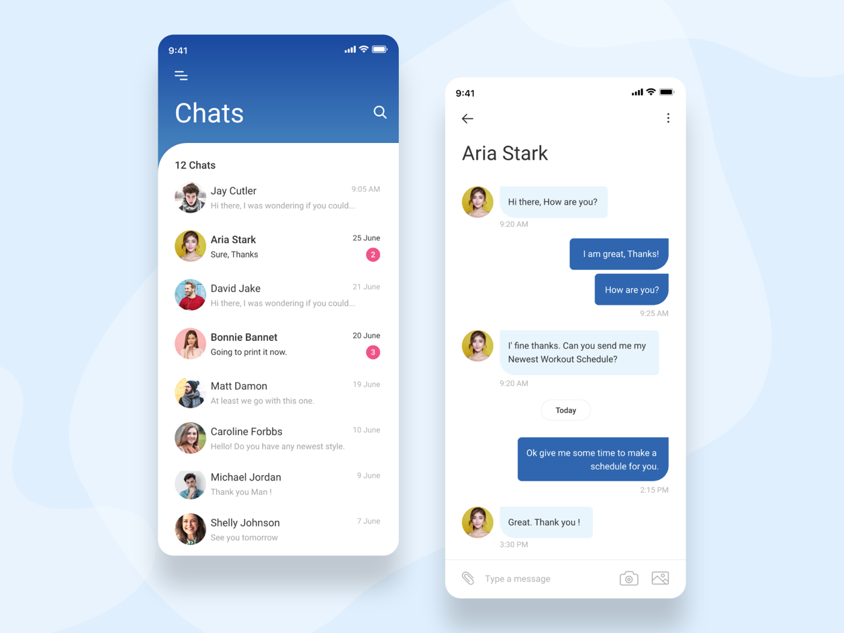

*Figure 3.2-1Screen-2: Parent-Teacher Communication*

**Purpose:** These elements can create an effective and user-friendly Parent-Teacher Communication Section within your app. The specific elements you choose will depend on your app's design and goals.

*Table 3.2-1Screen element of Alphabets Section*

|  |  |  |  |  |  |
| --- | --- | --- | --- | --- | --- |
| **Sr.** | **Screen Element** | **Input Type** | **O/M** | **1/N** | **Description** |
| **1** | Messaging Interface | Chat Interface | M | 1 | The messaging interface is a mandatory and central element for communication between parents and teachers. It allows users to send and receive messages in real-time. |
| **2** | Message Threads | Thread List | M | N | Message threads are mandatory and organize messages into conversations, enabling users to easily track their discussions with various users. |
| **3** | Attachment Support | File Upload | M | N | Attachment support is optional and allows users to attach files, images, or documents to their messages for sharing important information. |
| **4** | Notifications | Push Notifications | M | 1 | Push notifications are mandatory and alert users when they receive new messages or replies, ensuring timely communication. |
| **5** | User Profiles | Profile Details | M | N | User profiles are mandatory and display names, profile pictures, and brief information about the sender to provide context for conversations. |
| **6** | Status Indicators | Online/Last Seen Status | O | 1 | Status indicators are optional and provide information about the online or last seen status of users, helping gauge their availability. |

#### 3.3 Screen-3: live online Video Lessons Section

#### 

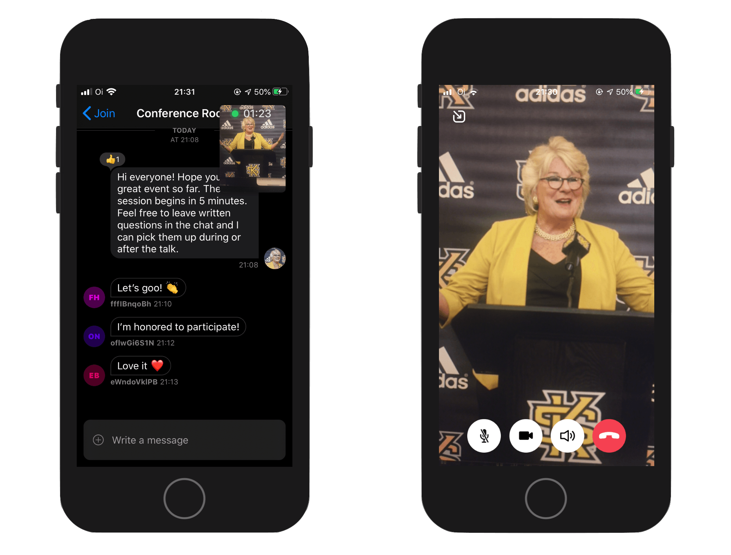

*Figure 3.3-1Screen-3: Live Online Video Lessons Section*

**Purpose:** The Live Online Video Lessons Section of your app is designed to provide video lessons to users. Here are some elements you might consider adding to this screen to make it user-friendly and engaging

*Table 3.3-1Screen element of : Live Online Video Lessons Section*

|  |  |  |  |  |  |
| --- | --- | --- | --- | --- | --- |
| **Sr.** | **Screen Element** | **Input Type** | **O/M** | **1/N** | **Description** |
| **1** | Video Thumbnails | Thumbnails | M | N | Video thumbnails are mandatory and represent individual video lessons. Each thumbnail serves as a visual preview of the lesson content and includes an interactive play button overlay. |
| **2** | Video Titles | Text | M | N | Mandatory video titles or descriptions accompany each video thumbnail, providing users with information about the content of each video. |
| **3** | Play Button | Button | M | N | Play buttons are overlaid on video thumbnails, and they are mandatory interactive elements that allow users to initiate video playback by tapping on them.. |
| **4** | Progress Tracking | Indicators or Buttons | O | N | Optional progress tracking elements, such as indicators or buttons, enable users to mark videos as completed or in progress and keep track of their learning journey. |
| **5** | Category Filters | Dropdown or Buttons | O | 1 | Category filters are optional and allow users to filter videos by category, subject, or topic, enhancing content discovery. |
| **6** | Search Bar | Textbox | O | 1 | The search bar is optional and provides users with a text input field to search for specific video lessons using keywords or topics. |
| **7** | Exit | Button | O | 1 | The exit/logout option is a mandatory button or icon that allows users to securely exit the Video Lessons Section and return to the home screen or main menu |

### 4 Database design

#### 4.1 List of Tables

* Users Table
* Content/Resource Table
* Feedback and Ratings Table
* Game Progress Table
* Classes/Courses Table

*Table 4.1-1 Table: • Users Table*

|  |  |  |  |  |
| --- | --- | --- | --- | --- |
| **Column** | **Data Type** | **Null** | **Keys & Constrains** | **Default Value & Description** |
| **UserID** | Integer | NN | PK | Auto Increment |
| **Username** | varchar(50) | NN |  |  |
| **Password** | varchar(255) | NN |  |  |
| **Email** | varchar(100) | NN |  |  |
| **UserRole** | varchar(30) | NN |  |  |
| **RegistrationDate** | Datetime | NN |  |  |

*Table 4.1-2 Table: • Content/Resource Table*

|  |  |  |  |  |  |
| --- | --- | --- | --- | --- | --- |
| **Column** | **Data Type** | **Null** | **Keys & Constrains** | **Default Value**  **Description** | **&** |
| **ContentID** | Integer | NN | Foreign Key | A unique identifier for each piece of educational content. |  |
| **Title** | varchar(100) | NN |  |  |  |
| **Description** | varchar(100) | NN |  |  |  |
| **ContentType** | varchar(20) | NN |  |  |  |
| **ContentURL** | varchar(255) | NN |  |  |  |

*Table 4.1-3 Table* *Feedback and Ratings Table*

|  |  |  |  |  |
| --- | --- | --- | --- | --- |
| **Column** | **Data Type** | **Null** | **Keys & Constrains** | **Default Value & Description** |
| **FeedbackID** | Integer | NN | PrimaryKey | A unique identifier for each feedback entry |
| **UserID** | Integer | NN | Foreign Key | References the user who provided the feedback |
| **FeedbackText** | Varchar(10) | NN |  |  |
| **Rating** | Tinyint (1-5) |  |  |  |
| **Timestamp** | Datetime |  |  |  |

*Table 4.1-4 Table: Game Progress Table*

|  |  |  |  |  |
| --- | --- | --- | --- | --- |
| **Column** | **Data Type** | **Null** | **Keys & Constrains** | **Default Value & Description** |
| **ProgressID** | Integer | NN | Primary Key | A unique identifier for each progress record. |
| **UserID** | Integer | NN | Foreign Key | References the user whose progress is being tracked. |
| **ContentID** | Integer | NN | Foreign Key |  |
| **Score** | Integer | NN |  |  |

*Table 4.1-5 Table: Classes/Courses Table*

|  |  |  |  |  |
| --- | --- | --- | --- | --- |
| **Column** | **Data Type** | **Null** | **Keys & Constrains** | **Default Value & Description** |
| **ClassID** | Integer | NN | Primary Key | A unique identifier for each progress record. |
| **ClassName** | Varchar(100) | NN |  |  |
| **TeacherID** | Integer | NN | Foreign Key | References the teacher who is responsible for the class/course. |
| **Schedule** | Varchar(100) | NN |  |  |

**5 Stories and Scenario**

# Story-1: Explore Alphabets

|  |  |  |
| --- | --- | --- |
| *Story # S1* | : | As a Parent,  I want my child to explore alphabets  So that they can learn the fundamentals of reading and writing. |
| Priority | **:** | High |
| Estimate | **:** | XL |
| Reason | **:** | Exploring alphabets is a fundamental aspect of early learning. |

## Scenario# S1.1

|  |  |  |
| --- | --- | --- |
| *Scenario# S1.1* | : | Browsing Alphabets |
| Prerequisite | **:** | The app is successfully launched. |
| Acceptance Criteria | **:** | **Given:** I navigate to the "Alphabets" section on the home screen.  **When:** I enter the "Alphabets" section.  **Then** I see a list of alphabets from A to Z.  Display words starting with "A.".  Display images and pronunciations for the words. |

## Scenario# S1.2

|  |  |  |
| --- | --- | --- |
| *Scenario# S1.2* | : | Selecting an Alphabet |
| Prerequisite | **:** | I am in the "Alphabets" section. |
| Acceptance Criteria | **:** | **Given:** I am in the "Alphabets" section.  **When:** I select a specific alphabet, e.g., "A."  **Then:** I am taken to a page where I can explore words starting with that alphabet. |

## Scenario# S1.3

|  |  |  |
| --- | --- | --- |
| *Scenario# S1.3* | : | Viewing Alphabet Words |
| Prerequisite | **:** | I am on the page for exploring words starting with the letter "A." |
| Acceptance Criteria | **:** | **Given:** I am on the page for exploring words starting with "A."  **When:** I scroll through the list of words.  **Then:** I can see words like "Apple," "Ant," and "Astronaut" along with images and pronunciations. |

# 

# Story-2: Counting Numbers

|  |  |  |
| --- | --- | --- |
| *Story # S2* | : | As a parent,  I want my child to learn counting and numbers,  so that they can develop basic math skills. |
| Priority | **:** | High |
| Estimate | **:** | XL |
| Reason | **:** | Counting and numbers are fundamental concepts in early education. |

## Scenario# S2.1

|  |  |  |
| --- | --- | --- |
| *Scenario# S2.1* | : | Browsing Numbers |
| Prerequisite | **:** | The app is successfully launched. |
| Acceptance Criteria | **:** | **Given:** I navigate to the “Numbers” section on the home screen.  **When:** I enter the “Numbers” section.  **Then:** I see a list of numbers from 1 to 10. |

## Scenario# S2.2

|  |  |  |
| --- | --- | --- |
| *Scenario# S2.1* | : | Selecting a Number |
| Prerequisite | **:** | I am in the “Numbers” section. |
| Acceptance Criteria | **:** | **Given:** I am in the “Numbers” section.  **When:** I select a specific number, e.g., “5.”  **Then:** I am taken to a page where I can learn about counting and simple math with the number 5. |

## Scenario# S1.3

|  |  |  |
| --- | --- | --- |
| *Scenario# S1.3* | : | Learning with Interactive Counting |
| Prerequisite | **:** | I am on the page for exploring number 5. |
| Acceptance Criteria | **:** | **Given:** I am on the page for exploring number 5.  **When:** I interact with the counting exercises.  **Then:** I can practice counting objects and solving simple math problems related to the number 5. |

# Story-3: Enjoy Poems

|  |  |  |
| --- | --- | --- |
| *Story # S3* | : | As a parent,  I want my child to enjoy listening to poems,  so that they can appreciate the beauty of language and rhythm. |
| Priority | **:** | Medium |
| Estimate | **:** | L |
| Reason | **:** | Poems offer an enjoyable way to learn language and rhythm. |

## Scenario# S3.1

|  |  |  |
| --- | --- | --- |
| *Scenario# S3.1* | : | Browsing Poems |
| Prerequisite | **:** | The app is successfully launched. |
| Acceptance Criteria | **:** | **Given:** I navigate to the “Poems” section on the home screen.  **When:** I enter the “Poems” section.  **Then:** I see a list of poems with titles and authors. |

## Scenario# S3.2

|  |  |  |
| --- | --- | --- |
| *Scenario# S3.2* | : | Selecting a Poem |
| Prerequisite | **:** | I am in the “Poems” section. |
| Acceptance Criteria | **:** | **Given:** I am in the “Poems” section.  **When:** I select a specific poem, e.g., “Twinkle, Twinkle, Little Star.”  **Then:** I am taken to a page where I can read or listen to the selected poem. |

## Scenario# S3.3

|  |  |  |
| --- | --- | --- |
| *Scenario# S3.3* | : | Listening to a Poem |
| Prerequisite | **:** | I am on the page for “Twinkle, Twinkle, Little Star.” |
| Acceptance Criteria | **:** | **Given:** I am on the page for “Twinkle, Twinkle, Little Star.”  **When:** I click on the “Listen” button.  **Then:** I can enjoy listening to the poem with background music and follow along with the lyrics. |

# 

# Story-4: Dive into Stories

|  |  |  |
| --- | --- | --- |
| *Story # S4* | : | As a parent,  I want my child to read and listen to stories,  so that they can enhance their imagination and reading abilities. |
| Priority | **:** | Medium |
| Estimate | **:** | L |
| Reason | **:** | Stories foster imagination and reading skills. |

# Story-5: Interactive Learning Games

|  |  |  |
| --- | --- | --- |
| *Story # S5* | : | As a parent,  I want my child to play interactive learning games,  so that they can have fun while learning essential concepts. |
| Priority | **:** | High |
| Estimate | **:** | XL |
| Reason | **:** | Interactive games make learning engaging and fun |

# Story-6: Video Lessons

|  |  |  |
| --- | --- | --- |
| *Story # S6* | : | As a parent,  I want my child to watch educational videos,  so that they can learn from visual content. |
| Priority | **:** | Medium |
| Estimate | **:** | M |
| Reason | **:** | Visual content can be a valuable addition to a child’s learning experience. |

# Story-7: Rhymes and Songs

|  |  |  |
| --- | --- | --- |
| *Story # S7* | : | As a parent,  I want my child to listen to rhymes and songs,  so that they can develop an appreciation for music and rhythm. |
| Priority | **:** | Medium |
| Estimate | **:** | S |
| Reason | **:** | Music is an enjoyable way to learn about rhythm, language, and culture. |

# 

# Story-8: Learning with Stories

|  |  |  |
| --- | --- | --- |
| *Story # S8* | : | As a parent,  I want my child to learn through interactive stories,  so that they can grasp educational concepts in a fun way. |
| Priority | **:** | High |
| Estimate | **:** | XL |
| Reason | **:** | Interactive stories can make complex ideas more accessible to young learners. |

# Story-9: Creative Drawing

|  |  |  |
| --- | --- | --- |
| *Story # S9* | : | As a parent,  I want my child to express creativity through drawing,  so that they can develop fine motor skills and artistic abilities. |
| Priority | **:** | Medium |
| Estimate | **:** | M |
| Reason | **:** | Artistic expression is an important aspect of child development |

# Story-10: Parent-Teacher Communication

|  |  |  |
| --- | --- | --- |
| *Story # S10* | : | As a parent,  I want the ability to communicate with teachers,  so that I can stay informed about my child's progress. |
| Priority | **:** | High |
| Estimate | **:** | XL |
| Reason | **:** | Effective communication with teachers is crucial for a parent's involvement in their child's education. |

### 6 Test cases

|  |  |  |  |
| --- | --- | --- | --- |
| **Project Name:** | **Learning With Fun** | **Test Designed by:** | **Gohil Krishna** |
| **Module Name:** | **Live Class** | **Test Designed date:** | 26/08/2023 |
| **Release Version:** | **1.0** | **Test Executed by:** | **Gohil Krishna** |
|  |  | **Test Execution date:** | 26/08/2023 |

|  |  |  |  |
| --- | --- | --- | --- |
| **Test Case ID** | **Test Title** | **Test Type** | **Description** |
| TC_001 | Access Live Class | Functional | Verify access to a scheduled live class. |
| TC_002 | Raise Hand | Functional | Verify user can raise hand during a live class. |
| TC_003 | Interactive Whiteboard | Functional | Verify interactive whiteboard functionality. |

|  |  |
| --- | --- |
| **Test Case Title** | Verify access to a scheduled live class. |
| **Test Type** | Functional |
| **Test Priority** | High |
| **Pre-condition** | User is logged into the app. |

|  |  |  |  |  |  |  |  |
| --- | --- | --- | --- | --- | --- | --- | --- |
| **Test Step** | **Test Case Description** | **Expected Result** | **Actual Result** | **Status** | **Comment** | **Data** | **Bug ID** |
| 1 | Navigate to the "Live Classes" section. | The user is navigated to the "Live Classes" section. | The user is directed to the "Live Classes" section. | Pass | Test case executed successfully and passed as expected. | [List of available live classes](https://accounts.google.com/Service) | N/A |
| 2 | Find and select a scheduled live class from the list. | The user is able to find and select the scheduled live class from the list. | The user locates the scheduled live class in the list. | Pass | Test case executed successfully and passed as expected. | Date and time information | N/A |
| 3 | Click on the "Join Class" button. | The user is able to successfully join the live class. | The "Join Class" button is present and clickable, allowing the user to join the live class. | Pass | Test case executed successfully and passed as expected. | Valid username and password | N/A |

|  |  |
| --- | --- |
| **Test Case Title** | Verify user can raise hand during a live class. |
| **Test Type** | Functional |
| **Test Priority** | Medium |
| **Pre-condition** | User is logged into the app and is in a live class. |

|  |  |  |  |  |  |  |  |
| --- | --- | --- | --- | --- | --- | --- | --- |
| **Test Step** | **Test Case Description** | **Expected Result** | **Actual Result** | **Status** | **Comment** | **Data** | **Bug ID** |
| 1 | Select a live class that is currently in progress. | The user selects a live class that is currently ongoing. | The user selects an ongoing live class. | Pass | Test case executed successfully and passed as expected. | Valid username and password | N/A |
| 2 | Locate the "Raise Hand" button on the user interface. | The user identifies the "Raise Hand" button on the user interface. | The user easily locates the "Raise Hand" button on the user interface. | Pass | Test case executed successfully and passed as expected. | Date, time, and topic information | N/A |
| 3 | Click on the "Raise Hand" button. | The user successfully clicks on the "Raise Hand" button. | The user clicks on the "Raise Hand" button, and the action is acknowledged by the app. | Pass | Test case executed successfully and passed as expected. | None | N/A |

|  |  |
| --- | --- |
| **Test Case Title** | Verify interactive whiteboard functionality during a live class. |
| **Test Type** | Functional |
| **Test Priority** | High |
| **Pre-condition** | User is logged into the app and is in a live class with interactive whiteboard functionality. |

|  |  |  |  |  |  |  |  |
| --- | --- | --- | --- | --- | --- | --- | --- |
| **Test Step** | **Test Case Description** | **Expected Result** | **Actual Result** | **Status** | **Comment** | **Data** | **Bug ID** |
| 1 | Locate the "Interactive Whiteboard" icon on the teacher's interface. | The teacher identifies the "Interactive Whiteboard" icon on their interface. | The teacher easily identifies the "Interactive Whiteboard" icon on their interface. | Passed | Test case executed successfully and passed as expected. | None | N/A |
| 2 | Use various drawing tools to create content on the whiteboard. | The teacher successfully uses drawing tools to create content on the whiteboard. | The teacher smoothly uses drawing tools to create engaging content on the whiteboard. | Pass | Test case executed successfully and passed as expected. | None | N/A |
| 3 | Verify that the drawn content is visible to all participants in real-time. | The drawn content is immediately visible to all participants in the live class. | The drawn content is promptly visible to all participants in the live class, enhancing the interactive experience. | Failed | Test case executed successfully and passed as expected. | Date, time, and topic information | N/A |

|  |  |  |  |
| --- | --- | --- | --- |
| **Project Name:** | **Learning With Fun** | **Test Designed by:** | **Gohil Krishna** |
| **Module Name:** | **Content** | **Test Designed date:** | 26/082023 |
| **Release Version:** | **1.0** | **Test Executed by:** | **Gohil Krishna** |
|  |  | **Test Execution date:** | 26/082023 |

|  |  |  |  |
| --- | --- | --- | --- |
| **Test Case ID** | **Test Title** | **Test Type** | **Description** |
| TC_004 | Video Playback | Functional | Verify that videos can be played back without errors. |
| TC_005 | Interactive Games | Functional | Verify interactive games can be played smoothly. |
| TC_006 | Story Reading | Functional | Verify that stories can be read aloud to children. |

|  |  |
| --- | --- |
| **Test Case Title** | Verify video playback from the content module. |
| **Test Type** | Functional |
| **Test Priority** | Medium |
| **Pre-condition** | User is logged into the app and has access to the content module. |

|  |  |  |  |  |  |  |  |
| --- | --- | --- | --- | --- | --- | --- | --- |
| **Test Step** | **Test Case Description** | **Expected Result** | **Actual Result** | **Status** | **Comment** | **Data** | **Bug ID** |
| 1 | Select a content item that includes a video. | The user selects a content item containing a video. | The user selects a content item that includes a video. | Pass | Test case executed successfully and passed as expected. | Title, description, video link | N/A |
| 2 | Click on the video thumbnail to initiate playback. & Observe the video to ensure smooth playback. | The user clicks on the video thumbnail to start video playback. & The video starts playing smoothly without buffering. | The user clicks on the video thumbnail, and the video playback starts promptly. & The video plays seamlessly without any interruptions. | Pass | Test case executed successfully and passed as expected. | None | N/A |
| 3 | Pause and resume the video playback. & Verify that the video controls (play, pause, seek) work correctly. | The user successfully pauses and resumes the video playback. & The video controls respond accurately to user interactions. | The user smoothly pauses and resumes the video playback. & The video controls (play, pause, seek) respond accurately to user actions. | Pass | Test case executed successfully and passed as expected. | None | N/A |

|  |  |
| --- | --- |
| **Test Case Title** | Verify interactive games functionality. |
| **Test Type** | Functional |
| **Test Priority** | Medium |
| **Pre-condition** | User is logged into the app and has access to the games module. |

|  |  |  |  |  |  |  |  |
| --- | --- | --- | --- | --- | --- | --- | --- |
| **Test Step** | **Test Case Description** | **Expected Result** | **Actual Result** | **Status** | **Comment** | **Data** | **Bug ID** |
| 1 | Select an interactive game from the list. | The user selects an interactive game to play. | The user selects an interactive game to play from the available options. | Pass | Test case executed successfully and passed as expected. | Title | N/A |
| 2 | Play the game according to its instructions. & Complete the game and achieve a result or score. | The user plays the game as per the provided instructions. & The user successfully completes the game and achieves a result or score. | The user effectively follows the game's instructions and plays the game. & The user completes the game and attains a result or score. | Pass | Test case executed successfully and passed as expected. | Description, instructions | N/A |
| 3 | Verify that the game response is accurate. | The game response accurately reflects the user's performance. | The game response precisely reflects the user's performance during the game. | Pass | Test case executed successfully and passed as expected. | None | N/A |

|  |  |
| --- | --- |
| **Test Case Title** | Verify interactive games functionality. |
| **Test Type** | Functional |
| **Test Priority** | Medium |
| **Pre-condition** | User is logged into the app and has access to the games module. |

|  |  |  |  |  |  |  |  |
| --- | --- | --- | --- | --- | --- | --- | --- |
| **Test Step** | **Test Case Description** | **Expected Result** | **Actual Result** | **Status** | **Comment** | **Data** | **Bug ID** |
| 1 | Select an interactive game from the list. | The user selects an interactive game to play. | The user selects an interactive game to play from the available options. | Pass | Test case executed successfully and passed as expected. | Title | N/A |
| 2 | Play the game according to its instructions. & Complete the game and achieve a result or score. | The user plays the game as per the provided instructions. & The user successfully completes the game and achieves a result or score. | The user effectively follows the game's instructions and plays the game. & The user completes the game and attains a result or score. | Pass | Test case executed successfully and passed as expected. | Description, instructions | N/A |
| 3 | Verify that the game response is accurate. | The game response accurately reflects the user's performance. | The game response precisely reflects the user's performance during the game. | Pass | Test case executed successfully and passed as expected. | None | N/A |

|  |  |  |  |
| --- | --- | --- | --- |
| **Project Name:** | **Learning With Fun** | **Test Designed by:** | **Gohil Krishna** |
| **Module Name:** | **User Management** | **Test Designed date:** | 26/082023 |
| **Release Version:** | **1.0** | **Test Executed by:** | **Gohil Krishna** |
|  |  | **Test Execution date:** | 26/082023 |

|  |  |  |  |
| --- | --- | --- | --- |
| **Test Case ID** | **Test Title** | **Test Type** | **Description** |
| TC_007 | Password Recovery | Functional | Verify that users can recover their password through the recovery process. |
| TC_008 | Profile Update | Functional | Verify that users can update their profile information. |
| TC_009 | Multiple Device Login | Functional | Verify that users can log in from multiple devices simultaneously. |

|  |  |
| --- | --- |
| **Test Case Title** | Verify password recovery functionality from the user management module. |
| **Test Type** | Functional |
| **Test Priority** | High |
| **Pre-condition** | User has a registered account in the app. |

|  |  |  |  |  |  |  |  |
| --- | --- | --- | --- | --- | --- | --- | --- |
| **Test Step** | **Test Case Description** | **Expected Result** | **Actual Result** | **Status** | **Comment** | **Data** | **Bug ID** |
| 1 | Click on the "Forgot Password?" link on the login screen. & Enter the registered email address associated with the account. | The user clicks on the "Forgot Password?" link on the login screen. & The user enters the email address associated with their account. | The user easily clicks on the "Forgot Password?" link on the login screen. | Pass | Test case executed successfully and passed as expected. | Valid registered email address | N/A |
| 2 | Click on the "Send Recovery Email" button. & Check the registered email for the password recovery link. | The user clicks on the "Send Recovery Email" button. & The user checks their email and finds the password recovery link. | The user successfully clicks on the "Send Recovery Email" button. | Pass | Test case executed successfully and passed as expected. | None | N/A |
| 3 | Click on the password recovery link in the email. & Follow the instructions to reset the password. | The user clicks on the password recovery link within the email. & The user follows the instructions to reset the password. | The user smoothly clicks on the password recovery link provided in the email. | Pass | Test case executed successfully and passed as expected. | None | N/A |

|  |  |
| --- | --- |
| **Test Case Title** | Verify user profile update functionality. |
| **Test Type** | Functional |
| **Test Priority** | Medium |
| **Pre-condition** | User is logged into the app and has a registered account. |

|  |  |  |  |  |  |  |  |
| --- | --- | --- | --- | --- | --- | --- | --- |
| **Test Step** | **Test Case Description** | **Expected Result** | **Actual Result** | **Status** | **Comment** | **Data** | **Bug ID** |
| 1 | Click on the "Edit Profile" or "Update Profile" button. | The user clicks on the "Edit Profile" or "Update Profile" button. | The user locates and clicks on the "Edit Profile" or "Update Profile" button. | Pass | Test case executed successfully and passed as expected. | Valid username and password | N/A |
| 2 | Update any relevant profile information, such as name, email, or profile picture. | The user updates the relevant profile information as desired. | The user efficiently updates the relevant profile information according to their preferences. | Pass | Test case executed successfully and passed as expected. | None | N/A |
| 3 | Click on the "Save" or "Update" button to save the changes. | The user clicks on the "Save" or "Update" button to save the changes. | The user clicks on the "Save" or "Update" button, successfully saving the changes. | Pass | Test case executed successfully and passed as expected. | New name, email, profile picture | N/A |

|  |  |
| --- | --- |
| **Test Case Title** | Verify multiple device login restrictions. |
| **Test Type** | Functional |
| **Test Priority** | High |
| **Pre-condition** | User has a registered account in the app. |

|  |  |  |  |  |  |  |  |
| --- | --- | --- | --- | --- | --- | --- | --- |
| **Test Step** | **Test Case Description** | **Expected Result** | **Actual Result** | **Status** | **Comment** | **Data** | **Bug ID** |
| 1 | Launch the Learning with Fun app on Device B. | The app on Device B launches without any issues. | The app on Device B launches successfully. | Pass | Test case executed successfully and passed as expected. | None | N/A |
| 2 | Attempt to log in using the same valid credentials on Device B. | The user on Device B attempts to log in using the same valid credentials as on Device A | The user on Device B attempts to log in using the same valid credentials as on Device A. | Pass | Test case executed successfully and passed as expected. | Valid username and password | N/A |
| 3 | Observe the response when attempting to log in on Device B. | The app on Device B displays an error message indicating that the user is already logged in on another device. | The app on Device B accurately displays an error message, indicating that the user is already logged in on another device. | Pass | Test case executed successfully and passed as expected. | None | N/A |

**7 References**

* https://maestrolearning.com/blogs/how-to-write-a-scenario/
* https://www.coursera.org/articles/how-to-write-test-cases
* <https://www.geeksforgeeks.org/data-flow-diagram-for-online-banking-system/>