**Sample Test Summary Report Created and published by:** [**http://SoftwareTestingHelp.com**](http://SoftwareTestingHelp.com/)

Test Summary Report

**Contents**

1. *Purpose* 2
2. *Application Overview* 2
3. *Testing Scope* 2
4. *Metrics* 3
5. *Types of testing performed* 5
6. *Test Environment & Tools* 5
7. *Lessons Learnt* 6
8. *Recommendations* 6
9. *Best Practices* 6
10. *Exit Criteria* 7
11. *Conclusion/Sign Off* 7
12. *Definitions, Acronyms, and Abbreviations* 7

# *Purpose*

### This document explains the various activities performed as part of Testing of ‘ABCD transport system’ application.

# *Application Overview*

### ‘ABCD transport system’ is a web based Bus ticket booking application. Tickets for various buses can be booked using the online facilities. Real time passenger information is received from a ‘Central repository system’, which will be referred before booking is confirmed. There are several modules like Registration, Booking, Payment and Reports which are integrated to fulfill the purpose.

# *Testing Scope*

*<This section explains about the functions/modules in scope & out of scope for testing;* Any items which are not tested due to any constraints/dependencies/restrictions.

***Example:*** *A functionality verification which needs connectivity to a third party* application cannot be tested, as the connectivity could not be established due to some technical limitations. This section should be clearly documented, else it will be assumed that Testing covered all areas of the application>

## In Scope

### Functional Testing for the following modules are in Scope of Testing

### Registration

### Booking

### Payment

## Out of Scope

### Performance Testing was not done for this application.

## Items not tested

### Verification of connectivity with the third party system ‘Central repository system’ was not tested, as the connectivity could not be established due to some technical limitations. This can be verified during UAT (User Acceptance Testing) where the connectivity is available or can be established.

# *Metrics*

*<Metrics will help to understand the test execution results, status of test cases & defects* etc. Required Metrics can be added as necessary. Example: Defect Summary-Severity wise; Defect Distribution-Function/Module wise; Defect Ageing etc.. Charts/Graphs can be attached for better visual representation>

## No. of test cases planned vs executed

## No. of test cases passed/failed

|  |  |  |  |
| --- | --- | --- | --- |
| **Test cases**  **planned** | **Test cases**  **executed** | **TCs**  **Pass** | **Tcs**  **Failed** |
| 80 | 75 | 70 | 5 |

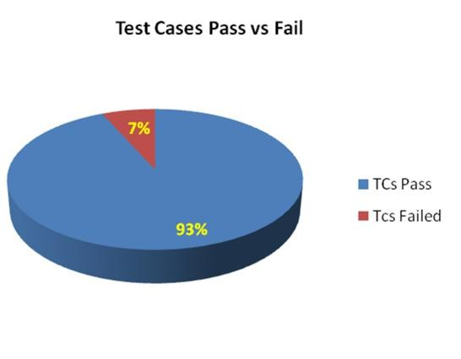

## No of defects identified and their Status & Severity

|  |  |  |  |  |  |
| --- | --- | --- | --- | --- | --- |
|  | **Critical** | **Major** | **Medium** | **Cosmetic** | **Total** |
| **Closed** | 25 | 15 | 20 | 0 | 60 |
| **Open** | 0 | 0 | 0 | 5 | 5 |
|  | | | | | 65 |

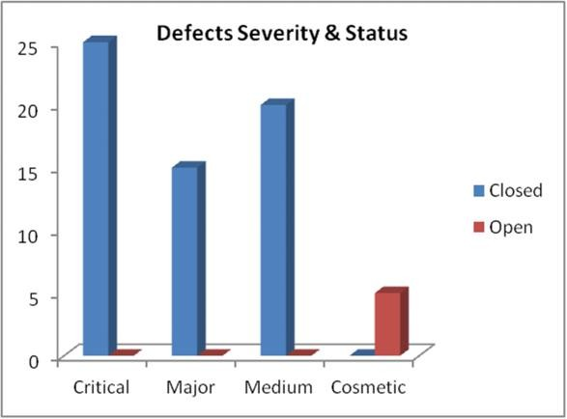

## Defects distribution – module wise

|  |  |  |  |  |  |
| --- | --- | --- | --- | --- | --- |
|  | **Registration** | **Booking** | **Payment** | **Reports** | **Total** |
| **Critical** | 6 | 7 | 5 | 7 | **25** |
| **Major** | 4 | 5 | 2 | 4 | **15** |
| **Medium** | 6 | 8 | 2 | 4 | **20** |
| **Cosmetic** | 1 | 2 | 1 | 1 | **5** |
| **Total-->** | **17** | **22** | **10** | **16** | **65** |

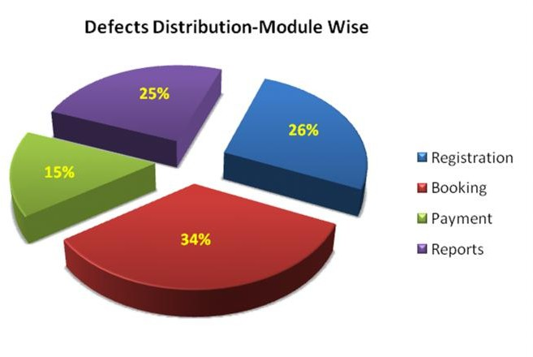

# *Types of testing performed*

## Smoke Testing

### This testing was done whenever a Build is received *(deployed into Test environment)* for Testing to make sure the major functionalities are working fine, Build can be accepted and Testing can start.

## System Integration Testing

### This is the Testing performed on the Application under test, to verify the entire application works as per the requirements.

### Critical Business scenarios were tested to make sure important functionalities in the application works as intended without any errors.

## Regression Testing

### Regression testing was performed each time a new build is deployed for testing which contains defect fixes and new enhancements, if any.

### Regression Testing is being done on the entire application and not just the new functionalities and Defect fixes.

### This testing ensures that existing functionalities works fine after defect fix and new enhancements are added to the existing application.

### Test cases for new functionalities are added to the existing test cases and executed.

*<Describe the various types of Testing performed for the Project. This will make sure the* application is being tested properly thro testing types agreed as per Test Strategy>

# *Test Environment & Tools*

*<Provide details on Test Environment in which the Testing is carried out. Server,* Database, Application URL etc. If any Tools were used like Quality Center (now HP ALM) for logging defects>

|  |  |
| --- | --- |
| **Application URL** | [http://abcd.2345.com](http://abcd.2345.com/) |
| **Apps Server** | 192.168.xxx.22 |
| **Database** | Oracle 12g |
| **HP QC/ALM** | 192.168.xxx.22 |

# *Lessons Learnt*

*<This section is used to describe the critical issues faced and their solutions (how they* were solved during the Testing). Lessons learnt will help to make proactive decisions during the next Testing engagement, by avoiding these mistakes or finding a suitable workaround >

|  |  |  |
| --- | --- | --- |
| **S. No** | **Issues faced** | **Solutions** |
| 1 | Smoke testing test cases required to be executed manually each time. | Smoke test cases were automated and the scripts were run, which ran fast and saved time. |
| 2 | Initially, Few testers were not having rights to change defect status in HP QC/ALM. Test lead need to perform this task. | Rights were obtained from Client, by explaining the difficulty. |

# *Recommendations*

*<Any workaround or suggestions can be mentioned here.>*

### Admin control for defect management tool can be given to Offshore Test lead/manager for providing access to Testing team.

### Each time the onsite Admin need not be contacted for requests whenever they arise, thereby saving time due to the geographical time zone difference.

# *Best Practices*

*<There will be lot of activities done by the Testing team during the project. Some of them* could have saved time, some proved to be a good & efficient way to work, etc. These can be documented as a ‘Value Add’ to show case to the Stakeholders.

***Example:*** *A repetitive task done manually every time was time consuming. This task was* automated by creating scripts and run each time, which saved time and resources.

### Smoke test cases were automated and the scripts were run, which ran fast and saved time.

### Automation scripts were prepared to create new customers, where lot of records need to be created for Testing.

### Business critical scenarios are separately tested on the entire application which are vital to certify they works fine.

# *Exit Criteria*

*<Exit Criteria is defined as a Completion of Testing by fulfilling certain conditions>*

### All test cases should be executed – **Yes**

### All defects in Critical, Major, Medium severity should be verified and closed – **Yes**.

* 1. Any open defects in trivial severity – **Action plan prepared with expected dates of closure.**

***Example:*** *No Severity1 defects should be ‘OPEN’; Only 2 Severity2 defects should be* ‘OPEN’; Only 4 Severity3 defects should be ‘OPEN’. Note: This may vary from project to project. Plan of Action for the Open defects should be clearly mentioned with details on when & how they will be addressed and closed.>

# *Conclusion/Sign Off*

*<This section will mention whether the Testing team agrees and gives a Green signal for* the application to ‘Go Live’ or not, after the Exit Criteria was met. If the application does not meet the Exit Criteria, then it can be mentioned as – “The application is not suggested to ‘Go Live’. In this scenario, It will be left with the decision of Senior Management and Client and other Stakeholders involved to take the call on whether the application can ‘Go Live’ or not.>

### As the Exit criteria was met and satisfied as mentioned in Section 10, this application is suggested to ‘Go Live’ by the Testing team. Appropriate User/Business acceptance testing should be performed before ‘Go Live’.

# *Definitions, Acronyms, and Abbreviations*

*<This section mentions the meanings of Abbreviated terms used in this document and* any other new definitions>

**\*\*\*\*\*\*\*\*\*\***

**Sample Test Summary Report Created and published by:** [**http://SoftwareTestingHelp.com**](http://SoftwareTestingHelp.com/)