# Neo4j Outputs when graph created using SPO Triples:

## Overall Graph:

**Partial Display:**

Example view 1:

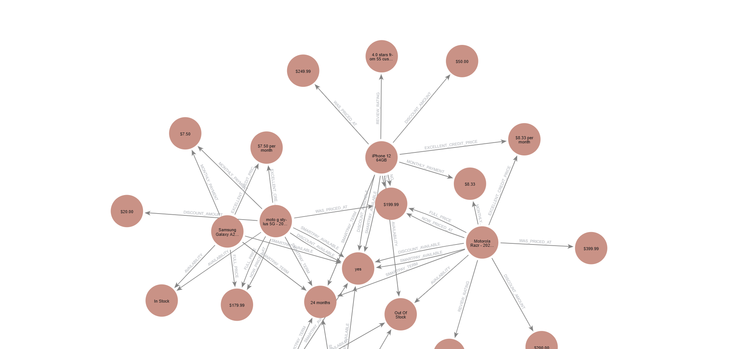

Example view 2:

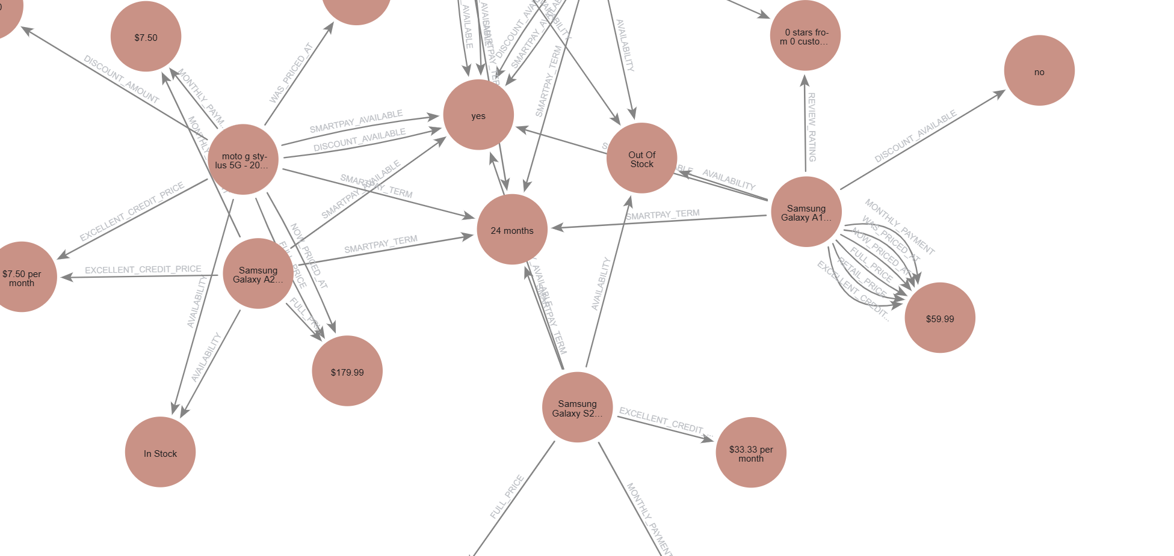

**Zoomed in for readability:**

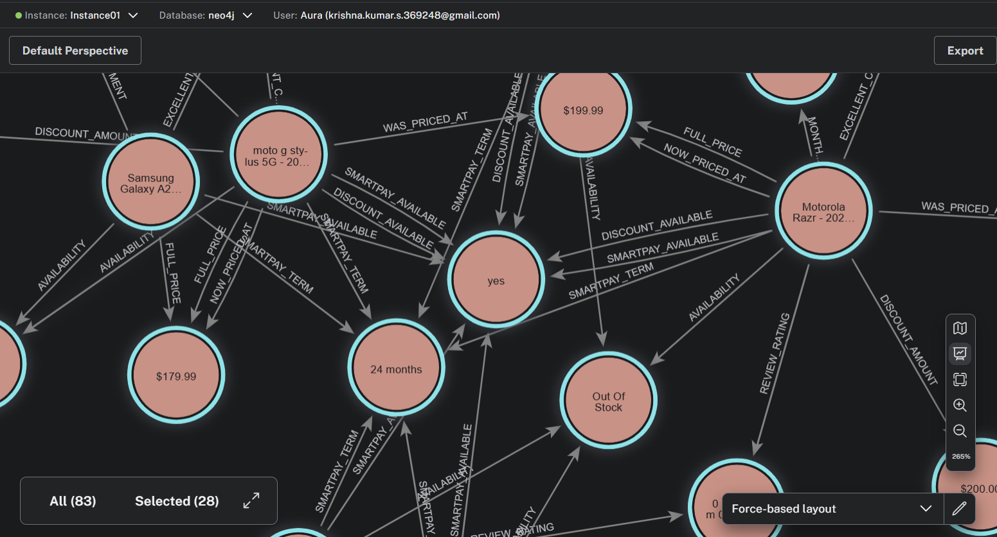

### Scenario 1:

**Natural language:** product with monthly payment options

**Neo4j generated - Cypher Query Language:**

MATCH (e:Entity)-[r:MONTHLY_PAYMENT]->(:Entity)

RETURN e.name

**Neo4j Tabular output:**

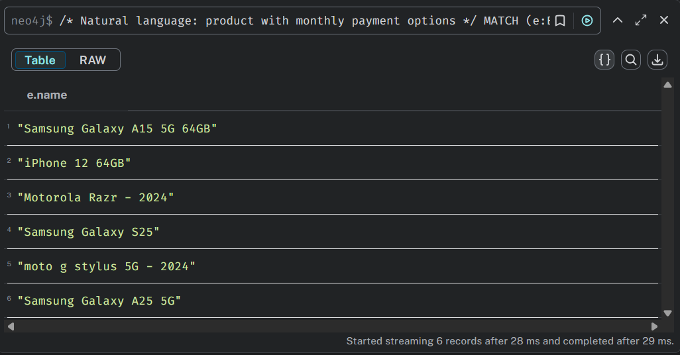

**Neo4j graph output:**

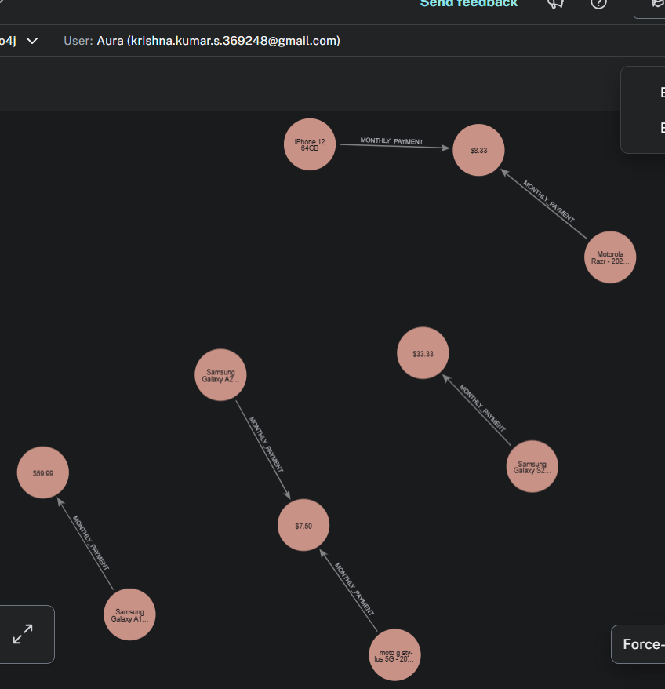

### Scenario 2:

**Natural language:** products with discounted price

**Neo4j generated - Cypher Query Language:**

MATCH (p:Entity)-[d:DISCOUNT_AMOUNT]->(discountedPrice:Entity)

RETURN p.name AS product, discountedPrice.name AS discountedPrice

**Neo4j Tabular output:**

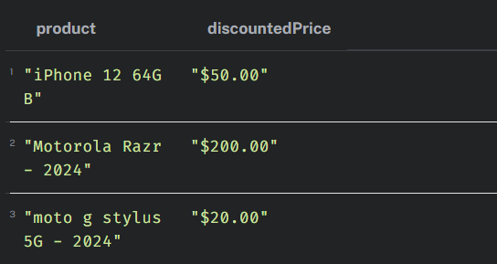

**Neo4j graph output: None**

### Scenario 3:

**Natural language:** moto products with discounts

**Neo4j generated - Cypher Query Language:**

MATCH (e:Entity)-[d:DISCOUNT_AMOUNT]->(:Entity)

WHERE e.name CONTAINS 'moto'

RETURN e.name

**Neo4j Tabular output:**

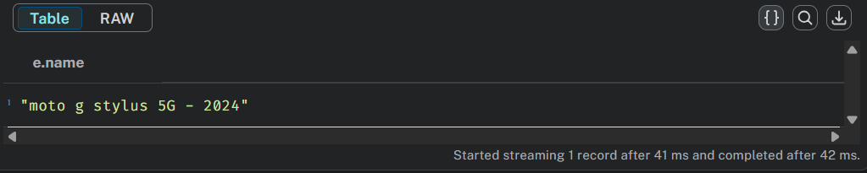

**Neo4j graph output: None**

### Scenario 4:

**Natural language:** products with price less than 100$

**Neo4j generated - Cypher Query Language:**

MATCH (p:Entity)-[r:RETAIL_PRICE]->(price:Entity)

WHERE price.name < '100'

RETURN p.name

**Neo4j Tabular output:**

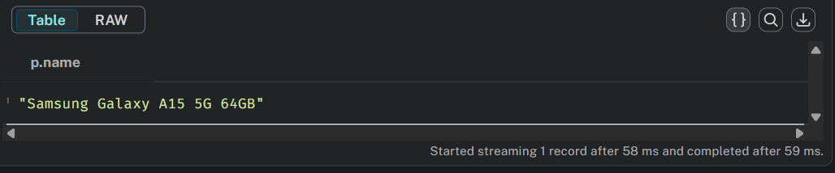

**Neo4j graph output: None**

### Scenario 5:

**Natural language:** All nodes of products that are in stock

**Neo4j generated - Cypher Query Language:**

MATCH (e:Entity)-[r:AVAILABILITY]->(e2:Entity)

WHERE e2.name = 'In Stock'

RETURN e

**Neo4j Tabular output:**

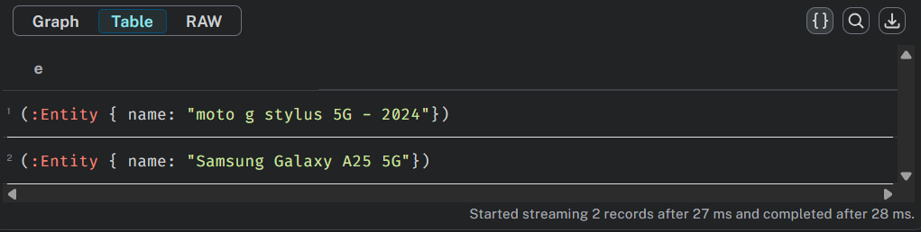

**Neo4j graph output:**

