HI 192 List of Project SS 25-26
DelaCruz/Doria/Rodriguez : (Optimizer and Learning Rate Study of Ovarian Cancer Prediction)
1. STRAMPN-HISTOPATHOLOGICAL IMAGES FOR OVARIAN CANCER PREDICTION
https://ieee-dataport.org/documents/strampn-histopathological-images-ovarian-cancer-prediction
Ovarian Cancer: 481 images
No Ovarian Cancer: 506 images
Total: 987 images
Balanced
75% training, 25% testing; training further split into 70% training 30 % validation
(247 images testing - 740 images training: 518 images training, 222 images validation)
Using transfer learning: VGG19, EfficientNetB3, ResNet50, DenseNet121
Fixed: drop-out (0.6, 0.4, 0.3), dense nodes (256, 128, 64), no of epochs:50, input size (256x256); batch size 32
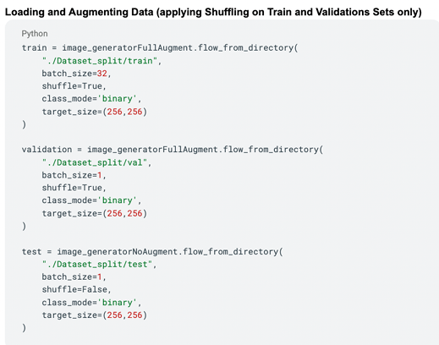

Apply pre-processing techniques: normalization, image shuffling, augmentation, train-test split
Should have augmentation on the training images only
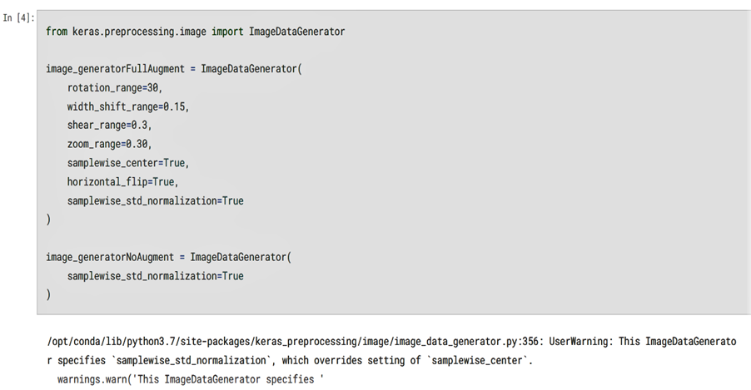
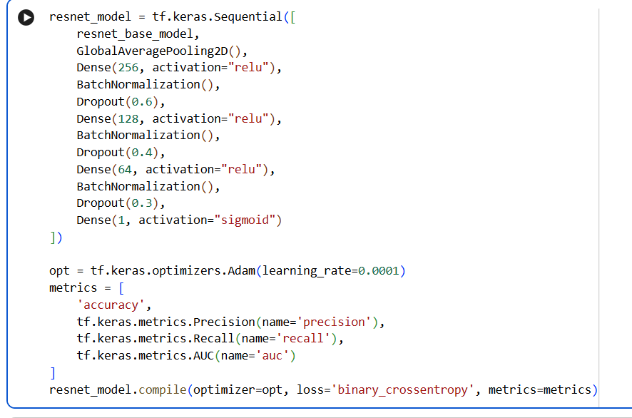

Main Experiments: to run at LR=0.0001, 0.00001, 0.000001
Adam (Adaptive Moment Estimation optimizer)
Adagrad (Adaptive Gradient optimizer)
Adamax (Maximum adaptive moment estimation optimizer)
AdaDelta
SGD (Stochastic Gradient Descent)
RMSProp (Root Mean Square Propagation optimizer)
TOTAL SIMULATION MODELS: 4 x 3 x 7= 84

Main Metric: Accuracy and AUC; but need to get all metrics (accuracy, recall, precision, specificity, F1-score and AUC)
Binary classification: With Cancer vs Without Cancer

Make sure to generate accuracy and loss curves for every 84 simulation.
Make sure to generate all AUC curves for all 84 simulations
=====================================================================

