## UML Diagrams

### UML Use Case Diagram

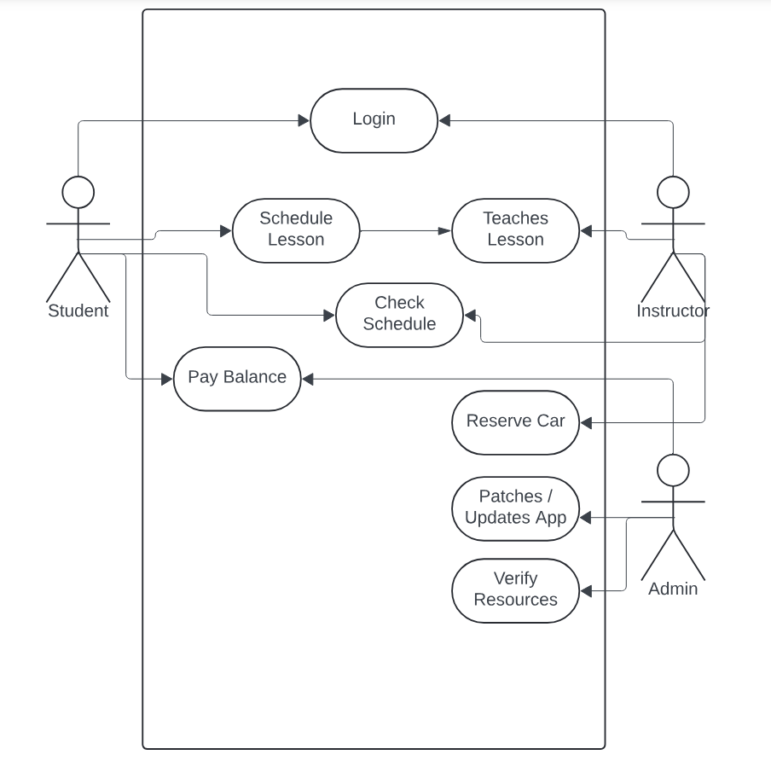

### UML Activity Diagrams

Login Activity:

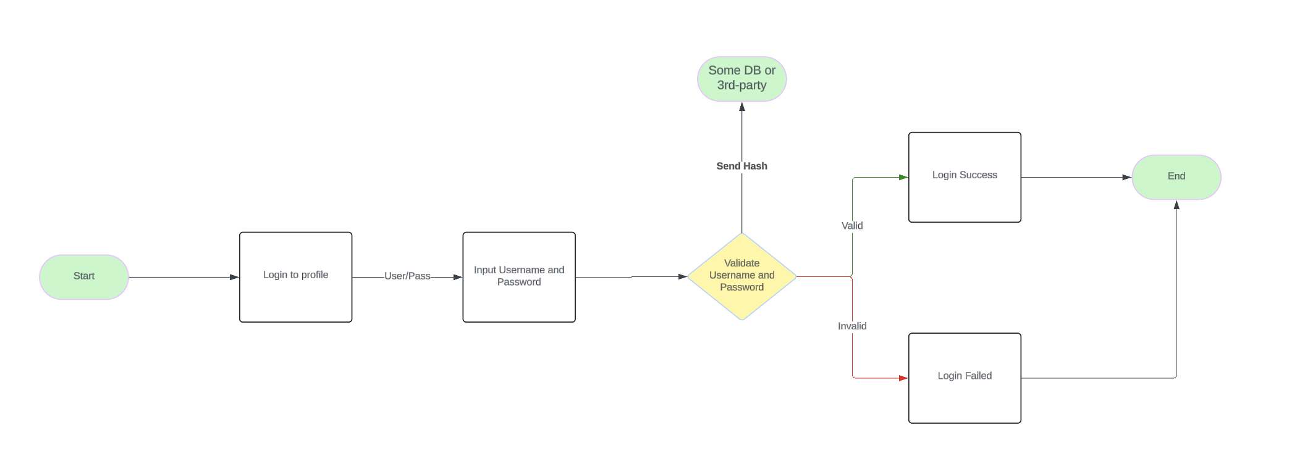

Payment Activity:

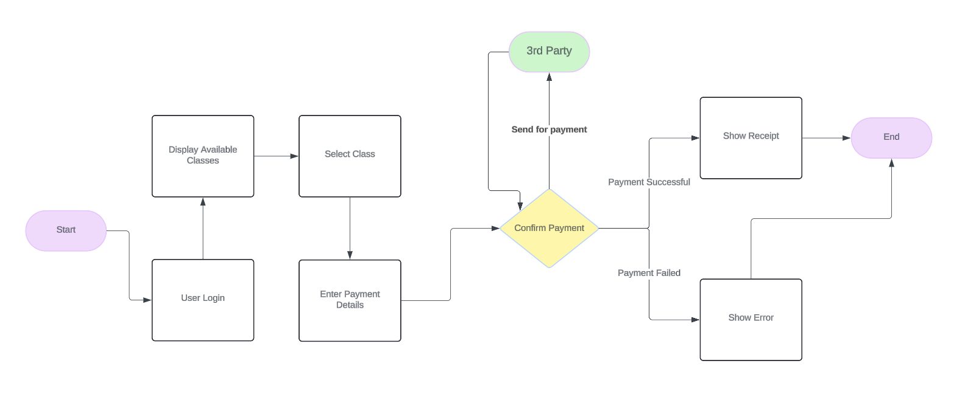

### UML Sequence Diagram

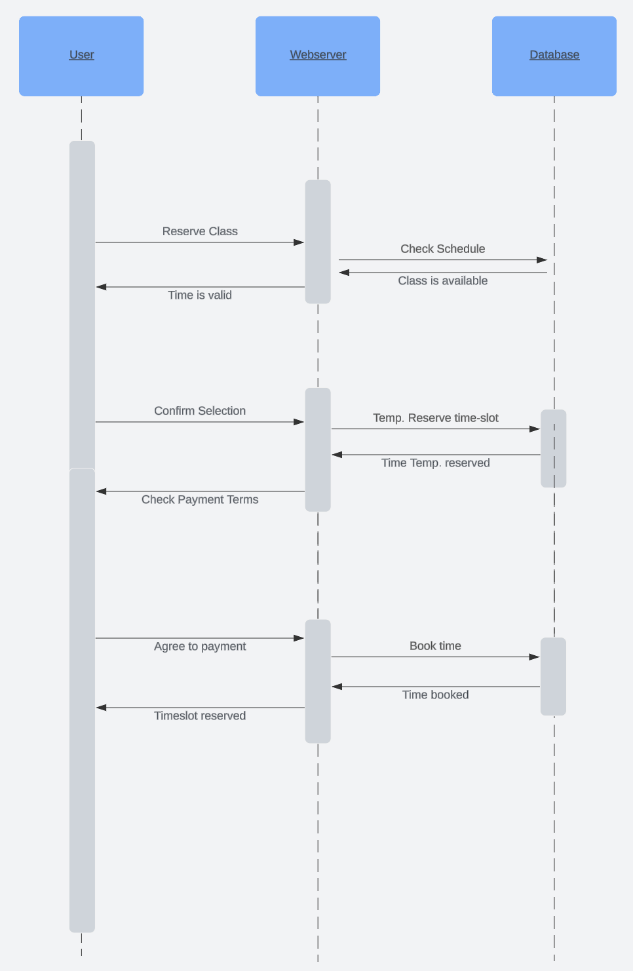

### UML Class Diagram

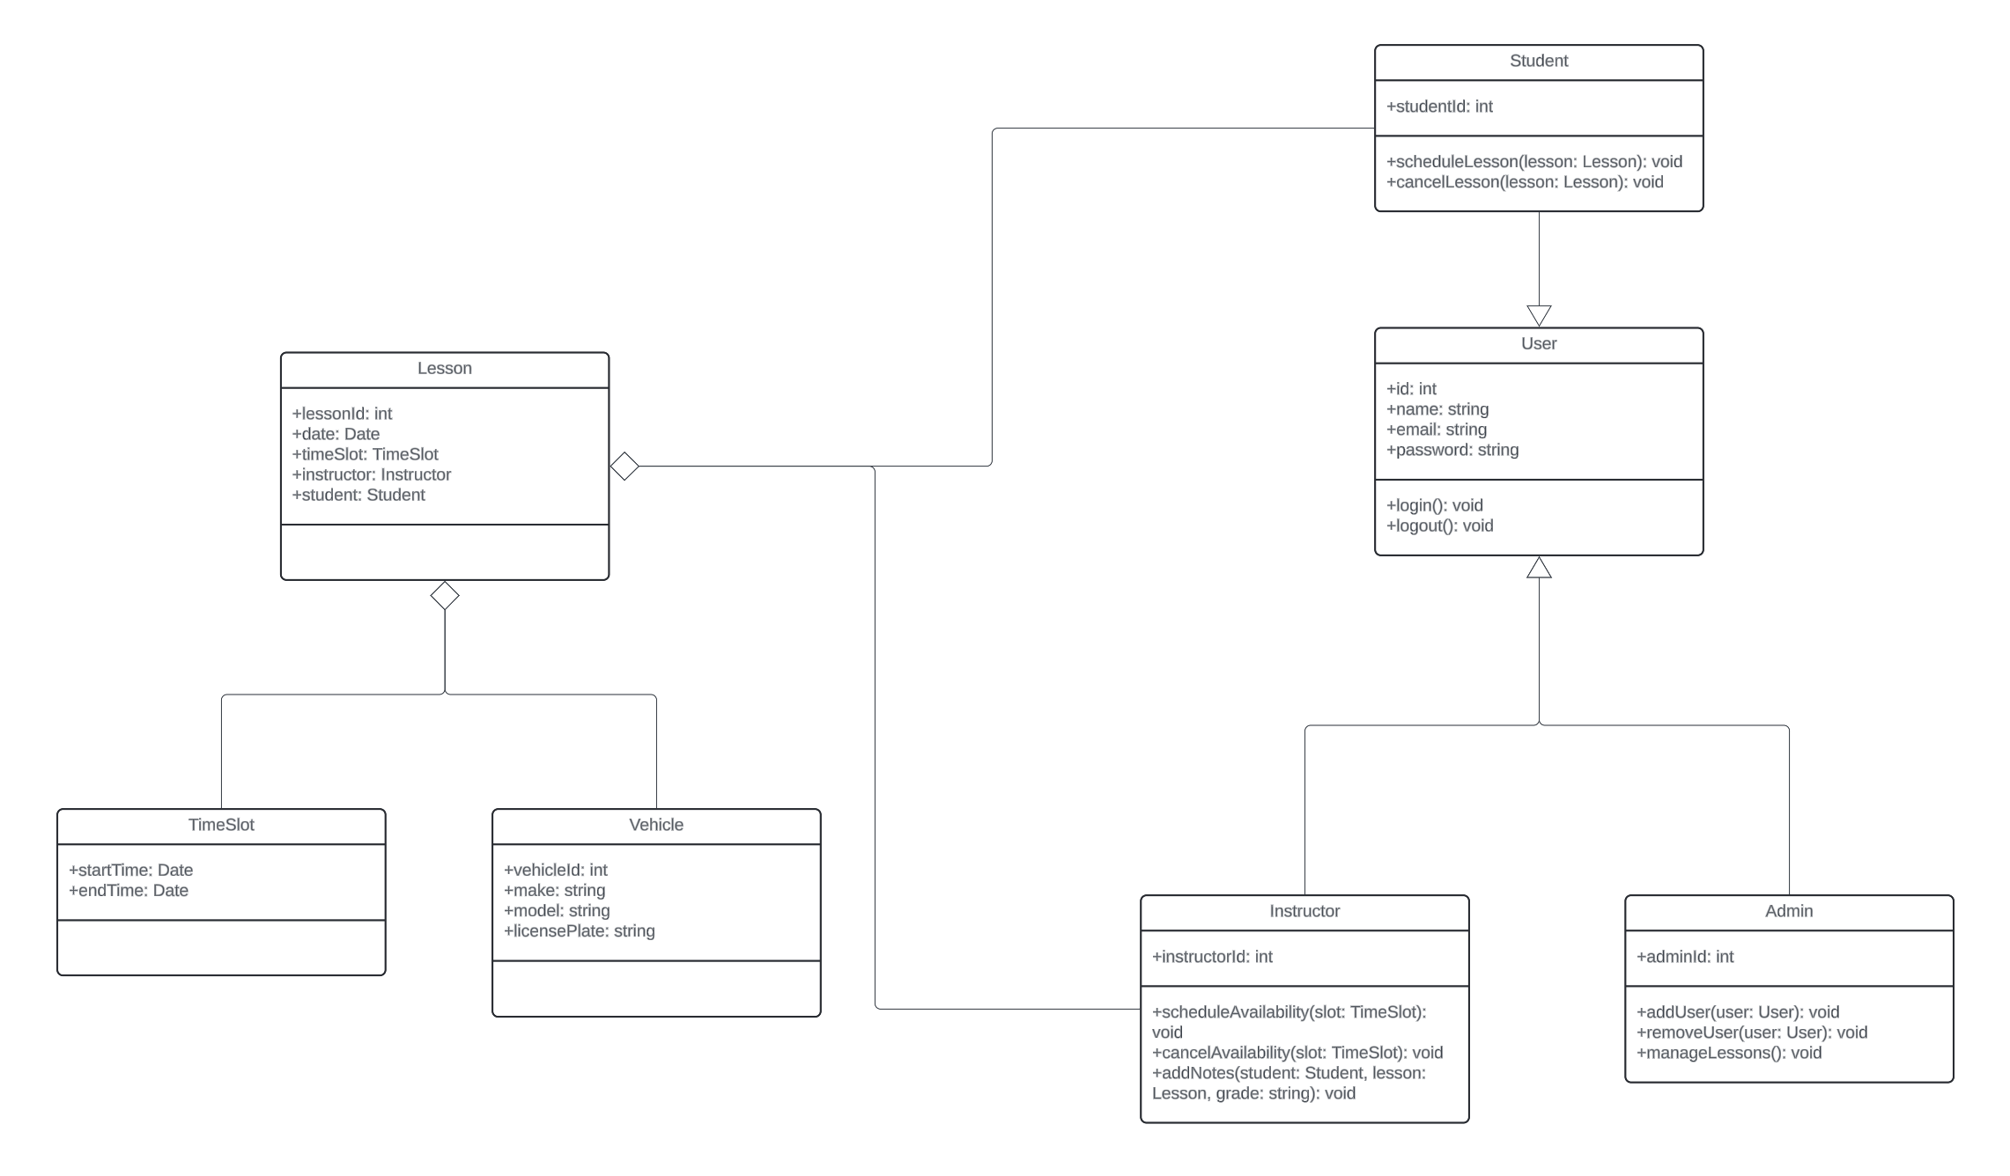

## Technical Requirements

The system required for the above specifications is minimal. We recommend running something this size in the cloud rather than hosting it on an on-prem system. By hosting it in the cloud, your infrastructure startup costs will be minimized while also providing you with availability zones for server redundancy. The systems should be a small EC2 instance or something similar running Ubuntu or an LTS build of RedHat. Apache can function as the web gateway and the backend framework can be written in Python using Django and a PostgreSQL database, both hosted in the cloud. If DBA costs is a concern, a cloud service such as Google Bigtable and the code can be adjust to NoSQL formatting.

Overall, resource costs should be relatively low for the expected volume of this site. Payment details and user account management should be offloaded to third-party services to avoid requirements for staffing an in-house SRE. Service providers such as Okta or PayPal can do this for you and the developers can simply use their robust APIs to integrate them to the finished product, lowering maintenance costs and decreasing development times.