
Quarterly Enrolment Report
Sample deliverable · Prepared 27 June 2026 · Office of Institutional Analysis

This sample Word document demonstrates the house theme applied to Office deliverables: Acadia Blue headings, Arial body text, the brand logo, an on-brand table, and charts using the Tableau Classic 10 palette.
Key takeaway
Growth was led by Pure & Applied Science, up 14% year over year.
Enrolment by faculty
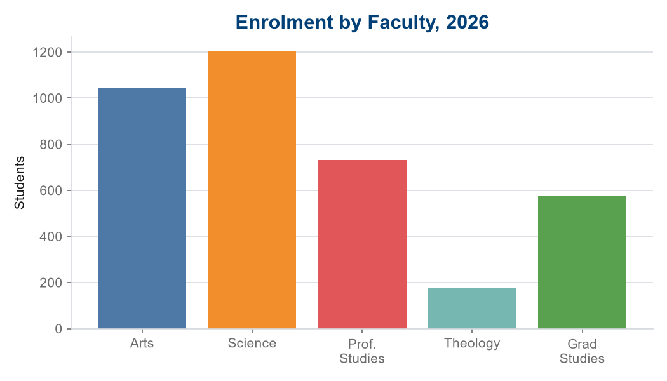
Year-over-year detail
Faculty | 2025 | 2026 | Change
Arts | 1,002 | 1,043 | +4.1%
Pure & Applied Science | 1,058 | 1,206 | +14.0%
Professional Studies | 742 | 731 | -1.5%
Theology | 168 | 174 | +3.6%
Graduate Studies | 512 | 578 | +12.9%
Enrolment trend
