Kristen Groom
Project Phase 1
CSC 555 online student
10/22/18

CSC 555: Mining Big Data
Project, Phase 1 (due Monday, October 22nd)

In this part of the project, you will 1) Set up a 3-node cluster and 2) perform data warehousing and transformation queries using Hive, Pig and Hadoop streaming.
Please be sure to submit all code and commands (pig, python, and SQL).

Part 1: Multi-node cluster

- Your first step is to setup a multi-node cluster and re-run a simple wordcount. For this part, you will create a 3-node cluster (with a total of 1 master + 2 worker nodes). Include your master node in the “slaves” file, to make sure all 3 nodes are working.
You need to perform the following steps:

You should verify that the cluster is running by pointing your browser to the link below.

http://< your public ips>:50070/

Make sure that the cluster is operational (you can see the 3 nodes under Datanodes tab).

Submit a screenshot of your cluster status view.

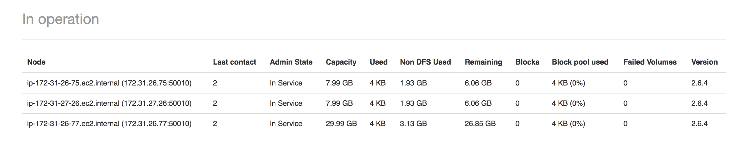

Repeat the steps for wordcount using bioproject.xml from Assignment 1 and submit screenshots of running it.

Make directory to hold the data:
hadoop fs -mkdir /data

download the file:
wget http://rasinsrv07.cstcis.cti.depaul.edu/CSC555/bioproject.xml

copy file to hdfs:
hadoop fs -put bioproject.xml /data/

check file:
hadoop fs -ls /data

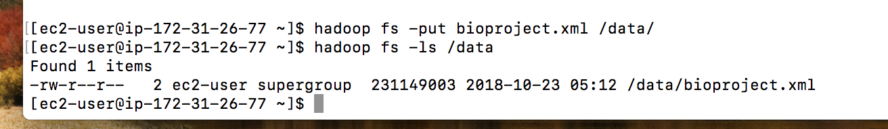

Run wordcount:
time hadoop jar hadoop-2.6.4/share/hadoop/mapreduce/hadoop-mapreduce-examples-2.6.4.jar wordcount /data/bioproject.xml /data/wordcount1

View output file:
hadoop fs -du /data/wordcount1/

Check how many occurrances of ‘subarctic’:
hadoop fs -cat /data/wordcount1/part-r-00000 | grep subarctic

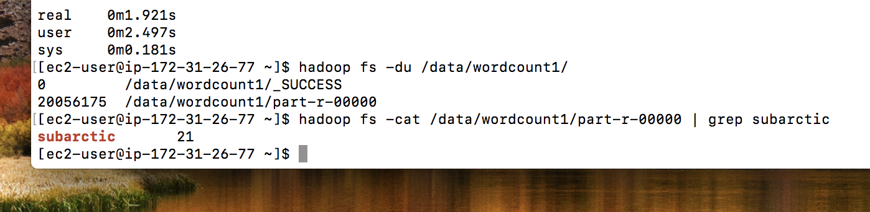

Part 2: Hive
Run the following three (1.2, 1.3 and 2.2) queries in Hive and record the time they take to execute: http://rasinsrv07.cstcis.cti.depaul.edu/CSC555/SSBM1/SSBM_queries.sql

To get the data:
wget http://rasinsrv07.cstcis.cti.depaul.edu/CSC555/SSBM1/dwdate.tbl
wget http://rasinsrv07.cstcis.cti.depaul.edu/CSC555/SSBM1/lineorder.tbl
wget http://rasinsrv07.cstcis.cti.depaul.edu/CSC555/SSBM1/part.tbl
wget http://rasinsrv07.cstcis.cti.depaul.edu/CSC555/SSBM1/supplier.tbl

dwdate schema:
create table dwdate (
d_datekey int,
d_date varchar(19),
d_dayofweek varchar(10),
d_month varchar(10),
d_year int,
d_yearmonthnum int,
d_yearmonth varchar(8),
d_daynuminweek int,
d_daynuminmonth int,
d_daynuminyear int,
d_monthnuminyear int,
d_weeknuminyear int,
d_sellingseason varchar(13),
d_lastdayinweekfl varchar(1),
d_lastdayinmonthfl varchar(1),
d_holidayfl varchar(1),
d_weekdayfl varchar(1)
)
ROW FORMAT DELIMITED FIELDS
TERMINATED BY '|' STORED AS TEXTFILE;

create table lineorder (
lo_orderkey int,
lo_linenumber int,
lo_custkey int,
lo_partkey int,
lo_suppkey int,
lo_orderdate int,
lo_orderpriority varchar(15),
lo_shippriority varchar(1),
lo_quantity int,
lo_extendedprice int,
lo_ordertotalprice int,
lo_discount int,
lo_revenue int,
lo_supplycost int,
lo_tax int,
lo_commitdate int,
lo_shipmode varchar(10)
)
ROW FORMAT DELIMITED FIELDS
TERMINATED BY '|' STORED AS TEXTFILE;

create table supplier (
s_suppkey int,
s_name varchar(25),
s_address varchar(25),
s_city varchar(10),
s_nation varchar(15),
s_region varchar(12),
s_phone varchar(15)
)
ROW FORMAT DELIMITED FIELDS
TERMINATED BY '|' STORED AS TEXTFILE;

create table part (
p_partkey int,
p_name varchar(22),
p_mfgr varchar(6),
p_category varchar(7),
p_brand1 varchar(9),
p_color varchar(11),
p_type varchar(25),
p_size int,
p_container varchar(10)
)
ROW FORMAT DELIMITED FIELDS
TERMINATED BY '|' STORED AS TEXTFILE;

Load the data:
LOAD DATA LOCAL INPATH '/home/ec2-user/dwdate.tbl'
OVERWRITE INTO TABLE dwdate;
LOAD DATA LOCAL INPATH '/home/ec2-user/lineorder.tbl'
OVERWRITE INTO TABLE lineorder;

LOAD DATA LOCAL INPATH '/home/ec2-user/supplier.tbl'
OVERWRITE INTO TABLE supplier;

LOAD DATA LOCAL INPATH '/home/ec2-user/part.tbl'
OVERWRITE INTO TABLE part;

Query 1.2 results:
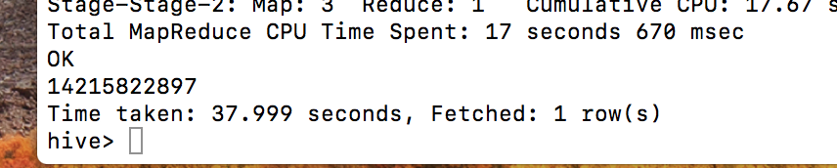
Time to perform query: 37.999 seconds

Query 1.3 results:
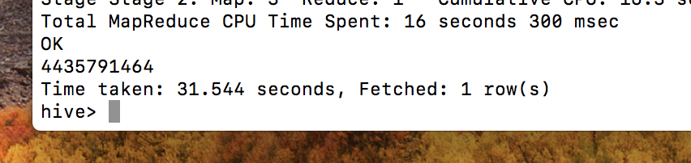
Time to perform query: 31.544 seconds

Query 2.2 results:
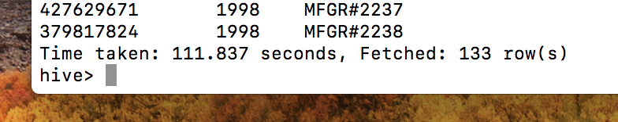
Time to perform query 111.837 seconds

Perform the following transform operation on the dwdate.tbl using python code
Keep the rest of the tables and add one new column (anywhere) that indicates the number of days from November 1st, 1994. If the date is earlier, the value should be negative (i.e., October 15th would be -17, November 10th would be 9)

Create new table to move transformed data into:
create table dwdate2 (
d_datekey int,
d_date varchar(19),
d_dayofweek varchar(10),
d_month varchar(10),
d_year int,
d_yearmonthnum int,
d_yearmonth varchar(8),
d_daynuminweek int,
d_daynuminmonth int,
d_daynuminyear int,
d_monthnuminyear int,
d_weeknuminyear int,
d_sellingseason varchar(13),
d_lastdayinweekfl varchar(1),
d_lastdayinmonthfl varchar(1),
d_holidayfl varchar(1),
d_weekdayfl varchar(1),
d_diffday int
)
ROW FORMAT DELIMITED FIELDS
TERMINATED BY '|' STORED AS TEXTFILE;

Python code:
#!/usr/bin/python
import sys, datetime

month_to_num = {'January':1, 'February':2, 'March':3, 'April':4, 'May':5, 'June':6, 'July':7,
'August':8, 'September':9, 'October':10, 'November':11, 'December':12}

compare_with = (1994, 11, 1)

for line in sys.stdin:
line = line.strip().split('\t')

date_to_transform = line[1]
dates = date_to_transform.strip().split(' ')
mon = dates[0]
mon = mon.replace('Augest', 'August')
mon = mon.replace('Octorber', 'October')
month = month_to_num[mon]
day = int(dates[1].strip(','))
year = int(dates[2])
d = datetime.date(year, month, day)
comp_year, comp_month, comp_day = compare_with
comp = datetime.date(comp_year, comp_month, comp_day)
diff = d - comp
diff = diff.days
diff = str(diff)
line_list = []
for val in line:
line_list.append(val)
line_list.append(diff)
print '\t'.join(line_list)

ADD FILE /home/ec2-user/add_diff.py;

INSERT OVERWRITE TABLE dwdate2 SELECT TRANSFORM (d_datekey, d_date, d_dayofweek, d_month, d_year, d_yearmonthnum, d_yearmonth, d_daynuminweek, d_daynuminmonth, d_daynuminyear, d_monthnuminyear, d_weeknuminyear, d_sellingseason, d_lastdayinweekfl, d_lastdayinmonthfl, d_holidayfl, d_weekdayfl) USING 'python add_diff.py' AS (d_datekey, d_date, d_dayofweek, d_month, d_year, d_yearmonthnum, d_yearmonth, d_daynuminweek, d_daynuminmonth, d_daynuminyear, d_monthnuminyear, d_weeknuminyear, d_sellingseason, d_lastdayinweekfl, d_lastdayinmonthfl, d_holidayfl, d_weekdayfl, d_diffday) FROM dwdate;

Checking table dwdate2:

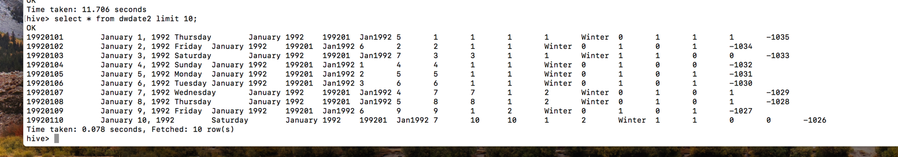

Time taken: 11.706 seconds with correct output, yay!

Part 3: Pig
Convert and load the data into Pig, implementing only queries 0.1, 0.2, 0.3.

Get lineorder.tble into hdfs:
hadoop fs -put lineorder.tbl /lineorder.tbl
download pig:
wget http://rasinsrv07.cstcis.cti.depaul.edu/CSC555/pig-0.15.0.tar.gz

compress and unzip:
gunzip pig-0.15.0.tar.gz
tar xvf pig-0.15.0.tar

load data:
lineorderData = LOAD '/data/lineorder.tbl' USING PigStorage('|')
AS (lo_orderkey:int, lo_linenumber:int, lo_custkey:int, lo_partkey:int, lo_suppkey:int, lo_orderdate:int, lo_orderpriority:chararray, lo_shippriority:chararray, lo_quantity:int, lo_extendedprice:int, lo_ordertotalprice:int, lo_discount:int, lo_revenue:int, lo_supplycost:int, lo_tax:int, lo_commitdate:int, lo_shipmode:chararray);

DESCRIBE lineorderData;

--Q0.1 Added simple test query
SELECT AVG(lo_revenue)
FROM lineorder;

lineG = GROUP lineorderData ALL;
AverageLine = FOREACH lineG GENERATE AVG(lineorderData.lo_revenue);
DUMP AverageLine;

Answer:
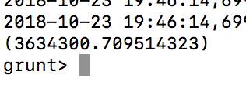
Time taken:

1 minute, 14 seconds and 116 milliseconds
--Q0.2 Added simple test query
SELECT lo_discount, COUNT(lo_extendedprice)
FROM lineorder
GROUP BY lo_discount;

Answer:
lineG = GROUP lineorderData BY lo_discount;
COUNT = FOREACH lineG GENERATE COUNT(lineorderData.lo_extendedprice);
DUMP COUNT;

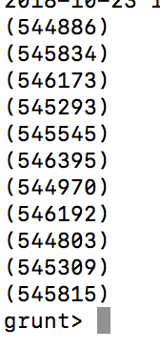

Time taken:

1 minute, 4 seconds and 127 milliseconds

--Q0.3 Added simple test query
SELECT lo_quantity, SUM(lo_revenue)
FROM lineorder
WHERE lo_discount < 3
GROUP BY lo_quantity;

Answer:

filtered_lineG = FILTER lineorderData BY lo_discount < 3;
lineG = GROUP filtered_lineG BY lo_quantity;
SUM_lo = FOREACH lineG GENERATE SUM(filtered_lineG.lo_revenue);
DUMP SUM_lo;

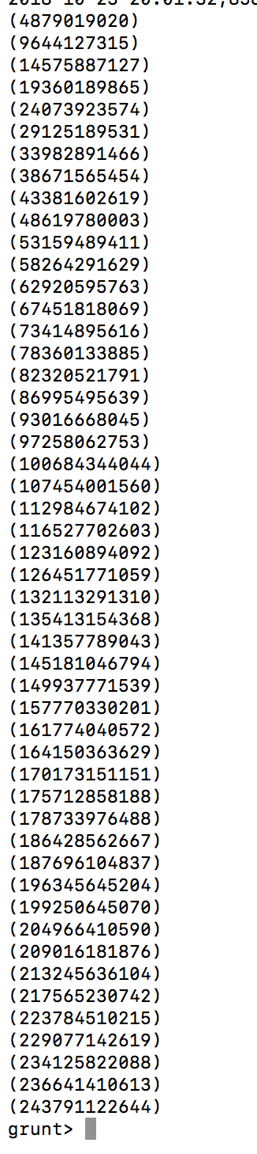
Time taken:
49 seconds and 60 ms

Check disk storage, if your disk usage is over 90% Pig may hang without an error or a warning.
One easy way to time Pig is as follows: put your sequence of pig commands into a text file and then run, from command line in pig directory (e.g., [ec2-user@ip-172-31-6-39 pig-0.15.0]$), bin/pig -f time_pig.pig (which will inform you how long the pig script took to run).

Part 4: Hadoop Streaming
Implement query 0.2 (only that query) using Hadoop streaming with python.
NOTE: You may implement this part in Java, if you prefer.

--Q0.2 Added simple test query
SELECT lo_discount, COUNT(lo_extendedprice)
FROM lineorder
GROUP BY lo_discount;

One row from lineorder =
1|1|7381|155190|828|19960102|5-LOW|0|17|2116823|17366547|4|2032150|74711|2|19960212|TRUCK|

Lineorder columns:
[0] lo_orderkey int,
[1] lo_linenumber int,
[2] lo_custkey int,
[3] lo_partkey int,
[4] lo_suppkey int,
[5] lo_orderdate int,
[6] lo_orderpriority varchar(15),
[7] lo_shippriority varchar(1),
[8] lo_quantity int,
[9] lo_extendedprice int,
[10] lo_ordertotalprice int,
[11] lo_discount int,
[12] lo_revenue int,
[13] lo_supplycost int,
[14] lo_tax int,
[15] lo_commitdate int,
[16] lo_shipmode varchar(10)

myMapper.py code:

#!/usr/bin/python
import sys, datetime

for line in sys.stdin:
line = line.strip().split('|')
discount = line[11]
ex_price = line[9]
print '{}\t{}'.format(discount, ex_price)

myReducer.py code, using same code as example from class b/c it is the same type of query:

#!/usr/bin/python
import sys

curr_id = None
curr_cnt = 0
id = None

# The input comes from standard input (line by line)
for line in sys.stdin:
line = line.strip()
# parse the line and split it by '\t'
ln = line.split('\t')
# grab the key (int)
id = int(ln[0])

if curr_id == id:
curr_cnt += 1
else:
if curr_id: # output the count, single key completed
# NOTE: Change this to '%s\t%d' if your key is a string
print '%d\t%d' % (curr_id, curr_cnt)
curr_id = id
curr_cnt = 0

# output the last key
if curr_id == id:
print '%s\t%d' % (curr_id, curr_cnt)

Copy .jar file into Hadoop directory:
find . -name "hadoop*stre*" -print
cp ./hadoop-2.6.4/share/hadoop/tools/lib/hadoop-streaming-2.6.4.jar /home/ec2-user/hadoop-2.6.4

Run the MapReduce code:
hadoop jar hadoop-streaming-2.6.4.jar -input /data/query_lineorder -output /data/output_query -mapper myMapper.py -reducer myReducer.py -file myReducer.py -file myReducer.py -file myMapper.py
Used to debug:
cat lineorder.tbl | python myMapper.py | sort | python myReducer.py

Which gave me the following output:
