Krissy Wong

BSAN 6070

4/1/2022

CA05 – Logistic Regression

Part 3: Evaluate the performance of your model (including ROC Curve), explain the performance and

draw a meaningful conclusion. (deliverable: Performance outputs in Notebook, explanation and

conclusion in Word/PDF document)

**Model Choosing**:

I chose the model with a penalty of “l2” and a C value of “0.8884981901414992”. I tested three different models by tuning the hyperparameters and adjusting the C values. The accuracy score using “l2” as the penalty and “0.8884981901414992” as the C value yielded the highest accuracy compared to the other two models. Although there is a slight increase in accuracy when the penalty and C value are adjusted for, the accuracy does not significantly differ from Models 1 and 2. Accuracy remained the same for Models 1 and 2.

Chosen Model/ Best Model

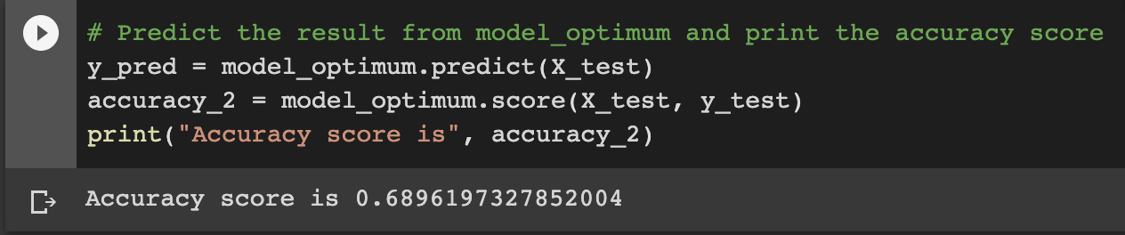

Model 1 with C = 1e40

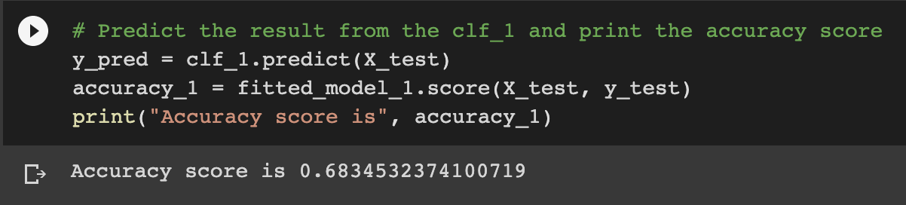

Model 2 with adjustments only penalty and not C value.

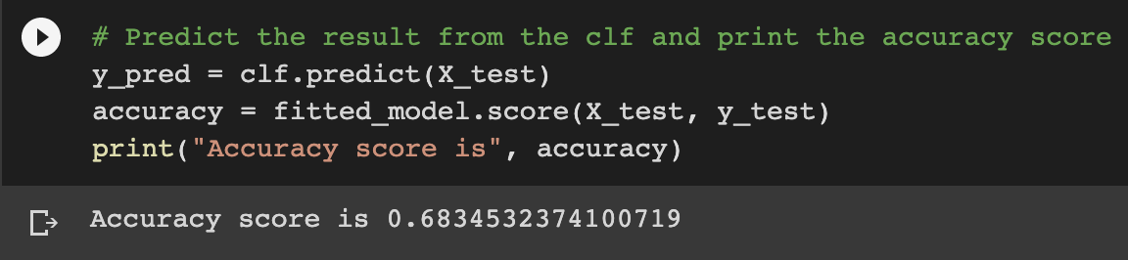

**Feature Importance**

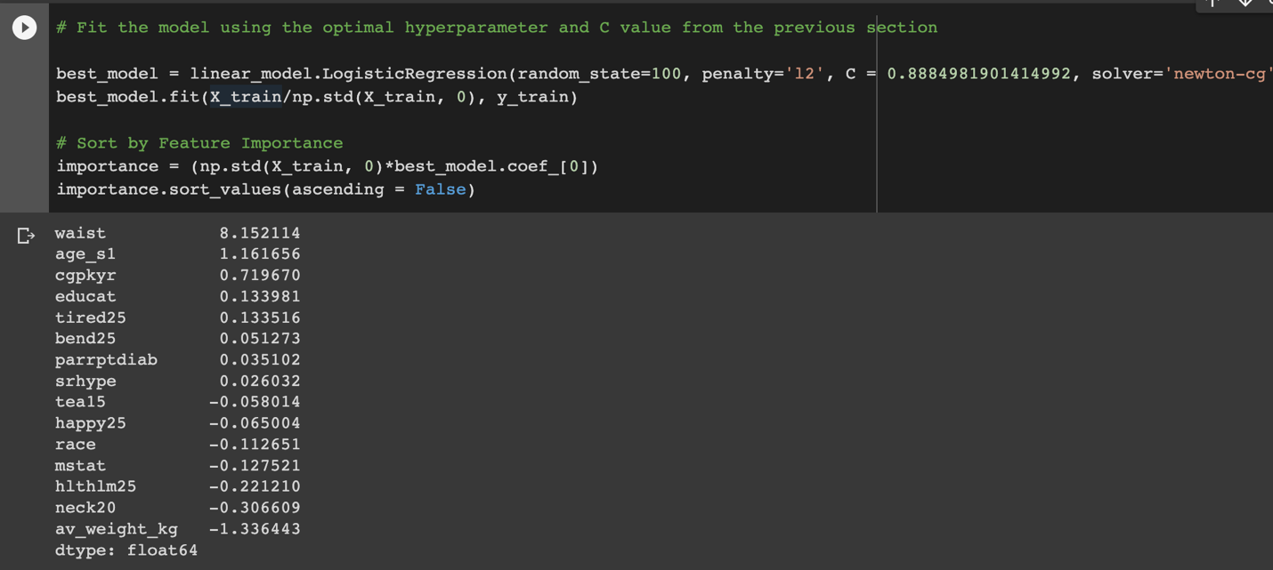

Waist seems to be the best predictor for CVD risks, followed by age_s1 and cgpkyr, which is cigarette pack-years, according to sleepdata.org.

**Model Performance**

The precision for risk (1) is lower than the precision for no risk (0) which indicates that the model has a higher chance for falsely predicting that a person has CVD. Recall is significantly higher for risk than no risk, meaning that fewer people with CVD risk would not be detected.

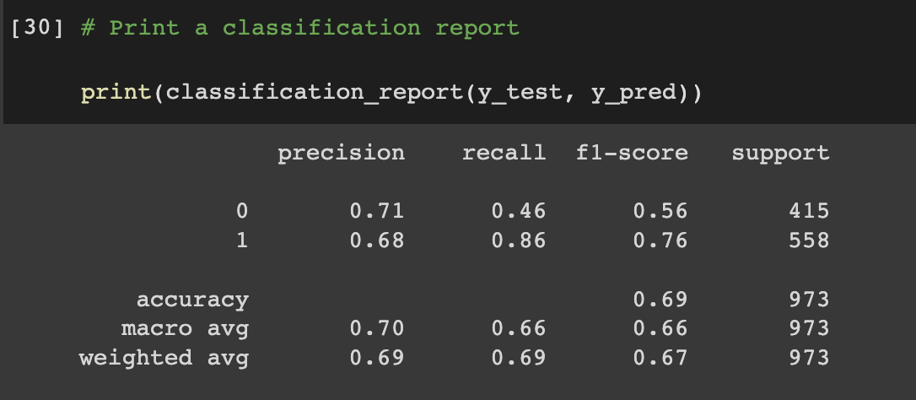

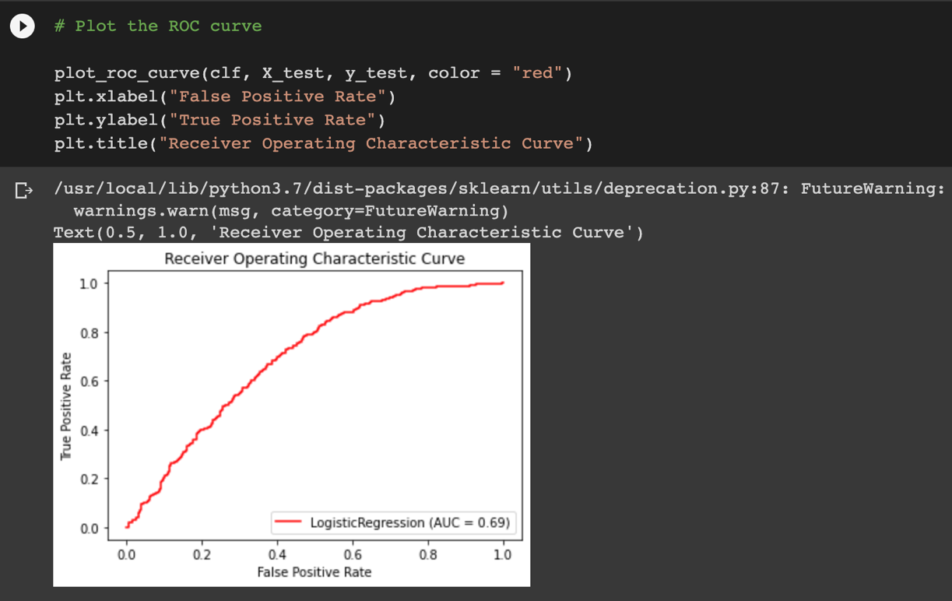

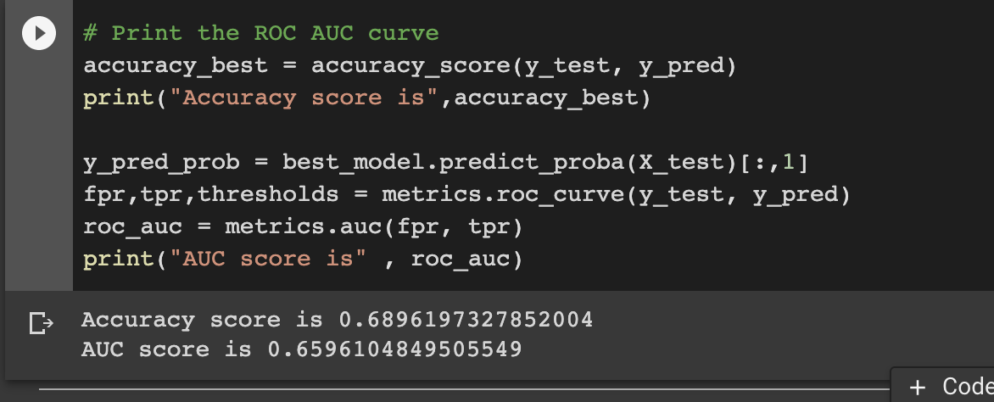

AUC and accuracy scores are 0.689 and 0.659, respectively, which are roughly in the midpoint due to the lower precision scores for risk and no risk.