SE Lab 3 Topic: Database Query Performance Profiler
Name: Krishitha Kankanala
Class: 5D
SRN: PES2UG24CS234

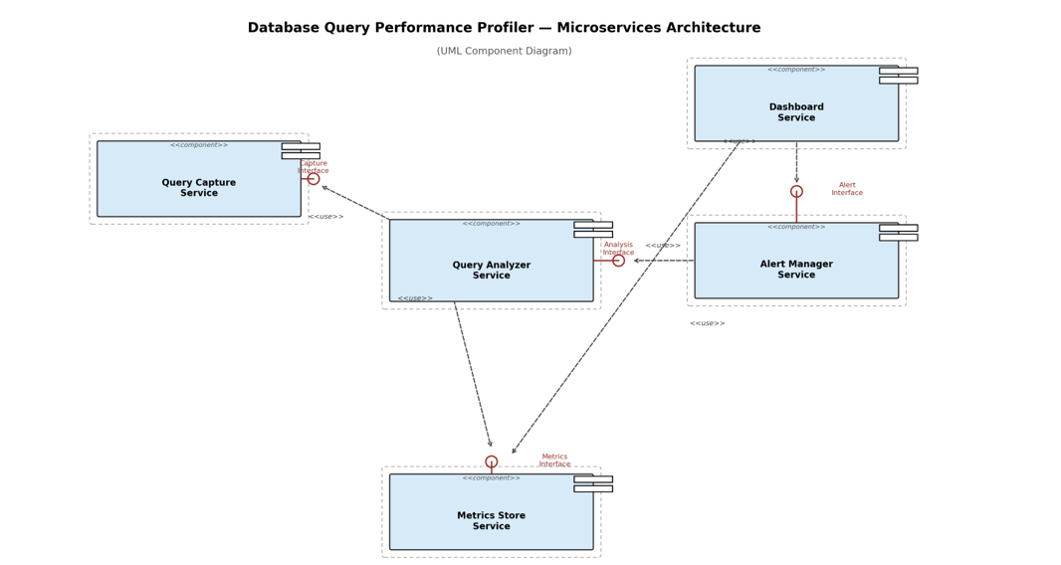

Architectural Choice (Microservices Architecture for the Database Query Performance Profiler System)
The profiler is implemented as a set of independently deployable microservices: a Query Capture Service that streams live query events from monitored databases, a Query Analyzer Service that computes execution metrics and flags anomalies, a Metrics Store Service that persists historical performance data, an Alert Manager Service that evaluates thresholds and issues notifications, and a Dashboard Service that exposes reports and visualizations. Each service owns its own data and communicates with the others only through published interfaces (Capture, Analysis, Metrics, and Alert Interfaces).
- Independent scaling for mismatched load profiles: Query capture must sustain a continuous, high-volume stream of executed queries from production databases, while the Dashboard Service handles comparatively low, bursty user traffic and the Alert Manager runs periodic threshold checks. Microservices let each of these be scaled horizontally on its own — for example, adding more Query Capture instances during peak database traffic — without over-provisioning the rest of the system, which a single monolithic Layered application could not do efficiently.
- Technology diversity and fault isolation across database engines: The profiler must support multiple database engines (e.g., MySQL, PostgreSQL), each with different capture mechanisms and drivers. Microservices allow the Query Capture Service to use engine-specific technology per instance while the Analyzer, Store, Alert, and Dashboard services remain unchanged. It also means a capture agent crashing or lagging for one database engine does not take down alerting, storage, or the dashboard, unlike a tightly coupled Layered or Client-Server design where a single failure can cascade.

Security Advantage
Because each microservice is a separate deployment unit with its own credentials, only the Query Capture Service needs direct network access and login credentials to the monitored production databases; the Analyzer, Metrics Store, Alert Manager, and Dashboard never touch those credentials and only exchange already-sanitized metrics through internal service interfaces. This least-privilege separation limits the blast radius if any one service — particularly the public-facing Dashboard Service — is compromised, since an attacker there would have no path to the underlying production databases.

Performance Benefit
Decoupling ingestion from analysis and presentation lets the Query Capture and Query Analyzer services be scaled out independently to absorb spikes in query volume, while the Metrics Store Service can use a datastore optimized for high-throughput writes without those write bursts slowing down the read-heavy queries the Dashboard Service issues for reports and trend charts. Because each service also owns its own datastore, the historical-data queries needed for reporting never contend for the same resources as live query capture, keeping both ingestion and the dashboard responsive under load.

