Text-Based Game Storyboard (Python)

An alien has infiltrated the spacecraft returning to planet Earth. You need to defeat the alien before arriving to Earth and unleashing the alien upon the planet, but before you fight the alien you will need a few items. You will need a weapon from the armory to defend yourself, a tranquilizer from the medical ward to attempt to subdue the alien before harming it, a tasty snack from the pantry to use as bait, a security guard from the officers’ quarters to help you fight the alien, the keys to an escape pod from the command room as a last resort, and a cocktail from the space lounge for courage.

Here is a map of the spacecraft rooms and items to help navigate your undertaking:

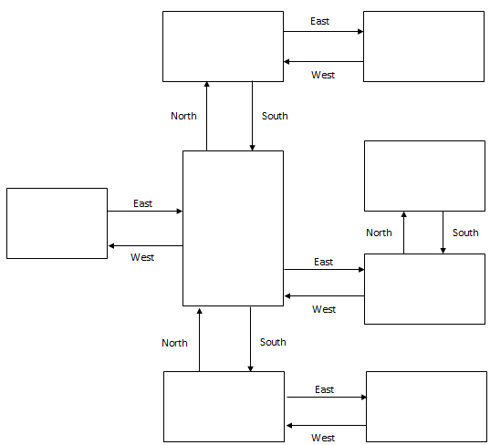

## Pseudocode or Flowchart for Code to “Move Between Rooms”:

## Pseudocode or Flowchart for Code to “Get an Item”:

