Globalization and Climate Change: Food Trade

Krista Waugh and Andrew Lind

11/24/2018

library(readr)  
library(ggplot2)  
library(dplyr)

 #Introduction and Explanation Climate change….. In this report, we will examine the effects globalization in relation to food on the climate. Taking inspiration from this cute image of the “Berkeley Food Pyramid”, found in Peet’s Coffee on 4th street, we will examine what it means for cities worldwide to adopt foreign foods as their own. In this example, we can see some products like wine, cheese, and produce, especially garlic, are produced in California and not shipped very far to come to Berkeley. However, other items like coffee and chocolate have to be shipped from countries mainly in the global south, like Colombia, Ethiopia, Vietnam, and Brazil. Cheap, widely available oil makes it easier to ship all goods, including food, all over the world, rather than engage in locally grown and produced goods. However, the convenience comes at a cost to the environment. We are going to examine the trends in US food imports, alongside trends in carbon emissions. While there are many contributing factors to climate change and it cannot be attributed to importing and exporting food alone, this analysis will hopefully highlight the global interconnectedness in all facets of trade and the way the current world economy drives climate change. The foods we studied were selected to mirror the “Berkeley Food Pyramid” shown above, to depict this trend in a way that challenges the idea that coffee and chocolate are part of Berkeley’s food culture, and to demonstrate that cities worldwide are accustomed to making certain foods part of their culture without mind to the damage to the environment that this practice causes. ###Information about the US Food Import Dataset, from the data.gov website U.S. consumers demand variety, quality, and convenience in the foods they consume. As Americans have become wealthier and more ethnically diverse, the American food basket reflects a growing share of tropical products, spices, and imported gourmet products. Seasonal and climatic factors drive U.S. imports of popular types of fruits and vegetables and tropical products, such as cocoa and coffee. In addition, a growing share of U.S. imports can be attributed to intra-industry trade, whereby agricultural-processing industries based in the United States carry out certain processing steps offshore and import products at different levels of processing from their subsidiaries in foreign markets.

This data set provides import values of edible products (food and beverages) entering U.S. ports and their origin of shipment. Data are from the U.S. Department of Commerce, U.S. Census Bureau. Food and beverage import values are compiled by calendar year into food groups corresponding to major commodities or level of processing. At least 10 years of annual data are included, enabling users to track long-term growth patterns.

Volume of food is represented in units of 1000 metric tons

berkeley_pyramid_imports <- read_csv("Berkeley_Pyramid_Imports.csv")  
berkeley_pyramid_imports

## # A tibble: 7 x 20  
## X1 `1999` `2000` `2001` `2002` `2003` `2004` `2005` `2006` `2007`  
## <chr> <dbl> <dbl> <dbl> <dbl> <dbl> <dbl> <dbl> <dbl> <dbl>  
## 1 Coff… 3604. 3442. 2401. 2455. 2872. 3144. 3771. 4195. 4791.  
## 2 Vege… 3632. 3771. 4157. 4391. 5082. 5730. 6043. 6619. 7256.  
## 3 Fruit 4764. 4629. 4665. 5068. 5558. 5962. 6874. 7707. 9217.  
## 4 Coco… 1522. 1404. 1536. 1761. 2439. 2484. 2751. 2659. 2662.  
## 5 Chee… 705. 685. 746. 788. 882. 982. 1007. 1029. 1107.  
## 6 Wine 2169. 2186. 2227. 2646. 3240. 3382. 3722. 4112. 4591.  
## 7 Wheat 421. 382. 435. 463. 349. 443. 418. 581. 849.  
## # ... with 10 more variables: `2008` <dbl>, `2009` <dbl>, `2010` <dbl>,  
## # `2011` <dbl>, `2012` <dbl>, `2013` <dbl>, `2014` <dbl>, `2015` <dbl>,  
## # `2016` <dbl>, `2017` <dbl>

product_imports <- read_csv("product_imports.csv")  
product_imports

## # A tibble: 133 x 3  
## Year Product Quantity  
## <int> <chr> <dbl>  
## 1 1999 Coffe & tea & spices 3604.  
## 2 2000 Coffe & tea & spices 3442.  
## 3 2001 Coffe & tea & spices 2401.  
## 4 2002 Coffe & tea & spices 2455.  
## 5 2003 Coffe & tea & spices 2872.  
## 6 2004 Coffe & tea & spices 3144.  
## 7 2005 Coffe & tea & spices 3771.  
## 8 2006 Coffe & tea & spices 4195.  
## 9 2007 Coffe & tea & spices 4791.  
## 10 2008 Coffe & tea & spices 5581.  
## # ... with 123 more rows

cheese <- filter(product_imports, Product == "Cheese")  
cheese

## # A tibble: 19 x 3  
## Year Product Quantity  
## <int> <chr> <dbl>  
## 1 1999 Cheese 705.  
## 2 2000 Cheese 685.  
## 3 2001 Cheese 746.  
## 4 2002 Cheese 788.  
## 5 2003 Cheese 882.  
## 6 2004 Cheese 982.  
## 7 2005 Cheese 1007.  
## 8 2006 Cheese 1029.  
## 9 2007 Cheese 1107.  
## 10 2008 Cheese 1168.  
## 11 2009 Cheese 1004.  
## 12 2010 Cheese 967.  
## 13 2011 Cheese 1073.  
## 14 2012 Cheese 1093.  
## 15 2013 Cheese 1145.  
## 16 2014 Cheese 1275.  
## 17 2015 Cheese 1291.  
## 18 2016 Cheese 1263.  
## 19 2017 Cheese 1179.

vegetables <- filter(product_imports, Product == "Vegetables")  
vegetables

## # A tibble: 19 x 3  
## Year Product Quantity  
## <int> <chr> <dbl>  
## 1 1999 Vegetables 3632.  
## 2 2000 Vegetables 3771.  
## 3 2001 Vegetables 4157.  
## 4 2002 Vegetables 4391.  
## 5 2003 Vegetables 5082.  
## 6 2004 Vegetables 5730.  
## 7 2005 Vegetables 6043.  
## 8 2006 Vegetables 6619.  
## 9 2007 Vegetables 7256.  
## 10 2008 Vegetables 7801.  
## 11 2009 Vegetables 7525.  
## 12 2010 Vegetables 8706.  
## 13 2011 Vegetables 9667.  
## 14 2012 Vegetables 9946.  
## 15 2013 Vegetables 10734.  
## 16 2014 Vegetables 10930.  
## 17 2015 Vegetables 11290.  
## 18 2016 Vegetables 12469.  
## 19 2017 Vegetables 12743.

wine <- filter(product_imports, Product == "Wine")  
wine

## # A tibble: 19 x 3  
## Year Product Quantity  
## <int> <chr> <dbl>  
## 1 1999 Wine 2169.  
## 2 2000 Wine 2186.  
## 3 2001 Wine 2227.  
## 4 2002 Wine 2646.  
## 5 2003 Wine 3240.  
## 6 2004 Wine 3382.  
## 7 2005 Wine 3722.  
## 8 2006 Wine 4112.  
## 9 2007 Wine 4591.  
## 10 2008 Wine 4580.  
## 11 2009 Wine 3972.  
## 12 2010 Wine 4223.  
## 13 2011 Wine 4793.  
## 14 2012 Wine 5040.  
## 15 2013 Wine 5227.  
## 16 2014 Wine 5341.  
## 17 2015 Wine 5385.  
## 18 2016 Wine 5549.  
## 19 2017 Wine 5924.

fruit <- filter(product_imports, Product == "Fruit")  
fruit

## # A tibble: 19 x 3  
## Year Product Quantity  
## <int> <chr> <dbl>  
## 1 1999 Fruit 4764.  
## 2 2000 Fruit 4629.  
## 3 2001 Fruit 4665.  
## 4 2002 Fruit 5068.  
## 5 2003 Fruit 5558.  
## 6 2004 Fruit 5962.  
## 7 2005 Fruit 6874.  
## 8 2006 Fruit 7707.  
## 9 2007 Fruit 9217.  
## 10 2008 Fruit 9888.  
## 11 2009 Fruit 9640.  
## 12 2010 Fruit 10649.  
## 13 2011 Fruit 11974.  
## 14 2012 Fruit 12538.  
## 15 2013 Fruit 13602.  
## 16 2014 Fruit 14808.  
## 17 2015 Fruit 15955.  
## 18 2016 Fruit 17157.  
## 19 2017 Fruit 18383.

cocoa <- filter(product_imports, Product == "Cocoa & chocolate")  
cocoa

## # A tibble: 19 x 3  
## Year Product Quantity  
## <int> <chr> <dbl>  
## 1 1999 Cocoa & chocolate 1522.  
## 2 2000 Cocoa & chocolate 1404.  
## 3 2001 Cocoa & chocolate 1536.  
## 4 2002 Cocoa & chocolate 1761.  
## 5 2003 Cocoa & chocolate 2439.  
## 6 2004 Cocoa & chocolate 2484.  
## 7 2005 Cocoa & chocolate 2751.  
## 8 2006 Cocoa & chocolate 2659.  
## 9 2007 Cocoa & chocolate 2662.  
## 10 2008 Cocoa & chocolate 3299.  
## 11 2009 Cocoa & chocolate 3476.  
## 12 2010 Cocoa & chocolate 4295.  
## 13 2011 Cocoa & chocolate 4681.  
## 14 2012 Cocoa & chocolate 4096.  
## 15 2013 Cocoa & chocolate 4159.  
## 16 2014 Cocoa & chocolate 4728.  
## 17 2015 Cocoa & chocolate 4860.  
## 18 2016 Cocoa & chocolate 5081.  
## 19 2017 Cocoa & chocolate 5007.

wheat <- filter(product_imports, Product == "Wheat")  
wheat

## # A tibble: 19 x 3  
## Year Product Quantity  
## <int> <chr> <dbl>  
## 1 1999 Wheat 421.  
## 2 2000 Wheat 382.  
## 3 2001 Wheat 435.  
## 4 2002 Wheat 463.  
## 5 2003 Wheat 349.  
## 6 2004 Wheat 443.  
## 7 2005 Wheat 418.  
## 8 2006 Wheat 581.  
## 9 2007 Wheat 849.  
## 10 2008 Wheat 1619.  
## 11 2009 Wheat 1168.  
## 12 2010 Wheat 1081.  
## 13 2011 Wheat 1165.  
## 14 2012 Wheat 1307.  
## 15 2013 Wheat 1664.  
## 16 2014 Wheat 1669.  
## 17 2015 Wheat 1361.  
## 18 2016 Wheat 1135.  
## 19 2017 Wheat 1370.

coffee <- filter(product_imports, Product == "Coffe & tea & spices")  
coffee

## # A tibble: 19 x 3  
## Year Product Quantity  
## <int> <chr> <dbl>  
## 1 1999 Coffe & tea & spices 3604.  
## 2 2000 Coffe & tea & spices 3442.  
## 3 2001 Coffe & tea & spices 2401.  
## 4 2002 Coffe & tea & spices 2455.  
## 5 2003 Coffe & tea & spices 2872.  
## 6 2004 Coffe & tea & spices 3144.  
## 7 2005 Coffe & tea & spices 3771.  
## 8 2006 Coffe & tea & spices 4195.  
## 9 2007 Coffe & tea & spices 4791.  
## 10 2008 Coffe & tea & spices 5581.  
## 11 2009 Coffe & tea & spices 5160.  
## 12 2010 Coffe & tea & spices 6265.  
## 13 2011 Coffe & tea & spices 9716.  
## 14 2012 Coffe & tea & spices 8726.  
## 15 2013 Coffe & tea & spices 7633.  
## 16 2014 Coffe & tea & spices 8299.  
## 17 2015 Coffe & tea & spices 8536.  
## 18 2016 Coffe & tea & spices 8311.  
## 19 2017 Coffe & tea & spices 9069.

ggplot(cheese, aes(Year, Quantity)) +geom_line()

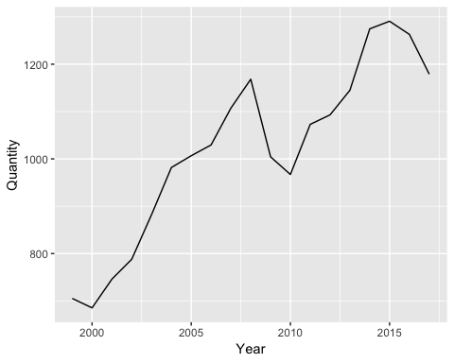

ggplot(wine, aes(Year, Quantity)) +geom_line()

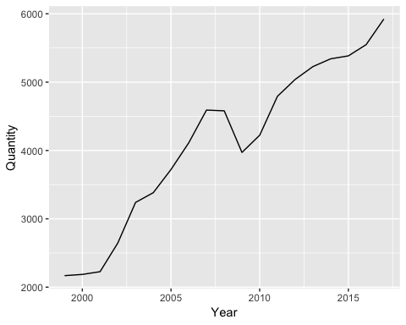

ggplot(vegetables, aes(Year, Quantity)) +geom_line()

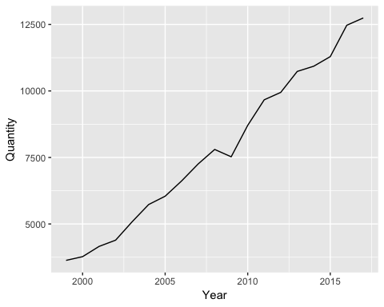

ggplot(fruit, aes(Year, Quantity)) +geom_line()

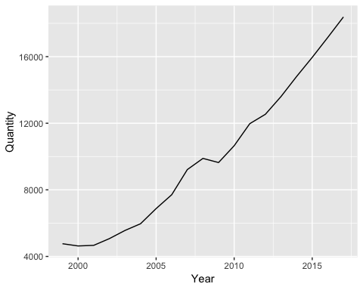

ggplot(coffee, aes(Year, Quantity)) +geom_line()

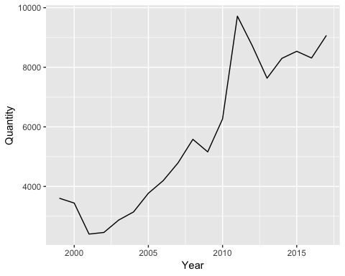

ggplot(wheat, aes(Year, Quantity)) +geom_line()

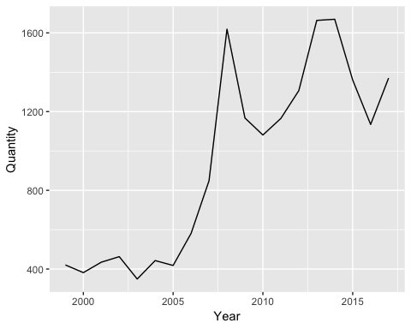

food_graph <-   
 ggplot( , aes(x = Year)) +  
 geom_line(data = cheese, aes(y = Quantity, color = "cheese")) +  
 geom_line(data = wine, aes(y = Quantity, color = "wine")) +  
 geom_line(data = vegetables, aes(y = Quantity, color = "vegetables")) +  
 geom_line(data = fruit, aes(y = Quantity, color = "fruit")) +  
 geom_line(data = coffee, aes(y = Quantity, color = "coffee")) +  
 geom_line(data = cocoa, aes(y = Quantity, color = "cocoa")) +  
 geom_line(data = wheat, aes(y = Quantity, color = "wheat")) +  
 scale_color_manual("",  
 breaks = c("cheese", "wine", "vegetables", "fruit", "coffee", "cocoa", "wheat"),  
 values = c("gold", "tan4", "black", "tomato", "forestgreen", "navajowhite", "maroon")) +  
 theme_classic() +  
 labs(x = "Year", y = "Quantity: units 1000 metric tons")  
food_graph

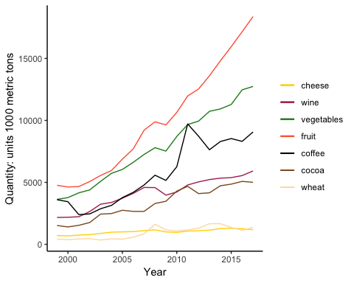

*CO2 DATA* Column “quantity” represents average quantity of carbon dioxide measured in the air, in units ppm.

co2 <-  
readr::read_table("ftp://aftp.cmdl.noaa.gov/products/trends/co2/co2_mm_mlo.txt",  
 comment = "#",  
 col_names = c("year", "month", "decimal_date", "average",  
 "interpolated", "trend", "days"),  
 na = c("-1", "-99.99"))  
  
co2

## # A tibble: 728 x 7  
## year month decimal_date average interpolated trend days  
## <int> <int> <dbl> <dbl> <dbl> <dbl> <int>  
## 1 1958 3 1958. 316. 316. 315. NA  
## 2 1958 4 1958. 317. 317. 315. NA  
## 3 1958 5 1958. 318. 318. 315. NA  
## 4 1958 6 1958. NA 317. 315. NA  
## 5 1958 7 1959. 316. 316. 315. NA  
## 6 1958 8 1959. 315. 315. 316. NA  
## 7 1958 9 1959. 313. 313. 316. NA  
## 8 1958 10 1959. NA 313. 316. NA  
## 9 1958 11 1959. 313. 313. 315. NA  
## 10 1958 12 1959. 315. 315. 316. NA  
## # ... with 718 more rows

berkeley_co2 <- filter(co2, year >= "1999", year <= "2017")  
berkeley_co2

## # A tibble: 228 x 7  
## year month decimal_date average interpolated trend days  
## <int> <int> <dbl> <dbl> <dbl> <dbl> <int>  
## 1 1999 1 1999. 368. 368. 368. 27  
## 2 1999 2 1999. 369. 369. 368. 22  
## 3 1999 3 1999. 370. 370. 368. 25  
## 4 1999 4 1999. 371. 371. 368. 29  
## 5 1999 5 1999. 371. 371. 368. 26  
## 6 1999 6 1999. 370. 370. 368. 26  
## 7 1999 7 2000. 369. 369. 369. 27  
## 8 1999 8 2000. 367. 367. 368. 25  
## 9 1999 9 2000. 365. 365. 368. 28  
## 10 1999 10 2000. 365. 365. 369. 31  
## # ... with 218 more rows

co2_plot <-  
ggplot(berkeley_co2, aes(x = year, y = average)) + geom_smooth() +  
 labs( x = "Year", y = "Average Annual Co2: units ppm") + ylim(300,450)   
co2_plot

## `geom_smooth()` using method = 'loess' and formula 'y ~ x'

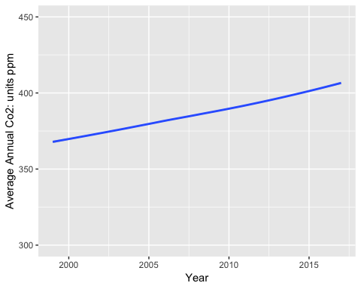

simple_co2 <- berkeley_co2 %>%  
 select(year, average)  
simple_co2

## # A tibble: 228 x 2  
## year average  
## <int> <dbl>  
## 1 1999 368.  
## 2 1999 369.  
## 3 1999 370.  
## 4 1999 371.  
## 5 1999 371.  
## 6 1999 370.  
## 7 1999 369.  
## 8 1999 367.  
## 9 1999 365.  
## 10 1999 365.  
## # ... with 218 more rows

simple_co2_plot <-   
 ggplot(simple_co2, aes(x = year, y = average)) + geom_smooth() +  
 labs( x = "Year", y = "Average Annual Co2: units ppm") + ylim(300,450)   
simple_co2_plot

## `geom_smooth()` using method = 'loess' and formula 'y ~ x'



#plot_grid(food_graph, co2_plot, labels=c("Annual U.S. Food Imports", "Atmospheric Co2 Levels"))