Part 4 Project Logbook

Project #43: Reconfigurable Neural Processing Unit (NPU) for Energy-Efficient AI at the Edge
Kristelle Sampang

ksam836@aucklanduni.ac.nz

ID: 463680577

Table of Contents
Week 1 4
03/03/25 – 09/03/25: 4
Thursday 6th March 2025 4
Time: 2PM 4
Week 2 5
10/03/25 – 16/03/25: 5
Tuesday 11th March 2025 5
Time: All Day 5
Wednesday 12th March 2025 5
Time: 11PM 5
Week 3 7
17/03/25 – 23/03/25: 7
Tuesday 18th March 2025 – Wednesday 19th Match 2025 7
Time: All Day 7
Thursday 20th March 2025 10
Time: 4pm-6pm 10
Week 4 12
24/03/25 – 30/03/25: 12
Monday 24th March 2025 12
Time: 1PM 12
Week 5 13
31/03/25 – 06/04/25: 13
Monday 31st March – Tuesday 1st April 13
Time: All Day 13
Week 8 14
05/05/25 – 11/05/25: 14
Wednesday 7th May 14
Time: All Day 14
Week 9 15
12/05/25 – 18/05/25: 15
Tuesday 13th May – Wednesday 14th May 15
Time: All Day 15
Week 10 18
19/05/25 – 25/05/25: 18
Wednesday 21st May – Thursday 22nd May 18
Time: All Day 18
INTER-SEMESTER BREAK 20
11/07/25 – 20/07/25: 20
Friday 11th July 2025 – Saturday 12th July 20
Time: All Day 20
Monday 14th July 2025 22
Time: All Day 22
Tuesday 15th July 2025 23
Time: All Day 23
Wednesday 16th July 2025 29
Time: All Day 29
Semester 2 Week 1 32
21/07/25 – 27/07/25: 32
Monday 21st July – Wednesday 23rd July 2025 32
Time: All Day 32
Week 3 35
04/08/25 – 10/08/25: 35
Monday 4th August 2025 35
Time: All DAY 35
Week 5 36
18/08/25 – 24/08/25: 36
Monday 18th August 2025 36
Time: All Day 36
MID-SEMESTER 37
01/09/25 – 14/09/25: 37
Friday 12th September 2025 37
Time: All Day 37
Week 7 38
15/09/25 – 21/09/25 38
Thursday 18th September 2025 38
Time: All Day 38
Week 8 39
22/09/25 – 28/09/25: 39
Monday 22nd September 2025 39
Time: All Day 39
Wednesday 24th September 2025 42
Time: All Day 42
Thursday 25th September 2025 43
Time: All Day 43
Friday 26th September 2025 43
Time: 1PM 43
Saturday 27th September 2025 44
Time: All Day 44
Complete To-Do list above 44
Week 9 45
29/09/25 – 05/10/25: 45
Monday 29th September 2025 45
Time: 4PM 45
Week 10 46
06/10/25 – 12/10/25: 46
Monday 6th September 2025 46
Time: 2PM 46
Wednesday 8th September 2025 47
Time: ALL DAY 47
Thursday 9th September 2025 47
Time: ALL DAY 47
Saturday 11th to Sunday 12th October 49
Time: All Day 49
Week X 51
XX/XX/25 – XX/XX/25: 51
XX X XXX 2025 51
Time: XX 51
XX X XXX 2025 51
Time: XX 51

Week 1 | 03/03/25 – 09/03/25:
Thursday 6th March 2025 | Time: 2PM
Initial Meeting with Supervisors
Objective: Meet with the supervisors to set weekly meetings and get advice on how to start the research project.
- Set weekly meetings to every Thursday 11.15pm for the first half of Semester One.
- Aim to implement NPU onto an FPGA.
- Gaining sufficient background knowledge will make implementation easier. Literature Review will help with this.
- Utilise UoA library for academic papers, can also find some online but start off with UoA library.
- Attempt to find academic papers individually. Read the abstract and table of contents to check its relevance to the project. Check the paper’s sources too for further explanation.
- Make sure to backup the work one – could use online sources like Git but Morteza suggests a physical hard drive.

Week 2 | 10/03/25 – 16/03/25:
Tuesday 11th March 2025 | Time: All Day
Management System
Objective: Create a management system for P4P and start reading the information on Canva
- Created a Sharepoint website through Teams and shared with supervisors.
- Set up a Discord server for communication.
- Created a GitHub repository to backup code files.
- Read the P4P handbook for more context.
- Started to go through ‘Finding Information’ under Literature Review
Wednesday 12th March 2025 | Time: 11PM
Finding relevant papers
Objective: Start to look for academic papers that are relevant to project
- 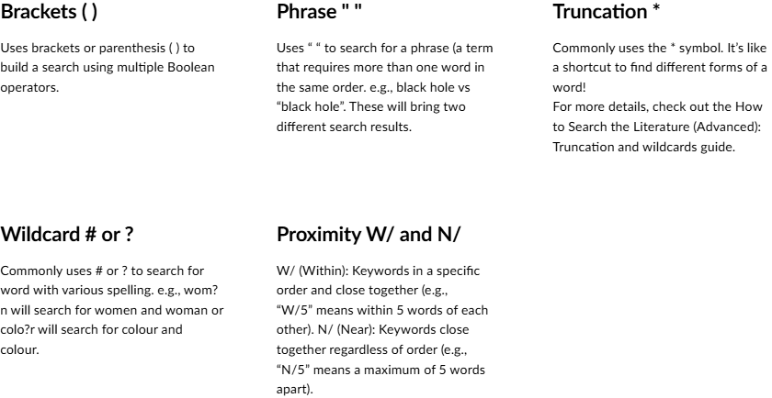
NPU relevance:
- A Reconfigurable Multithreaded Accelerator for Recurrent Neural Networks (https://ieeexplore.ieee.org/document/9415593)
- EPU: An Energy-Efficient Explainable AI Accelerator With Sparsity-Free Computation and Heat Map Compression/Pruning (https://ieeexplore.ieee.org/document/10412195)

FPGA relevance:
- Acceleration of Rotated Object Detection on FPGA (https://ieeexplore.ieee.org/document/9680680)
- Hardware conversion of neural networks simulation models for neural processing accelerator implemented as FPGA-based SoC (https://ieeexplore.ieee.org/document/6927383)

Edge Device relevance:
- Acceleration of Rotated Object Detection on FPGA (https://ieeexplore.ieee.org/document/9803862)
- Efficient Real-time Object Detection on Edge NPU Device with TOPST AI (https://ieeexplore.ieee.org/document/10773198)

Energy-Efficient relevance:
- AI-Optimized Hardware Design for Internet of Things (IoT) Devices (https://ieeexplore.ieee.org/document/10578352)

Directly Relevant:
- Energy-Efficient Computing Acceleration of Unmanned Aerial Vehicles Based on a CPU/FPGA/NPU Heterogeneous System (https://ieeexplore.ieee.org/document/10525057)
- Custom Hardware Inference Accelerator for TensorFlow Lite for Microcontrollers (https://ieeexplore.ieee.org/document/9825651)

Questions:
- There is a lot of knowledge gaps with NPUs. How can I find academic papers that will explain this in a high-level? Or should I just just Google?
- There were many types of neural networks that papers talked about, how much impact would this have on the relevance of the paper? Or can we test it using any NN?

Search words used:
- Hardware accelerator npu
- Npu edge device
- Npu fpga

Week 3 | 17/03/25 – 23/03/25:
Tuesday 18th March 2025 – Wednesday 19th Match 2025 |  | Time: All Day
Title: Back to Basics
Objective: Gain background knowledge on needed for the project
Machine Learning (copied from OneNotes)

But what is a neural network? | Deep learning chapter 1
Notes:
- What are neural networks?
Example: recognising a number between 0-9 from a 28x28 pixel image greyscale.
Input layer: Each pixel in the image will have a value between 0 to 1 that corresponds to how bright the pixel is. This is the first layer of the network.
Hidden layers: From the input layer to a hidden layer, relevant data is identified and separated, and passed onto the next hidden layers until it reaches the output layer.
Output layer: The final prediction of what it thinks the number is.
- Why are the networks layered?
The numbers can be broken down in many pieces. These pieces have a particular pattern e.g. loop, straight lines. Then, these little patterns will have smaller components. When these smaller components go through the layer, it will light up neurons that correspond to it, and as it passes through the layers, it will detect the bigger pieces until it can determine / make a prediction.

Deep Learning | What is Deep Learning? | Deep Learning Tutorial For Beginners | 2023 | Simplilearn

Notes:
- Deep learning is inspired by the structure of the human brain using neural networks.
- Deep learning vs machine learning:
  - ML: need to tell the machine the features
  - DL: features are picked out using neural networks without human intervention
- How does neural networks work?
  - Activation function determines if the neuron is activated. The output makes a prediction based on what neuron is turned on.

Deep Learning Basics: Introduction and Overview

Notes:
- Deep learning is more about representation of patterns
- Data is usually trivial, it's harder to display using algorithms
- Purpose: to remove human intervention
- Skipped to 38:30
- Loss functions: mean squared error, cross entropy loss, gap between prediction and truth
  - Update the weights and biases to decrease loss function
- Rest of the lecture seems like it was going into the detail of the accuracy of ML (does not feel relevant)


http://neuralnetworksanddeeplearning.com/chap1
Notes:
- Did not finish the entire chapter – went into detail which I felt like is not necessary background knowledge for this research

CNN
What are Convolutional Neural Networks (CNNs)?
Notes:
- Filters in CNN perform the pattern recognition
- A filter is a 3x3 block that specifies a pattern to look for e.g. straight line or an L shape
  - This block is compared to a 3x3 section of the given image and checks if it is the same. It continues to slide over the image until all 3x3 have been mapped on the image.
- Pooling: combining all the numeric arrays from each filter
- The filters become more abstract the deeper it goes into the neural network where it recognises the larger part of a pattern

https://www.datacamp.com/tutorial/introduction-to-convolutional-neural-networks-cnns
Notes: (only read key concepts)
- Used for object recognition, image classification, detection, and segmentation.
- Can identify and extract patterns and features
- Made up of 4 main layers: convolutional layers, rectified linear unit, pooling layers, and fully connected layers
- Convolutional layer:
  - Filter: Small matrices of the same size contain a pattern that is part of the image. These matrices are compared to the entire image.
  - 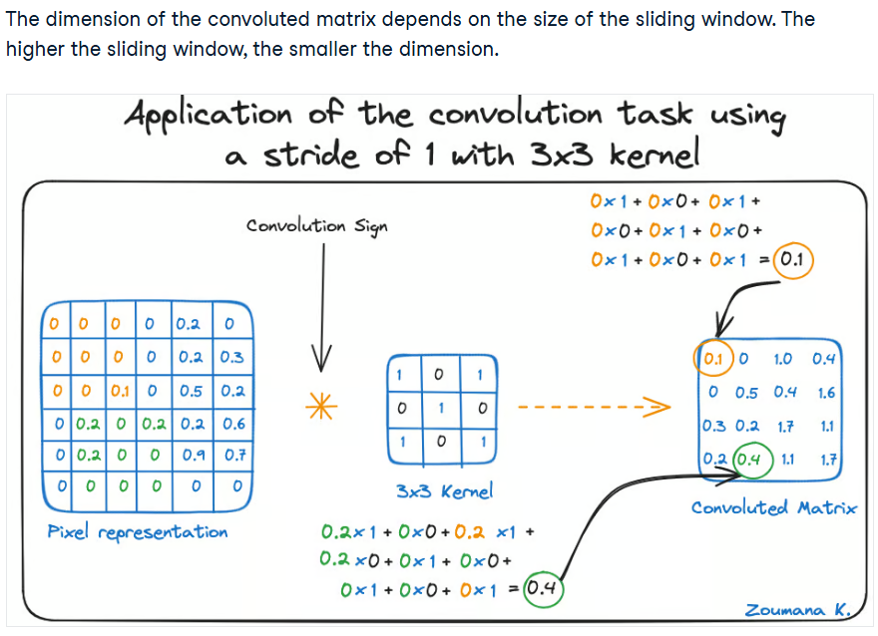
- Rectified Linear Unit (ReLU) activation function: helps learn the relationships between the features of the image
- Pooling layer:
  - Pulls the most significant features from the convoluted matrix
  - 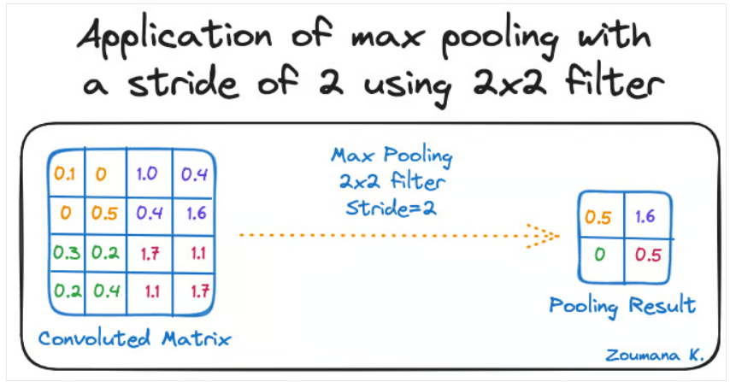
- Fully connected layers:
  - Output layer where all extracted features are transformed into predictions

DNN
https://www.datacamp.com/tutorial/introduction-to-deep-neural-networks
Notes:
- A Neural Network is deep when it has more than one hidden layer

RNN
The Power of Recurrent Neural Networks (RNN)
Notes:
- Handles sequence data
- Has loops so can use information from past (memory)
- A recurrent neuron has its own loop, called the hidden state
- Output depends on the hidden state
- Hidden state is calculated based on the current input and the previous hidden state
- Hidden state is updated at every step allowing to learn based on previous hidden states
- During updates, the weights of each neuron also changes. If the weight is too small, then it can't really use the previous state. If too large then it becomes unstable

https://www.ibm.com/think/topics/recurrent-neural-networks
Notes:
- Has a specific sequence and uses this information for a prediction
- Hidden states acts like a memory that stores information about previous inputs
- Same weight within each layer of the network
- Sigmoid function: determines whether data should be kept or removed

Learning Outcomes:
- How a neural network works and its main three layers: input, hidden, and output layer
- Deep learning is based on learning patterns and requires no human intervention
- Neural networks mimic how the brain works and is trained using large batches of images
- DNN becomes “deep” because it has more than one hidden layer
- CNN uses a filter that slides around the entire images and uses that to compare
- RNN has a memory that updates as it learns through its hidden state loops

Thursday 20th March 2025 | Time: 4pm-6pm
NPU focused background research
Objective: Gain more background knowledge about NPUs
NPU (copied from OneNote):
WHAT IS NPU | MOST ADVANCED AI COMPUTER PROCESSOR
Notes:
• Specialised processor to accelerate AI and ML workloads
• Tailored for complex computation
• Integrated within the main CPU but it can be discrete in some cases like data centres
• NPUs are optimised for heavy computations in deep learning like facial recognition and autonomous driving
• Avoids having to send to cloud for processing so its better privacy

The NEW Chip Inside Your Phone! (NPUs)
Notes:
• Cloud hardware might be more powerful but the latency / delay is the issue
• Prefer to run AI functions locally

https://www.ibm.com/think/topics/neural-processing-unit
Notes:
Advantages:
- Parallel processor so many multiple neural network operations run concurrently
- Low precision arithmetic (usually 8 bits or lower) so computational complexity is less (cause there is less data stored) so it's more energy efficient (check https://research.ibm.com/blog/low-precision-computing)
- High-bandwidth memory: can stored and access memory quicker for tasks
How does it work?
- Purpose built for problem-solving functions that can improve overtime using different types of data and inputs
- NOT built for precise computations so that it can prioritise speed and efficiency for AI
- Has addition and multiplication modules used for AI tasks that calculate things like matrix multiplication/additinoal, convolution, and dot product etc
- Normal CPUs might need thousands instructions to complete one neuron processing but NPU can do similar operation in one
- Uses synaptic weights (how strong the connection is between two nodes) for storage and computation for more efficiency

Week 4 | 24/03/25 – 30/03/25:
Monday 24th March 2025 | Time: 1PM
Energy-Efficiency and Systolic Arrays Background Knowledge
Objective: Gain background knowledge
Energy-Effiency (copied from OneNote):
https://research.ibm.com/blog/low-precision-computing Notes:
- Because there is so many instructions in an AI calculation, each instruction does not need high precision and there is a lot of redundant precision that can be excluded
- Can use some form of estimation without sacrificing accuracy
- 16 and 98 bit precision is industry accepted
- Full-precision computing: Model weights are larger so more storage needed
- With "smaller" computations like a*b, the answer will always be the same regardless if its 32 or 64 bits
- In a neural network, if one neuron makes a mistakes then the other neuron can capture the sginal
  - Meaning: the neural network will be given the one big task. Each neuron will do little bits of the task. If one neuron messes up their tasks, then the other neurons will still be accurate enough to give a reasonable prediction

https://www.reflexces.com/newsroom/6-reasons-to-use-fpgas-for-ai#:~:text=Energy%20efficiency,-One%20of%20the&text=AI%20tasks%2C%20such%20as%20machine,consumption%20than%20CPUs%20and%20GPUs.
Notes:
- FPGA can become energy efficiency if their configurations are optimised for low power consumption

https://www.ibm.com/think/topics/fpga-vs-gpu
Notes:
- Don’t need much more background knowledge about energy efficiency. Can just see this through performance testing during implementation

Week 5 | 31/03/25 – 06/04/25:
Monday 31st March – Tuesday 1st April | Time: All Day
Literature Review
Objective: Read at least 10 papers and start on the literature review
- Created a mindmap with references noted -> makes literature review easier to write

Week 8 | 05/05/25 – 11/05/25:
Wednesday 7th May | Time: All Day
Literature Review Feedback
Objective: Receive Feedback on the literature review and go with a direction
- Fix the formatting
- Some aims and objectives were too ambitious, find something simpler

Week 9 | 12/05/25 – 18/05/25:
Tuesday 13th May – Wednesday 14th May | Time: All Day
Pre-trained Machine Learning Models
Objective: Have a look at the available CNN models available for the FPGA
- DE1-SOC ARM Processor: ARM* Cortex* A9
Paper: A CNN Inference Accelerator on FPGA With Compression and Layer-Chaining Techniques for Style Transfer Applications uses the same
- ImageNet: https://www.kaggle.com/models/iree/mobilenet-v3
- There is documentation on how to deploy TinyML in Altera
- ‘Deploying tinyML on Altera FPGA’
  - TFLite is the ML used in the example
  - Instructions for both NIOS and Arm
  - Can run TensorFlow Lite Micro on NIOS II, will need to use ARM if we want TensorFlow Lite
- 

Found a project from Coloumbia University that basically replicates what we’re trying to do:
https://www.cs.columbia.edu/~sedwards/classes/2025/4840-spring/proposals/Systolic.pdf
https://www.cs.columbia.edu/~sedwards/classes/2025/4840-spring/designs/Systolic.pdf
https://www.cs.columbia.edu/~sedwards/classes/2025/4840-spring/index.html

Links that might be useful but have not been saved
https://www.cse.wustl.edu/~roger/560M.f17/01653825.pdf

How do Systolic Arrays work?
To implement systolic arrays in FPGA, we must understand the fundamental behaviour of a systolic array. Systolic arrays are made up of a network of processing elements to perform simple operations alongside other PEs (JOHN P. CONDORODIS)
So, how does a processing element work?
To put simply, a processing element is just a cell that ‘processes’ something. For our case, we want this to do a multiply and accumulate operation. For the sake of simplicity, I will just use multiply as an example for my understanding.
“The processing element (PE) is essentially an arithmetic logic unit (ALU) with attached working registers and local memory (Briggs and Hwang 1984).”
If we take this quote and apply to our PE, to find the input and outputs, we simply think of “What do we need to give the ALU so that it performs multiplication?”
This tells us that we just need input_a and input_b with output_c
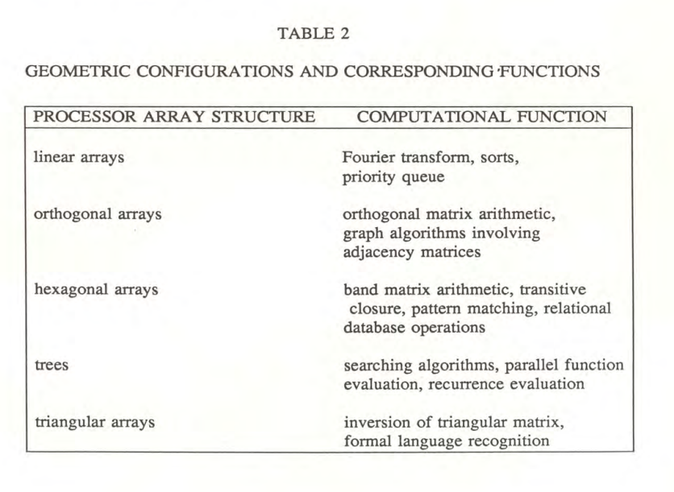The input of the systolic array is the weight and the activation. “A CNN Inference Accelerator on FPGA With Compression and Layer-Chaining Techniques for Style Transfer Applications” mentions data compression and how they’ve used an 8 bit unsigned input and output

Questions to answer:
- What data type are the weights and activations to the input of the MAC operations?
- If we end up using a Vector Processing Unit Block and a Convolution Processing Unit Block, and the data type of above is floats, can we use a LUT table instead?

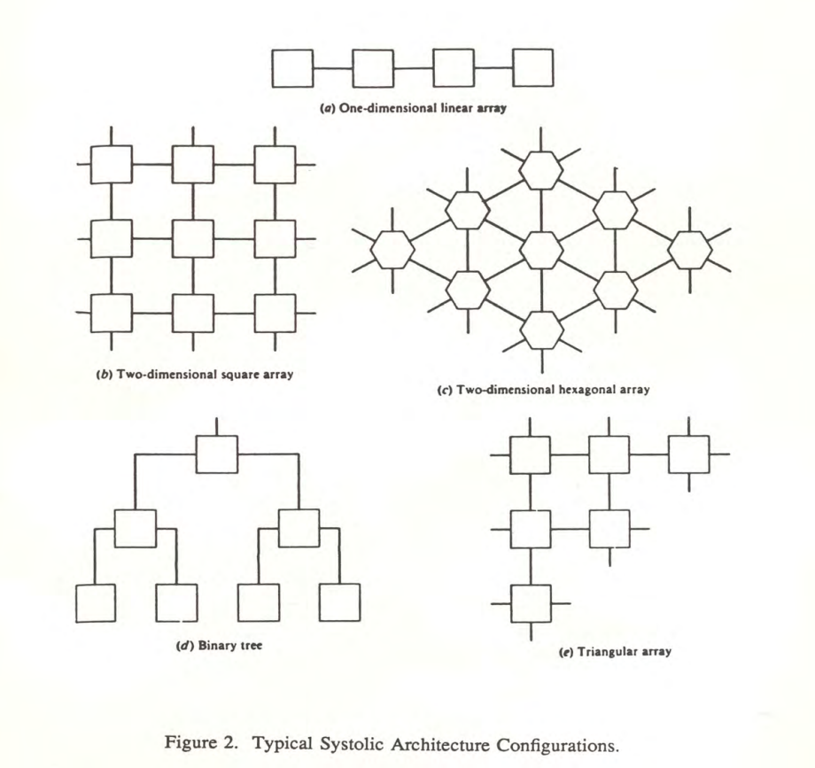

Week 10 | 19/05/25 – 25/05/25:
Wednesday 21st May – Thursday 22nd May | Time: All Day
Creating Processing Element and Systolic Array in VHDL
Objective: Create a 3x3 systolic array and test via ModelSim
- A processing element is made up of this:
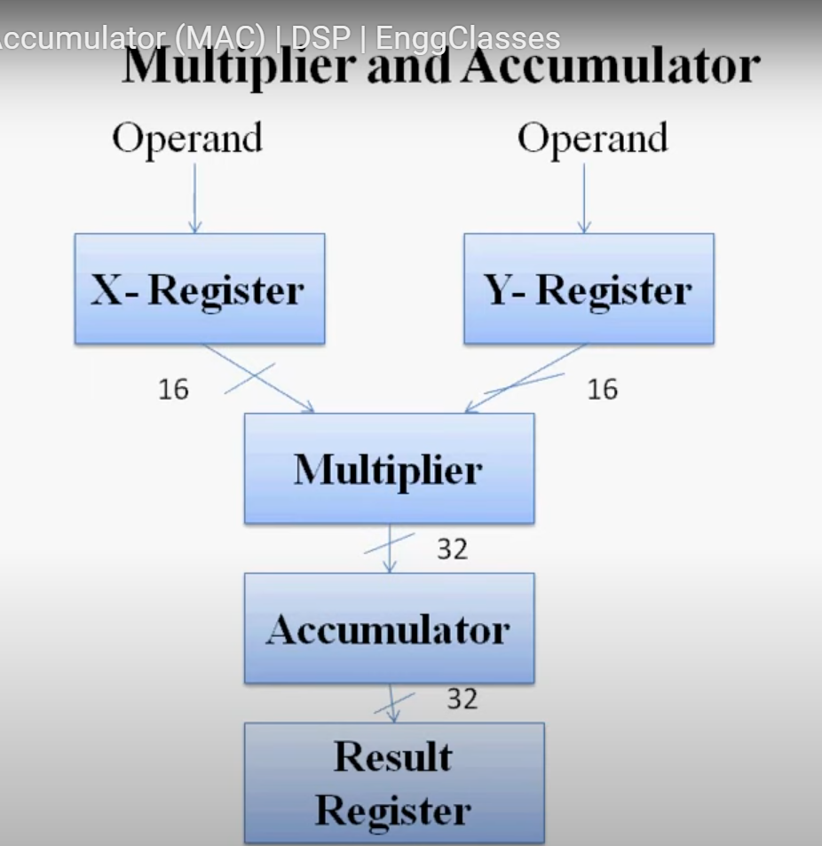
- Basically, the result and the accumulation stays within the PE. It doesn’t actually get passed through the systolic array. The output of the systolic array is the result register
- This is the systolic array architecture that we are trying to implement. Between each PE there is an interconnection signal that needs to be instantiated. The red lines represent the data value passing through the green represent the weight value passing through. 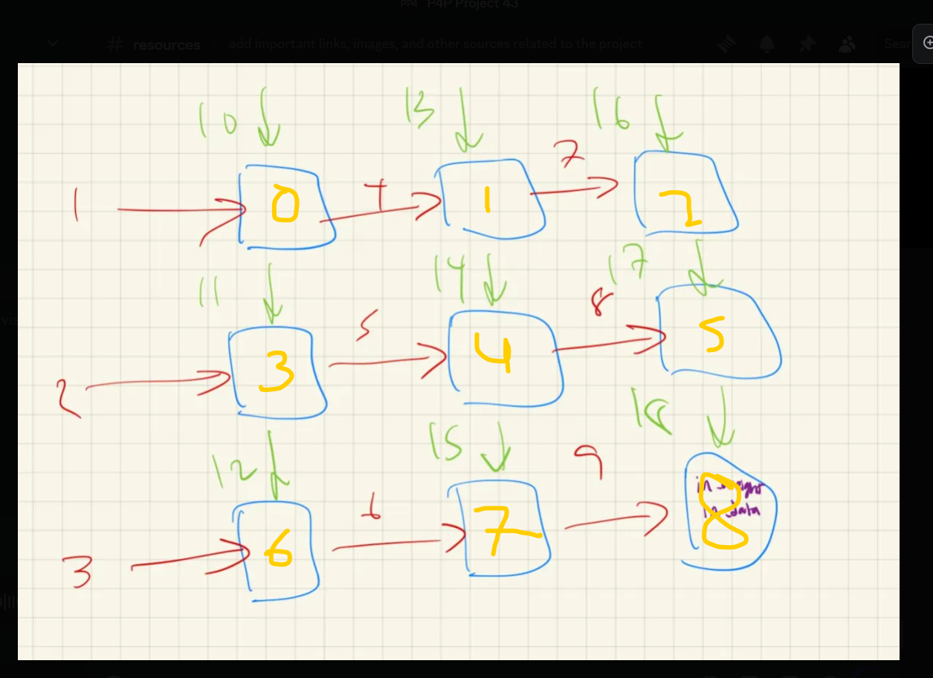

Systolic Array Implementation on VHDL:
- There is something wrong with the processing element where we are struggling to implement the accumulator register
- The systolic array itself is passing through the data properly when we only do multiplication
- The data is staggered through from the top left corner to the bottom right corner
- Manually injecting the data

Ideas to implement it better:
- Use a control unit to pass the data through the entry points of the systolic array
  - Consider the difference between row major vs column major
- Try adding the memory buffer of the PE in the top level of the systolic array

To do:
- Get a proper understanding on how systolic arrays work
- Then move onto the sparse matrices

INTER-SEMESTER BREAK | 11/07/25 – 20/07/25:
Friday 11th July 2025 – Saturday 12th July | Time: All Day
Catch up!
Objective: Get back into P4P by revising what has happened previously
What is happeninng? I am lost.

Based on Pratham’s modified PEs and Systolic Array:
- In the original code, we had the accumulator value passed throughout the systolic array. THIS IS NOT WHAT WE WANT! The current code has a local accumulator for each PE. (This simplifies the code)
- The systolic array is still hardcoded to feed in the inputs

From these results, what should we do?
- I will be focusing on how to dynamically adapt to the systolic array to any NxN matrix input
- This is the purpose of the control unit
- The idea is to have a set systolic array size, for example 16x16 systolic array that can only take up to 16x16 inputs. If an input is the smaller, then some PEs will “turn off”

How do we do this?
- We need to figure out a way to turn off PEs. I think this is more of a VHDL syntax/code problem than a logic problem.
- Each PE can have an Enable bit to check whether or not it should be processed
- Then on the higher level, systolic array, it needs to know it should stop.
- Another thing we need to consider is to check if we can find a formula for calculating how many clock cycles are needed for a given input.

NxN | Clock Cycles
1 | 1
2 | 4
3 | 7
4 | 10
5 | 13
6 | 16

Based on this table, we know that the formula is: 3n-2

To get the array size, use the `length attribute
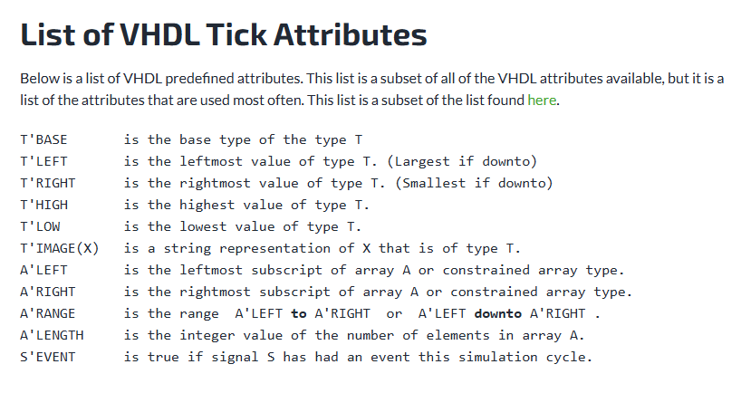

Okay now that we have this basic information, what will the control unit actually do?
- The control unit is part of the NPU (higher level VHDL code), something like this
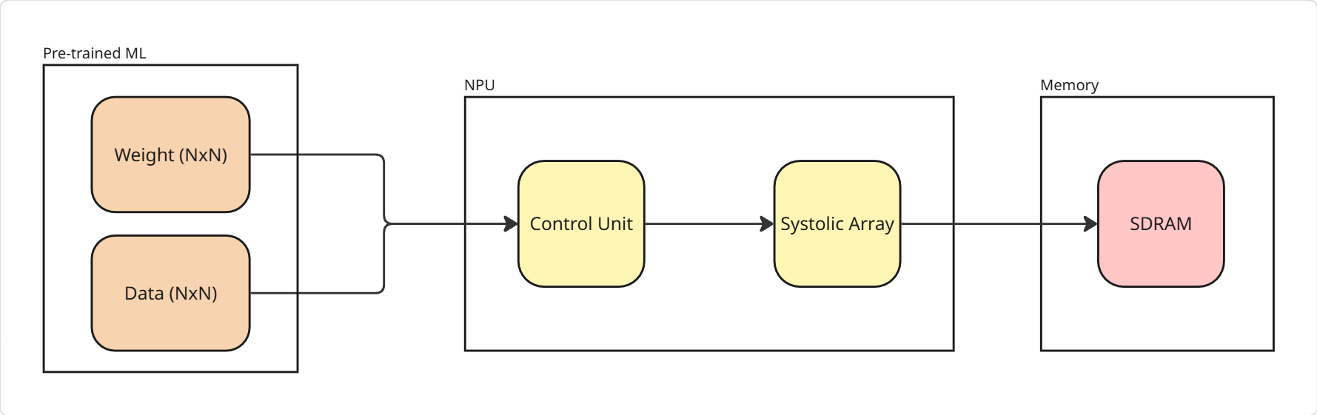
- The inputs and outputs of the control unit will be:
Input | Output
Clk (bit_1) | Array_Size (int)
Reset (bit_1) | Weight_Input (bit_8 size of however big the systolic array is)
Weight (NxN) | Data_Input (bit_8 size of however big the systolic array is)
Data (NxN) | Injection_Rdy (bit_1)
 | PE_On (bit_1 size of however big the systolic array is)
- The idea is for the control unit to analyse the given weight and data matrix. It will get the size of both arrays, assuming they will always be identical (for now). Then, based on this information, it will calculate the clock cycles based on the formula. Then, one by one, it will feed the correct values into the systolic array.
- PE_On is a mask that represents which PE should be turned on

Systolic array:
- How will it turn off the PE? It will take in the mask and align it with the PE enable

Monday 14th July 2025 | Time: All Day
Systolic Array with dynamic PE size
Objective: Continue to figure out how to turn off specific PEs for a fixed NxN matrix input
Research Papers:
A Design and Simulation for Dynamically Reconfigurable Systolic Array
- Paper focuses on simulating reconfigurable systolic array in VHDL
- Reconfigurable Systolic Array Block (RSAB) uses multiplexers to configure different arrangements of 4 PEs
- Not sure if this is applicable to the project
Mapping multiple algorithms into a reconfigurable systolic array
- Multiple algorithm are mapped into a reconfigurable systolic array that can compute one algorithm at a time
- Systolic array can be expanded using time or space redundancy (??) so it can computer multiple algorithms simultaneously
- Hard to follow, I have no idea what this was talking about
An Energy-Efficient Convolutional Neural Network Processor Architecture Based on a Systolic Array
- Cyclic Tiling (??) reduces hardware resource usage
- By reusing the input image data and weight data combined with multi-level storage methods, power of memory access is reduced and high-energy efficiency is obtained.
- 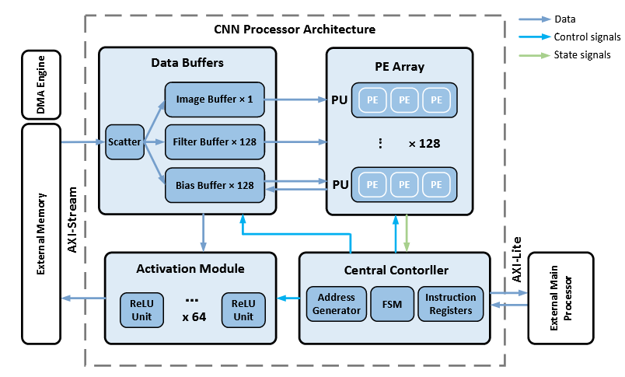
- Looks helpful for future implementation, but not what I need right now

Questions:
- Are we going to stick to one arrangement of a systolic array e.g. orthogonal or something like the diagonally configuration? Or should we allow the PEs to arrange itself in different orders? I think it’s better to look into the best arrangement for CNN algorithms and optimise that
- Instead of simply just turning on/off a processing element, can maybe we can somehow use the disabled PEs somehow so that we increase hardware utilisation

Code:
- Processing unit now has an input enable bit and has a conditional statement to ensure that it only processes data if enabled
- “custom_types.vhd” is basically a copy of what we had in recop, to simplify coding for us

Tuesday 15th July 2025 |  | Time: All Day
Create a dynamic systolic array
Objective: Learn how to use the “generate” statement
To Do:
- Learn how to use the “generate” statement
- Generate 8x8 PE systolic array
- Test with a 1x1, 2x2,3x3....8x8 array input
- Create a separate file for control unit

Testing Screenshots
Set up: 8x8 Systolic Array. Tests will start from 1x1 all the way to 8x8
1x1
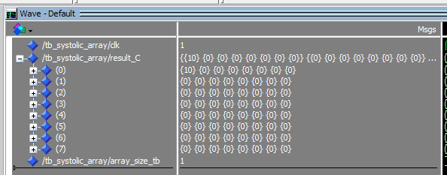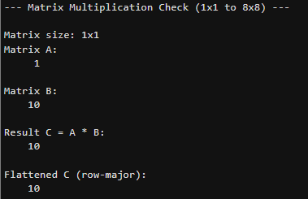

2x2
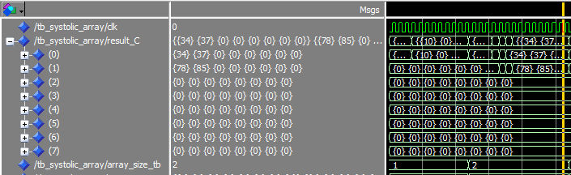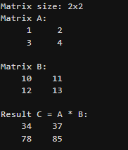
3x3
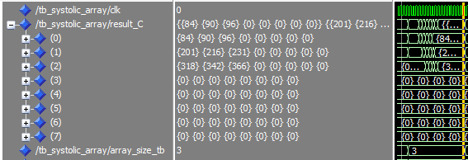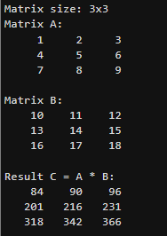

4x4
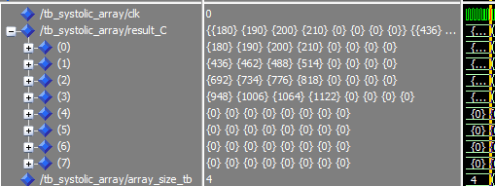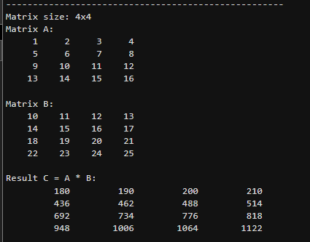

5x5
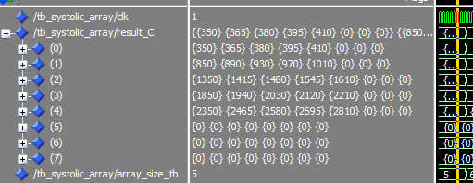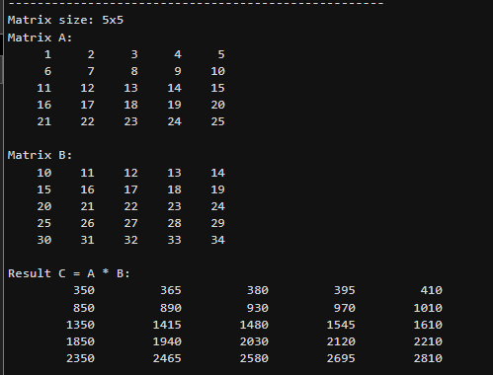

6x6
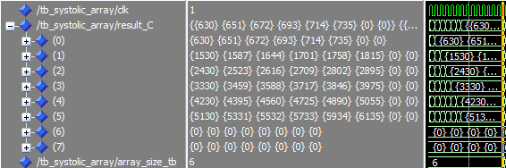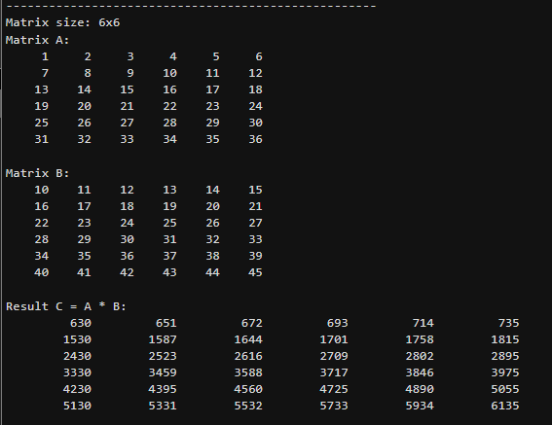

7x7
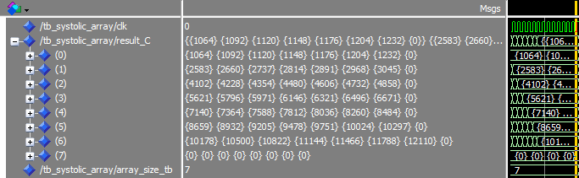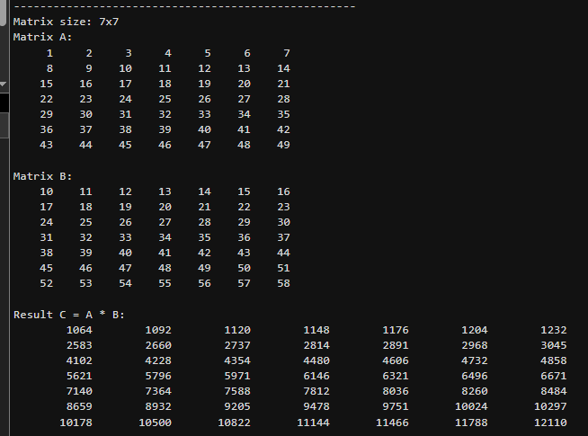
8x8` 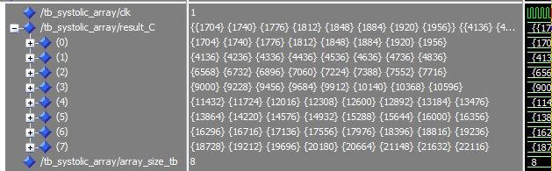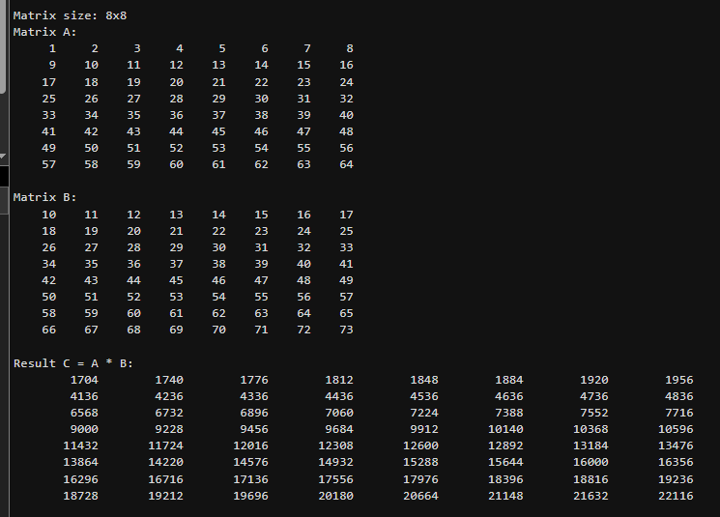
Control Unit:
- Needs to add a mask to the data/weight inputs to make it fit into the 8x8

Conclusion:
- Now we have allowed space for an 8x8 systolic array.
- If we give an NxN input where N = [1..8], the systolic array automatically adapt to it
- It is now confirmed that executing the MAC operation and passing the data/weights occur in one clock cycle
- The formula found – clock_cycles = 3n-2 – has been proven in the simulation. This tells us that the systolic array will NOT execute any operation (i.e PE is off) when it is not needed. This has minimised our energy consumption to the very least.

Thoughts for the future:
- How can we utilise hardware better? If we have a 8x8 systolic array but only using 4x4, can we make the systolic array run four 4x4 in parallel, speeding up the computations? Or can we re-route or change how the systolic arrays are arranged?
- Chunking / blocking? Look into the .rbf / DPR paper (although might be a bit difficult)
- Is there a better way to do MAC operations?
Wednesday 16th July 2025 |  |  | Time: All Day
Optimising Systolic Array
Objective: Re-read research papers to find how we can utilise the hardware better
Systolic Array Design for Efficient FPGA Implementation of CNN Accelerators: Power and Area Optimizations
- “heterogenous systolic arrays are especially advantageous for depth wise convolutions, which involve lesser computations”
- Dynamic precision handling – bit-width of operations is adjusted based on the data requirements
- Reducing precision for simpler data/less complex cnn layers, then less power consumption and computational complexity
- Systolic is used for multiple types of operations so better resource utilsation (better for edge devices)
- To reduce external memory, buffering and data reuse techniques are employed (because accessing external memory is a major contributor to power consumption)
- Power gating (shuts off idle units) and clock gating

Planaria: Dynamic Architecture Fission for Spatial Multi-Tenant Acceleration of Deep Neural Networks
- Focuse don mutli-tenancy in the architecture design of DNN accelerators
- “For example, speech recognition and voice synthesis systems tend to require multiple models in deployment and can significantly benefit from multitenancy and co-location” But our use case is for objection recognition so I’m wondering if this is even relevant

Developing and Implementing Dynamic Partial Reconfiguration for Pre-Emptible Context Switching and Continuous End-To-End Dataflow Applications
- Reconfigurable at run time without having to reprogram
- Mulitasking by context switching is possible on an FPGA by saving and restoring the context of the registersm flip-flops, and memory
- PDR uses a wrapper around the reconfigurable region that holds the input signals during the reconfigurable process to prevent operation in that region and limit Single Event Upsets (SEU)
- Prevents the compiler from using the space in the reconfigurable design region for other parts of the design
- Our current implementation isn’t even assigning parts of the fabric nor are we region locking (https://www.intel.com/content/www/us/en/docs/programmable/683641/21-3/regions.html ). We are only controlling the dataflow but not the array itself
- To actually change the 8x8 static array to a smaller array, then we would need to do DPR, where its each syntehised and placed in a reconfigurable region
- Our design, by masking, is still saving power, but there is still leakage power consumed (which makes DPR more efficient)

Secure Energy-Efficient Implementation of CNN on FPGAs for Accuracy Dependent Real Time Task Processing
- Embedded Memory Blocks (EMBs)
- To utilise EMBs, we have to determine the available memory spaces and divide it into several memory blocks that can be loaded with pre-computed data.
- Pre-computing means instead of using systolic arrays to do MAC operations, we do this separately and save all the possibilities into a memory block
- This can be useful to use as the weights/data are fixed, especially for the early layers, and we can mix this with some systolic arrays if needed

Optimizing FPGA-based Accelerator Design for Deep Convolutional Neural Networks https://ceca.pku.edu.cn/media/lw/b73586e2ac7b5f8d63e8e584f398f17f.pdf

Hardware Utilisation
Technique | How | Relevance
Planaria, Data-Mirroring | Running multiple models in one architecture (“multi-tenancy”) | Not relevant  Edge devices are likely to only run one model at a time  Keeps it lightweight and consumes less power
Dynamic Partial Reconfiguration (DPR) – Beasley | Allows for reconfiguration of FPGA architecture at run time without having to reprogram. | Relevant but only for ideas not execution  Executed in a FPGA we are familiar with
Embedded Memory Blocks (EMBs)  Secure Energy-Efficient Implementation of CNN on FPGAs  for Accuracy Dependent Real Time Task Processing | Storing weights and immediate results in on-chip EMBs to reduce accessing external memory | Relevant  Reduces power consumption
Batching Multiple Inputs | Processing multiple input samples simultaneously fills systolic array pipelines more full, increasing parallelism

Objective 2: Research about ML in depth to find why we have sparsity in the matrices and how the systolic array receives the matrices

Vanishing Gradient Problem
https://www.engati.com/glossary/vanishing-gradient-problem#:~:text=exploding%20gradient%20problem?-,What%20is%20vanishing%20gradient%20problem?,layer%20to%20the%20input%20layer.
- Occurs during training DNNs
- Gradients are used to update the network and this becomes extremely small or “vanish” when they are backpropagted from output to earlier layers
- Backpropogation algorithm calculates gradient by propagating the error from the output layer to the input
- Consequences of DGP: slow convergence, network getting stuck in low minima, and impaired learning
- Issue arises in deep structures with lots of layers: activation functions like ReLU can help with this
- Can be detected when: higher layers change but lower layers barely change, model weights become 0 (this is what causes the sparsity in our context)
- What are activation functions?
  - Rectified Linear Unit (ReLU) allow for better gradient flow

Summary:
The gradient is calculated to tell each layer how much it should change to reduce the final loss. To calculate this, gradient = slope * output error of the layer ahead of it (keep in mind this is back propagation). Each layer has its own slope and the gradient is calculated for the weight and neuron. When the gradient is applied to all layers, the error gets smaller and smaller as it gets closer to the input layer causing the vanishing gradient layer. The purpose of the ReLU is deciding whether or not the gradient should be applied. If the neurons are activated (i.e found a feature), then the gradient is applied to enhance that feature. Otherwise, the ReLU does not apply the gradient, keeping the weights unchanged, and blocks the rest of the back propagation layers from changing its weights as well.


How does the system work?
- The pre-trained model will provide the initial image matrix (data matrix) and all the weight matrices of each convolutional layer. Only in the first layer is the image provided as the data matrix. The weight matrices are stored in memory.
- These are passed onto the control unit where it will decide what the systolic array needs to do to process the data.
- The systolic array will perform the MAC operations. Once completed, this will be stored in memory as well. The output of systolic array becomes the data input of the following layer. For example, the inputs of layer 2 is: systolic array output of layer 1 and the weights of layer 2. This becomes a loop until the systolic array has completed all the layers.
- Once all the layers are completed, we need to do some processing with a CPU (maybe NIOS?) that will make the final prediction.

Question:
- If the inputs are not NxN size nor are the data and weight matrices the same size, what happens?

Semester 2 Week 1 | 21/07/25 – 27/07/25:
Monday 21st July – Wednesday 23rd July 2025 | Time: All Day
Back at it again!
Objective: Complete writing technical report by Wednesday Night
Research Paper:

Sense: Model-Hardware Codesign for Accelerating Sparse CNNs on Systolic Arrays
- Found issue is the irregularity of sparsity reduces performance
- Reduces DRAM access by 1.17-1.8x compared to Swallow
- “Since data movement consumes much more energy than computation”
- Focused on data reuse
- “For IFMs, approximately half of their elements are zeros because of the widely used nonlinear function rectified linear unit (ReLU); for weights, the fault tolerance of CNN allows of a large number of redundant zeros, which inspires researchers to develop pruning and quantization methods”
- “But sparse IFMs and weights can be irregular and fragmented, which leads to lower memory access efficiency.”
- Why systolic array: “Second, systolic arrays propagate data horizontally and vertically with simplified inter-PE connection, which can highly reuse data and reduce data movement consumption. Finally, communication with the outside occurs only at the boundary PEs, providing huge bandwidth saving.”
- Why systolic array good: “Due to the structured dataflow, the control unit only takes up a small portion of system hardware cost, achieving high resource utilization.”
- Issue with sparsity in systolic array: “However, the irregularity of Fig. 2. Systolic array architecture. Fig. 3. (a) Imbalanced and (b) balanced loads of sparse weights in the systolic array. sparsity conflicts with the structured dataflow in systolic array, which may induce imbalanced workloads, causing low PE utilization and insufficient acceleration.”
- Load-balancing weight pruning flow: basically analyse each kernel, make the two kernels have the same number of non-zero elements by pruning the least important element to zero, then compare accuracy, if accuracy not lost then continue to prune the same way
  - how does it determine what is the least important element? CNNs contain many redundant weights, and with smaller absolute value of weight comes less importance.
  - Having an equal sized kernel leads to better hardware utilisation and 1.5x speed
- Channel clustering:
  - Finds a common characteristic in the channel (i.e. sparsity) and groups them together
  - The cluster will do computations together
- This system loads in the pruned weights
- On-Chip Buffer contains the input, weight, and output buffers, two BRAMs
- What is Ping-Point buffers?

PRUNING CONVOLUTIONAL NEURAL NETWORKS FOR RESOURCE EFFICIENT INFERENCE
- Prunes the entire feature maps so resulting network can run efficiency even on embedded devices
- Uses second-order taylor expansion to select parameters for deletion
- Criteria for pruning
  - Minimum weight: have a minimum weight threshold
  - Activation: ReLU functions tend to zero out values (like negative values). If the kernel is consistently zeros, then we can assume that it is not relevant to the prediction without risking accuracy
“it is reasonable to assume that if an activation value (an output feature map) is small then this feature detector is not important for prediction task at hand”
  - Taylor expansion: ????

How does changing the kernel values not affect inference?
CNNs contain many weights and layers with lots of computations. pruning one weight matrix would not have as a large impact as we think we have. for example, if one node is inaccurate, in the scale of CNNs, it actually change the prediction. additionally, whilst the weight values do matter, the purpose of the CNN is to have an accurate prediction. lets say we have a control model and the pruned model, if they have different weight values at inference, but can recognise the same object, then both are still accurate

Compiling on Quartus:
- Fmax is at 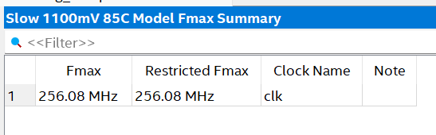
- However we are failing the timing requirements because we have not set it up properly so Quartus is assuming that we are running it at the highest speed
- We create a constraints.sdc file that sets the 50Mhz:
# Define a 50 MHz clock on the top-level input port 'clk'
create_clock -name clk -period 20.000 [get_ports clk]
- Now the output of the timing analyser is
- 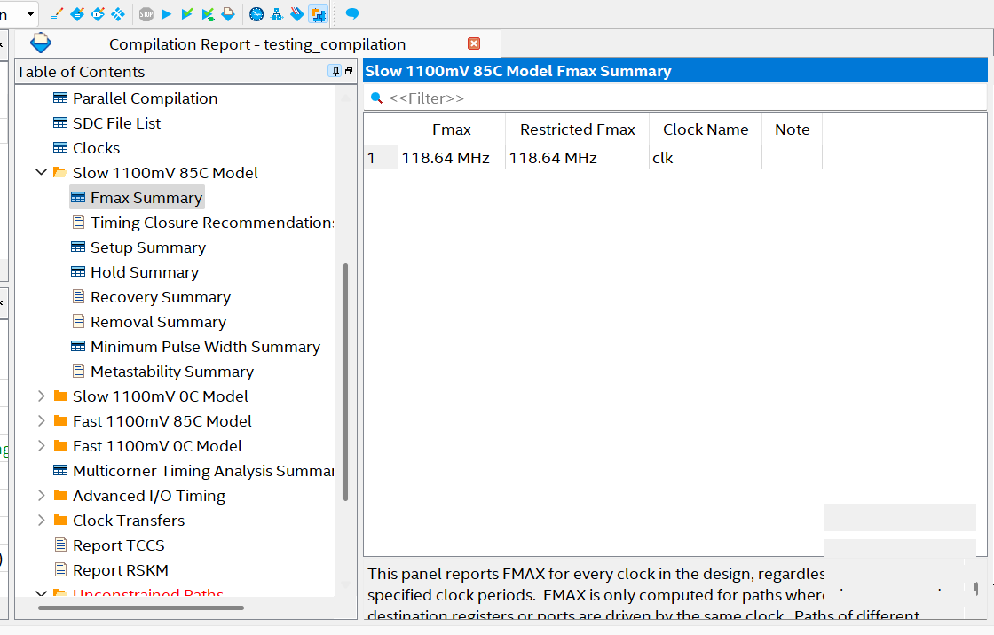
- This means that our simulation from ModelSim is valid because it is running at 50MHz

Questions:
- How does the systolic array’s output become its own input through the layers?
- Basically how does the kernel / filtering thing work (if the image is 128x128 and our kernel is 3x3, what happens?)

Gap:
- Why systolic array: “Second, systolic arrays propagate data horizontally and vertically with simplified inter-PE connection, which can highly reuse data and reduce data movement consumption. Finally, communication with the outside occurs only at the boundary PEs, providing huge bandwidth saving.” – SENSE
- Why systolic array good: “Due to the structured dataflow, the control unit only takes up a small portion of system hardware cost, achieving high resource utilization.” – SENSE
- “Sparsity conflicts with the structured dataflow in systolic array, which may induce imbalanced workloads, causing low PE utilization and insufficient acceleration” – SENSE
- “Computation of convolutional neural network (CNN) requires a significant amount of memory access, which leads to lots of energy consumption. As the increase of neural network scale, this phenomenon is further obvious, the energy consumption of memory access and data migration between on-chip buffer and off-chip DRAM is even much more than the computation energy on processing element array (PE array).” From Reconfigurable Architecture and Dataflow for Memory Traffic Minimization of CNNs Computation
What can we do about this gap?
- Load-Balancing Pruning – SENSE
- Memory??
- FPGA Fabric??

Week 3 | 04/08/25 – 10/08/25:
Monday 4th August 2025 | Time: All DAY
Major Catch-Ups on doubts
Objective: Fill in the conceptual gaps
How are we going to utilise ML in our project?
- Once we have a pre-trained model, we can actually extract CNN layers on Python.
- https://www.datacamp.com/tutorial/cnn-tensorflow-python
- Use the BRAM of the FPGA to locally store the numerical weights and activation layers

Plan for the next 2 weeks:
1. Get a version of AlexNet on Python
2. Extract the numerical weights and activation layers as matrices. Most likely just extracting 1 layer as a test-case.
3. Figure out how to store the matrix into the FPGA (this is conceptually not implementing)
4. Make a software-only case where Python will execute the layer and time it
5. Figure out how we do the same with the current implementation of the systolic array. See what changes need to be made
So, what does this mean in the context of our project?
We have AlexNet running on Python that allows us to extract one fully connected layer of weight matrix. As this has been tiled, we can make it fit into our 8x8 systolic array. Our current activation layer is only utilising 1xN. This is actually not idea, we would be better off running 8 batches in parallel so we can continue with our matrix multilicatiopn of our systolic array.

To do:
- Weight stationary
- Figure out what python code means

Week 5 | 18/08/25 – 24/08/25:
Monday 18th August 2025 | Time: All Day
Getting back to it
Objective: Convert .mif to 2D array
- 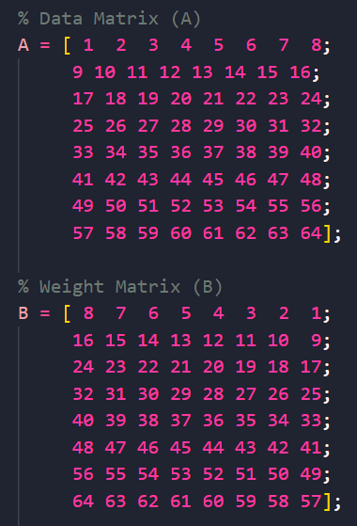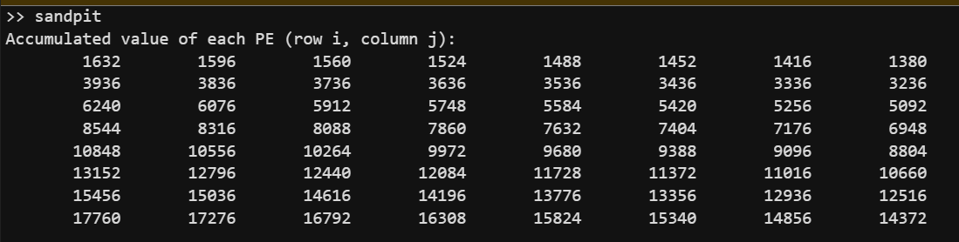

MID-SEMESTER | 01/09/25 – 14/09/25:
Friday 12th September 2025 | Time: All Day
Sparsity Algorithm
Objective: Find a way to combat sparsity that is not during pre-processing (NIOS) and does not interfere with the systolic array pipelining
FPGA Prototyping of Systolic Array-based Accelerator for Low-Precision Inference of Deep Neural Networks
- “If structured sparsity exists in the granularity of the 128×128 square block, our inference accelerator can skip the entire computation for the corresponding block, thereby significantly minimizing the computation cycle”

Sparse-TPU: Adapting Systolic Arrays for Sparse Matrices
- The way packing works here is that you look at a column. You check the column on the right and push it onto the first column. If there are any collisions, then a new row is created.
- Keep track of this because we need to rearrange the input the same way so that we can mathematically do the MAC operations correctly. This basically just skips out on the zeros in the systolic array.

Week 7 | 15/09/25 – 21/09/25
Thursday 18th September 2025 | Time: All Day
Objective: Find Sparsity Handling
Gating and Packing idea:
- We don’t want to start off with a packing scheme then change up the systolic array pipeline
- The current systolic array handles a uniform NxN set
- Instead of changing the architecture of the systolic array, we would rather handle this on the control unit’s end
- We want to remove the zero elements / sparsity in the matrix from the ML
- With gating, the systolic array still oversees the zero elements but it still ‘processes’ it. Instead we want to get rid of the zeros before it comes in
- However, when the zeros are removed, we would be sending LOCATIONs of the useful instead

Gating with Mask:
- When looking at the input matrices, we mask the non-zero elements with ones and find the positions of these
- We send this to the systolic array so it knows beforehand what PEs to turn on or off
- In comparison to the baseline systolic array, the original still does a process where it checks if it should be on, but with this, the control unit knows already

Week 8 | 22/09/25 – 28/09/25:
Monday 22nd September 2025 | Time: All Day
Read SCNN Paper and attempt an implementation through code
SCNN: An Accelerator for Compressed-sparse Convolutional Neural Networks
- the SCNN dataflow only delivers weights and activations to the multiplier array that can all be multiplied by one another in the manner of a Cartesian product. Furthermore, the activation vectors are reused in an input stationary [6] fashion against a number of weight vectors to reduce data accesses. Finally, only non-zero weights and activations are fetched from the input storage arrays and delivered to the multiplier array.
- SCNN doesn’t do the typical MAC operation where the multiplied output is directly multiplied in the PE. Instead, it tracks the output coordinate
- Their methods of exploiting sparsity:
  - Compressing data: Encoding the sparse weights and/or activations provides an architecture an opportunity to reduce the amount of data that must be moved throughout the memory hierarchy. It also reduces the data footprint, which allows larger matrices to be held a given size storage structure.
  - Eliminating computation: For multiplications that have a zero weight and/or activation operand, the operation can be data gated or the operands might never be sent to the multiplier. This can save energy consumption or both time and energy consumption, respectively.

Code Changes:
- Building upon the power-gating method where we are sending an enable mask to the systolic array if one of the input is going to be zero
- Extracting an 8x8 tile from one of the ML layer and saving it as .mif
- Using Python to extract a 8x8 matrix from AlexNet model
- Using Matlab to read the .mif and convert to 2D array, ready for pre-processing
https://pypi.org/project/mif/

Basic Column Packing Algorithm (from Sparse-TPU paper)

% This is a script to call our MIF reader function and pack the matrix
clear;
clc;

% 1. Define the path to your .mif file
mif_filepath = 'C:/Users/iamkr/Documents/part-4-project/Systolic Array (packing)/mif/basic_packing_algo.mif';
N = 8; % Define the matrix size

% 2. Call the function to get the 1D array
my_data_array_1d = mif_to_1d_array_matlab(mif_filepath);

% 3. Reshape the 1D array into a 2D matrix
my_data_array_2d = reshape(my_data_array_1d, [N, N])';

disp('Original 8x8 Array:');
disp(my_data_array_2d);

% --- Corrected Column Packing Algorithm ---
packed_groups = {};

for i = 1:size(my_data_array_2d, 2)
candidate_col = my_data_array_2d(:, i);

if ~any(candidate_col)
continue;
end

was_packed = false;

for g = 1:length(packed_groups)
% Corrected collision check: Element-wise multiply.
% If the sum is 0, no non-zero elements overlapped.
if sum(packed_groups{g} .* candidate_col) == 0
% No collision, so merge
packed_groups{g} = packed_groups{g} + candidate_col;
was_packed = true;
break;
end
end

if ~was_packed
packed_groups{end+1} = candidate_col;
end
end

% --- Reassemble for display ---
if ~isempty(packed_groups)
num_packed_cols = length(packed_groups);
packed_array = zeros(size(my_data_array_2d, 1), num_packed_cols);
for i = 1:num_packed_cols
packed_array(:, i) = packed_groups{i};
end
else
packed_array = [];
end

disp('Packed Array:');
disp(packed_array);

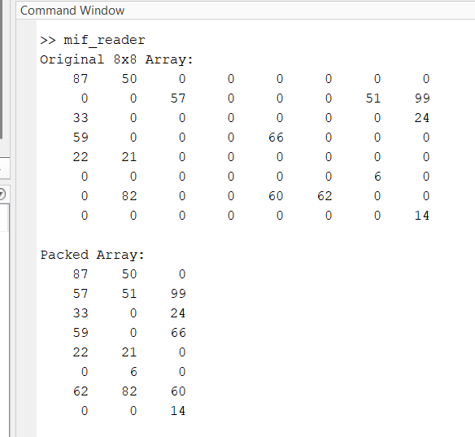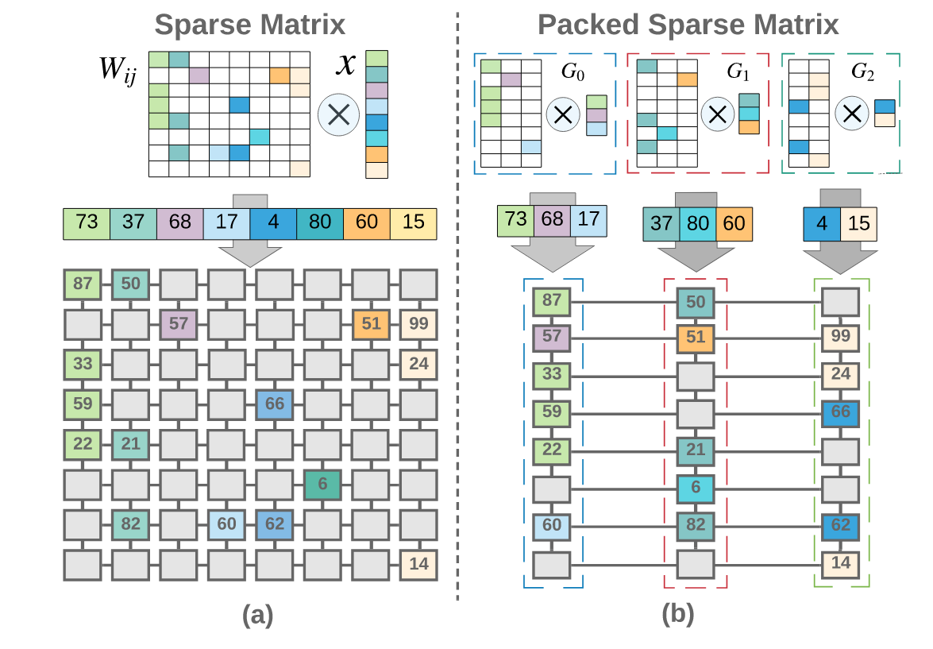
This version of the code is slightly wrong, specifically with the second to last row. Will try a new method
Simple Packing Idea:
- Count the amount of non-zero values in a matrix
- Find the best matrix size to remap it to. For example for 15 non-zero elements, it can fit in a 4x4 matrix.
- Keep track of the original position to the new one using cell arrays
- But by providing the .mif, we actually know where the original position of the numbers are
Wednesday 24th September 2025 | Time: All Day
Working Row/Column Stripping method
- This only works for structured sparsity where the entire row/column must be all zeros
- The way it works is that in the Python file, we look at the matrix and get rid of all the rows/columns with zeros
- We print out the VHDL code for the test bench here as well
- In the test bench, model sim will display without the sparse row/columns but we need to pass this back to software to “re-arrange” it back
- The stripping method works because we are basically shifting the row and column, so we are just skipping the entire row and column, which keeps the maths consistent with the systolic array

Thursday 25th September 2025 | Time: All Day
NPU Wrapper
- When synthesising onto the board, the code has issues where we can’t actually compile it because of pin overflow.
- DE1-SOC has 256KB memory.
  - Input: 64 element matrix * 2 matrix * 1 byte (int8) = 128 Bytes
  - Output: 64 element matrix * 4 bytes (int32) = 256 Bytes
  - Totalling = 385 Bytes

Friday 26th September 2025 | Time: 1PM
Tiling:
- Store the whole layer in the SDRAM as tiles
- In Python, we tile (for example 64x64) into 8x8 and save as MIF. Then we send through UART
- By tiling, we are able to split the sections of the layers, and see that there are sections of rows/columns of zeros, which we may not see if all the way zoomed out

To do:
- Function that can send MIF through UART using PySerial
- Check why Activation layer is 8x8 whilst Weight is 64x64
- Keep track of the stripped column/rows and put it back
- Tile and store the meta data that includes the coordinate of the zero elements OF THE TILED AND STRIPED
- Fix the stripping algo by letting it take sizes from matrices (Pratham)
- Is it possible to calculate the active row/cols in NIOS instead? (Pratham)

Saturday 27th September 2025 | Time: All Day

Complete To-Do list above

AlexNet:
- Eight Layers: 5 convolutional, some max-pooling layers, three fully connected layers
- The avgpool flattens the activation layer

Check why Activation layer is 8x8 whilst Weight is 64x64
- Due to incorrect code. This is now fixed

Issue with the current Stripping Algorithm:
- The issue comes from the fact that we are doing row stripping on both. For hatever reason, when we row strip BOTH the activation and data matrices, there is mismatch happening between the multiplication.
- Looking at the first PE, row of A, and column of B alone:
  - We are expecting the behaviour of 90x13 + 90x4 + 90 x 27 = 3960. However, because we have stripped a row in data, we get 90x13 + 90x4 + **92**x27 = 4014
  - This indicates what when we row strip from the data matrix, the activation matrix's column is somehow one column behind
Modified Stripping Algorithm:
- Algorithm now considers both matrices at the same time when getting rid of a row/column. What this does is if it gets rid of a row in Matrix A, it checks if we get rid of the column in Matrix B
- This maintains the positions correctly so we can correctly apply the MAC operation in the systolic array.
- The downside to this (compared to the original algorithm) is that there is less row/column stripping happening. This means that we are not reducing the clock cycles as much as we hope, but at least we know it could work for real matrices.
- An important note is that since the activation matrix is always going to be 1x8, the weight matrix will always be 8x8 UNLESS we get rid of a column.
  - This is because we can't get rid of rows in the weightmatrix since there is a number in all the columns of the activation matrix
  - So, in terms of reduction, we have to hope that there is an empty column in the weight

Week 9 | 29/09/25 – 05/10/25:
Monday 29th September 2025 | Time: 4PM
Combine all the Python Code into one file
- Made the separate files into helper functions
- Simulated a systolic array behaviour

Week 10 | 06/10/25 – 12/10/25:
Monday 6th September 2025 | Time: 2PM
Memory!
Objective: Attempt to connect the MIF to simulation
My approach to this is the same as the To-Do in the meeting minutes
- Instantiate the buffers in the TB
- Read the buffers separately. Store these values into an array.
  - Create an FSM with START, READ, END states.
  - Test with a simple 8x8 array
  - Test with a sparse matrix
- Hardcode the active_rows and active_cols values into the TB itself. Can later add this to the MIF if required / have the time.

Current Implementation of tb_memory.vhd
LatencyTest Process: FSM Logic
IDLE: waits for rising edge
APPLY_RESET: asserts raising edge for 2 clock cyclces
LOAD_DATA:
- Read data and weight simultaneously
- Address begins at zero
- Index is shifted by 2
  - Noticed during test that we would add numbers to the matrix two positions early
  - Hardcoded solution for now
  - Need to figure out root cause (potentially latching issue)
- Target_row: index/N, target_col: index mod N
- If the counter reaches the end of the MIF, move to next state
WAIT_FOR_COMPLETION:
- waits for the process to end
- feels like a redundant state
Additional Updates to the code:
- control unit now has a ready signal, asserted when we are done reading the MIF files. This is because it will start counting as soon as rising edge starts, meaning that we are not accessing the matrix in time
- 3N-2 is the theoretical clock cycle formula, however, since most of the testing we have done are with 1D arrays (post sparsity processing), this formula has become 2n. NOTE: this is only for 1D arrays
Next Steps:
- Packing method: allows us to read multiple lines in the MIF, reduces memory reads
- Generate varying MIF files from AlexNet
  - Start with no sparsity, building up to more sparsity
- Track throughput and systolic array size to determine performance
  - Can calculate energy efficiency based on this
Wednesday 8th September 2025 | Time: ALL DAY
Testing
Objective: Get Data !
Notes:
- we found that the stripping algorithm does not remove any sparse row or column
- when the algorithm is deciding whether or not to strip a row or column, it must check the if the inner dimensions are
- for example, if the data matrix can be compacted down to 5x3 but the weight matrix is limited to 8x8, the algorithm does not strip the columns in the data matrix. This means that the size will still be 5x8 for oblige with matrix multiplication rules
  - This means that in modelsim, we will still process those zero columns, but since we are accumulating zeros to the PE, the results matrix will stop updating much earlier on
  - Although it might not update its value on modelsim, it is important to note that these processes are still happening
  - This may not be the most efficient algorithm but the latency is still less than 3N-2+1.
  - The table should show this
- For a completely sparse data matrix, the latency is still 15 clock cycles. This feels wasteful but it is better than 23.
- Can’t column strip. This means that if the structured sparsity is at the columns, and the weight is dense (i.e. all 64 values), then we must utilise all 23 clock cycles.
Thursday 9th September 2025 | Time: ALL DAY
NPU Wrapper
Objective: Create an NPU wrapper to be synthesised to Quartus
Observations:
- MAC Count: counting the active PEs in the output (i.e. output dimension – PE with zero output)
  - Noticed that none of the tested output contained zero in the output dimension
- NPU Wrapper:
  - Instantiated top_level_systolic_array and the data buffers
  - Because we have limited pins in DE1-SoC, we cannot map the systolic_array 8x8 output to the GPIO pins
  - We modified this by sending the 32-bit value through an output bus
- Compilation Report:
  - No DSPs are used as design is simple and small
  - Processing Element no longer does zero-gating.
    - This sped up compilation from 4:12 to 3:30. We can get away with this because accumulating zero does not change the result AND using comparators for the if condition is costly for hardware.
    - Furthermore, the active matrix is sparse, but the weight matrix is dense. This means that the output matrix (as mentioned above) will never be zero. Although accumulating zero is redundant, going through the if condition and doing the MAC operation is done in the same clock cycle
    - Since this does not change the timing analysis or hardware utilisation (in terms of the slack value), then this decision makes more sense
  - Uses 1 RAM block: both data and weight buffers use 128 words x 8 bits. The size of 1 M10K block is 1024 words x 8 bits
  - No matter file we test, Quartus will synthesise it worst case. Since we are always instantiating the systolic array to be 8x8, even though we are PE-gating, it will synthesise it as 8x8 regardless
Pratham’s Testing:
--- Sparsity Analysis Summary ---
Total images processed: 156
Average Original Latency (dense 8x8): 22.00 cycles
Average Compacted Latency (after stripping): 9.07 cycles
Latency Reduction: 58.75%
--- ALEXNET MODEL PROFILING ---
Total MACs for AlexNet: 0.71 GMACS
to conclude:
a latency reduction of 58.75% would mean that the NPU would only use 41.25% of the original cycles
Acceleration factor: 1/0.4125 = 2.42
total cycles saved 710,000,000 * 0.5875 = 417 Million Cycles
THIS MEANS WE HAVE (FOR THIS DATASET) A SPEEDUP OF 2.42
Saturday 11th to Sunday 12th October | Time: All Day
Connecting UART
Objective: Figure out a way to transmit data through UART
Purpose:
- Find a way to output something from the FPGA to a terminal

HPS / USB-UART:
- Has a mini USB-B port to USB-A port
- Requires the ARM processor
- Hard to configure and time consuming
- Configured QSF file to connect to all the peripherals and GPIO
Pico:
- Found a Youtube Video: https://www.youtube.com/watch?v=fMmcSpgOtJ4
- Use that and this GitHub as a reference: https://github.com/NoamElbaum/VHDL-UART
- The idea is that, I use two GPIO pins from the FPGA as the RX and TX ports of the UART.
- I am using the UART code from the video/GitHub and modifying it to fit our code
- However, an issue found is that we a TTL to USB adapter so we can actually read these pins. It was Sunday, the shop was closed, didn’t want to wait 24 hours.
- BUT I found that we can actually use microcontrollers to be this middle-man instead.
- Originally, I was using the Arduino UNO R3 but these GPIO pins need 5V to be driven high, whereas the FPGA output GPIO pins only output 3.3V
- From Capstone, A Raspberry Pi Pico uses 3.3V so I went out to buy one (I have one at Uni but I’m at home)
- 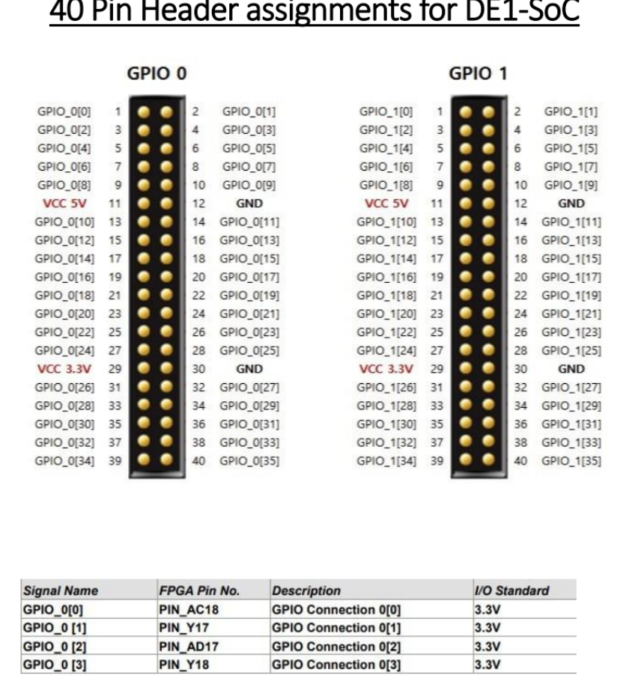

- Based on the pin assignments, GPIO_0[0] / PIN_AC18 has been assigned to UART RX and GPIO_0[1] / PIN_Y17 has been assigned to UART TX
- 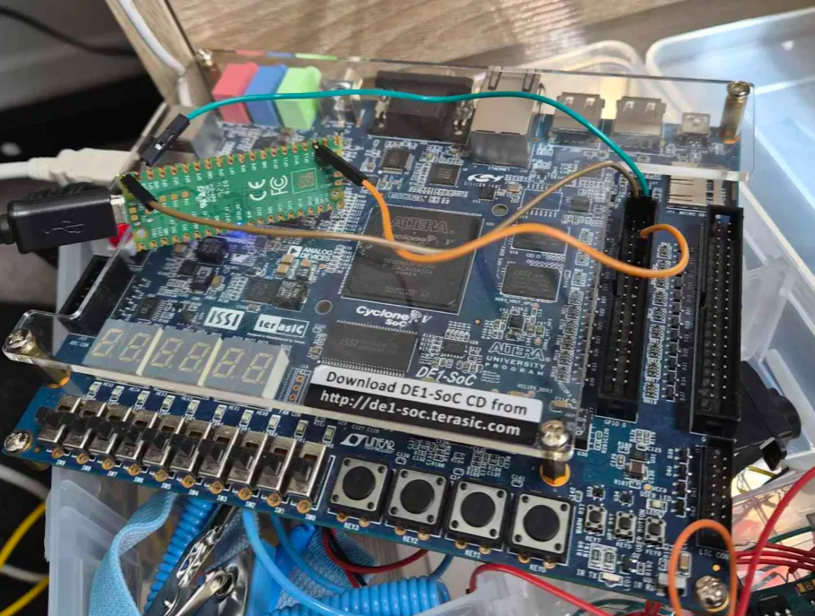
After many hours of debugging, we finding issues in NPU_wrapper, the most recent configuration of UART is:
- UART can send 8 bits / 1 byte
- GPIO_0[0] / PIN_AC18 has been assigned to UART RX and GPIO_0[1] / PIN_Y17 has been assigned to UART TX
- Pressing KEY[1] will make the FPGA send data through UART
- The data sent through is the clock cycles it took for the Systolic Array to do its computations
- The FPGA will send this and the Pico will calculate the time taken by multiplying the clock cycles by 1/50MHz.

Results:
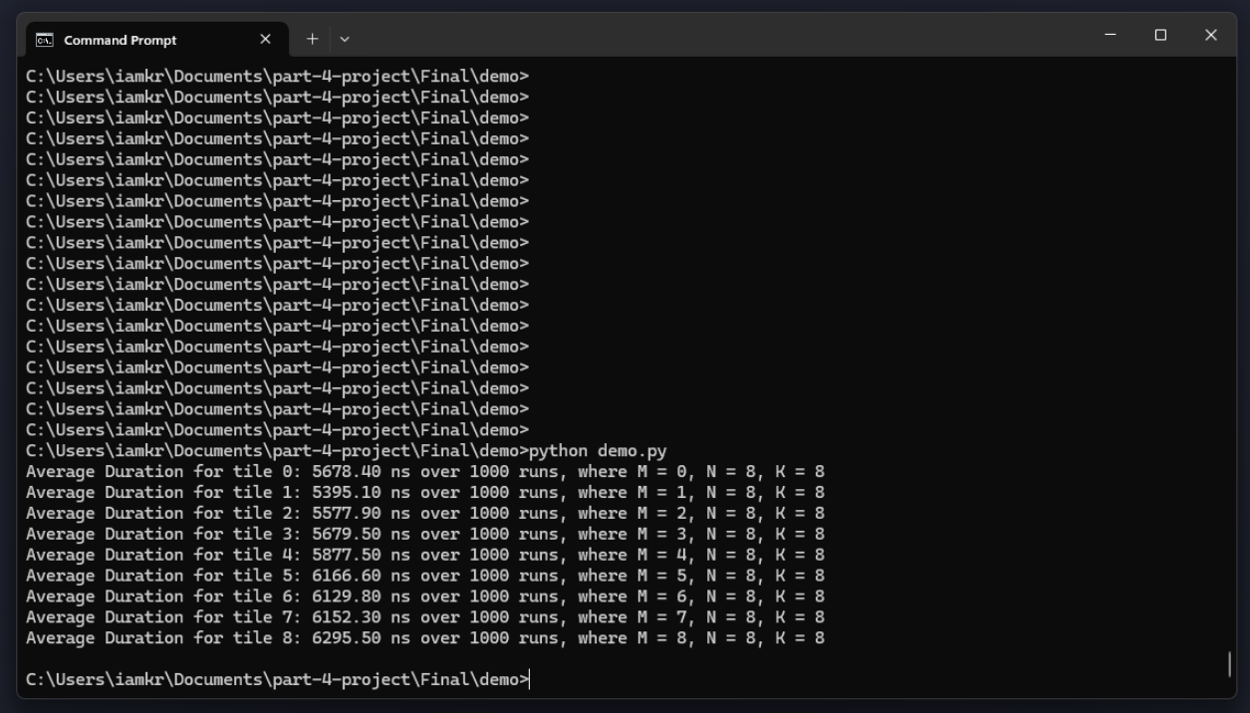

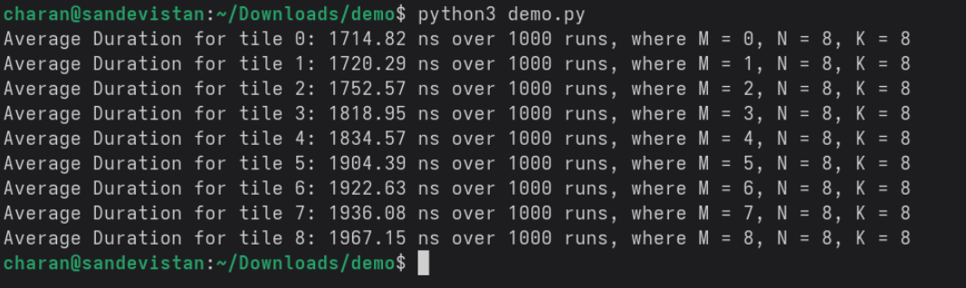

Weekly Logbook Entry Template
Week X | XX/XX/25 – XX/XX/25:
XX X XXX 2025 | Time: XX
Title:
Objective:
- Point 1

XX X XXX 2025 | Time: XX
Title:
Objective:
- Point 1

