## Supervisor-specific functionality

1. Skill adjustment for supervisors

1. Current Dialogs – supervisors need access to each rep’s current call, as well as interaction histories

*1/19 – Needs to be able to view realtime contacts per agent – what is agents status, who are they speaking with and this will drive whether or not supervisors monitor the call. KC – we would need to be able for the agent to enter the order number realtime JDS and then lookup order info to display in supervisor widget order number, name on order, agent currently on call and ability to monitor this call. In addition, they want to pull last activity from the customer (not specific to order) – this would reside in Entrylink. Agent view should show activity from caller – last 10 times the customer called in this week and what the calls were regarding. DC noted agents will live in Entrylink, but supervisor view might be in Contact Center.*

1. Call Monitoring - supervisors need access to monitor all agents within their team

*1/19 – DC there are tools to monitor sentiment, desktop records, audio recordings – table this for future enhancement*

## Agent-specific functionality

1. Popup of order when call is answered

Lookup of account is done in IVR, but order lookup is after the agent has answered. First group asks for the order number and enters in gadget.

Agent default gadget view shows these tabs. When a call is answered or placed, “My History” changes to Details of the call.

* 1. Incoming call presents Details tab with caller info:

* 1. Agent searches for order on the Order & Customer Lookup tab

* 1. Agent A then transfers to Agent B in the EntryLink group.

Call arrives with this info shown on Agent B gadget:

After Agent B answers, it presents entrylink page

The gadget contact History now shows all history for this account:

1. Agents need a faster way to lookup a callers call history, while on the call and after the call

*1/19 – On call, screenpop call history. After call, they want to be able to view this call history. DC – while on call, show call history. If after all, search button to view call history in Entrylink. KC – it sounds like they don’t currently write call history to Entrylink as an activity. Does API exist to do this? Banana guy – envisions while on call, agent enters everything in EL. After call, writes to EL so that history can be viewed. He says this is a maybe. DC – mentions agent answers to summarize notes from phonecall. (jds)*

1. Ability to lookup order, pull specific attributes, save order to cisco call data record.

*1/19 - #2 addresses this*

1. Automatic lookup phone number in entryLINK customer data(multiple tables) and return a result in cisco.
2. State action dropdown or buttons

*1/19 – agent can control state within EL*

1. Quick transfer buttons for first impressions agents – This isn’t needed for other teams

*1/19 – Banana guy – possibly pull this into menu they have now. Asked if we have iFrame or they need to control that as well.*

1. Dropdown consult/transfer options for all teams

*1/19 – DC said this sounds like it would be for the First Impressions group – KC – they will not live in Entry Link, so these buttons would reside in Contact Center – Chick – two different sets of transfer buttons. First Impressions have one click transfers from WxCC. – KC – do transfer buttons need to exist in EL? – DC – asked if there need to be different layouts in EntryLink – Answer was one layout. First Impressions can use “Native Interface”*

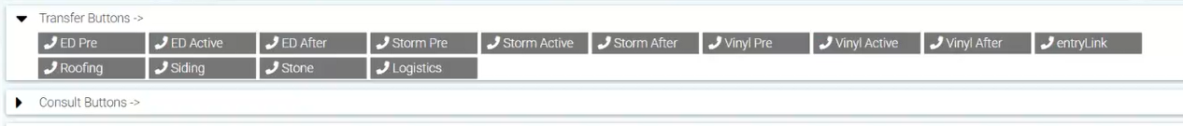

* 1. Include the workgroup extensions and employee directory

1. Wrap-up codes during call and wrap-up time countdown

Enter wrap up and then time to enter notes which are then visible from the gadget on the My History tab. Notes are not stored anywhere, but they would like this functionality if possible.

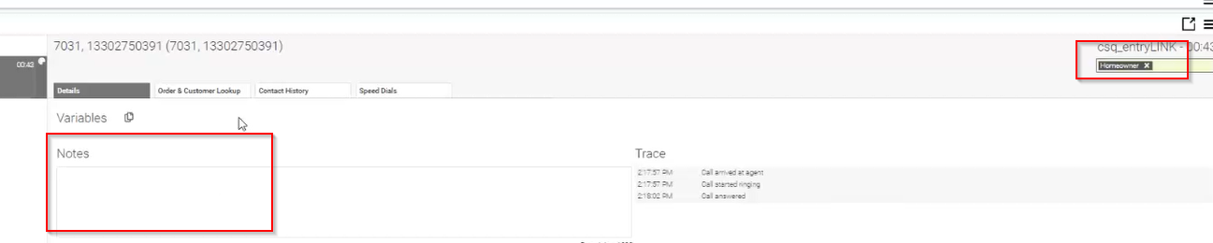

1. Visibility to teammate states

1. Visibility to count of ready agents

Visible from top of Finesse today



1. Visibility to count of calls in queue

## Strech goals for project/Wishes

1. Call notes and notes in entryLINK:
   1. Have call notes seamlessly load into the message log of the order
   2. Also saves in visible table so agents can review their calls and make additional notes

*1/19 – Discussed this above. Call history will be available in both EL and WxCC. BG – asked if there was a unique ID associated w/call. Was thinking begin recording activity when call starts directly to EL. As agent enters notes, navigates to different tab, etc, this would be recorded in EL. – Chick – we should discuss this. Agents often have multiple tabs open, etc.*

1. Single sign-on
2. Call center gadgets embedded into entryLINK or as an expandable browser extension – Remove the need to go into cisco separately from our regular work by integrating contact center functions into our regular work

*1/19 – No gadgets/widgets, we will add call controls, state change in EL*

1. Emails queued and tracked within the contact center
2. Call Recording – considering adding this in the future, and look for a simple transition once the decision is made to do so.

*1/19 – DC - We download and hyperlink recording to CRM/EL. Provia – what do we need to do for recording – just a statement that we are recording? DC instructed to review state requirements*

1. **Important information to know** – most of our agents have internet issues at home. This is a very rural area. Work from home is not offered regularly, but it is an occasional allowance made as needed. While we would like to retain this as an option, functionality that’s driven by this need is probably not essential to our operations.

*1/19**– DC noted agents can use any phone number for voice side. DC hates work from home LOL*

## Misc Notes

* Send order numbers to middleware server in place today. This system then pulls 40 variables from the order system for use in Tableau.
* Wallboards – this view shows agent names and states, calls in queue/realtime as well as historical at the bottom.

* Call history is recorded as an activity in EntryLink
* Speed dials

**DC – mid to end of April provisioning. We will build in lab, move to provisioned. Finish in 3-4 month timeframe.