ENG 270 Jad Ayoub (ID:20231228)
INTRO TO ENG Report
-Abstract:
The successful creation of a self-driving car in the experiment demonstrates the practicality of using Arduino and basic components for autonomous navigation. Overcoming challenges outlined in the introduction, such as obstacle detection and navigation control, validates the effectiveness of the chosen approach. However, there remains room for advancement, particularly in enhancing control algorithms and refining sensor parameters to enhance reliability and efficiency.
In summary, the experiment demonstrates the successful development of a prototype for a self-driving car, marking progress in addressing the problem highlighted in the introduction. The experiment achieved its goal of creating a functional autonomous vehicle capable of obstacle avoidance. Nevertheless, there are opportunities for further enhancements and optimizations.
The objective of this project was to utilize Arduino microcontroller technology alongside fundamental electronic components to construct a self-driving car. The car was outfitted with two DC motors for movement, an ultrasonic obstacle detection sensor, and LEDs for visual feedback. Through the development of a control system, the car could autonomously navigate a predefined area and evade obstacles in real-time. The experimental setup included calibrating sensors and motors, programming control logic, and connecting components to the Arduino board. Despite minor deviations in movement precision, the project effectively produced a functional prototype of an autonomous car, as evidenced by its ability to identify and circumvent obstacles.

-Introduction:

The project centers around an electric vehicle operating autonomously through an Arduino Uno R3, which we programmed to fulfill its objectives. Its main goal relies on an ultrasonic sensor to assist the vehicle's movement by detecting obstacles ahead and instructing the Arduino to steer left or right accordingly. The vehicle is powered by a battery connected to the Arduino via wires. Additionally, it features two LED lights at the front programmed to flash intermittently, mimicking those of a service vehicle. Furthermore, the DC motors operate according to the Arduino's code, enabling the vehicle to maneuver left or right upon detecting obstacles via the ultrasonic sensor. A micro servo positioned at the front rotates, resembling a steering mechanism for added realism.

-Experiment description:
In this experiment, the listed components were assembled using various tools like pliers and wire strippers to initiate the construction process. Ties and zip ties were utilized to secure components such as the Arduino and ultrasonic sensors in place.
Component List:
Arduino Uno microcontroller board
Ultrasonic sensor (HC-SR04)
Two DC motors
Two LEDs
Motor driver (L298N or similar)
Chassis for the car
Wheels and motor mounts
Power source (battery or power supply)
Jumper wires and breadboard (if necessary)
Wiring Diagram:
Arduino pin connections to components:
Ultrasonic sensor: Trigger pin to Arduino digital pin
Motor driver: Enable pins to Arduino digital pins Motor connections to motor driver outputs
LEDs: Anode to digital pins Cathode to ground
Power connections: Motor driver power inputs, Arduino power
Arduino Code:
Implementation of the self-driving algorithm:
Reading ultrasonic sensor data
Calculating distances to obstacles
Controlling motor speeds and directions based on obstacle proximity.
Activating LEDs for visual feedback
Calibration and Testing:
Calibration of ultrasonic sensor: Ensuring accurate distance measurements and adjusting sensor parameters if necessary.
Motor calibration: Ensuring both motors have similar speed and direction control for balanced movement.
Testing: Conducting tests in controlled environments to evaluate the car's performance in obstacle detection, avoidance, and overall navigation.
Challenges and Solutions:
Addressing issues such as sensor noise, motor synchronization, and power supply stability.
Debugging code for potential errors or unexpected behavior.
Fine-tuning parameters to optimize the car's performance and responsiveness.
Data Collection and Analysis:
Recording sensor readings, motor movements, and LED activations during experimental runs.
Analyzing data to evaluate the effectiveness of the self-driving algorithm and identify areas for improvement.
Safety Considerations:
Ensuring proper insulation and wiring to prevent short circuits or electrical hazards.
Supervising experiments to prevent accidents or damage to components.
Using appropriate protective gear (e.g., safety goggles) when handling tools or conducting tests.
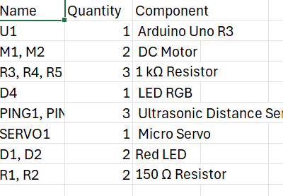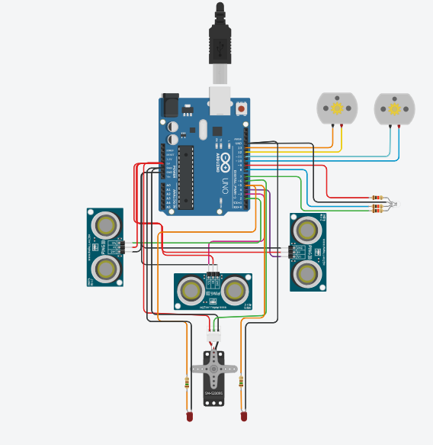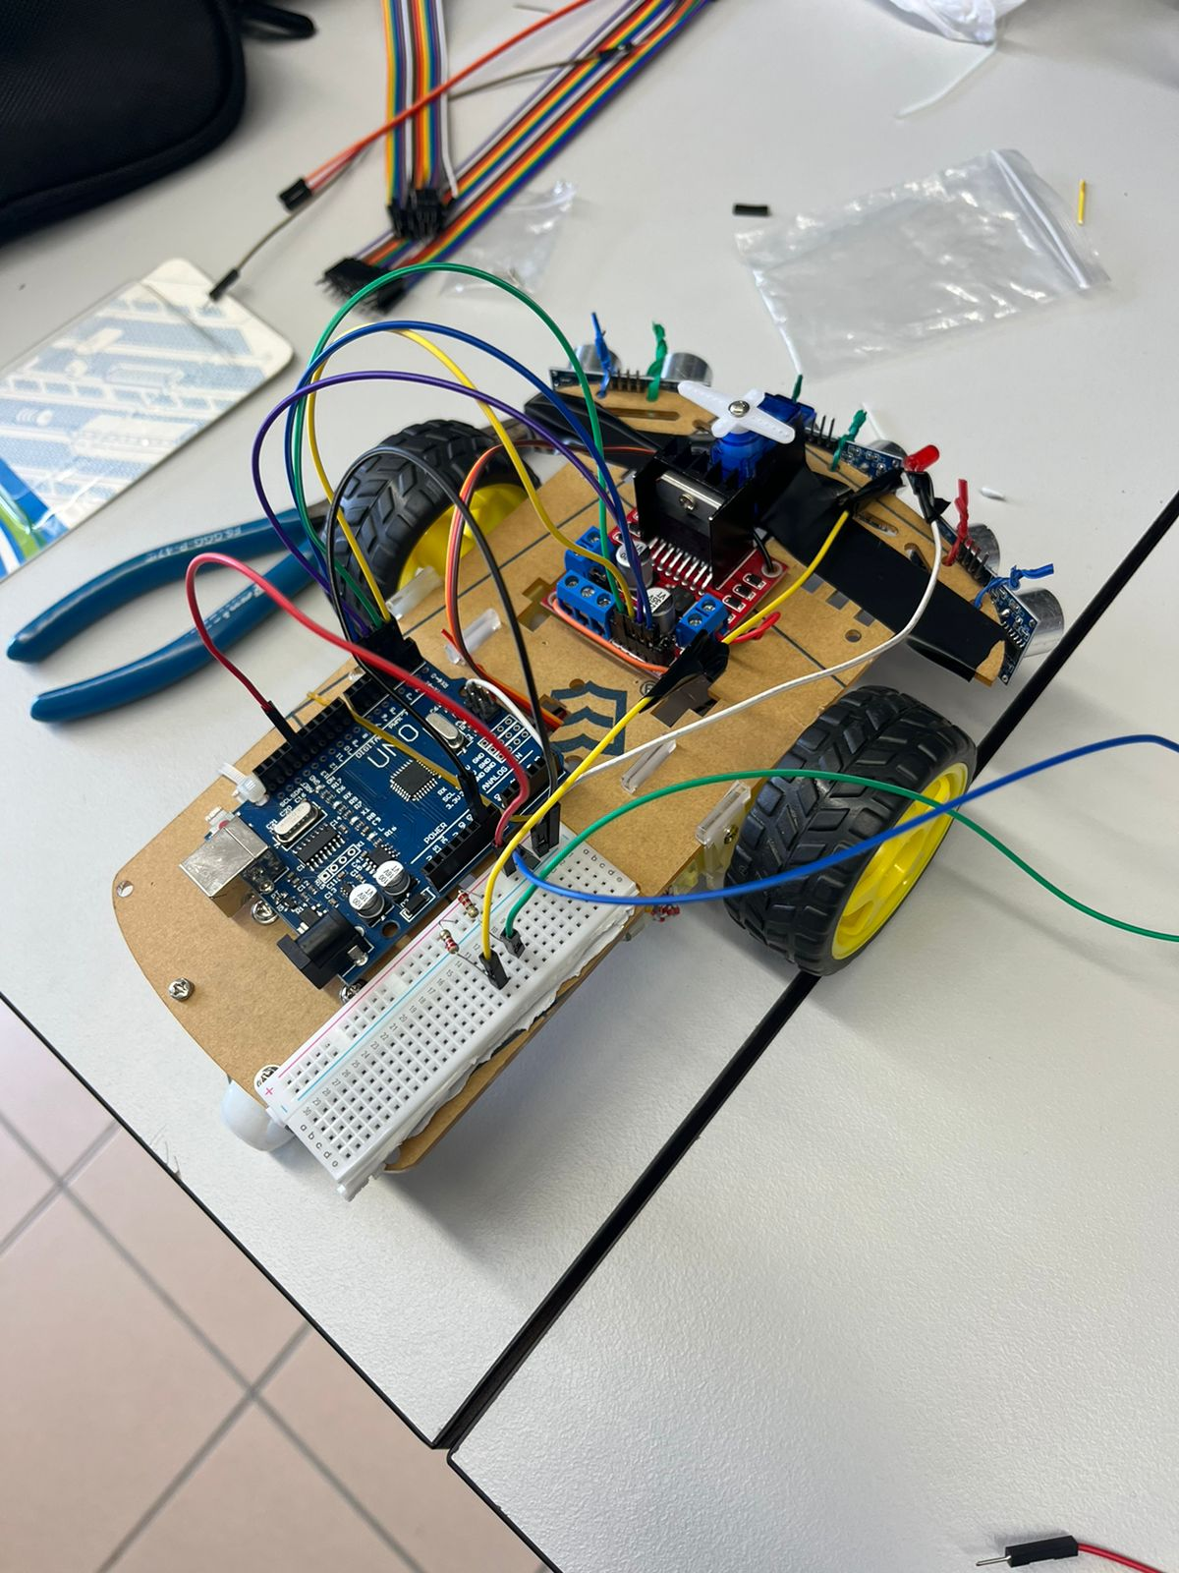

-Results and Interpretations:

Functionality of Components: The experiment successfully integrated Arduino, two DC motors, an ultrasonic sensor, and two LEDs to create a self-driving vehicle capable of navigating around obstacles.
Obstacle Detection and Avoidance: The ultrasonic sensor effectively detected obstacles in the car's path. When an obstacle was detected, the car appropriately adjusted its course to avoid collision, demonstrating the effectiveness of the obstacle avoidance algorithm.
Movement Accuracy: The car's movement was relatively accurate, with the DC motors providing sufficient power and control for navigating the environment. However, there might have been minor deviations in movement due to factors such as motor calibration or surface irregularities.
Performance Evaluation: The performance of the self-driving car met the expectations set by the experiment's design goals. It was able to maneuver through a predefined space, avoiding obstacles in real-time.
Comparison with Theory: The experimental results closely matched the theoretical expectations based on the design and programming of the self-driving system. Any discrepancies observed could be attributed to real-world factors such as sensor noise, motor limitations, or environmental conditions.
Improvement Opportunities: To enhance the accuracy and reliability of the self-driving car, several modifications could be considered. These include fine-tuning the sensor parameters, optimizing the control algorithm, and implementing feedback mechanisms for better navigation control.
-Conclusion:
The successful creation of a self-driving car in the experiment demonstrates the feasibility of using Arduino and basic components for autonomous navigation. Overcoming challenges outlined in the introduction, such as obstacle recognition and navigation control, validates the effectiveness of the chosen approach. However, there is room for further development, particularly in enhancing control algorithms and refining sensor values to enhance reliability and performance.
In summary, the experiment demonstrates the successful creation of a prototype for a self-driving car, marking progress in addressing the issue outlined in the introduction. The experiment achieved its goal of constructing a functional autonomous vehicle capable of evading obstacles. Nevertheless, there are opportunities for further refinement and optimization.

-Appendix:
