AI Judges for Car-Aesthetics Ratings
Top judges vs. baselines — full-pool evaluation, per-dimension metrics, and significance tests
Full pool: 672 raters × 20 held-out cars × 5 dimensions (67,200 predictions per run), 2 random seeds, seed-averaged. Generated 2026-07-27.

Executive summary
Twelve of a rater’s own car ratings, shown to the model as in-context exemplars, do almost all of the work. Moving from the constant population-mean baseline to the exemplar judge b_persona cuts mean absolute error from 1.256 to 0.852 and lifts rank agreement (ICC) from ≈0 to 0.665. Every other lever tested — interpreted-demographic “taste cards,” a two-stage prediction recipe, and their combination — is worth at most 0.0055 MAE on top of that — under 2% of what the exemplars deliver.
The best guide-conditioned design, g_card_twostage, posts the lowest MAE overall (0.846) and the effect is statistically real (95% CI excludes zero on both seeds; Wilcoxon p ≈ 3×10⁻³). But it is a calibration gain, not a personalization gain: rank-agreement metrics (ICC, Spearman ρ, within-rater ρ) tick down by ~0.002, and the entire MAE improvement is concentrated in the single preference dimension (−0.017). By the pre-registered rule — a winning judge must lower MAE and raise ICC/ρ — b_persona remains the recommended judge; g_card_twostage is documented as an optional MAE-only variant.
The new population-mean baseline is itself informative: at MAE 1.256 it is worse than the 0-shot LLM (1.161), and because it is constant within a dimension it has no ability to rank cars at all (ICC = 0, ρ undefined). It marks the true floor against which every judge’s ranking ability should be read.

Methods

Judges and baselines
All numbers are recomputed from scratch from the per-cell prediction files of the full-pool confirmation runs (tag confirm800), independently reproducing the run-level MAE/ICC/ρ to four decimals. Five systems are compared:
- Population mean (constant) — NEW baseline. For each dimension, predict the grand mean of that dimension across the evaluation set. The simplest possible predictor: it captures the level of each attribute and nothing about which car or which person.
- Per-car mean (consensus) — reference baseline. Predict each car’s average rating per dimension (the population consensus). Strong on shared taste; identical for every rater of a given car, so it cannot personalize.
- b_nocontext (no-context, 0-shot). The image-only LLM judge with no exemplars — the project’s standing anchor for “what the model knows before it sees the person.”
- b_persona (recommended). 12 random own-car exemplars + persona prompt. The incumbent winner of the earlier lever sweep.
- g_card_twostage (variant). b_persona plus a per-rater taste card (interpreted demographics/Big-Five) and the two-stage recipe (estimate shared styling first, then convert to the person’s numbers).
Metrics per dimension and overall: MAE, RMSE, within-1 accuracy, ICC(2,1) absolute agreement, Spearman ρ, quadratic-weighted κ, and within-rater ρ (mean over raters of the correlation between a rater’s true and predicted ratings). Statistical tests: paired Wilcoxon signed-rank on per-cell absolute errors, and 95% confidence intervals on ΔMAE from a cluster bootstrap that resamples raters (2,000 iterations), so the uncertainty respects the 672 independent people rather than the 67,200 correlated cells.

Overall results
Judge / baseline | MAE ↓ | RMSE ↓ | Within-1 ↑ | ICC(2,1) ↑ | Spearman ρ ↑ | Wtd κ ↑ | Within-rater ρ ↑
Population mean (constant) | 1.256 | 1.491 | 0.427 | — | — | — | —
No-context (0-shot LLM) | 1.161 | 1.517 | 0.686 | 0.427 | 0.448 | 0.427 | 0.483
Per-car mean (consensus) | 1.001 | 1.234 | 0.589 | 0.539 | 0.603 | 0.523 | 0.621
b_persona (recommended) | 0.852 | 1.236 | 0.813 | 0.665 | 0.664 | 0.665 | 0.593
g_card_twostage (variant) | 0.846 | 1.221 | 0.816 | 0.663 | 0.662 | 0.663 | 0.592
Table 1. Seed-averaged overall metrics. Arrows show the good direction. The population-mean baseline’s rank metrics are shown as “—”: within a dimension it is constant, so ICC/ρ are 0 or undefined.
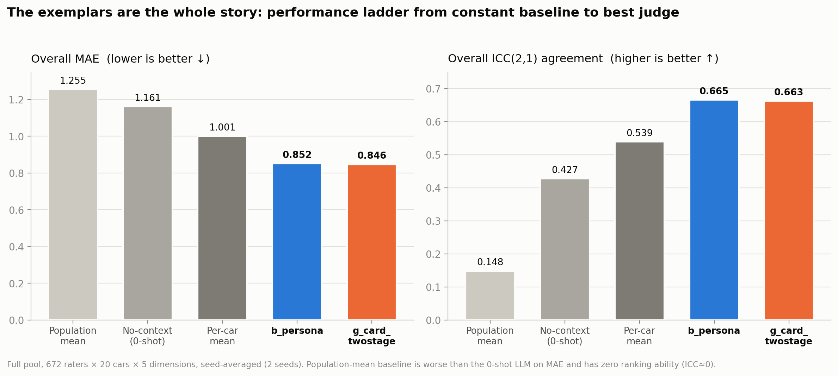
Figure 1. Performance ladder from the constant baseline to the best judge. The large gaps are baseline→exemplar; b_persona and g_card_twostage are visually indistinguishable.
Reading the ladder: the population-mean baseline (MAE 1.256) is beaten by the 0-shot LLM (1.161), which is beaten by per-car consensus (1.001), which is beaten by the personalized exemplar judges (~0.85). The single largest jump is adding the 12 exemplars — 0.31 MAE, about 27% — which also carries ICC from 0.427 to 0.665. Everything after that is a rounding error by comparison.

Per-dimension results
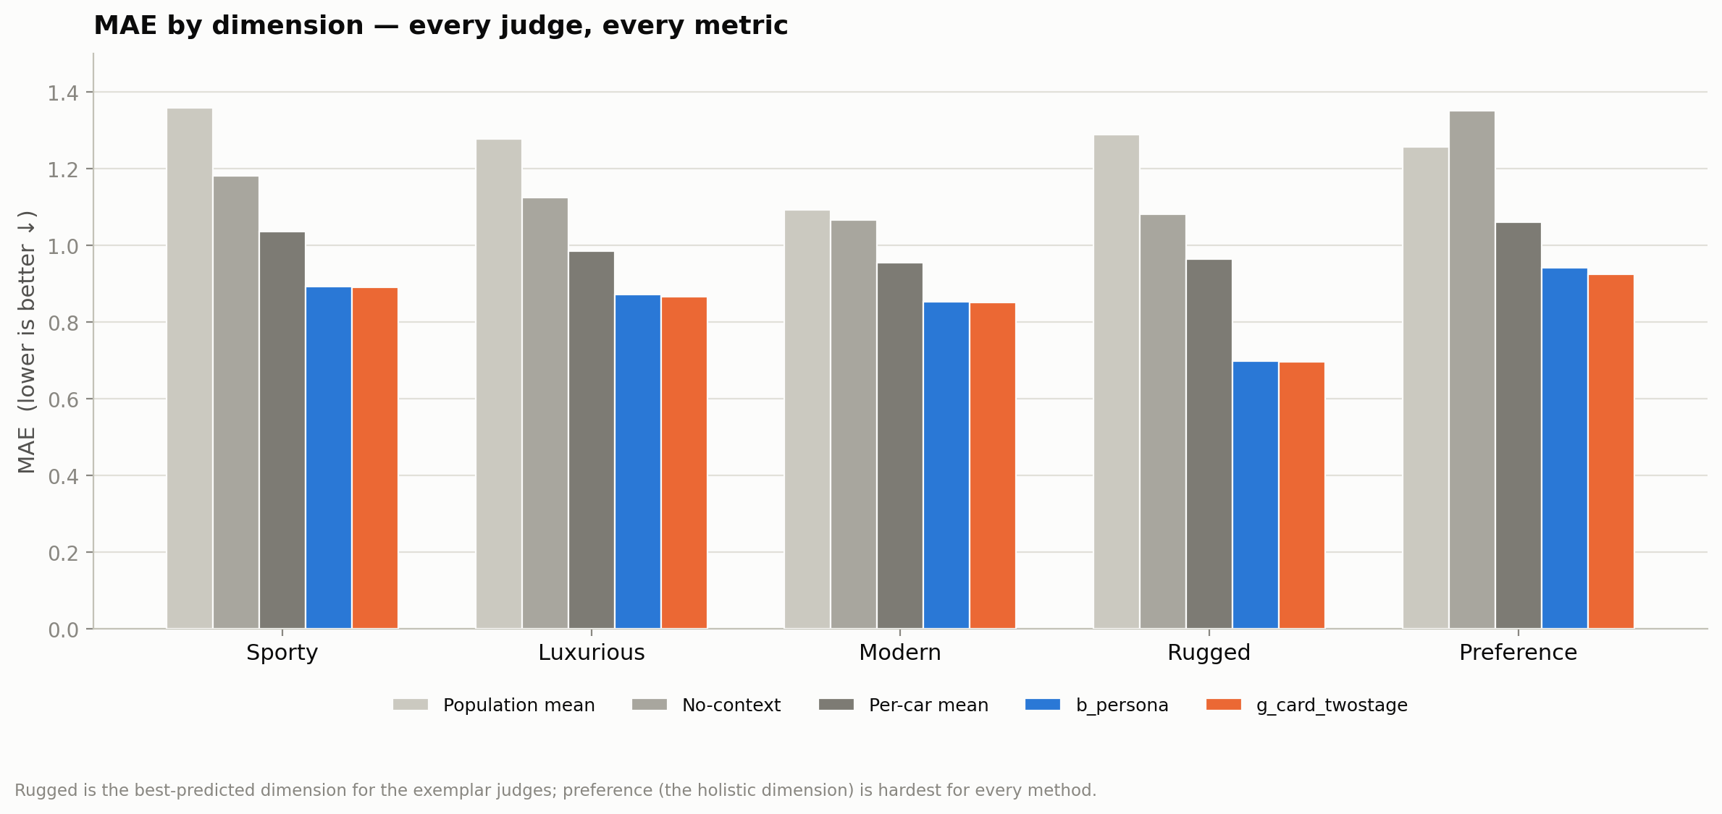
Figure 2. MAE for every judge across all five dimensions. Rugged is the best-predicted dimension for the exemplar judges (MAE ≈ 0.70); preference is the hardest for every method.

MAE by dimension
Judge / baseline | Sporty | Luxurious | Modern | Rugged | Preference
Population mean | 1.360 | 1.279 | 1.093 | 1.289 | 1.257
No-context | 1.182 | 1.125 | 1.067 | 1.081 | 1.351
Per-car mean | 1.037 | 0.986 | 0.955 | 0.965 | 1.061
b_persona (recommended) | 0.893 | 0.872 | 0.853 | 0.698 | 0.942
g_card_twostage (variant) | 0.891 | 0.868 | 0.852 | 0.696 | 0.924
Table 2. Seed-averaged MAE per dimension (lower is better).

ICC(2,1) agreement by dimension
Judge / baseline | Sporty | Luxurious | Modern | Rugged | Preference
Population mean | 0.00 | 0.00 | 0.00 | 0.00 | 0.00
No-context | 0.382 | 0.345 | 0.289 | 0.509 | 0.178
Per-car mean | 0.514 | 0.513 | 0.424 | 0.533 | 0.382
b_persona (recommended) | 0.641 | 0.620 | 0.585 | 0.728 | 0.567
g_card_twostage (variant) | 0.633 | 0.618 | 0.577 | 0.725 | 0.575
Table 3. Seed-averaged ICC(2,1) per dimension (higher is better). The constant baseline is 0 by construction.
Two patterns stand out. First, rugged is where the exemplar judges do best in both error (MAE 0.70) and agreement (ICC 0.73) — consistent with rugged carrying a strong, legible personal signal that 12 examples capture cleanly. Second, preference is uniformly the hardest holistic dimension, and it is the only place the two-stage recipe moves the needle (see below).

Full metric suite, one figure per dimension
Each panel shows all five systems on one dimension: error metrics on the left (lower is better), agreement/ranking metrics on the right (higher is better). The constant baseline’s ranking bars are marked “n/a”.
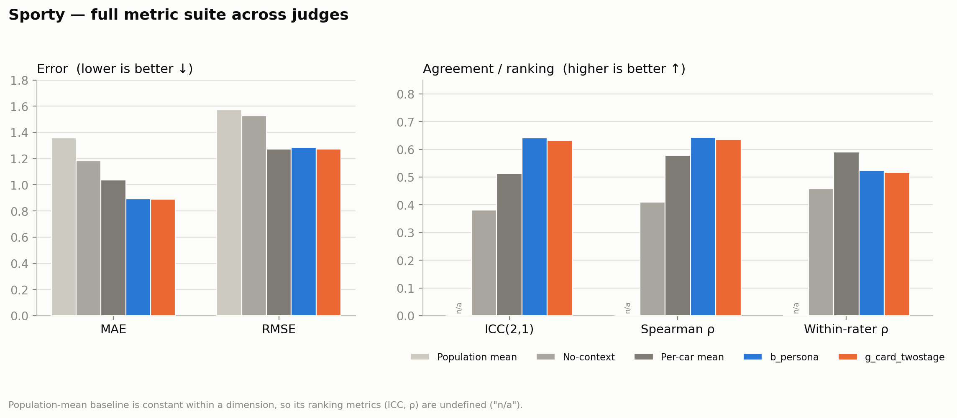
Figure 3. Sporty: MAE/RMSE and ICC/ρ/within-rater ρ across all judges and baselines.
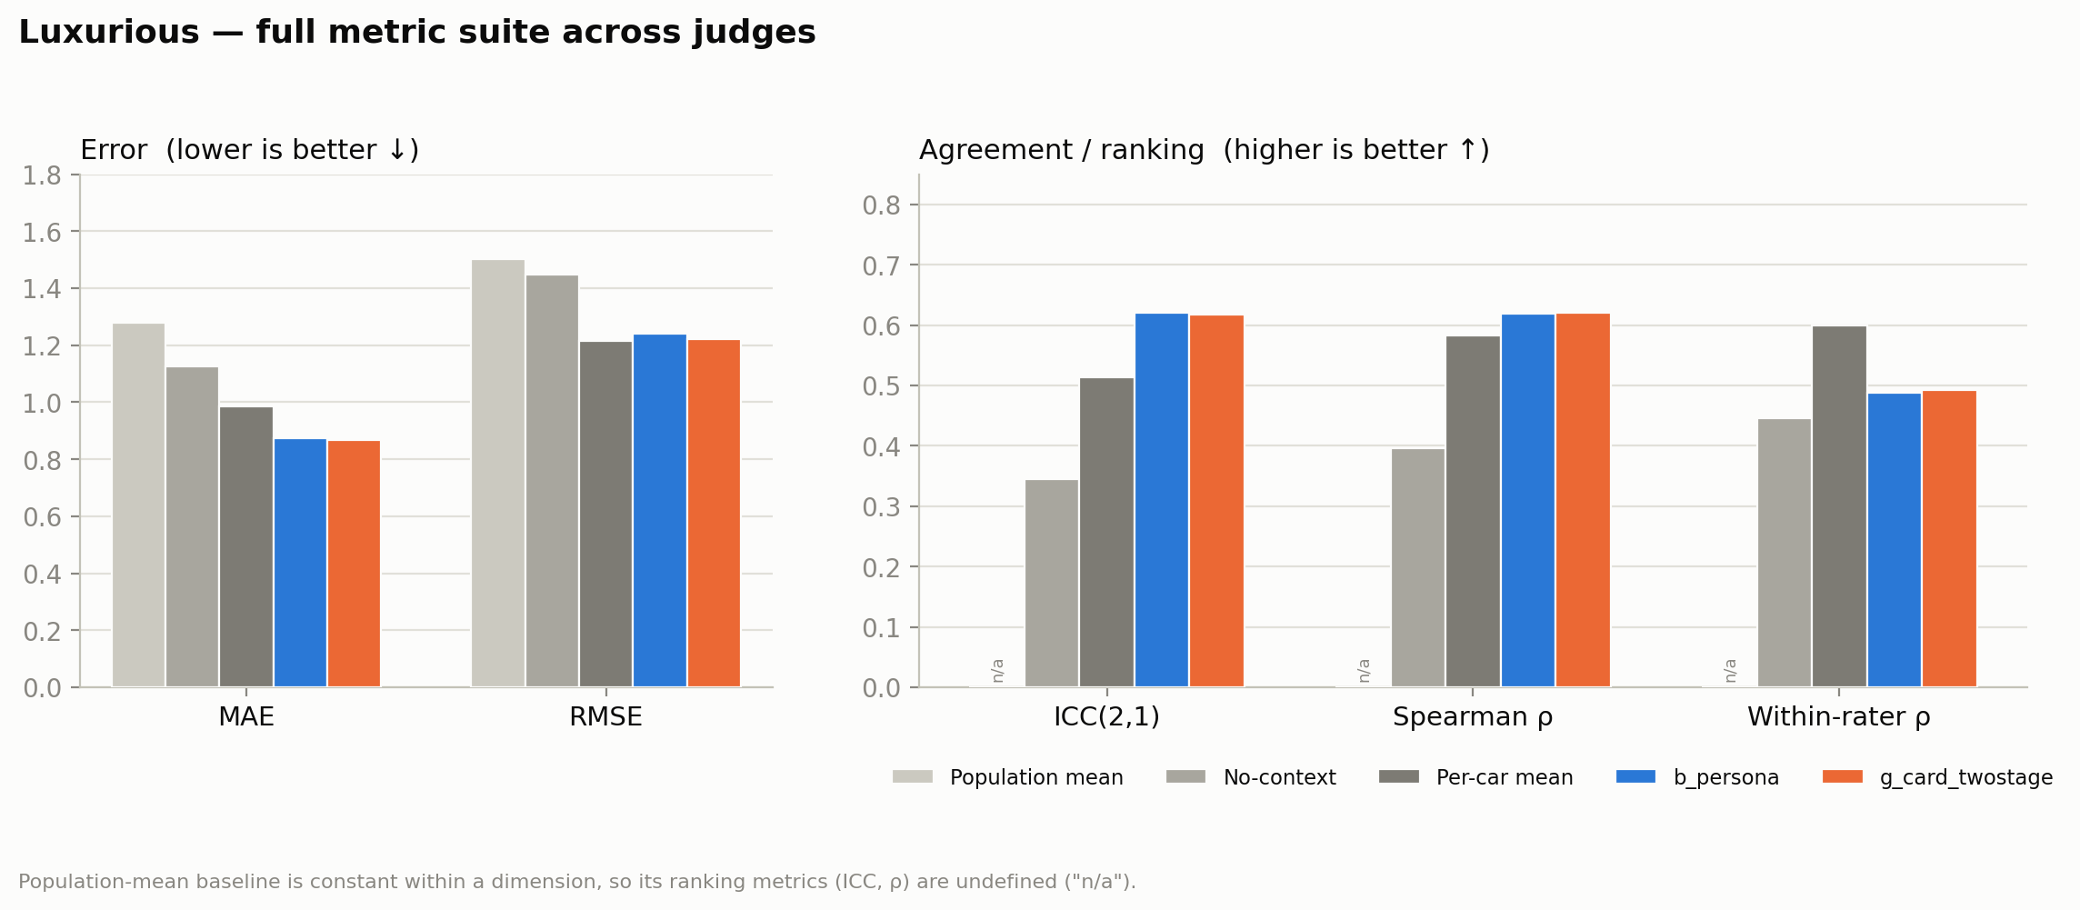
Figure 4. Luxurious: MAE/RMSE and ICC/ρ/within-rater ρ across all judges and baselines.
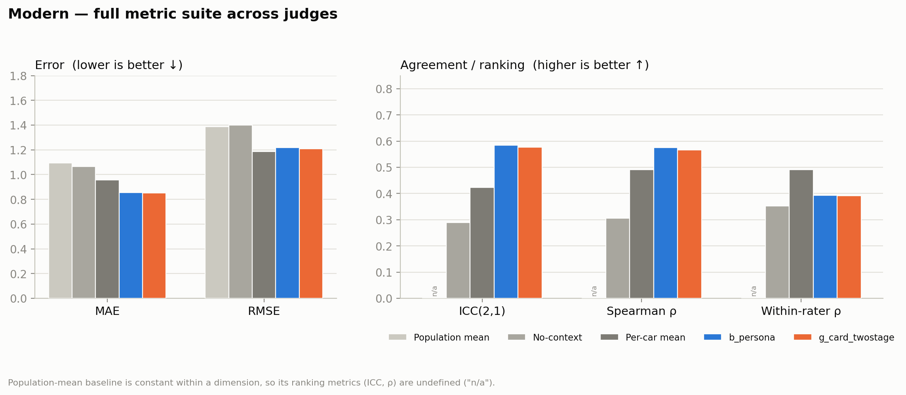
Figure 5. Modern: MAE/RMSE and ICC/ρ/within-rater ρ across all judges and baselines.
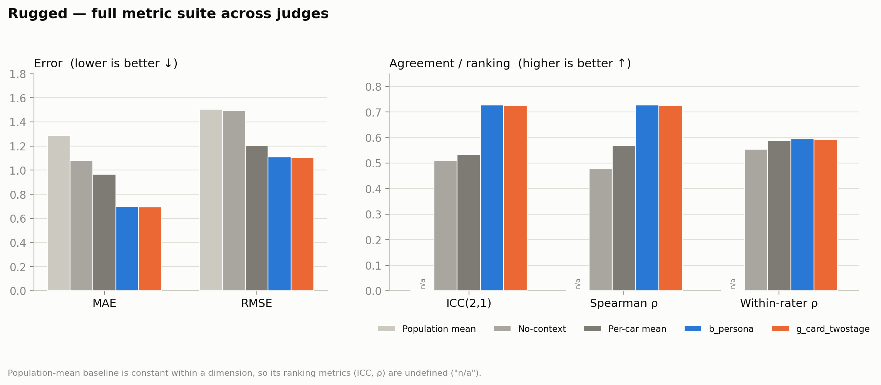
Figure 6. Rugged: MAE/RMSE and ICC/ρ/within-rater ρ across all judges and baselines.
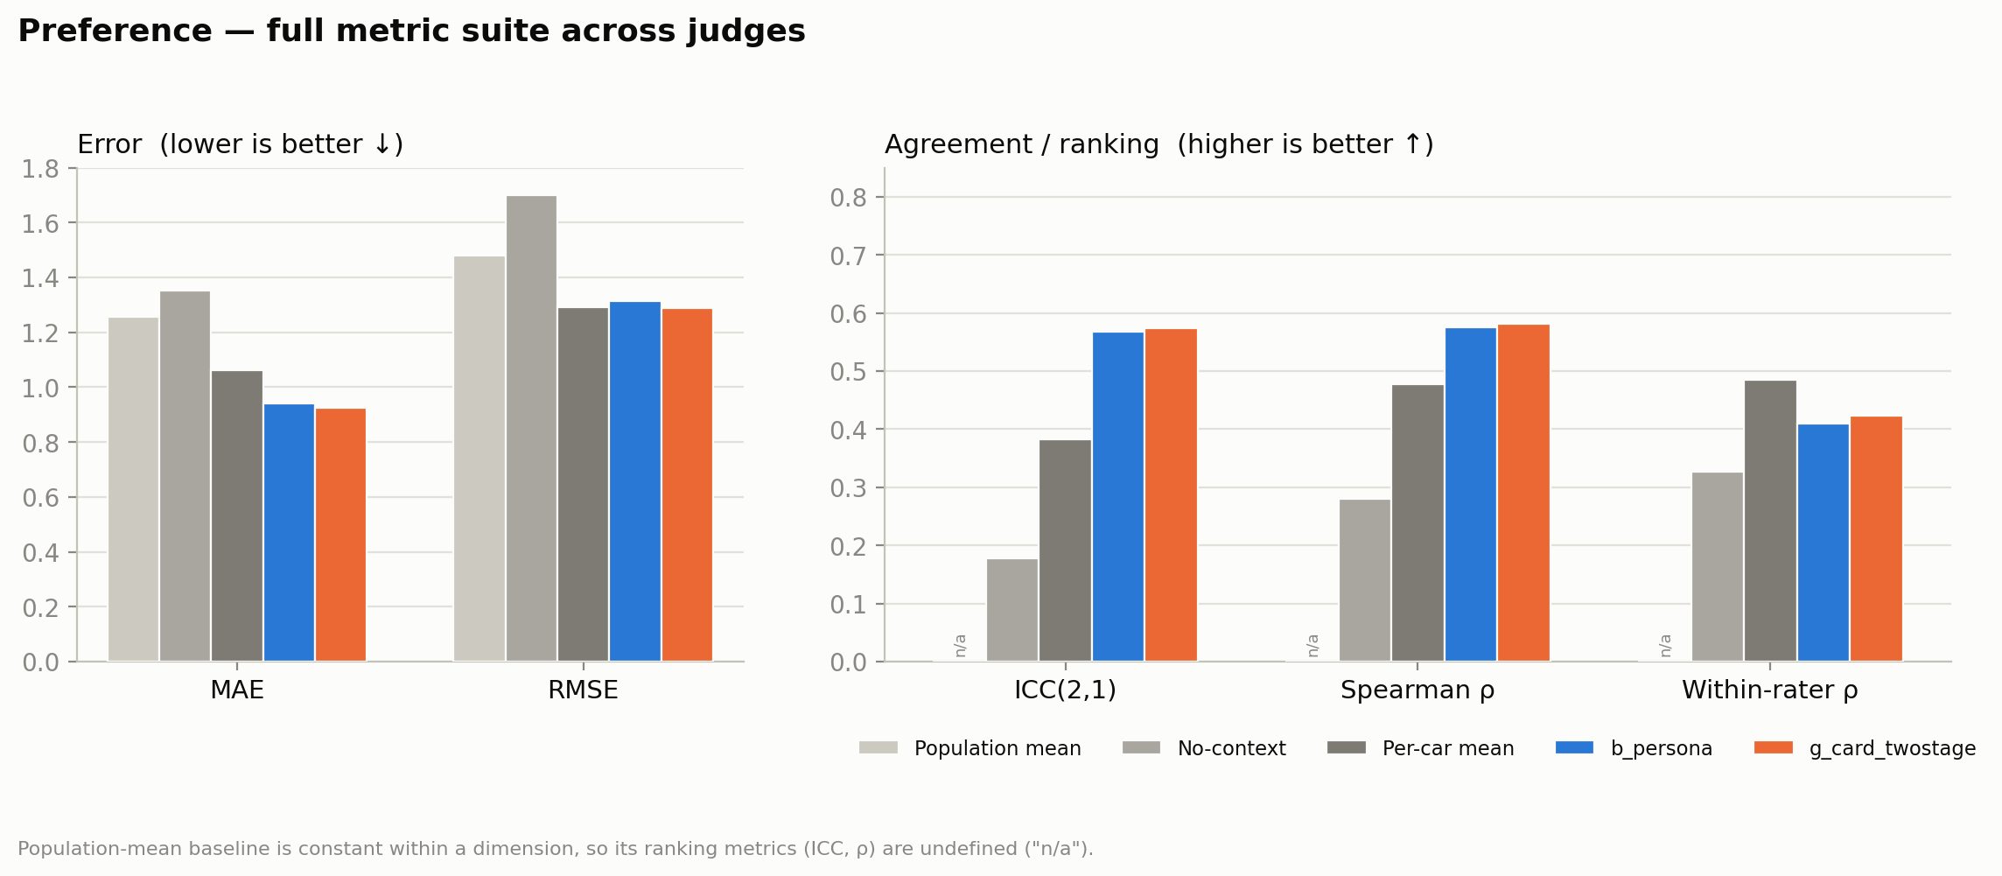
Figure 7. Preference: MAE/RMSE and ICC/ρ/within-rater ρ across all judges and baselines.

Statistical comparisons
Comparison (A − B) | ΔMAE | 95% CI (cluster boot.) | Wilcoxon p | Verdict
No-context − Population mean | −0.094 | [−0.112, −0.077] | 5e-92 | LLM beats constant
Per-car mean − Population mean | −0.255 | [−0.266, −0.244] | <1e-300 | consensus ≫ constant
b_persona − Population mean | −0.404 | [−0.426, −0.382] | <1e-300 | huge
g_card_twostage − Population mean | −0.409 | [−0.431, −0.389] | <1e-300 | huge
b_persona − No-context | −0.309 | [−0.330, −0.290] | <1e-300 | value of context
b_persona − Per-car mean | −0.149 | [−0.169, −0.130] | <1e-300 | personalization gain
g_card_twostage − b_persona | −0.0055 | [−0.010, −0.001] | 3.2e-3 | real, tiny, MAE-only
Table 4. Paired ΔMAE (A − B, negative means A is better), 95% cluster-bootstrap CI (clustered by rater), and paired Wilcoxon p (larger of the two seeds). Every comparison excludes zero.
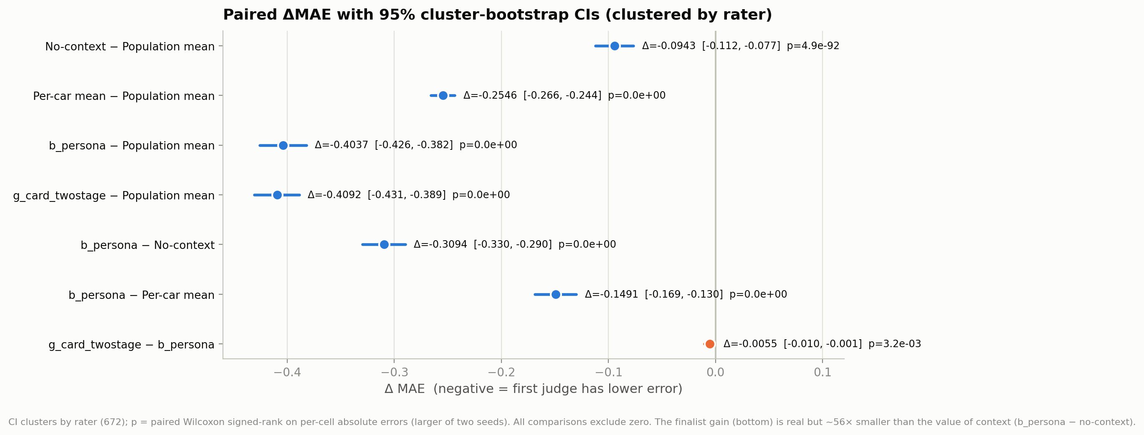
Figure 8. The same comparisons as a forest plot. The value of context (b_persona − no-context, −0.31) dwarfs the finalist gain (g_card_twostage − b_persona, −0.0055) by roughly 56×.
All differences are statistically significant, but effect sizes span two orders of magnitude. The finalist improvement of g_card_twostage over b_persona is real and replicated — the cluster-bootstrap CI excludes zero on both seeds and the effect is 3× the measured run-to-run noise floor — yet it is about 1.8% of the value the exemplars themselves provide.

Where the two-stage recipe helps: preference only
Dimension | ΔMAE (variant − b_persona) | Wilcoxon p (seed 0, 1) | CI excludes 0?
Sporty | −0.0019 | 0.393, 0.050 | no
Luxurious | −0.0048 | 0.346, 0.138 | no
Modern | −0.0014 | 0.864, 0.327 | no
Rugged | −0.0017 | 0.150, 0.742 | no
Preference | −0.0174 | 0.000, 0.015 | yes ✓
Table 5. g_card_twostage vs. b_persona, per dimension. Only preference is significant; the other four dimensions are indistinguishable from the incumbent.
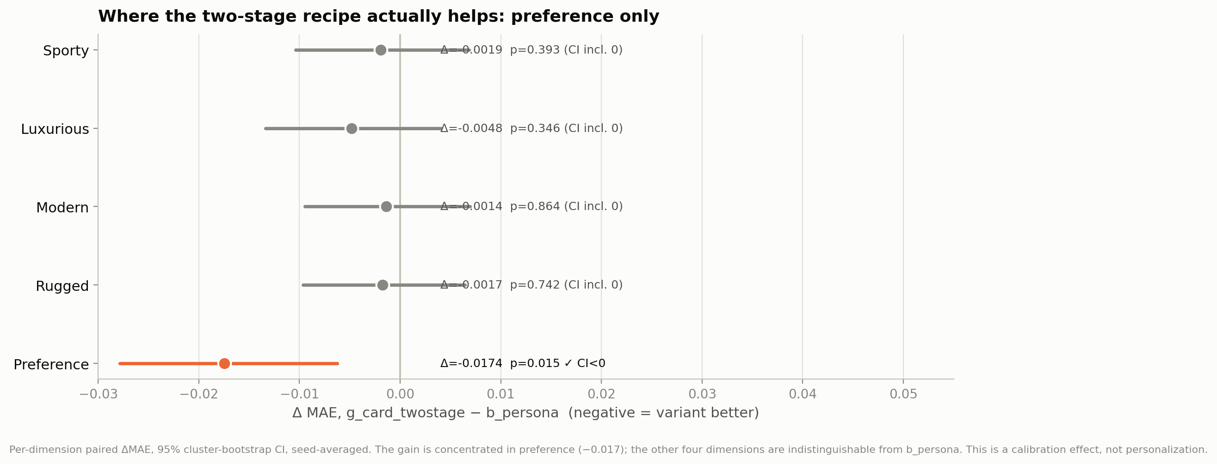
Figure 9. Per-dimension ΔMAE for the finalist vs. incumbent. The gain lives entirely in preference (−0.017); the other four straddle zero.
This is the crux of the verdict. The two-stage recipe improves the level of predictions on the hardest holistic dimension (population anchoring pulls preference predictions toward better-calibrated values), but it does not track any person’s ordering of cars better than b_persona already does. Its overall ICC and ρ are fractionally lower, not higher — the signature of a calibration effect rather than sharper personalization.

The population-mean baseline in context
The requested constant baseline answers a specific question: how much of each judge’s accuracy is just knowing the average rating? The answer is “less than you might fear, and none of the ranking.” On MAE the constant scores 1.256 — actually worse than the 0-shot LLM, because guessing 3.5 for every car pays a large penalty on the extremes. More importantly, a constant has zero rank information: within any dimension its ICC is 0 and Spearman ρ is undefined. So the ICC gap from 0 (constant) to 0.665 (b_persona) is a clean measure of how much genuine car-to-car and person-to-person discrimination the judge adds over knowing nothing but the mean. The median would shave a little off the constant’s MAE, but not its total absence of ranking ability.
The per-car consensus baseline is the more demanding reference: at MAE 1.001 / ICC 0.539 it already captures the large shared component of taste, and it even edges b_persona on average within-rater ρ (0.621 vs 0.593) because most of a person’s car-to-car ordering is shared. b_persona’s advantage over consensus (ΔMAE −0.149, ICC +0.126) is precisely the personalization headroom — the part of the signal that is specific to the individual.

Reliability and the noise floor
An identical re-run of b_persona (same config, same split, seed 0) reproduced MAE to within 0.00003 (0.853140 vs 0.853110), even though ~15% of individual cell predictions flip between runs due to server-side nondeterminism at temperature 0. Aggregate metrics are therefore rock-stable at N = 672 while individual predictions are noisy — which is exactly why the finalist effect had to be confirmed at the full pool: the 150-rater search had estimated it at −0.014, three times larger, a textbook winner’s-curse shrinkage once the full sample was in.

Verdict and recommendation
- Ship b_persona. It is the only design that satisfies the pre-registered win rule (lower error and higher agreement). Overall MAE 0.852, ICC 0.665, ρ 0.664.
- Keep g_card_twostage as a documented MAE-only variant. Its −0.0055 MAE edge is real and replicated but is calibration, not personalization: ICC/ρ tick down and the gain is confined to preference. Prefer it only where absolute error on preference is the sole objective and per-person ranking does not matter.
- Lead with the taste-card null. Interpreting demographics into structured priors adds nothing measurable over the raw exemplars — 12 rated examples already encode the person’s leniency, spread, and tilt. This is a clean, defensible negative result.
- Spend the next runs on ranking, not calibration. Every method plateaus at ICC ≈ 0.66 / within-rater ρ ≈ 0.59; nothing tested moved person-specific ranking. The most promising untried lever is guide-conditioned context selection — using the taste card to choose which exemplars to show (e.g. spanning the rugged/preference axes) — because it attacks ranking, the one axis that has not moved since exemplars were introduced.

