Program 1:

Program 2:

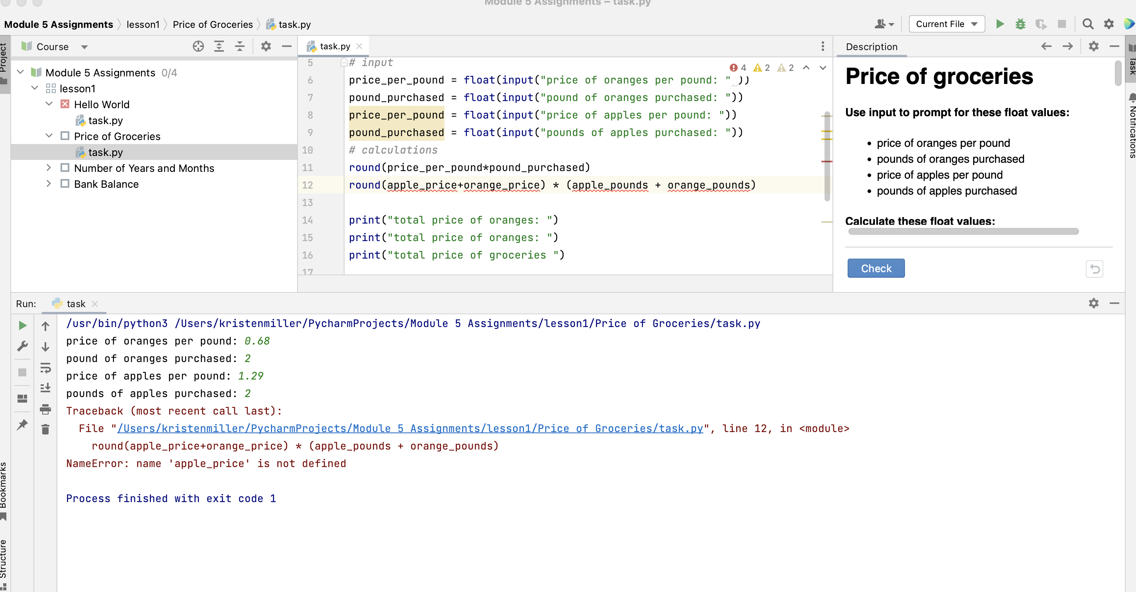

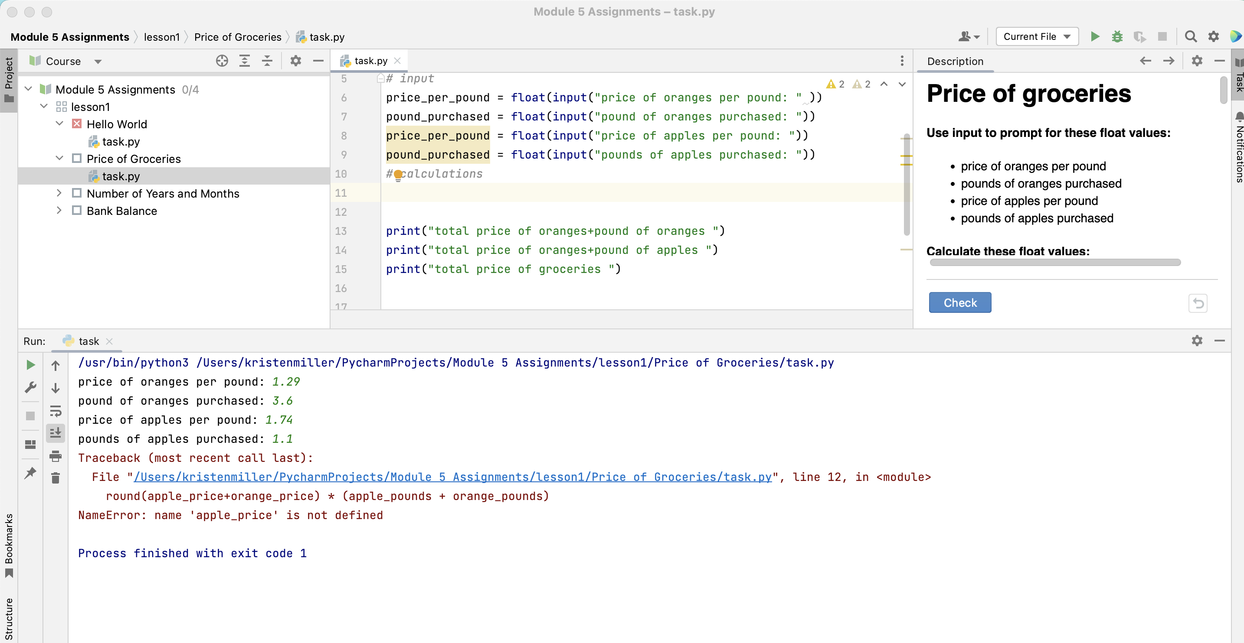

Program 3:

Program 4:



