

Foundation Programming Assignment 1

Kristian Welsh



October 27, 2015

University of Sussex, School of Engineering and Informatics

Contents

Jackson Structured Programming Diagram 2

Value Restrictions 3

Screen Layouts 4

Storyboard 5

Code listing 6

Proof of testing 10

Evaluation 11

Appendix 12

# Jackson Structured Programming Diagram

program.c

Display output

Calculate cost

Get user input

A

B

C

Ask width

Ask height

Ask length

Ask paint type

Ask undercoat

Ask labour

A

Ask name

Calculate area

Calculate materials

Calculate labour

Calculate VAT

B

Paint cost

Undercoat cost O

Economy paint O

Standard paint O

Deluxe paint O

Raise to min labour O

Display Matterials

Display labour

Display VAT

Display Total

C

Display name

Figure 1 – A Jackson Structured Programming diagram showing the intended design of my application

# Value Restrictions

Here is a table showing the restrictions that were placed on the user’s inputs.

|  |  |  |  |
| --- | --- | --- | --- |
| **Value Name** | **Minimum** | **Maximum** | **Specific Allowed** |
| Name |  |  |  |
| Height | 2 | 6 |  |
| Width | 1 | 25 |  |
| Length | 1 | 25 |  |
| Paint Type |  |  | E, S, L |
| Undercoat |  |  | Y, N |
| Labour Hours |  |  |  |

Table 1 – The restrictions placed on user inputs.

# Screen Layouts

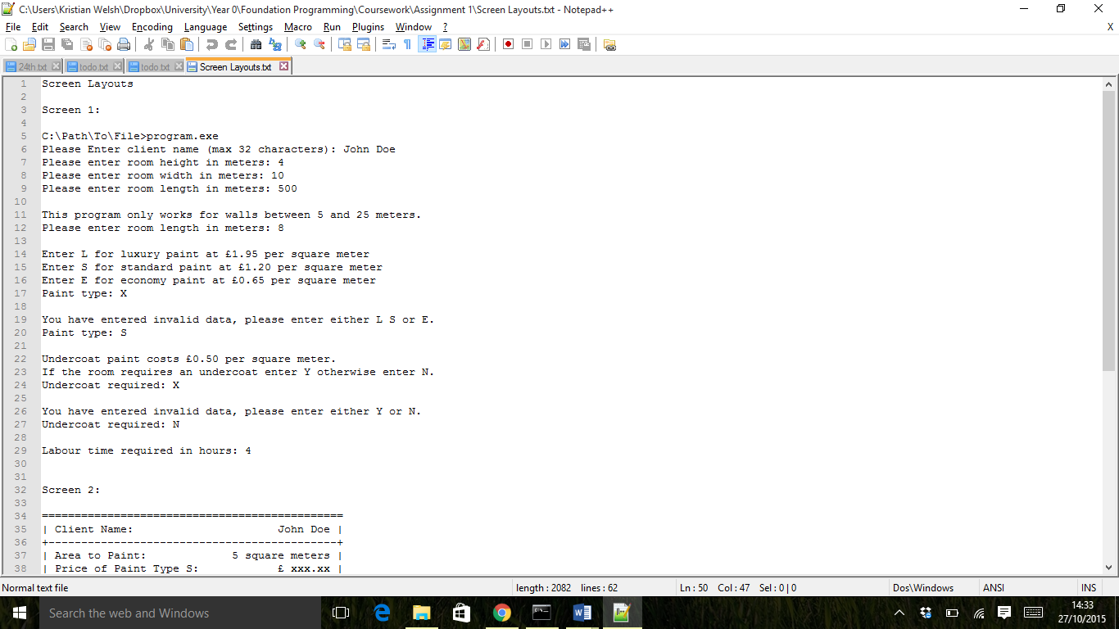

Figure 2 – The intended design of the first screen of my application

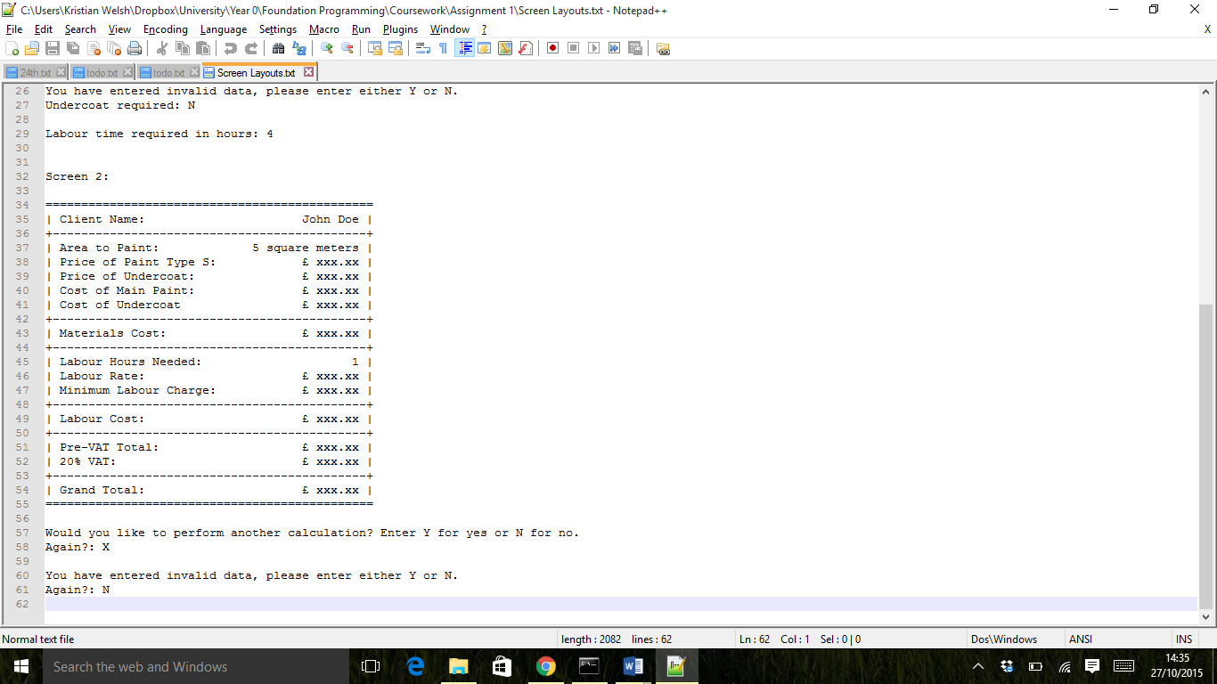

Figure 3 – The intended design of the second screen of my application

# Storyboard

Program Start

Screen 1

Screen 2

Program End

Figure 4 - A storyboard showing how my application transitions between screens

# Code listing

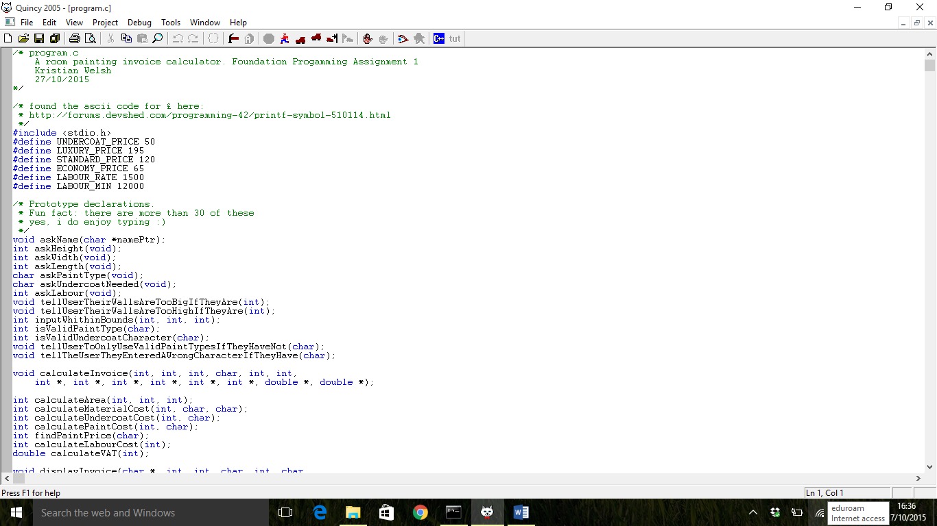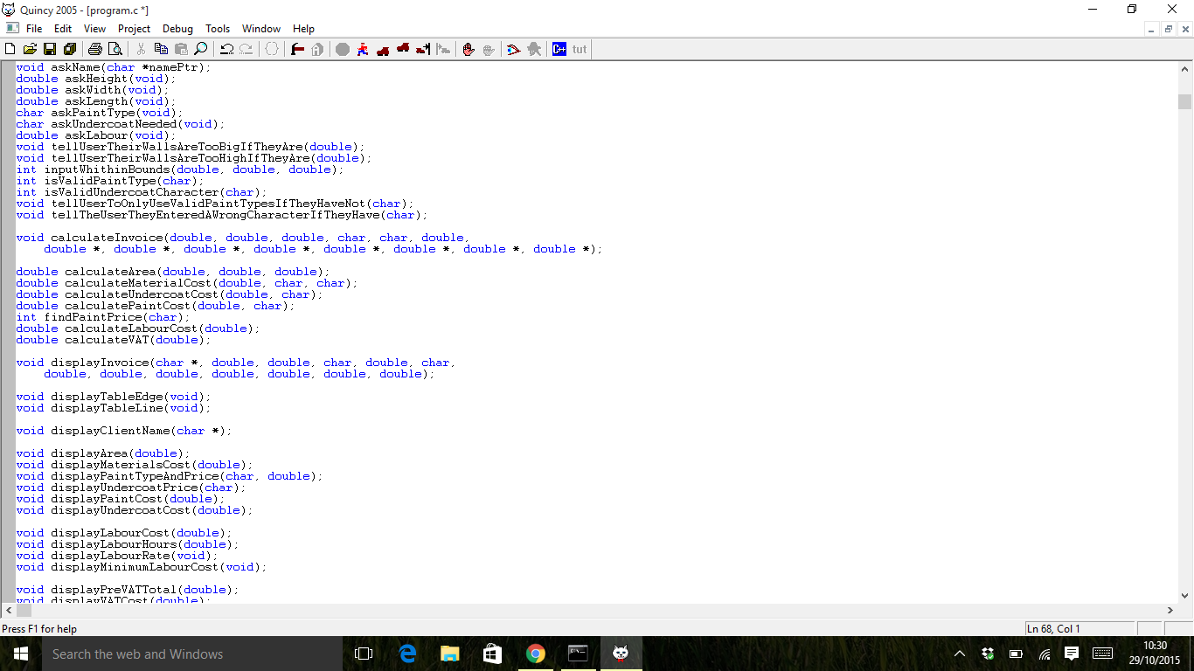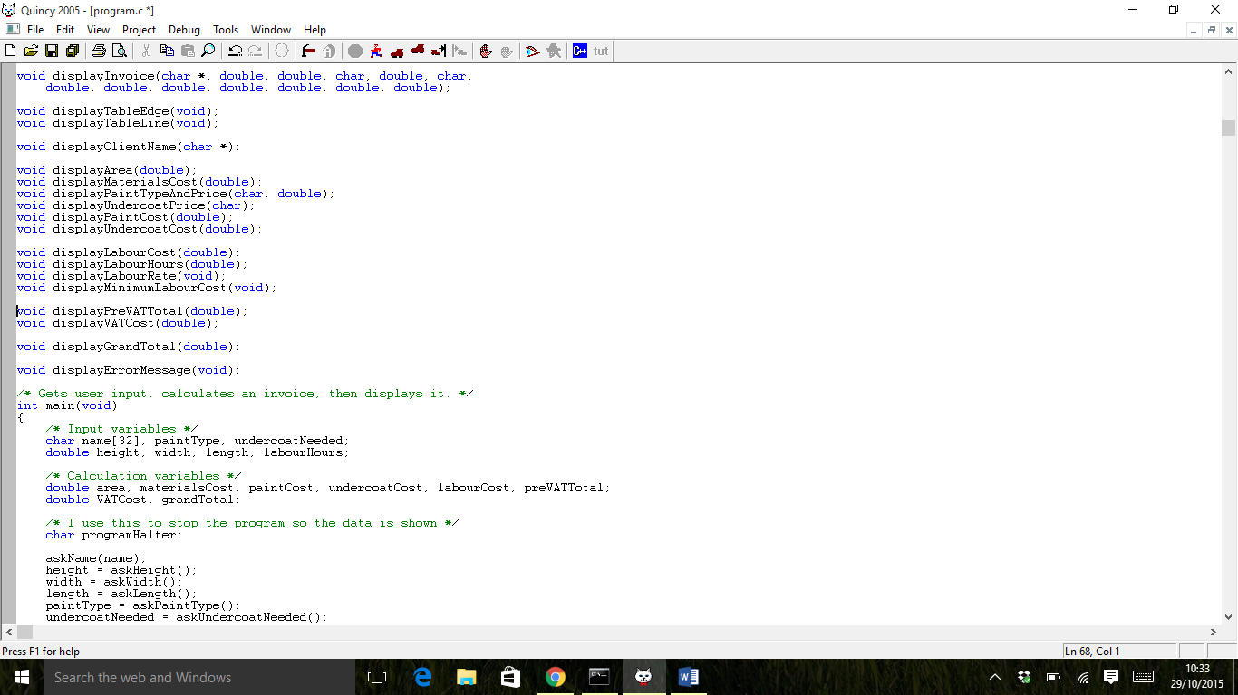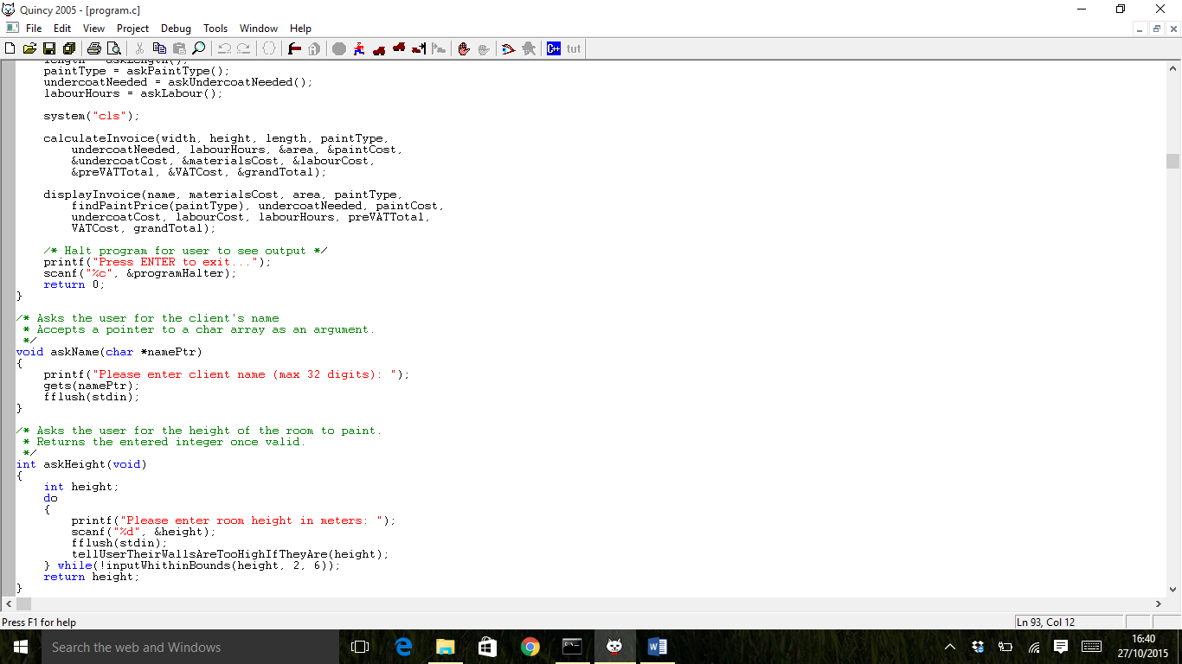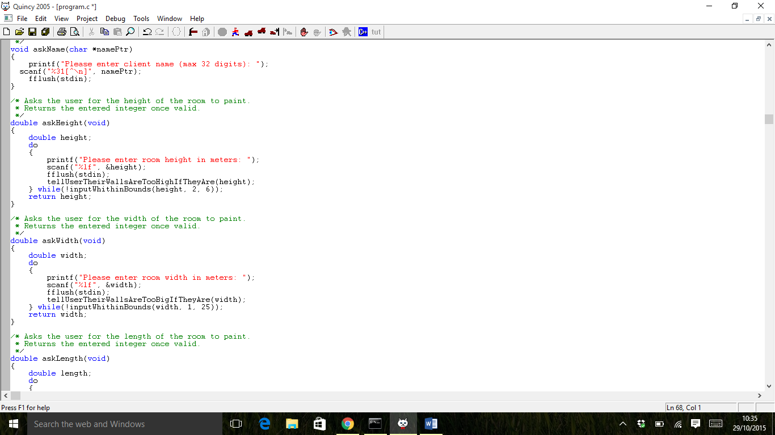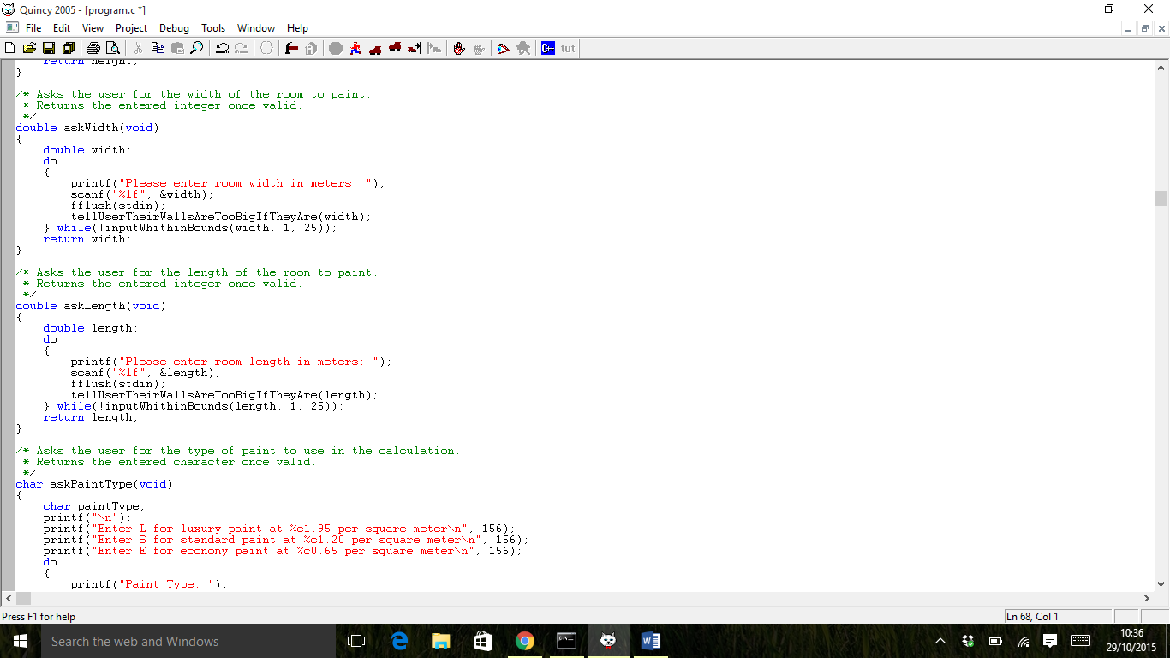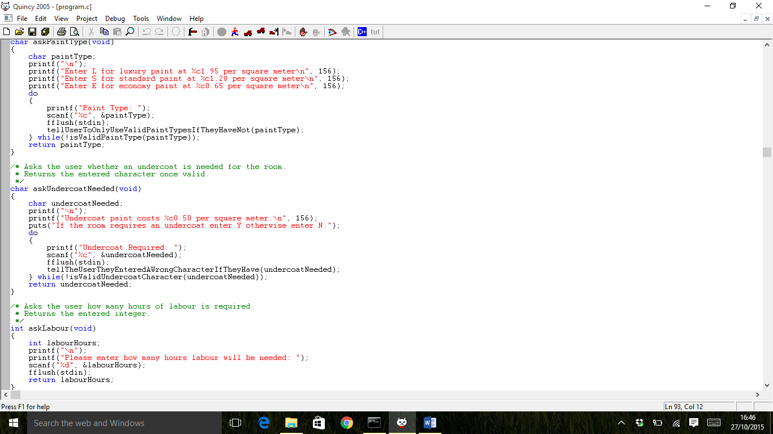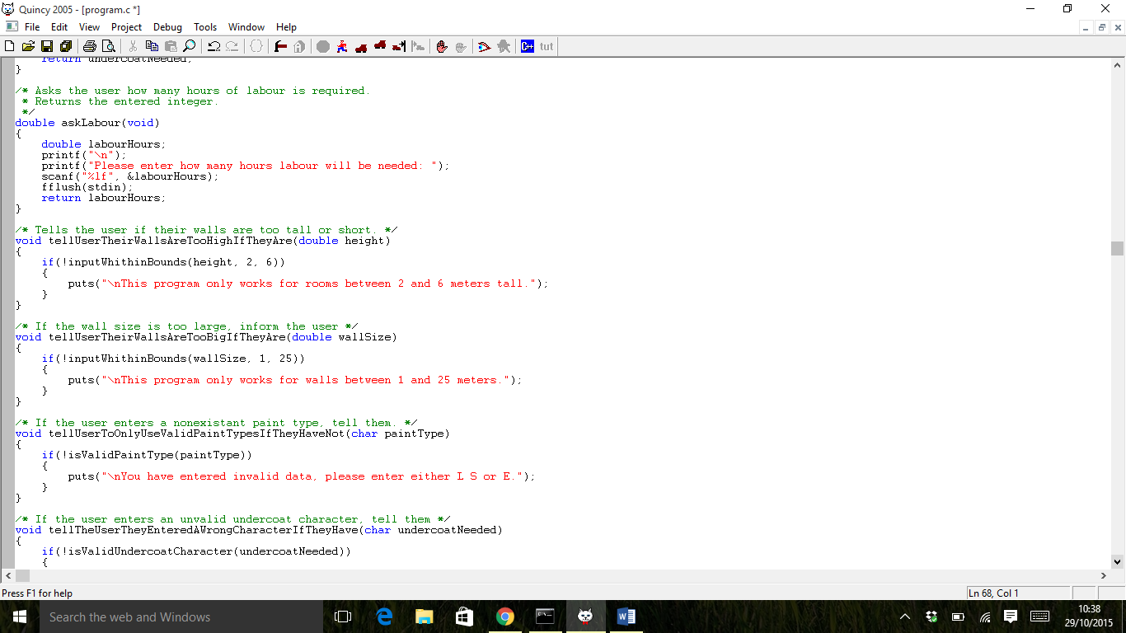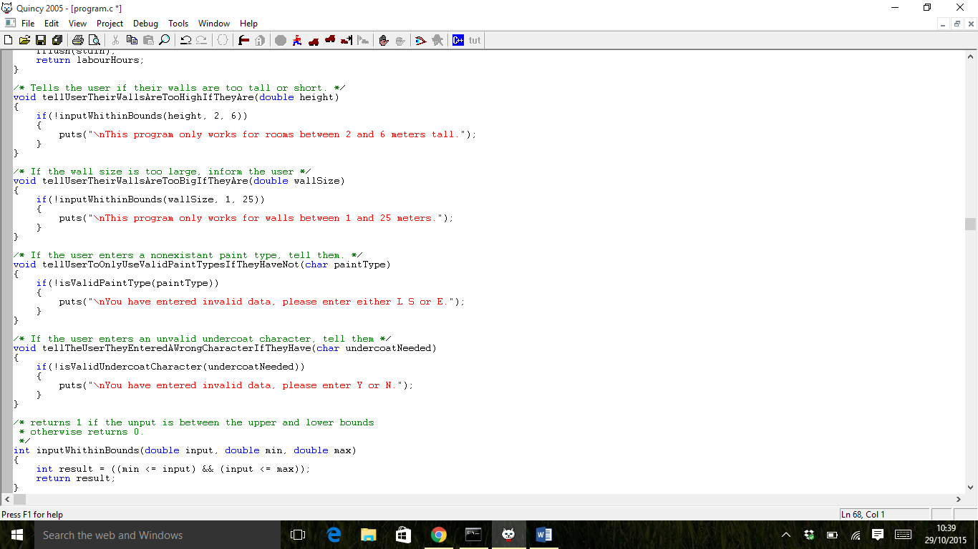

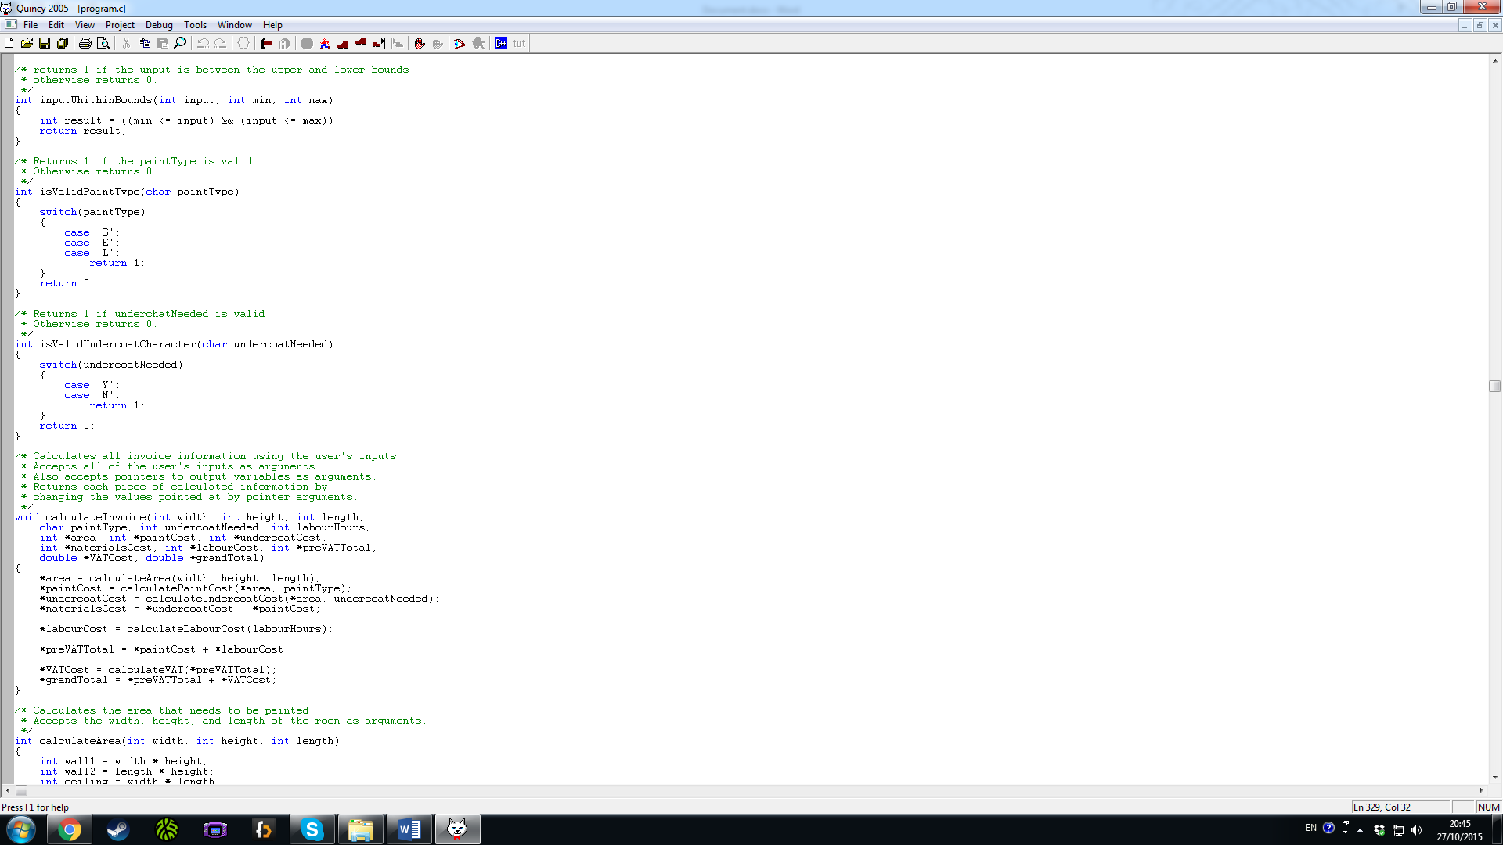

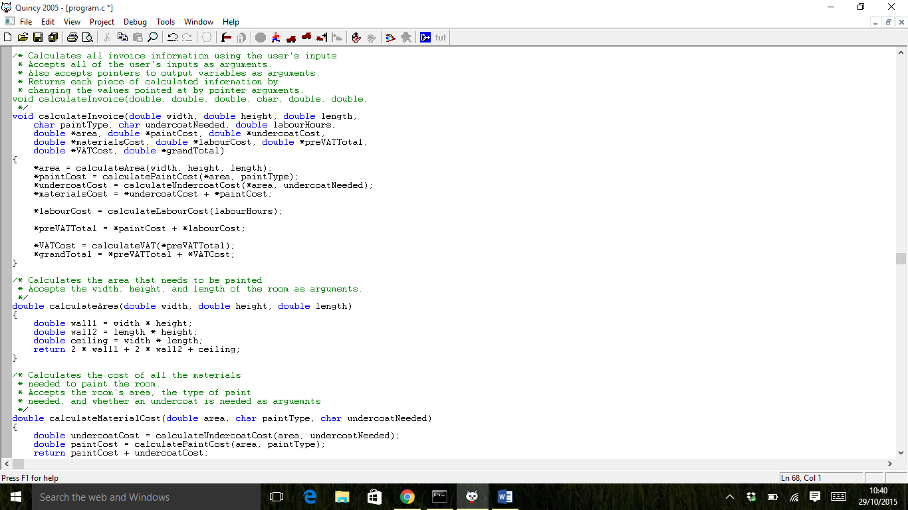  
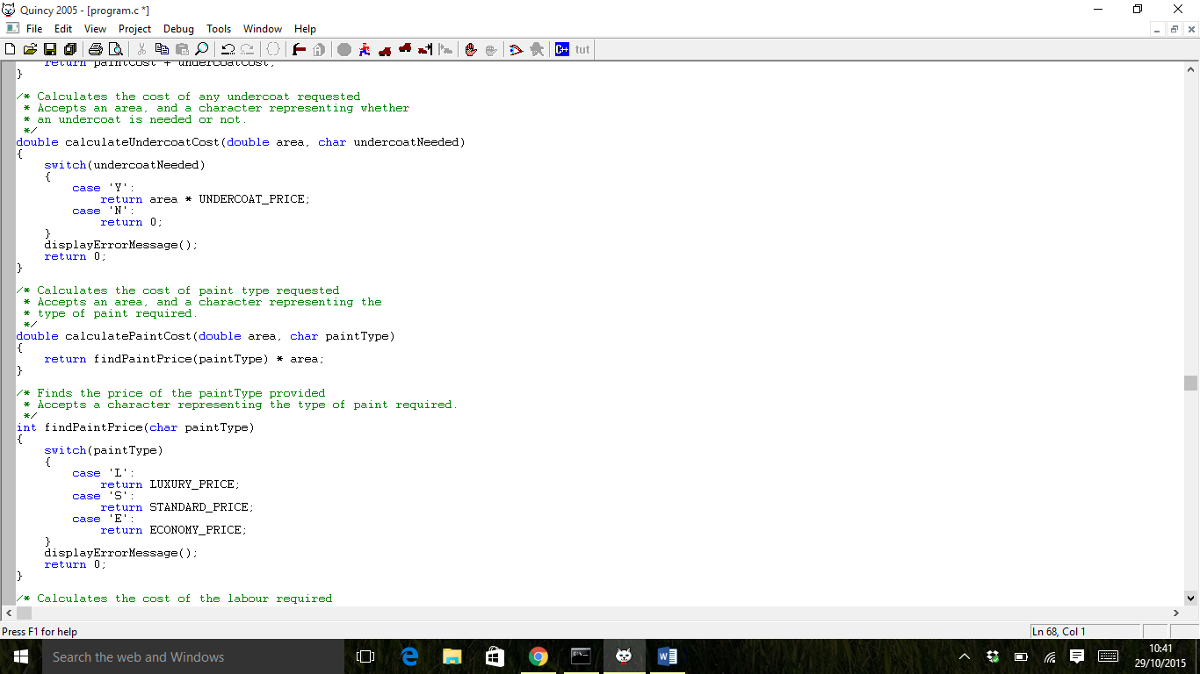  
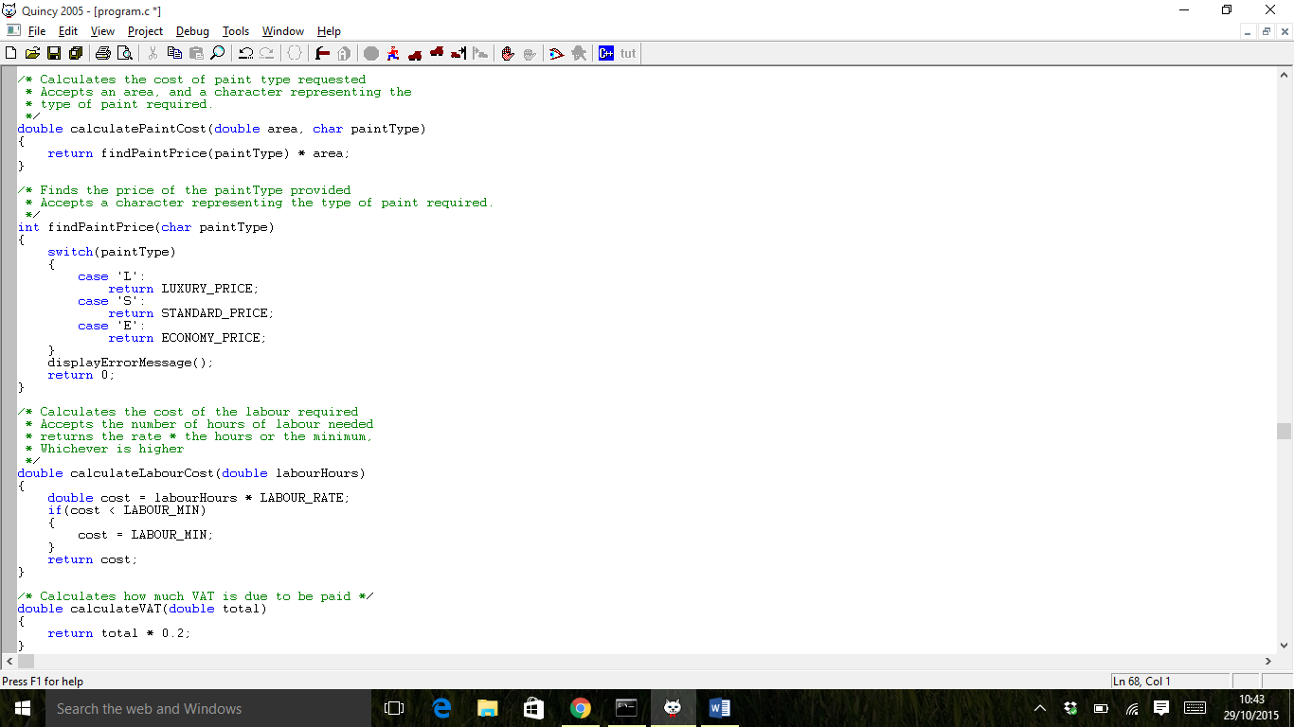  
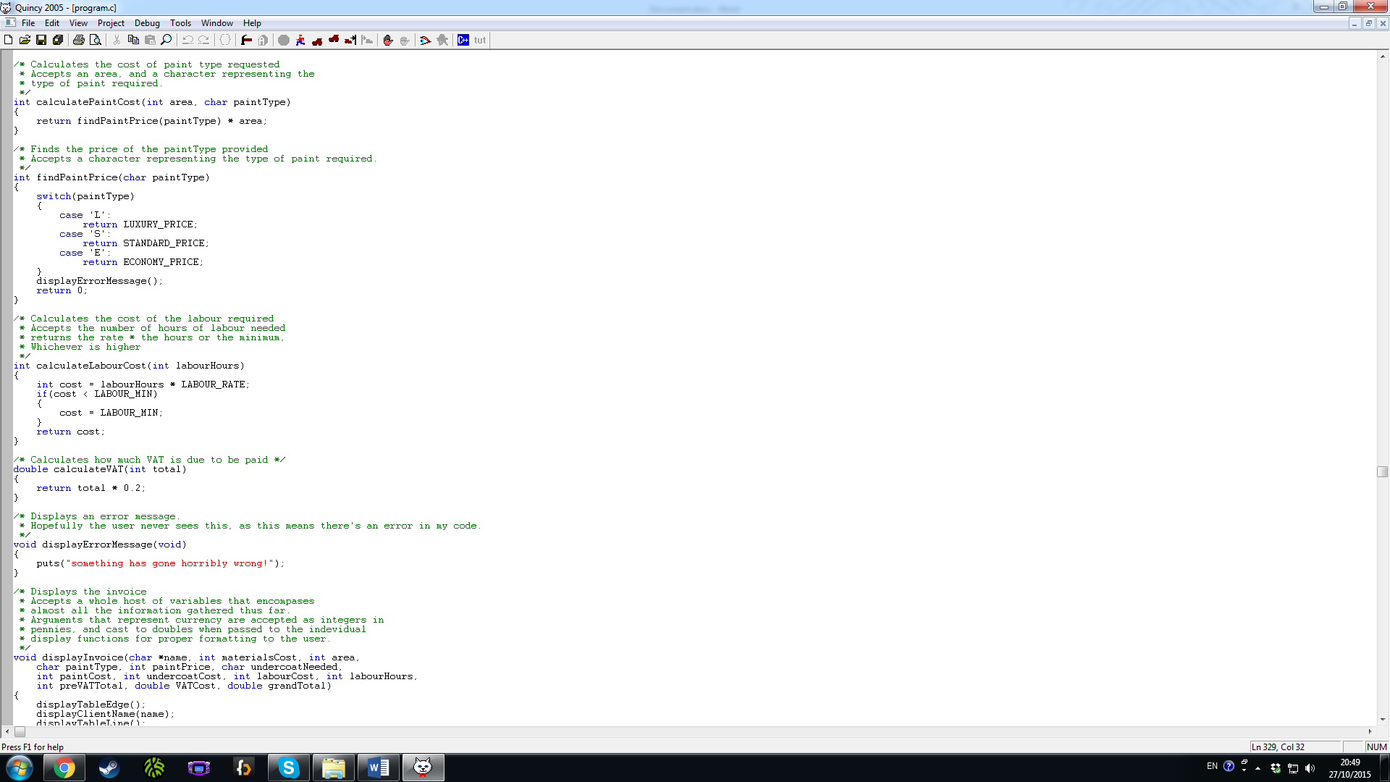  
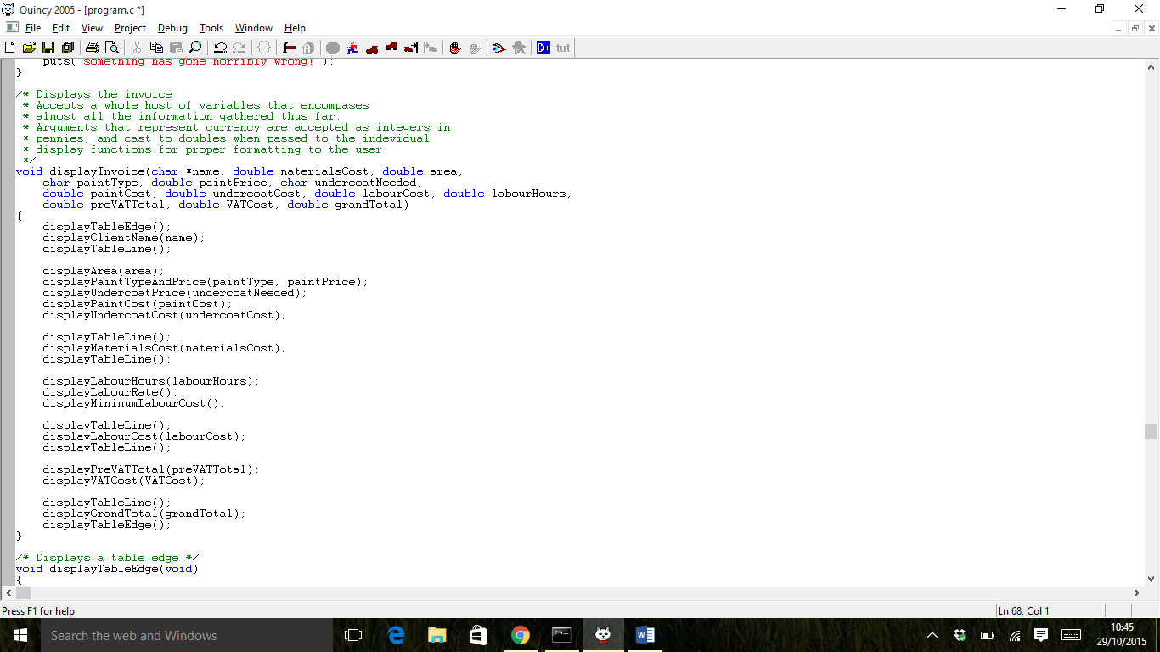

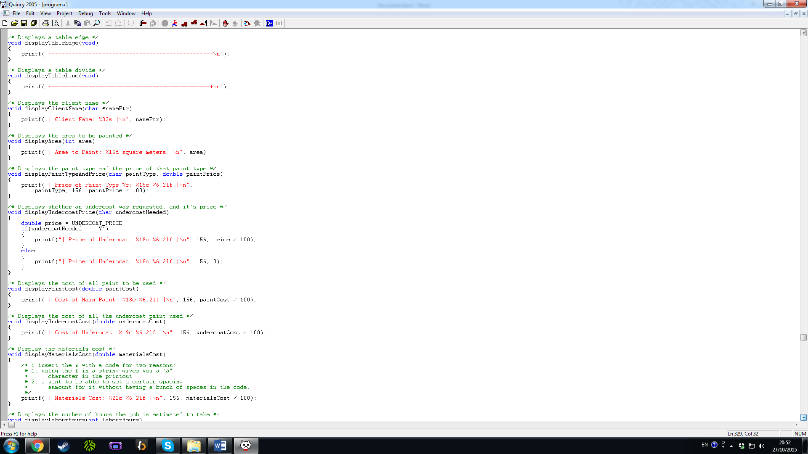  
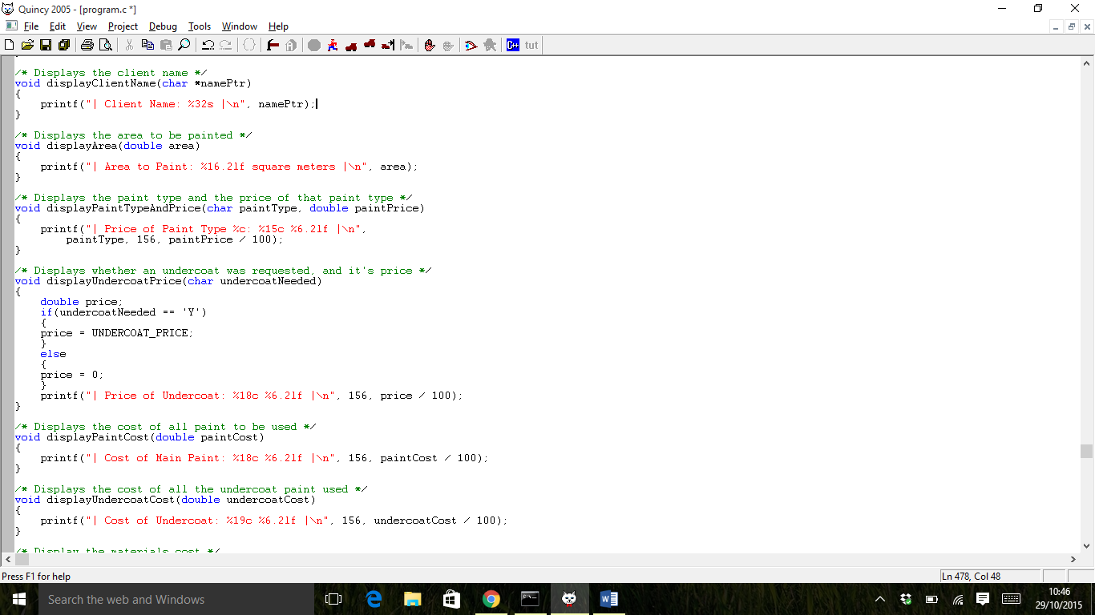  
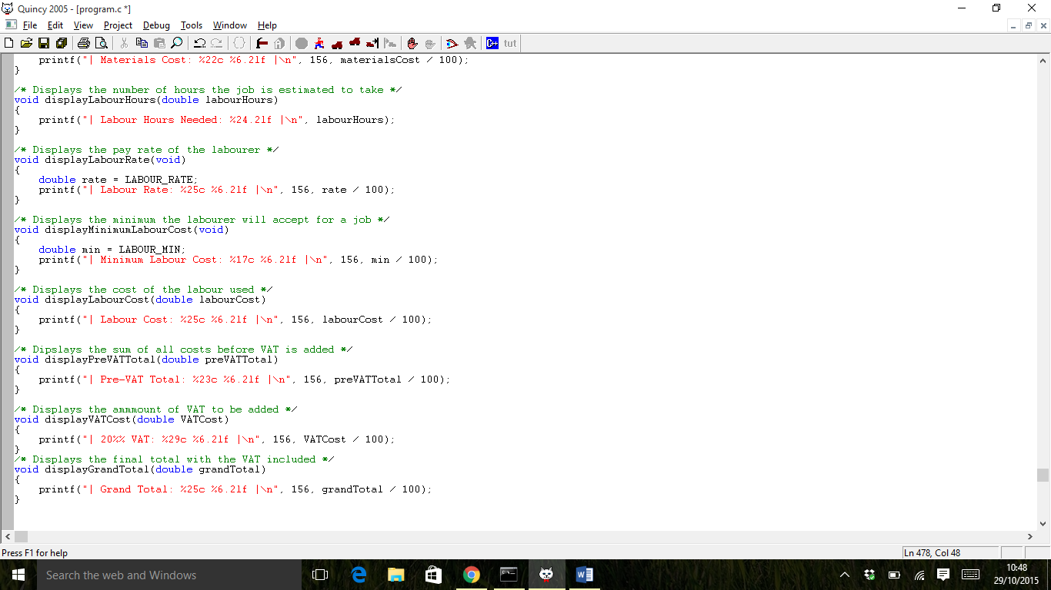  
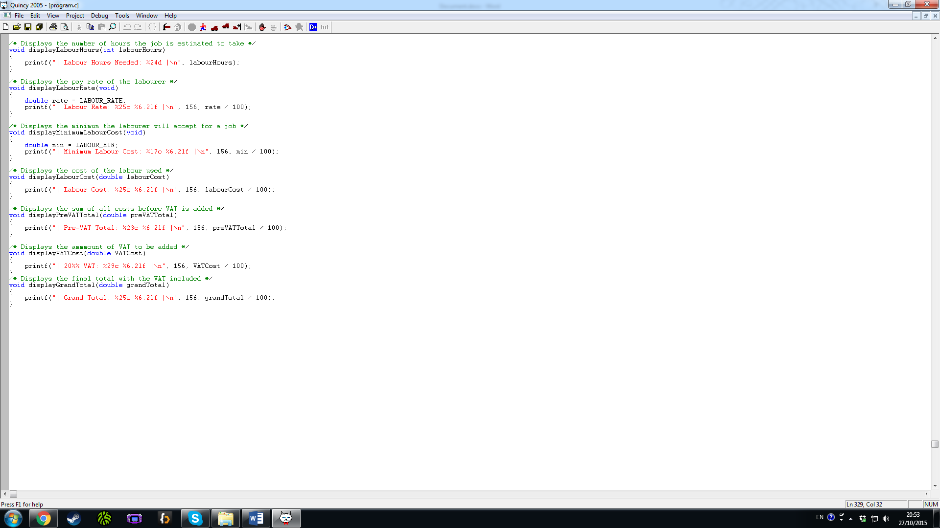

Figure 5 – The code that I wrote to compile a program that accomplishes the program’s objective

# Proof of testing

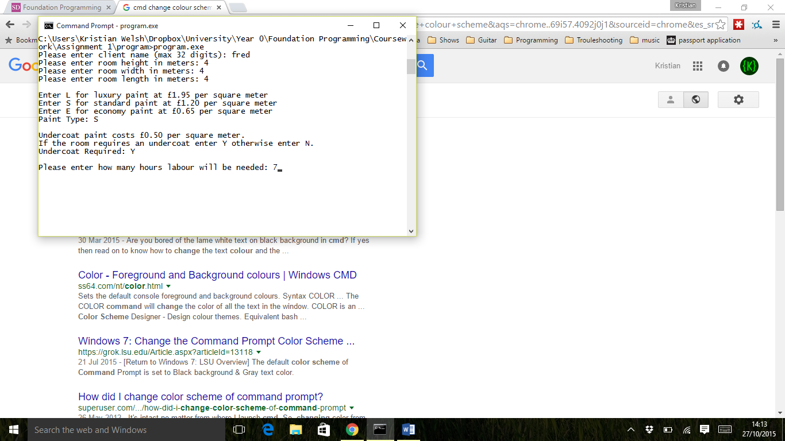

Figure 6 – Testing the first screen of my application

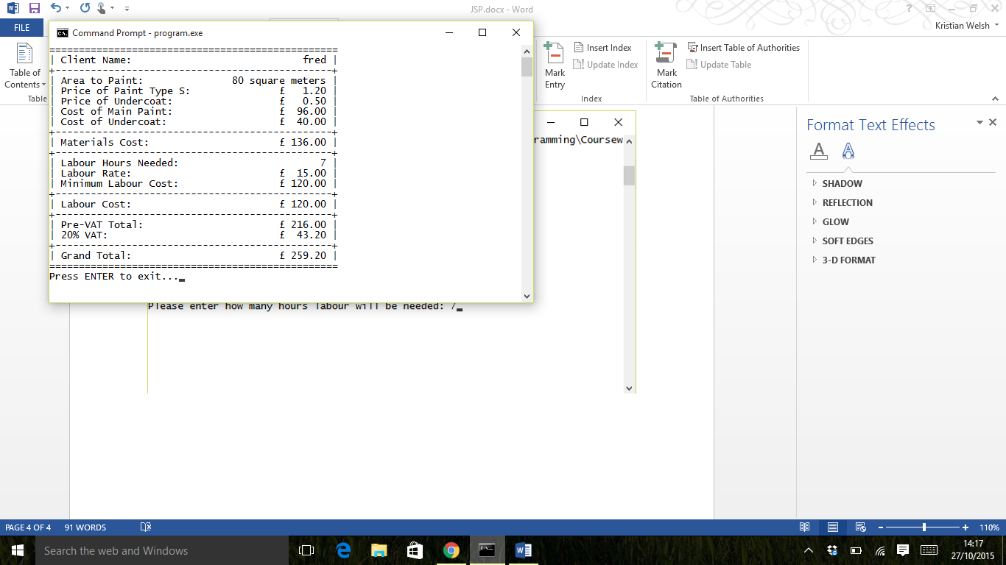

Figure 7 – testing the second screen of my application

# Evaluation

I found it difficult to adapt my prior knowledge to fit the C language. For example I had some difficulty passing the customer’s name around because I didn’t fully understand pointer notation. I had a passing knowledge from reading code samples in the past, but had difficulty recalling it.

I tend to make small methods and I quite like the program structures this leads to, but I feel that the need keep method prototypes, method calls, and method declarations synchronised has slowed me down considerably. If given more time I would have extracted smaller functions to remove some of the duplication in the input accepting functions.

I feel that the JSP diagram was the most difficult planning document I needed to produce. When producing a diagram like this in the future I will look for a better tool than word’s drawing tools. I feel that designing the program in advance has really helped me to create a nicely presented invoice, the screen designs were especially useful as a reference to create the input and display functions.

I tried replacing some if statements with ternary statements in order to make conditional variable assignment neater. However I couldn’t get return values to assign to the variable on the left of the ternary condition. I also feel that I wasted time and effort juggling function prototypes while trying to develop the application, I should instead have written it all in main and extracted functions after I had completed all of the functionality.

# Appendix

Here is a list of all word features used, followed by how I used them.

* Header and footer
* Page breaks
* Styles for paragraphs and headings
* Bulleted list
* Table
* Screenshots
* Diagram
* Table of contents
* Appendix

A header and footer is included at the top and bottom of each page of this document except for the cover page. I edited this information by clicking above and below the margin marks and editing the text. I inserted a page number by clicking insert then page number.

Page breaks are included at the last page of each section before the next header. I inserted these by pressing ctrl+Enter, and occasionally by clicking the insert tab then clicking page break.

I have used styles for all paragraphs and headings except for text in diagrams. I applied these by changing the presentation of one piece of text then right-clicking on the associated style and clicking “update ___ to match selection”.

I have listed the features at the top of this page with in a bulleted list. I inserted it by starting a new line and clicking on the bullets button in the paragraph section of the home tab, a new bullet is created by pressing enter.

A table is used on page 3 to show what restrictions are placed on the data the user inputs, I created this by clicking on insert then on table, and selecting the dimensions of the table I needed. I inserted the caption by right clicking then clicking insert caption.

There are multiple screenshots featured in this document on page 4 and pages 6-10. I have inserted the screenshots by pressing the print-screen key on my keyboard, then pasting them into the document. I then right clicked and cropped the image to show the relevant section of the screenshots. After that I dragged one of the corners while holding shift to resize it proportionally. I captioned them by right clicking on them and selecting the caption option. I then hit the okay button then edited the text that was placed under the image.

I have drawn the JSP structure graph as a diagram using word’s shape tools. I inserted these by clicking insert, then shapes, then the shape I wished to add. I captioned it as previously described.

I have inserted a table of contents on the second page of my document, I did this by clicking on the references tab, then the “Table of contents” drop down menu, selecting the style of contents page I wanted. I added each header to the table of contents by selecting the header1 style from the styles section of the home tab. I then update the table of contents by clicking the references tab then clicking update table then okay.

I have created this appendix by creating a new page with the heading appendix and inserting a bulleted list with this text.