# Foundation Year in Computing Sciences

# Foundation Programming – G6065

# Autumn term 2015 – Programming Project 2 – Knockout Competition

|  |  |
| --- | --- |
| **Set:** | Monday 2 November 2015 |
| **Due:** | Term 1 Week 9 – Thursday 19 November 2015 by 4PM – Informatics Admin office |
| **Format:** | A printed, hardcopy, Word document. |
| **Learning Outcomes Assessed** | 1. Employ a range of basic programming constructs to develop a programming solution in a suitable high-level, imperative programming language 2. Transform a program specification into a design using a standard top-down design technique 3. Use a programming environment to edit, debug and compile a simple program 4. Design and use a test plan for verification of a program, and draw conclusions from the outcomes 5. Understand the reasons for, and show ability in documenting programs to a good standard |

# Specification and Tasks:

You are required to design, write and test a program to handle a table tennis knockout competition. The competition starts with 16 players, giving a total of 8 matches in the first round. Each match is fought until one player has won 3 games, ie the best of 5 games. Only the winner of a match progresses to the next round, see the diagram below.

Your program starts by allowing the user to enter the 16 player names for the first round. Then a menu list should be displayed to allow the user the following options:

1. Enter a game result
2. Display the current round
3. Display those who are through to the next round
4. Display the previous round
5. Exit program

When a round is completed, the program will step onto the next round and continue until the final is completed. All first round games must be completed before a second round game is played.

# What to submit:

A printed, hardcopy, Word document containing your design, C programming code, a test plan and test logs. Your design should include all screen layouts with a story board and a JSP structure chart. The program code should be appropriately commented and the layout should conform to the house style given during lectures. You are also required to write a short evaluation account (about 500 words) outlining the skills you have gained in writing the program and to include why certain statements, data types, data structures, user defined functions and information sources were used.

In addition please submit your code source file by email to me

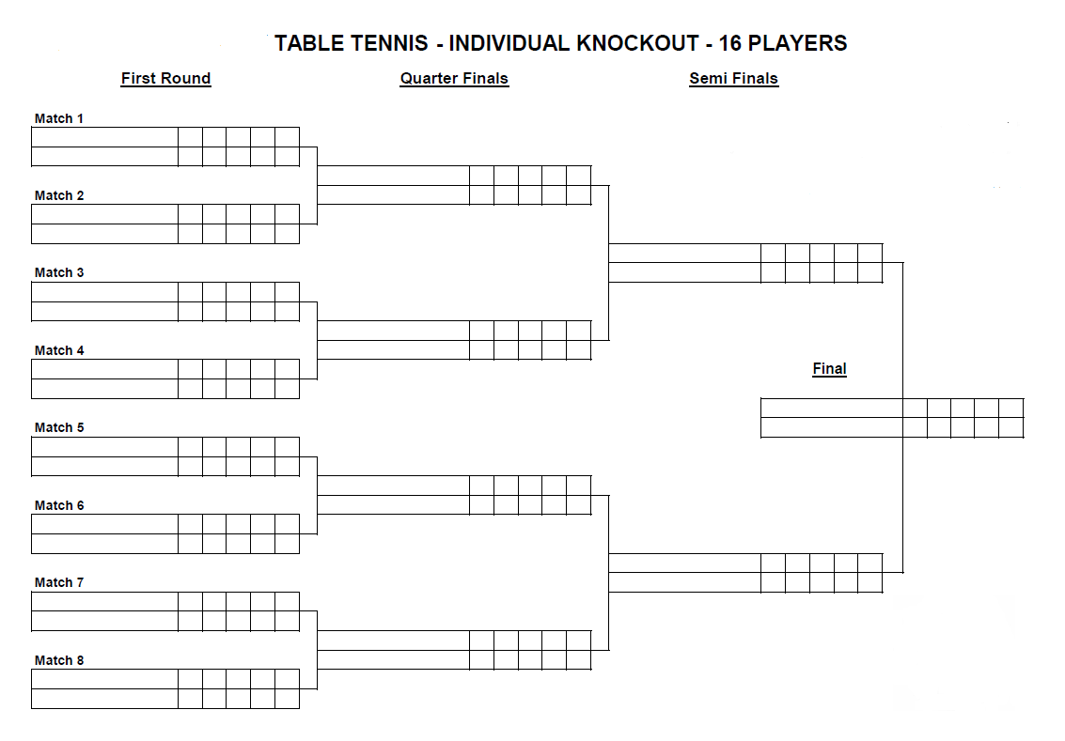

# Assessment Criteria

A PASS mark will require:

* A Word document containing:
  + A contents list
  + The design
  + The C programming code
  + A test plan and some test logs
  + A written evaluation
* The design must be appropriate
* The program must contain appropriate comments and suitable names for variables and user design functions
* The program must have basic functionality of entering results for the first round.

A higher grade will require in addition:

* A good working user interface
* Good error handling
* Good and efficient coding used
* The use of arrays passed to user defined functions
* Consistency between the specification, design and the tested program
* The written evaluation to show a good understanding of the programming concepts used.