**Helicopter Rescue Missions***by Kristian80*

**Installation**

To install HRM, simply copy the content of your zip file into the X-Plane plugins folder:  
X-Plane 11\Resources\plugins\

You need the following libraries installed for the missions:

*x_prefab_library*

*world-models*

*the-handy-objects-library*

*ruscenery*

*RescueX Library*

*RE_Library*

*RD_Library*

*R2_Library*

*pm_library*

*Ground Textures Library*

*the-fruit-stand-aircraft-library*

*OpenSceneryX*

*MisterX Library*

*JB Hangars*

*JB_Houses*

*JB_Objects*

*Helipads-Pack 1*

*Helipads-Pack 2*

*Swisscreations Library*

*Europe-Library*

*CDB-Library*

*BS2001 Object Library*

*3D people library*

*ff-library-extended-lod-version*  
  
By pure coincidence this list of libraries is exactly the same as for the *Montana Helicopter Destinations* scenery.

To enable sling line missions, you need X-Hoist aka X-Slingline installed.

To enable FSE Autoconnect, you need the X-Economy client installed.

FSEconomy is not part of this plugin and this plugin is not part of FSEconomy. All it does is trigger the start/finish flight commands of the X-Economy client.

**Start Mission**

To start a new mission, open the HRM control window via the menu. It will look something like this:

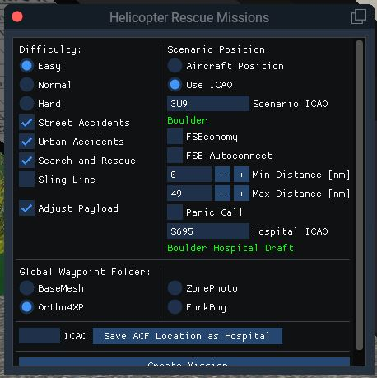

Here you have several options:

**Difficulty:** Adjusts the available time to successfully finish the mission

**Type:** Depending on the type, you will either get missions on straight street section, crossings within urban environment or search and rescue missions in the country side. If you select multiple options, the selection is random.

Sling line support is only basic and will place an object on the given coordinates. It is recommended that you reset the object position when you are close to the scene.

**Adjust Payload**: If enabled, this adjusts the payload to cover crew, medical equipment and patient. The weight can be adjusted in the ini file.

**Scenario Position:** You can adjust the position for the generated scenario either from your current location or by entering a dedicated ICAO. Here, you can adjust the minimum or maximum distance from the selected position.

**FSEconomy:** If you are using FSEconomy, a position will be selected that corresponds to the entered FSE ICAO. FSEconomy always assumes that the closest FSE airport is the one you are departing and arriving from. This plugin uses the fact that this can be anywhere on the map, as long as no other FSE airport is closer than the selected one.

To make mixing HRM and FSE even more conveniently, you can select **FSE Autoconnect**. Here, HRM will try to start/finish the flight according to your mission status. Remember that you have to setup an appropriate FSE Flight on the Game Server before starting your HRM mission. This flight should include assignments from your current position to the selected Scenario ICAO, and from the Scenario ICAO to the ICAO of the selected hospital.

**Panic Call:** By enabling this feature, you will not get precise coordinates for your scenario. Just like in the real world, it will be unsure if the person making the emergency call gave you the right position or not. Maybe it is right on spot, maybe it is completely off. When enabling this, you will be able to adjust the search range from 500m x 500m up to 5km x 5km.

**Hospital ICAO:** This is the destination of your rescue flight. This can be a normal x-plane airport or the ICAO that corresponds with the hospital of your scenery. For example the *Montana Helicopter Destinations* scenery has an ICAO for each Hospital. However, if your scenery does not come with an ICAO, you are able to generate a custom ICAO (see below).

**Global Waypoint Folder:**

Depending on the x-plane scenery you are using, you can select if you use computed waypoints for the x-plane base mesh, Ortho4XP, ZonePhoto (Europe), or the ForkBoy Photosceneries. ForkBoy might not be part of the initial release.

**Creating a Custom Hospital ICAO:**

If your desired hospital does not come with an x-plane ICAO, you may position your aircraft at the helipad, enter a unique X-Plane ICAO into the text-box and press Save ACF Location as Hospital. If there is already a custom ICAO with the same name, the position is updated.

**Create Mission:**

If you have selected all options according to your needs, you can hit this button to enter the flight planning phase.

**Flight Planning**

This phase is dedicated to flight planning.

After hitting *Create Mission* HRM created a new flight plan called HRM.fms in your x-plane FMS directory. You can open it in any flight planner supporting the X-Plane 11 file format and add/remove waypoints just as you would in the real world.

Remember that no real pilot would start an medevac mission without creating a flight plan, checking the expected destination for possible obstacles and landing sites.

In difference to the real world, you have no time limit for this task.

Once you are done, hit *Start Flight*.

**Flight to the Patient**

If you start your aircraft cold and dark, you will get additional time for the start up. If you are quicker, your remaining time will be added to the available flight time.

If you start with battery or engines already on, the flight time will start ticking as soon as you take off.

The flight to the patient is straight forwards, just get there as quickly as possible. You will get maximum points if you achieve an average speed of 120kt or more. If your time is up, you will be able to finish the mission, but you will get zero points.

Land within 100m of the scenario's center. There is no indication for the center, just need to guess it.

To finish your flight, completely lower to collective. If FSE Autoconnect is selected, meet the finish flight criteria for FSE (parking brake on or engine off).

**Patient Pickup**

Just wait until the medical crew is done and the patient is on board.

**Flight to the Hospital**

Fly as gentle as possible! All G forces are being measured and result in the patient comfort level evaluation.

You will get maximum points for the patient comfort if the forces are below 0.2 g forward/reward, 0.15g to the sides, 1.3g vertically and above 0.7g vertically. Higher forces result in higher point reduction.

You will get maximum points if you achieve an average speed of 120kt or more. If your time is up, you will be able to finish the mission, but you will get zero points.

To finish your flight, completely lower to collective. If FSE Autoconnect is selected, meet the finish flight criteria for FSE (parking brake on or engine off).

**Patient Deboarding**

Just wait until time is up and watch your mission evaluation.

**License**

This program is free software: you can redistribute it and/or modify it under the terms of the GNU General Public License as published by the Free Software Foundation, version 3.

This program is distributed in the hope that it will be useful, but WITHOUT ANY WARRANTY; without even the implied warranty of MERCHANTABILITY or FITNESS FOR A PARTICULAR PURPOSE. See the GNU General Public License for more details.

You should have received a copy of the GNU General Public License along with this program. If not, see <http://www.gnu.org/licenses/>.