I. Brief Description

CFG Developer

This program aims to create a context-free-grammar builder within JavaScript.  
  
The user may be able to create context-free-grammar scripts and produce an output. The builder also checks if the grammar is valid or not.  
  
You can highlight the invalid notification to see the error message.

Usage

Start adding a syntax by pressing the 'Add New +' button on the right side of the panel below. Add a keyword, and define it's new value equivalent. The first one has been filled for you.  
  
You can remove the added group by clicking the red button wastebin on the top right of the input group.

Authors

This project was built by developers Brandon, Lourdes, Mica, Marian, and Rick. An activity for the Computer Science subject Automata.

II. Simulation

Suppose we want to create a grammar that adds two numbers together. We first declare the new value ‘silbe’ for our function, and ‘ibalik’ for return.

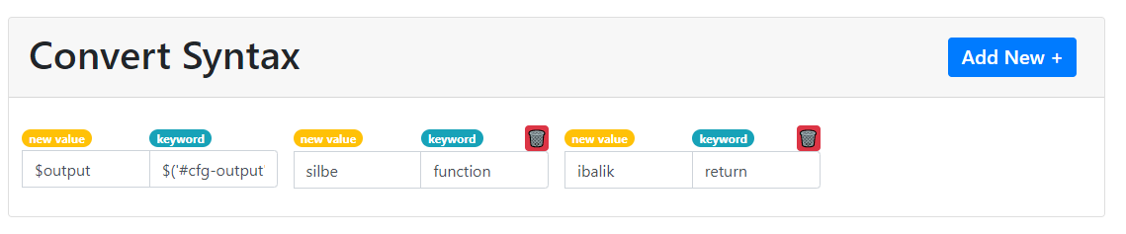

We then create a code that we can use to print two values together.

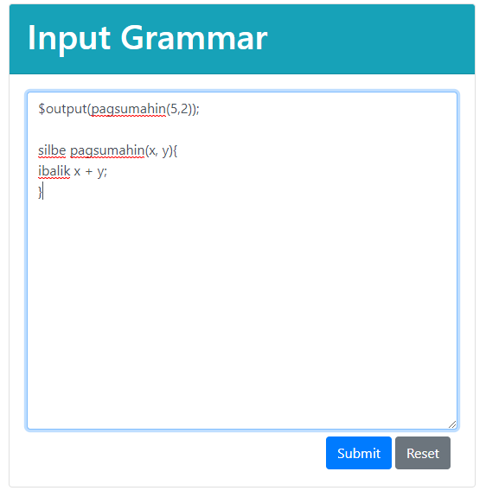

Once we click Submit, we can check whether the syntax is valid or not. 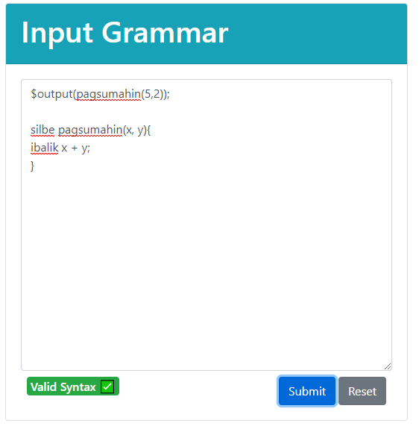

On the right side of the page, we can see our output.

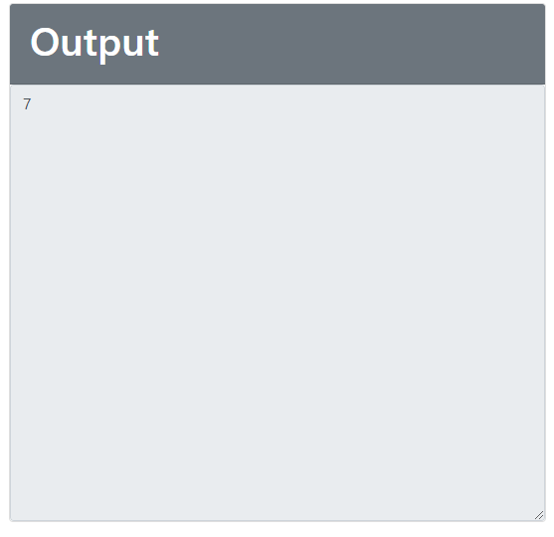

Suppose we try to purposely create an error on the code, by let’s say creating a variable that we did not declare.

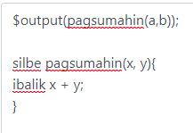

By clicking submit, we can see our syntax error warning below, and hovering over it can see our error message.

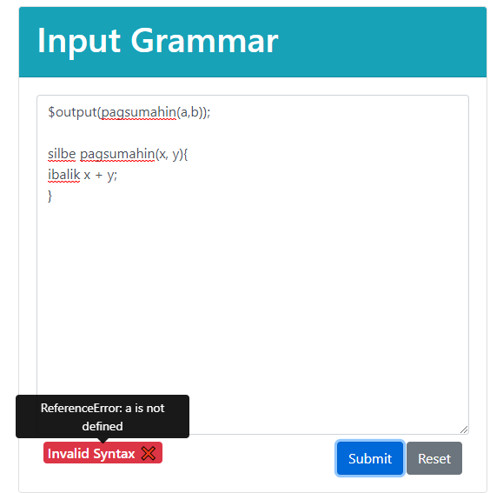

III. Codes

//counter is a unique identifier for each created cfg group

        let counter = 1;

        $("#btnAddNew").on('click', function(){

            $("#syntaxRow").append(`

            <div class="input-group p-2 col-md-3" id="cfgGroup`+counter+`">

                <div class="col-6 p-0">

                    <div class="badge badge-pill badge-warning text-white">

                        new value

                    </div>

                </div>

                <div class="col-6 p-0">

                    <div class="badge badge-pill badge-info">

                        keyword

                    </div>

                    <button class="btn btn-danger p-0 float-right" data-toggle="tooltip" title="Remove this CFG Group" onclick="if (confirm('Are you sure you want to remove this Syntax Group?')) $('#cfgGroup`+counter+`').remove(); ">🗑️</button>

                </div>

                <input class="form-control" type="text" placeholder="Keyword" name="cfgKey`+counter+`" value="" />

                <input class="form-control" type="text" placeholder="New Value" name="cfgVal`+counter+`" value="" />

            </div>

            `);

            $('[data-toggle="tooltip"]').tooltip();

            ++counter;

        });

        function submitGrammar() {

            keys = [];

            keyValue = [];

            for(let i = 0; i < counter; i++){

                let key = $("[name=cfgKey"+i+"]").val();

                let val = $("[name=cfgVal"+i+"]").val();

                if (key != undefined && val != undefined){

                    keys.push(key+"");

                    keyValue.push(val+"");

                }

            }

            var cfg = document.getElementById('cfg-input').value;

            $("#cfg-output").html("");

            keys.forEach(function (item, index) {

                cfg = cfg.replaceAll(item, keyValue[index]);

            });

            $("#cfg-input").on('change', function () {

                $("#cfg-output").html("");

            })

            try {

                eval(cfg);

                $("#isValid").attr("class", "badge badge-success float-left").html("<h6 class='mb-0'>Valid Syntax ✅</h6>");

            }

            catch (err) {

                $("#cfg-output").html("");

                $("#isValid").attr("class", "badge badge-danger float-left").html("<h6 class='mb-0' data-toggle='tooltip' title='"+err+"'>Invalid Syntax ❌</h6>");

            }

            $('[data-toggle="tooltip"]').tooltip();

        }